PART B

(PART B : TO BE COMPLETED BY STUDENTS)

***(Students must submit the soft copy as per following segments within two hours of the practical. The soft copy must be uploaded on the Blackboard or emailed to the concerned lab in charge faculties at the end of the practical in case the there is no Black board access available)***

|  |  |
| --- | --- |
| Roll No.A019 | Name:Divisht K |
| Class :MCA | Batch :2 |
| Date of Experiment: | Date of Submission: |
| Grade : |  |

**B.1 Classification Code and screenshot by student:**

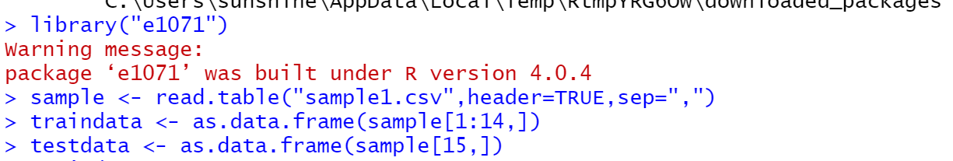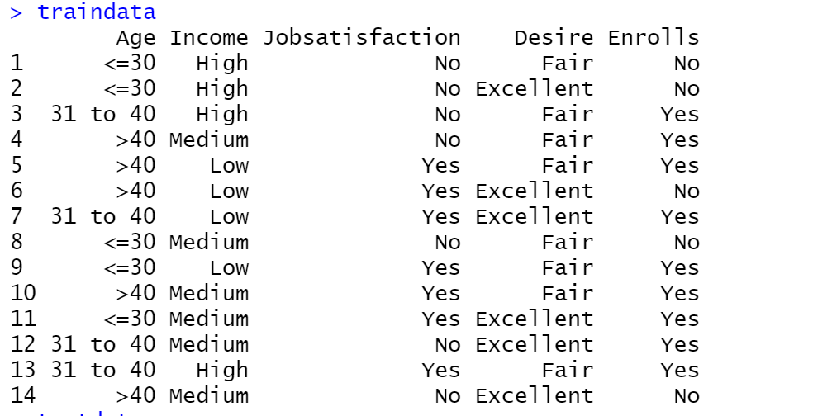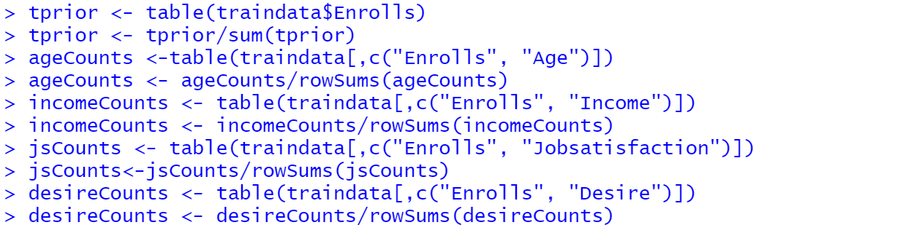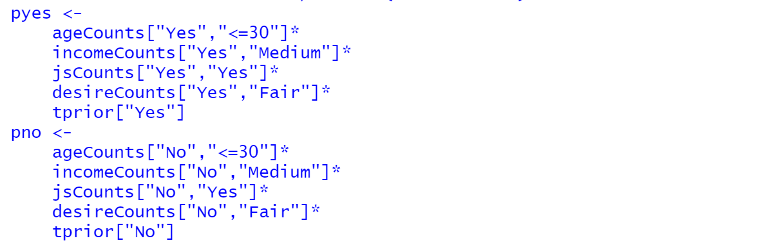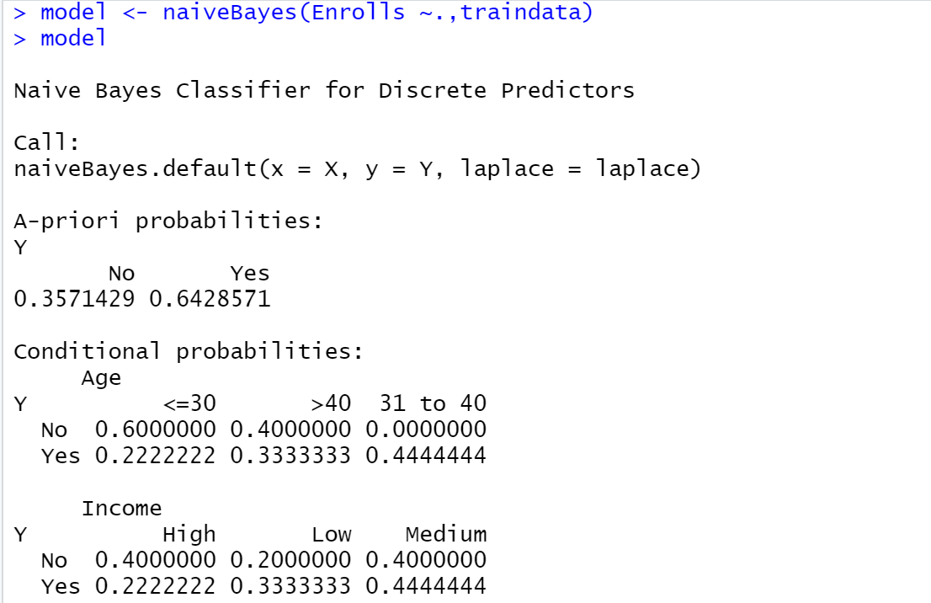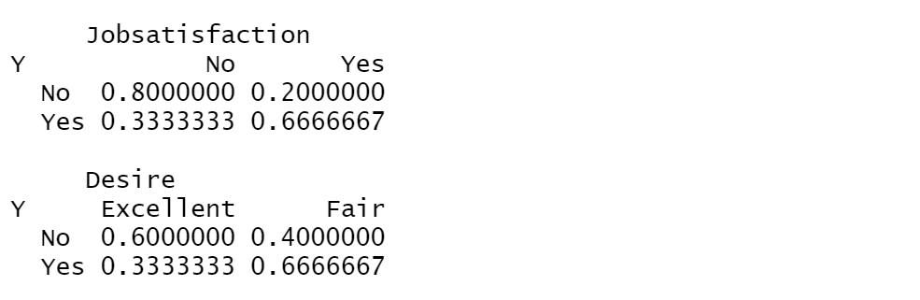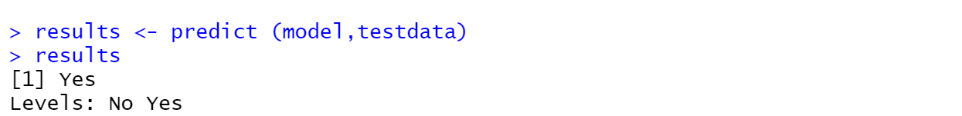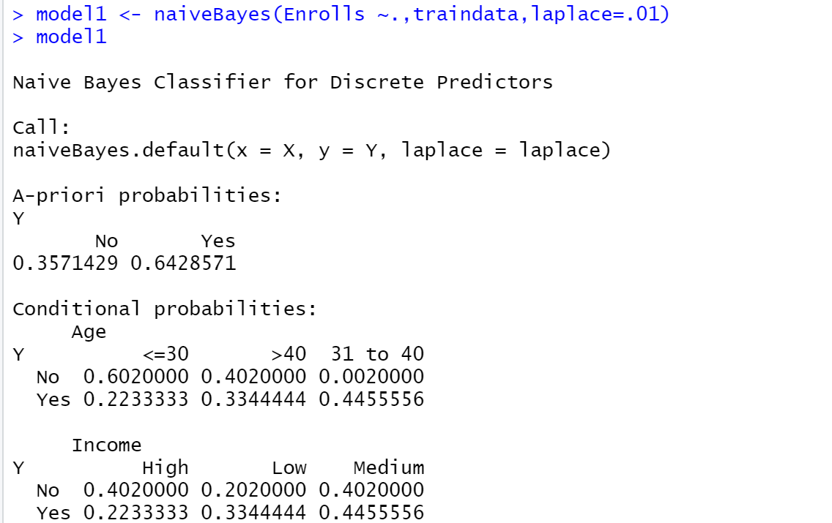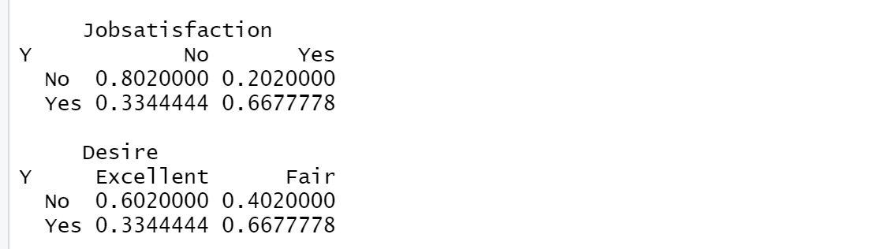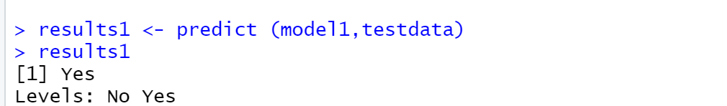

**B.2 Observations and learning:**

***In the Bayesian Classification theorem we can predict class membership probabilities such that a given query belongs to particular class. The main purpose of this algorithm is to find a particular class for a particular query***

**B.3 Conclusion:**

***On completion of this experiment ,I understood the concept of Bayesian classification.***

*************************