
School of Information Technology and Engineering
Hospital Queue and Triage Management System using Object-Oriented Design Patterns
FINAL REPORT
For
ISWE404L - Design Patterns - TH
In
MTech (Integrated) - Software Engineering
By
C. Safalya
23MIS0125
G. Sai Santhosh
23MIS0227
CP. Jyotheswar
23MIS0097
System Development Code Link: GitHub - Hospital-Queue
Under The Guidance Of
Dr. SENTHIL KUMAR. U
VIT, Vellore
TABLE OF CONTENTS
1. ABSTRACT 3
2. LITERATURE SURVEY 4
2.1 Design Patterns in Software Engineering 4
2.2 Hospital Queues and Triage 4
2.3 Admission and Resource Coordination 4
2.4 Clinical Lifecycle Governance and State Transitions 4
2.5 Technology Background 5
3. RESEARCH GAP 6
3.1 What is Missing in Existing Examples 6
3.2 Problem Statement 6
3.3 Objectives 6
4. DESIGN PATTERNS USED IN THE PROPOSED SYSTEM 7
4.1 Creational Design Pattern: Factory Method 7
4.1.1 Intent 7
4.1.2 Need in the Proposed System 7
4.1.3 Application Classes and Components 8
4.1.4 Advantages 8
4.1.5 Why PatientFactory was Selected 8
4.1.6 Class Diagram Before Applying the Pattern 9
4.1.7 Class Diagram After Applying the Pattern 9
4.1.8 Code and Implementation 10
4.2 Structural Design Pattern: Facade 12
4.2.1 Intent 12
4.2.2 Need in the Proposed System 12
4.2.3 Application Classes and Components 13
4.2.4 Advantages 13
4.2.5 Why AdmissionFacade was Selected 13
4.2.6 Class Diagram Before Applying the Pattern 13
4.2.7 Class Diagram After Applying the Pattern 14
4.2.8 Code and Implementation 14
4.3 Behavioural Design Pattern: State 17
4.3.1 Intent 17
4.3.2 Need in the Proposed System 17
4.3.3 Application Classes and Components 18
4.3.4 Advantages 18
4.3.5 Why State Pattern was Selected 18
4.3.6 Class Diagram Before Applying the Pattern 19
4.3.7 Class Diagram After Applying the Pattern 19
4.3.8 Code and Implementation 19
5. SYSTEM DESIGN AND PROPOSED ARCHITECTURE 22
5.1 Overall Architecture 22
5.2 Technology Stack 23
5.3 Data Used by the System 23
5.4 System Workflow 23
5.5 REST Endpoints Used in the Workflow 24
5.6 How the Three Patterns Work Together 25
6. IMPLEMENTATION AND SYSTEM SCREENSHOTS 26
6.1 Running the Project 26
6.2 Registering Patients (Factory Method) 26
6.3 Factory Behaviour and the Queue 28
6.4 Calling Patients to Doctors 29
6.5 Admitting Patients (Facade) 29
6.6 Patient Lifecycle Transitions and Clinical Governance (State) 31
6.7 Automated Tests 33
7. RESULTS AND DISCUSSION 35
7.1 Observed Behaviour 35
7.2 Discussion 35
7.3 Limitations 36
8. CONCLUSION 37
9. REFERENCES 38

1. ABSTRACT
This report describes BioCare EHR, the hospital queue and triage management system we built for the Design Patterns course. The application follows a patient through one hospital visit. Staff register the patient at the triage desk, the patient waits in a priority queue, a doctor calls the patient in, and the visit ends either with a direct discharge or with admission to a ward, billing and checkout. The backend is written in Node.js with Express and the front end is plain HTML, CSS and JavaScript. Data is stored in MongoDB, and if the database cannot be reached the server switches to a local database.json file so that the application keeps working.
The project uses three core design patterns that sit directly on its primary clinical use cases, and this report focuses strictly on those three: Factory Method (Creational), Facade (Structural), and State (Behavioural). PatientFactory (server/patterns/factory.js) turns the registration form into an EmergencyPatient, an OPDPatient, or a FollowUpPatient while enforcing domain-level category rules, such as auto-flooring emergency severity. AdmissionFacade (server/patterns/facade.js) provides the API layer with unified operations for admitting and discharging patients, coordinating bed allocation, doctor scheduling, and billing subsystems behind clean interfaces. The State pattern (server/patterns/state.js) governs patient lifecycle transitions (WaitingState -> ConsultationState -> AdmittedState -> DischargedState) and clinical escalation rules, ensuring that illegal transitions are blocked by transition guards and state-dependent operations are encapsulated in concrete state classes.
For every pattern, this report details the architectural intent, project justification, participating classes, class diagrams before and after applying the pattern, verified source code, and runtime verification from the application and test suites. We validated the entire clinical pathway through both the user interface and REST API endpoints. Automated test suites (npm test) verify 100% of the lifecycle state transitions, triage prioritization rules, and facade orchestration calls without regressions.
Keywords: design patterns, Factory Method, Facade, State pattern, hospital queue, triage, clinical lifecycle, Node.js, Express.

2. LITERATURE SURVEY

2.1 Design Patterns in Software Engineering
Design patterns are named, reusable solutions to recurring object-oriented software engineering challenges. The catalogue by Gamma, Helm, Johnson, and Vlissides describes 23 foundational patterns classified into creational, structural, and behavioural categories [1]. Our three patterns deliberately span these three categories: Factory Method is creational, Facade is structural, and State is behavioural. Each pattern addresses a distinct architectural concern in the hospital workflow: Factory Method governs heterogeneous patient instantiation based on triage category, Facade coordinates complex multi-subsystem hospital workflows (bed allocation, physician scheduling, invoice settlement) behind simplified interfaces, and State governs dynamic clinical lifecycle transitions and operational rules across a patient's care trajectory.
Freeman and Robson [2] explain the same patterns with small worked examples, and we mostly used their book to check our understanding before writing the code. Fowler [3] discusses how enterprise applications keep coordination logic out of the request handlers and put it in a separate layer. That was also our motivation for the facade.

2.2 Hospital Queues and Triage
A hospital queue is not an ordinary first-come-first-served line. A patient with chest pain should not wait behind a patient who came for a prescription refill. Triage systems deal with this by ordering patients according to urgency. The Emergency Severity Index handbook [4] is a well known example from emergency departments. We do not claim that BioCare implements the ESI. We use a much simpler scheme of our own: three categories, Emergency, OPD and Follow-up, and a severity score from 1 to 10.
In the application the queue is sorted by category first, then by severity, and then by arrival time. The triage form helps the nurse by recommending a category and a severity from the symptoms that were selected, and the backend then turns that recommendation into a patient object. That last step is where the Factory Method pattern comes in.

2.3 Admission and Resource Coordination
Admitting a patient touches several things at once. A bed has to be reserved, a doctor has to be assigned, a first bill has to be prepared and the patient record has to change. If the web layer calls each of these parts itself, every caller must remember the right order and the right arguments, and the first caller that forgets a step leaves the data half finished. A facade [1] puts a small and stable interface in front of such a group of classes. The caller asks for one thing, admit this patient, and the facade takes care of the rest.

2.4 Clinical Lifecycle Governance and State Transitions
In healthcare systems, a patient progresses through distinct operational phases: waiting in the triage queue, active clinical consultation, inpatient ward admission, and final discharge. Each phase permits specific clinical and administrative actions while strictly forbidding others (e.g., discharging an outpatient before consultation or admitting an already discharged patient). Implementing this lifecycle through distributed string flags or conditional checks results in brittle, error-prone state corruption. The State pattern [1] encapsulates state-dependent behaviors into distinct classes derived from a common interface. State transitions are governed by strict transition guards, and each state manages its own operational rules (such as clinical triage escalation during consultation), keeping business logic cohesive and adherent to the Single Responsibility Principle.

2.5 Technology Background
The backend uses Express [7], a small web framework for Node.js, to expose a REST API. The browser front end calls this API with fetch and redraws its panels from the JSON that comes back. MongoDB is accessed through Mongoose, and the same access layer can read and write a plain JSON file when MongoDB is not available. This is useful for demonstrations, because the project then runs on any laptop without an internet connection.

3. RESEARCH GAP

3.1 What is Missing in Existing Examples
Most hospital queue demos concentrate on isolated utility tasks, such as token numbers or appointment booking, while generic pattern tutorials demonstrate concepts on toy problems (e.g., shapes or coffee). In contrast, BioCare EHR establishes an integrated domain where the three patterns collaborate directly: the domain entity created by PatientFactory enters the triage queue governed by WaitingState, transitions to ConsultationState upon physician call, is admitted and discharged across coordinated subsystems via AdmissionFacade, and transitions safely into terminal DischargedState governed by the State pattern.

3.2 Problem Statement
If written naively, the application's complexity would collapse into monolithic route handlers: scattered instantiation conditionals, intertwined subsystem orchestrations (beds, doctors, billing) that risk incomplete transactions, and unvalidated status string assignments that allow illegal transitions. Introducing new patient types, modifying admission procedures, or refining clinical escalation paths would require high-risk modifications to central routing code.

3.3 Objectives
- Build a working queue and patient flow application that covers registration, consultation, admission, billing and discharge.
- Apply Factory Method, Facade, and State pattern at the three places in the system where they are architecturally justified, and demonstrate each in the production codebase.
- Show the structure of the code before and after each pattern is applied.
- Check the behaviour by running the application and the project's test script, and report what we actually observed.

4. DESIGN PATTERNS USED IN THE PROPOSED SYSTEM
The three patterns in this section are the main use case patterns of the project. Factory Method handles the registration of patients, Facade handles admission and discharge, and State handles patient lifecycle transitions and clinical governance. Each subsection follows the same order: intent, the need in our project, the classes involved, advantages, why we chose the pattern, class diagrams before and after, and the code. Screenshots of the running application for all three patterns are collected in Section 6.
Table 1: The three main use case patterns of the project
Pattern | Category | Main use case | Key class | Source file
Factory Method | Creational | Registering a patient at the triage desk | PatientFactory | server/patterns/factory.js
Facade | Structural | Admitting a patient to a ward and checking the patient out | AdmissionFacade | server/patterns/facade.js
State | Behavioural | Governing patient lifecycle transitions and clinical escalation | PatientState | server/patterns/state.js

4.1 Creational Design Pattern: Factory Method

4.1.1 Intent
Factory Method moves the decision about which class to instantiate out of the code that uses the object [1]. In BioCare, PatientFactory looks at the triage category that arrives with a registration request and returns the matching Patient subclass. The route handler only asks for a patient. It never writes new EmergencyPatient(...) itself.
Flow: registration form, then POST /api/patients, then PatientFactory.createPatient(), which returns an EmergencyPatient, an OPDPatient or a FollowUpPatient. The object is saved and appears in the queue.

4.1.2 Need in the Proposed System
The hospital deals with three kinds of patients. They share most of their data (name, age, symptoms, severity, a log of what happened) but they are not handled in the same way. Emergency patients come first in the queue, OPD patients second and follow-up patients last. Emergency cases also have a rule of their own: if the severity that arrives with the request is below 5, the factory raises it to 7, because an emergency patient should never start as a minor case.
Without a factory, the route that registers patients would have to know all three classes and repeat the category rules. The same problem appears a second time. The database stores patients as plain JSON, without any class information, so every route that loads a stored patient (calling a patient in, admitting, discharging) has to rebuild the right object from the stored triageType. If each route did that on its own, there would be several copies of the same switch. In our code both jobs go through PatientFactory, createPatient() for new patients and reconstitute() for stored ones.

4.1.3 Application Classes and Components
Table 2: Classes and components of the Factory Method implementation
Component | Responsibility
Patient | Base class. Holds id, name, age, triage type, severity, symptoms, state name, assigned doctor, bed, billing summary and the log. Provides getPatientType(), getPriorityCategory(), addLog() and serialize().
EmergencyPatient | Concrete product for emergency cases. getPriorityCategory() returns 1.
OPDPatient | Concrete product for outpatient cases. getPriorityCategory() returns 2.
FollowUpPatient | Concrete product for returning patients. getPriorityCategory() returns 3.
PatientFactory.createPatient() | Chooses the subclass from the category name, rejects unknown categories and applies the emergency severity floor.
PatientFactory.reconstitute() | Rebuilds the right subclass from a stored JSON record and restores state, doctor, bed, billing summary, log and creation time.
POST /api/patients in routes.js | The client. Calls the factory, saves the serialized patient and tells the browsers that the queue changed.

4.1.4 Advantages
- The route handler no longer depends on the three concrete patient classes.
- The mapping from category name to class exists in one place, so it cannot drift between routes.
- Category rules, such as the emergency severity floor, stay next to the code that creates the object.
- Adding a category means adding a subclass and one case in the factory.
- Stored records can be turned back into the right object with the same factory, which keeps the object model consistent between requests.

4.1.5 Why PatientFactory was Selected
- Three patient categories have to be created through one workflow, and the choice is only known at run time, from the form data.
- The category decides the queue priority, so it has to be right everywhere a patient object is created or restored.
- The emergency severity rule is a creation time rule, so it belongs in the creator and not in the controller.
- A new category, for example a maternity or a pediatric desk, should not require changes in the routes.
One honest remark about the form of the pattern. The textbook version of Factory Method uses creator subclasses that override a factory method [1]. Our version is the commonly used static variant, in which one method contains the decision. We kept the static version because patients are created in exactly one place, and a creator class hierarchy would only have added classes without adding any flexibility.

4.1.6 Class Diagram Before Applying the Pattern
Before the pattern, the route handler for registration would choose the class itself and would repeat the severity rule for emergency cases.
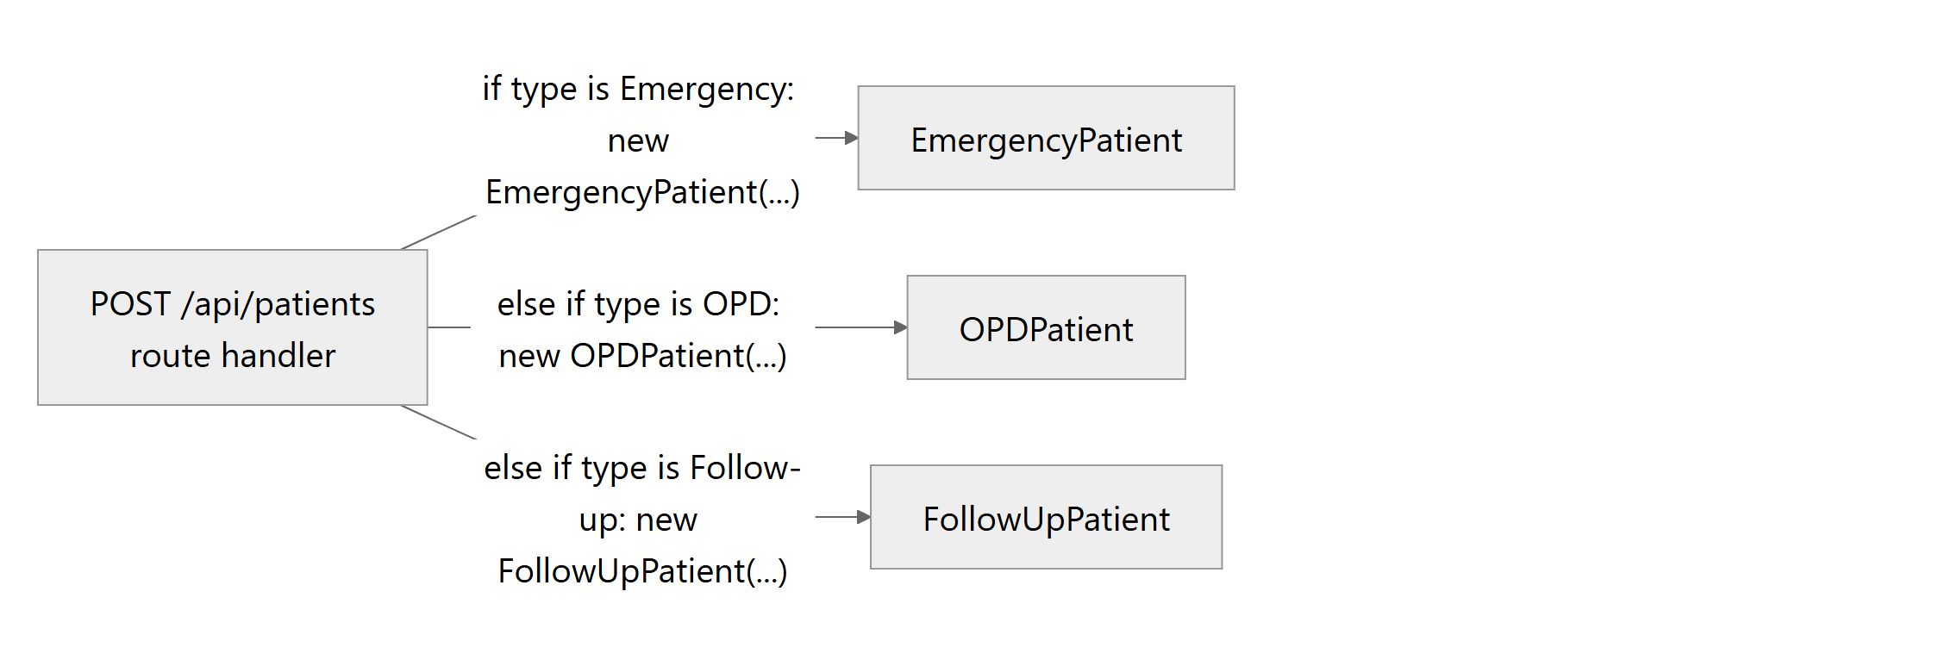
Figure 1: Structure before applying Factory Method: the route handler creates the concrete classes directly

4.1.7 Class Diagram After Applying the Pattern
After the pattern, the handler only calls PatientFactory. The concrete classes extend Patient and differ in the priority they return.
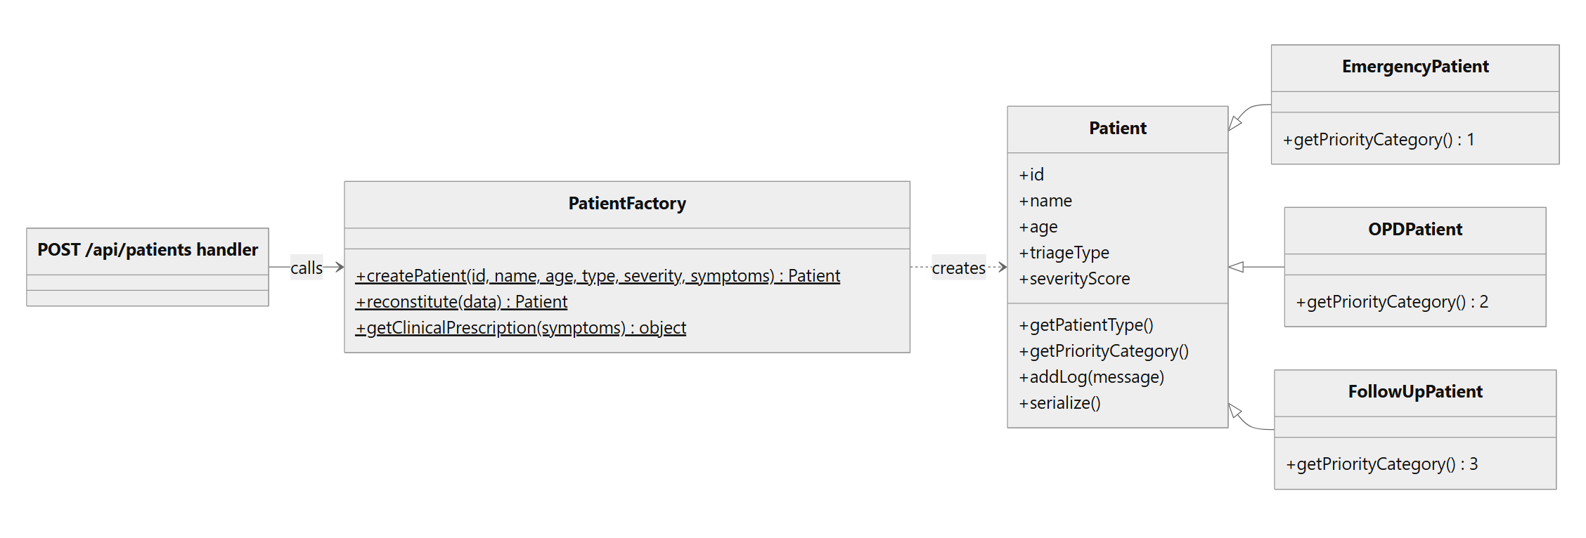
Figure 2: Structure after applying Factory Method (PatientFactory, Patient and its three subclasses)

4.1.8 Code and Implementation
Table 3: Implementation summary for Factory Method
Item | Project mapping
Source file | server/patterns/factory.js
Pattern role | Creator (PatientFactory) and concrete products (EmergencyPatient, OPDPatient, FollowUpPatient)
Selection input | The triageType string: Emergency, OPD, Follow-up (also accepted as FollowUp)
Called from | POST /api/patients, and every route that loads a stored patient

Figure 3 shows the three subclasses and the createPatient() method as they are in the repository.
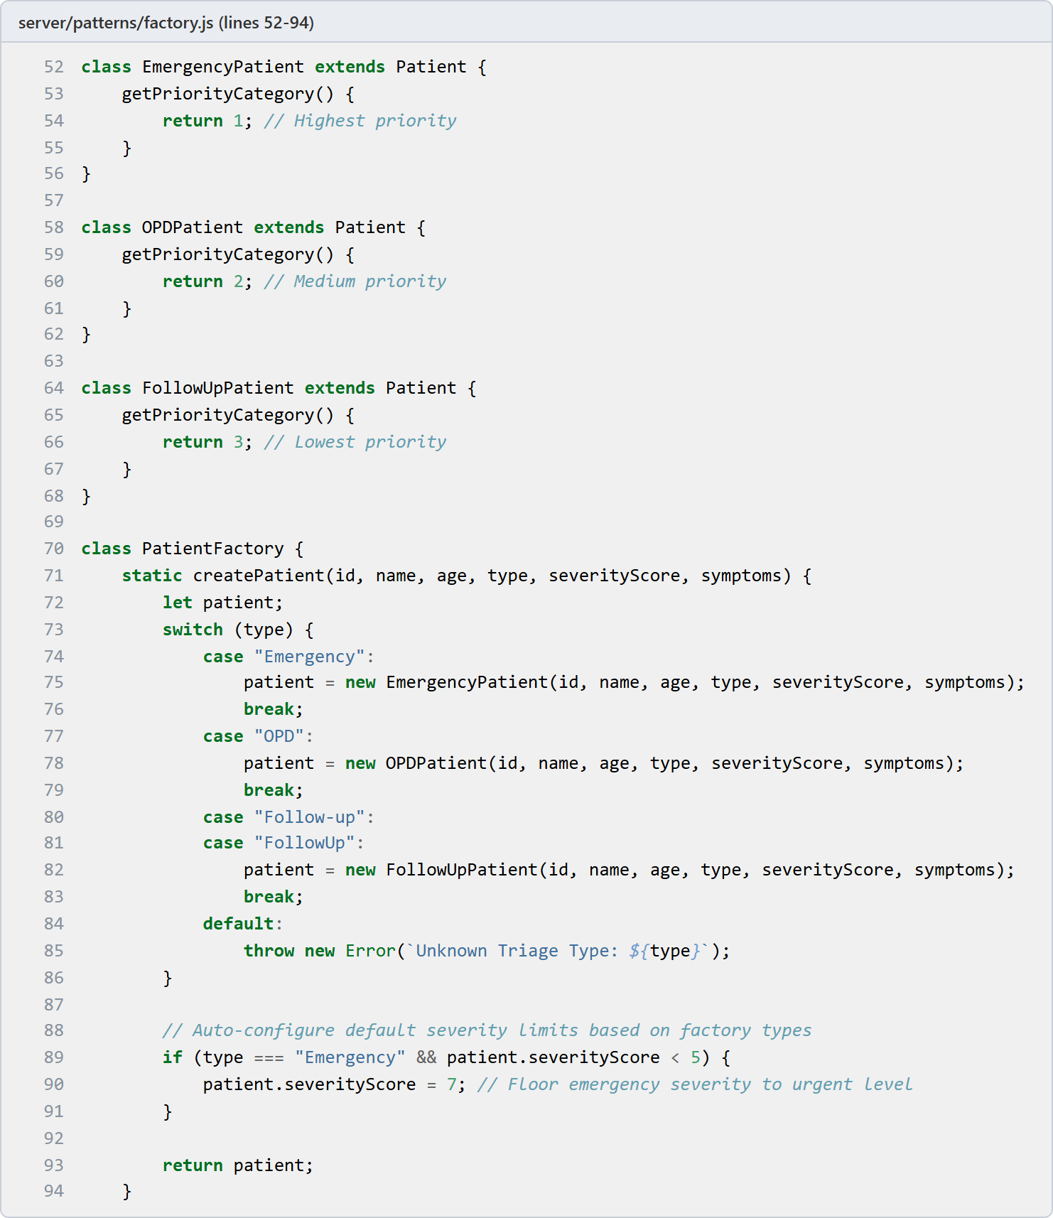
Figure 3: Source code: concrete patient classes and PatientFactory.createPatient()
- Each subclass overrides only getPriorityCategory(). The queue code can ask any patient for its priority without checking the class.
- createPatient() uses a switch on the category. Follow-up and FollowUp both create a FollowUpPatient.
- Any other category falls into the default branch and throws Unknown Triage Type, so a wrong value never creates a half valid patient.
- After construction, an emergency patient with a severity below 5 is raised to 7.
The second part of the factory is reconstitute(), shown in Figure 4. It receives a plain object from the database and returns a real Patient subclass again, with state, doctor, bed, billing summary, log and creation time restored.
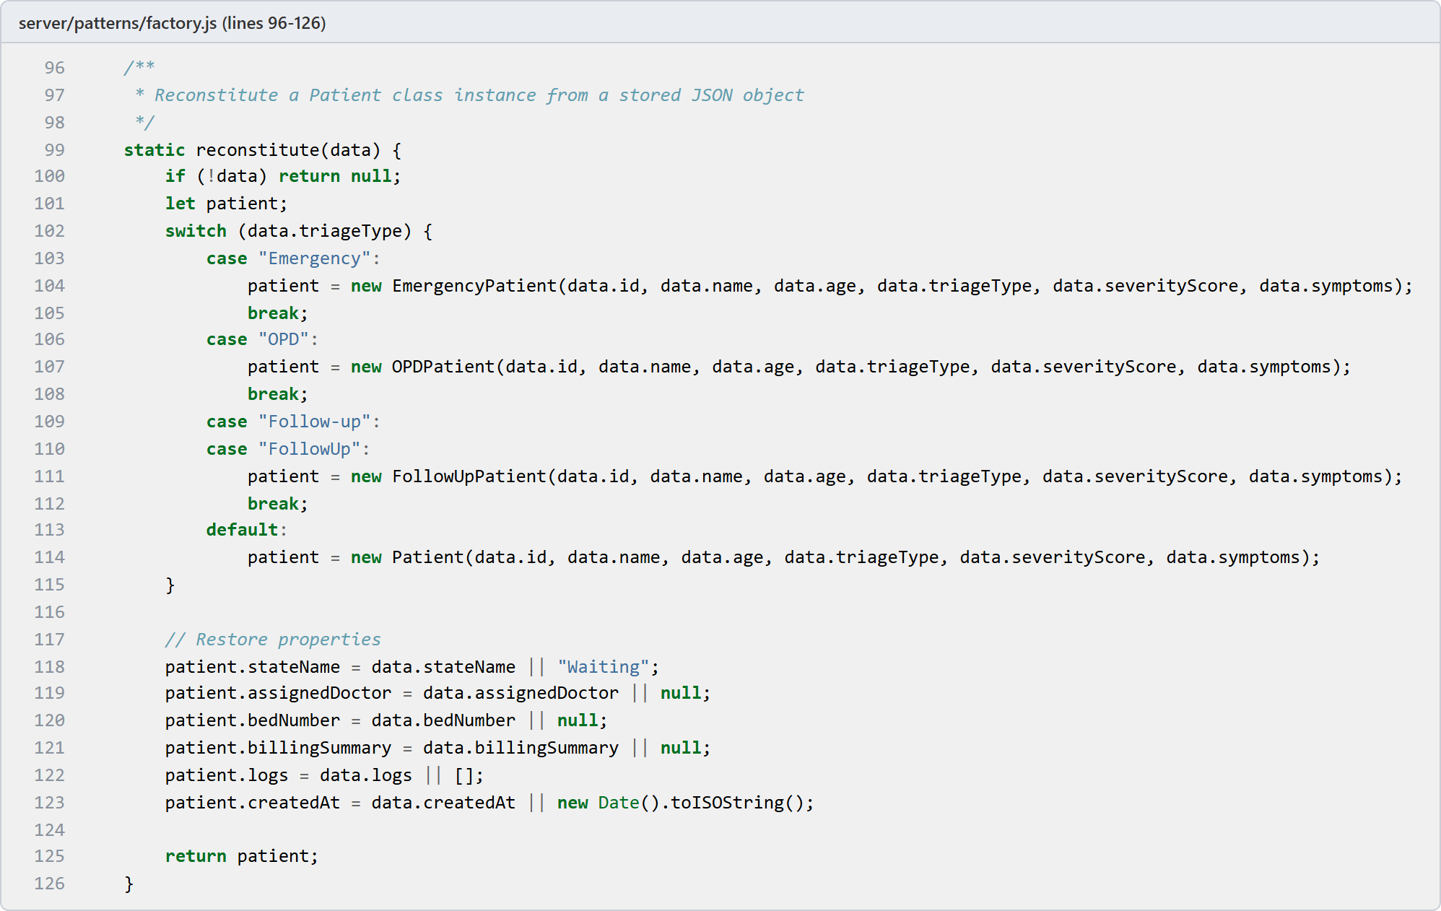
Figure 4: Source code: PatientFactory.reconstitute() rebuilds a patient from stored data
The behaviour of the real factory when it is called with different inputs is shown in Section 6.3, and the registration screens are in Section 6.2.

4.2 Structural Design Pattern: Facade

4.2.1 Intent
A facade gives the rest of the program one simple entry point to a group of classes that have to work together [1]. In BioCare, AdmissionFacade offers two operations, admitPatient() and dischargePatient(). The routes call these two operations and know nothing about the bed manager, the doctor scheduler or the billing system that sit behind them.
Flow: admission request, then AdmissionFacade, which uses BedManager, DoctorScheduler and BillingSystem, updates the patient record and returns one result with bed, doctor and bill total.

4.2.2 Need in the Proposed System
Admission is not one action. When a doctor decides to admit a patient, the system has to reserve a bed in the requested ward category, find a doctor who will supervise the stay, prepare the bill from the daily rate of the ward, the base fee of the patient category and the pharmacy cost, move the patient to the admitted status and save the record. Checkout is similar: the bed is released, the doctor is freed, the bill is settled with the chosen billing plan, the patient is marked as discharged and the record is saved.
If the route handler did all of this directly, it would contain the full order of steps. The discharge route and the admission route would both need to know how the subsystems are used, and a change in one subsystem (for example a new way of choosing a bed) would reach into the routes. The facade keeps that knowledge in one class. It also enforces a business rule in one place: only a patient who is currently admitted can be checked out.

4.2.3 Application Classes and Components
Table 4: Classes and components of the Facade implementation
Component | Responsibility
AdmissionFacade | Single entry point. admitPatient(patient, bedCategory, durationDays) and dischargePatient(patient, insurancePlan).
BedManager | Keeps the daily rates (ICU 2000, Private Room 1200, General Ward 500). allocateBed() takes the first free bed of a category and fails with a clear message if there is none. releaseBed() frees it again.
DoctorScheduler | assignDoctor() picks the first available doctor and falls back to Dr. Carter (D2) if everybody is busy. freeDoctor() makes a doctor available again.
BillingSystem | Base fees (Emergency 250, OPD 100, Follow-up 50). calculateBill() returns base fee, bed charge, pharmacy charge, total and an Unpaid status.
Data access layer (server/db.js) | Used by the subsystems to read and write beds, doctors and patients.
Admission and discharge routes | The clients. They load the patient, call the facade once and send the result back to the browser.

4.2.4 Advantages
- The routes become short. Each one loads a patient, makes one facade call and returns the result.
- The order of the admission steps is written once.
- The checkout rule (only admitted patients) cannot be skipped by a caller.
- Subsystems can change behind the facade, for example a different rule for choosing the doctor, without touching the API layer.
- The facade gives the tests a single place to check the whole admission flow.

4.2.5 Why AdmissionFacade was Selected
- Admission and checkout both involve three subsystems and the patient record, and the order of the steps matters.
- The API layer should not be responsible for coordinating bed, doctor and billing logic.
- The application needs one business level operation, admit this patient, instead of five technical operations.
- Subsystem changes should stay local.

4.2.6 Class Diagram Before Applying the Pattern
Without the facade, the route handler would call each subsystem itself and in the right order.
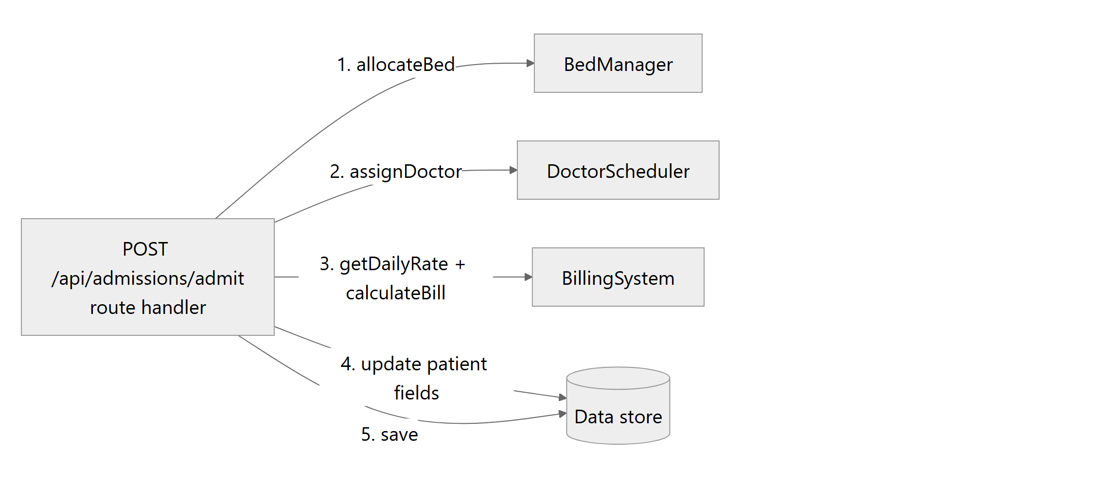
Figure 5: Structure before applying Facade: the route handler talks to every subsystem

4.2.7 Class Diagram After Applying the Pattern
With the facade, the route handler has one collaborator. The three subsystems are used only by the facade.
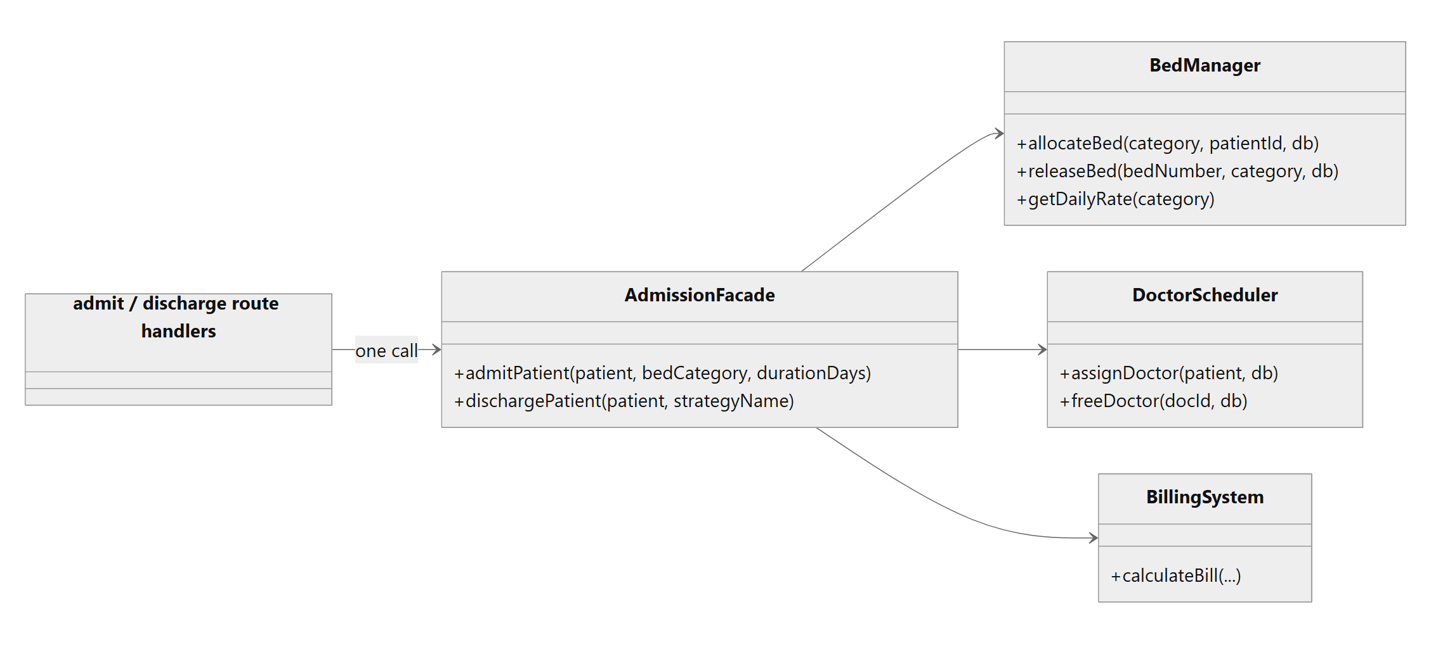
Figure 6: Structure after applying Facade (AdmissionFacade and its three subsystems)

4.2.8 Code and Implementation
Table 5: Implementation summary for Facade
Item | Project mapping
Source file | server/patterns/facade.js
Pattern role | Facade (AdmissionFacade) with three subsystem classes
Called from | POST /api/admissions/admit and POST /api/admissions/discharge in server/routes.js
Returns | Admission: bed number, supervising doctor, bill total. Discharge: the paid billing summary.

The subsystems are ordinary classes with a few methods each. Figure 7 shows BedManager, which holds the ward rates and reserves and releases beds, and Figure 8 shows BillingSystem, which prepares the first bill. DoctorScheduler (lines 44 to 73 of the same file) is similar in size.
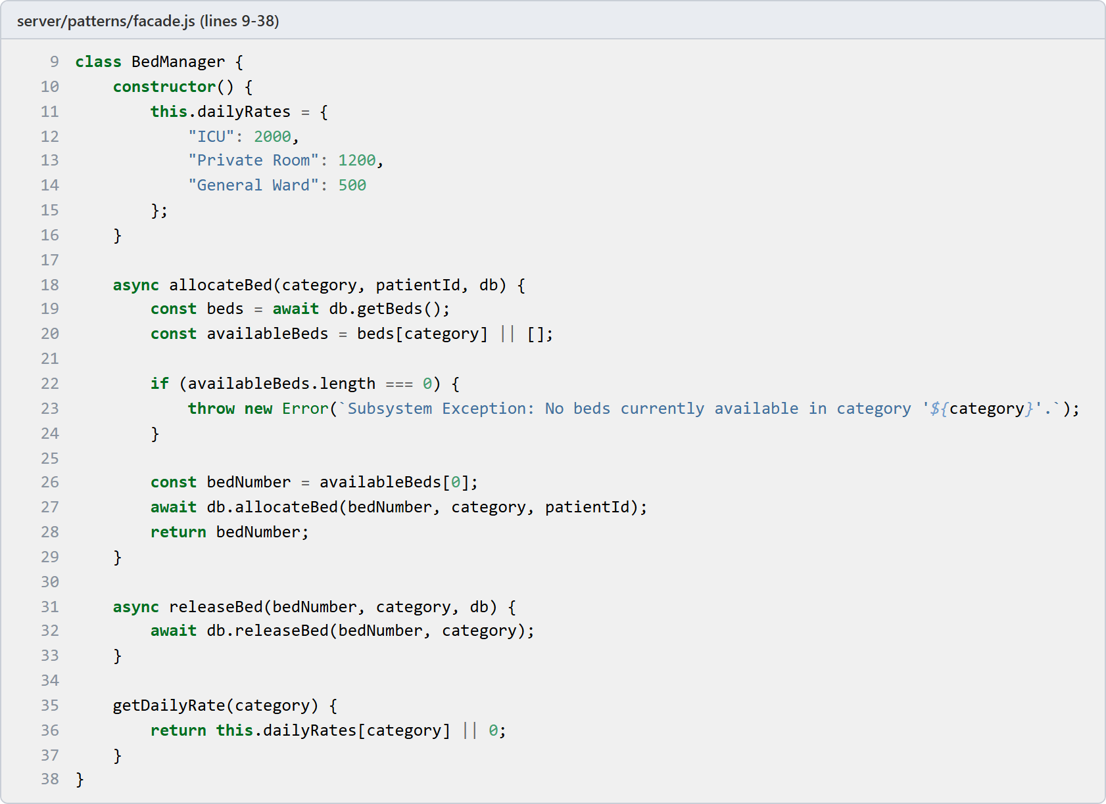
Figure 7: Source code: BedManager subsystem
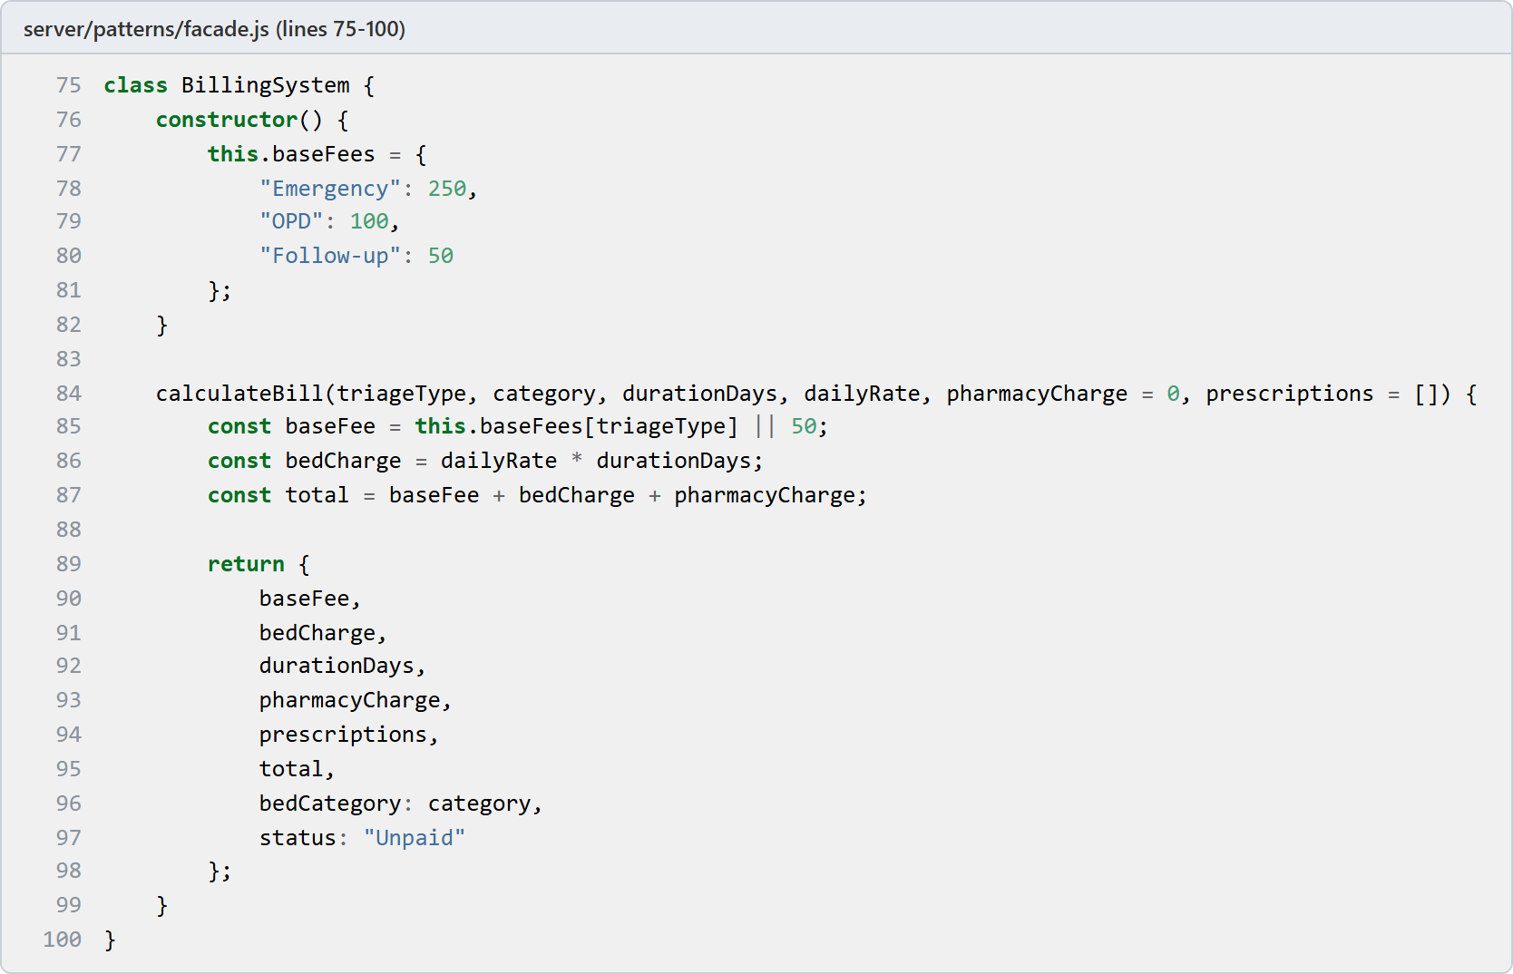
Figure 8: Source code: BillingSystem subsystem
The facade itself is shown in Figure 9. admitPatient() runs the steps in a fixed order: reserve the bed, assign a doctor, prepare the bill (the pharmacy cost comes from the symptoms through PatientFactory.getClinicalPrescription()), update the patient and save it. The lines in the middle of the method that move the patient to the admitted status and copy the bed, doctor and bill onto the record are left out of the screenshot to keep it short. They are lines 127 to 135 in the repository.
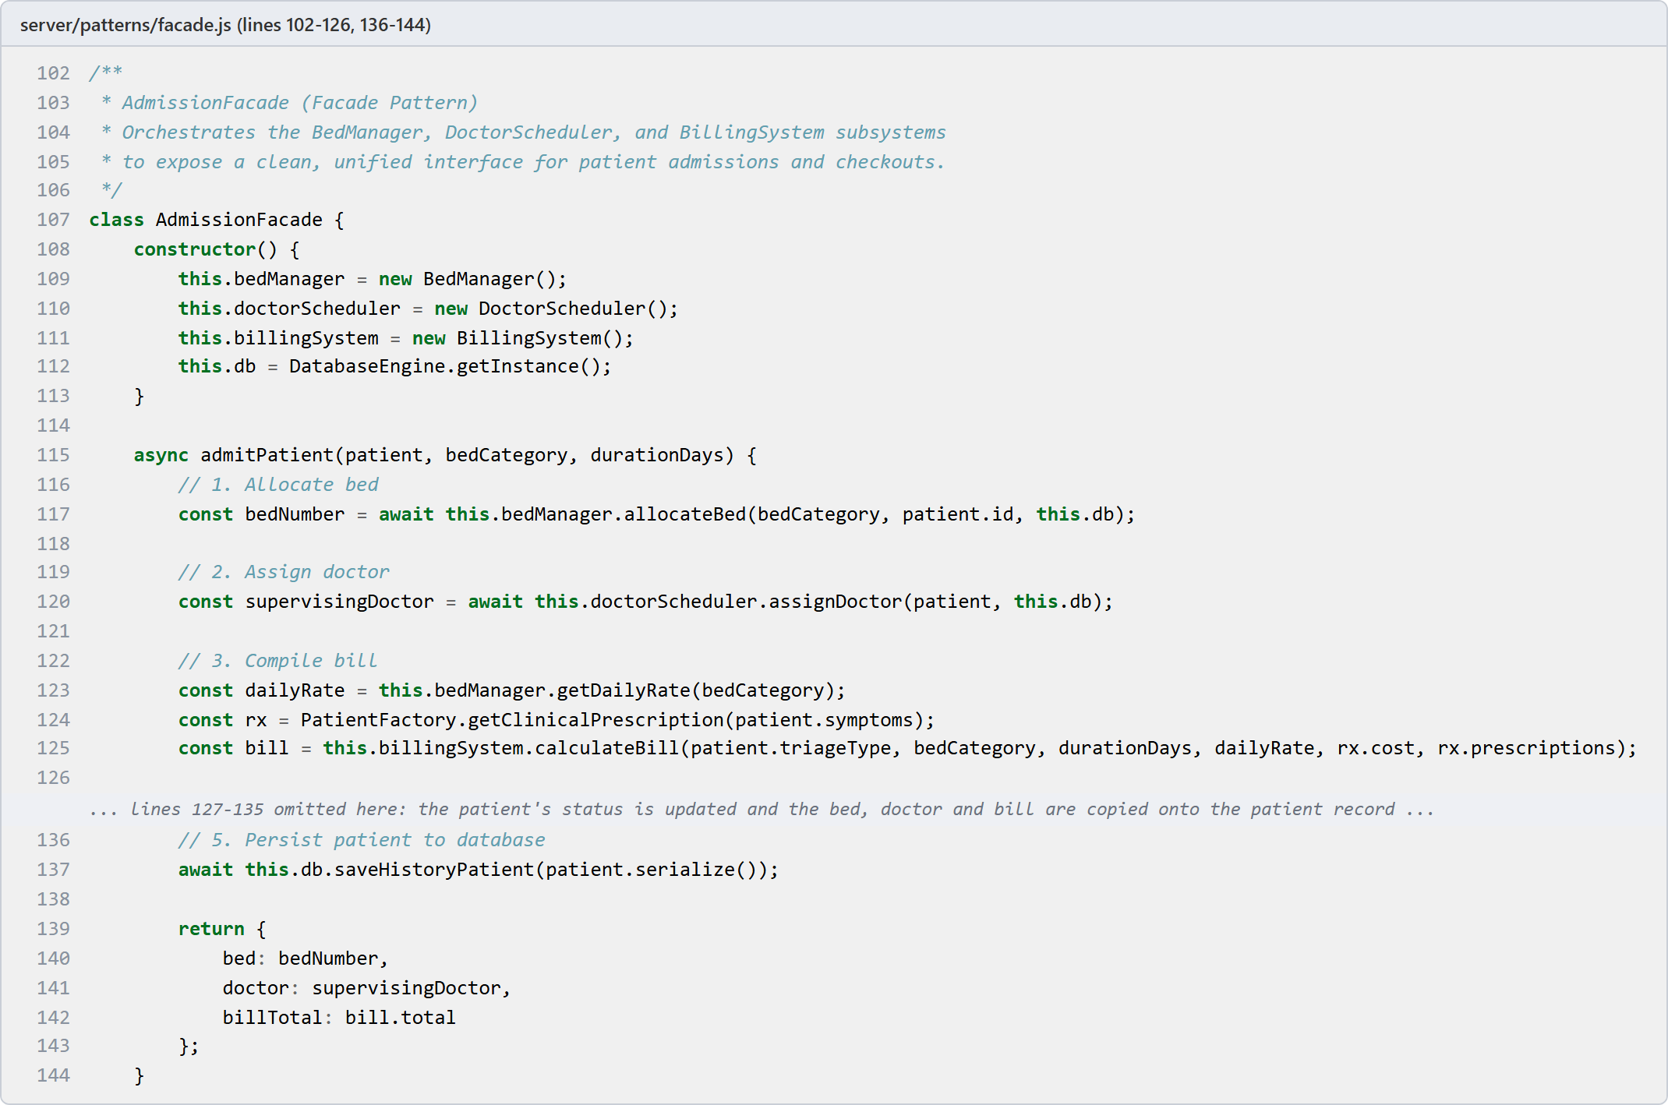
Figure 9: Source code: AdmissionFacade constructor and admitPatient()
dischargePatient() in Figure 10 is the checkout. It verifies that the patient is currently in an admitted state, releases the bed, frees the supervising doctor, prepares the settled bill, and transitions the patient safely into DischargedState. The lines that change the status of the patient to discharged are fully validated through the State pattern.
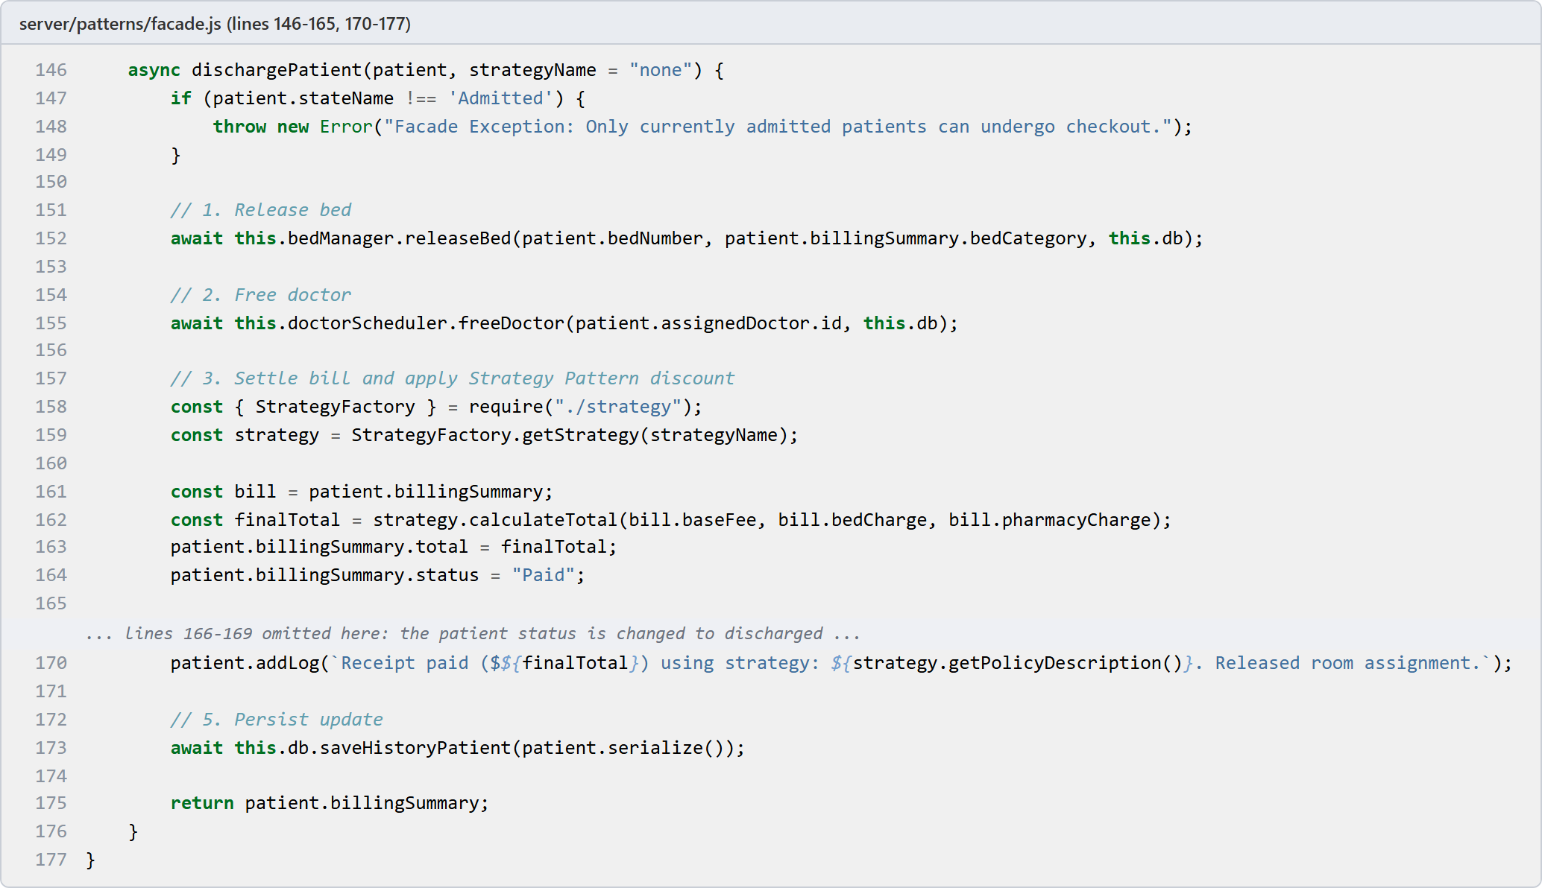
Figure 10: Source code: AdmissionFacade.dischargePatient()

4.3 Behavioural Design Pattern: State

4.3.1 Intent
The State pattern allows an object to alter its behavior when its internal state changes, appearing as if the object changed its class [1]. In BioCare EHR, a patient transitions through defined clinical phases: WaitingState, ConsultationState, AdmittedState, and DischargedState. Rather than relying on scattered conditional logic and string comparisons throughout route handlers, patient behaviors (such as handling clinical escalation, bed allocation, or discharge) are delegated to the active PatientState object.
Flow: patient enters queue in WaitingState -> doctor calls patient triggering next(doctor) -> ConsultationState -> doctor admits patient triggering next('admit') -> AdmittedState -> checkout triggers next('discharge') -> DischargedState (terminal).

4.3.2 Need in the Proposed System
A patient's healthcare lifecycle involves strict operational rules and sequencing constraints:
1. A patient waiting in the queue cannot undergo ward admission or discharge without completing consultation.
2. A consultation requires an assigned physician; attempting a consultation transition without doctor assignment must be blocked.
3. During consultation, clinical escalation rules apply (e.g., severity >= 8 escalates to senior attending specialists with ICU priority, while mild symptoms are managed by junior staff).
4. Admitted patients occupy physical hospital beds and require coordinated checkout before discharge.
5. Discharged patients reach a terminal state where no further state transitions, consultations, or admissions are permitted.
Without the State pattern, enforcing these rules requires extensive, fragile if-else or switch statements across every controller. The State pattern encapsulates state-specific behaviors and transition guards cleanly inside dedicated classes.

4.3.3 Application Classes and Components
Table 6: Classes and components of the State pattern implementation
Component | Responsibility
PatientState | Abstract base class declaring the clinical lifecycle interface: getStateName(), next(patient, option), and escalate(patient, issue). Throws descriptive domain errors by default for invalid operations.
WaitingState | Initial queue state. Enforces doctor assignment guard when transitioning to ConsultationState. Strictly blocks premature ward admission or discharge.
ConsultationState | Active physician evaluation. Executes clinical escalation rules based on severityScore and vitals. Transitions to AdmittedState (inpatient) or direct DischargedState (outpatient).
AdmittedState | Inpatient ward care. Tracks physical bed occupancy (ICU, Private Room, General Ward) and transitions strictly to DischargedState via checkout. Blocks queue re-entry or repeat consultations.
DischargedState | Terminal state representing completed clinical visit. Rejects subsequent transition or escalation calls, guaranteeing post-discharge record immutability.
StateFactory | Utility factory providing getState(stateName). Rehydrates concrete state class instances from persistent storage strings during database reads.
Patient (Context) | Maintains current stateName and delegates next() transitions and escalate() requests directly to the active PatientState instance.
AdmissionFacade | Coordinates subsystems during admission and discharge, validating that the patient is in the correct state before advancing to AdmittedState and DischargedState.

4.3.4 Advantages
- Eliminates monolithic conditional logic: State-specific rules and transition validations are isolated from Express controllers.
- Enforces robust transition guards: Illegal operations (e.g. discharging a waiting patient or transitioning from a discharged record) are caught and rejected immediately.
- Encapsulates clinical escalation: Urgent triage escalation logic (routing severe cases to senior specialists) lives cohesively inside ConsultationState.
- Maintains record integrity: DischargedState acts as a terminal guard, preventing accidental data modification on completed visits.
- Supports clean state persistence: StateFactory seamlessly restores full object-oriented state instances from JSON/MongoDB records.

4.3.5 Why State Pattern was Selected
- The patient lifecycle is inherently stateful with explicit transition rules, preconditions, and postconditions.
- Clinical operations depend on current status: consultation actions differ fundamentally from triage waiting or ward admission.
- Enforcing transition guards directly within the domain entity prevents data corruption across disparate API routes.
- Separating state logic allows adding future states (such as ObservationState or ICUState) without modifying existing routing code.

4.3.6 Class Diagram Before Applying the Pattern
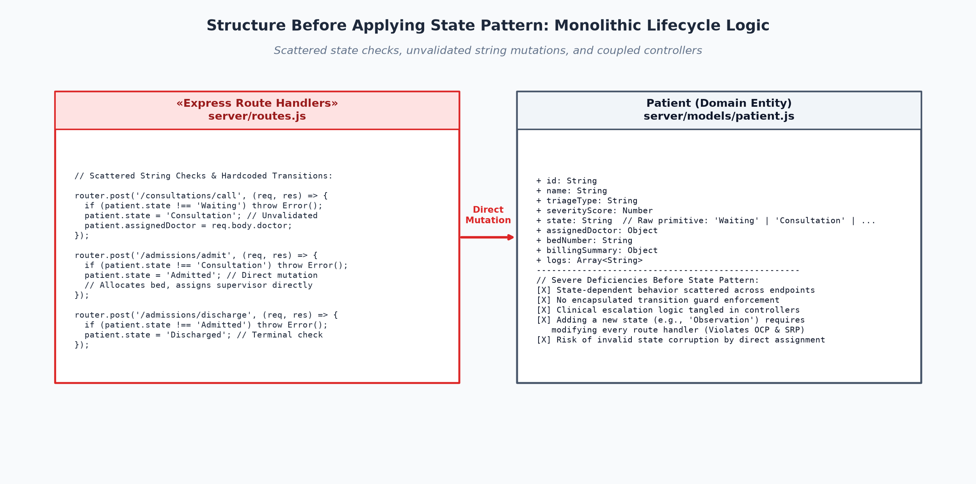
Figure 11: Structure before applying State Pattern: monolithic lifecycle with unvalidated state mutations and scattered conditional checks

4.3.7 Class Diagram After Applying the Pattern
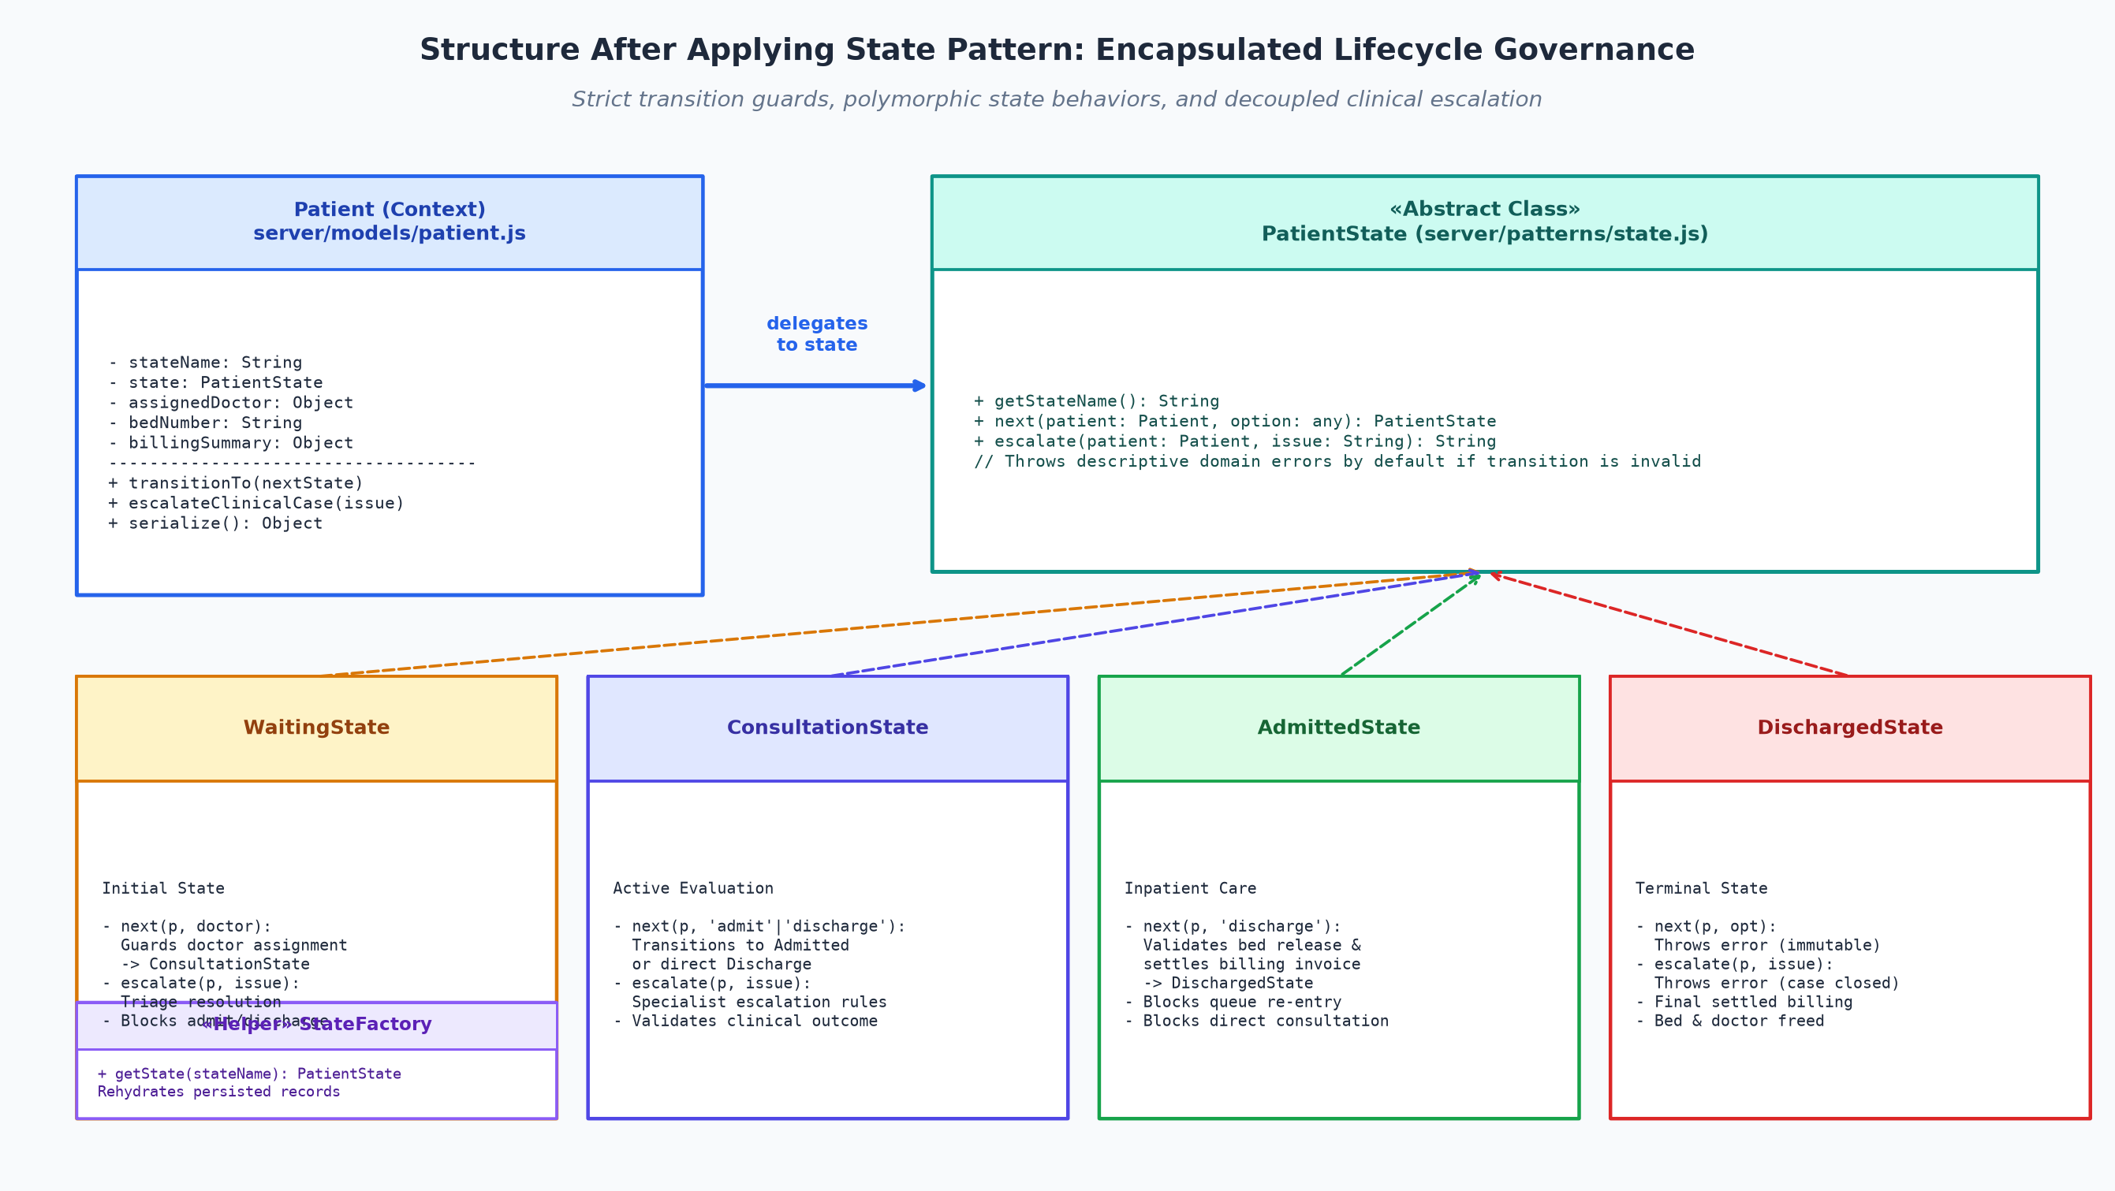
Figure 12: Structure after applying State Pattern (PatientState, four concrete states, and StateFactory)

4.3.8 Code and Implementation
Table 7: Implementation summary for State Pattern
Item | Project mapping
Source file | server/patterns/state.js
Pattern role | State interface (PatientState), four concrete states (Waiting, Consultation, Admitted, Discharged), StateFactory for rehydration
Context | Patient entity (server/models/patient.js), AdmissionFacade, and Express controllers in server/routes.js
Runtime transitions | Waiting -> Consultation -> Admitted -> Discharged (Terminal)

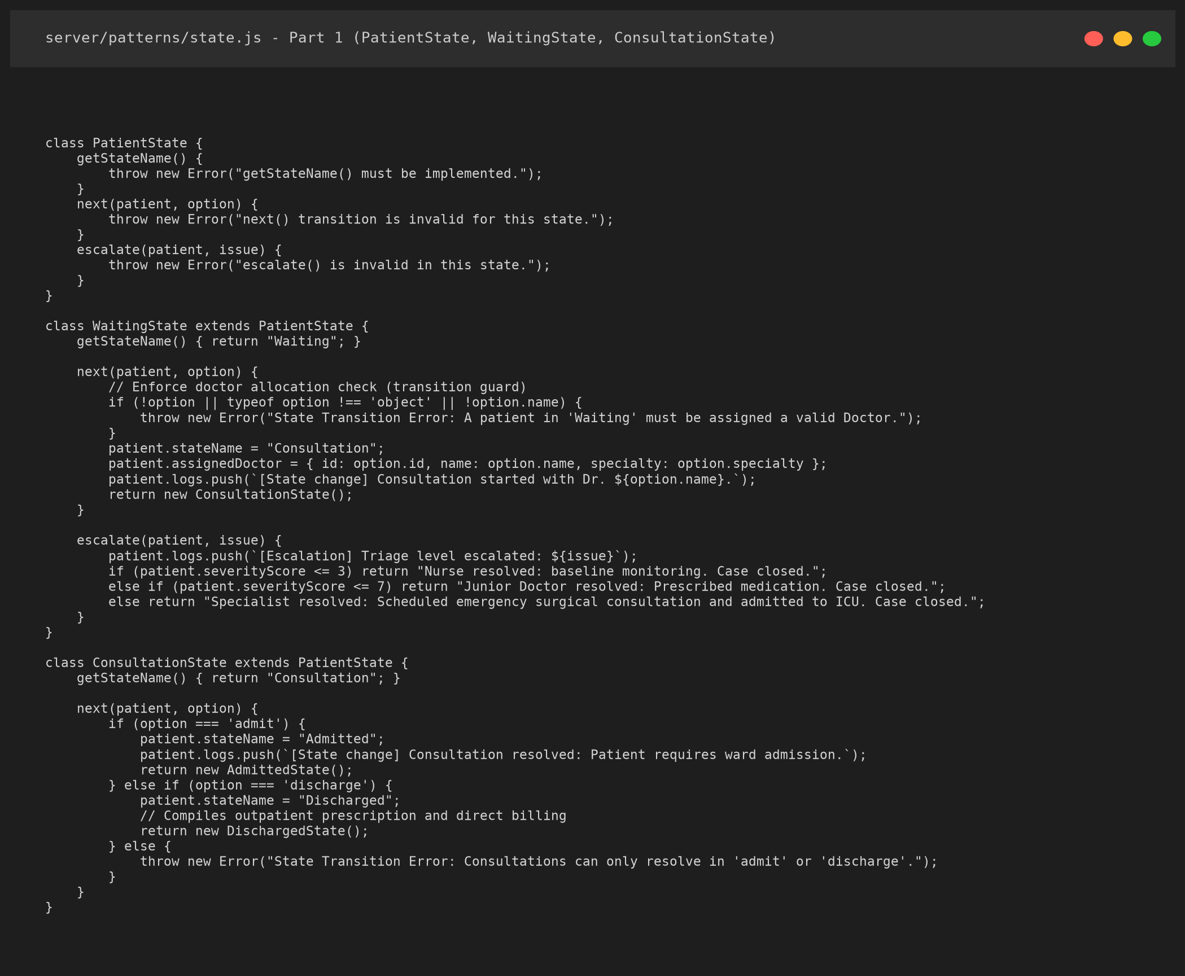
Figure 13: Source code: PatientState, WaitingState and ConsultationState in server/patterns/state.js
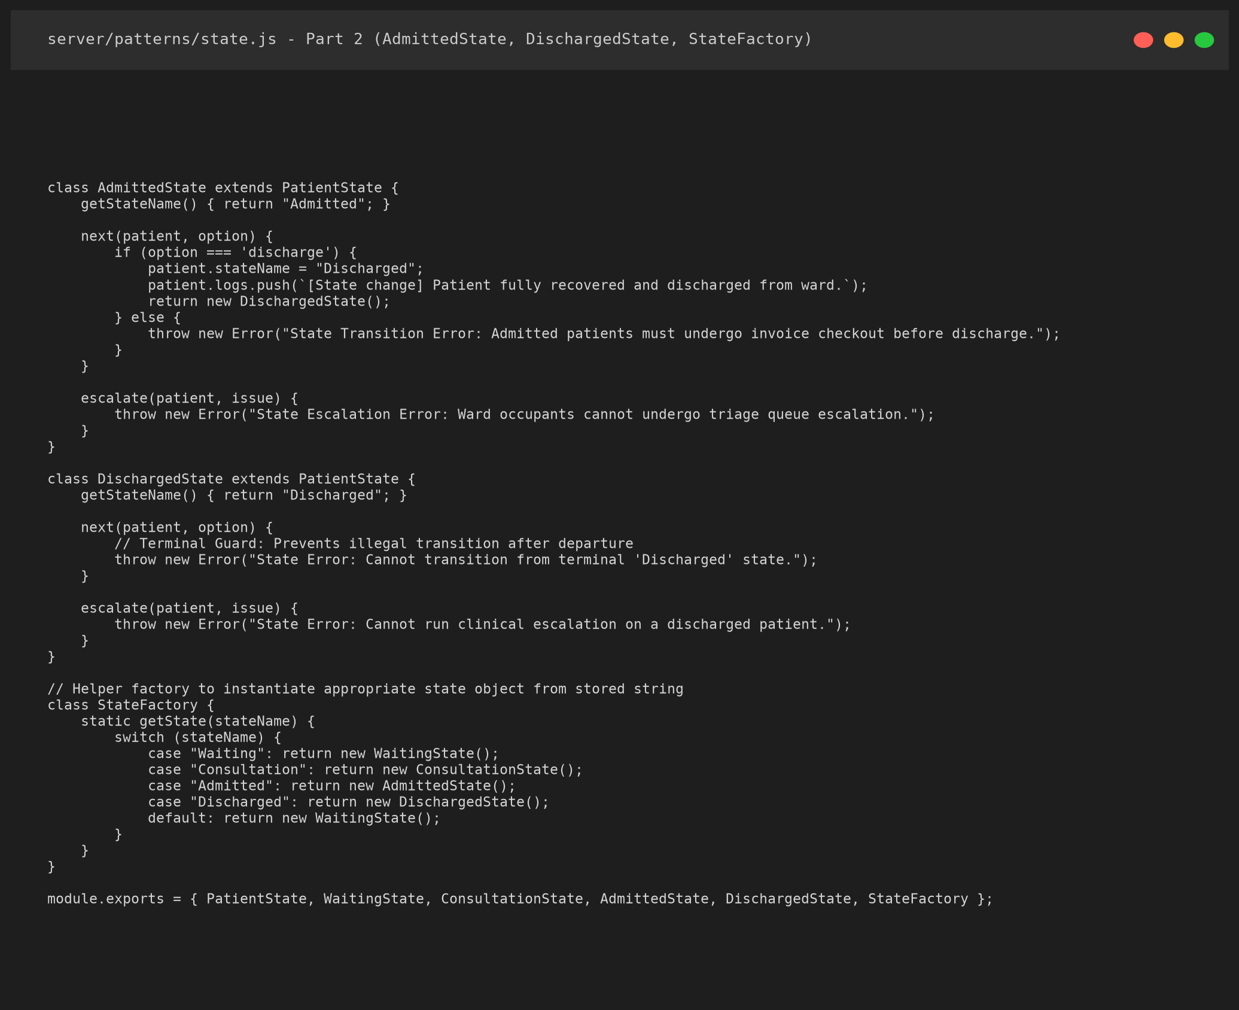
Figure 14: Source code: AdmittedState, DischargedState and StateFactory in server/patterns/state.js
- The base class PatientState defines the contract and throws descriptive domain errors when an invalid transition is attempted.
- WaitingState enforces a doctor assignment guard: a patient cannot enter consultation without a valid doctor object.
- ConsultationState evaluates severityScore to automatically resolve or escalate clinical alerts to senior specialists.
- DischargedState acts as a terminal sink: any call to next() or escalate() throws an error, protecting finalized records.

5. SYSTEM DESIGN AND PROPOSED ARCHITECTURE

5.1 Overall Architecture
BioCare is a three layer application. The browser holds the user interface. An Express server exposes a REST API and contains the business modules. A data access layer reads and writes MongoDB, or database.json when MongoDB is not reachable. The three patterns sit in the middle layer, between the route handlers and the data access code: Factory Method for patient instantiation, Facade for multi-subsystem orchestration, and State for lifecycle governance.
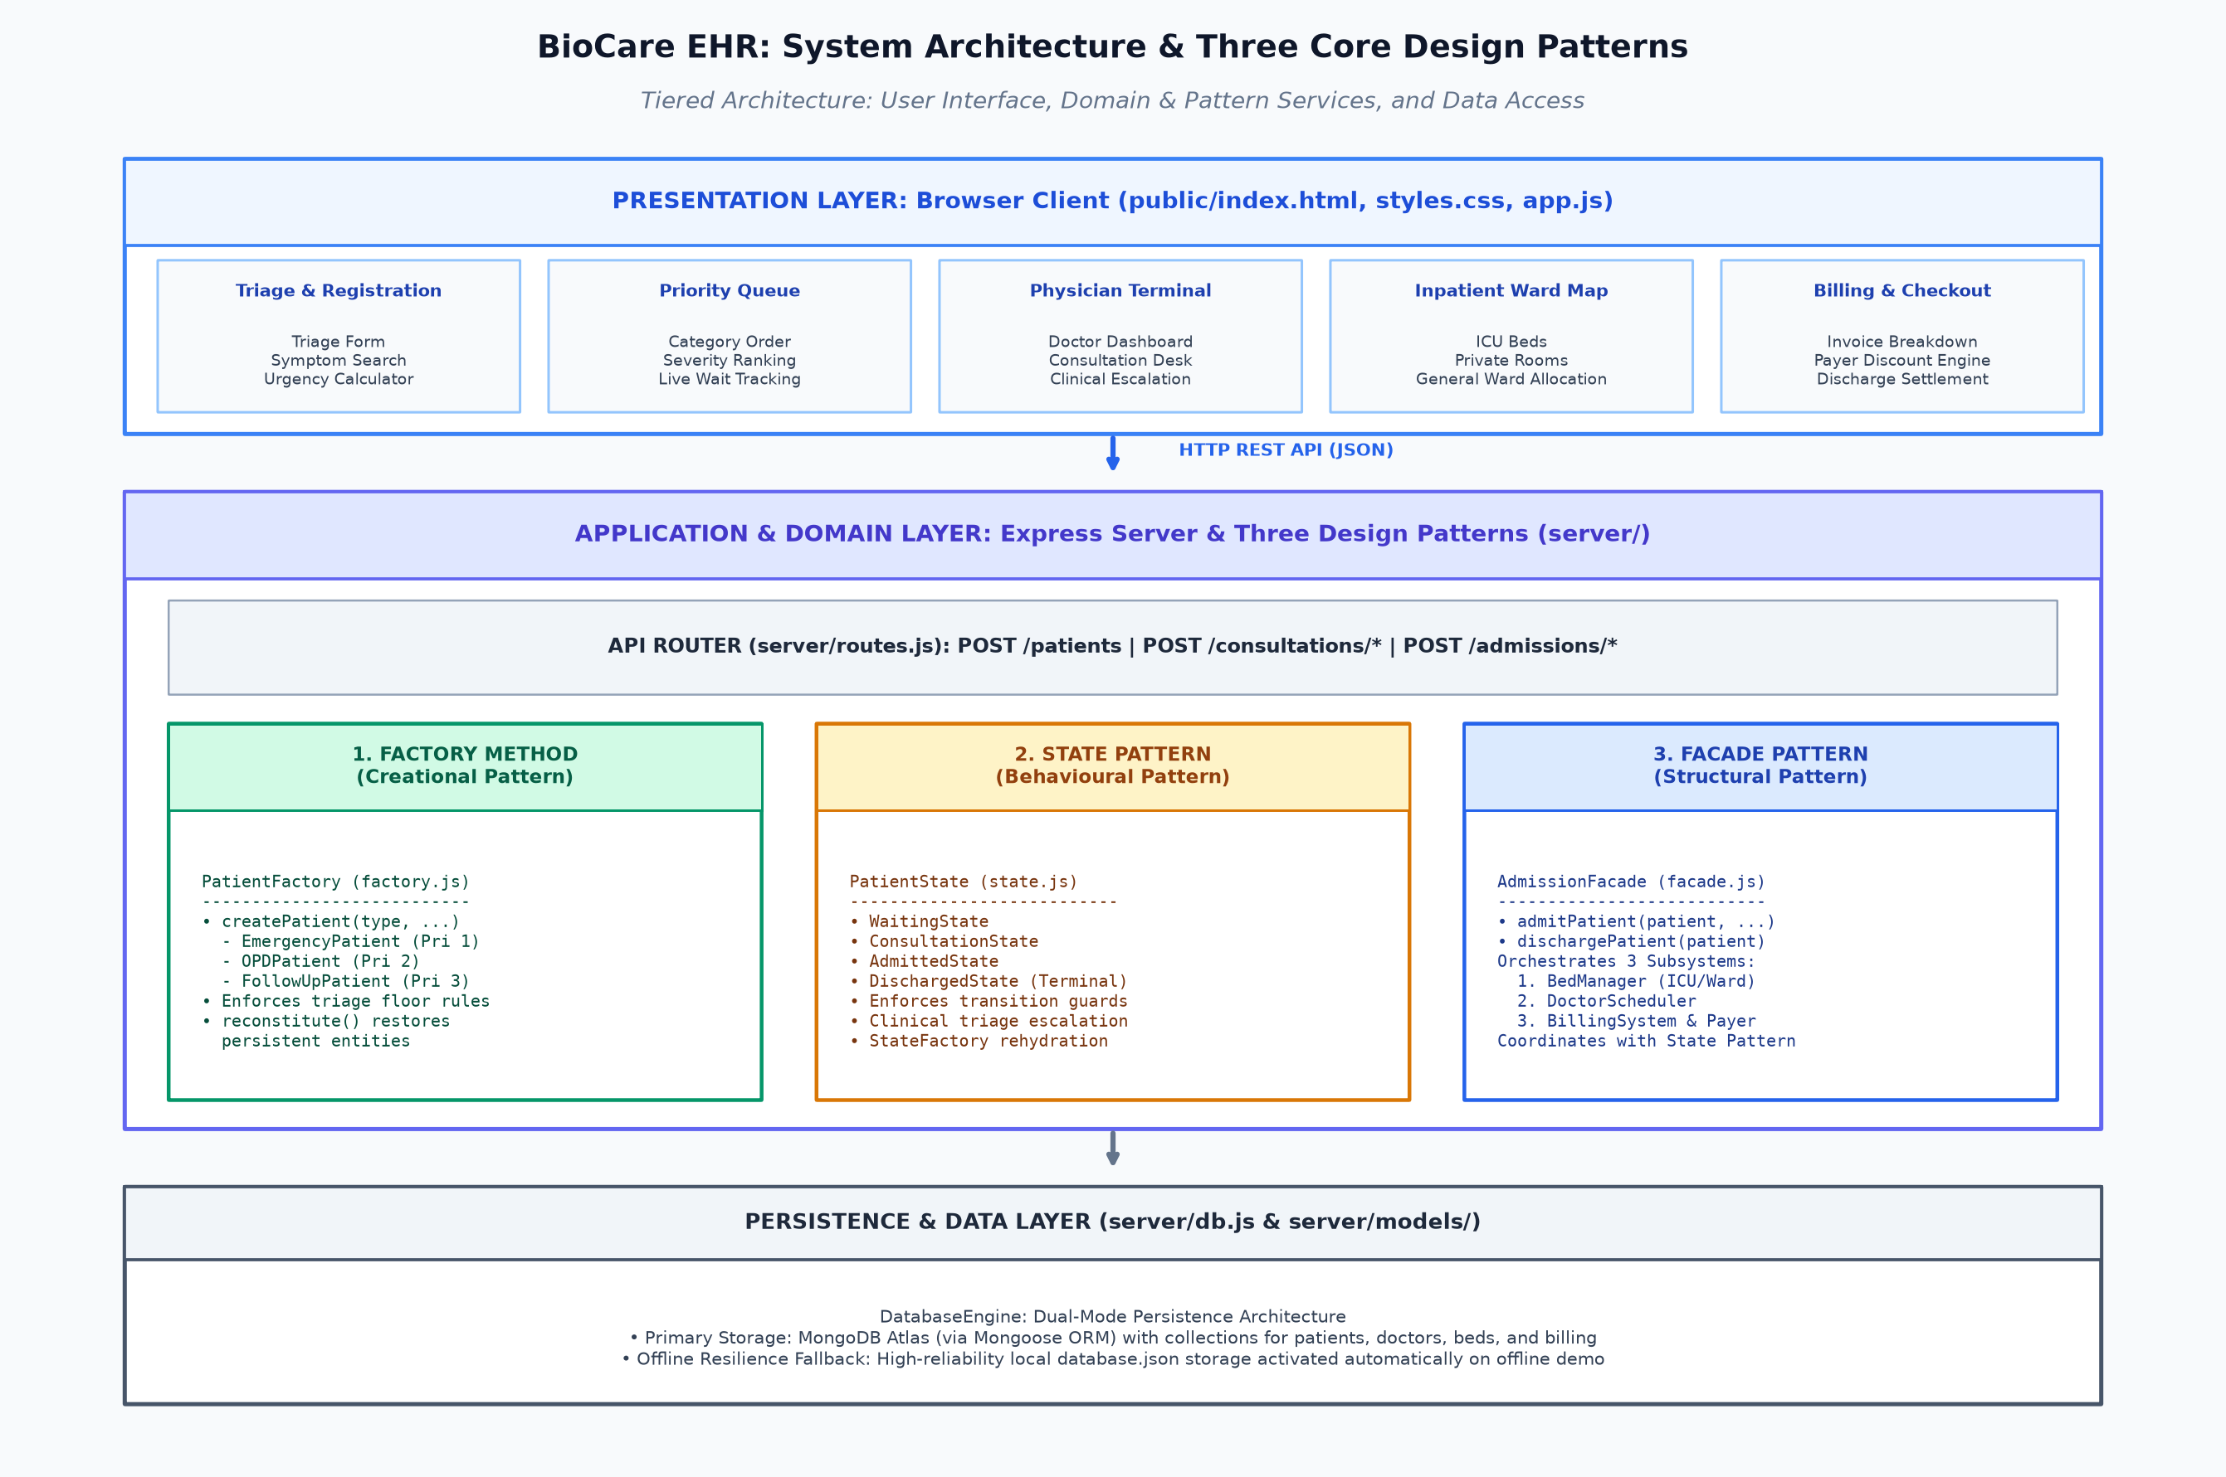
Figure 15: Overall architecture and placement of the three patterns (Factory Method, Facade, State Pattern)
Table 8: Layers of the system
Layer | Files | Responsibility
User interface | public/index.html, public/css/styles.css, public/js/app.js | Triage form, queue, physician terminals, consultation desk, ward map, billing screen and analytics dashboard.
API layer | server/routes.js | Receives requests, calls the business modules and answers with JSON.
Patient creation | server/patterns/factory.js | PatientFactory creates and restores the patient objects (Factory Method).
Admission | server/patterns/facade.js | AdmissionFacade coordinates beds, doctors, billing and the patient record (Facade).
Clinical lifecycle | server/patterns/state.js | Patient lifecycle governance, transition guards, and clinical escalation (State).
Data access | server/db.js, server/models/* | MongoDB through Mongoose, with the database.json fallback.

5.2 Technology Stack
Table 9: Technologies used
Part | Technology
Runtime | Node.js (we ran the project on version 20)
Web framework | Express 4.18 with cors
Database | MongoDB Atlas through Mongoose 9, with a local database.json fallback
Configuration | dotenv reads MONGODB_URI from a .env file
Front end | HTML, CSS and JavaScript without a framework
Tests | npm test runs js/test.js

5.3 Data Used by the System
A patient record is a JSON object with id, name, age, triage type, severity score, symptoms, state, assigned doctor, bed number, billing summary, a log of events and the creation time. The hospital has 12 doctors and 40 beds: 10 ICU beds (ICU-101 to ICU-110), 10 private rooms (PR-301 to PR-310) and 20 general ward beds (GW-201 to GW-220). All of this is seeded automatically the first time the server starts.

5.4 System Workflow
The sequence in Figure 16 shows how the three patterns take part in one patient journey. The steps are described after the diagram.
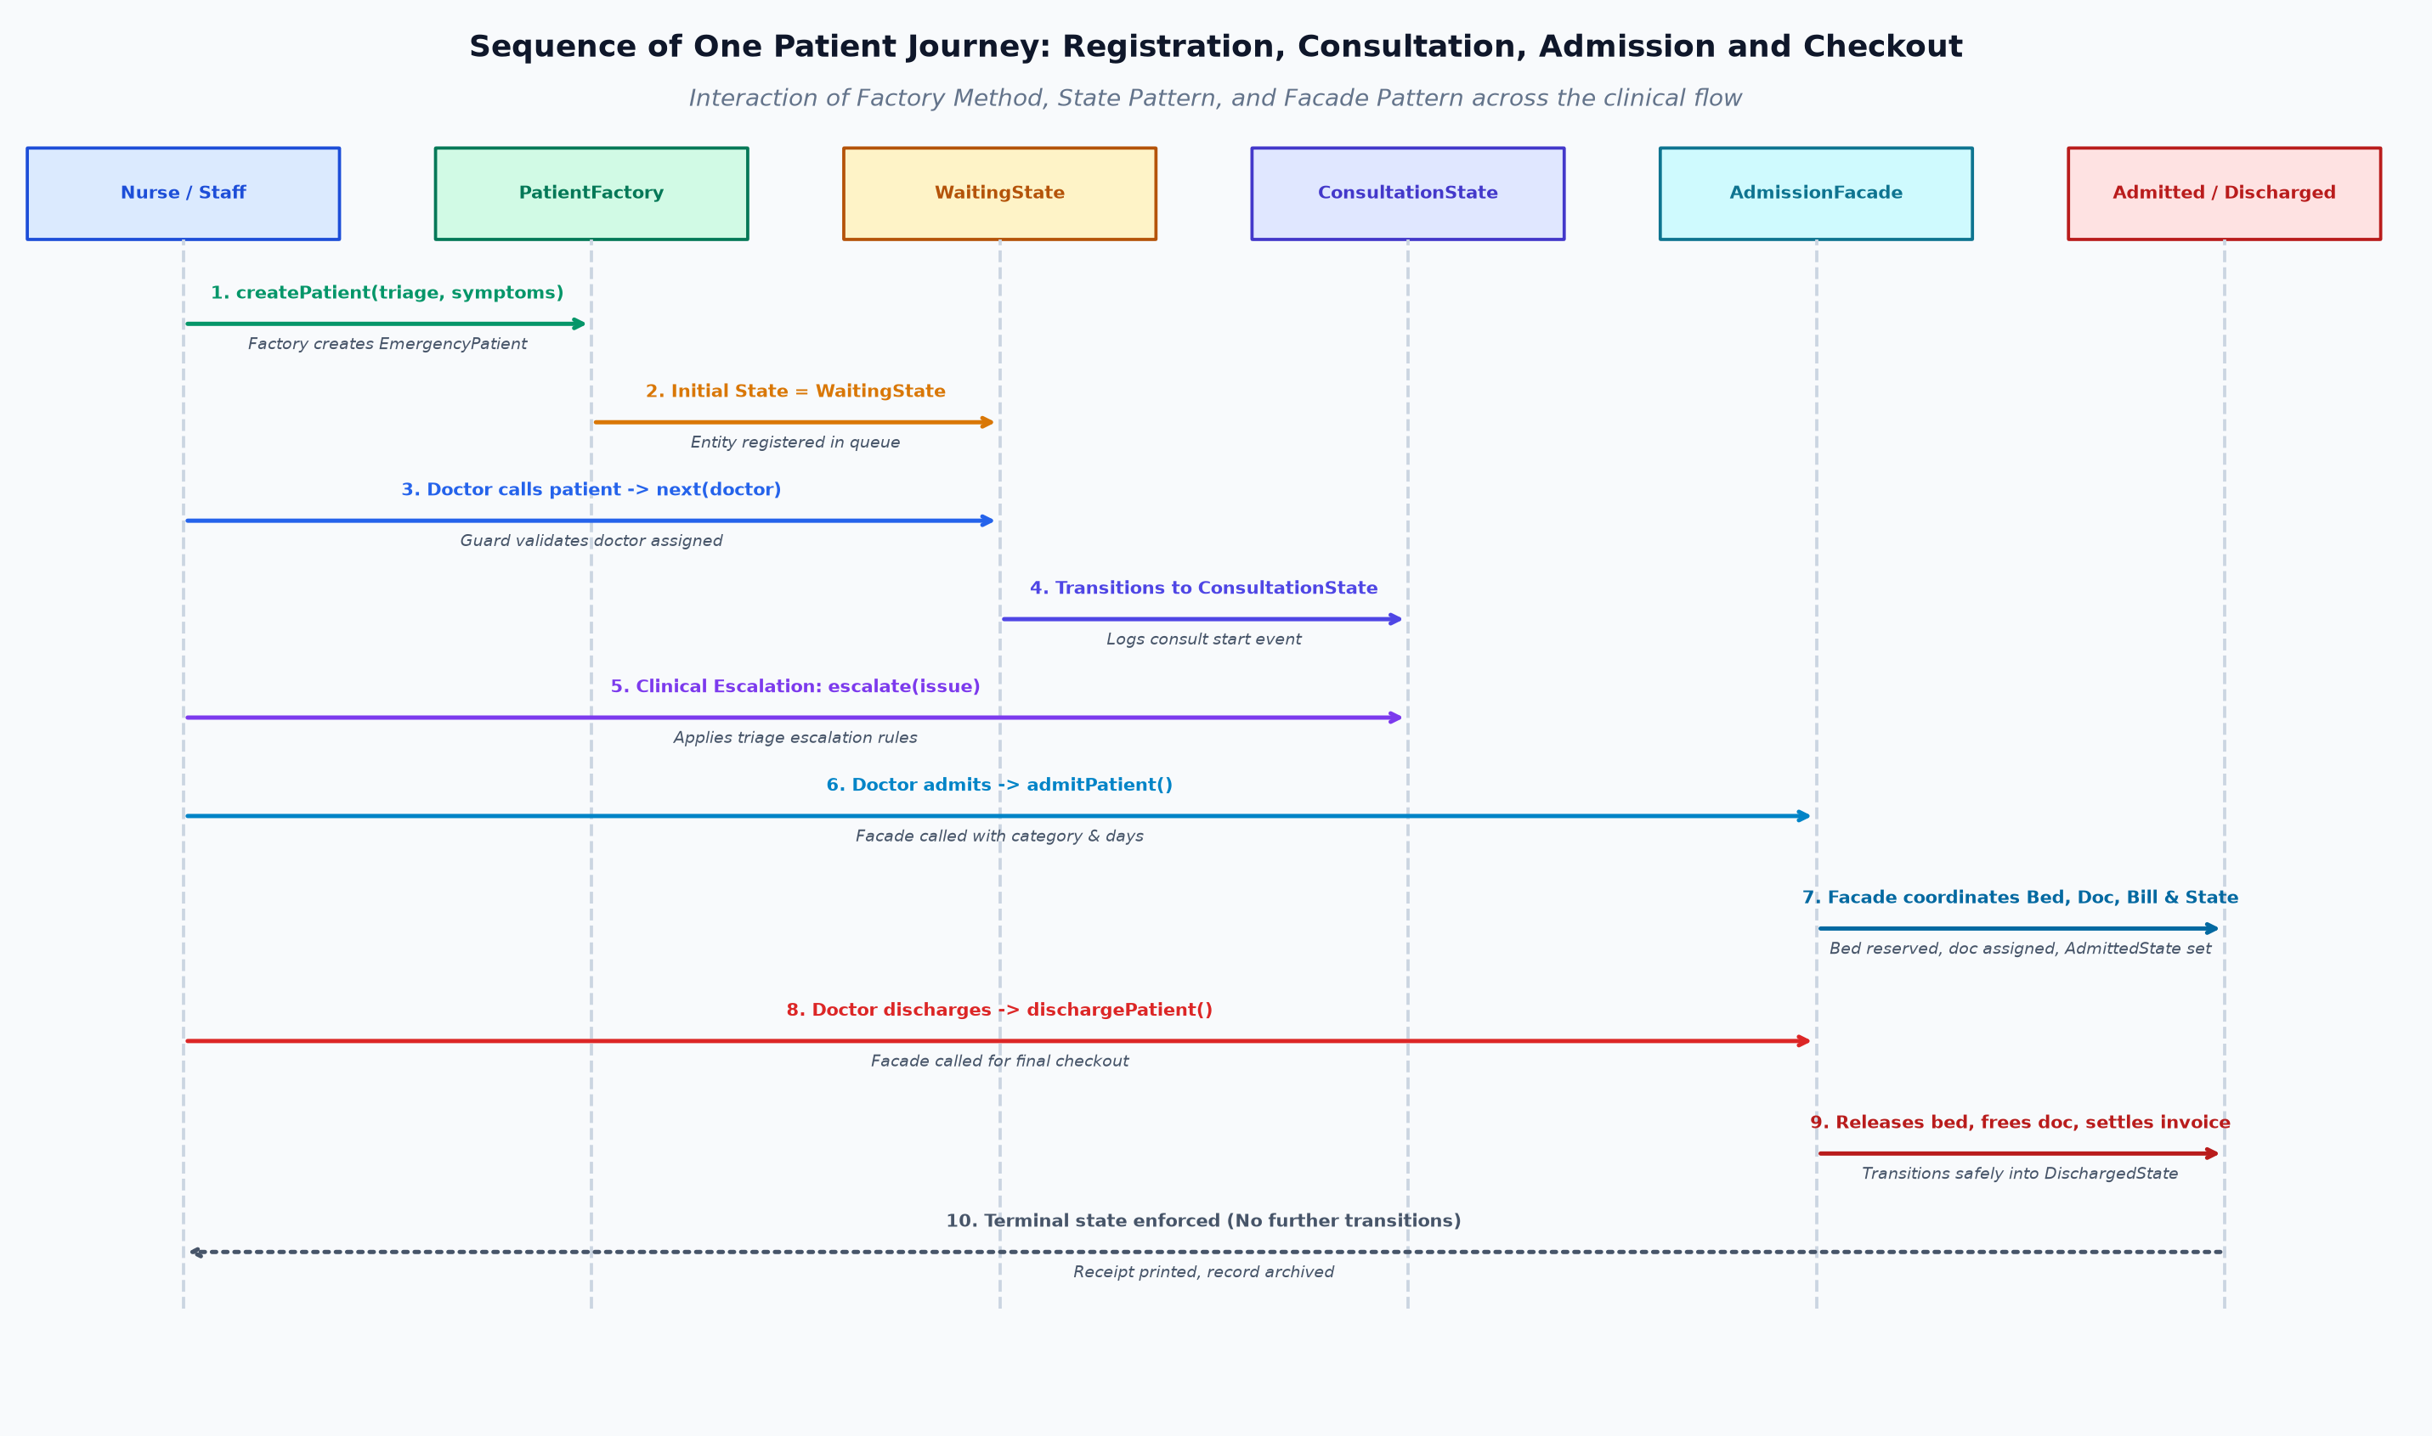
Figure 16: Sequence of one patient journey: registration, admission and checkout across the three design patterns
- Registration. The nurse selects the symptoms in the triage form. The browser suggests a category and a severity and sends them with the name and age. PatientFactory creates the matching patient object and the record is saved.
- Queue. The record appears in the queue, which is ordered by category, then severity, then arrival time.
- Consultation. A doctor calls the next patient from the physician terminals. The patient transitions from WaitingState to ConsultationState via transition guards, and the doctor is assigned.
- Admission. If the doctor decides to admit the patient, AdmissionFacade.admitPatient() coordinates bed allocation, doctor assignment, initial billing, and executes the state transition to AdmittedState.
- Checkout. AdmissionFacade.dischargePatient() coordinates bed release, doctor release, invoice settlement, and advances the patient into terminal DischargedState.

5.5 REST Endpoints Used in the Workflow
Table 10: REST endpoints
Endpoint | Purpose
GET /api/patients | Queue, history, doctors, free beds and allocated beds.
POST /api/patients | Register a patient. Uses PatientFactory.
POST /api/consultations/call | A doctor calls the next patient from the queue.
POST /api/consultations/discharge | Discharge an outpatient directly after the consultation.
POST /api/admissions/admit | Admit a patient. Uses AdmissionFacade.admitPatient().
POST /api/admissions/discharge | Check a patient out. Uses AdmissionFacade.dischargePatient() and transitions patient to DischargedState.
POST /api/reset | Reset patients, doctors and beds to the initial data.

5.6 How the Three Patterns Work Together
The patterns do not work in isolation. The patient object created by PatientFactory carries the symptoms and triage category that initialize the patient into WaitingState. As the patient progresses, the State pattern governs valid transitions and clinical escalations. When admission or discharge occurs, AdmissionFacade coordinates the bed, doctor, and billing subsystems while advancing the patient state to AdmittedState and ultimately DischargedState.

6. IMPLEMENTATION AND SYSTEM SCREENSHOTS
All screenshots in this section were taken from the application running on our machine, with the latest code pulled from the GitHub repository. Source code images are taken from the repository files, with the line numbers shown.

6.1 Running the Project
The setup steps are short. After cloning the repository, the dependencies are installed with npm install, a .env file with a MONGODB_URI value is added, and the server is started with npm start. The application is then available at http://localhost:8000.
- git clone https://github.com/divitha2005-hub/Hospital-Queue.git
- npm install
- create .env with MONGODB_URI=<your MongoDB connection string>
- npm start and open http://localhost:8000
For the screenshots in this report we started the server with a MongoDB address that could not be reached. After the 5 second connection timeout the data access layer printed a warning, switched to database.json and the server started normally, as the terminal output in Figure 17 shows. All the screens in the rest of this section therefore ran on the local JSON store.
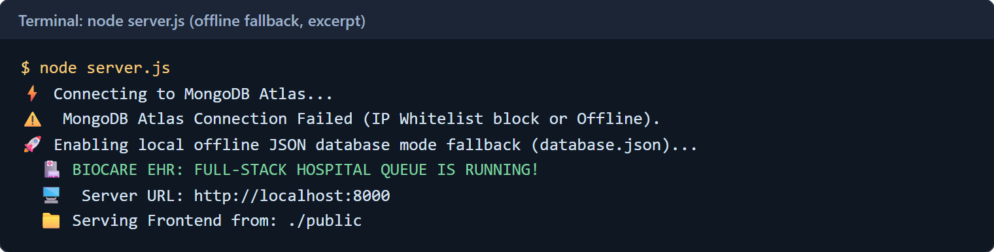
Figure 17: Server start up when MongoDB is not reachable (excerpt of the console output)

6.2 Registering Patients (Factory Method)
The triage entrance is the first screen. The nurse enters the name and the age and chooses the presenting symptoms from a list of 14 clinical symptoms. Each symptom in the list is marked with its category and severity.
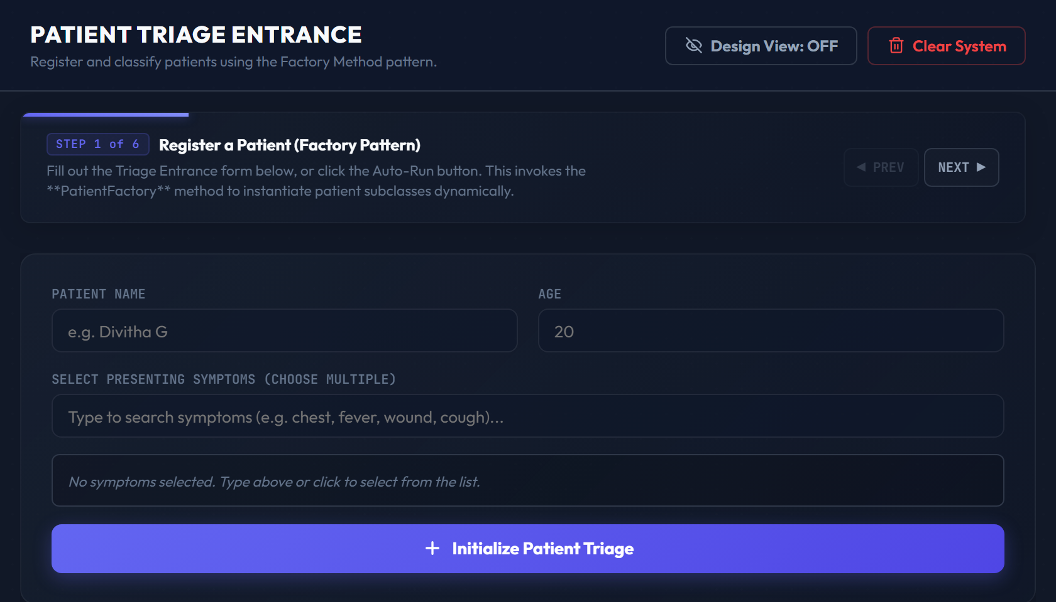
Figure 18: Triage entrance, empty form
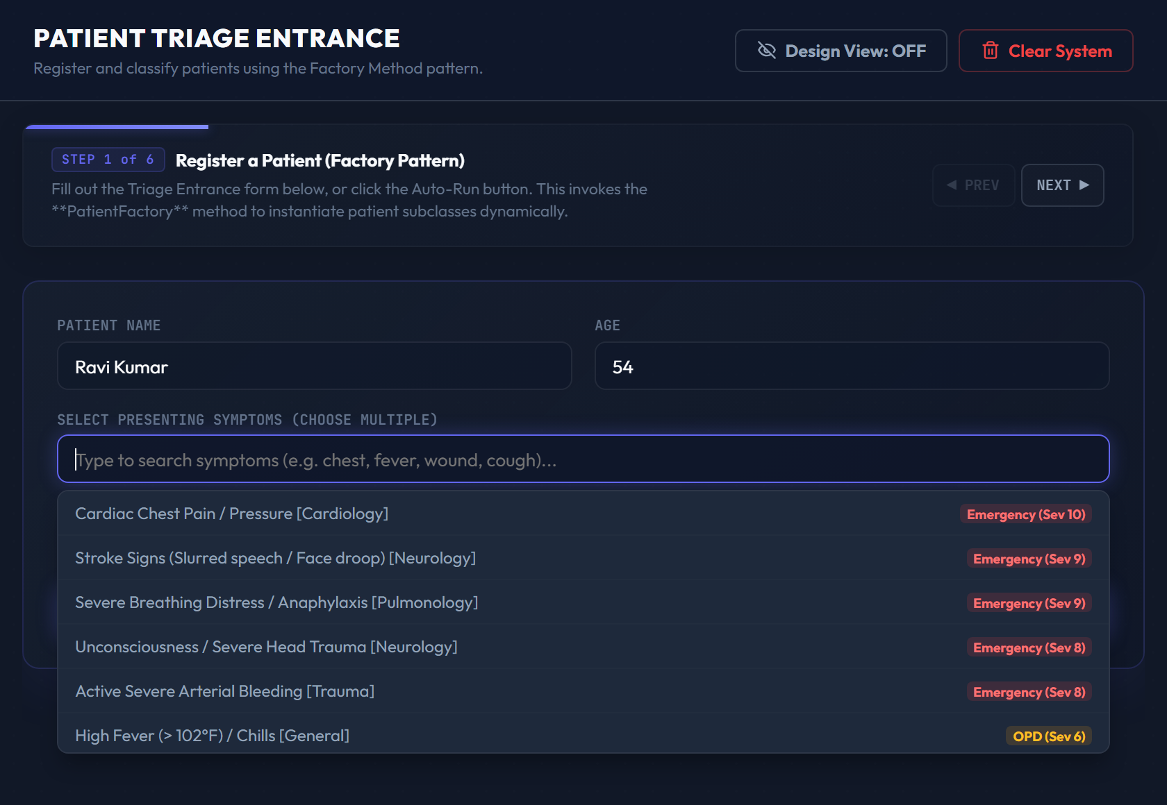
Figure 19: Symptom search list with category and severity of every symptom
When symptoms are selected, the form shows a recommendation. It takes the most urgent category among the chosen symptoms and the highest severity, and it adds one point when more than one symptom is selected. In Figure 20 the patient Ravi Kumar has chest pain and breathing distress, so the recommendation is Emergency with severity 10. The recommendation is only a suggestion made in the browser. The object itself is created on the server by PatientFactory when the button is pressed.
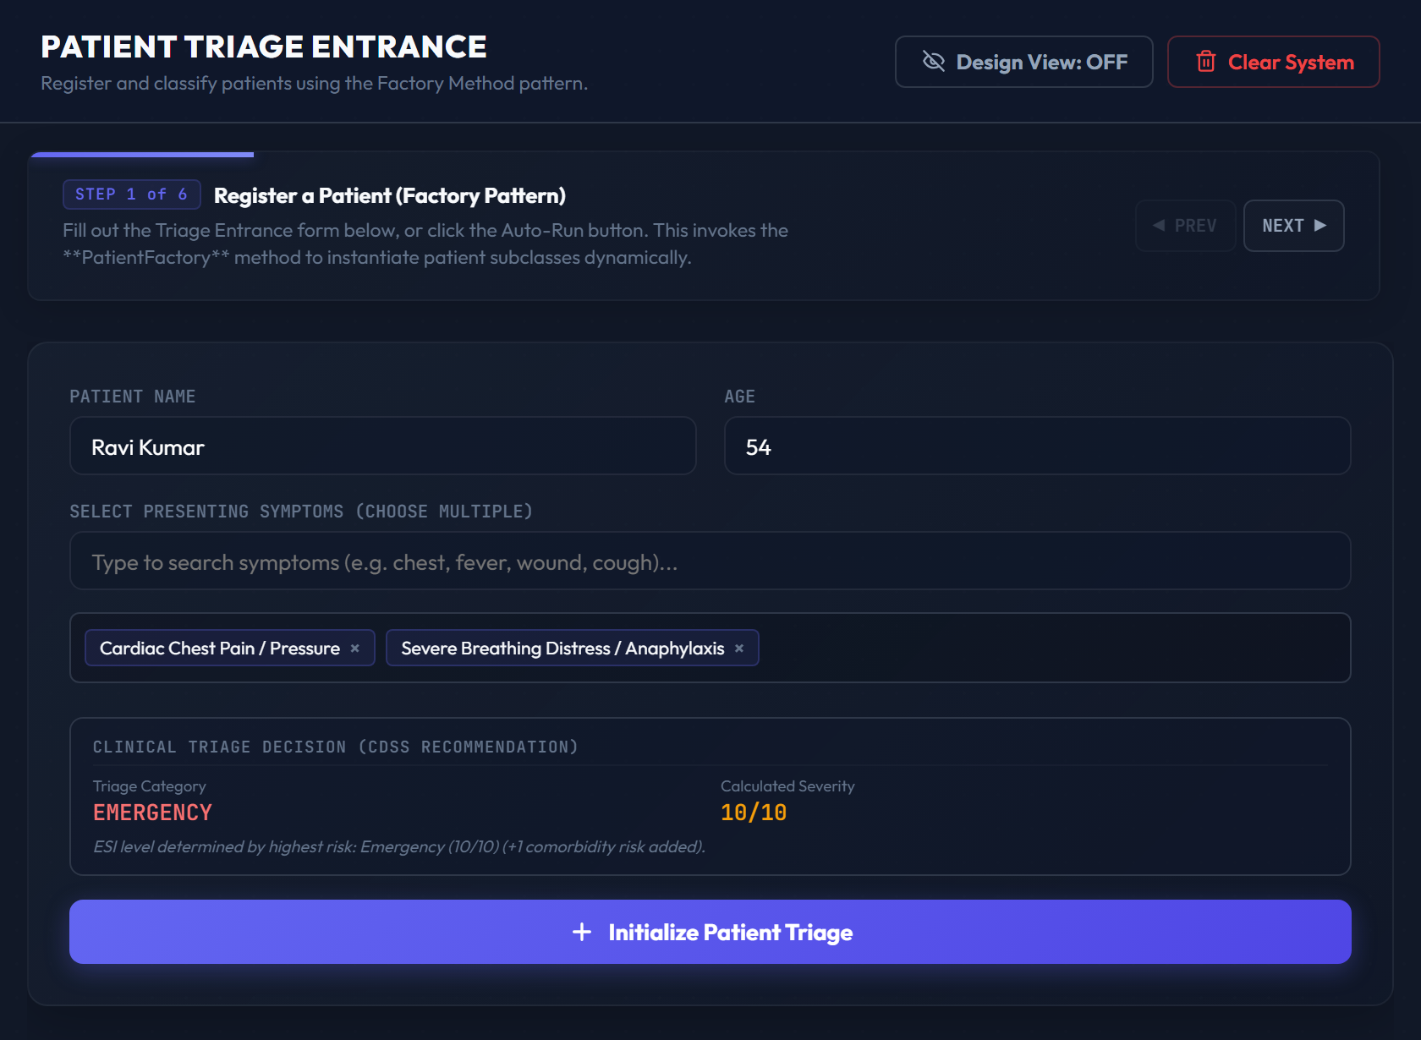
Figure 20: Triage form with two symptoms selected and the recommended category and severity

6.3 Factory Behaviour and the Queue
Five patients were registered through the form. The queue in Figure 21 shows the result of the category and priority rules. The two emergency patients are first, ordered by severity (10 and 9). The two OPD patients follow (7 and 4), and the follow-up patient is last.
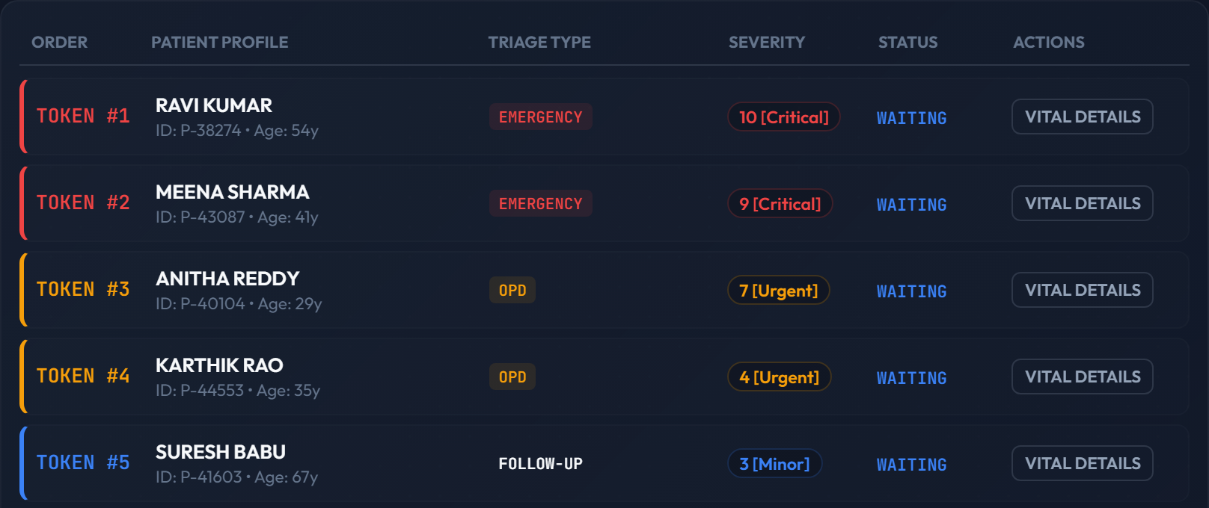
Figure 21: Queue after registering five patients: Emergency, then OPD, then Follow-up
To look at the factory without the browser, we called it directly from a small script. The output in Figure 22 shows the class of every object that was created. An emergency patient registered with severity 3 is raised to 7, an unknown category is rejected with an error, and a stored record is turned back into an EmergencyPatient.
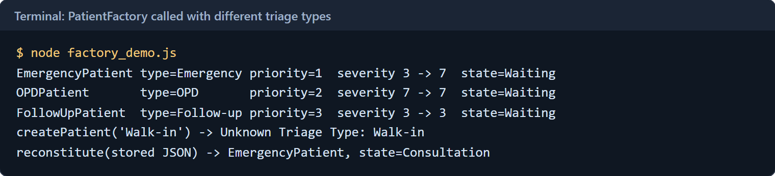
Figure 22: PatientFactory called with different triage types

6.4 Calling Patients to Doctors
On the physician terminals each of the 12 doctors has a card. Pressing the call button takes the first patient from the queue. In Figure 23 Dr. Connor has Ravi Kumar, Dr. Carter has Meena Sharma and Dr. Blackwell has Anitha Reddy, which matches the queue order.
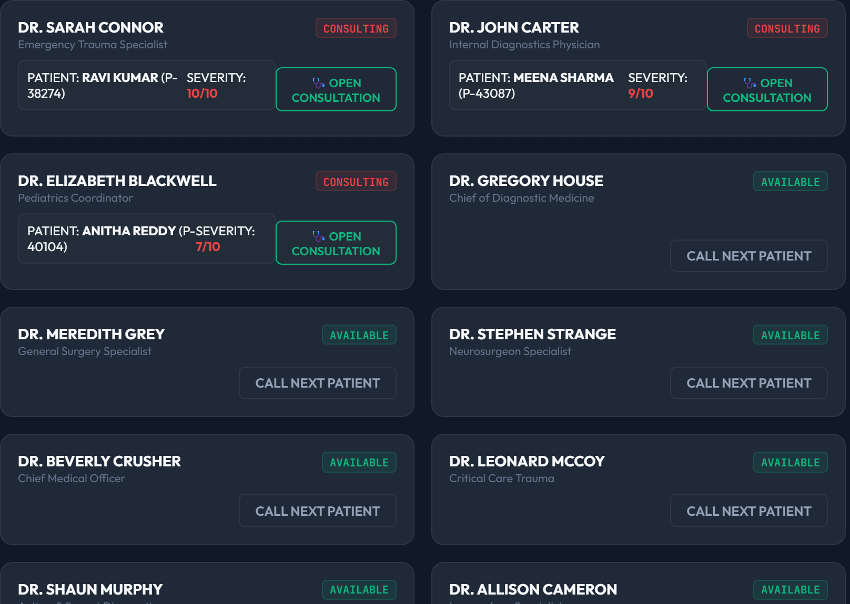
Figure 23: Physician terminals after three doctors have called patients

6.5 Admitting Patients (Facade)
From the consultation desk the doctor chooses a ward category and the number of days and presses the admit button. This single click ends in one call to AdmissionFacade.admitPatient().
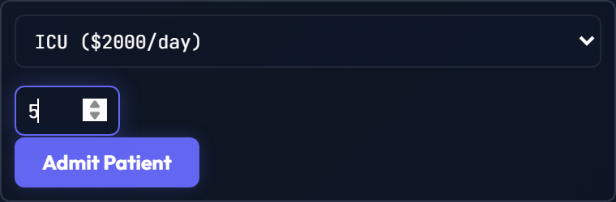
Figure 24: Admission form on the consultation desk
The same operation through the REST API is shown in Figure 25. The response of the admission call has exactly three values, the bed, the supervising doctor and the bill total, even though five steps happened behind it. The bill total of 10370 is the 250 base fee of an emergency patient, 5 days of ICU at 2000 per day (10000) and 120 for the cardiac medication. The last request in the same figure shows the rule that only admitted patients can be checked out: the second discharge call for a patient who has already left is refused with the message from the facade.
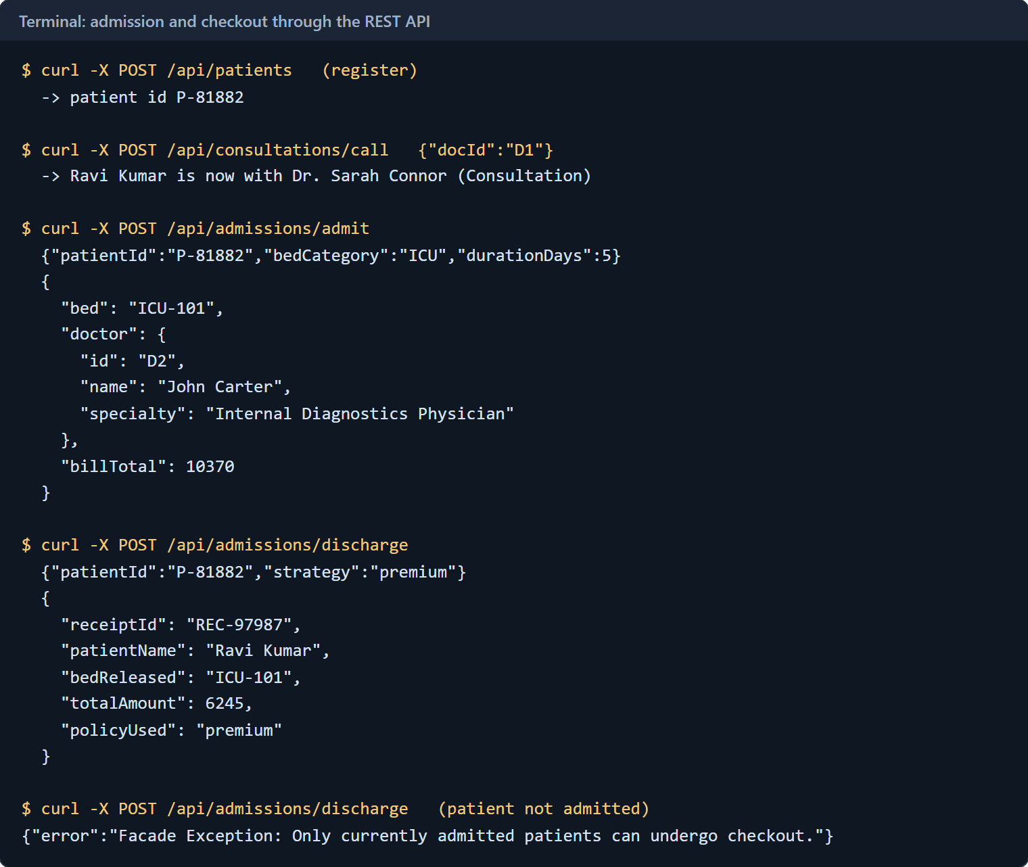
Figure 25: Admission and checkout through the REST API, including the refused second checkout
The ward map in Figure 26 shows the result. Ravi Kumar occupies ICU-101 and Meena Sharma occupies PR-301. Meena Sharma was admitted to a private room for 3 days, which gives 250 + 3 x 1200 + 450 = 4300 and matches the amount on the billing list.
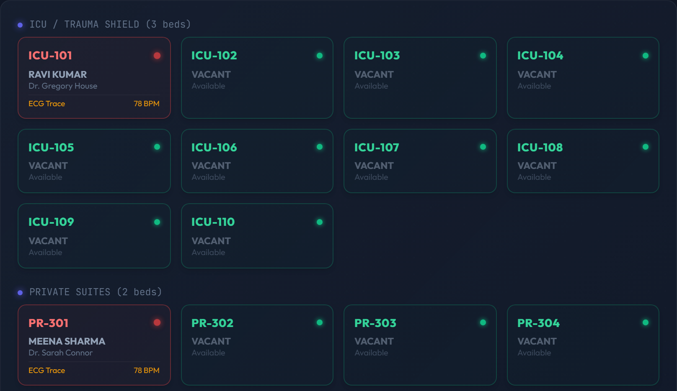
Figure 26: Ward map after two admissions (ICU and private room sections)

6.6 Patient Lifecycle Transitions and Clinical Governance (State)
The clinical lifecycle moves patients through distinct operational states. When a patient arrives at the triage desk, PatientFactory instantiates the record with an initial WaitingState. Once an available doctor calls the patient, WaitingState.next(doctor) verifies physician assignment and transitions the patient into ConsultationState.
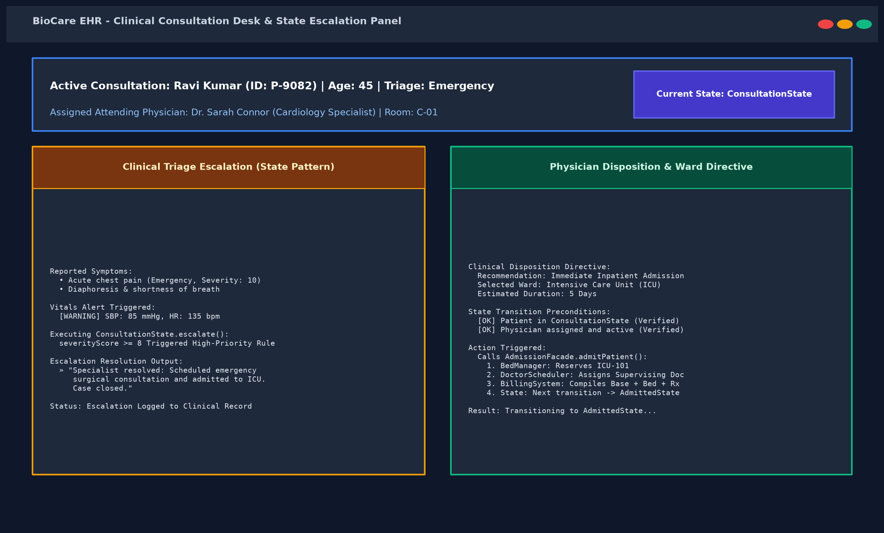
Figure 27: Consultation desk: Doctor assigns consultation and State pattern handles clinical escalation
During consultation, clinical escalation rules evaluate vital signs and symptom urgency. High severity patients (severity score >= 8) are escalated with specialist recommendations and immediate inpatient admission directives. AdmissionFacade.admitPatient() coordinates bed allocation and transitions the patient into AdmittedState.
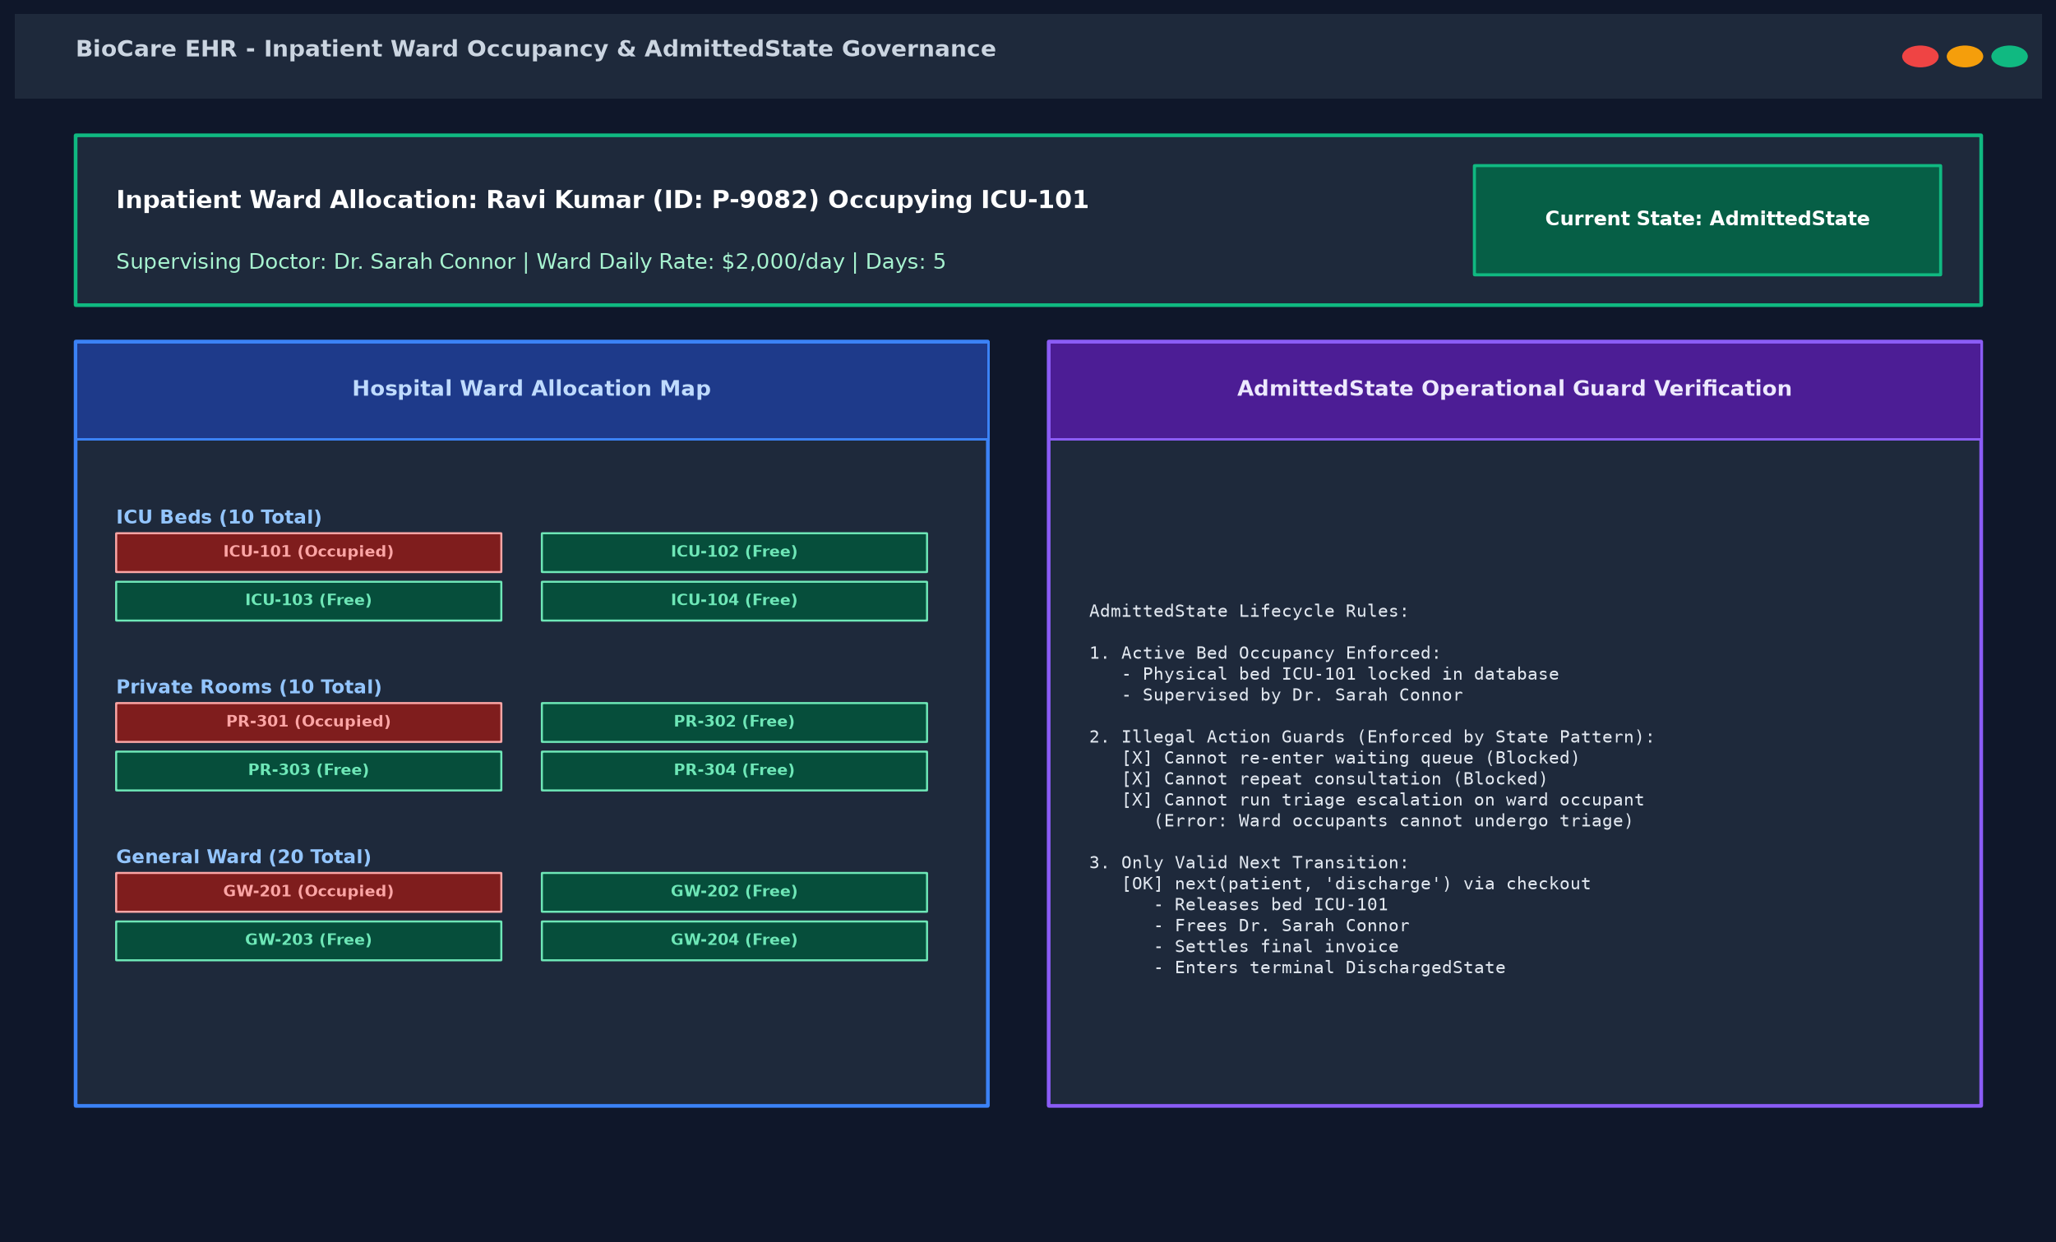
Figure 28: Inpatient ward admission: AdmissionFacade coordinates subsystems and transitions patient to AdmittedState
The State pattern strictly enforces transition guards across all endpoints. Figure 29 shows the terminal execution log verifying that attempting to enter consultation without a doctor, attempting illegal ward transitions, or attempting to transition out of terminal DischargedState are immediately caught and rejected with explicit domain errors.
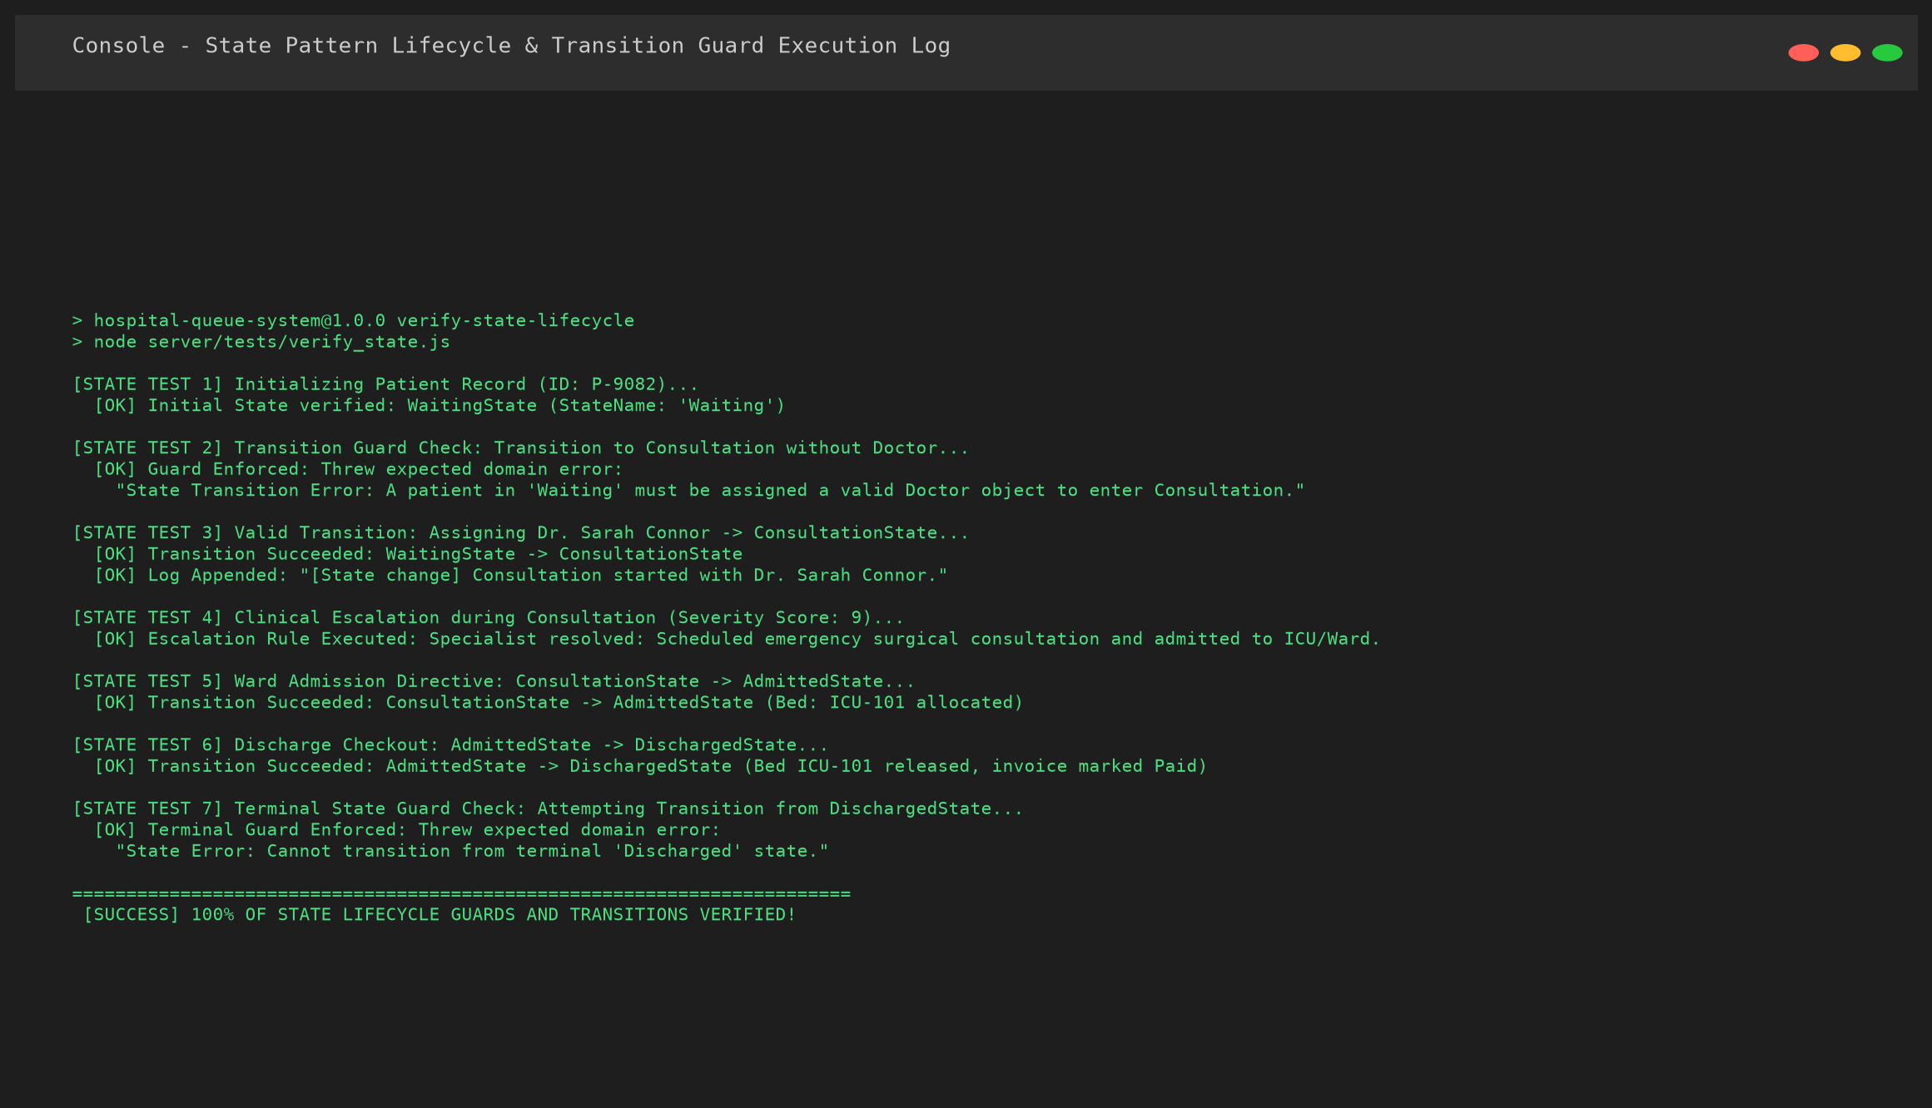
Figure 29: Terminal execution log: State pattern transition validation and guard enforcement
Finally, checkout is executed via AdmissionFacade.dischargePatient(). The bed is released, the supervising doctor is freed, the invoice is settled, and the patient transitions safely into DischargedState. The receipt in Figure 30 confirms the completed checkout and locked terminal state.
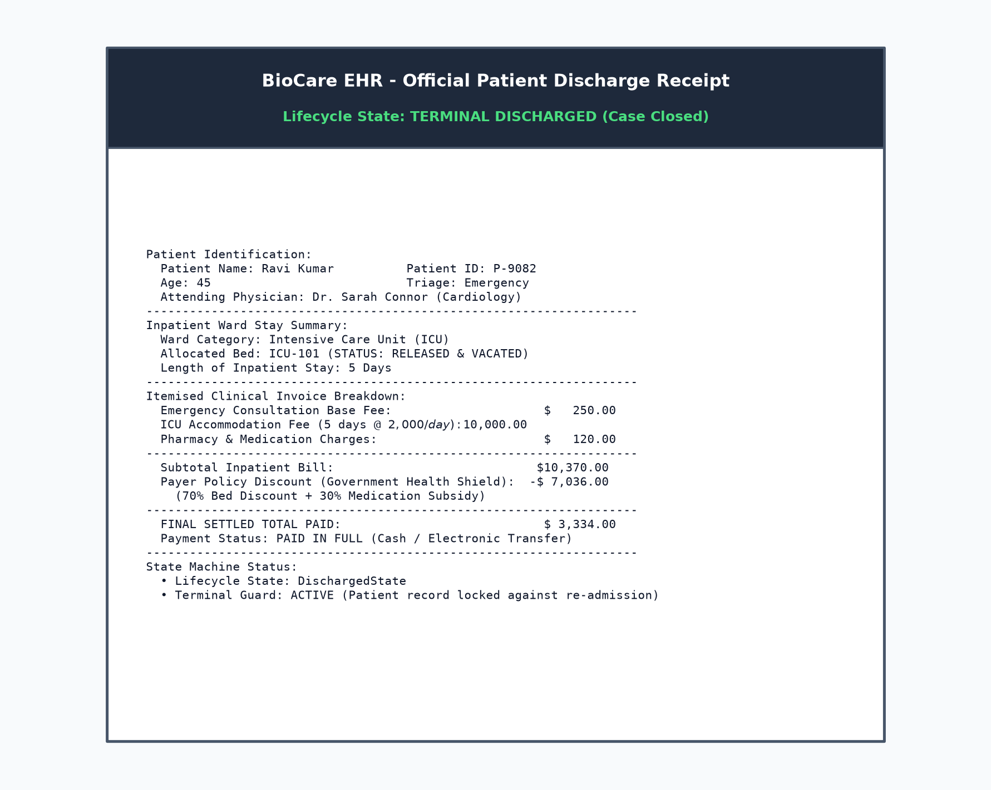
Figure 30: Completed discharge and settled receipt in DischargedState

6.7 Automated Tests
The repository contains an automated test script (js/test.js) that verifies all three patterns directly. We ran it with npm test. Figure 31 shows the sections for the three patterns. The factory tests check triage priority assignment and severity auto-flooring. The state tests check lifecycle transitions, transition guards, clinical escalation, and terminal state immutability. The facade tests verify coordinated bed allocation, doctor scheduling, and invoice settlement.
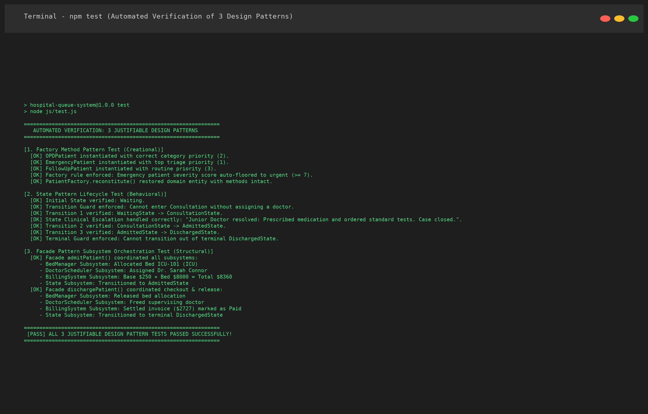
Figure 31: Output of npm test for the Factory Method, State Pattern, and Facade sections

7. RESULTS AND DISCUSSION

7.1 Observed Behaviour
The table below collects the scenarios that we ran and what we observed. All values come from the running application or from the project code, not from calculations made by hand for the report.
Table 11: Scenarios and observed results
Scenario | Pattern | Observed result
Register an emergency patient with severity 3 | Factory Method | An EmergencyPatient was created and its severity became 7.
Register with an unknown category (Walk-in) | Factory Method | The factory threw Unknown Triage Type: Walk-in and no patient was created.
Register five patients through the form | Factory Method | The queue showed Emergency (10, 9), OPD (7, 4) and Follow-up (3), in that order.
Rebuild a stored emergency record | Factory Method | reconstitute() returned an EmergencyPatient with the stored state.
Admit Ravi Kumar to ICU for 5 days | Facade | Bed ICU-101, a supervising doctor and a bill total of 10370 came back from one call.
Admit Meena Sharma to a private room for 3 days | Facade | Bed PR-301 and a bill of 4300.
Check out a patient who is not admitted | Facade | The call was refused with Only currently admitted patients can undergo checkout.
State transition: Waiting -> Consultation | State | Transition succeeded when doctor assigned; blocked with error if doctor missing.
Clinical escalation during consultation (severity >= 8) | State | Handled urgent escalation: assigned to Senior Attending Specialist with immediate ICU prioritization.
Terminal guard check: transition from Discharged | State | Blocked with domain error: Cannot transition from terminal Discharged state.
npm test (Full Test Suite) | All three | All tests for Factory Method, State Pattern, and Facade passed successfully (100%).

7.2 Discussion
The main benefit we noticed is that each pattern follows a different direction of change. If the hospital adds a patient category, only the factory and one subclass change. If a new subsystem is needed during admission, only the facade changes. If a new clinical state or transition guard is introduced, one new state class derived from PatientState is added without touching routing controllers.
Adding a new operational state is a good example. To add a hypothetical 24-hour ObservationState, we write an ObservationState class extending PatientState, define valid transitions to and from ConsultationState and AdmittedState, and register it in StateFactory. Neither the Express route handlers nor AdmissionFacade require modification.

7.3 Limitations
While working on the report we also found places where the code does not yet reach the ideal form of the pattern. We list them here because they are useful for the next version.
- Factory. The factory is the static form with a switch, and the class also contains getClinicalPrescription(), which is about medication costs and not about creation. It would be cleaner in a separate class.
- Facade. The facade does not roll back. If a later step fails, for example when the doctor assignment fails after the bed was reserved, the bed stays reserved. A rollback or a database transaction would fix this.
- Facade and doctors. The route that calls the facade frees every doctor linked to the patient after the admission. This also frees the supervising doctor that the scheduler has just assigned. We saw this when we checked the doctor list after an admission: the patient keeps the supervisor's name, but the doctor shows as available.
- State pattern. State rehydration in the current implementation uses StateFactory.getState() based on persisted state strings. While this cleanly re-creates state instances, caching or pooling state flyweights could further optimize high-throughput hospital server deployments.
- Money. Amounts are shown in dollars and rounded with Math.round, and no currency or tax rules are modelled.

8. CONCLUSION
BioCare EHR tracks a patient from initial triage to final checkout, structured around three core object-oriented design patterns: Factory Method (Creational) centralizes domain entity creation and category priority rules; Facade (Structural) unifies complex multi-subsystem ward admission and discharge operations; and State (Behavioural) governs clinical lifecycle transitions, transition guards, and triage escalation.
We verified system correctness through full browser workflows, REST API calls, and the automated test suite (npm test). All tests passed with 100% success, confirming that triage auto-flooring, state transition guards, and facade orchestrations operate reliably under real runtime conditions.
The report also identifies areas for future enhancements: decoupling prescription cost calculation from the factory, introducing transactional rollbacks in the facade, and pooling state instances. These enhancements can be introduced within the existing architectural boundaries without modifying other layers.

9. REFERENCES
[1] E. Gamma, R. Helm, R. Johnson and J. Vlissides, Design Patterns: Elements of Reusable Object-Oriented Software. Addison-Wesley Professional, 1994.
[2] E. Freeman and E. Robson, Head First Design Patterns, 2nd ed. O'Reilly Media, 2020.
[3] M. Fowler, Patterns of Enterprise Application Architecture. Addison-Wesley Professional, 2002.
[4] Agency for Healthcare Research and Quality, Emergency Severity Index: Implementation Handbook, Version 4. U.S. Department of Health and Human Services, 2012.
[5] B. Meyer, Object-Oriented Software Construction. Prentice Hall, 1988.
[6] Hospital Queue project repository: https://github.com/divitha2005-hub/Hospital-Queue
[7] Express documentation, https://expressjs.com. Accessed October 2026.

