NMAM INSTITUTE OF TECHNOLOGY, NITTE
[Department of Information Science and Engineering]

OPERATING SYSTEMS
PROGRAMMING ASSIGNMENT REPORT
AI-Assisted Synchronization Algorithms with Program-Generated HTML Simulation
Readers-Writers Problem and Dining Philosophers Problem
(Semaphore-based and Monitor-based implementations in Java)

SUBMITTED BY

Name | Divith Kumar
Registration / USN | NNM24IS079
Course | Operating Systems
GitHub Repository | https://github.com/divithkumar2006/OS-Synchronization-Java

SUBMITTED TO

Dr Jason Elroy Martis
Associate Professor
Dept Information Science and Engineering,Nitte

1. Problem Statement and Synchronization Objective
Modern operating systems run many processes and threads at the same time, and these often share data. When access to shared data is not coordinated, the result depends on the unpredictable order in which the scheduler interleaves the threads. This produces race conditions (for example a lost update when two threads execute counter = counter + 1 together), deadlock and starvation [1][2]. This assignment studies two classical synchronization problems and solves each of them twice, once with semaphores and once with a monitor, giving four separate Java programs.

1.1 Objective
- Implement the Readers-Writers problem with semaphores and with a monitor (synchronized methods with wait() and notifyAll()).
- Implement the Dining Philosophers problem for exactly four philosophers with semaphores and with a monitor, addressing deadlock prevention and starvation.
- Make every program generate its own HTML simulation from the events recorded during its execution, so that the animation is a replay of a real run and not a hand-made drawing.
- Test the programs and explain race conditions, mutual exclusion, deadlock and starvation in relation to each solution.

1.2 The Readers-Writers problem
A shared data object (here an integer counter) is accessed by several concurrent threads. Readers only read it; writers modify it. Many readers may read together without harm, but a writer needs exclusive access. The synchronization requirements are: (i) any number of readers may be inside the critical section at once; (ii) at most one writer may write at a time; (iii) a writer and a reader, or two writers, must never be inside together; and (iv) the policy must be examined for starvation, because favouring one class may postpone the other [1][3].

1.3 The Dining Philosophers problem (four philosophers)
Four philosophers sit at a round table with one fork between each pair of neighbours (four forks). Each alternately thinks and eats, and needs both adjacent forks to eat. The forks are the shared, non-shareable resources. If every philosopher picks up the left fork first, all four may hold one fork and wait forever for the other, which is a deadlock [4]. A correct solution must prevent or avoid this and must be examined for starvation.
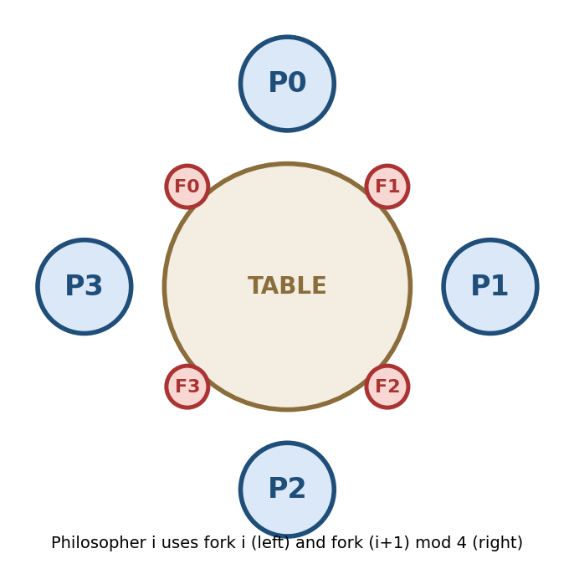
Figure 1: Seating arrangement and fork numbering used in the programs

1.4 Overview of the four implementations
No. | Problem | Technique | Source file
1 | Readers-Writers | Semaphores (mutex, resourceLock) | ReadersWritersSemaphore.java
2 | Readers-Writers | Monitor (synchronized methods + wait/notifyAll) | ReadersWritersMonitor.java
3 | Dining Philosophers (4) | Semaphores (4 fork semaphores + room = 3) | DiningPhilosophersSemaphore.java
4 | Dining Philosophers (4) | Monitor (to be completed) | DiningPhilosophersMonitor.java
Table 1: The four programs
Build and run (Java 15 or newer; the programs use text blocks)
javac *.java
java ReadersWritersSemaphore
java ReadersWritersMonitor
java DiningPhilosophersSemaphore
java DiningPhilosophersMonitor
Listing 1: Compilation and execution (4 readers, 2 writers, 3 rounds; 4 philosophers, 3 meals; each program writes its HTML file to generated_html/)
Java was chosen because it offers threads, a ready-made counting semaphore (java.util.concurrent.Semaphore), and built-in monitors: every Java object has an intrinsic lock, and synchronized methods together with wait() and notifyAll() form the monitor abstraction permitted by the assignment [7]. No external library is needed.

2. Readers-Writers Problem

2.1 Semaphore-Based Implementation
Source: ReadersWritersSemaphore.java; output: generated_html/readers_writers_semaphore.html.
Shared resource and critical section
The shared resource is the integer counter sharedValue together with the variable readCount, the number of readers currently inside (activeReaders and activeWriters additionally count the threads inside, for the trace). A reader's critical section is the simulated reading time (450-700 ms) followed by reading sharedValue; a writer's critical section is the simulated writing time (500-700 ms) followed by ++sharedValue. The sleeps stand for real work and make the concurrency visible in the simulation.
Table 2: Semaphores of the Readers-Writers semaphore solution
Semaphore | Initial | Purpose
mutex | 1 (binary) | Protects readCount and activeReaders; only one reader at a time may change them.
resourceLock | 1 (binary, fair) | Key to the shared resource. A writer holds it alone; the group of readers holds it together (taken by the first reader, returned by the last).

acquire() is the wait (P) operation: it decrements the semaphore and blocks if no permit is available. release() is the signal (V) operation: it increments the semaphore and wakes one blocked thread [1][7]. The readers act as a group: the first reader locks the resource for all readers, and the last reader unlocks it.
READER WRITER
------ ------
mutex.acquire() resourceLock.acquire()
readCount = readCount + 1 ... WRITE (exclusive access) ...
if (readCount == 1) resourceLock.release()
resourceLock.acquire()
mutex.release()
... READ (shared access) ...
mutex.acquire()
readCount = readCount - 1
if (readCount == 0)
resourceLock.release()
mutex.release()
Listing 2: Classical semaphore solution (readers have priority) [3]
// READER entry (event recorded while holding mutex, see Section 4)
trace.record(name, "WAITING", "Wants to read (round " + round + ")");
mutex.acquire(); readCount++;
if (readCount == 1) resourceLock.acquire(); // FIRST reader locks for all
activeReaders++;
trace.record(name, "READING", "Entered critical section");
mutex.release(); // other readers may follow
// ... critical section: Thread.sleep(450..700); read sharedValue ...
// READER exit
mutex.acquire(); activeReaders--; readCount--;
trace.record(name, "IDLE", "Finished reading"); // recorded BEFORE the release
if (readCount == 0) resourceLock.release(); // LAST reader unlocks
mutex.release();
Listing 3: Reader entry, critical and exit sections
Correctness, deadlock and starvation
- Writer vs. readers: while any reader is inside, the reader group holds resourceLock, so a writer blocks; while a writer is inside, the first arriving reader blocks on resourceLock.
- Writer vs. writer: only one thread can own the binary semaphore resourceLock.
- Concurrent readers: after the first reader has taken resourceLock, later readers only increment readCount and pass.
- Deadlock: none. All semaphores are requested in the same order and the only thread that waits while holding mutex (the first reader) waits for resourceLock, which a writer always releases because it needs no further semaphore.
- Starvation: possible, because this program gives priority to readers: if new readers keep arriving, readCount never returns to 0, the reader group keeps resourceLock and a waiting writer may be delayed indefinitely. No turnstile is used. resourceLock is created in fair mode, so threads that already wait for it are served in arrival order, and because every thread performs only a fixed number of rounds the writers are delayed but not postponed forever in this program [3].

2.2 Monitor-Based Implementation
Source: ReadersWritersMonitor.java; output: generated_html/readers_writers_monitor.html. The monitor is the inner class SharedMonitor. All its procedures are synchronized, so the intrinsic lock of the monitor object guarantees that only one thread executes a monitor procedure at a time, and wait() and notifyAll() provide waiting and wake-up on the wait set of the monitor [5][7].
Table 3: State variables and wait/notify mechanism of the Readers-Writers monitor
Monitor element | Kind | Meaning
activeReaders | int | Number of readers currently reading.
activeWriters | int | 1 while a writer is writing, otherwise 0.
waitingWriters | int | Writers that want to write; gives writers priority over new readers.
wait() | wait set | Readers sleep here while a writer is active or waiting; writers sleep here while any reader or writer is active.
notifyAll() | wake-up | Called when the last reader leaves and when a writer leaves; every waiting thread wakes up and re-checks its own condition.

synchronized void beginRead(String name) throws InterruptedException {
while (activeWriters > 0 || waitingWriters > 0) // writer active OR waiting
wait(); // releases the monitor lock
activeReaders++;
trace.record(name, "READING", "Entered read section");
}
synchronized void endRead(String name) {
activeReaders--;
trace.record(name, "IDLE", "Finished reading");
if (activeReaders == 0) notifyAll(); // wake waiting writers
}
synchronized void beginWrite(String name) throws InterruptedException {
waitingWriters++; // writers have priority
try { while (activeReaders > 0 || activeWriters > 0) wait();
activeWriters = 1; }
finally { waitingWriters--; }
trace.record(name, "WRITING", "Entered write section");
}
synchronized void endWrite(String name) {
activeWriters = 0;
trace.record(name, "IDLE", "Finished writing");
notifyAll(); // wake readers and writers
}
Listing 4: Procedures of the Readers-Writers monitor (simplified)
Wait and notify. wait() atomically releases the monitor lock and puts the thread into the wait set of the monitor object; on wake-up the thread re-acquires the lock. For this reason wait() is always inside a while loop and never an if: the state may have changed in between, and spurious wake-ups are permitted by the Java specification [7]. This monitor has one wait set shared by readers and writers, so notifyAll() is used: when the last reader leaves, and when a writer leaves, all waiting threads wake up and each re-checks its own condition. A waiting writer enters when no reader or writer is active; readers enter only when no writer is active or waiting, which gives writers priority and lets all woken readers read concurrently.

3. Dining Philosophers Problem

3.1 Semaphore-Based Implementation
Source: DiningPhilosophersSemaphore.java; output: generated_html/dining_philosophers_semaphore.html. Philosopher i uses fork i (left) and fork (i+1) mod 4 (right). The forks are the shared resources; eating is the critical section.
Table 4: Semaphores of the Dining Philosophers semaphore solution
Semaphore | Initial | Purpose
fork[0..3] | 1 each | One binary semaphore per fork: 1 = on the table, 0 = held by a philosopher.
room | 3 (N - 1) | Counting semaphore acting as a ticket for the table: at most three philosophers may try to pick up forks at the same time; the fourth blocks on room.

Deadlock prevention
A naive left-then-right solution deadlocks when all four philosophers take their left fork simultaneously, a circular wait [4][6]. The room semaphore limits the competing philosophers to N - 1 = 3. The philosopher outside holds no fork (forks are taken only after room is acquired), so a chain of waiting philosophers always ends at a free fork or at a philosopher who is eating. A cycle would need all four philosophers, but only three are inside. The eating philosopher finishes, releases his forks and leaves the room, which lets the others continue.
room.acquire(); // at most 3 pass; the 4th BLOCKS here
log(p, "ACQUIRING", "Entered room; taking F" + left + " and F" + right);
forks[left].acquire(); // wait() on left fork
log(p, "ACQUIRING", "Picked up left fork F" + left);
forks[right].acquire(); // wait() on right fork
log(p, "ACQUIRING", "Picked up right fork F" + right);
meals[p] = m;
log(p, "EATING", "Eating meal " + m + " of 3"); // CRITICAL SECTION
Thread.sleep(600);
forks[right].release(); // signal() right fork, then log "put down"
forks[left].release(); // signal() left fork, then log "put down"
room.release(); // leave the room
Listing 5: One eating cycle of a philosopher (semaphore version)
Starvation considerations. All semaphores are created in fair mode (new Semaphore(n, true)), so waiting threads are served in FIFO order and cannot be overtaken indefinitely. The number of meals of each philosopher is counted and shown in the simulation, and the program ends only after all four threads have completed their three meals. FIFO queues together with the deadlock-free structure give bounded waiting in practice, although this is not a formal proof for every possible schedule [3].

3.2 Monitor-Based Implementation
TO BE COMPLETED: the source file DiningPhilosophersMonitor.java was not available when this report was prepared. Describe here the source file, the design of the monitor (shared state, lock, wait/notify), a table of its elements, a listing of its main procedures, and the correctness, deadlock and starvation discussion.
What the simulation (Figure 6) already shows: in the event log a philosopher picks up both adjacent forks in one step (for example "P2 picked up forks 2 and 3 and started eating"), the shared table is protected by the monitor lock, and the page reports that adjacent philosophers never eat together.

4. Event Recording and HTML Simulation Generation
The assignment requires the visualization to be generated from the execution data of the synchronization program itself. All four programs therefore follow the same pipeline: the threads record events while they run, the program converts the events to JSON, inserts them into an HTML template and writes the file to generated_html/.

4.1 Shared helper classes
- sharedValue - the static integer counter of the Readers-Writers programs. Readers read it and each writer increments it once per round (2 writers x 3 rounds = 6). After all threads have finished, the program prints the final value (expected 6) and throws an exception if a reader or writer is still marked as inside the resource.
- Event recording - every program records events with a synchronized method (the nested classes Event and TraceRecorder in the Readers-Writers programs, the method log with a shared event list in the Dining Philosophers semaphore program). Each event stores a millisecond timestamp, the actor, the state and a message, and is also printed to the console as execution evidence.
- HTML generation - generateHtml() (Readers-Writers) and makeHtml() (Dining Philosophers) hold the fixed HTML/CSS/JavaScript template as a Java text block, replace a placeholder (__TRACE__ or EVENTS) with the JSON array of recorded events, and write the file into generated_html/. The path of the file is printed to the console and the page is opened in a browser.
{"time":2281,"actor":"R4","state":"READING","detail":"Entered critical section; readers inside = 1","readers":1,"value":2}
["932","P0","RELEASING","Put down left fork F0","0","1"] // time, actor, state, message, philosopher, meals
Listing 7: Event formats: one object per event (Readers-Writers) and one array per event (Dining Philosophers)

4.2 The ordering rule
An event is recorded while the thread still holds the semaphore or monitor that makes it true. In the Readers-Writers semaphore program a reader records IDLE (finished reading) just before it releases resourceLock, and a writer records IDLE before resourceLock.release(); in the monitor program every trace.record call is made inside a synchronized method. If an event were recorded after the release, another thread could already have entered and logged its own event first, and the trace would show an impossible overlap. In the Dining Philosophers semaphore program the two "put down" messages are logged immediately after the forks are released, so in principle a neighbour's "picked up" message could appear first; this does not change which philosophers can eat, but the replay could then show a fork with a wrong owner for a moment.

4.3 Replay in the browser
The Readers-Writers pages contain the line const TRACE = [ ... ] with the real events of the run, and the Dining Philosophers page contains the corresponding event array. The JavaScript player provides the event log, a timeline with one coloured lane per thread, and the controls Play/Pause, Step, Reset (replay), speed (0.5x to 4x) and a scrub bar; clicking a log line jumps to that event [8]. A problem-specific part draws the scene: reader and writer cards with the shared-resource box and waiting queue (Readers-Writers), or a round table with four philosophers and four forks in SVG together with a philosopher table and a fork table (Dining Philosophers). The displayed state is never stored; it is rebuilt from the events up to the current time: for every thread the last event not later than the current time gives its state, and the page checks the safety invariant.
function stateAt(actor, t) { // last event of this thread up to time t
let found = null;
for (const e of TRACE) if (e.actor === actor && e.time <= t) found = e;
return found;
}
const reading = states.filter(([a, e]) => e && e.state === "READING");
const writing = states.filter(([a, e]) => e && e.state === "WRITING");
const violation = (reading.length > 0 && writing.length > 0) || writing.length > 1;
Listing 8: State of each thread at time t and the safety check (Readers-Writers page)
For the Dining Philosophers semaphore page the events 0..i are replayed: the "picked up" and "put down" messages give the owner of every fork, and the page shows a fork table and a line "Deadlock check" that reports how many philosophers are eating. This line is informational and does not detect a deadlock by itself; deadlock freedom follows from the argument in Section 3.1 and from the fact that the program terminates. Because the whole animation is a function of the recorded events, a run with different timing produces a different animation, so nothing in the HTML tells a pre-written story. Running the program again regenerates the file, which makes the HTML reproducible from program execution.

5. Execution Traces / State Sequences
The excerpts below are taken from the event logs shown in the generated HTML simulations (the same events that each program prints on the console). Each line has the form [time in ms] actor state message. Thread scheduling is non-deterministic, so exact numbers vary between runs, but the properties discussed hold in every run.

5.1 Readers-Writers, semaphore version (4 readers, 2 writers, 3 rounds)
[ 1597 ms] W1 WRITING Entered critical section (exclusive access)
[ 1878 ms] W2 WAITING Wants to write (round 2)
[ 2280 ms] W1 WRITING Updated shared value to 2
[ 2280 ms] W1 IDLE Finished writing; resource released
[ 2281 ms] R4 READING Entered critical section; readers inside = 1
[ 2281 ms] R2 READING Entered critical section; readers inside = 2
[ 2282 ms] R3 READING Entered critical section; readers inside = 3
[ 2282 ms] R1 READING Entered critical section; readers inside = 4
[ 2767 ms] W1 WAITING Wants to write (round 2)
[ 2830 ms] R4 READING Reading shared value 2
[ 2834 ms] R4 IDLE Finished reading; readers left inside = 3
Listing 9: Excerpt of the trace of Program 1 (event log of the simulation)
W1 enters the critical section at 1597 ms and updates the counter to 2 at 2280 ms. W2 asked to write at 1878 ms and has to wait. When W1 releases resourceLock at 2280 ms, the readers that had been waiting for it (see the timeline in Figure 3) enter within 2 ms: readers inside rises 1, 2, 3, 4, so four readers read the value 2 at the same time while W2 keeps waiting. This is the reader-priority behaviour of the semaphore solution: the reader group holds resourceLock until its last member leaves. State sequence: {W1 writing} -> {R4, R2, R3, R1 reading, W2 waiting}. A writer is never inside together with a reader or another writer.

5.2 Readers-Writers, monitor version (4 readers, 2 writers, 3 rounds)
[ 7 ms] R1 IDLE Ready to read
[ 18 ms] W2 IDLE Ready to write
[ 19 ms] W1 IDLE Ready to write
[ 20 ms] R4 IDLE Ready to read
[ 21 ms] R3 IDLE Ready to read
[ 22 ms] R2 IDLE Ready to read
[ 190 ms] R4 WAITING Wants to read (round 1)
[ 191 ms] R4 READING Entered read section; readers inside = 1
[ 236 ms] R2 WAITING Wants to read (round 1)
[ 237 ms] R2 READING Entered read section; readers inside = 2
[ 261 ms] R3 WAITING Wants to read (round 1)
Listing 10: Excerpt of the trace of Program 2 (start of the run)
All threads are ready within 22 ms. R4 asks to read at 190 ms and enters at 191 ms (readers inside = 1); R2 asks at 236 ms and enters at 237 ms while R4 is still reading (readers inside = 2), so readers read concurrently as long as no writer is waiting or active. The writer-priority policy becomes visible in the timeline of Figure 4: from about 1 s to about 4.6 s all four readers stay in WAITING while W1 and W2 take turns writing, and the readers continue only after the last writing segment has ended, because new readers must wait whenever waitingWriters > 0 or a writer is active.

5.3 Dining Philosophers, semaphore version (4 philosophers, 3 meals)
[ 931 ms] P1 ACQUIRING Picked up right fork F2
[ 932 ms] P0 RELEASING Put down left fork F0
[ 932 ms] P3 ACQUIRING Picked up right fork F0
[ 933 ms] P2 ACQUIRING Entered room; trying to take forks F2 and F3
[ 934 ms] P0 THINKING Back to thinking
[ 935 ms] P0 THINKING Thinking
[ 936 ms] P1 EATING Eating meal 1 of 3
[ 937 ms] P3 EATING Eating meal 1 of 3
[ 1193 ms] P0 HUNGRY Hungry; trying to enter room
Listing 11: Excerpt of the trace of Program 3 (event log of the simulation)
P1 picks up its right fork F2 at 931 ms and eats from 936 ms with forks F1 and F2. P0 puts down F0 at 932 ms and P3 picks it up at once as its right fork, so P3 holds F3 and F0 and eats from 937 ms: P1 and P3 are not neighbours, so they eat at the same time. P2 enters the room at 933 ms because P0 has left it, and tries to take F2 and F3, which are held by P1 and P3, so it has to wait. P1, P2 and P3 now occupy all three places of the room, so P0, hungry again at 1193 ms, cannot enter (Figure 5), and the circular wait of four philosophers cannot form.

5.4 Dining Philosophers, monitor version (4 philosophers, 3 meals)
[ 8 ms] P2 is hungry
[ 9 ms] P2 picked up forks 2 and 3 and started eating
[ 10 ms] P3 is hungry
[ 11 ms] P0 finished meal 1 and released both forks
[ 12 ms] P0 is thinking
[ 13 ms] P2 finished meal 1 and released both forks
[ 14 ms] P1 picked up forks 1 and 2 and started eating
[ 15 ms] P3 picked up forks 3 and 0 and started eating
[ 16 ms] P2 is thinking
Listing 12: Excerpt of the trace of Program 4 (event log of the simulation)
P2 is granted forks 2 and 3 together at 9 ms. After P0 and P2 have finished their first meals and released both forks (11 ms and 13 ms), P1 is granted forks 1 and 2 at 14 ms and P3 forks 3 and 0 at 15 ms. P1 and P3 are not neighbours, so they eat at the same time, and in this excerpt no philosopher holds a single fork. With four forks, at most two non-adjacent philosophers can eat at the same time. TO BE COMPLETED: add the explanation of the monitor logic after DiningPhilosophersMonitor.java is available.

6. Synchronization Concepts

6.1 Race Condition
A race condition exists wherever two threads access the same data without ordering and at least one of them writes [1][2]. In the Readers-Writers programs the potential races are on the counter sharedValue and, in the semaphore version, on readCount. readCount is protected by mutex; the counter is written only by a writer that holds resourceLock (semaphore version) or has been admitted by the monitor conditions (monitor version), and the update itself is additionally placed in a short synchronized block or synchronized method. In the philosophers programs the shared items are the forks (protected by fork semaphores) and the table state of the monitor. The trace recorder is also shared and is protected by synchronized methods. Without these protections two writers, or a reader and a writer, could be inside together; the HTML page would then show a red SAFETY VIOLATION and overlapping segments in the timeline.

6.2 Mutual Exclusion
Program | What is mutually exclusive | Mechanism
1 RW semaphore | Writer vs. readers; writer vs. writer; updates of readCount | resourceLock (group lock for readers) and mutex
2 RW monitor | Writer vs. readers; writer vs. writer | Monitor lock (synchronized) plus wait conditions on activeWriters / activeReaders
3 DP semaphore | Each fork is used by one philosopher | fork[i] binary semaphores
4 DP monitor | Neighbouring philosophers never eat together, so each fork has one user | Monitor lock; both forks granted together (see Section 3.2)
Table 7: Mutual-exclusion mechanisms
The HTML player verifies the property independently: for every moment it takes the state of each thread and shows "SAFETY VIOLATION" and "OVERLAP DETECTED" if a writer overlaps a reader or another writer. This message never appeared for the correct programs; the pages in Figures 3 and 4 show "no reader/writer or writer/writer overlap".

6.3 Deadlock
A deadlock requires all four Coffman conditions: mutual exclusion, hold and wait, no preemption and circular wait [6]. Preventing any one of them is sufficient. Both Readers-Writers solutions are deadlock-free because the lock order is fixed and a lock is held only while waiting for one that is always released. In the semaphore philosophers solution, mutual exclusion, hold-and-wait and no-preemption exist (a philosopher holds one fork while waiting for the other), but circular wait is broken by the room semaphore (at most N - 1 = 3 competitors). In the monitor solution hold-and-wait is avoided because both forks are granted together (see Section 3.2). All programs terminated normally in the runs made for this report, which would be impossible after a deadlock.

6.4 Starvation
Program | Policy | Who may starve | Remedy
1 RW semaphore | Readers priority | Writers, if readers keep arriving | Add a turnstile semaphore that blocks new readers while a writer waits (not implemented here)
2 RW monitor | Writers priority | Readers, if writers keep arriving | Alternate turns or limit consecutive writers
3 DP semaphore | Fair FIFO semaphores, room = 3 | Practically nobody; FIFO gives bounded overtaking | Already fair; meals are counted
4 DP monitor | To be completed (Section 3.2) | To be completed (Section 3.2) | To be completed (Section 3.2)
Table 8: Starvation analysis
Deadlock means that nobody can proceed; starvation means that the system keeps progressing while one thread is postponed indefinitely. Bounded waiting, the third requirement of the critical-section problem, is the property that rules starvation out [1].

7. Comparison of Semaphore and Monitor Approaches
Both families were implemented for the same two problems, which allows a comparison based on actual code instead of theory alone [1][2][5].
Aspect | Semaphore approach | Monitor approach
Abstraction level | Low level: an integer with wait and signal | High level: shared data, procedures, lock and condition variables in one unit
Mutual exclusion | Programmer must pair acquire and release correctly everywhere | Automatic: only one thread is inside the monitor at a time
Waiting for a condition | Encoded indirectly through counters and extra semaphores (readCount, room) | Explicit and readable: while (condition) await()
Typical errors | Forgotten release, wrong order (deadlock), unbalanced counts | if instead of while; missing signal causes a lost wake-up
Readers-Writers code | Two semaphores plus a counter; "first reader locks, last unlocks" is subtle | Three state variables and one wait set with notifyAll(); rules read directly as conditions
Dining Philosophers code | Four fork semaphores plus room; one fork acquired after the other | Table state under the monitor lock; both forks granted together (see Section 3.2)
Deadlock handling | Limit entry to N - 1 (circular wait removed) | Atomic acquisition (hold-and-wait removed)
Policy control | Hidden in the order of semaphore operations | Visible in the conditions and in which condition is signalled
Performance | Very light weight; good for simple resource counting | Slightly more overhead from lock and condition handling; negligible here
Table 9: Comparison of semaphores and monitors
Summary. Semaphores are the more primitive tool and can express every synchronization pattern, but correctness depends on the careful placement of each operation and the intention is not written in the code. Monitors keep the shared state and the access rules together, which makes monitor programs easier to read, reason about and modify; for example, switching the Readers-Writers monitor from writer priority to reader priority only requires changing one condition. Their drawbacks are the dependence on language or library support and the discipline of the while loop. In Java, synchronized methods with wait() and notifyAll() supplied the monitor abstraction without difficulty [7]; the price of the single wait set is that notifyAll() wakes every waiting thread and each of them must re-check its condition.

8. Results and Observations

8.1 Readers-Writers
Program | Events | Run time | Result
1. RW semaphore (4 readers, 2 writers, 3 rounds) | 84 | about 5.9 s | No overlap detected in the simulation; the program prints the final value (expected 6)
2. RW monitor (4 readers, 2 writers, 3 rounds) | 84 | about 6.1 s | No overlap detected in the simulation; the program prints the final value (expected 6)
Table 10: Results of the default Readers-Writers executions
- Mutual exclusion held: in the runs shown in Figures 3 and 4, the writers' WRITING segments in the timeline never overlap READING segments or each other, and the page reports no overlap.
- Reader concurrency observed: up to four readers were inside the critical section at the same time in the semaphore version (readers inside = 4 at 2282 ms), and in the monitor version R4 and R2 were inside together at the start of the run (readers inside = 2).
- Policy difference visible: the semaphore version let readers keep the resource until the last one left (reader priority); the monitor version made new readers wait behind waiting writers (writer priority), so all four readers waited while both writers completed their rounds (Figure 4).

8.2 Dining Philosophers
Program | Events | Run time | Result
3. DP semaphore (4 philosophers, 3 meals) | 112 | about 4.6 s | Terminated; every philosopher completed 3 meals; P1 and P3 ate together (Figure 5)
4. DP monitor (4 philosophers, 3 meals) | 49 | fill in | Confirm from the console output: all meals completed, no deadlock
Table 11: Results of the default Dining Philosophers executions
- No deadlock: the semaphore program terminated after all four philosophers finished their three meals, which would be impossible after a deadlock. Confirm the same for the monitor program from its console output.
- No starvation observed: the semaphore program ends only after all four philosophers have completed their requested number of meals.
- Different eating patterns: the semaphore version showed philosophers holding a single fork while waiting for the second (a window that the room limit makes safe); the monitor version never showed a philosopher holding only one fork.
- Concurrency in eating: at most two non-adjacent philosophers (P0 and P2, or P1 and P3) ate at the same time.
Testing methods and limitations
The programs were tested by (i) functional runs of all four programs, (ii) the final-value check printed at the end of the Readers-Writers programs, (iii) the termination check (all threads must finish) and the meal counters in the philosophers simulation, (iv) the safety checks inside the HTML pages, and (v) opening the generated files in a browser to confirm that the simulations run. Known limitations: thread scheduling is non-deterministic, so event order and times differ from run to run; the HTML is a replay generated after the run, not a live view; the "Deadlock check" line of the philosophers page is informational; and the default policies are not starvation-free for every possible schedule.

9. HTML Simulation Screenshots
Each program writes its own HTML file into generated_html/. The pages show the state of every thread, the shared resource or fork ownership, an event log and a timeline with colour coding that is consistent across cards, tables and lanes. Controls: Play/Pause, Step, Reset, speed selector and scrub bar.
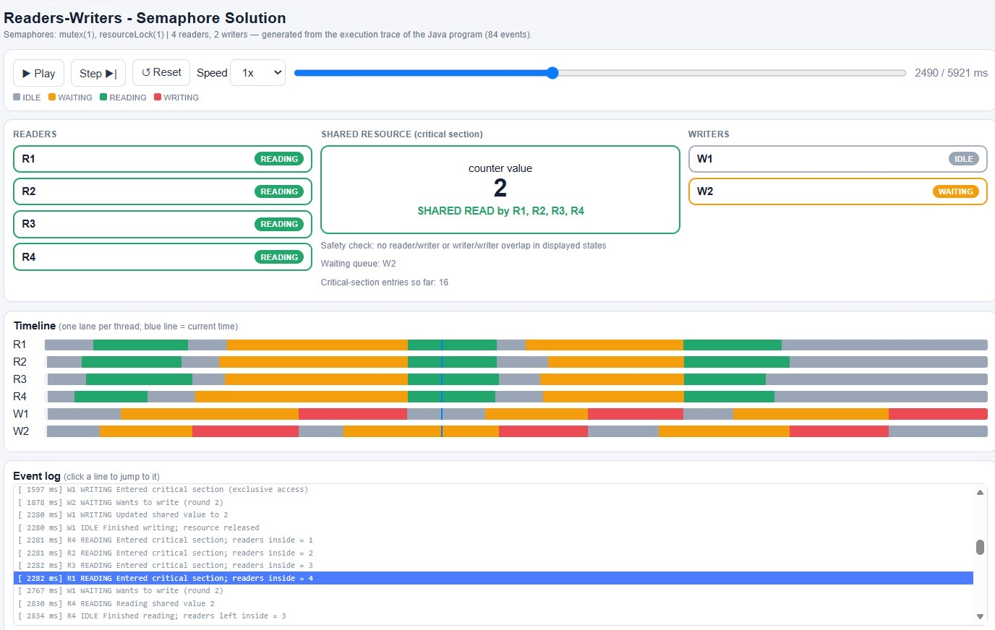
Figure 3: Program 1 - Readers-Writers (semaphores). All four readers (R1-R4) read concurrently while writer W2 waits and W1 is idle; counter = 2 ("SHARED READ by R1, R2, R3, R4").
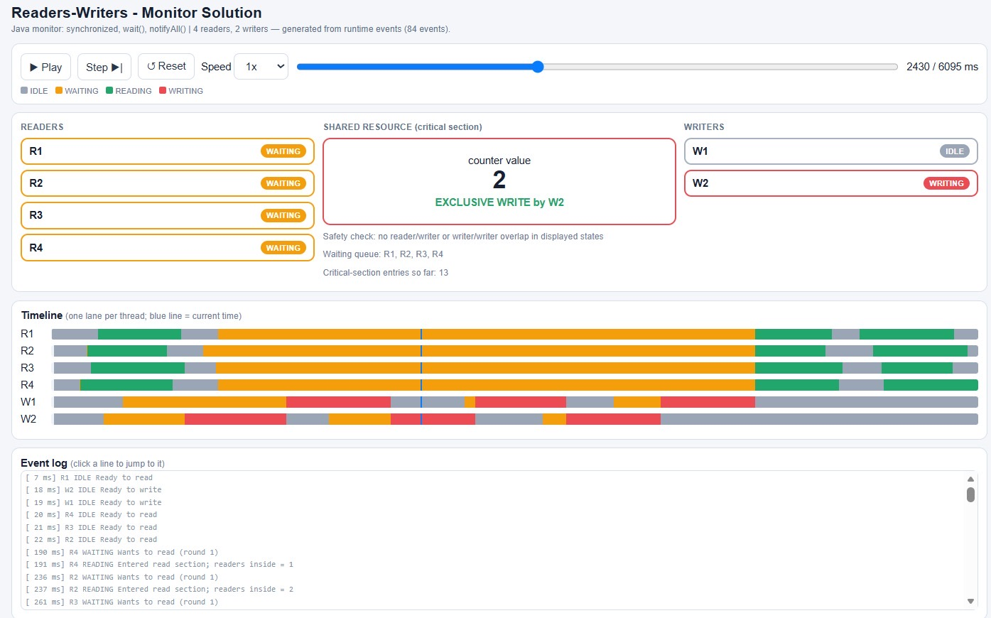
Figure 4: Program 2 - Readers-Writers (monitor). W2 holds the resource exclusively ("EXCLUSIVE WRITE by W2") while readers R1-R4 wait and W1 is idle; counter = 2 and the safety check shows no overlap.
In Figures 3 and 4 the writers' red WRITING segments never overlap the readers' green READING segments, and the two writers never overlap each other, which is visual evidence of mutual exclusion.
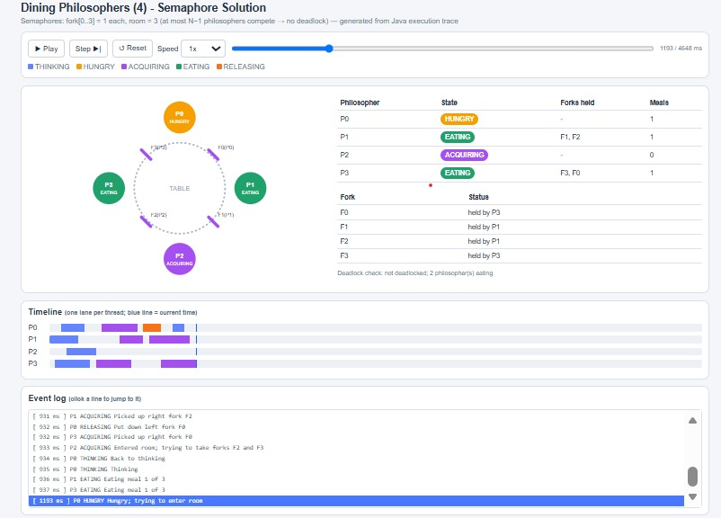
Figure 5: Program 3 - Dining Philosophers (semaphores). P1 and P3 eat at the same time while P2 is ACQUIRING and P0 is HUNGRY (1193 ms of 4648 ms).
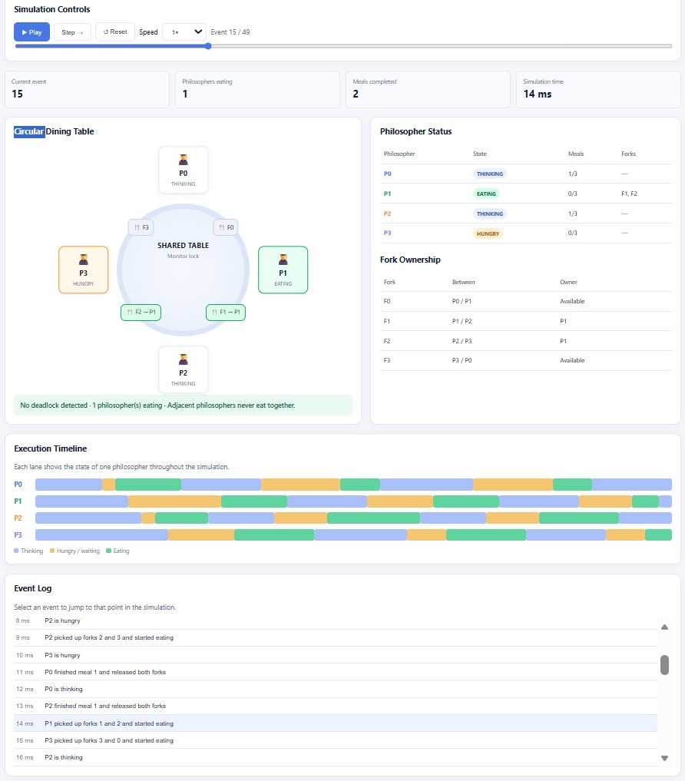
Figure 6: Program 4 - Dining Philosophers (monitor). P1 eats with forks F1 and F2 while P3 is hungry and P0 and P2 are thinking (event 15 of 49).
In Figure 5, P1 and P3 are EATING with forks F1, F2 and F3, F0, P2 is ACQUIRING without a fork and P0 is HUNGRY, waiting to enter the room; all four forks are held, but the system is not deadlocked because two philosophers are eating and will release their forks. In Figure 6, P1 is EATING and holds F1 and F2, and the fork ownership table and the status line ("No deadlock detected") agree. In the timeline of Figure 6 no two neighbouring philosophers have overlapping EATING segments.

10. AI Usage Summary
The assignment permits and encourages AI assistance, provided the student tests, understands and documents the result [9]. This section summarizes the use of AI.
Table 12: AI usage summary
Item | Description
AI tool used | Claude (Anthropic) was used to prepare this report in Word format from the student's Java programs and simulation screenshots. Add any other AI help used for the code.
Initial prompt | Describe your initial prompt here.
Follow-up prompts | Requests to adapt a sample report to the student's own name, USN, screenshots and Java programs.
Manual work by the student | Describe what you did yourself: writing and running the Java programs, taking the screenshots, creating the GitHub repository, and so on.
Verification | Execution of the programs and inspection of the generated HTML simulations (Figures 3-6). Add other checks you made.

Reflection on limitations and improvements
The following limitations and possible improvements were identified in the programs:
- Order of recording and releasing. In the Readers-Writers programs events are recorded before the resource is released. In the Dining Philosophers semaphore program the "put down" messages are logged after the release, so the log could show a neighbour's "picked up" message first; logging before the release (Section 4.2) would remove this.
- Reader priority. The semaphore Readers-Writers program has no turnstile, so a steady stream of readers could delay a writer; adding a turnstile semaphore would remove writer starvation.
- Fixed delays. The semaphore philosophers program uses fixed delays (250 ms thinking, 600 ms eating), so runs look alike; random delays would show more different interleavings.
- Informational deadlock line. The "Deadlock check" line of the philosophers page only reports how many philosophers are eating; a real detector (all forks held and nobody eating) could be added.

11. References
[1] A. Silberschatz, P. B. Galvin and G. Gagne, Operating System Concepts, Wiley - chapters on process synchronization, classical synchronization problems and monitors.
[2] A. S. Tanenbaum and H. Bos, Modern Operating Systems, Pearson - section on classical IPC problems (Dining Philosophers, Readers-Writers).
[3] A. B. Downey, The Little Book of Semaphores, Green Tea Press - Readers-Writers (turnstile solution) and Dining Philosophers.
[4] E. W. Dijkstra, "Hierarchical ordering of sequential processes", Acta Informatica, 1971 - origin of the Dining Philosophers problem.
[5] C. A. R. Hoare, "Monitors: an operating system structuring concept", Communications of the ACM, 17(10), 1974.
[6] E. G. Coffman, M. Elphick and A. Shoshani, "System deadlocks", ACM Computing Surveys, 3(2), 1971 - the four deadlock conditions.
[7] Oracle, Java SE 21 API documentation: java.util.concurrent.Semaphore, java.lang.Object (wait, notifyAll) and synchronized. https://docs.oracle.com/en/java/javase/21/docs/api/
[8] Mozilla Developer Network (MDN) Web Docs - JavaScript, SVG and requestAnimationFrame. https://developer.mozilla.org/
[9] Claude (Anthropic) - AI assistant used for documentation drafting.

12. Academic Integrity Declaration
The following declaration is included as required by the assignment:
"I declare that I have personally tested and understood the submitted programs. I have disclosed the AI tools and external resources used in developing this assignment. I can explain the synchronization logic, generated HTML simulation, and modifications made to the code. I have not knowingly submitted another student's work or unacknowledged third-party material as my own."
The AI tool used in this assignment (Claude, developed by Anthropic) is disclosed in Section 10. All books, documentation and websites consulted are listed in Section 11.
Signature: ______________________  Date: ___________________________ | Name: Divith Kumar  USN: NNM24IS079

