Name & ID: Divit Kejriwal 2025A7PS0409U Date: 29th September
EXPERIMENT- 4
Adder and Subtractor: Assignment
1. Verilog code and testbench for converting 8-bit binary number to gray code using data flow modeling.
Ans: Link1: https://edaplayground.com/x/b2Qc
Verilog Code (Screenshot)-
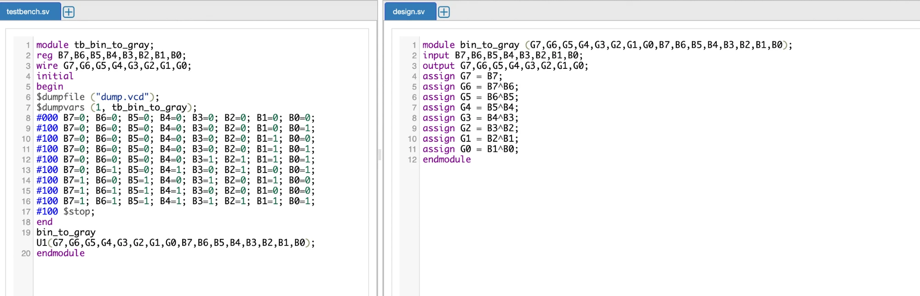
EDA Playground waveform (Screenshot)--
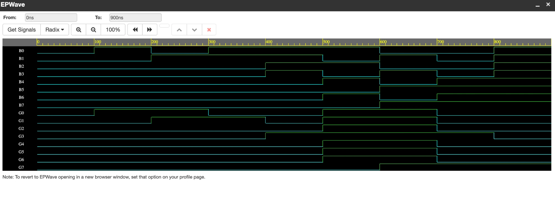

2. Verilog code and testbench for full subtractor using data flow modeling.
Ans: Link2: https://edaplayground.com/x/LzAa
Verilog Code (Screenshot)-
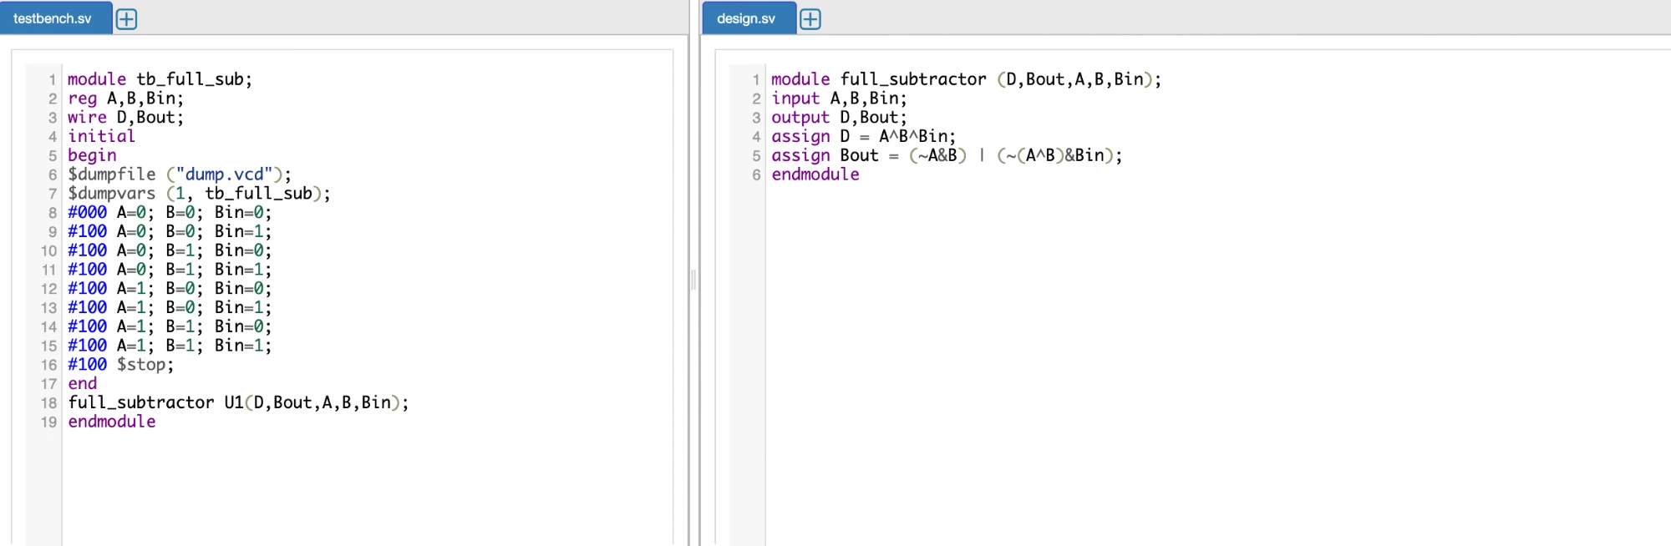
EDA Playground waveform (Screenshot)--
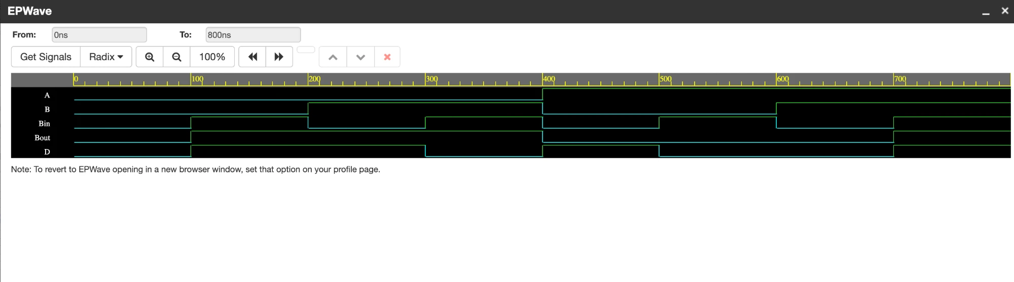

3. Verilog code and testbench for full subtractor using behavioral modeling.
Ans: Link3: https://edaplayground.com/x/diJY
Verilog Code (Screenshot)-
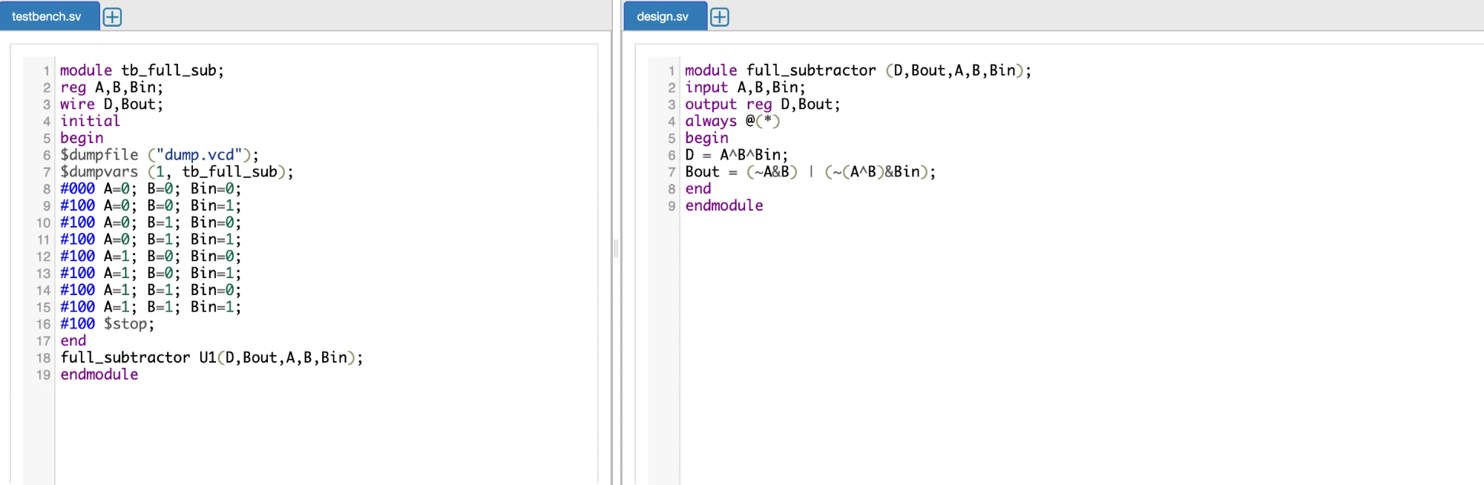
EDA Playground waveform (Screenshot)--
