Name & ID: Divit Kejriwal 2025A7PS0409U Date: 17th September
EXPERIMENT- 3
Basic Logic Gates Using Universal Gates: Assignment
1. Design and write structural Verilog code to implement a 2-input AND gate using only 2-input NOR gates.
Ans: Link1: https://edaplayground.com/x/q2AF
Verilog Code (Screenshot)-
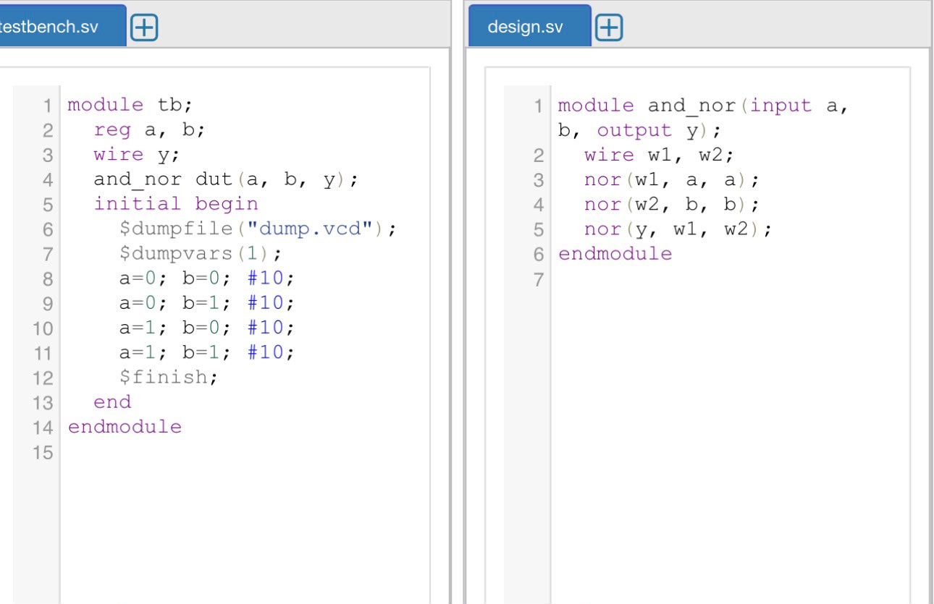
EDA Playground waveform (Screenshot)--
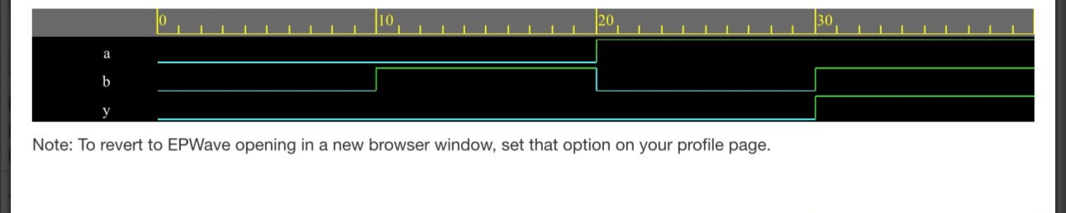

2. Verilog code and testbench to simulate the gates using nand circuit for all possible combinations.
Ans: Link2: https://edaplayground.com/x/vQx7
Verilog Code (Screenshot)-
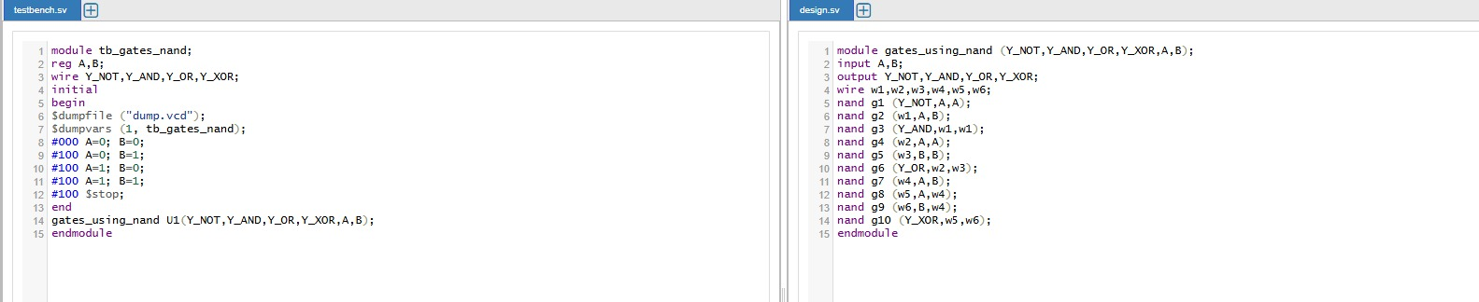
EDA Playground waveform (Screenshot)--
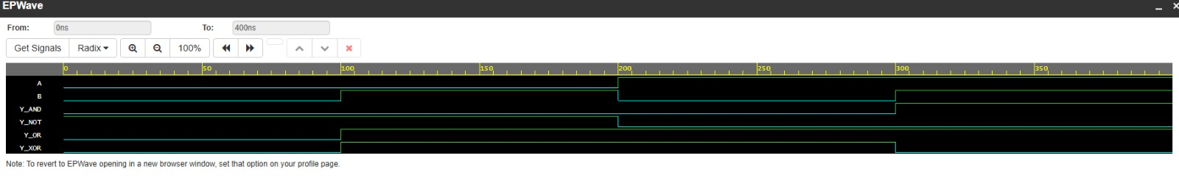

3. Write Verilog code and testbench for generating even parity bit for 4-bit binary numbers. (Hint: you can use the structure of run-2 of this experiment also or y = A^B^C^D).
Ans: Link3: https://edaplayground.com/x/AkRc
Verilog Code (Screenshot)-
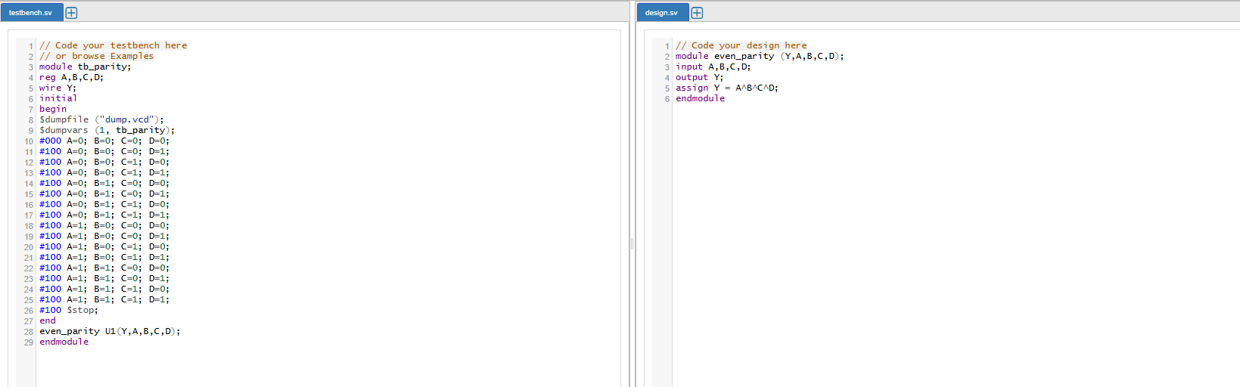
EDA Playground waveform (Screenshot)--
