


CityPulse: A Weather Analytics Pipeline
Data Engineering Coursework Report

Data Engineering

Student Index Numbers : COHNDDS25.1F-024 (Dhulakshan.K)
COHNDDS25.1F-025 (Diviyan)
COHNDDS25.1F-028 (Musaf)

1. Introduction
CityPulse is an end-to-end data engineering pipeline that collects live weather data for five cities (Colombo, London, New York, Tokyo, and Sydney), streams it through Apache Kafka, lands it in a PostgreSQL staging table, transforms it with PySpark into an analytics-ready warehouse, and answers a set of analytical questions with SQL. The whole platform - PostgreSQL, Kafka, and Apache Airflow - runs locally via a single Docker Compose file, and the two production DAGs (ingest_weather and transform_weather) are scheduled to run unattended: hourly ingestion and daily transformation, respectively.
This report explains the design decisions behind the schemas and the pipeline, the problems encountered while deploying and running it and how they were resolved, the results of the five required analytical queries, and a summary of the work carried out.

2. Architecture
The pipeline follows a classic Extract-Load-Transform pattern. An Airflow DAG calls the Open-Meteo forecast API once per hour for each of the five fixed cities and publishes each reading as a JSON message to a single Kafka topic, weather_raw. A second task in the same DAG consumes new messages from that topic and inserts them, unchanged, into a PostgreSQL staging table (staging.weather_raw). A separate, daily-scheduled DAG then runs a local-mode PySpark job that reads the staging table via JDBC, cleans and de-duplicates the data, maps the numeric WMO weather code to a human-readable category, and writes three warehouse tables: a city dimension (warehouse.dim_city) and two fact tables (warehouse.fact_weather_hourly and warehouse.fact_weather_daily). The five analytical queries in sql/analytics.sql run directly against those warehouse tables.
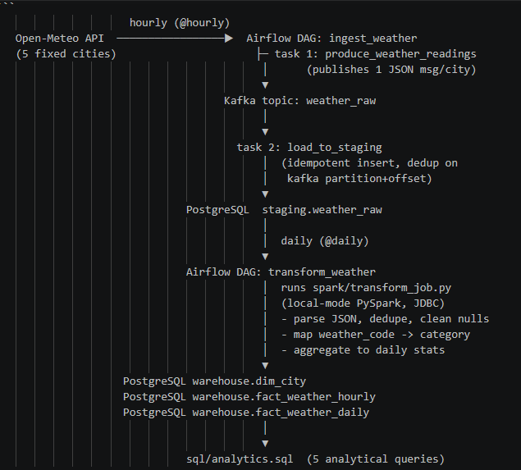

2.1 Why a single Postgres instance for both metadata and warehouse data
The coursework specifies that PostgreSQL should also serve as Airflow's own metadata database. Rather than running two separate Postgres containers, one container hosts two databases: 'airflow', used exclusively by Airflow itself (DAG state, task history, connections), and 'weatherdb', which holds the staging and warehouse schemas used by the pipeline. This keeps the project to a single Postgres service as required, while still cleanly separating Airflow's internal bookkeeping from the project's own data.

2.2 Schema design
staging.weather_raw stores the raw JSON payload exactly as received from Kafka, plus the Kafka partition and offset it came from. A unique constraint on that (partition, offset) pair is what makes the load idempotent: if the consumer task is re-run, ON CONFLICT DO NOTHING guarantees the same message can never be inserted twice, and the Kafka offset is only committed after the database insert succeeds, so a crash between the two never silently drops or duplicates data.
The warehouse uses a small star schema: dim_city holds the five cities with their coordinates, fact_weather_hourly holds one cleaned row per city per hourly reading, and fact_weather_daily holds one pre-aggregated row per city per day, so the analytical queries don't need to re-aggregate the hourly table every time they run.

2.3 Overwrite vs. upsert
The PySpark job overwrites both warehouse fact tables completely on every run (using truncate=true so the primary/foreign key constraints are preserved), rather than incrementally upserting new rows. This was a deliberate choice: the data volume is small, so a full recompute from staging costs Spark almost nothing, and it makes the job naturally idempotent and self-healing - if an earlier run produced wrong values, simply re-running the fixed job corrects the warehouse completely, with no need to reason about which rows an upsert should touch. The trade-off is that this would not scale to a much larger data volume; an incremental upsert keyed on (city_id, reading_time) would be the natural next step at that point.

2.4 Scheduling, retries, and backfilling history
ingest_weather runs on Airflow's @hourly preset and transform_weather on @daily. Both are configured with retries and a retry_delay, so a transient failure (for example the API timing out) is retried automatically. A third, manually-triggered DAG, backfill_weather, was added to seed several days of real historical data immediately using Open-Meteo's past_days parameter, publishing every historical reading through the same Kafka topic the live DAG uses, so it still exercises the same Kafka -> staging path rather than writing to the database directly. This was necessary given the project timeline and is discussed further below.

3. Deployment and Execution Evidence
The full platform was deployed locally with Docker Compose and run end-to-end: all containers built and started successfully, all three DAGs were triggered from the Airflow UI, and the resulting data was verified directly in Postgres.
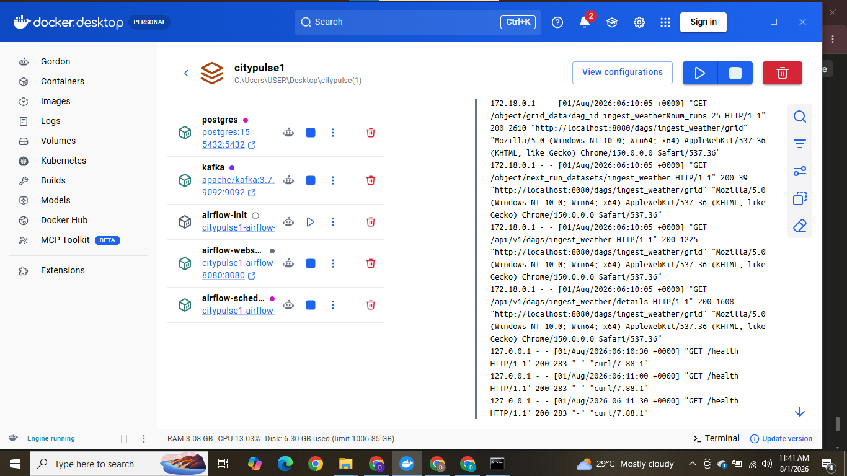
Figure 1: All five containers (Postgres, Kafka, Airflow init/webserver/scheduler) running via Docker Compose.
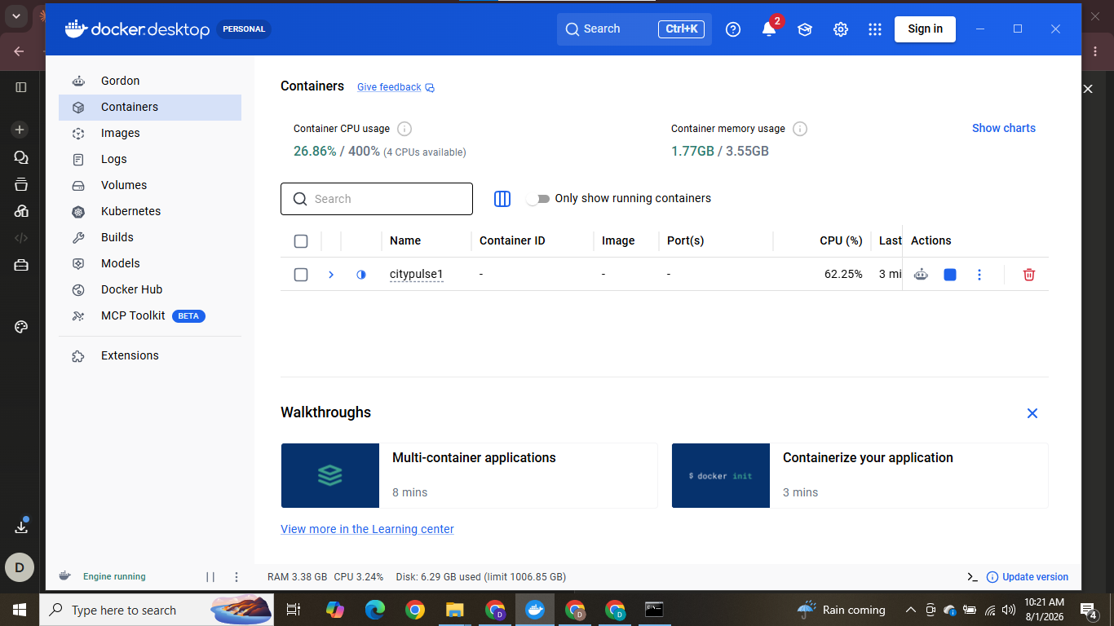
Figure 2: Docker Desktop resource view confirming the full stack is up and healthy.
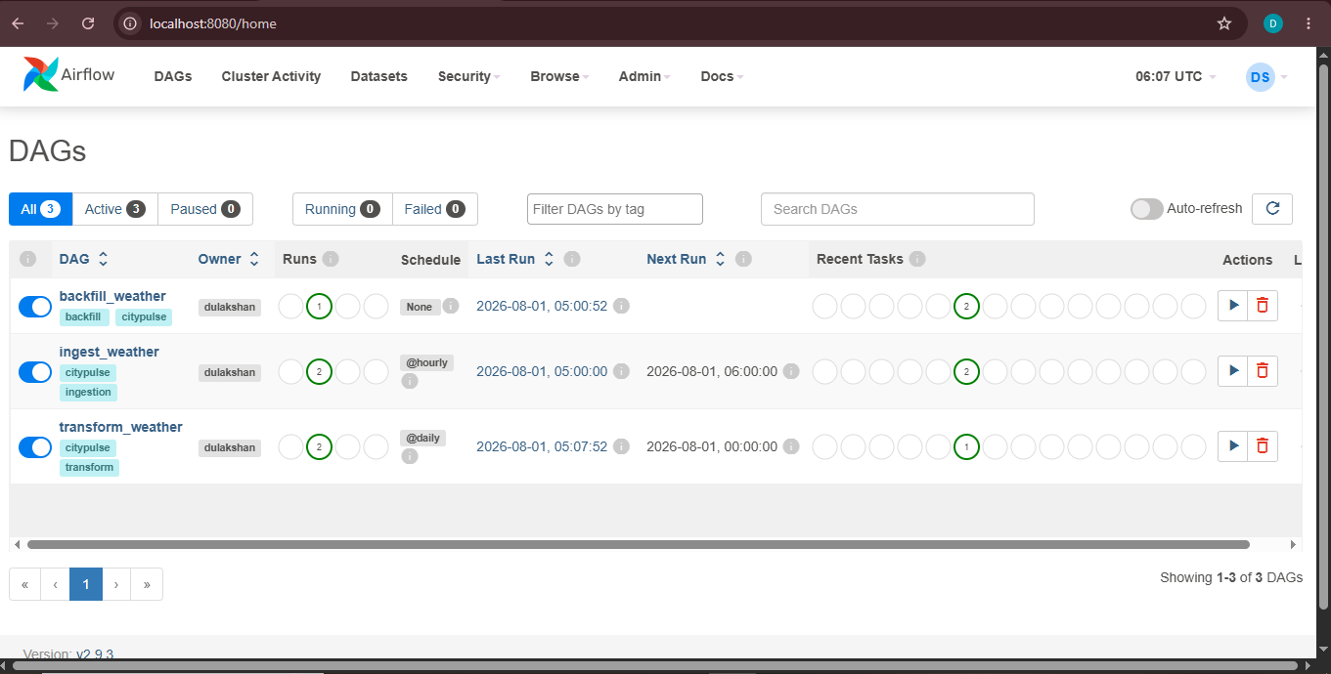
Figure 3: All three DAGs (backfill_weather, ingest_weather, transform_weather) active in the Airflow UI, with successful recent runs.

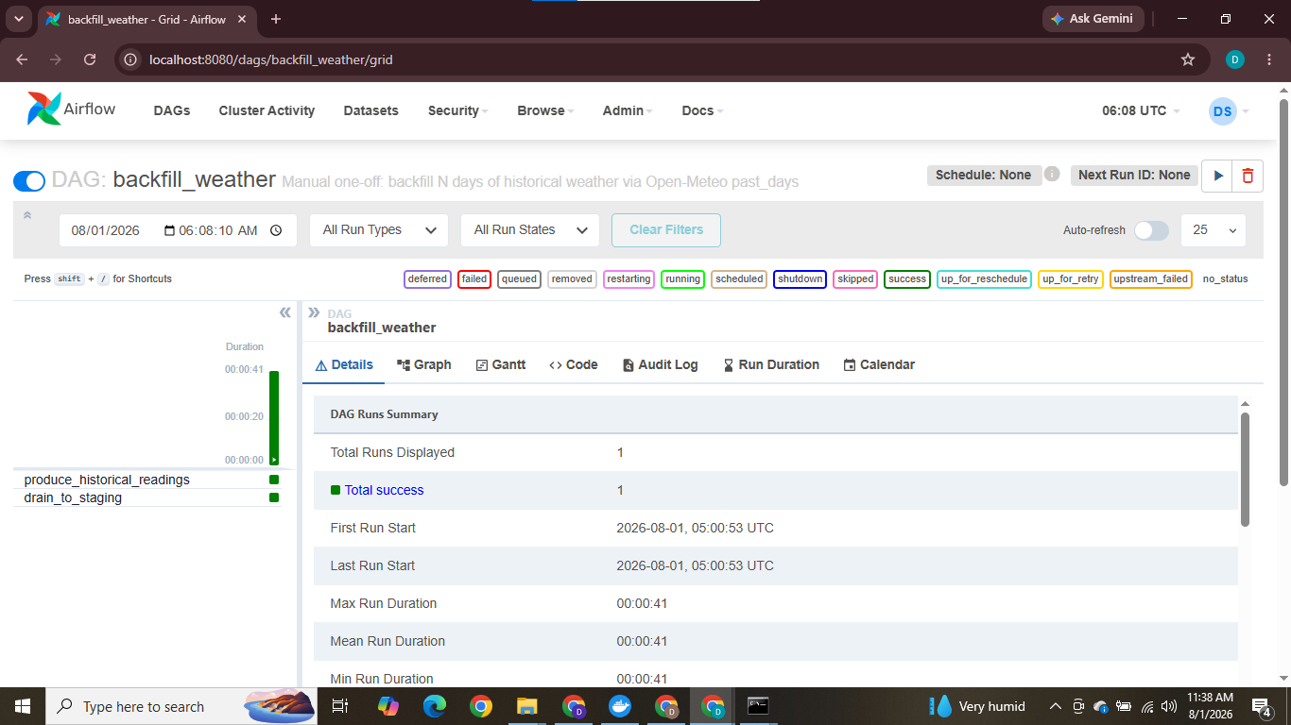
Figure 4: backfill_weather DAG run - both tasks succeeded, seeding historical data through Kafka into staging.
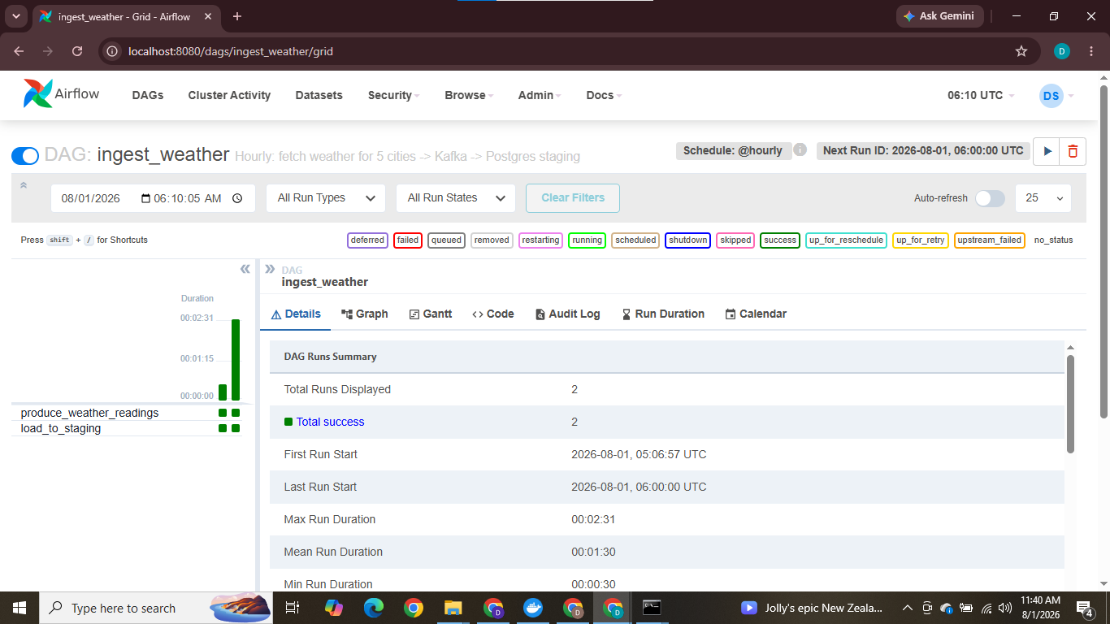
Figure 5: ingest_weather DAG - hourly live ingestion running successfully on schedule.

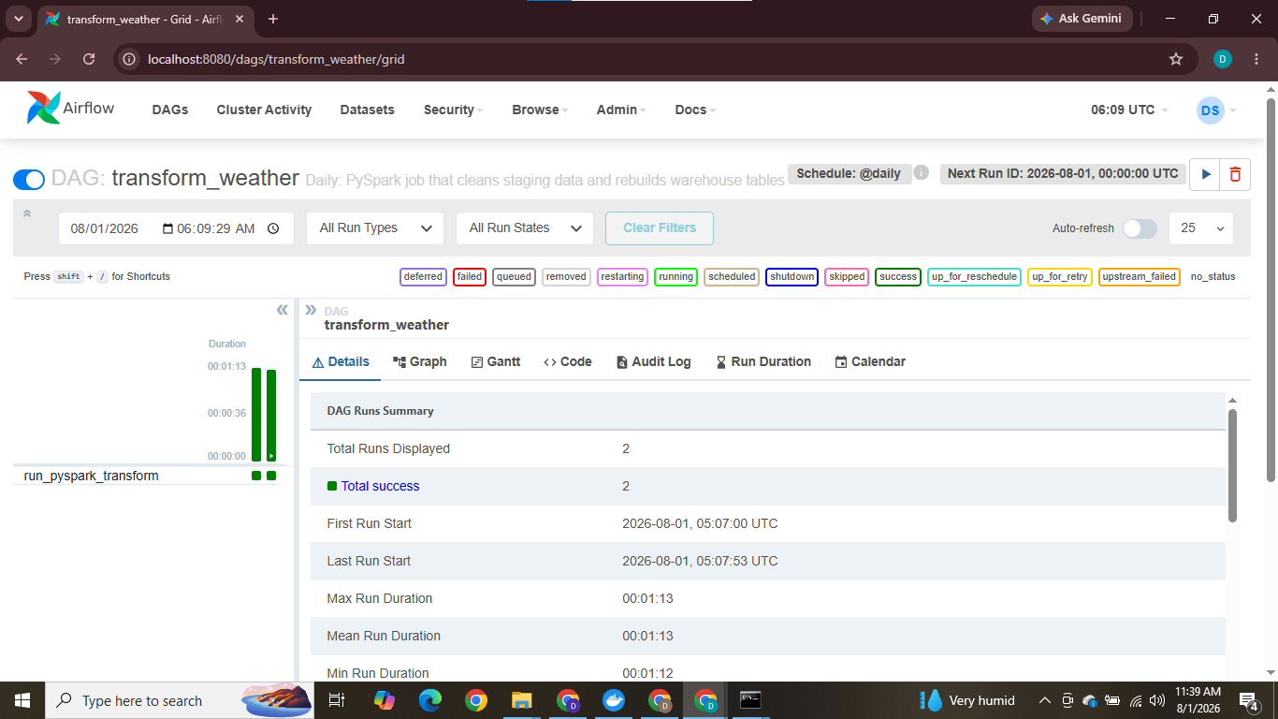
Figure 6: transform_weather DAG - the PySpark transformation job completing successfully.
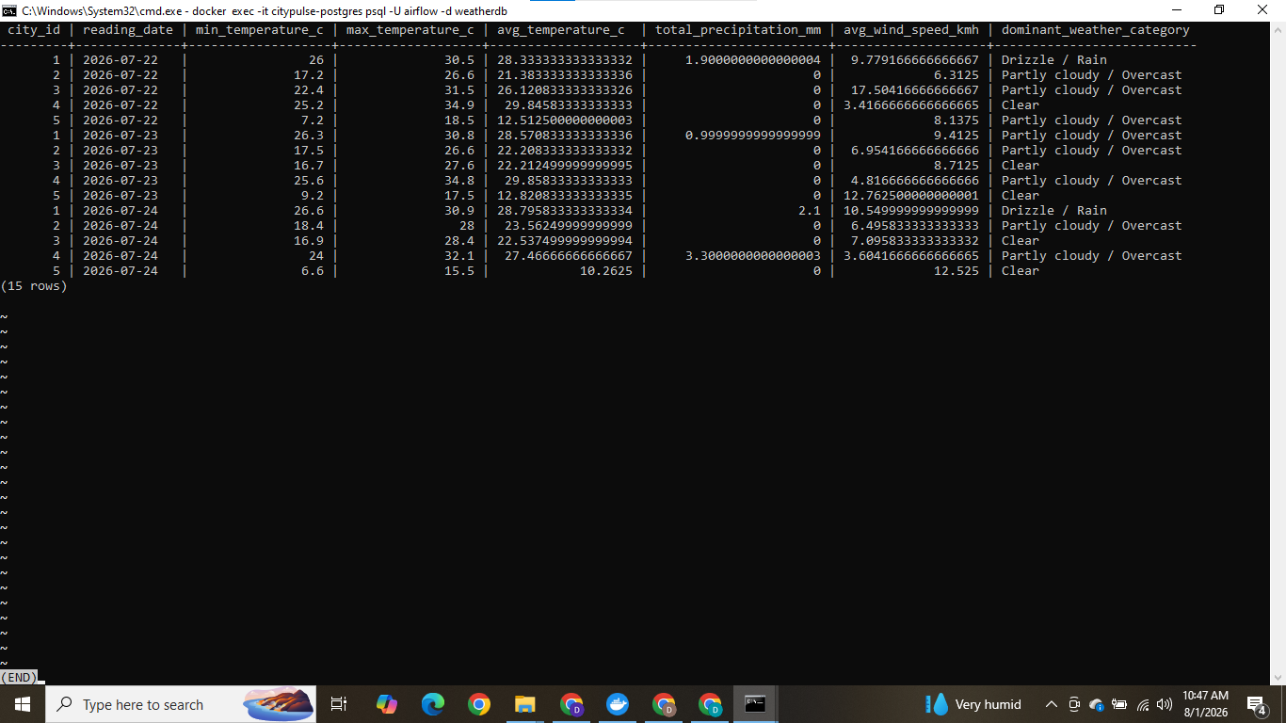
Figure 7: Sample rows from warehouse.fact_weather_daily, confirming the Spark job produced correct per-city, per-day aggregates.

4. Problems Encountered and How They Were Solved
Two real infrastructure problems came up while deploying this project, both before any pipeline code ran at all.

4.1 Bitnami removed the Kafka image tag being used
The initial docker-compose.yml referenced bitnami/kafka:3.7. Docker Compose failed with 'failed to resolve reference "docker.io/bitnami/kafka:3.7": not found', because Bitnami recently restructured their Docker Hub catalog and removed most versioned tags from the free tier, keeping only a small set of current tags. The fix was to switch to the official apache/kafka:3.7.0 image instead, which supports the same KRaft (no-Zookeeper) mode, just with a different set of environment variable names (KAFKA_* rather than KAFKA_CFG_*) and a different path for the Kafka CLI scripts (/opt/kafka/bin/ instead of a location already on PATH).
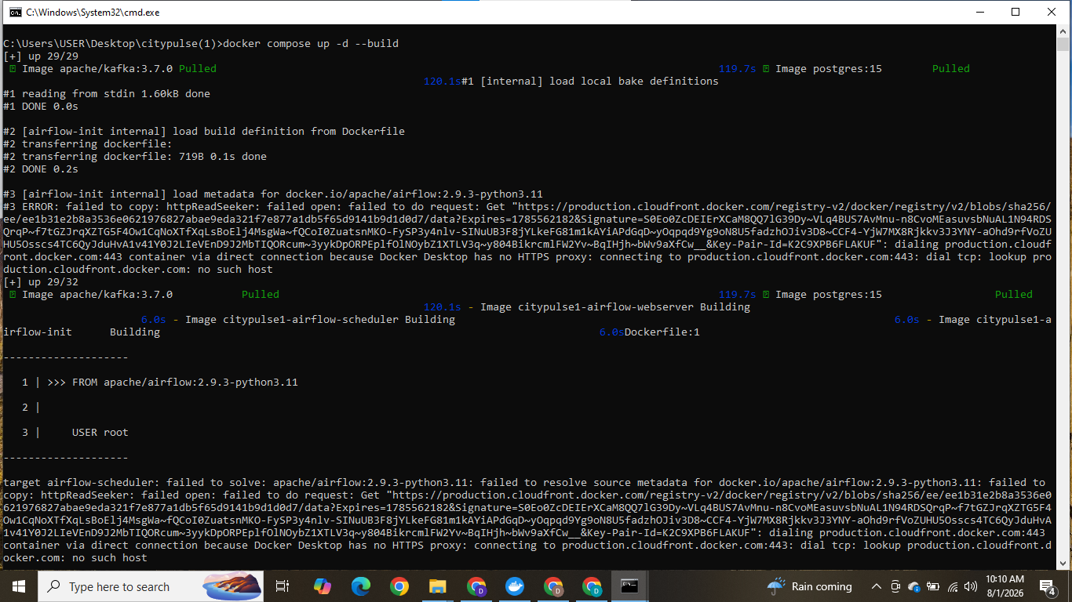
Figure 8: The Bitnami image resolution error encountered during the first docker compose up --build.

4.2 Docker Desktop networking hiccup mid-build
On the next attempt, the build failed again partway through - this time with Docker unable to reach production.cloudfront.docker.com while pulling image layers, reporting 'no such host'. Postgres and the new Kafka image had already pulled successfully by that point, which pointed to a transient DNS/network issue in Docker Desktop rather than a configuration problem. Restarting the Docker Desktop / WSL2 engine and re-running the same build command resolved it completely - the second attempt pulled every image and built all three custom Airflow images without any further errors.
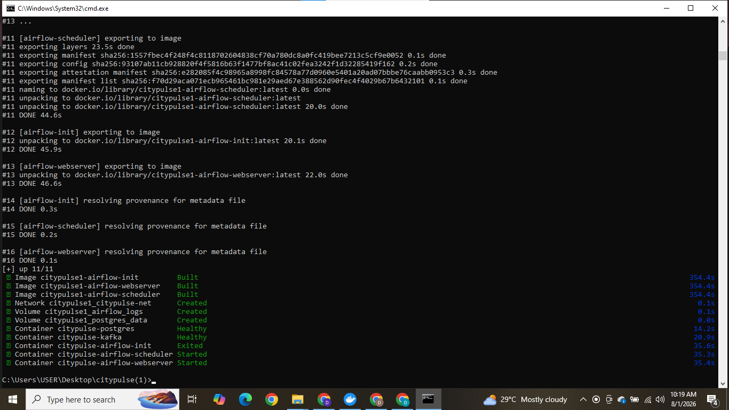
Figure 9: The successful build after restarting Docker's engine - all containers built and started (11/11).

4.3 No Airflow login existed after first startup
After the containers started, http://localhost:8080 had no valid admin/admin login. The airflow-init container is supposed to create that user automatically on first run, but its user-creation command was chained with '|| true' (so that a harmless 'user already exists' error on a later restart wouldn't fail the whole init step) - which meant a different, real failure earlier in that same command was silently swallowed too. The fix was simply to run the user-creation command directly against the running webserver container: docker exec -it citypulse-airflow-webserver airflow users create ... which created the admin account immediately.

5. Analytics Results
The following results were produced by running the five queries in sql/analytics.sql against the warehouse schema, after the backfill DAG and one run of the PySpark transform job.

5.1 Hottest and coldest city each day
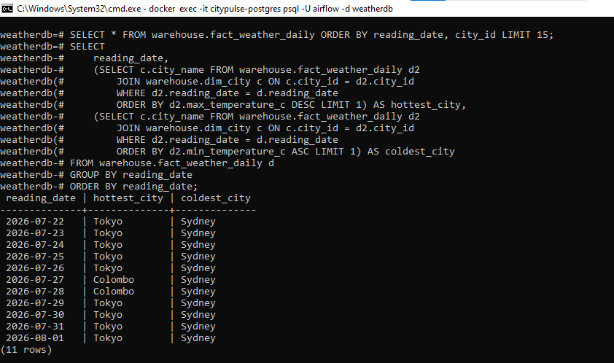
Figure 10: Output of Query 1 (hottest/coldest city per day)

Tokyo was the hottest city on most days in the collection window, with Colombo taking over on a couple of days; Sydney was the coldest city on every single day. This is consistent with the time of year in the southern vs. northern hemisphere at the point of data collection.

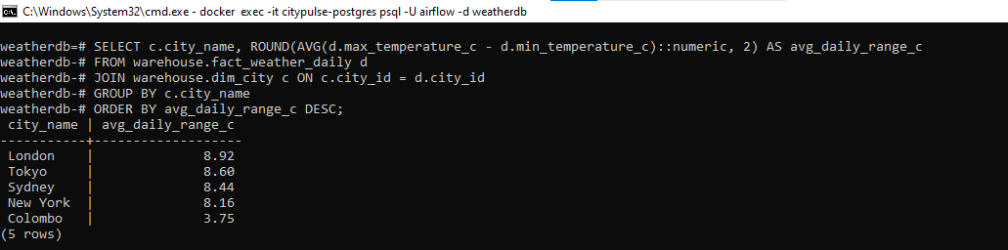
5.2 Average daily temperature range per city

Query 2 (average daily temperature range per city).

London has the widest average daily temperature swing (8.92°C), followed closely by Tokyo, Sydney, and New York, while Colombo has by far the narrowest swing (3.75°C). This matches expectations: Colombo is tropical and close to the equator, so its day/night temperature range is naturally small, while the other four cities are all in temperate zones with much larger diurnal swings.

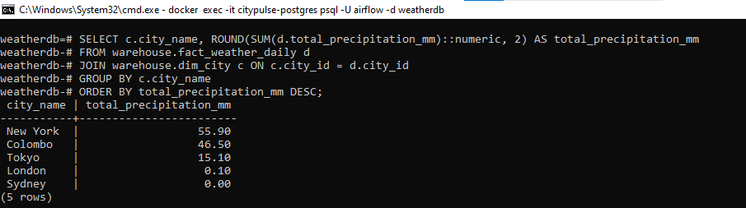
5.3 City with the most total precipitation

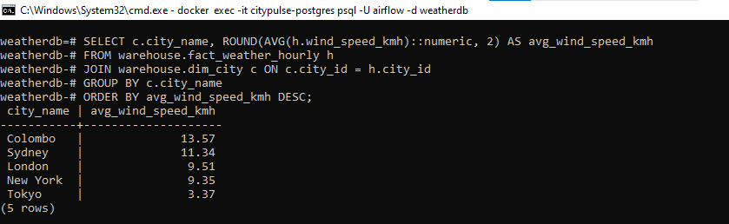
5.4 Windiest city on average

Figure 11: Output of Query 4 (average wind speed per city)

Colombo is the windiest city on average (13.57 km/h), followed by Sydney, London, and New York, with Tokyo the calmest (3.37 km/h).

5.5 Hours of each weather category per city

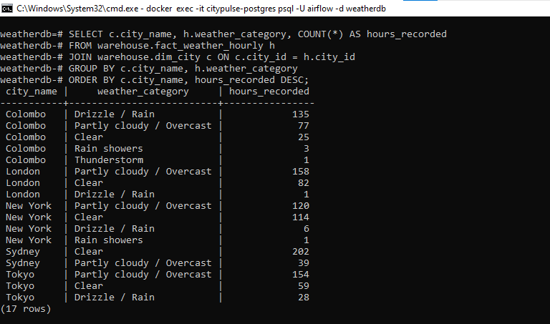
Query 5 (hours recorded per weather category, per city).
Sydney recorded the most fully clear hours (202) of any city, while Colombo recorded the most rain/drizzle hours (135) and was the only city to record a thunderstorm hour in the collection window - consistent with it being the wettest and windiest of the five cities in this dataset.

6. Contribution
This project was completed as group. We set up the full local environment in Docker (Postgres, Kafka, and two Airflow services) and deployed it via Docker Compose. During deployment I diagnosed and fixed two real infrastructure failures - a removed Docker Hub image tag (switching Kafka to the official apache/kafka image) and a transient Docker Desktop networking failure mid-build - and manually created the Airflow admin account after the automatic setup step silently failed to. I triggered and monitored all three DAGs (backfill_weather, ingest_weather, transform_weather) to completion, connected to Postgres directly to validate that the staging and warehouse tables contained correct, sensible data, and ran and interpreted all five required analytical queries against the resulting warehouse.

