Running Instructions

## GUI setup: We imported Tkinter to support our GUI functions.

The GUI looks as follows:

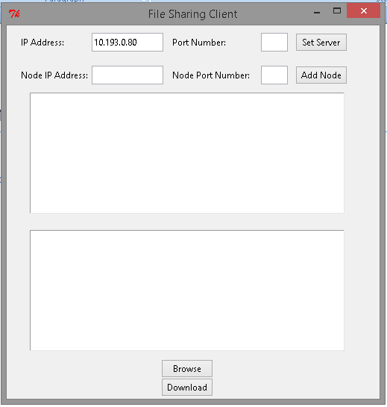

In the IP Address space we fill in the Server's IP, and then the port number in the corresponding section.

The Node IP address and Node Port Number is for any new peer added onto the client by using the Add Node button.

Any new node added would be displayed.

The Browse Button will search the server node for all available files and share it on the display.

The connected nodes could do the same, and the files could be downloaded to a destination as mentioned.

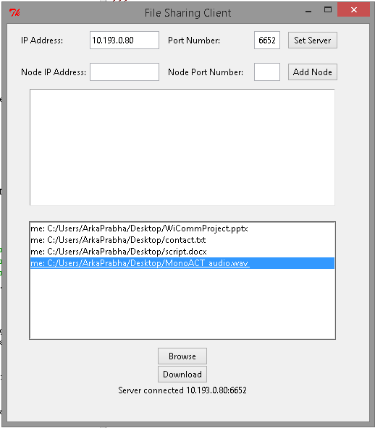

As you can see, you can add files by browsing and add them on the server.

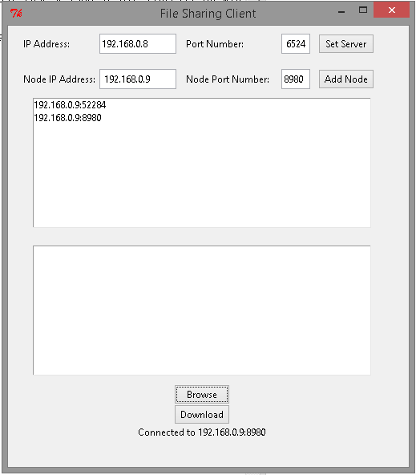

Here you can add new peers or nodes.

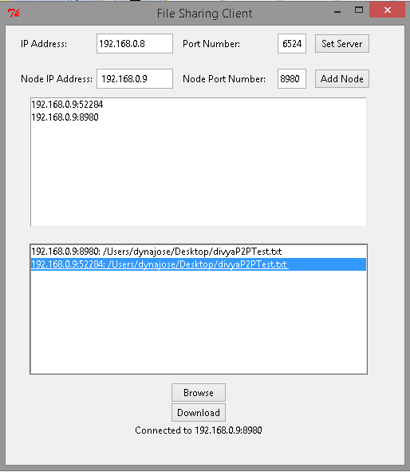

The new peer updates the file list with new files.

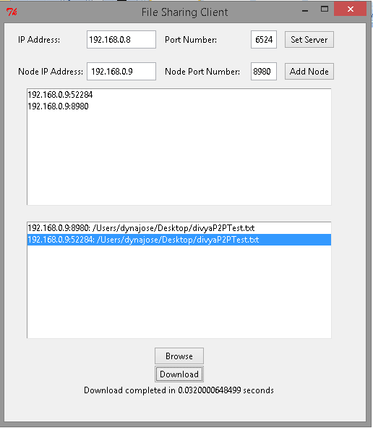

After downloading the files to a aforementioned destination, the download time is displayed.

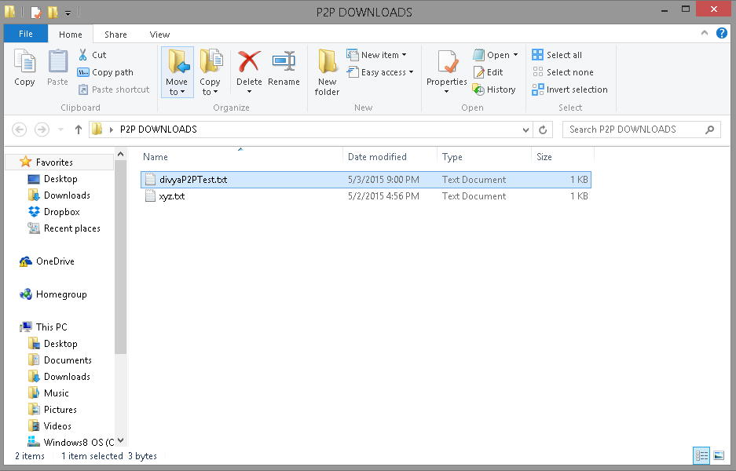

The downloaded file in the destination.

Reference:

1) https://github.com/siddharthasahu/P2P-chat-application/blob/master/chatApp.py