**Date: 16th Dec 2024**

**Name: Divya Macharla**

# Question 1

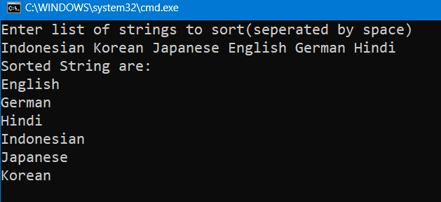

# Question 2

# Question 3

# Question 4