EdgeConverter
Project Design Document
Team: The Sixth Sense

Doroteja Krtalić <dk5399@rit.edu>
Swen Grgičeivć <sg9750@rit.edu>
Michel Brassard <mb6149@rit.edu>
Divna Mijić <dm9718@rit.edu>
Petra Cesar <pc7841@rit.edu>



Project Summary

The EdgeConverter application is a Java-based application that enables its users to read a file generated from a diagramming tool and generate appropriate SQL statements for any number of database management systems for that file. Simply stated, the EdgeConverter takes in generic input and is capable of generating generic output, which depends purely on the user’s request.

The application is concerned with parsing algorithms necessary for different output file types, with an emphasis on the information necessary for the creation of database tables on different DBMS without the need for major redesign or restructuring of the code, while ensuring peak performance for the users.

The product that follows these guidelines, in addition to good practices in the field of software architecture and design, will allow for easy maintenance, and extendibility, and will be easily adjusted to fit different companies’ needs, depending on the technologies they use.

Design Overview

The application we decided to develop will follow the MVC architecture, which aims to ensure that our product is maintainable, easily extendable, coherent, well-organized, and well-structured. By introducing such patterns, our program inherently adheres to the separation of concerns, and consequently ensures high cohesion and low coupling between the classes within the subsystems.

The architecture ensures that the subsystems are able to communicate accordingly, where the Controller plays the key role in coordinating the processes that must occur in order for the application to deliver precisely what the user has requested. The View subsystem ensures that the user is able to utilize all functionalities the application is set to deliver, while the Model guarantees data accuracy and perseverance. The user’s requests are therefore, registered by the View, handled by the Controller, and processed based on the given input and data processed by the Model.

Due to the extensiveness and the complexity of the Model subsystem, we have applied the Factory pattern in order to improve the performance of the overall program and to organize our code to follow the best practices in terms of sustainability, endurance, and maintenance. As the Factory pattern supports the concept of programming to an interface, rather than an implementation, we introduced abstract classes and an interface in our class structure. Additionally, to aid with the initialization of concrete objects through the Factory pattern, we introduced enum classes which further enhance the separation of concerns that was already set in place with the MVC subsystems.

Additionally, to further embellish the structure of our application, a “util” directory was created outside the MVC subsystems, to accommodate the underlying aim of preserving logical separation of concerns within the program. These classes are purely focused on preserving consistency of our design, as well as certain UI-related aspects, such as font size, fonts, colors, dialog design, etc.

Overall System Structure

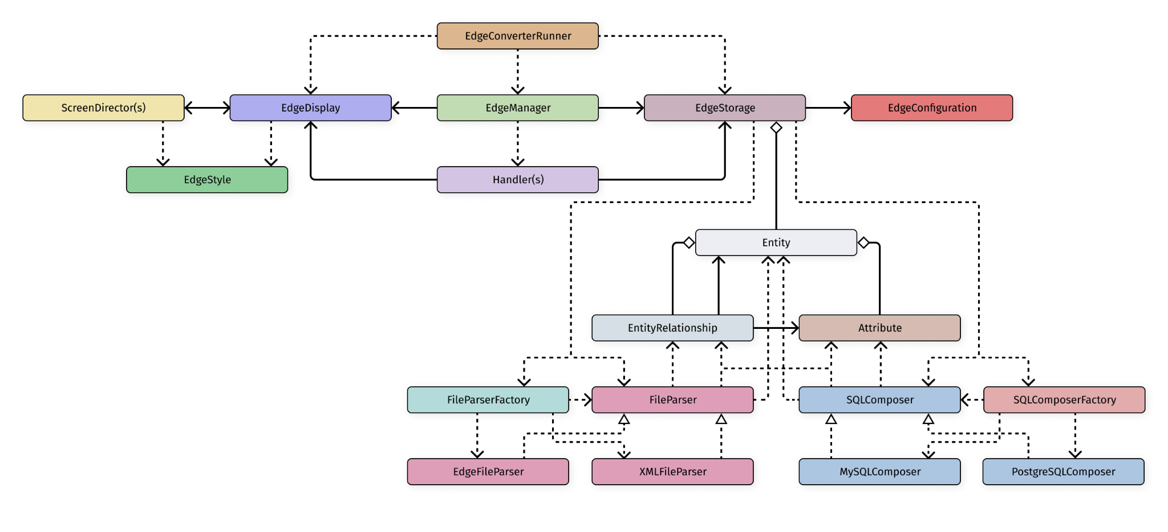
Description
The system is structured into three distinct components: The Controller, the View, and the Model, adhering to the MVC (Model-View-Controller) architectural pattern. This MVC structure allows the system’s model and view components to function independently from each other, with the controller acting as the intermediary responsible for managing communication between them, as the controller has a reference to both of them.

The Controller (EdgeManager)
The EdgeManager class acts as an intermediary between the view and the model by using the handler objects that it instantiates. The handle classes then further process user requests between the user interface and the core application logic and data.

The View (EdgeDisplay)
EdgeDisplay plays the role of the view within our MVC architecture. The Class is connected with ScreenDirector classes by association, meaning that the objects responsible for creating the GUI contain the necessary elements depending on which screen the user interacts with. Additionally, both of these classes use EdgeStyle to ensure a uniform appearance in the GUI's look and feel.
On top of the methods dedicated to the process of setting up the scene and the stage inside of the EdgeDisplay, the methods inside of this and the ScreenDirector classes will be responsible for attaching correct handlers on the elements the user will be able to interact with, so that the program can respond accordingly.

The Model (EdgeStorage)
EdgeStorage functions as the Model within the established MVC architecture, and it contains an EdgeConfiguration object. Inside EdgeStorage, a collection of Entity objects is stored. The Entity class can possess multiple attributes, along with the relationship objects defining the relationship between the current object and the other object in the relationship. Additionally, in order for an entity relationship to be established, it is necessary for an attribute from one entity to be linked or associated with an attribute of another entity, forming the relationship between them.
EdgeStorage also uses the FileParserFactory and the FileParser class. Various file types can be processed by the FileParserFactory. For example, it uses EdgeFileParser for parsing Edge files and XMLFileParser for XML files. The FileParser classes use the Entity, Attribute, and EntityRelationship classes since they are required for the application.
Similarly, EdgeStorage also utilizes the SQLComposer class and SQLComposerFactory class. The SQLComposerFactory is capable of composing multiple SQL for numerous Database Management Systems. For example, for PostgreSQL databases, the PostgreSQLComposer class is used, as well as MySQLComposer class for MySQL databases. The classes use the Entity, Attribute and EntityRelationship classes to generate complete queries.

Subsystems
The following sections elaborate on the subsystems in greater detail, focusing on providing class-related information, as well as the roles and responsibilities each class plays within its dedicated subsystem.

Subsystem View
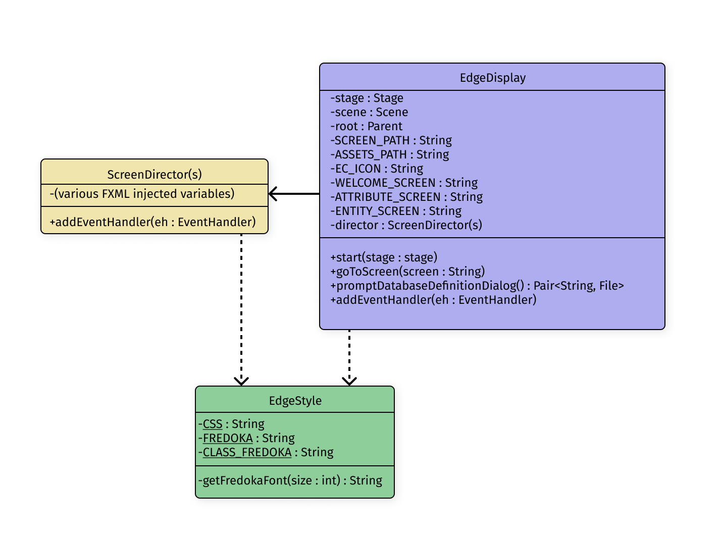

EdgeDisplay
- Main GUI class that contains objects of ScreenDirector classes, which are located inside the “view/director/” folder.
- This class is responsible for displaying the interface to the user in order for the program to receive user input
- The class contains methods that define which handler will be triggered (handlers are all located and defined inside the controller), aka will “handle” the specific action taken in the UI
  - e.g.
public void setOnCloseRequestHandler(EventHandler<WindowEvent> ehWe) {
this.stage.setOnCloseRequest(ehWe);
}
- This class contains a “start” method which starts the stage and loads the FXML file, which then sets the scene to be shown with the loaded data && a “setController()” method to set the FXML controller in place
- Instantiated upon the program’s start-up

ScreenDirector(s)
Package: (view/director/)

- These classes govern the different screens that will be rendered depending on the user’s interaction with the application
- They contain the elements which must be rendered in the UI and have the handlers passed to them through the EdgeDisplay in order for the events to be accurately triggered upon a user action
- These classes contain “initialize()” method which will initialize the controller upon the FXML file being loaded into the program

Subsystem Controller
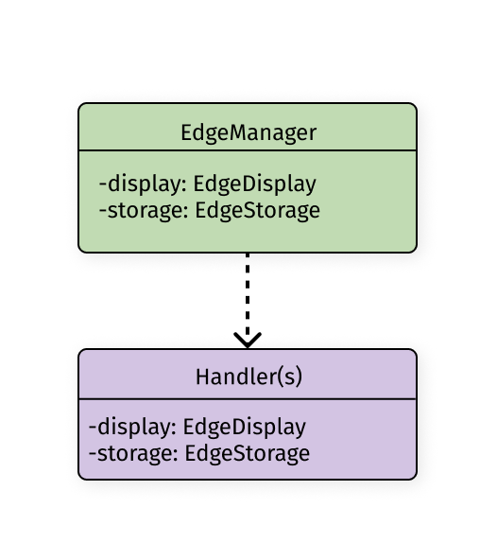

EdgeManager
- This class uses all handlers existing in the program
- Acts as the core controller in the MVC (EdgeDisplay display, EdgeStorage storage)
- The handlers are set up inside this class on the display object contained inside the class
- Inside the constructor, the class contains the line that reads the recent files from the storage which are to be shown in the display (the most recent state of the application is saved and loaded as needed -> loadConfiguration / saveConfiguration)
- Instantiated upon the program’s start-up

Handler(s)
Package: (controller/handler/)

- All handlers implement the EventHandler interface
- Each handle contains its own method that is defined to manage, aka handle, the user’s action

Subsystem Model
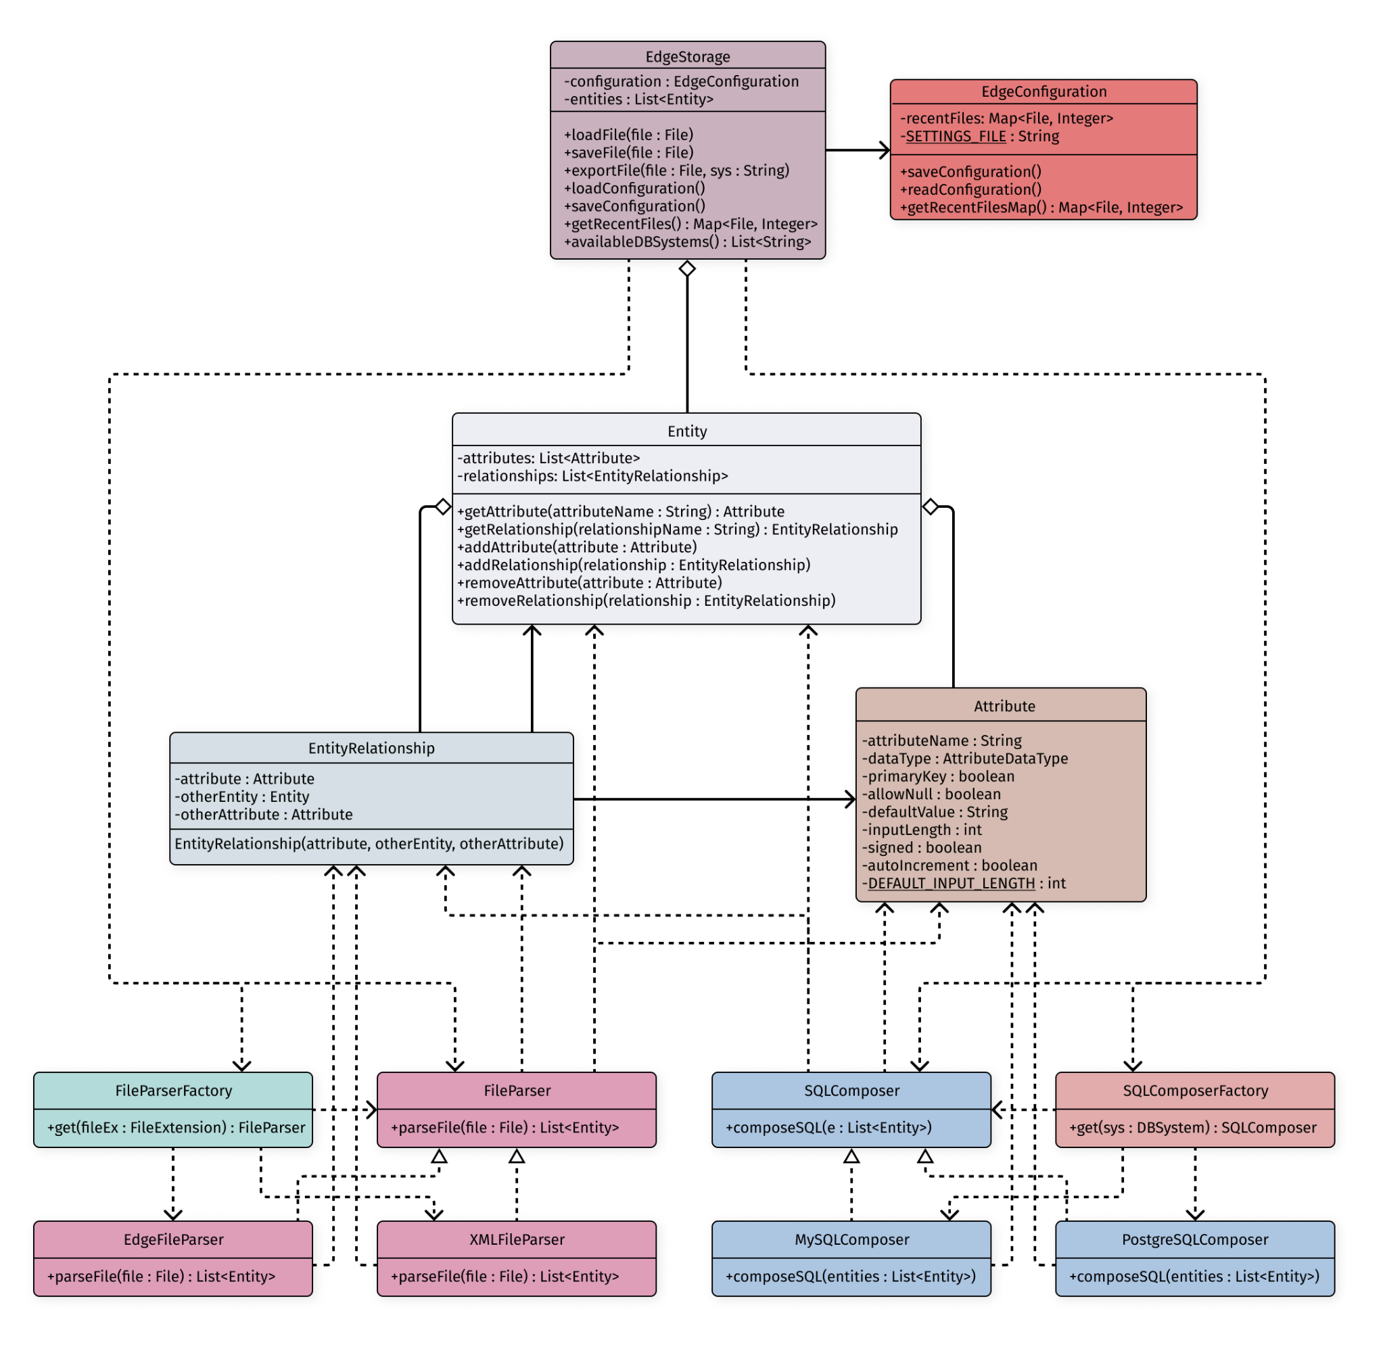

EdgeStorage
- Main Model class in the application which contains a collection of all entities (in the form of a List) and uses the two factories for parsing and composing (aka exporting)
- The collection of entities contains within itself all the data necessary for the application to perform the tasks upon the user’s request
- The class uses the two factories to instantiate the accurate objects, depending on the user’s input, and forwards them to the Controller upon request
- The class contains an EdgeConfiguration object which holds the file that must be loaded in order for the application to start in its most recent state
- Instantiated upon the program’s start-up

Entity
Package: (model/db/)

- A concrete class that contains collections of Attribute objects and EntityRelationship objects, together with the name of the entity, representing a table in the database
- Contains only accessors and mutators

Attribute
Package: (model/db/)

- Class that contains all the information about a specific attribute as variables
- The class defines its own data type in form of a AttributeDataType enum

AttributeDataType
Package: (model/db/)

- Enum class that contains all the attribute data types such as VARCHAR, INT, DOUBLE, BOOLEAN

FileParser
Package: (model/parser/)

- Parent Interface class that contains a method to be implemented in it’s own child concrete classes to parse the file given as a parameter

Concrete FileParser(s)
Package: (model/parser/)

- Classes which contain defined rules for accurate parsing of each file type that the application recognizes and knows how to handle
- These objects will be instantiated based on the enum passed from the FileParserFactory depending on the user’s request
- Contains the “parse()” method and implements FileParser class

FileParserFactory
Package: (model/parser/util/)

- Factory which instantiates a new concrete FIleParser to handle the given file based on the FileExtension enum
- The class only contains a static method which will initialize the correct constructor depending on the received enum value

FileExtension
Package: (model/parser/util/)

- Enum class which contains all the file types that the application knows how to handle, written in form of the name and the extension
  - e.g. EDGE(“edg”)

SQLComposer
Package: (model/composer/)

- Parent Interface class that contains a method to be implemented in it’s own child concrete classes to compose the sql for the file given as a parameter

Concrete SQLComposer(s)
Package: (model/composer/)

- Classes which contain defined rules for accurate composing of each DBMS SQL Statements that the application recognizes and knows how to handle
- These objects will be instantiated based on the enum passed from the SQLComposerFactory depending on the user’s request
- Contains the “compose()” method and implements SQLComposer class

SQLComposerFactory
Package: (model/composer/util/)

- Factory which instantiates a new concrete SQLComposer to handle the given file based on the DBSystem enum
- The class only contains a static method which will initialize the correct constructor depending on the received enum value

DBSystem
Package: (model/composer/util/)

- Enum class which contains all the DBMS types that the application knows how to handle, written in the form of the DBMS name
  - e.g. MYSQL

Sequence Diagrams

Sequence Diagram 1
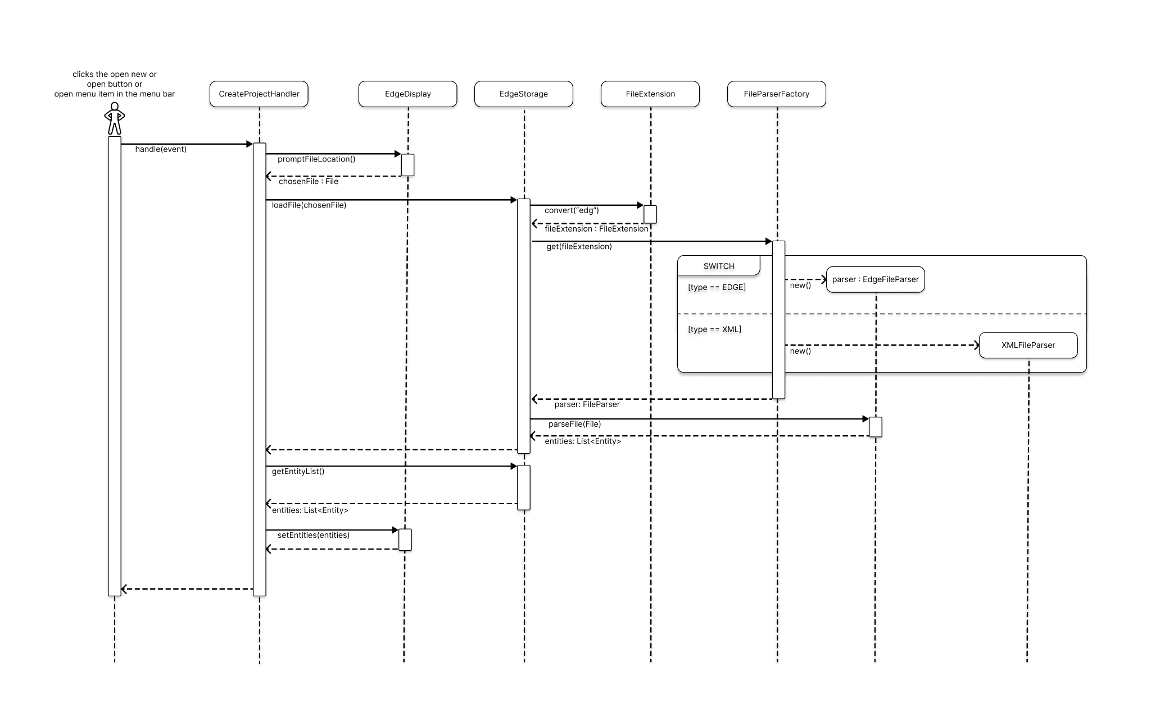
(File parsing and loading into the model)

Description
The program responds to user interactions, such as clicking buttons like 'open new' or 'open' or selecting options from the menu bar. Each of these actions triggers the event handler, specifically the 'handle(event)' method, which runs a corresponding sequence.
In this scenario, the 'CreateProjectHandler' class uses the 'promptFileLocation()' method from the 'EdgeDisplay' class, prompting the user to choose a file to work on. The selected file is saved as 'chosenFile.' To work with this file, it must be loaded, which is done using the 'loadFile()' method in the 'EdgeStorage' class, with 'chosenFile' as the parameter.
The program then determines the file type by obtaining an enum constant through 'FileExtension.convert("edg").' This constant identifies the file type and helps select the appropriate parser. The 'FileParserFactory' simplifies this process by using a switch case and the newly acquired enum as the parameter. For example, in this case, the chosen file is of type 'edge,' and an 'edgeFileParser' is created. Alternatively, if it's an XML file, an 'XMLFileParser' is generated.
Once the relevant file parser is created, it's returned to the 'EdgeStorage' class, where the chosen file is parsed, in this case, using the 'EdgeFileParser'. The 'parseFile()' method is used for this purpose, with the chosen file as input, resulting in an array list of entities.
Following this, the 'CreateProjectHandler' requests for this newly generated list of entities and decides to visually display them to the user with the assistance of the 'EdgeDisplay.' This is accomplished using the 'setEntities' method, with the array list of entities as the parameter.

Sequence Diagram 2
(Model Entities conversion into the SQL Script)
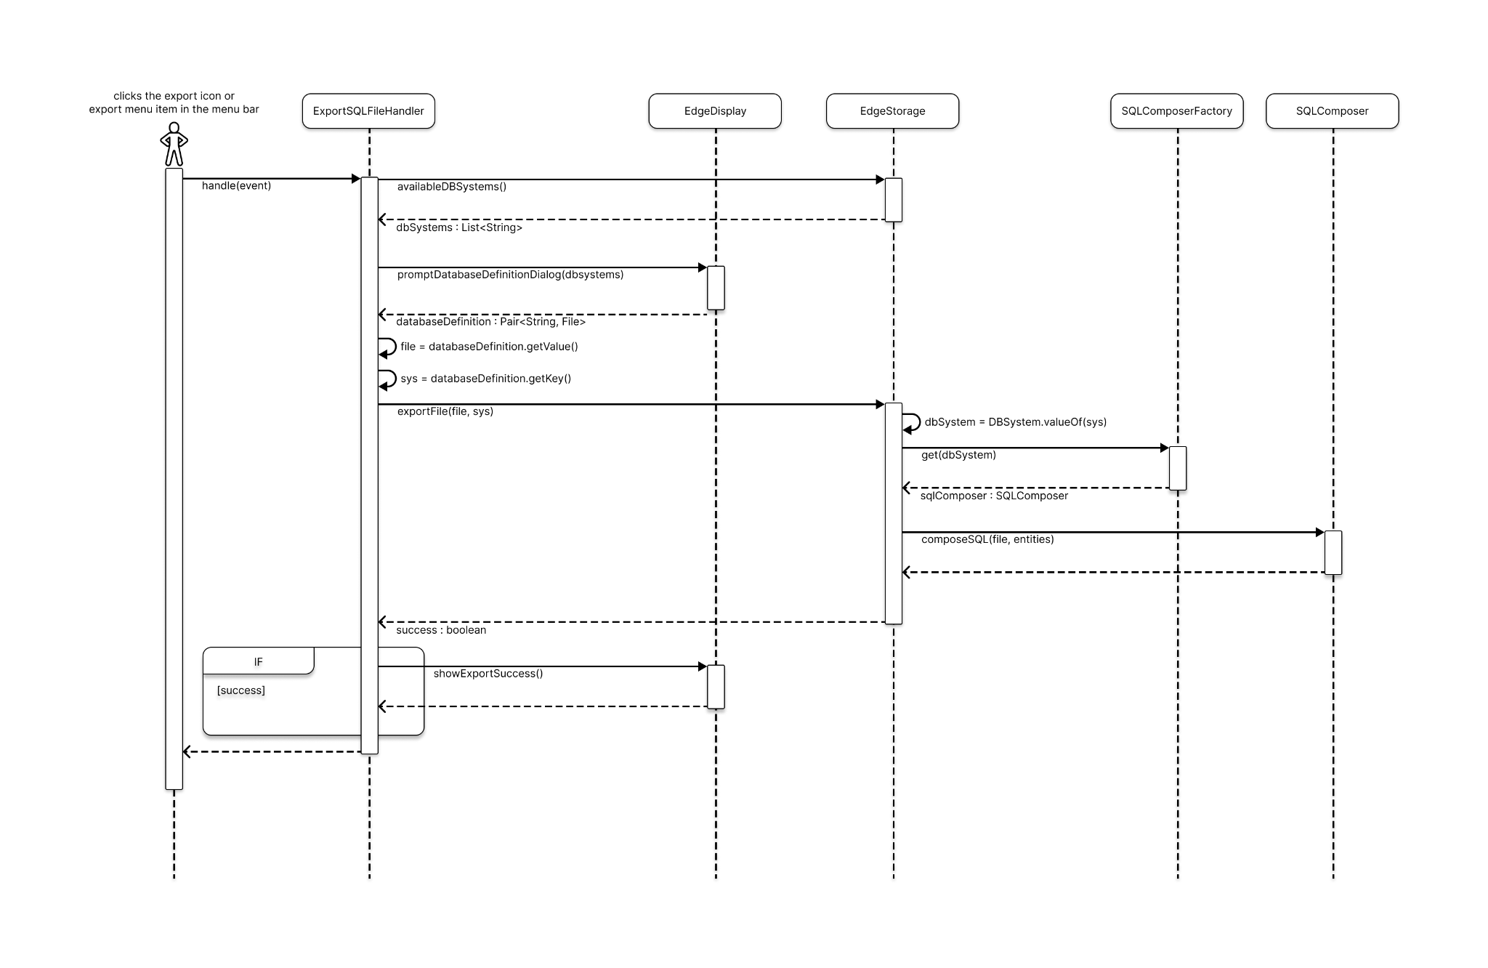

Description

The export event is initiated by the user through either clicking on the icon within the editor screens or using the menu to export their current project. When triggered, ExportSQLFileHandler’s handle method is called to manage the export process. Firstly, the handler retrieves the available Database management systems from the storage, which will be used to prompt the user for further information required for the file export. The handler then invokes the prompt method from the display to request further database definition from the user.
The prompt method allows the user to select the database system for transforming the current project into SQL statements. It also collects information regarding the file location and desired file name for the export. The file and the database system name are then passed to the storage method for further processing. To process the chosen database system, the database system is turned into an enum constant to facilitate the use of the Factory pattern. The Factory is used to return a concrete SQLComposer class based on the enum constant.
Afterwards, the composeSQL method is invoked, along with the file and all the entities associated with the current project. The composeSQL method then constructs the file given in the parameter with the SQL Statements. Upon completion of the composeSQL method, the Storage returns a boolean value indicating whether the export was successful, which is then presented to the user.

