Queryfier
Project Design Document
Team: The Sixth Sense

Doroteja Krtalić <dk5399@rit.edu>
Swen Grgičeivć <sg9750@rit.edu>
Michel Brassard <mb6149@rit.edu>
Divna Mijić <dm9718@rit.edu>
Petra Cesar <pc7841@rit.edu>



Project Summary 3
Design Overview 4
Overall System Structure 6
Description 6
The Controller (QueryfierManager) 7
The View (QueryfierDisplay) 7
The Model (QueryfierStorage) 7
Subsystems 9
Subsystem View 9
QueryfierDisplay 10
DialogCreator 10
QueryfierStyle 10
FileExportDefinition 10
Subsystem Controller 11
QueryfierManager 11
Handler(s) 12
Subsystem Model 12
QueryfierStorage 13
Entity 14
Attribute 14
AttributeDataType 14
DatabaseSchema 15
FileParser 15
Concrete FileParser(s) 15
FileParserFactory 15
FileExtension 16
SQLComposer 16
Concrete SQLComposer(s) 16
SQLComposerFactory 16
DBSystem 17
Sequence Diagrams 18
Sequence Diagram 1 18
Description 20
Sequence Diagram 2 21
Description 22
Appendix: Overall System Structure (Print) 23

Project Summary

The Queryfier application is a Java-based application that enables its users to read a file generated from a diagramming tool and create appropriate SQL statements for any number of database management systems for that file. Simply stated, the Queryfier takes in generic input and provides the users with an option to choose an export file type, thus providing them with generic output that depends purely on the user’s request.

The application is concerned with parsing algorithms necessary for different output file types, with an emphasis on key information for creating database tables on different DBMS (without the need for major redesign or restructuring of the code, while ensuring peak performance for the users).

The product that follows these guidelines, in addition to good practices in software architecture and design, will allow for easy maintenance and extendibility, and will be easily adjusted to fit different companies’ needs, depending on the technologies they use.

Design Overview

The application we decided to develop will follow the MVC architecture, which aims to ensure that our product is maintainable, easily extendable, coherent, well-organized, and well-structured. By introducing such patterns, our program inherently adheres to the separation of concerns, and consequently ensures high cohesion and low coupling between the classes within the subsystems.

The architecture ensures that the subsystems are able to communicate accordingly, where the Controller plays the key role in coordinating the processes that must occur in order for the application to deliver precisely what the user has requested. The View subsystem ensures that the user is able to utilize all functionalities the application is set to deliver, while the Model guarantees data accuracy and perseverance. The user’s requests are therefore, registered by the View, handled by the Controller, and processed based on the given input and data processed by the Model.

Due to the extensiveness and the complexity of the Model subsystem, we have applied the Factory pattern in order to improve the performance of the overall program and to organize our code to follow the best practices in terms of sustainability, endurance, and maintenance. As the Factory pattern supports the concept of programming to an interface, rather than an implementation, we introduced interfaces in our class structure - SQLComposer and FileParser. Additionally, to aid with the initialization of concrete objects through the Factory pattern, we introduced enum classes that further enhance the separation of concerns already set in place with the MVC subsystems.

Additionally, to further embellish the structure of our application, a “util” directory was created outside the MVC subsystems to accommodate the underlying aim of preserving logical separation of concerns within the program. These classes are purely focused on preserving consistency of our design, as well as certain UI-related aspects, such as font size, font family, colors, dialog design, etc.

Currently, the architecture fully supports all features that have been implemented, such as loading files, parsing files, correctly displaying them in the GUI, and exporting the data as an SQL script composed of DDL statements. The file selection supports Edge, XML, and JSON file types, with parsing only being applied to Edge files; the remaining two file types can be selected, but the code generates a dummy database that is then shown in the GUI.
The carefully designed GUI provides a user-friendly interface that is easy to understand and allows for simple manipulation of the displayed data. The checkboxes and similar submenus in the GUI have all been implemented, while the creation of new tables, deletion of existing ones, and (un)binding of tables are functionalities that remain to be implemented.

Finally, information, errors, and warnings will be shown to the user through dialogue boxes according to the processes running behind the scenes, as well as the dialogues that prompt the user to choose the location for their file to be saved at.

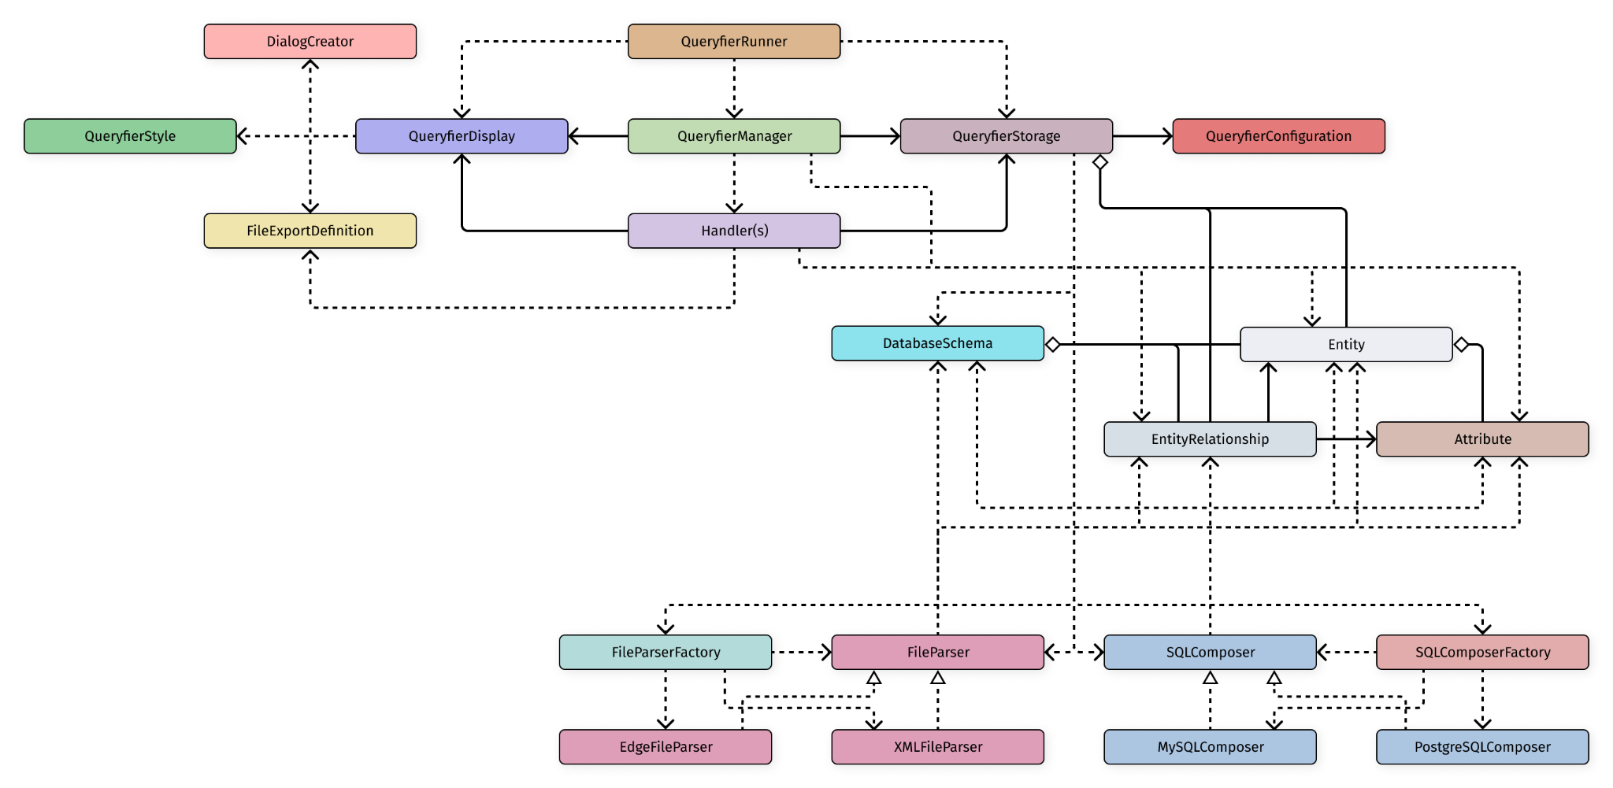
Overall System Structure

Description
The system is structured into three distinct components: The Controller, the View, and the Model, adhering to the MVC (Model-View-Controller) architectural pattern. This MVC structure allows the system’s model and view components to function independently from each other, with the controller acting as the intermediary responsible for managing communication between them, as the controller has a reference to both of them.

The Controller (QueryfierManager)
The QueryfierManager class acts as an intermediary between the view and the model by using the handler objects that it instantiates. The handle classes then further process user requests between the user interface and the core application logic and data.

The View (QueryfierDisplay)
QueryfierDisplay plays the role of the view within our MVC architecture. The Class is connected with ScreenDirector classes by association, meaning that the objects responsible for creating the GUI contain the necessary elements depending on which screen the user interacts with. Additionally, both of these classes use QueryfierStyle to ensure a uniform appearance in the GUI's look and feel.
On top of the methods dedicated to the process of setting up the scene and the stage inside of the QueryfierDisplay, the methods inside of this and the ScreenDirector classes will be responsible for attaching correct handlers on the elements the user will be able to interact with, so that the program can respond accordingly.

The Model (QueryfierStorage)
QueryfierStorage functions as the Model within the established MVC architecture, and it contains a QueryfierConfiguration object. Inside QueryfierStorage, a collection of Entity objects is stored. The Entity class can possess multiple attributes, along with the relationship objects defining the relationship between the current object and the other object in the relationship. Additionally, in order for an entity relationship to be established, it is necessary for an attribute from one entity to be linked or associated with an attribute of another entity, forming the relationship between them.
QueryfierStorage also uses the FileParserFactory and the FileParser class. Various file types can be processed by the FileParserFactory. For example, it uses EdgeFileParser for parsing Edge files and XMLFileParser for XML files. The FileParser classes use the Entity, Attribute, and EntityRelationship classes since they are required for the application.
Similarly, QueryfierStorage also utilizes the SQLComposer class and SQLComposerFactory class. The SQLComposerFactory is capable of composing multiple SQL for numerous Database Management Systems. For example, for PostgreSQL databases, the PostgreSQLComposer class is used, as well as the MySQLComposer class for MySQL databases. The classes use the Entity, Attribute, and EntityRelationship classes to generate complete queries.

Subsystems
The following sections elaborate on the subsystems in greater detail, focusing on providing class-related information, as well as the roles and responsibilities each class plays within its dedicated subsystem.

Subsystem View
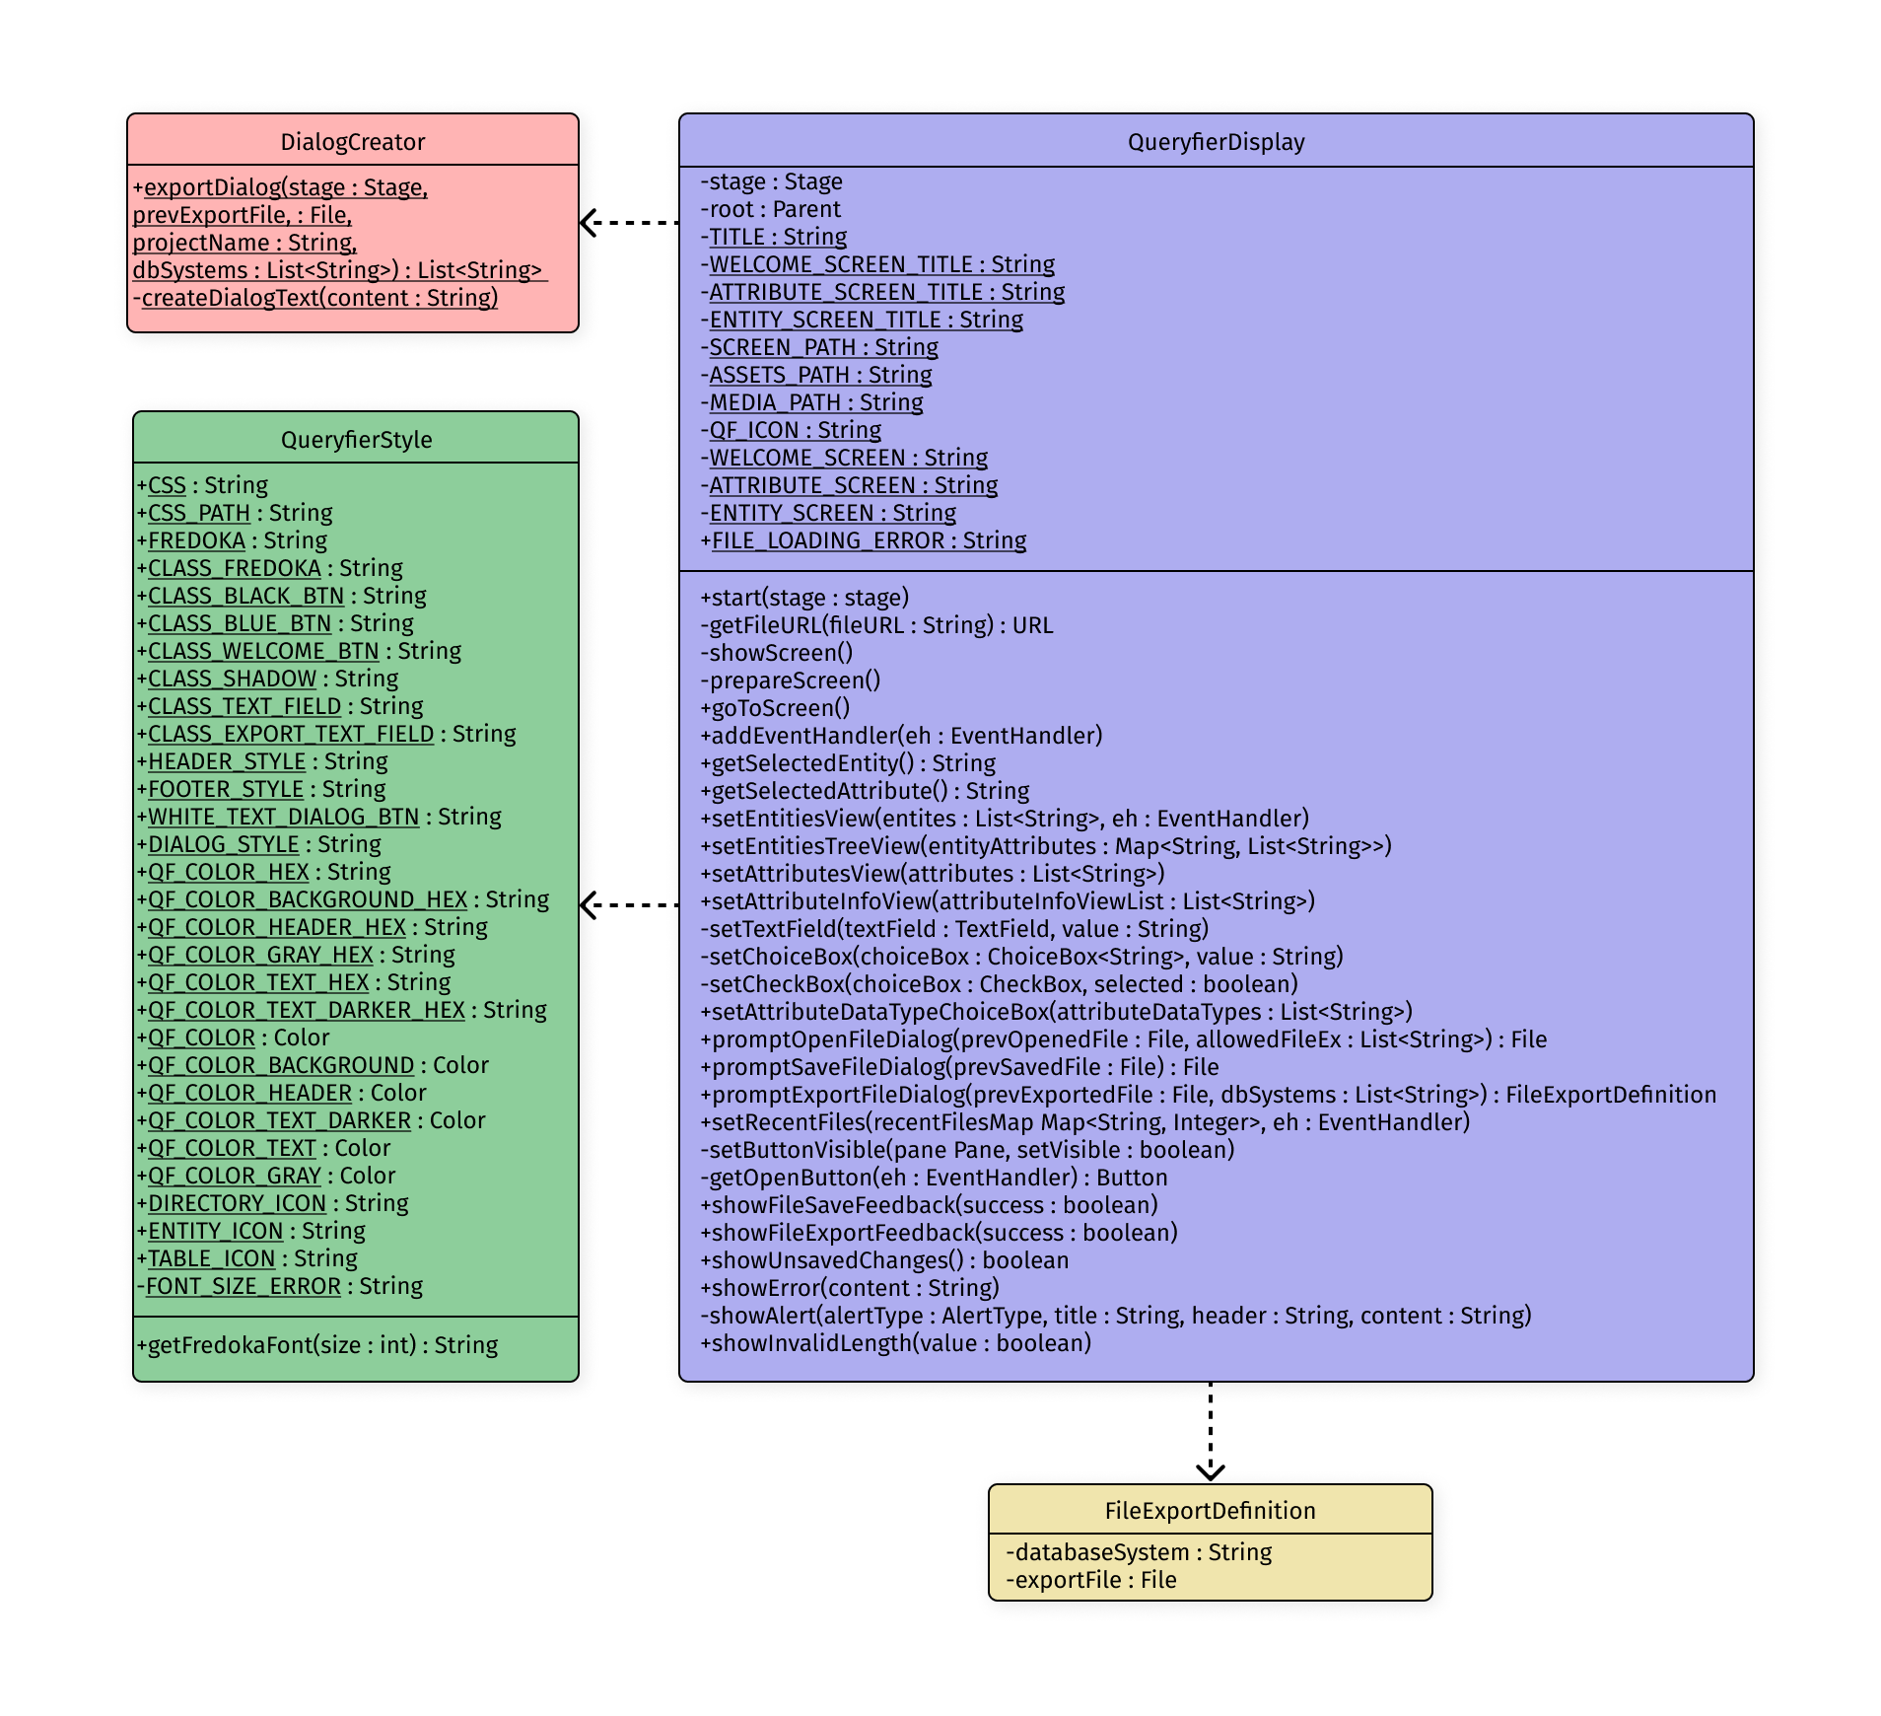

QueryfierDisplay
- This class is responsible for displaying the interface to the user in order for the program to receive user input
- The class contains methods that define which handler will be triggered (handlers are all located and defined inside the controller directory), aka will “handle” the specific action taken in the UI
  - e.g.
public void addEHOnOpenNewProjectButton(EventHandler<Event> eh) {
this.openNewProjectButton.setOnMouseClicked(eh);
}
- This class contains a “start” method which starts the stage and loads the FXML file, which then sets the scene to be shown with the loaded data && a “setController()” method to set the FXML controller in place
- Instantiated upon the program’s start-up

DialogCreator
Package: (view/util/)
- This class is responsible for making dialogs for the user in order for the application to further process the information given in the subsystems

QueryfierStyle
Package: (view/util/)
- This class is responsible for making sure GUI looks and feels the same, thus providing constants and utility methods for managing CSS styles, font sizes, and other styling-related properties

FileExportDefinition
Package: (view/util/)

- This class contains all the information about the file export when the user decides to export the file into the SQL Statements

Subsystem Controller
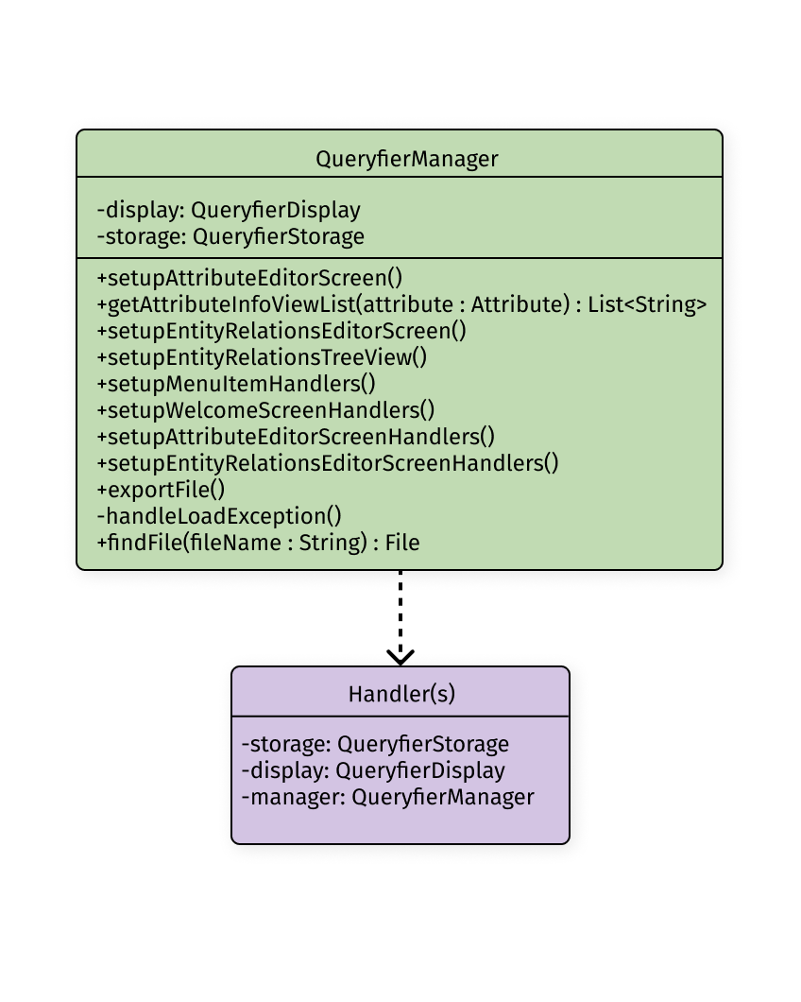

QueryfierManager
- This class uses all handlers existing in the program
- Acts as the core controller in the MVC (QueryfierDisplay display, QueryfierStorage storage)
- The handlers are set up inside this class on the display object contained inside the class
- Inside the constructor, the class contains the line that reads the recent files from the storage which are to be shown in the display (the most recent state of the application is saved and loaded as needed -> loadConfiguration / saveConfiguration)
- Instantiated upon the program’s start-up

Handler(s)
Package: (controller/handler/)

- All handlers implement the EventHandler interface
- Each handle contains its own method that is defined to manage, aka handle, the user’s action

Subsystem Model
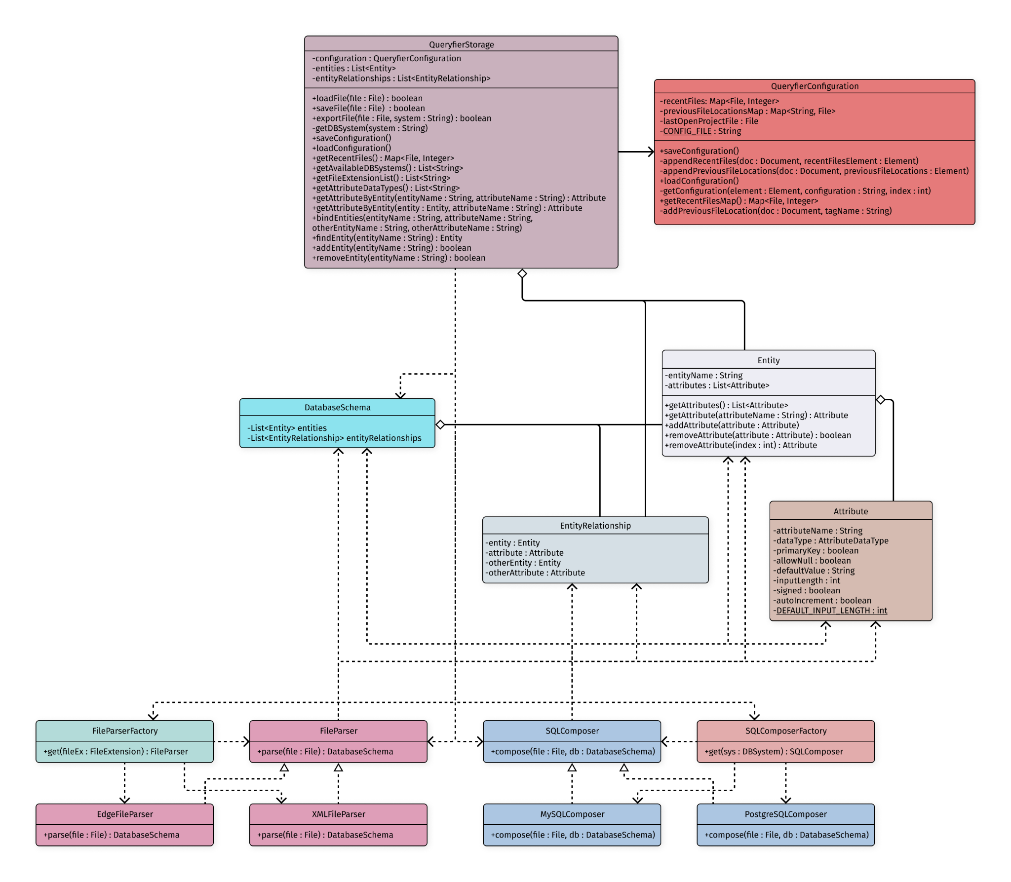

QueryfierStorage
- Main Model class in the application which contains a collection of all entities (in the form of a List) and uses the two factories for parsing and composing (aka exporting)
- The collection of entities and entity relationships contains within itself all the data necessary for the application to perform the tasks upon the user’s request
- The class uses the two factories to instantiate the accurate objects, depending on the user’s input, and forwards them to the Controller upon request
- The class contains an QueryfierConfiguration object which holds the file that must be loaded in order for the application to start in its most recent state
- Instantiated upon the program’s start-up

Entity
Package: (model/db/)

- A concrete class that contains collections of Attribute objects, together with the name of the entity, representing a table in the database
- Contains only accessors and mutators

Attribute
Package: (model/db/)

- Class that contains all the information about a specific attribute as variables
- The class defines its own data type in form of a AttributeDataType enum

AttributeDataType
Package: (model/db/)

- Enum class that contains all the attribute data types such as VARCHAR, INT, DOUBLE, BOOLEAN

DatabaseSchema
Package: (model/db/)

- Wrapper record for a collection of Entity class and EntityRelationship class

FileParser
Package: (io/parser/)

- Parent Interface class that contains a method to be implemented in it’s own child concrete classes to parse the file given as a parameter

Concrete FileParser(s)
Package: (io/parser/)

- Classes which contain defined rules for accurate parsing of each file type that the application recognizes and knows how to handle
- These objects will be instantiated based on the enum passed from the FileParserFactory depending on the user’s request
- Contains the “parse()” method and implements FileParser class

FileParserFactory
Package: (io/parser/util/)

- Factory which instantiates a new concrete FIleParser to handle the given file based on the FileExtension enum
- The class only contains a static method which will initialize the correct constructor depending on the received enum value

FileExtension
Package: (io/parser/util/)

- Enum class which contains all the file types that the application knows how to handle, written in form of the name and the extension
  - e.g. EDGE(“edg”)

SQLComposer
Package: (io/composer/)

- Parent Interface class that contains a method to be implemented in it’s own child concrete classes to compose the sql for the file and database schema given as a parameter

Concrete SQLComposer(s)
Package: (io/composer/)

- Classes which contain defined rules for accurate composing of each DBMS SQL Statements that the application recognizes and knows how to handle
- These objects will be instantiated based on the enum passed from the SQLComposerFactory depending on the user’s request
- Contains the “compose()” method and implements SQLComposer class

SQLComposerFactory
Package: (io/composer/util/)

- Factory which instantiates a new concrete SQLComposer to handle the given file based on the DBSystem enum
- The class only contains a static method which will initialize the correct constructor depending on the received enum value

DBSystem
Package: (io/composer/util/)

- Enum class which contains all the DBMS types that the application knows how to handle, written in the form of the DBMS name
  - e.g. MYSQL, POSTGRESQL

Sequence Diagrams

Sequence Diagram 1
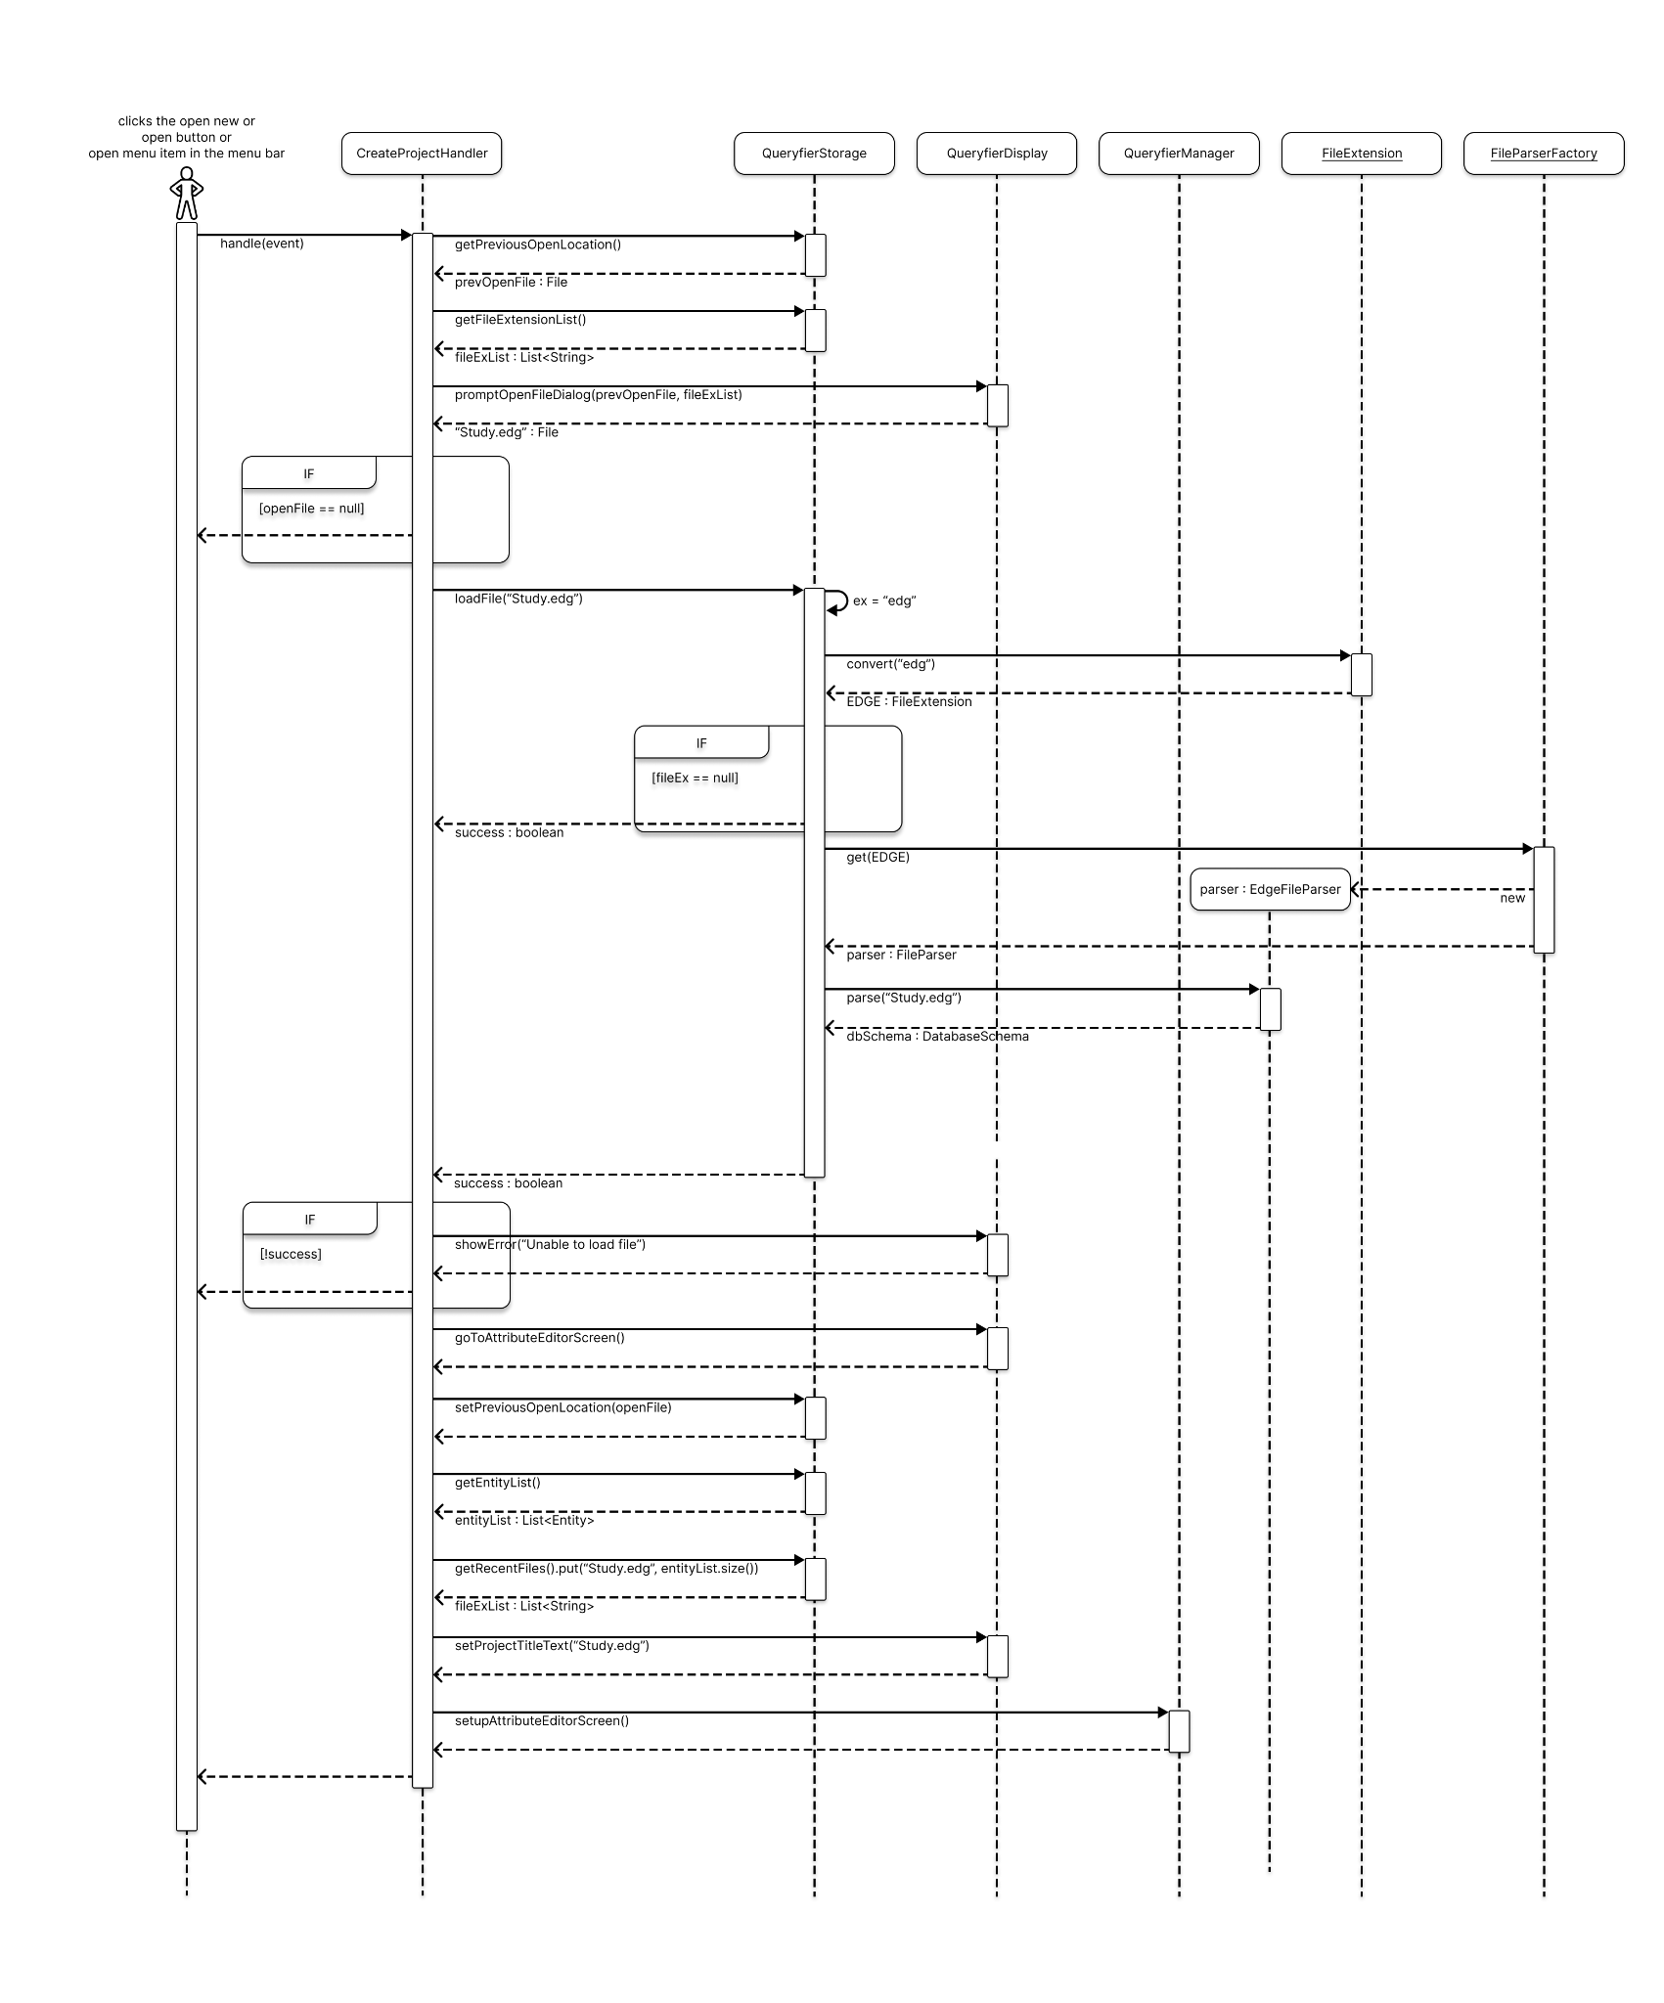
(File parsing and loading into the model)

FileParserFactory’s get method
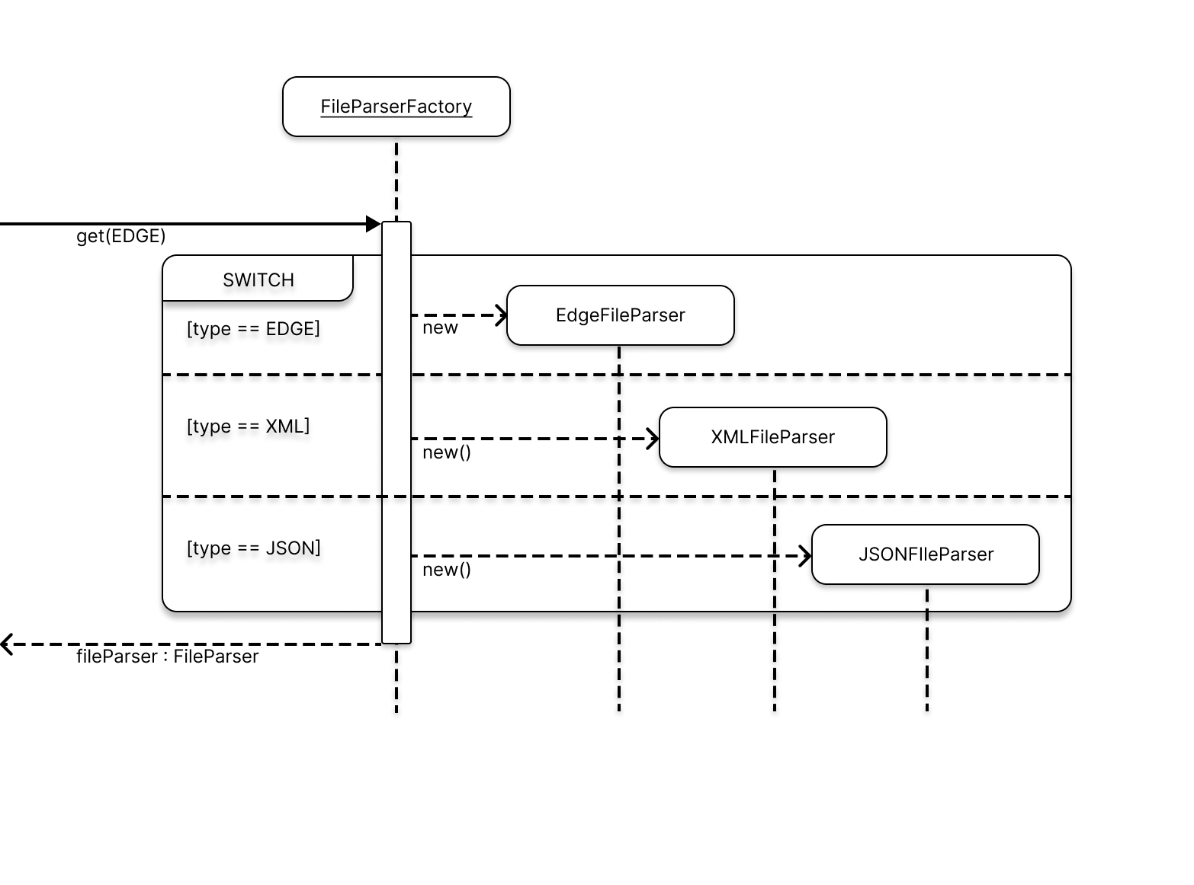

QueryfierManager’s setupAttributeEditorScreen method

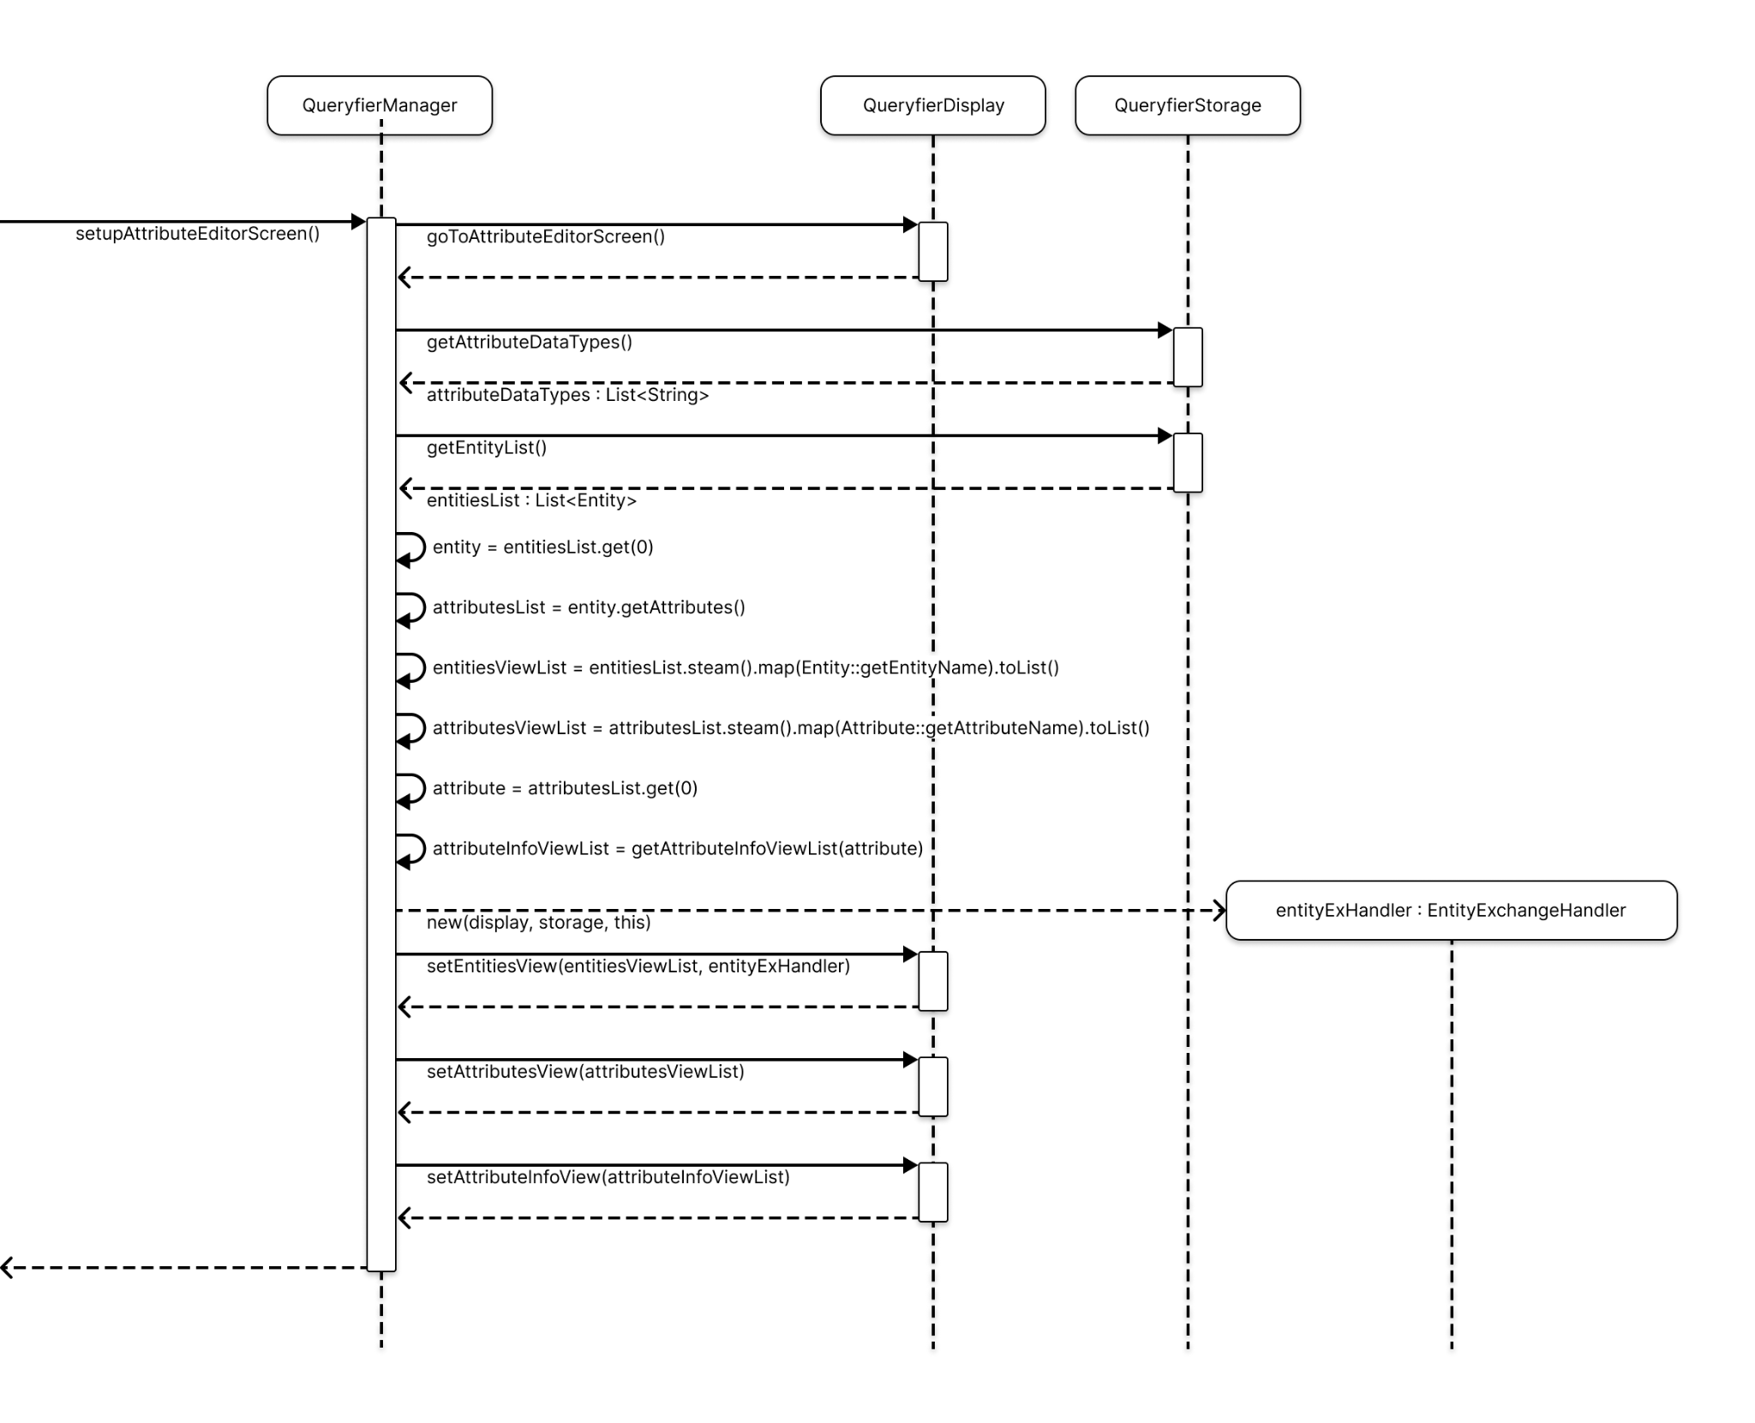

Description
The open event is initiated by the user either clicking the open button on a recent file, opening a new button under the drag-and-drop file icon on the welcome screen, or by using the menu to open a file. When triggered, CreateProjectHandler’s handle() method is called to manage the creation of a new project.
Firstly, the handler retrieves the previously open file location in the form of a file, which is going to be used to open the dialog with the initial directory. Next, a list of all file extensions are fetched to only show the files that the user is able to choose from. Then, the dialog is shown to the user with the initial directory of the previous file (if one exists) and the file extensions the application is able to process.
After the edge file has been selected by the user (in this case “Study.edg” file), the file is loaded into the application’s storage. In order to do that, the file is handled in a way that the extension of the file is processed into a FileExtension enum constant - EDGE constant. The constant is then used to get the EdgeFileParser from the FileParser factory.
After acquiring the suitable FileParser, the FileParser’s parse() method is invoked to parse the file. After parsing the file, a Database Schema is then received to be loaded into the storage.
Then, the application goes to the attribute editor screen, persists the previously open file location, alongside the list of recent files to the storage, and then sets the Storage’s entity list and attribute list to the display, along with the first attribute’s information.

Sequence Diagram 2
(Database Schema conversion into the SQL Script)
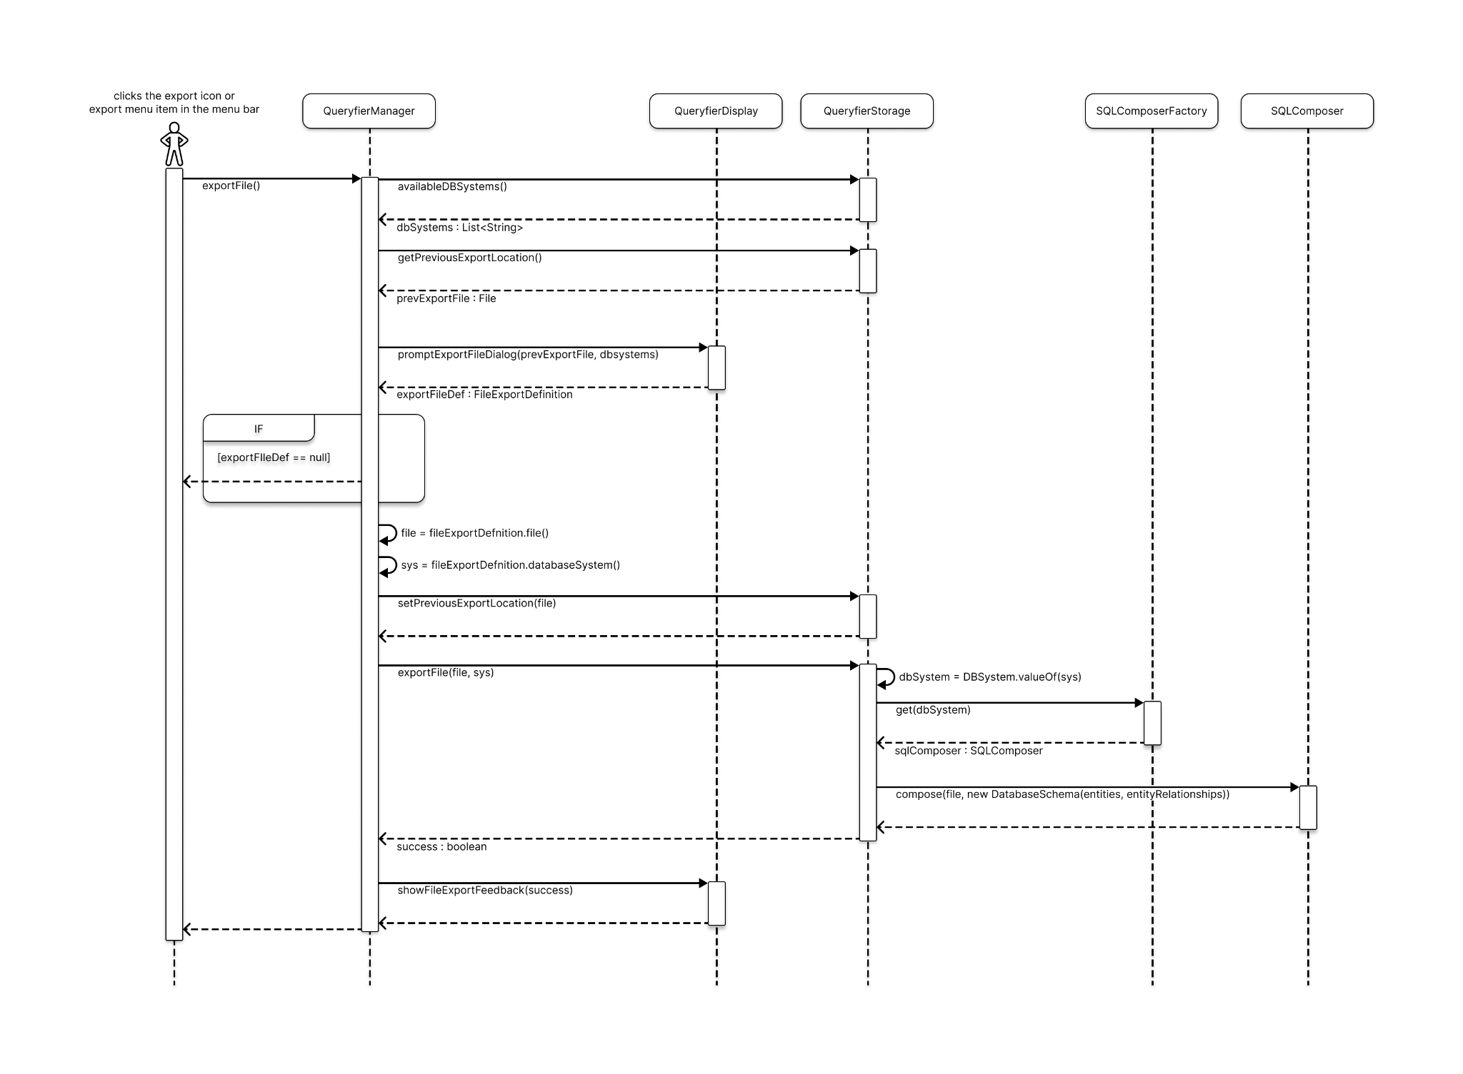

Description

The export event is initiated by the user by either clicking on the icon within the editor screens or using the menu to export their current project. When triggered, ExportSQLFileHandler’s handle method is called to manage the export process. Firstly, the handler retrieves the available Database management systems from the storage, which will be used to prompt the user for further information required for the file export. The handler then invokes the prompt method from the display to request further database definition from the user.
The prompt method allows the user to select the database system for transforming the current project into SQL statements. It also collects information regarding the file location and desired file name for the export. The file and the database system name are then passed to the storage method for further processing. To process the chosen database system, the database system is turned into an enum constant to facilitate the use of the Factory pattern. The Factory is used to return a concrete SQLComposer class based on the enum constant.
Afterwards, the compose method of the SQLComposer class is invoked. The method uses the database schema with all the entities and entity relationships currently saved in the application to generate SQL statements. After the conversion, the SQL statements are written in a file. Upon completion of the compose method, the Storage returns a boolean value indicating whether the export was successful, which is then presented to the user.

Appendix: Overall System Structure (Print)
