EXPERIMENT 8
Configuring User Management and Role-Based Access Control (RBAC) in a Zoho Creator Application
Application: Vehicle Service & Repair Request Management
Submitted by
Name : Divoshini V
Roll No : 241401020

AIM
To configure user management and role-based access control (RBAC) in a Zoho Creator application by adding users, defining permission profiles, creating a role hierarchy and setting up data sharing rules, so that each user can access only the data and components appropriate to their role.
PROCEDURE
Part A: User Management
- Log in to Zoho Creator and open the Admin Dashboard.
- From the left menu, under MANAGE, click Users to view all users added to the account.
- Click Add User to invite a new user by entering name and email address, and assign the required role/profile.
- Verify that every user (Super Admin, Service Advisor, Service Staff and Customer) shows the status Active.
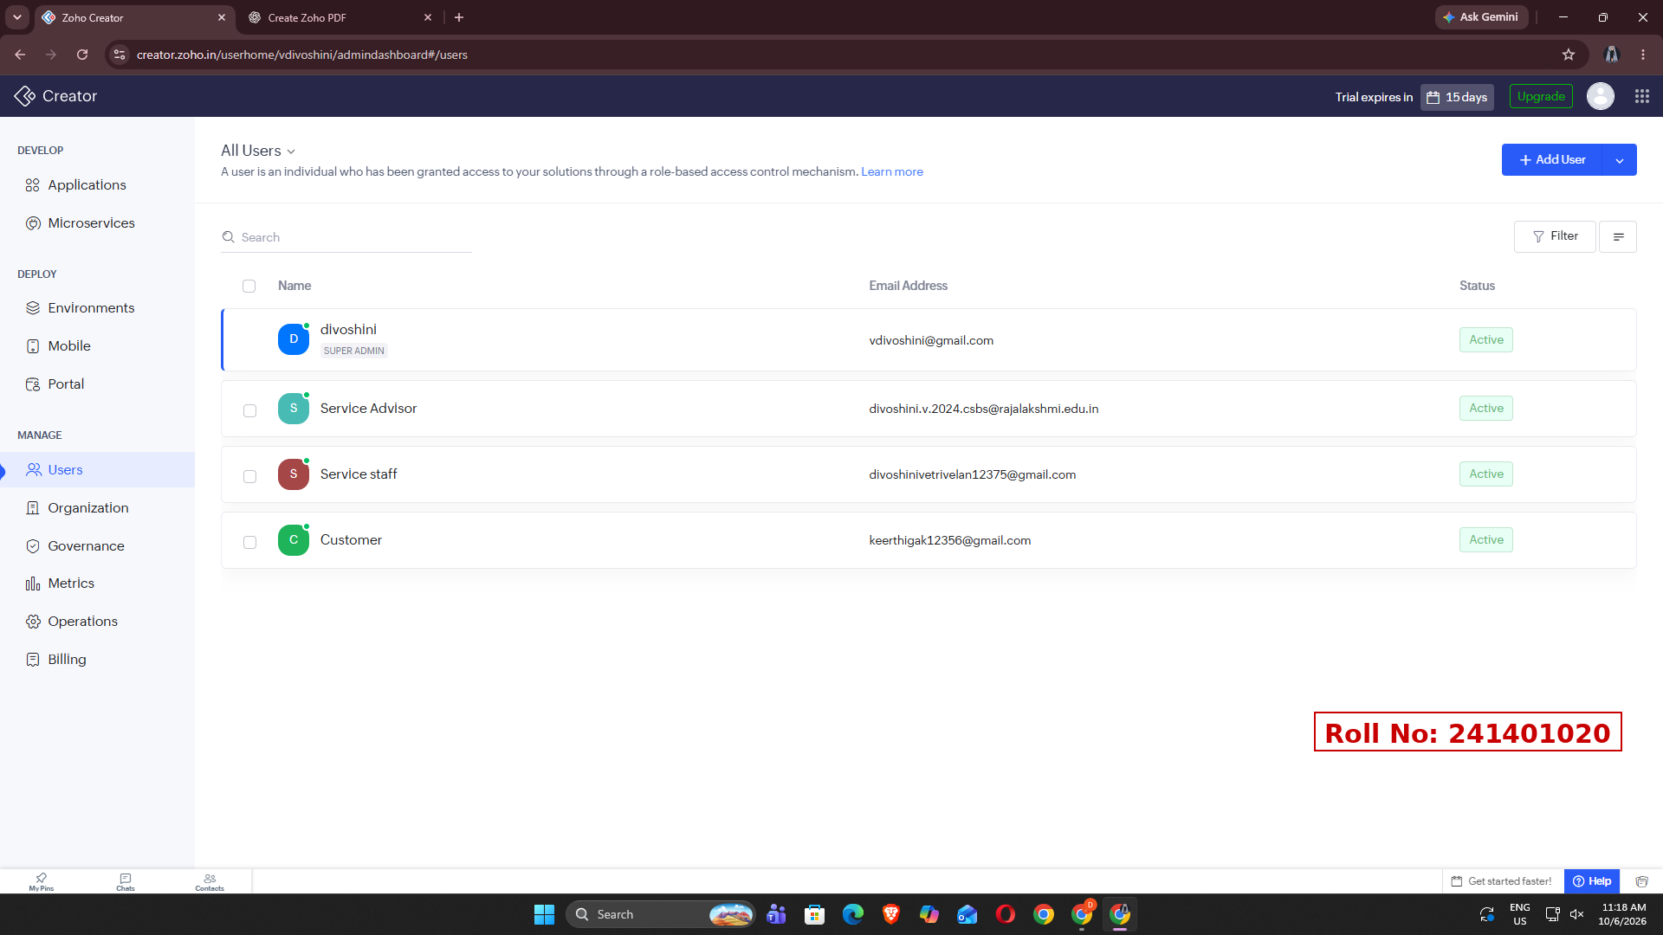
Figure 1: All Users page showing the users and their status
Part B: Creating Permission Profiles
- Open the application and go to Settings, then Users and Permissions (User Permissions).
- In the Permissions tab, click Add Permission to create a profile.
- Create the profiles Customer_Permission, Service_Manager_Permission and Service_Staff_Permission, and select the forms, reports and pages each profile may access. The default Read and Write profiles are also available.
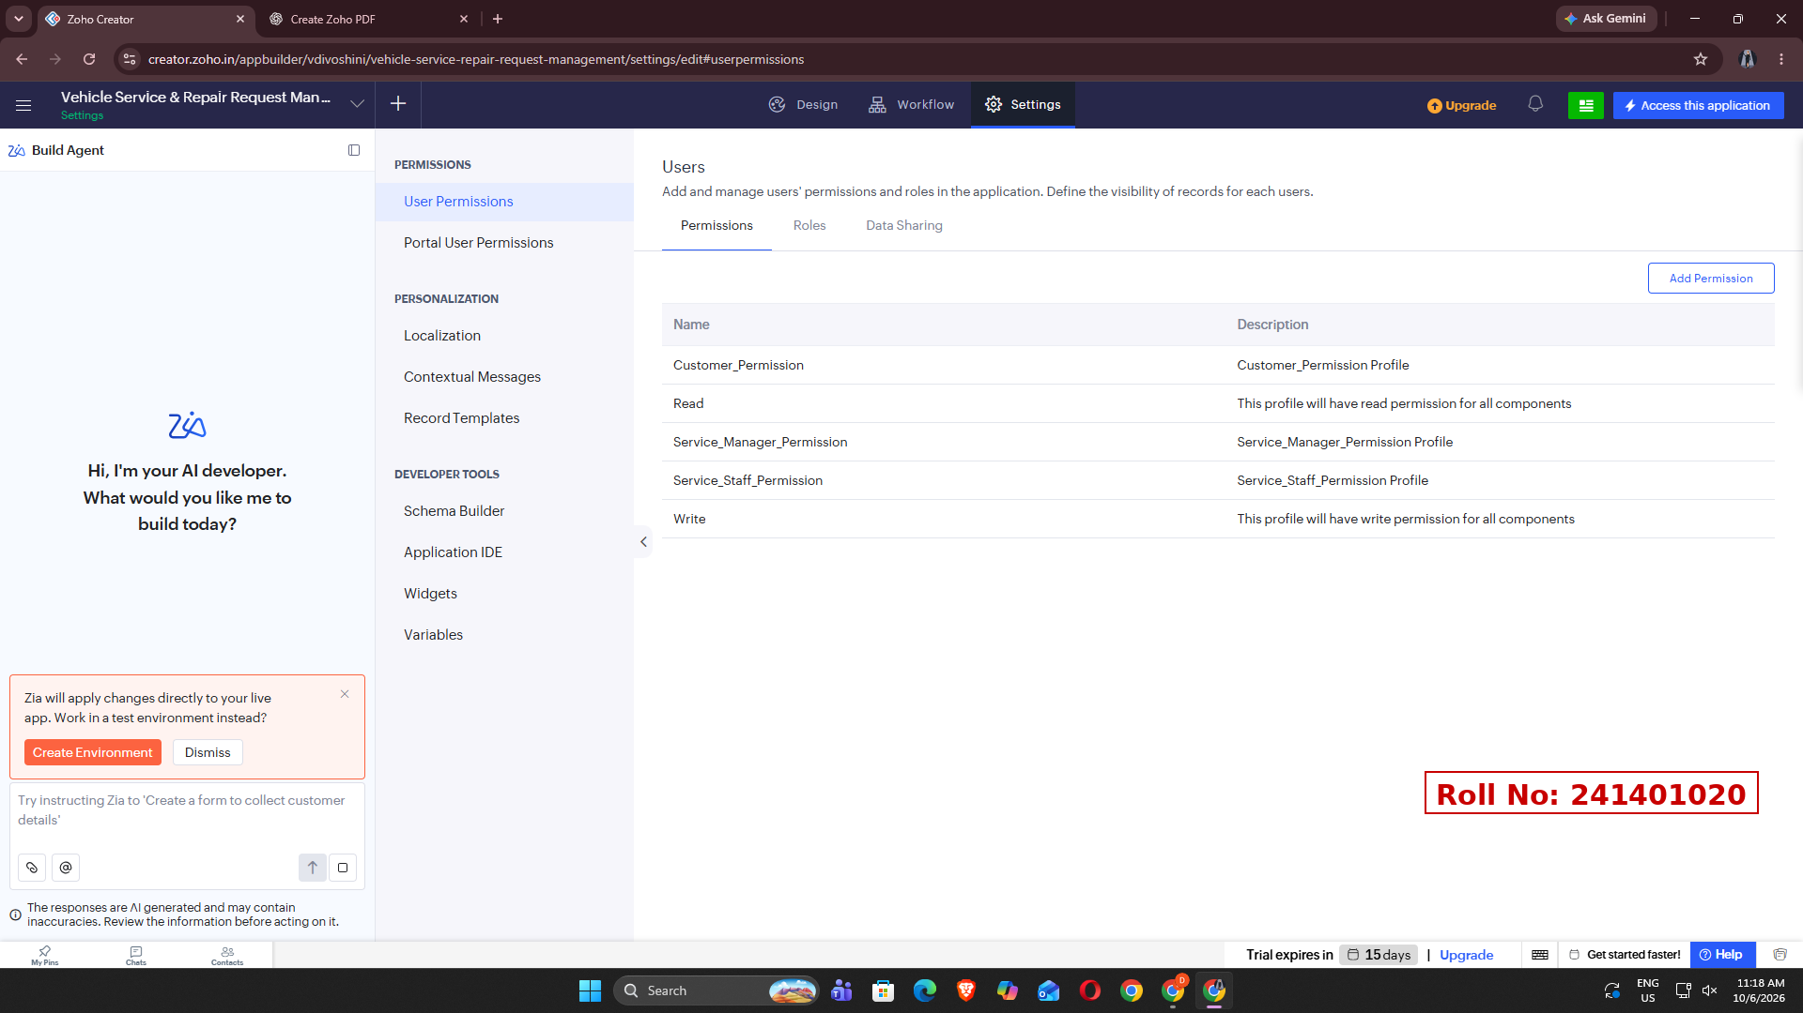
Figure 2: Permissions tab listing the permission profiles
Part C: Defining the Role Hierarchy
- Click the Roles tab in User Permissions.
- Click Add Role to create each role, and Manage Role Hierarchy to arrange them.
- Create the hierarchy: CEO at the top; Service Advisor and Customer below CEO; Service Staff below Service Advisor.
- Use Expand All / Collapse All to verify the structure.
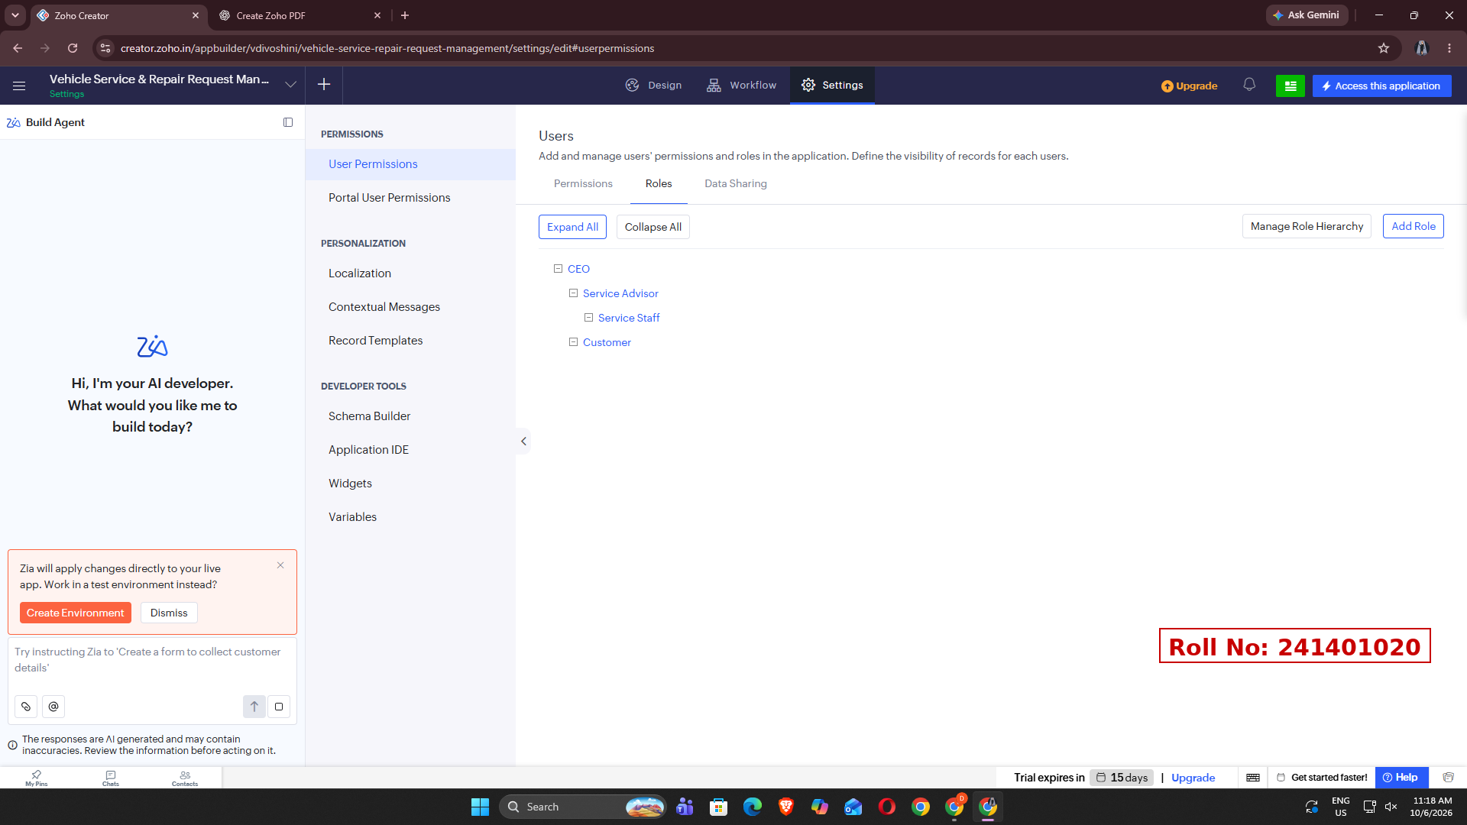
Figure 3: Roles tab showing the role hierarchy
Part D: Configuring Data Sharing Rules
- Click the Data Sharing tab and choose New Share Rule.
- Select the form (Service_Request_Form), the role the data is shared from, the role it is shared to, and the level of access.
- Create the three share rules shown in the table below and save them.
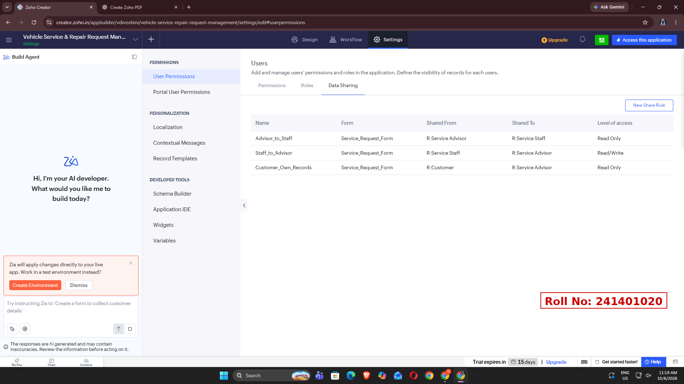
Figure 4: Data Sharing tab showing the share rules
Data sharing rules configured
Rule Name | Shared From → Shared To | Level of Access
Advisor_to_Staff | Service Advisor → Service Staff | Read Only
Staff_to_Advisor | Service Staff → Service Advisor | Read/Write
Customer_Own_Records | Customer → Service Advisor | Read Only

OBSERVATION
- Four users (Super Admin, Service Advisor, Service Staff and Customer) were present and Active.
- Five permission profiles were available: Customer_Permission, Read, Service_Manager_Permission, Service_Staff_Permission and Write.
- The role hierarchy was CEO > Service Advisor > Service Staff, with Customer directly under CEO.
- Three data sharing rules on Service_Request_Form controlled record visibility between roles.
RESULT
Thus, user management and role-based access control were successfully configured in the Zoho Creator application "Vehicle Service & Repair Request Management". Users were added and assigned roles, permission profiles were defined, a role hierarchy was created, and data sharing rules were applied, ensuring that each user can access only the records and components permitted for their role.

