**Assignments of GIT**

1. Create a directory ‘project_dir’ & cd to ‘project_dir’.

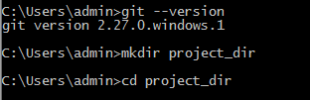

1. **Initialize git version database. (git init)**



1. **Create a new file index.html.**



1. **Check the git status. You should find index.html as untracked file.**

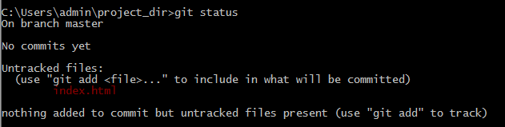

**5. Stage the index.html file.**

**6. Commit index.html**

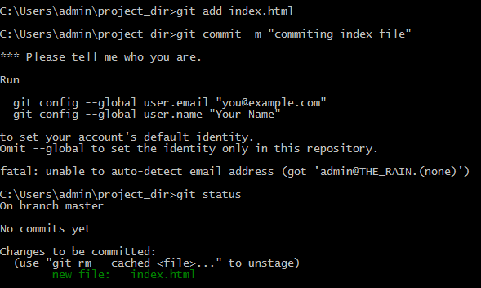

**7. Make few changes in index.html & create a new file info.txt file.**

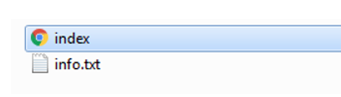

**8. Check git status. You should find index.html & info.txt as untracked files.**

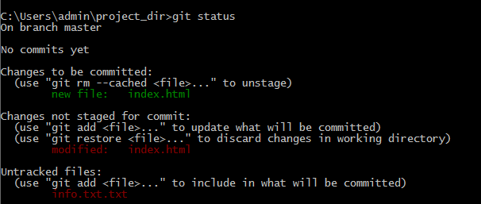

**9. Configure GIT to ignore all txt files.**



**10. Again check the git status. You should find only index.html as untracked file.**

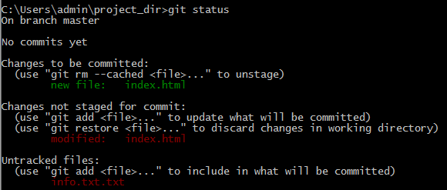

**11. State & commit index.html**

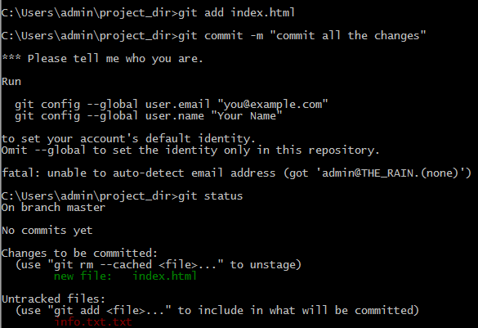

**12. Log all your comments so far.**

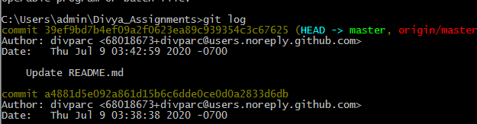

**13. Make some changes in index.html.**

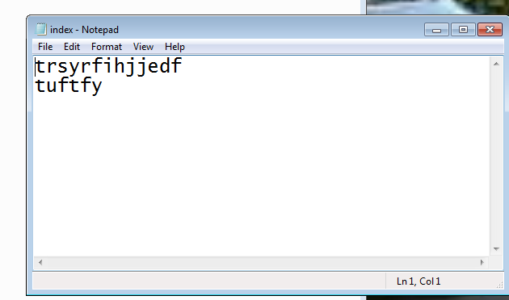

**14. Revert the change made in the previous step using git command.**

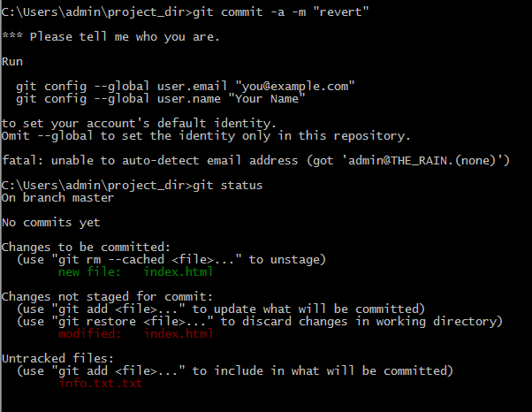

**15. Again change index.html.**

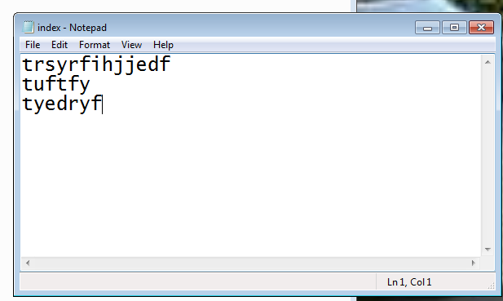

**16. Stage index.html**



**17. Revert back the last stage.**

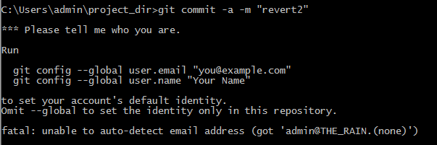

SECTION-1 (HTML assignments)

**22. Create an empty directory ‘Assignments’ & cd to ‘Assignments’.**

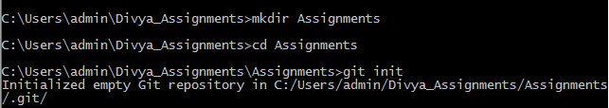

**23. Create a file README.txt inside ‘Assignments’ & write few lines about the contents of**

**‘Assignments’ folder.**

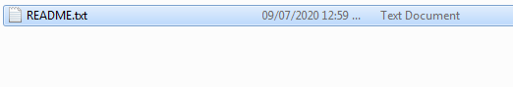

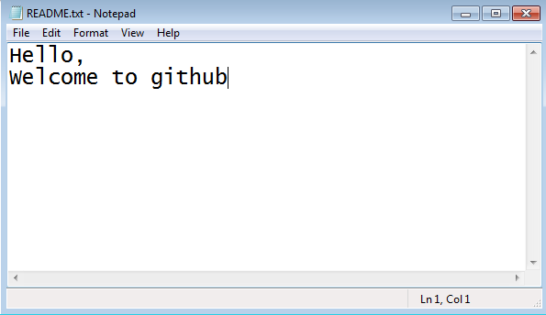

**24. Commit README.txt file.**

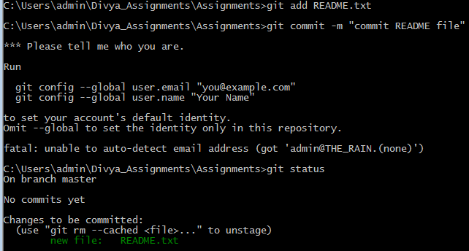

**25. Now create a new branch ‘html-assignments’.**



**26. Switch to ‘html-assignments’ branch.**

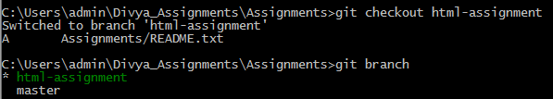

**27. Copy all HTML assignments inside ‘Assignments’ folder.**

**28. Commit HTML assignments into ‘html-assignments’ branch.**

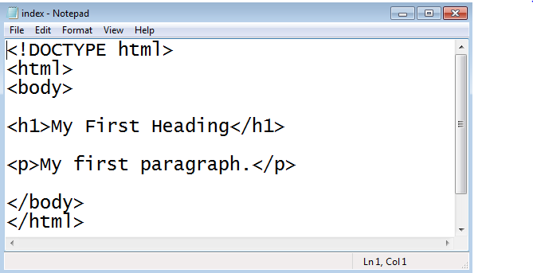

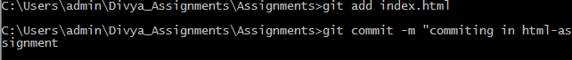

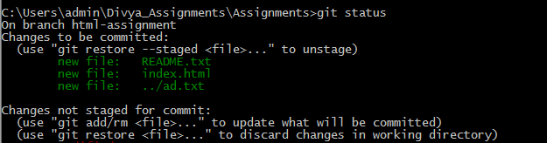

**29. Make minor changes into few files belonging to ‘html-assignments’ branch.**

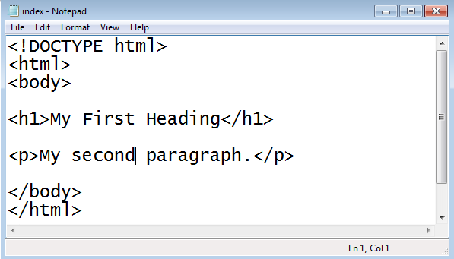

**30. Commit those changed files.**



**31. Switch to master branch.**

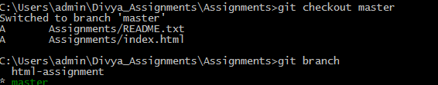

**32. Make minor changes into README.txt file & commit those changes into master.**

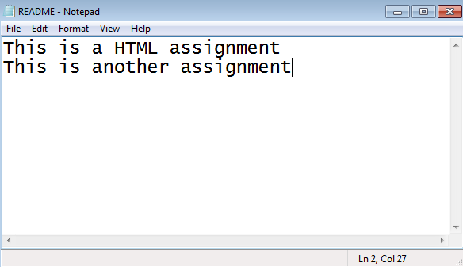

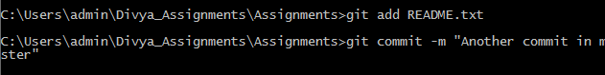

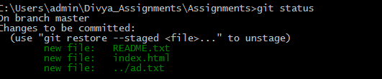

**33. Again switch to ‘html-assignments’ branch.**

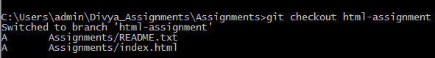

**34. Make minor changes into few files belonging to ‘html-assignments’ branch.**

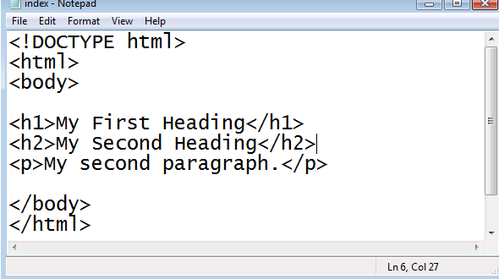

**35. Commit those changes.**

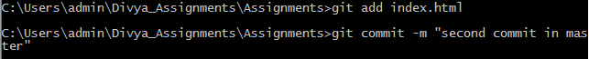

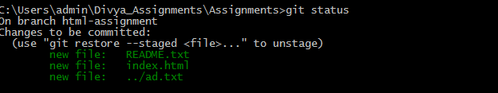

**36. Switch to master.**

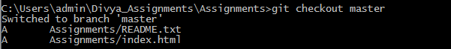

**37. Merge ‘html-assignments’ branch into master. Confirm all html assignments are shown**

**in master.**



**SECTION 2 (CSS ASSIGNMENTS)**

1. **Create a new branch ‘css-assignments’.**



1. **Switch to ‘css-assignments’ branch.**

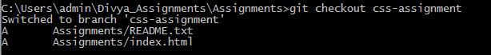

1. **Copy all CSS assignments inside ‘Assignments’ folder.**

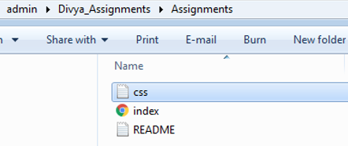

1. **Commit CSS assignments into ‘css-assignments’ branch.**

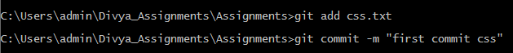

1. **Make minor changes into README.txt file on line 1 belonging to ‘css-assignments’**

**branch.**

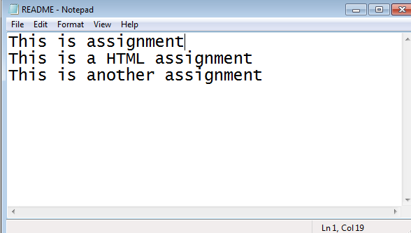

1. **Commit those changed files.**



1. **Switch to master branch.**

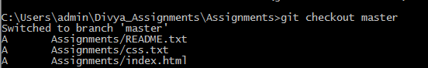

1. **Make minor changes into README.txt file on line 3 & commit those changes into**

**master.**

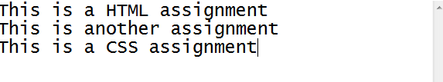



1. **Again switch to ‘css-assignments’ branch.**



1. **Make minor changes into few files belonging to ‘css-assignments’ branch.**

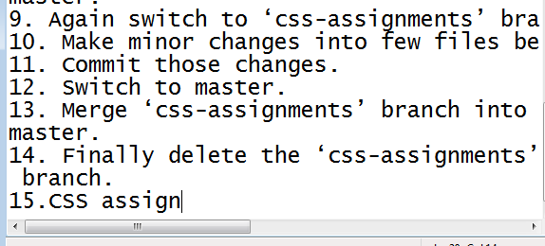

1. **Commit those changes.**



1. **Switch to master.**



1. **Merge ‘css-assignments’ branch into master. Confirm all css assignments are shown in**

**master.**



**Section 3- JS assignment**

1. Create a new branch ‘js-assignments’.



1. **Switch to ‘js-assignments’ branch.**



1. **Copy all JavaScript assignments inside ‘Assignments’ folder.**

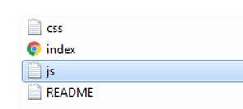

1. **Commit JavaScript assignments into ‘js-assignments’ branch.**



1. **Make minor changes into README.txt file on line 1 belonging to ‘js-assignments’ branch.**



1. **Commit those changed files.**



1. **Switch to master branch.**



1. **Make minor changes into README.txt file on line 1 & commit those changes into**

**master.**

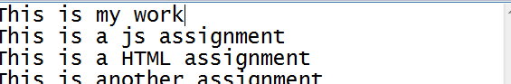



1. **Again switch to ‘js-assignments’ branch.**



1. **Make minor changes into few files belonging to ‘js-assignments’ branch.**

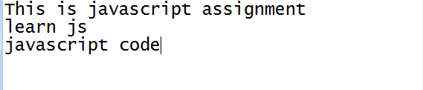

1. **Commit those changes.**



1. **Switch to master.**



1. **Merge ‘js-assignments’ branch into master. Confirm all JavaScript assignments are**

**shown in master.**

