The purpose of this document is to explain how the two ARD datasets can be converted into a reusable Semantic Data Product.

They contain business columns such as:
- reporting period
- fiscal period
- alignment period
- product
- indication
- geography / territory / region
- primary geography
- customer / provider / account attributes
- metric values
- target / actual / score-related fields

What Is a Semantic Data Product?
A semantic data product is a cleaned, governed, business-ready version of data where technical source columns are converted into business-friendly terms.
Instead of every report developer directly using raw ARD columns and recreating logic again and again, we create one common semantic layer with:
- standard business dimensions
- standard measures
- standard metric definitions
- standard date logic
- standard geography hierarchy
- standard product hierarchy
- standard calculation rules
This allows business users and reporting teams to use the same trusted version of the data.
A semantic data product is a curated analytics model built over trusted data assets. It exposes data through facts, dimensions, metrics, and business definitions.
From mentioned ARDs, the semantic data product should convert flat ARD extracts into a dimensional model such as:
- FACT_PERFORMANCE_METRIC
- DIM_DATE
- DIM_PRODUCT
- DIM_GEOGRAPHY
- DIM_TERRITORY
- DIM_CUSTOMER
- DIM_METRIC
- DIM_PERIOD
- DIM_SOURCE_ARD
The semantic model can then be consumed by Power BI, Tableau, downstream marts, APIs, or business users.

Current Understanding
ARD 1 appears to contain weekly goal / performance / alignment-related data. The visible columns suggest it has:
- data reference date
- ARD name or file identifier
- SQL alignment name
- alignment period
- product / territory / indication-related fields
- area / region / geography fields
- time period fields such as week and fiscal period
- metric fields
- possible target / attainment / score / adjustment fields
This ARD looks like a business reporting extract used to analyse performance across products, territories, regions, and reporting periods.

ARD 2 appears to contain a similar but slightly different business view. It includes fields related to:
- data reference date
- ARD name
- SQL alignment
- product
- indication
- geography
- primary geography
- territory
- person / role / owner-related attributes
- period fields
- metric values
- category or segmentation fields
This ARD looks like another reporting extract that may represent a different business domain, different geography grain, or different calculation view.

Target Semantic Data Product
This semantic data product will provide a trusted, reusable model to analyze performance, goals, targets, and metrics across:
- product
- indication
- geography
- territory
- region
- area
- time period
- alignment period
- business metric
The semantic data product should include:
- ARD 1 ingestion
- ARD 2 ingestion
- standardization of common columns
- date and fiscal period normalization
- product and indication normalization
- geography and territory hierarchy creation
- metric standardization
- fact and dimension model
- Power BI semantic model
- data quality checks
- lineage and audit metadata

Semantic Product Design
The ARDs should first be ingested into staging, then standardized, then modelled into facts and dimensions.
Recommended flow:
- Load ARD files into raw/staging tables
- Standardize column names and data types
- Create conformed dimensions
- Create fact table at the correct grain
- Build semantic views
- Expose semantic model to Power BI

Diagram 1: ARD 1 Current State Flow
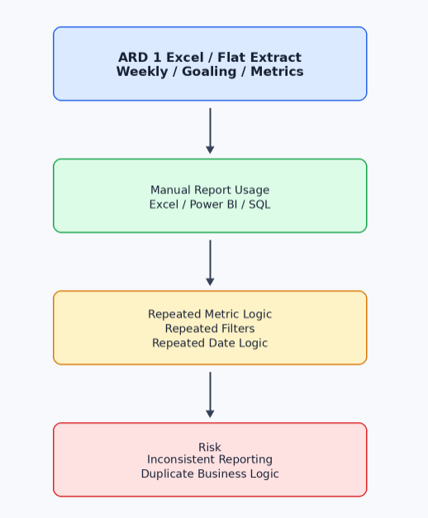

Diagram 2: ARD 2 Current State Flow
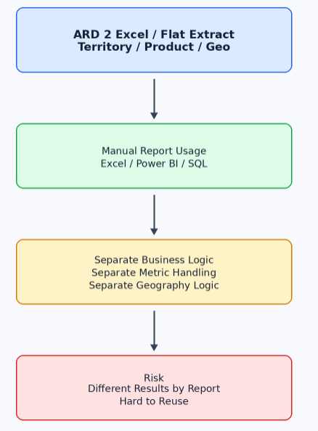
Diagram 3: Target Semantic Data Product Architecture
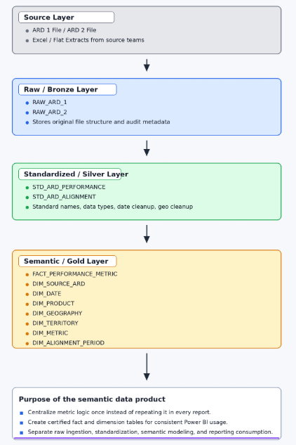

Data Model
FACT_PERFORMANCE_METRIC
This table stores the numeric business performance values from the ARDs.
Column | Description
FACT_PERFORMANCE_KEY | Surrogate key
SOURCE_ARD_KEY | ARD source reference
DATE_KEY | Reporting date key
PERIOD_KEY | Week / fiscal period key
PRODUCT_KEY | Product dimension key
GEOGRAPHY_KEY | Geography dimension key
TERRITORY_KEY | Territory dimension key
METRIC_KEY | Metric dimension key
ALIGNMENT_PERIOD_KEY | Alignment period key
METRIC_VALUE | Actual value
TARGET_VALUE | Target / goal value
ATTAINMENT_VALUE | Attainment percentage or calculated value
SOURCE_FILE_NAME | File audit reference
LOAD_TIMESTAMP | Load timestamp

DIM_DATE
Column | Description
DATE_KEY | Date surrogate key
CALENDAR_DATE | Actual date
YEAR | Calendar year
MONTH | Calendar month
WEEK_NUMBER | Week number
FISCAL_YEAR | Fiscal year
FISCAL_PERIOD | Fiscal reporting period
FISCAL_QUARTER | Fiscal quarter

DIM_PRODUCT
Column | Description
PRODUCT_KEY | Product surrogate key
PRODUCT_NAME | Product name from ARD
PRODUCT_FAMILY | Product family
INDICATION | Indication / market category
PRODUCT_GROUP | Higher level product grouping
IS_ACTIVE | Active flag
DIM_GEOGRAPHY
Column | Description
GEOGRAPHY_KEY | Geography surrogate key
AREA_NAME | Area
REGION_NAME | Region
MARKET_NAME | Market
STATE_NAME | State
CITY_NAME | City
PRIMARY_GEOGRAPHY | Primary geography from ARD

DIM_TERRITORY
Column | Description
TERRITORY_KEY | Territory surrogate key
TERRITORY_ID | Territory code
TERRITORY_NAME | Territory name
TERRITORY_TYPE | Territory type
REGION_NAME | Region mapping
AREA_NAME | Area mapping
OWNER_NAME | Business owner / rep / role, if available

DIM_METRIC
Column | Description
METRIC_KEY | Metric surrogate key
METRIC_CODE | Source metric code
METRIC_NAME | Business metric name
METRIC_CATEGORY | Metric group
METRIC_TYPE | Actual / Target / Score / Attainment
CALCULATION_RULE | Business definition
UNIT_OF_MEASURE | Count, %, currency, score, etc.

DIM_ALIGNMENT_PERIOD
Column | Description
ALIGNMENT_PERIOD_KEY | Alignment period surrogate key
ALIGNMENT_PERIOD | Source alignment period
START_DATE | Alignment start date
END_DATE | Alignment end date
IS_CURRENT | Current alignment flag

Semantic Star Schema
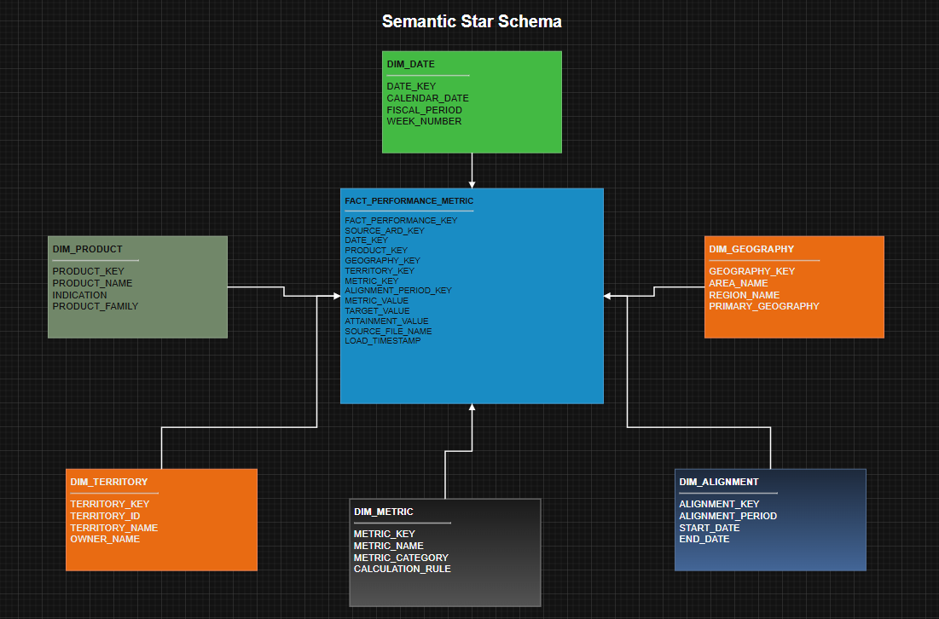

Layered Data Engineering Flow
