1. Create Database and Collection:

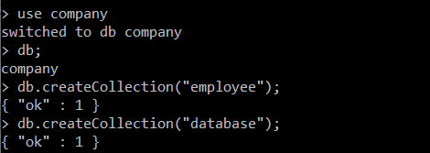

1. Insert into employee collection:

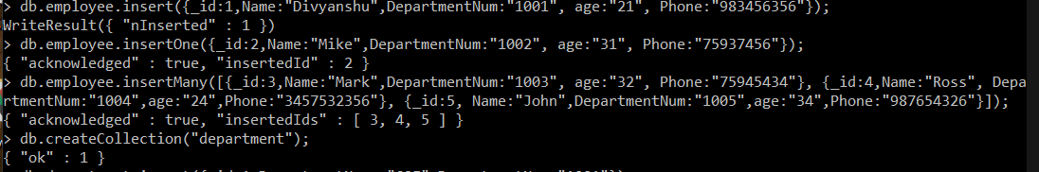

Insert using Save:

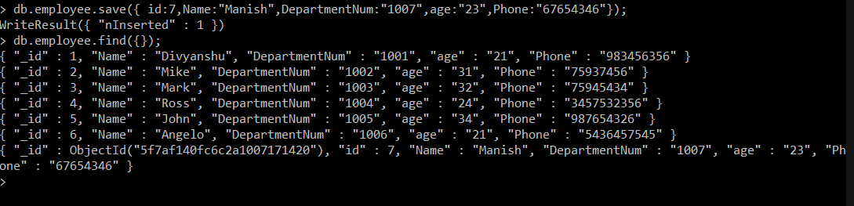

Insert with update and upsert:

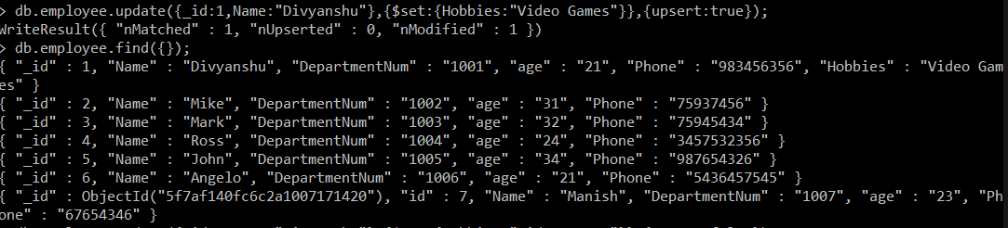

1. Insert into Department Collection:

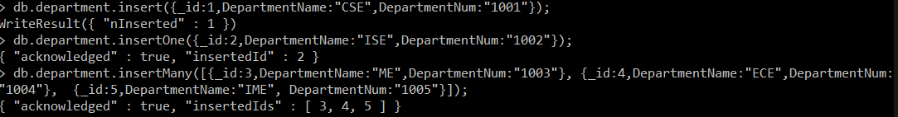

1. Update Employee Details:



1. Select All:

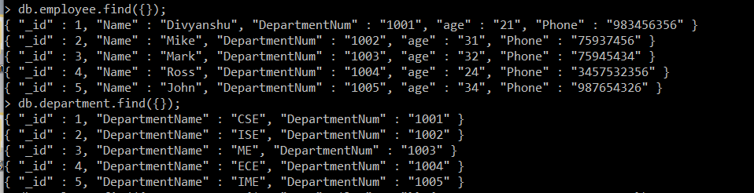

1. Find employee whose age is greater than 30:



1. Find employee whose name starts with A:

