1. Creation of Customer Collection, Inserting the documents

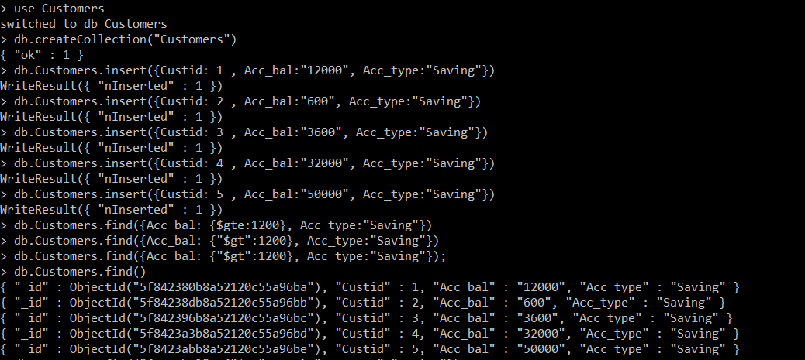

1. Showing the documents wholse balance is more than 1200:

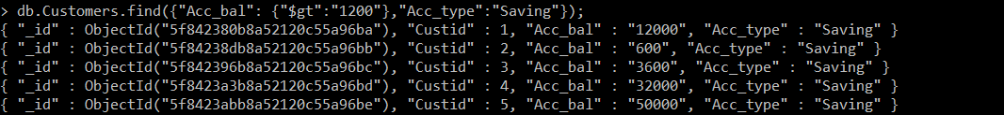

1. Minimum and Maximum account balance for each customer_id:

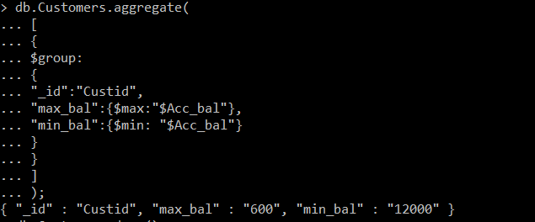

1. Exporting to csv file



1. Drop the table:

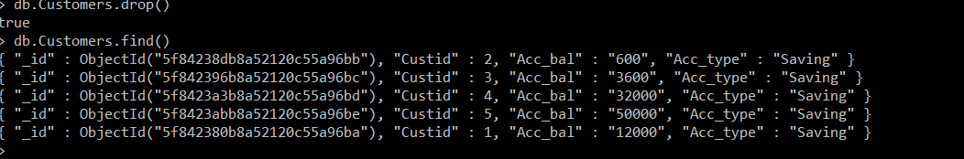

1. Importing the file:

