1. Create Students Collection, Insert fields, Change Email, Modify the Name

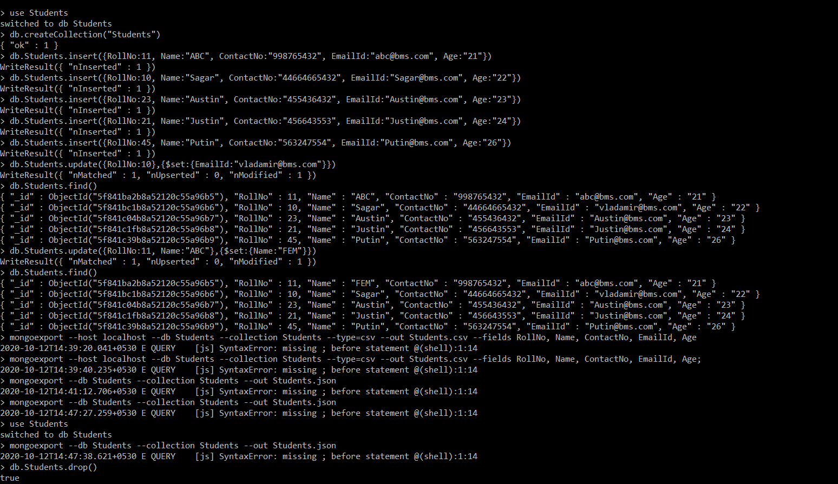

1. Export to json file



1. Import From Json File



1. Showing the data

