CASSANDRA INTRODUCTION LAB:

1. Create a Keyspace by name **Student:**

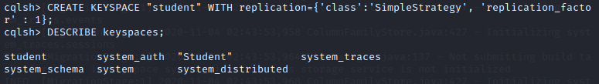

1. Create a Column Family by name **studentInfo** with attributes studentID, name, dateOfJoining, semester, departmentName:

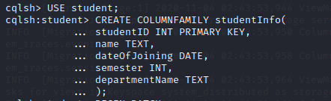

1. Insert values into column family **studentInfo** in batch:

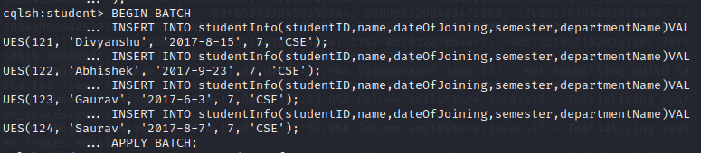

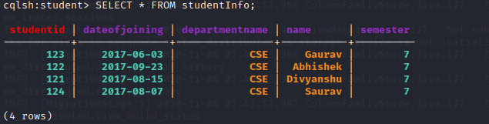

1. Update **name** of studentID 121:

