

LA GRANDEE INTERNATIONAL COLLEGE
Simalchaur, Pokhara, Nepal

Lab Assignment
Of
“DSA (Data Structures & Algorithm)”
Submitted By Submitted To
Divya Sharma Ashwin Poudel
PU Registration no: 2025-1-53-0323
Semester: 3rd
Program: BCA

LAB:1
Q1. Program to Input and Display 5 Elements of an Array
Algorithm:
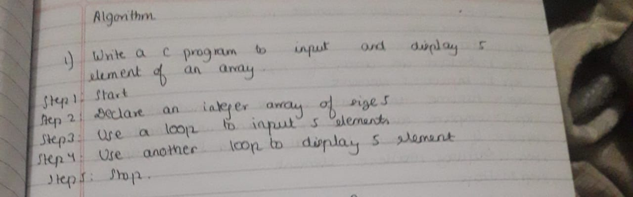
Code:

#include <stdio.h>
int main()
{
int a[5], i;
printf("Name: Divya Sharma\n");
printf("Registration No: 2025-1-53-0323\n");
printf("Enter 5 elements:\n");
for(i = 0; i < 5; i++)
{
scanf("%d", &a[i]);
}
printf("The elements are:\n");
for(i = 0; i < 5; i++)
{
printf("%d ", a[i]);
}
return 0;
}

Output:
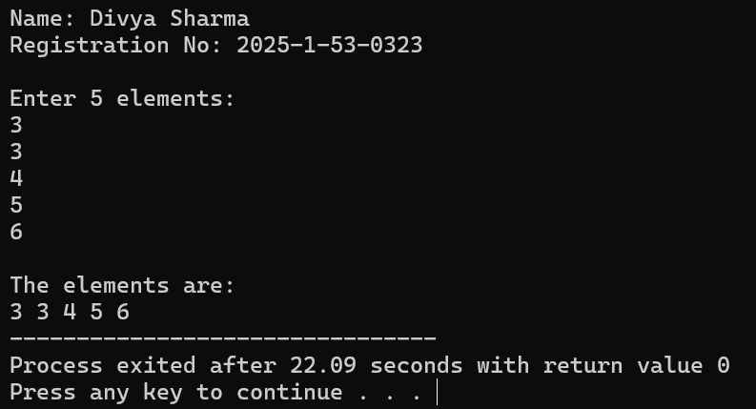
Time and Space Complexity
- Time Complexity: O(n)
- Space Complexity: O(n)

Q2. Program to Find the Sum of All Elements in an Array
Algorithm:
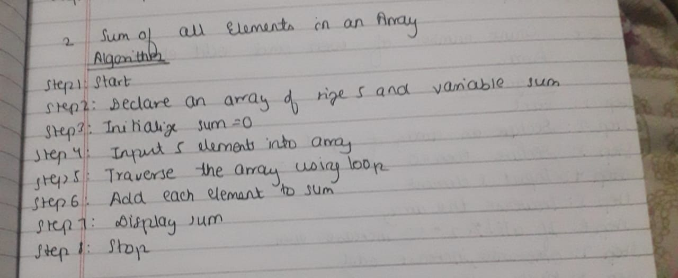
Code:

#include <stdio.h>
int main()
{
int a[5], i, sum = 0;
printf("Name: Divya Sharma\n");
printf("Registration No: 2025-1-53-0323\n");
printf("Enter 5 elements:\n");
for(i = 0; i < 5; i++)
{
scanf("%d", &a[i]);
}
for(i = 0; i < 5; i++)
{
sum = sum + a[i];
}
printf("Sum of all elements = %d\n", sum);
return 0;
}
Output:
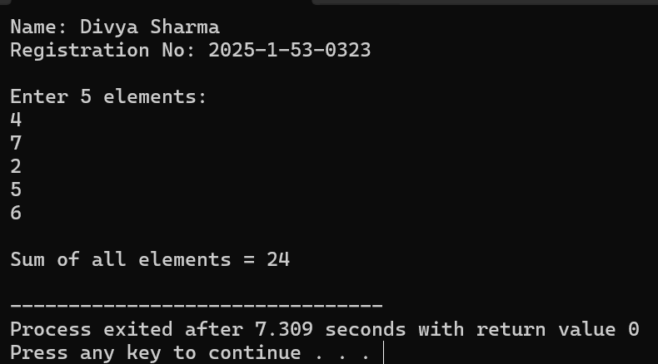
Time and Space Complexity
- Time Complexity: O(n)
- Space Complexity: O(n)

Q3. Program to Find the Largest Element in an Array
Algorithm:
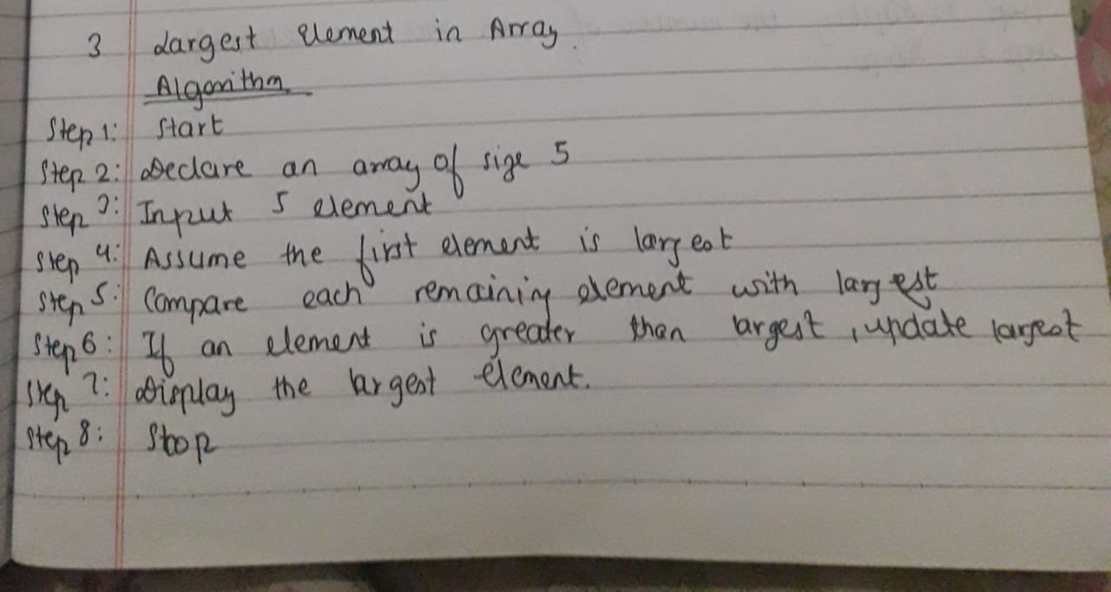

Code:

#include <stdio.h>
int main()
{
int a[5], i, largest;
printf("Name: Divya Sharma\n");
printf("Registration No: 2025-1-53-0323\n");
printf("Enter 5 elements:\n");
for(i = 0; i < 5; i++)
{
scanf("%d", &a[i]);
}
largest = a[0];
for(i = 1; i < 5; i++)
{
if(a[i] > largest)
{
largest = a[i];
}
}
printf("Largest element = %d\n", largest);
return 0;
}

Output:
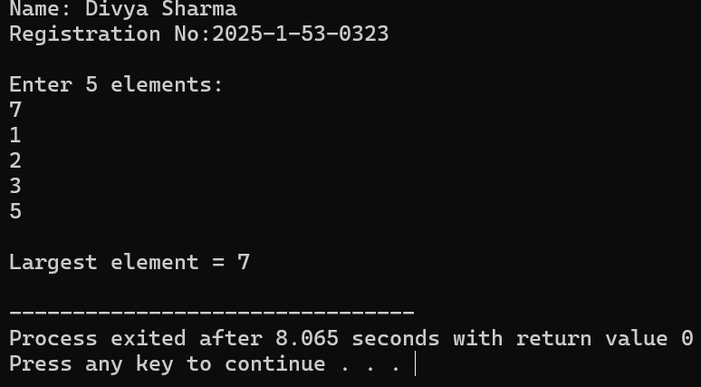
Time and Space Complexity
- Time Complexity: O(n)
- Space Complexity: O(n)

Q4. To find the Smallest Element in an Array
Algorithm:
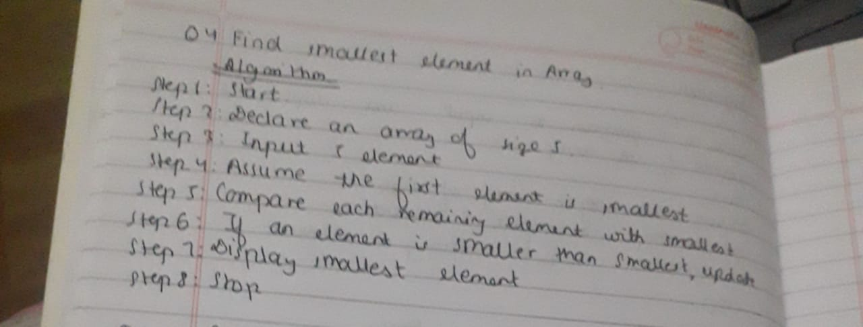
Code:

#include <stdio.h>

int main()
{
int a[5], i, smallest;
printf("Name: Divya Sharma\n");
printf("Registration No: 2025-1-53-0323\n");
printf("Enter 5 elements:\n");
for(i = 0; i < 5; i++)
{
scanf("%d", &a[i]);
}
smallest = a[0];
for(i = 1; i < 5; i++)
{
if(a[i] < smallest)
{
smallest = a[i];
}
}
printf("Smallest element = %d\n", smallest);
return 0;
}
Output:
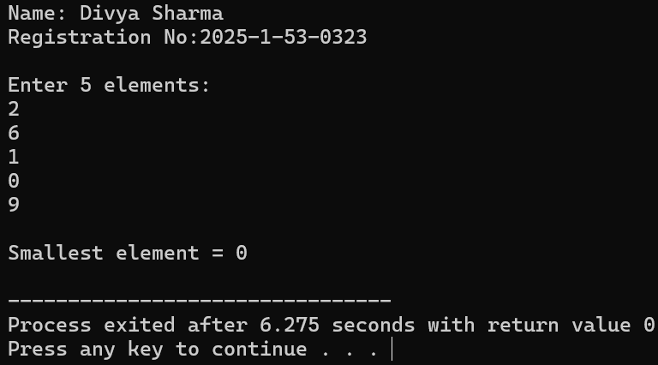
Time and Space Complexity
- Time Complexity: O(n)
- Space Complexity: O(n)

Q5. To Count Even and Odd Elements in an Array
Algorithm:
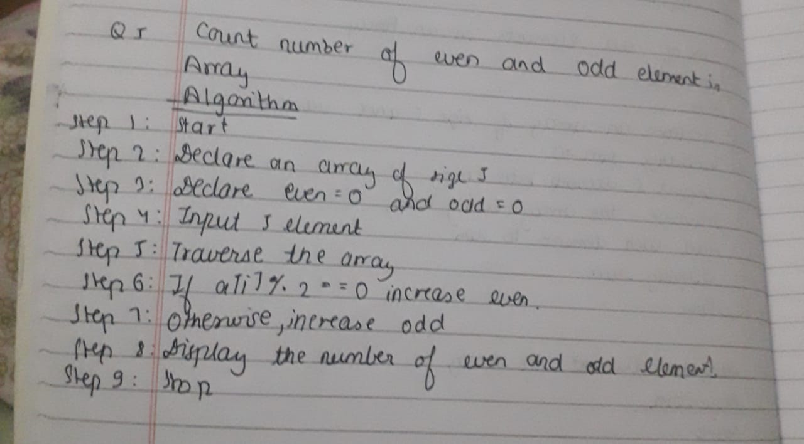
Code:
#include <stdio.h>
int main()
{
int a[5], i, even = 0, odd = 0;
printf("Name: Divya Sharma\n");
printf("Registration No: 2025-1-53-0323\n");
printf("Enter 5 elements:\n");
for(i = 0; i < 5; i++)
{
scanf("%d", &a[i]);
}
for(i = 0; i < 5; i++)
{
if(a[i] % 2 == 0)
{
even++;
}
else
{
odd++;
}
}
printf("Number of even elements = %d\n", even);
printf("Number of odd elements = %d\n", odd);

return 0;
}
Output:
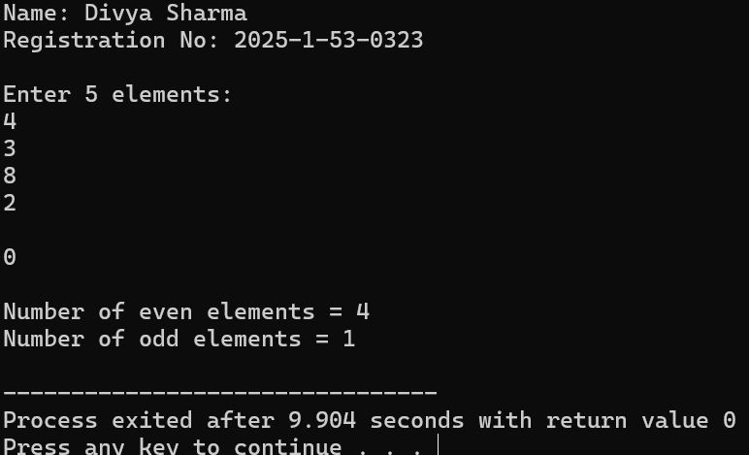
Time and Space Complexity
- Time Complexity: O(n)
- Space Complexity: O(n)

