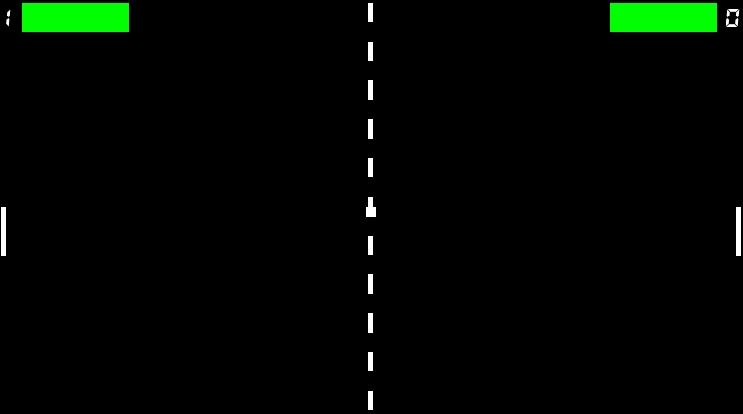

K

I

L

S

W

A

R

USE THE SUPERPOWER

USE THE SUPERPOWER

START THE GAME