Project Report
On
"Attendance-Linked Incentive Program"
Submitted to Punjab Technical University, Jalandhar
In partial fulfillment of the requirements
For the degree of
Bachelor of Technology in Computer Science and Engineering

Submitted To:  Ms. Sarabjit Kaur (Assistant Professor)  Department of Computer Science and Engineering | Submitted By:  Divya  Roll No: 2329321  Class / Section: Btech CSE 4B  Session: [2023-2024]
PCTE INSTITUTE OF ENGINEERING & TECHNOLOGY, LUDHIANA

Declaration
I swear that the work being presented by me in the dissertation titled "Attendance-Linked Incentive Program" in partial requirements for the fulfillment of degree of B.Tech Computer Science and Engineering to be submitted in PCTE INSTITUTE OF ENGINEERING AND TECHNOLOGY, LUDHIANA affiliated to PTU, Jalandhar is authentic record of my own work carried out by me under the supervision of Ms. Sarabjit Kaur.

Signature: ____________________
Divya
Roll no.: 2329321
Acknowledgement
On the very outset I would like to thank the almighty GOD for showering his blessing & providing me with the courage, motivation & strength to complete my project.
Every Project work demands a lot of hard work, time, patience and concentration. While working on this project, apart from these aspects, I have developed necessary skills and attitude, which are always required in a professional field. I am thankful to all those who helped me in completing this project.
I express my deep sense of gratitude towards my respected Project In-charge "Ms. Sarabjit Kaur", and faculty members of PCTE Institute of Engineering and Technology from whom I have learnt the technical skills for completion of this Project. Without their guidance, I would have found it really difficult to undertake the project work. I would like to thank them for their ever available, unconditional help & guidance that they made available throughout the project work.
I would also like to acknowledge the encouraging attitude of my friends & other staff members of P.C.T.E family that helped me to complete the project work.

Certificate from Organization
This is to certify that format and quality of presentation of project report submitted by
Divya and Gazi (Roll No. 2329321, 2329330)
As one of the requirements for the degree of
B.Tech Computer Science and Engineering
is acceptable to
Department of Computer Science and Engineering,
PCTE, Ludhiana

PCTE Institute of Engineering and Technology, Ludhiana
Certificate from Internal Guide
This is to certify that the project title "Attendance-Linked Incentive Program" submitted for the degree of B.Tech Computer Science and Engineering in the project of PCTE Institute of Engineering and Technology, Ludhiana affiliated to PTU, Jalandhar is a benefited research which is carried out by group of 2 member(s) under my supervision and no part of this project has been for any other degree. They have worked very hard and sincerely during this project.

Project Supervisor
SARABJIT KAUR
(Faculty, PCTE)
Ludhiana

Contents
- Introduction to project
- Study of Existing System
- Study of Proposed System
- Software and Hardware Requirements at time of development
- Objectives of Project
- Features of Project
- Site Map
- Module wise description
- Project Design (forms)
- Project Plan
- Development tool
- Conclusion and Future Scope

1. Introduction to Project

1.1 Overview
The Attendance-Linked Incentive Program is a blockchain-based decentralized application (DApp) that records student attendance on a public ledger and automatically rewards students who maintain the required attendance percentage. The core business logic is written as a smart contract in the Solidity programming language and deployed on an Ethereum-compatible network. A React.js frontend, a Node.js/Express backend and a Supabase (PostgreSQL) cloud database complete the system so that teachers, students and the administrator can use it through an ordinary web browser.
The central idea is simple: attendance is no longer a record that can be altered by anybody who controls a register or a database. Once a teacher confirms attendance through a blockchain transaction, the entry becomes tamper-proof and transparent. The reward rule (for example, minimum 75% attendance) is embedded in the contract, so the incentive is released by code and not by manual approval.

1.2 Background
Regular attendance is strongly linked to academic performance, yet most institutions still depend on paper registers or centralized ERP software. These systems rely on trust in a single administrator and can be affected by proxy attendance, manual errors and unauthorised edits. Blockchain technology provides an immutable, distributed and auditable ledger, while smart contracts allow rules to be executed automatically without a middle party. Combining the two gives a natural solution for transparent attendance tracking and rule-based incentives.

1.3 Problem Statement
Traditional attendance systems suffer from data tampering, proxy attendance, lack of transparency, delayed reporting and no direct motivation for students to attend regularly. There is a need for a system in which attendance records cannot be altered after confirmation, the eligibility rule is publicly verifiable, and incentives are delivered automatically and fairly.

1.4 Scope of the Project
- Role-based system with three roles: Admin, Teacher and Student.
- On-chain storage of sessions, attendance marks and reward claims, with off-chain storage of profile and reporting data in a database.
- Automatic reward payment when a student reaches the attendance threshold set by the admin.
- Deployment and testing on a local blockchain (Hardhat) and an Ethereum test network (Sepolia). Real-money deployment is outside the scope of this academic project.

2. Study of Existing System
In most colleges attendance is currently maintained in one of the following ways:
- Manual paper register: the teacher calls roll numbers and marks them in a register, which is later copied to a consolidated sheet.
- Centralized ERP / spreadsheet: attendance is typed into software stored on a single institutional server.
- Biometric or RFID devices: attendance is captured by hardware but still stored in a central database.

2.1 Limitations of the Existing System
Limitation | Description
Data tampering | Records in a register or central database can be edited or deleted by anyone with access, and the change may go unnoticed.
Proxy attendance | Roll-number based marking makes it easy for one student to mark another.
Lack of transparency | Students cannot independently verify how their attendance percentage was calculated.
Single point of failure | A server crash, data loss or lost register can destroy the entire record.
Time consuming | Manual consolidation and report preparation take significant time of faculty.
No incentive | Attendance is only monitored; there is no automatic benefit linked to good attendance.

3. Study of Proposed System
The proposed system moves the attendance rules and records to a smart contract. The teacher marks attendance through a signed transaction, the contract updates the student's count and emits an event, and a student who meets the minimum percentage can claim the reward directly from the contract. The backend and database mirror the on-chain events to provide fast searching, dashboards and reports.
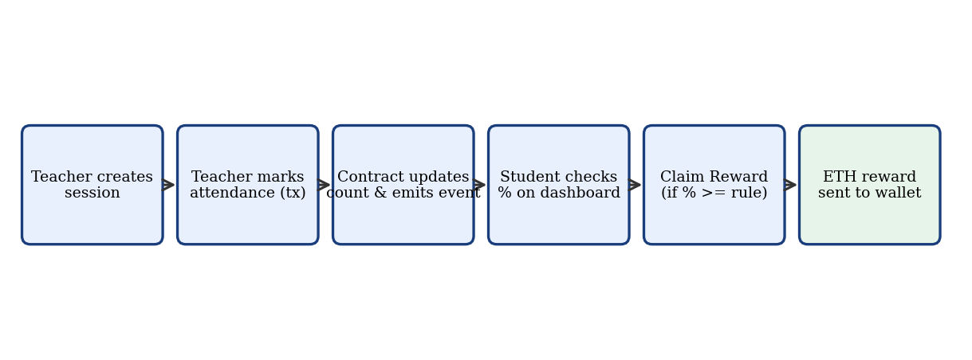
Fig 3.1: Working flow of the proposed system
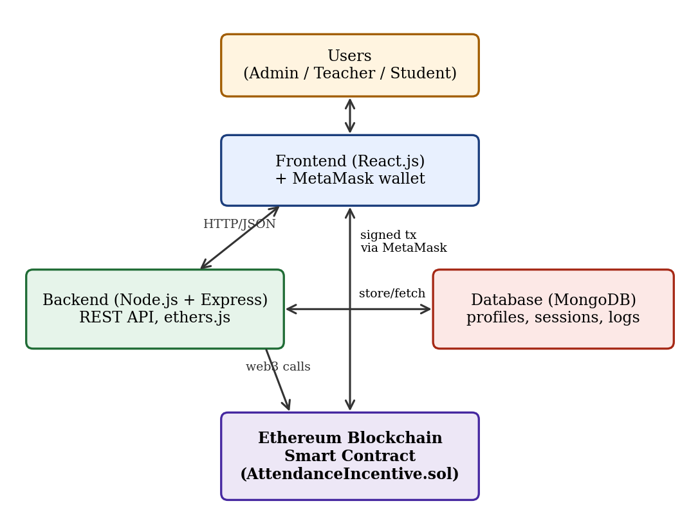
Fig 3.2: System architecture

3.1 How the System Works
- The admin deploys the smart contract, sets the required attendance percentage and reward amount, adds teachers and funds the contract.
- A teacher registers students (by wallet address) and creates a class session.
- For every session the teacher marks the present students. Each mark is a blockchain transaction that cannot be changed later.
- The contract increases the attended count of the student; the percentage is calculated as (attended x 100) / total sessions.
- A student opens the dashboard, views the percentage and, if eligible, presses Claim Reward. The contract verifies the rule and transfers the reward once.
- The backend listens to contract events and stores them in Supabase (PostgreSQL) for fast querying, reports, and history.

3.2 Existing versus Proposed System
Parameter | Existing System | Proposed System
Data integrity | Can be modified | Immutable once confirmed on chain
Transparency | Limited to administrators | Publicly verifiable by transaction hash
Trust | Depends on one authority | Enforced by smart contract code
Incentive | Manual or none | Automatic reward on meeting the rule
Availability | Single server | Distributed network nodes
Audit trail | Weak | Complete event log with timestamps

3.3 Advantages of the Proposed System
- Tamper-proof and auditable attendance records.
- Automatic and unbiased reward distribution.
- Reduced paperwork and faster reporting.
- Students can verify their own record at any time.
- Rule changes are controlled by the admin and are visible to everybody.

4. Software and Hardware Requirements at Time of Development

4.1 Software Requirements
Component | Specification
Operating System | Windows 10/11, Ubuntu 22.04 or macOS
Smart contract language | Solidity ^0.8.20
Blockchain framework | Hardhat (local node, compile, test, deploy); Remix IDE for quick trials
Blockchain network | Hardhat local network and Ethereum Sepolia test network
Frontend | React.js, HTML5, CSS3, JavaScript (ES6), ethers.js
Backend | Node.js (LTS) with Express.js
Database | Supabase (Cloud PostgreSQL) with @supabase/supabase-js
Wallet | MetaMask browser extension
Code editor | Visual Studio Code
Version control | Git and GitHub
Testing tools | Hardhat/Chai tests, Postman
Browser | Google Chrome or Brave with MetaMask support

4.2 Hardware Requirements
Component | Minimum Specification
Processor | Intel Core i3 / AMD Ryzen 3 or higher
RAM | 8 GB (4 GB minimum)
Storage | 10 GB free disk space
Network | Active internet connection (needed for Sepolia test network)
Display | 1366 x 768 or higher

5. Objectives of Project
- To design a tamper-proof attendance system using blockchain and smart contracts.
- To link attendance directly with an automatic incentive so that students are motivated to attend regularly.
- To remove dependence on a single trusted authority for storing and verifying attendance.
- To provide role-based access for admin, teacher and student with wallet-based authentication.
- To build a complete end-to-end application consisting of a Solidity smart contract, a REST backend, a database and a user-friendly web frontend.
- To provide transparent reports and a verifiable history of every attendance mark and reward claim.
- To study and apply security practices in smart-contract development such as access control and safe fund transfer.

6. Features of Project

6.1 Admin Features
- Deploys the contract and becomes the owner.
- Adds or authorises teachers.
- Sets the required attendance percentage and reward amount.
- Funds the contract that pays the rewards.

6.2 Teacher Features
- Registers students using their wallet address.
- Creates class sessions.
- Marks attendance on-chain; duplicate marking is rejected by the contract.
- Views session-wise and student-wise attendance reports.

6.3 Student Features
- Connects MetaMask wallet to log in.
- Views total sessions attended and live attendance percentage.
- Sees eligibility status for the reward.
- Claims the reward once when eligible and views transaction history.

6.4 System and Security Features
- Immutable records with event logs and timestamps.
- Role-based access control implemented with Solidity modifiers.
- One-time reward claim protection and state update before transfer (checks-effects-interactions pattern).
- Input validation on the smart contract, backend and frontend.
- Responsive web interface and real-time transaction status messages.

7. Site Map
The site map shows the navigation structure of the web application. After connecting the wallet, the user is routed to the dashboard of his or her role.
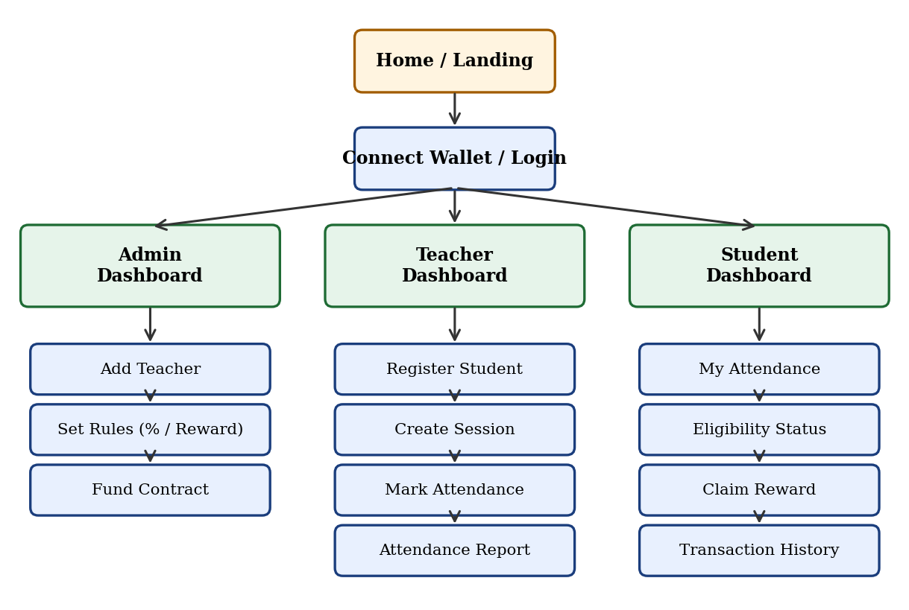
Fig 7.1: Site map of the application

8. Module Wise Description
The project is divided into five modules. Each module is developed and tested independently and then integrated.

8.1 Module 1: Smart Contract (Blockchain Layer)
This module contains the file AttendanceIncentive.sol. It stores students, teachers, sessions and attendance and implements the reward rule. The important functions are listed below; the full source code is given in Appendix A.
Function | Access | Purpose
constructor(percent, reward) | Deployer | Sets admin, required percentage and reward amount
addTeacher(address) | Admin | Authorises a teacher wallet
registerStudent(address) | Teacher | Registers a student
createSession() | Teacher | Creates a new class session and increases total sessions
markAttendance(id, student) | Teacher | Marks a student present for a session (no duplicates)
attendancePercent(student) | Public view | Returns attendance percentage
claimReward() | Student | Checks eligibility and transfers reward once
fund() | Anyone | Adds ETH to the contract balance for rewards
The contract also emits the events StudentRegistered, SessionCreated, AttendanceMarked and RewardClaimed, which the backend listens to.

8.2 Module 2: Backend (Server Layer)
Built with Node.js and Express. It exposes REST APIs, connects to the blockchain using ethers.js, listens to contract events and stores processed data in the database.
Endpoint | Method | Description
/api/auth/nonce | GET | Returns a random message for wallet signature login
/api/auth/verify | POST | Verifies the signed message and returns a JWT token with the role
/api/students | GET/POST | List students or save student profile details
/api/sessions | GET/POST | List sessions or store a new session with its transaction hash
/api/attendance/:sessionId | GET | Attendance list for a session
/api/students/:id/summary | GET | Attendance percentage and eligibility of one student
/api/rewards | GET | Reward claim history
/api/sessions/code | GET/POST | Generates or retrieves active 6-digit rolling PIN for anti-proxy presence (120s timer)
/api/sessions/verify-presence | POST | Cryptographically verifies student presence against active classroom PIN
/api/messages | GET/POST | Lists student helpdesk queries or submits a new grievance ticket
/api/messages/:id/reply | POST | Faculty posts official resolution reply to student grievance ticket

8.3 Module 3: Database (Storage Layer)
Supabase (Cloud PostgreSQL) stores off-chain relational data that is expensive to keep on the blockchain, such as student profiles, roll numbers, session metadata, anti-proxy verification PINs, helpdesk query messages, and an indexed mirror of blockchain events for instant querying. The blockchain remains the single source of truth; every database record carries the transaction hash so that it can be independently verified.
PostgreSQL Table (Supabase) | Relational Schema & Key Attributes
users | wallet_address (PK), name, roll_no, department, semester, role, created_at
sessions | session_id (PK), subject, tx_hash, created_by (FK -> users), conducted_at
attendance | session_id (FK -> sessions), student_address (FK -> users), status, tx_hash, marked_at
rewards | tx_hash (PK), student_address (FK -> users), percent, amount_eth, claimed_at
messages | id (PK), student_address (FK -> users), subject, message_text, reply_text, status, created_at
presence_codes | session_id (PK, FK -> sessions), rolling_code (VARCHAR 6), expires_at (TIMESTAMP)

8.4 Module 4: Frontend (User Interface Layer)
Developed in React.js with a responsive layout. It uses ethers.js and MetaMask to send signed transactions, and Axios to call the backend. Separate dashboards are provided for admin, teacher and student, with loading indicators and success or error messages for each transaction.

8.5 Module 5: Authentication and Wallet Integration
Users do not create passwords. They sign a one-time message with MetaMask, the backend verifies the signature, checks the role (from the contract and database) and issues a JWT token for API access. This removes password leakage risks and proves ownership of the wallet address.

9. Project Design (Forms)

9.1 Database Design (ER Diagram)
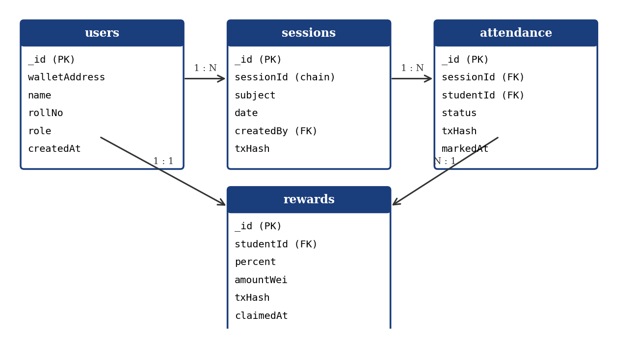
Fig 9.1: Entity relationship diagram

9.2 User Interface Forms
The screenshots of the actual running application are to be inserted in the boxes below, in the same order. 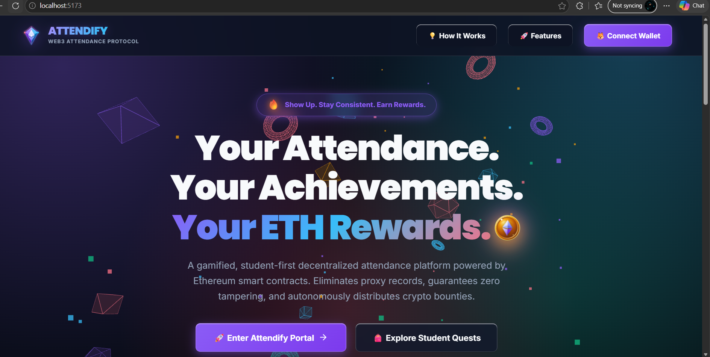
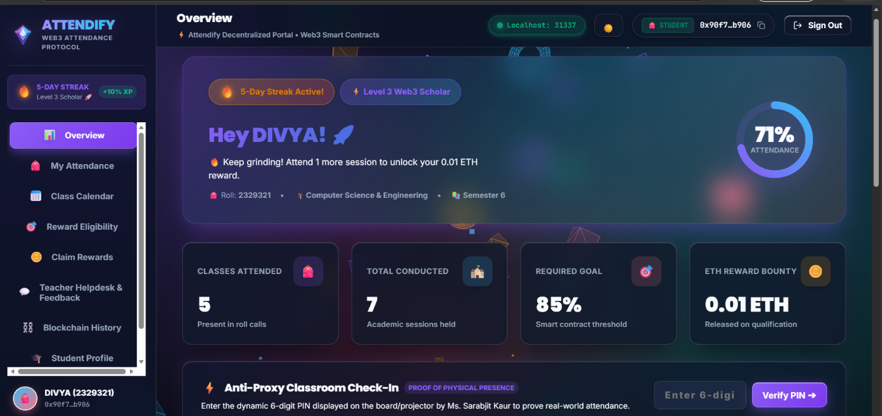
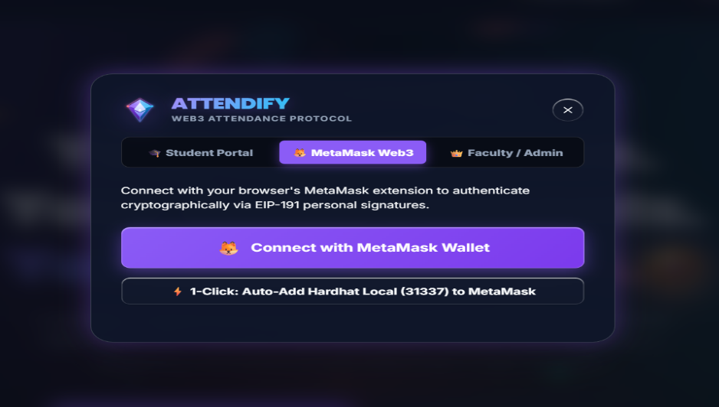

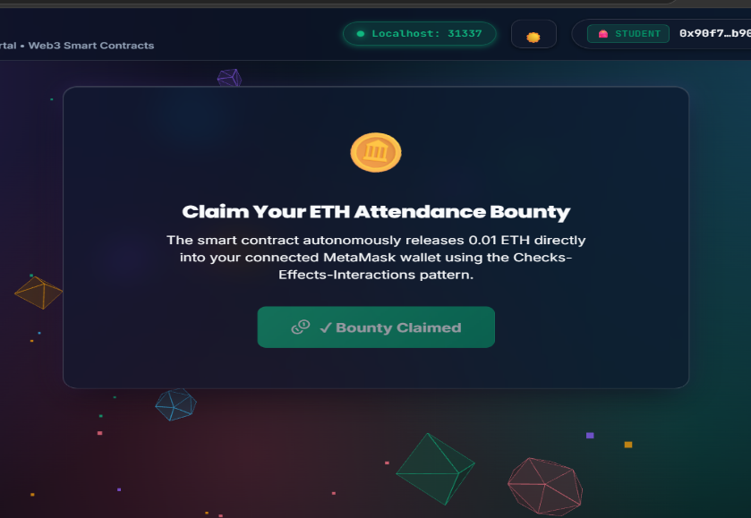

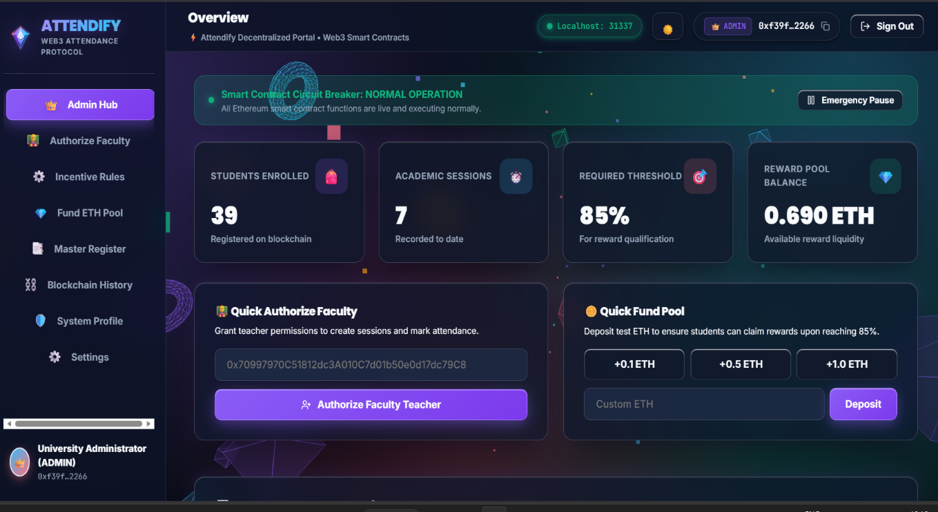

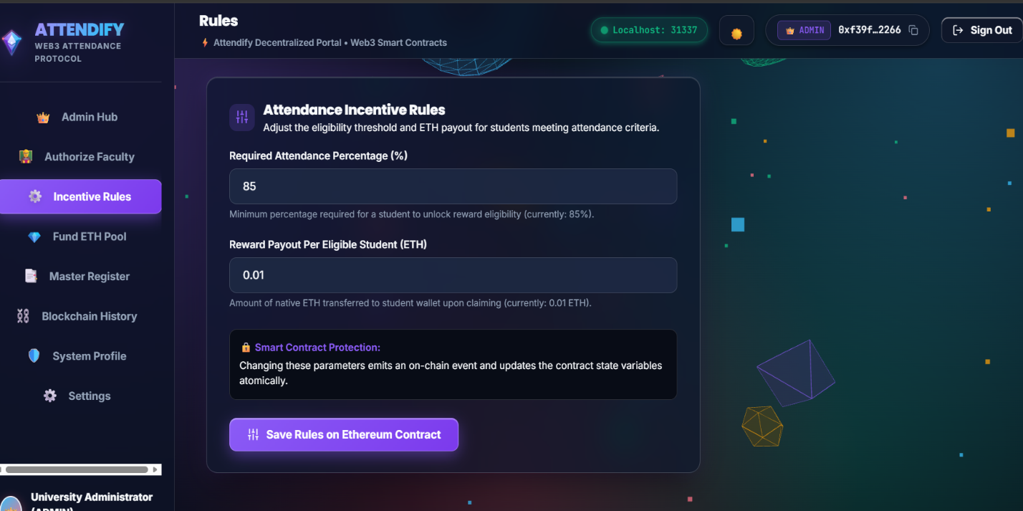

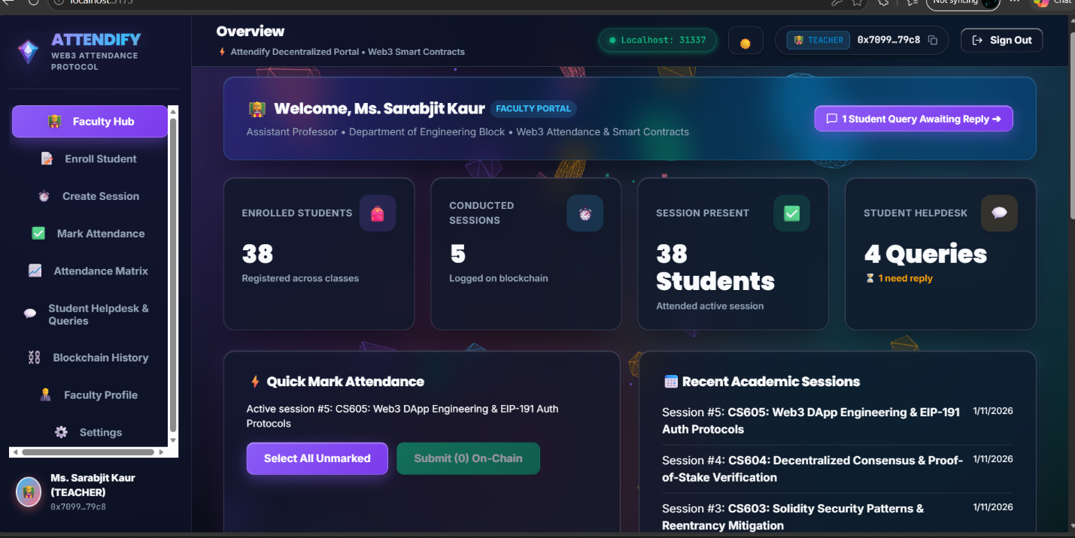

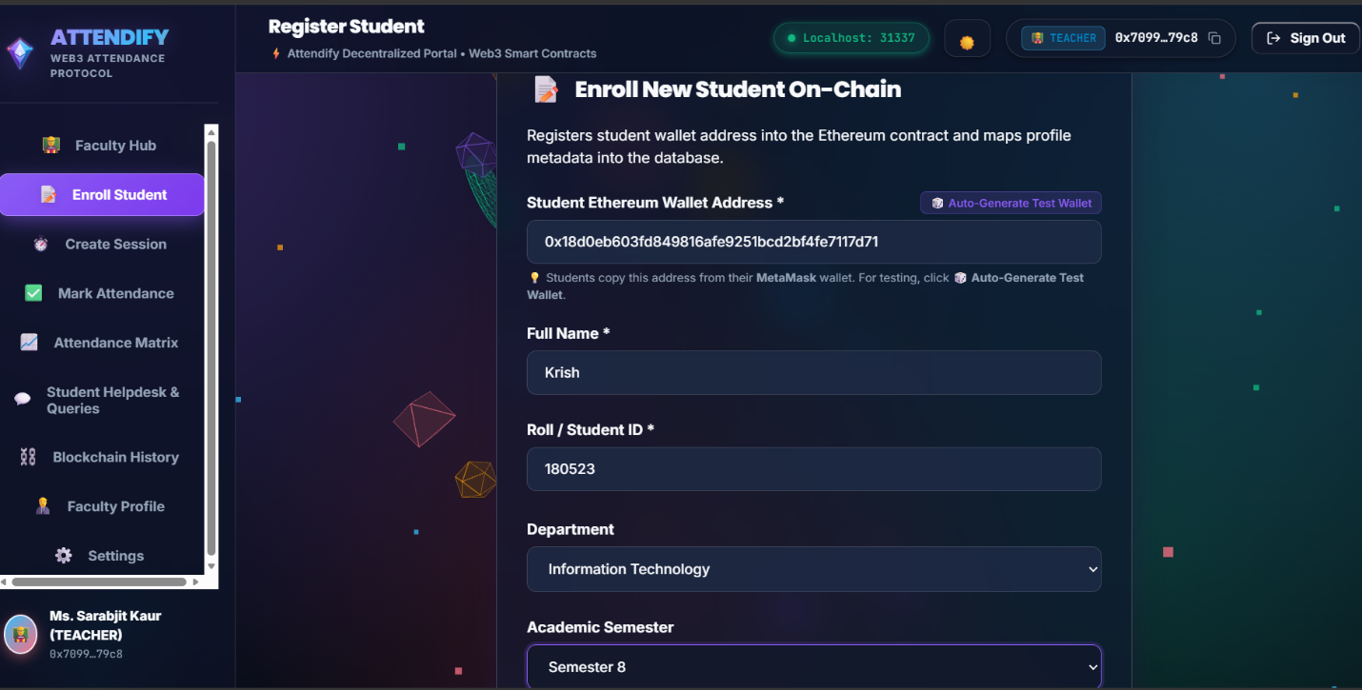

9.3 Test Cases
No. | Test Case | Expected Result | Status
1 | Non-teacher calls markAttendance | Transaction reverts with "Only teacher" | [Pass]
2 | Mark same student twice for one session | Reverts with "Already marked" | [Pass]
3 | Mark unregistered student | Reverts with "Not registered" | [Pass]
4 | Claim reward with attendance below required % | Reverts with "Attendance too low" | [Pass]
5 | Claim reward with attendance at or above required % | Reward transferred, event emitted | [Pass]
6 | Claim reward second time | Reverts with "Already claimed" | [Pass]
7 | Claim when contract balance is low | Reverts with "Insufficient funds" | [Pass]
8 | Login with invalid signature | Backend returns 401 Unauthorized | [Pass]
9 | Batch marking attendance for multiple students | markAttendanceBatch commits records in 1 atomic tx | [Pass]
10 | Create session with empty subject string | Reverts with custom error "Empty subject" | [Pass]
11 | Non-admin attempts to add or remove teachers | Reverts with custom error "OnlyAdmin" | [Pass]
12 | Registering already enrolled student or 0x0 address | Reverts with "StudentAlreadyRegistered" | [Pass]
13 | Emergency Circuit Breaker: admin pauses contract | State-changing calls revert with "EnforcedPause" | [Pass]
14 | Admin dynamically adjusts criteria (setRules) | Parameters update atomically on-chain; event emitted | [Pass]
15 | Mathematical analytics helper functions | attendancePercent and isEligible return exact metrics | [Pass]
Note: All 15 automated unit test cases were verified and passed with a 100% success rate on Hardhat.

10. Project Plan
The project was planned in phases following an incremental development model.
No. | Phase | Activities | Duration
1 | Requirement analysis | Problem study, literature survey, finalising features and roles | Week 1-2
2 | System design | Architecture, site map, database design, contract design | Week 3
3 | Smart contract development | Writing Solidity code, unit tests, local deployment | Week 4-5
4 | Backend and database | REST APIs, event listener, Supabase SQL schema & client SDK, JWT login | Week 6-7
5 | Frontend development | React pages, MetaMask integration, dashboards | Week 8-9
6 | Integration and testing | End-to-end testing on Sepolia, bug fixing, security review | Week 10-11
7 | Documentation | Project report, screenshots, presentation | Week 12
[Adjust the durations to match your real timeline.]

11. Development Tools
Tool | Use in the Project
Solidity | Programming language of the smart contract
Hardhat | Compile, test and deploy contracts; local blockchain
Remix IDE | Browser IDE for quick contract experiments
MetaMask | Wallet for signing transactions and login
ethers.js | Library for interacting with the contract from frontend and backend
React.js | Building the user interface
Node.js and Express.js | Backend server and REST API
Supabase (PostgreSQL) | Cloud relational database and real-time client SDK
Postman | Testing the REST APIs
Git and GitHub | Version control and code hosting
Visual Studio Code | Source code editor

12. Conclusion and Future Scope

12.1 Conclusion
The Attendance-Linked Incentive Program demonstrates how blockchain and smart contracts can bring transparency, trust and automation into the attendance process. Attendance records become tamper-proof, eligibility is calculated by code, and rewards are released without manual intervention. The project also gave practical experience in Solidity, wallet integration, backend development and database design.

12.2 Future Scope
- Replace the ETH reward with an ERC-20 token or a digital certificate (NFT) for achievement.
- Add face recognition, QR code or geo-fencing to prevent proxy attendance before the on-chain mark.
- Deploy on a low-cost layer-2 network or a permissioned blockchain to reduce gas fees.
- Integrate with the college ERP and provide a mobile application.
- Add analytics dashboards and automatic alerts for students with low attendance.

