Assignment Submission

Heading: Challenge 01

Approach: First, I looked at the status of the interface devices. I got the IP of the server i.e. 10.0.0.1, I tried connecting it but failed.
Solution: I went to the switch this time directly, went to the Config tab and tried seeing the config of fastEthernet 0/1, this gave me access to the CLI and I ran the following commands:
(config)#exit
#copy running-config startup-config

These commands helped me recover the running config which is in the primary memory of the switch making it volatile, further when exporting these files I got a file stating all the commands used for setting up the network. One command in particular caught my attention:
username net privilege 1 password 0 game
This gave me the username ‘net’ and the password ‘game'
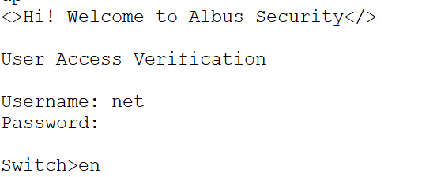

Heading: Challenge 03

Approach: We check the status of the VLAN. Try to find the issues and do the needful to set the VLAN properly.
Solution: While checking the communication of packets, we see bob and vicer are configured to 2 different VLANs, hence hindering in their communication. To make them work, we switch the VLAN of fastEthernet 0/3 of admin switch to 1 instead of 2 to make it work. I did it with the following step:
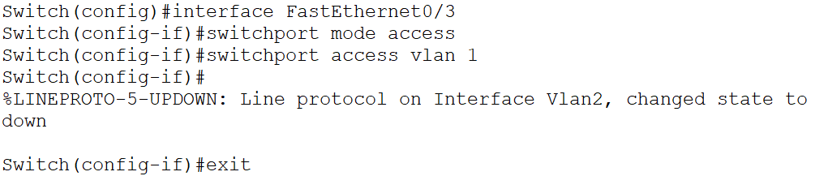

Heading: Challenge 04
Approach: Understand the problem of configuring the hostname on a switch. Researched methods for Cisco switches running IOS. Analyse with available commands.
Solution:
Utilized the following command for Cisco switches running IOS:
Switch# configure terminal
Switch(config)# hostname R1

Heading: Challenge 05
Approach: Understand the problem between lines and solve them.
Solution:
line status of fastEthernet 0/3 of the Junior switch was down, brought that up by using the following commands:
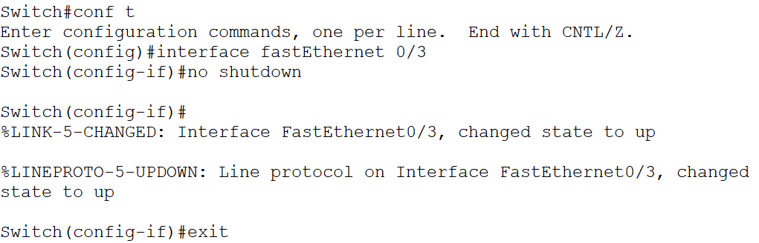

Heading: Challenge 06
Approach: Troubleshoot for the error in the network and fix it with the pre-requisite knowledge.
Solution:
Configure the switches first-
Admin:
Switch(config)#interface gig0/1
Switch(config-if)#switchport mode trunk
Switch(config)#interface fa0/3
Switch(config-if)#switchport mode access
Switch(config-if)#switchport access vlan 2
Switch(config-if)#exit
Switch(config)#interface fa0/2
Switch(config-if)#switchport mode access
Switch(config-if)#switchport access vlan 1
Switch(config-if)#exit
Switch(config)#interface fa0/1
Switch(config-if)#switchport mode access
Switch(config-if)#switchport access vlan 3
Switch(config-if)#exit
Switch(config)#end
Switch#write memory

Senior:
Switch(config)#interface gig0/1
Switch(config-if)#switchport mode trunk
Switch(config)#interface fa0/1
Switch(config-if)#switchport mode access
Switch(config-if)#switchport access vlan 2
Switch(config-if)#exit
Switch(config)#interface fa0/2
Switch(config-if)#switchport mode access
Switch(config-if)#switchport access vlan 3
Switch(config-if)#exit
Switch(config)#interface fa0/3
Switch(config-if)#switchport access vlan 1
Switch(config-if)#switchport mode access
Switch(config-if)#switchport access vlan 1
Switch(config-if)#exit
Switch(config)#end
Switch#write memory

Now I changed the following IPs:
VLAN1 On Senior: 10.0.0.2
VLAN2 on Senior: 30.0.0.2
VLAN3 on Senior: 40.0.0.2
Bob’s IP: 192.168.2.1
Hope’s IP: 192.168.1.1
Vicer’s IP: 192.168.3.1
Carlos’s IP: 192.168.2.2
Jack’s IP: 192.168.3.2
Harry’s IP: 192.168.1.2
All of this made the network work again.
Heading: Challenge 7
Approach: I took the following actions to resolve a layer 1 problem on functional interfaces, specifically duplex mismatches shown by late collisions.
Solution:
Fixed duplex mismatch in one of the switches named Senior using the following commands:
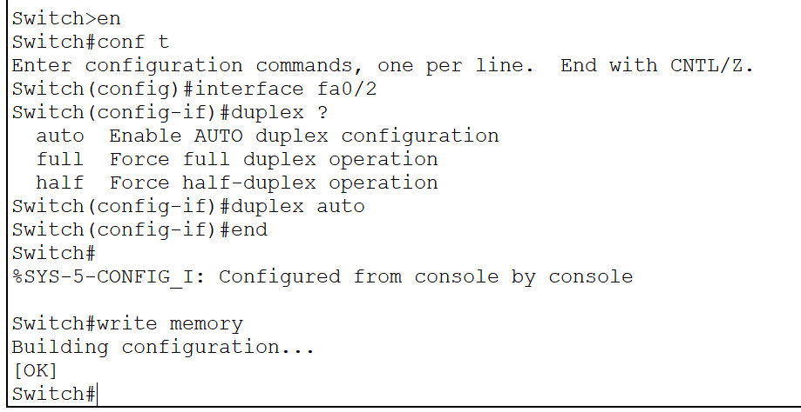

Heading: Challenge 08
Approach: Read the running-configs. See the configuration of SSH in the switches and configure them accordingly.
Solution:
The Admin Switch had SSH setup improperly. I set it up properly using the following commands:

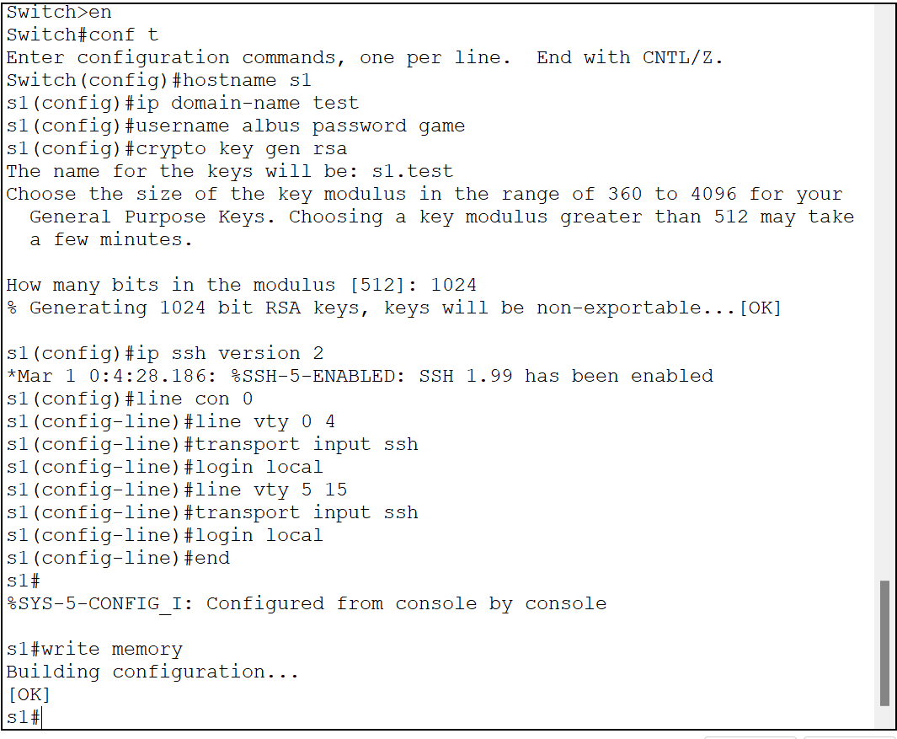

Heading: Challenge 09
Approach: Learn about SSH timeouts
Solution:
Disable SSH timeout:
Switch(config)#line vty 0 15
Switch(config-line)#exec-timeout 0 0

Disable console timeout:
Switch(config)# line console 0
Switch(config-line)# exec-timeout 0 0

Don’t forget to save the settings using : write memory

Heading: Challenge 10
Approach: Recognised trunking and VLAN problems in the lab.
based on research, selected a methodical troubleshooting technique.
Solution:
To fix the VLAN, we perform the following operations in the switches:
Switch Admin:
Switch(config)#interface vlan 1
Switch(config-if)#ip address 10.0.0.3 255.255.255.0
Switch(config-if)#no shutdown
Switch(config)#interface fa0/1-2
Switch(config-if)#switchport mode trunk
Switch(config-if)#interface fa0/3
Switch(config-if)#switchport mode access
Switch(config-if)#switchport access vlan 1

Switch Junior:
Switch(config)#interface vlan 1
Switch(config-if)#ip address 10.0.0.1 255.255.255.0
Switch(config-if)#no shutdown
Switch(config)#interface fa0/1-2
Switch(config-if)#switchport mode trunk
Switch(config-if)#interface fa0/3
Switch(config-if)#switchport mode access
Switch(config-if)#switchport access vlan 1

Switch Senior:
Switch(config)#interface fa0/1
Switch(config-if)#no shutdown
Switch(config)#interface fa0/1-2
Switch(config-if)#switchport mode trunk

