THADOMAL SHAHANI ENGINEERING COLLEGE
University of Mumbai
Department of Computer Engineering

DATA WAREHOUSING AND MINING LABORATORY
Lab Code 2115120 | Semester V | Academic Year 2026-27
COMPLETE LABORATORY DOCUMENTATION
Experiments 1 to 8 — running documents with code, output screenshots and results

CASE STUDY
Predicting Trends and Uncovering Patterns in Bitcoin Price Movement Using Data Mining Techniques
Retail investors trade Bitcoin on hype, influencer opinion and panic rather than on evidence. Bitcoin trades 24x7 and has produced an uninterrupted daily OHLC series since July 2010 that covers several documented boom-bust cycles. This project builds a data mart over 5,684 daily records (17 July 2010 to 27 March 2026, 20 attributes) and mines it for patterns in trend and volatility — comparing behaviour across the five block-reward (halving) eras, discovering recurring market regimes, and benchmarking how far next-day direction can honestly be predicted.
Domain | Financial Technology (FinTech) — cryptocurrency market analytics
Dataset | btc_flat_final_2.csv — 5,684 daily records, 20 attributes, 1.10 MB
Period covered | 17 July 2010 to 27 March 2026 (15 years 8 months)
Tools used | PostgreSQL 16, Python 3 (pandas, NumPy, matplotlib, seaborn, SciPy), Microsoft Excel, Jupyter Notebook
Techniques applied | Dimensional modelling, ETL, OLAP, preprocessing, classification, clustering, association rule mining
SUBMITTED BY
Name | Roll No. | Class
Divvye Kansara | 2403080 | TE Computer Engineering
Jai Kukreja | 2403090 | TE Computer Engineering
SUBJECT IN-CHARGE
Dr. Ujwala Bharambe

Date of submission: 13 September 2026

INDEX
Exp | Title | CO | Contents
1 | Case Study, Business Requirements and Dimensional Modelling | LO1 | Problem statement, dataset description, data dictionary, star and snowflake schema
2 | Implementation of Dimension and Fact Tables in PostgreSQL | LO1 | Database creation, DDL, ETL with surrogate keys, verification of the loaded mart
3 | Implementation of OLAP Operations | LO2 | Slice, dice, roll-up, drill-down, pivot and CUBE in SQL, plus Excel pivot tables
4 | Data Preprocessing and Exploration | LO3 | Code review of the cleaning script, descriptive analysis, null handling, normalization, discretization
5 | Naive Bayesian and Classification Tree Algorithms | LO4 | Next-day direction prediction, both classifiers from scratch, confusion matrix and metrics
6 | Implementation of Clustering Algorithm (K-Means) | LO4 | Hand-solved example, K-Means from scratch, market regimes, performance matrix
7 | Implementation of Hierarchical Clustering | LO4 | Agglomerative clustering from scratch, four linkage rules, dendrograms, interpretation
8 | Implementation of Association Rule Mining (Apriori) | LO4 | Transaction modelling, Apriori from scratch, frequent itemsets, rules with lift
NOTE ON THE WORK
- Every result in this document was produced by running the code, not by transcription. PostgreSQL 16 was used for Experiments 2 and 3; the psql output in the screenshots is the actual session output.
- Each algorithm required by the syllabus — K-Means, Naive Bayes, the classification tree, agglomerative clustering and Apriori — is implemented from first principles without a library implementation, and each is verified against a reference (scikit-learn, SciPy, or exhaustive enumeration) in its own experiment.
- The existing cleaning script was reviewed as part of Experiment 4; five defects were found and corrected in data_cleaning_v2.py, including one that made the script fail outright on its configured input file.

EXPERIMENT 1: CASE STUDY, BUSINESS REQUIREMENTS AND DIMENSIONAL MODELLING
Bitcoin price data mart — detailed problem statement, dataset description, data dictionary, and the design of the star and snowflake schemas
Lab Code | Lab Name | Sem | Experiment | Course Outcome
2115120 | Data Warehousing and Mining | V | 1 | LO1

1. Aim
To select a case study for building a data warehouse / data mart, write a detailed problem statement with its business requirements, describe the dataset and prepare its data dictionary, and design the dimensional model by constructing the star and snowflake schemas.
2. Problem Statement
Domain: Financial Technology (FinTech) — cryptocurrency market analytics, a subfield of quantitative finance that applies statistical and data-mining methods to digital-asset price behaviour.
Retail investors frequently make Bitcoin trading decisions on hype, influencer opinion or panic rather than on historical evidence, which leads to poor timing and avoidable losses. Bitcoin trades continuously — 24 hours a day, 7 days a week — and has produced an uninterrupted daily OHLC series since July 2010 that spans several well-documented boom-bust cycles (2013, 2017-18, 2021 and 2024-25). That history is long enough, and dense enough, to be mined for recurring statistical patterns in trend and volatility behaviour.
The project therefore builds a data mart over 15+ years of daily Bitcoin OHLC data and applies the core DWM techniques on top of it — OLAP analysis, preprocessing, classification, clustering and association rule mining — to answer questions such as: how has volatility behaved across the halving eras, which market regimes recur, and can next-day direction be predicted better than a coin toss. Because the dataset is purely numeric (open, high, low, close plus derived indicators), it avoids the noise of unstructured or categorical data and allows the techniques to be applied directly.
Scope note: given the well-documented difficulty of forecasting financial markets, the project is framed around pattern discovery, trend visualisation and honest model benchmarking rather than high-accuracy price prediction.
3. Business Requirements
- Volatility and risk profiling: quantify daily volatility (intraday range and 30-day rolling standard deviation) so that periods of elevated risk can be identified and used as inputs to risk-alert and position-sizing rules.
- Halving-era comparison: measure how return and volatility behaviour differs across the five block-reward eras (50, 25, 12.5, 6.25 and 3.125 BTC/block), testing whether the market has matured as the reward has fallen.
- Trend and momentum analysis: track price against its 7-, 30- and 200-day moving averages, MACD and RSI to classify each trading day as trending, ranging, overbought or oversold.
- Market-regime discovery: group historical trading days into regimes (calm, mild trend, volatile sell-off, volatile rally) so that current conditions can be matched against comparable historical periods.
- Directional prediction benchmark: build and honestly evaluate a next-day up/down classifier, establishing a documented baseline rather than an over-claimed forecasting tool.
- Cycle-level reporting: support roll-up and drill-down from daily prices to monthly, quarterly, yearly and halving-era summaries for reporting and presentation.
4. Dataset Description
The dataset is a single flat file of daily Bitcoin market data with pre-computed technical indicators. It is the source (staging) file from which the data mart is loaded.
Property | Value
Source file | btc_flat_final_2.csv (1.10 MB)
Asset | BTC (Bitcoin), quoted in USD
Total records | 5,684 daily observations
Total attributes | 20 columns
Time span | 17 July 2010 to 27 March 2026 (15 years 8 months)
Granularity | one row per calendar day per asset
Price range covered | $0.0495 (Jul 2010) to $125,173.00 (all-time high)
Halving eras covered | 5 (Genesis 50 BTC/block through Post-Halving 4, 3.125 BTC/block)
Missing calendar days | 50 dates absent from an otherwise continuous daily series
Duplicate dates | 1
Null values | 279 in total, concentrated in the moving-average burn-in period
Target variables | close (regression), next-day direction (classification), daily_pct_change and daily_range (clustering)

Records per halving era: Post-Halving 3 (6.25 BTC/block) 1,440; Post-Halving 2 (12.5) 1,402; Post-Halving 1 (25) 1,319; Genesis (50) 865; Post-Halving 4 (3.125) 658.
Data-quality observations that carry forward into Experiment 4: the 50 missing calendar days must be filled (Bitcoin trades every day, so a gap is a recording gap, not a market holiday); the single duplicate date must be removed; the nulls in ma_7 / ma_30 / ma_200 / volatility_30d / rsi_14 are the natural burn-in of a rolling window, not corrupted data; and the extreme values in February 2014 (daily_pct_change up to +336.84%) are genuine Mt. Gox-era prints that must be treated as outliers rather than errors.

5. Data Dictionary
Field-level definition of the source dataset. The SQL types are those used for the staging table in Experiment 2.
Field Name | SQL Data Type | Key | Nullable (count) | Description | Domain / Range
date | DATE | PK (business) | No | Calendar date of the trading day | 2010-07-17 to 2026-03-27
ticker | VARCHAR(10) | None | Yes (1) | Asset symbol; constant for this dataset | BTC
halving_era | VARCHAR(40) | None | No | Block-reward era the day belongs to | 5 distinct values
days_since_halving | INT | None | No | Days elapsed since the start of the current era | 0 to 1439
open | NUMERIC(14,4) | None | No | Opening price of the day in USD | 0.0495 to 125172.70
high | NUMERIC(14,4) | None | Yes (1) | Highest price reached during the day | 0.0495 to 126300.60
low | NUMERIC(14,4) | None | No | Lowest price reached during the day | 0.0100 to 122812.50
close | NUMERIC(14,4) | None | No | Closing price of the day in USD | 0.0495 to 125173.00
daily_change | NUMERIC(14,4) | None | No | close - open, in USD | -8570.45 to 8138.70
daily_pct_change | NUMERIC(10,4) | None | No | (close - open) / open x 100 | -57.21 to 336.84
daily_range | NUMERIC(14,4) | None | No | high - low, in USD (intraday swing) | 0.00 to 18347.30
ma_7 | NUMERIC(14,4) | None | Yes (6) | 7-day simple moving average of close | 0.0562 to 122800.51
ma_30 | NUMERIC(14,4) | None | Yes (29) | 30-day simple moving average of close | 0.0617 to 117479.00
ma_200 | NUMERIC(14,4) | None | Yes (199) | 200-day simple moving average of close | 0.1784 to 110381.32
volatility_30d | NUMERIC(10,4) | None | Yes (29) | 30-day rolling std dev of daily_pct_change | 0.7026 to 68.5481
ema_12 | NUMERIC(14,4) | None | No | 12-day exponential moving average of close | 0.0495 to 120201.75
ema_26 | NUMERIC(14,4) | None | No | 26-day exponential moving average of close | 0.0495 to 117657.88
macd | NUMERIC(14,4) | None | No | ema_12 - ema_26 (momentum indicator) | -5957.30 to 7015.04
macd_signal | NUMERIC(14,4) | None | No | 9-day EMA of macd (signal line) | -5223.48 to 6427.57
rsi_14 | NUMERIC(6,3) | None | Yes (14) | 14-day Relative Strength Index | 10.864 to 95.981

6. Dimensional Modelling
6.1 Grain, facts and dimensions
Grain (the single most important design decision): one row in the fact table represents the trading activity of one asset on one calendar day. Every measure in the fact table must be true at that grain.
Element | Design decision
Fact table | FACT_BTC_DAILY — 5,684 rows at load, one per asset per day
Measures (additive) | daily_change (USD)
Measures (semi-additive) | open_price, high_price, low_price, close_price — averaged or picked as first/last over time, never summed
Measures (non-additive) | daily_pct_change, rsi_14, macd, volatility_30d — ratios and indicators, re-computed rather than summed
Degenerate dimension | days_since_halving — a counter carried in the fact row
Dimensions | DIM_DATE, DIM_ASSET, DIM_HALVING_ERA, DIM_MARKET_STATE

6.2 Dimension design
Dimension | Purpose | Key attributes | Rows
DIM_DATE | time hierarchy for roll-up and drill-down | full_date, day_of_week, week_of_year, month, quarter, year | 5,733
DIM_ASSET | the traded instrument (extensible to other coins) | ticker, asset_name, asset_type | 1
DIM_HALVING_ERA | Bitcoin's supply-schedule era | era_name, block_reward_btc, era_start_date, era_end_date | 5
DIM_MARKET_STATE | derived descriptive state of the day | direction (Up/Down/Flat), volatility_band (Low/Medium/High), rsi_zone (Oversold/Neutral/Overbought/Unknown) | 36

6.3 Star schema
In the star schema every dimension is a single denormalised table joined directly to the fact table, giving one join per dimension and the simplest possible query path.
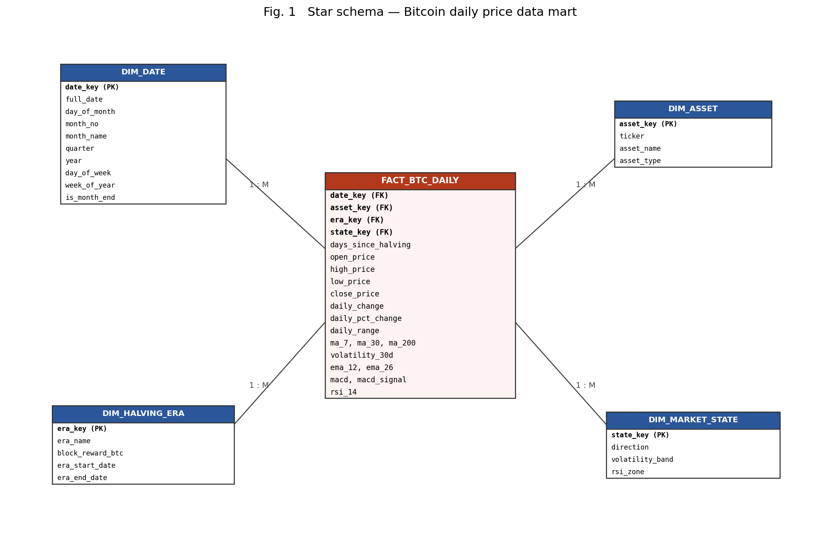
Fig. 1: Star schema — FACT_BTC_DAILY surrounded by four denormalised dimensions
6.4 Snowflake schema
The snowflake schema normalises the dimensions into their natural hierarchies: DIM_DATE is split into month, quarter and year levels; DIM_ASSET into asset type; and DIM_MARKET_STATE into volatility-band and RSI-zone look-up tables. Redundancy falls, but every roll-up now costs extra joins.
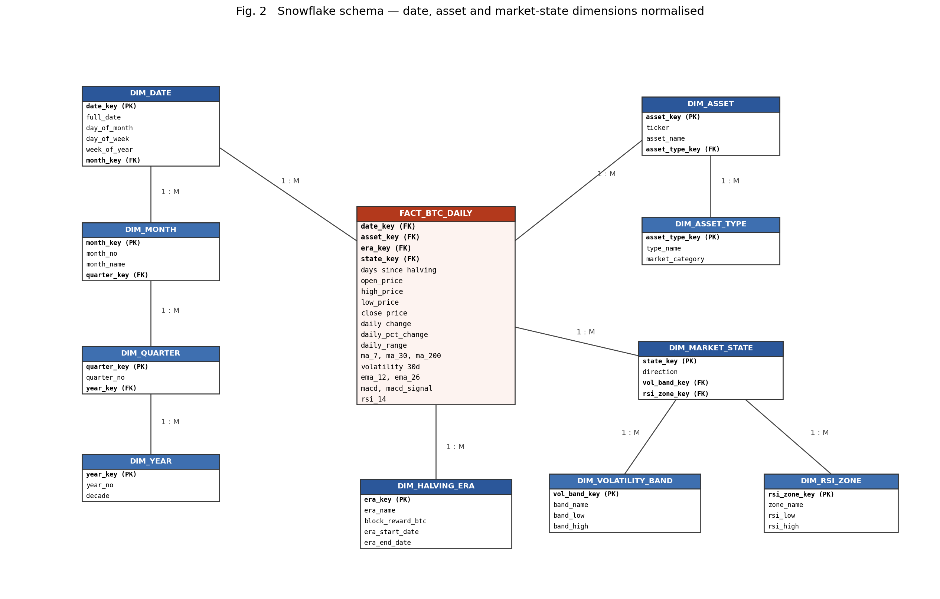
Fig. 2: Snowflake schema — the same fact table with normalised dimension hierarchies
6.5 Comparison and the design chosen
Criterion | Star schema | Snowflake schema
Dimension tables | 4 (denormalised) | 10 (normalised into hierarchies)
Joins for a yearly roll-up | 1 (fact to DIM_DATE) | 4 (date to month to quarter to year)
Query performance | Faster — fewer joins | Slower on large aggregations
Storage / redundancy | Higher redundancy (year repeated on every date row) | Lower redundancy
Maintenance of hierarchies | Update in many rows | Update in one look-up row
Ease of understanding | Very easy for end users | More complex
Normal form | Dimensions in 2NF | Dimensions in 3NF

Design chosen: the star schema is implemented in PostgreSQL in Experiment 2. The data mart is read-heavy, the dimensions are small (5,733 dates, 5 eras, 36 market states, 1 asset), and query simplicity matters more than the few kilobytes of redundancy the snowflake would save. The snowflake design is documented here as the normalised alternative.
7. Conclusion
A case study on Bitcoin price movement was selected and a detailed problem statement with six business requirements was written. The source dataset — 5,684 daily records with 20 attributes spanning July 2010 to March 2026 — was described and documented in a field-level data dictionary, including its data-quality issues (50 missing calendar days, 1 duplicate date, 279 nulls from indicator burn-in). A dimensional model was designed at a grain of one asset-day, with one fact table and four dimensions, and was drawn both as a star schema and as a snowflake schema. The star schema was selected for implementation on the grounds of query simplicity and small dimension sizes.

EXPERIMENT 2: IMPLEMENTATION OF THE DIMENSION AND FACT TABLES IN POSTGRESQL
Database creation, DDL for the staging layer and star schema, ETL with surrogate-key resolution, and verification of the loaded data mart
Lab Code | Lab Name | Sem | Experiment | Course Outcome
2115120 | Data Warehousing and Mining | V | 2 | LO1

1. Aim
To implement the dimensional model designed in Experiment 1 in PostgreSQL — creating the database, the staging table, all dimension tables and the fact table, loading the Bitcoin dataset through an ETL process, and verifying the result.
2. Design Being Implemented
Star schema at a grain of one asset on one calendar day: FACT_BTC_DAILY referencing DIM_DATE, DIM_ASSET, DIM_HALVING_ERA and DIM_MARKET_STATE. A staging table mirroring the CSV sits in front of the star so that raw data can be loaded first and transformed afterwards.
Fig. 1: The star schema implemented in this experiment
3. Database Creation Script
PostgreSQL syntax for creating and connecting to the dedicated data-mart database:
-- =====================================================================
-- Experiment 2 | Step 1 : create the data-mart database
-- Run from the psql client: psql -U postgres -f exp2_01_create_database.sql
-- =====================================================================

DROP DATABASE IF EXISTS btc_dw;

CREATE DATABASE btc_dw
WITH ENCODING = 'UTF8'
TEMPLATE = template0;

COMMENT ON DATABASE btc_dw IS
'Bitcoin daily price data mart - DWM Lab Experiment 2 (star schema)';

-- Connect to the new database before running step 2:
-- \c btc_dw

4. Table Creation Script (DDL)
4.1 Staging layer
The staging table mirrors the CSV exactly — same columns, same order, no keys and no constraints, so that a bad row can never block the load. All cleansing happens after this point.
-- Drop in dependency order (fact first, it references the dimensions)
DROP TABLE IF EXISTS fact_btc_daily CASCADE;
DROP TABLE IF EXISTS dim_date CASCADE;
DROP TABLE IF EXISTS dim_asset CASCADE;
DROP TABLE IF EXISTS dim_halving_era CASCADE;
DROP TABLE IF EXISTS dim_market_state CASCADE;
DROP TABLE IF EXISTS staging_btc_daily CASCADE;

-- 2.1 STAGING LAYER : mirrors the CSV exactly, no constraints, no keys
-- ---------------------------------------------------------------------
CREATE TABLE staging_btc_daily (
date DATE,
ticker VARCHAR(10),
halving_era VARCHAR(40),
days_since_halving INTEGER,
open NUMERIC(14,4),
high NUMERIC(14,4),
low NUMERIC(14,4),
close NUMERIC(14,4),
daily_change NUMERIC(14,4),
daily_pct_change NUMERIC(12,4),
daily_range NUMERIC(14,4),
ma_7 NUMERIC(14,4),
ma_30 NUMERIC(14,4),
ma_200 NUMERIC(14,4),
volatility_30d NUMERIC(12,4),
ema_12 NUMERIC(14,4),
ema_26 NUMERIC(14,4),
macd NUMERIC(14,4),
macd_signal NUMERIC(14,4),
rsi_14 NUMERIC(8,4)
);

-- ---------------------------------------------------------------------

4.2 Dimension tables
Each dimension carries a surrogate key. DIM_DATE uses a yyyymmdd smart key; the other three use SERIAL sequences. Natural keys are protected with UNIQUE constraints and the descriptive columns of DIM_MARKET_STATE are protected with CHECK constraints.
-- 2.2 DIMENSION TABLES (star schema - denormalised, surrogate keys)
-- ---------------------------------------------------------------------
CREATE TABLE dim_date (
date_key INTEGER PRIMARY KEY, -- yyyymmdd smart key
full_date DATE NOT NULL UNIQUE,
day_of_month SMALLINT NOT NULL,
month_no SMALLINT NOT NULL,
month_name VARCHAR(12) NOT NULL,
quarter SMALLINT NOT NULL,
year SMALLINT NOT NULL,
day_of_week VARCHAR(10) NOT NULL,
week_of_year SMALLINT NOT NULL,
is_month_end BOOLEAN NOT NULL,
is_weekend BOOLEAN NOT NULL
);

CREATE TABLE dim_asset (
asset_key SERIAL PRIMARY KEY,
ticker VARCHAR(10) NOT NULL UNIQUE,
asset_name VARCHAR(40) NOT NULL,
asset_type VARCHAR(30) NOT NULL,
quote_currency VARCHAR(10) NOT NULL
);

CREATE TABLE dim_halving_era (
era_key SERIAL PRIMARY KEY,
era_name VARCHAR(40) NOT NULL UNIQUE,
era_sequence SMALLINT NOT NULL,
block_reward_btc NUMERIC(8,4) NOT NULL,
era_start_date DATE NOT NULL,
era_end_date DATE NOT NULL,
era_days INTEGER NOT NULL
);

CREATE TABLE dim_market_state (
state_key SERIAL PRIMARY KEY,
direction VARCHAR(10) NOT NULL, -- Up / Down / Flat
volatility_band VARCHAR(10) NOT NULL, -- Low / Medium / High
rsi_zone VARCHAR(12) NOT NULL, -- Oversold / Neutral / Overbought / Unknown
state_label VARCHAR(60) NOT NULL,
CONSTRAINT uq_market_state UNIQUE (direction, volatility_band, rsi_zone),
CONSTRAINT chk_direction CHECK (direction IN ('Up','Down','Flat')),
CONSTRAINT chk_vol_band CHECK (volatility_band IN ('Low','Medium','High')),
CONSTRAINT chk_rsi_zone CHECK (rsi_zone IN ('Oversold','Neutral','Overbought','Unknown'))
);

-- ---------------------------------------------------------------------

4.3 Fact table
The fact table holds the measures and four foreign keys. UQ_FACT_GRAIN enforces the declared grain — one row per (date, asset) — and indexes are created on every foreign key because those are the join paths the OLAP queries of Experiment 3 will use.
-- 2.3 FACT TABLE : grain = one asset on one calendar day
-- ---------------------------------------------------------------------
CREATE TABLE fact_btc_daily (
fact_key BIGSERIAL PRIMARY KEY,
date_key INTEGER NOT NULL REFERENCES dim_date(date_key),
asset_key INTEGER NOT NULL REFERENCES dim_asset(asset_key),
era_key INTEGER NOT NULL REFERENCES dim_halving_era(era_key),
state_key INTEGER NOT NULL REFERENCES dim_market_state(state_key),
days_since_halving INTEGER NOT NULL, -- degenerate dimension
open_price NUMERIC(14,4) NOT NULL,
high_price NUMERIC(14,4),
low_price NUMERIC(14,4) NOT NULL,
close_price NUMERIC(14,4) NOT NULL,
daily_change NUMERIC(14,4) NOT NULL,
daily_pct_change NUMERIC(12,4) NOT NULL,
daily_range NUMERIC(14,4) NOT NULL,
ma_7 NUMERIC(14,4),
ma_30 NUMERIC(14,4),
ma_200 NUMERIC(14,4),
volatility_30d NUMERIC(12,4),
ema_12 NUMERIC(14,4),
ema_26 NUMERIC(14,4),
macd NUMERIC(14,4),
macd_signal NUMERIC(14,4),
rsi_14 NUMERIC(8,4),
CONSTRAINT uq_fact_grain UNIQUE (date_key, asset_key), -- enforces the grain
CONSTRAINT chk_prices_positive CHECK (open_price > 0 AND close_price > 0 AND low_price > 0)
);

-- Indexes on the foreign keys - the join paths OLAP queries use
CREATE INDEX idx_fact_date_key ON fact_btc_daily(date_key);
CREATE INDEX idx_fact_era_key ON fact_btc_daily(era_key);
CREATE INDEX idx_fact_state_key ON fact_btc_daily(state_key);
CREATE INDEX idx_dim_date_year ON dim_date(year, month_no);

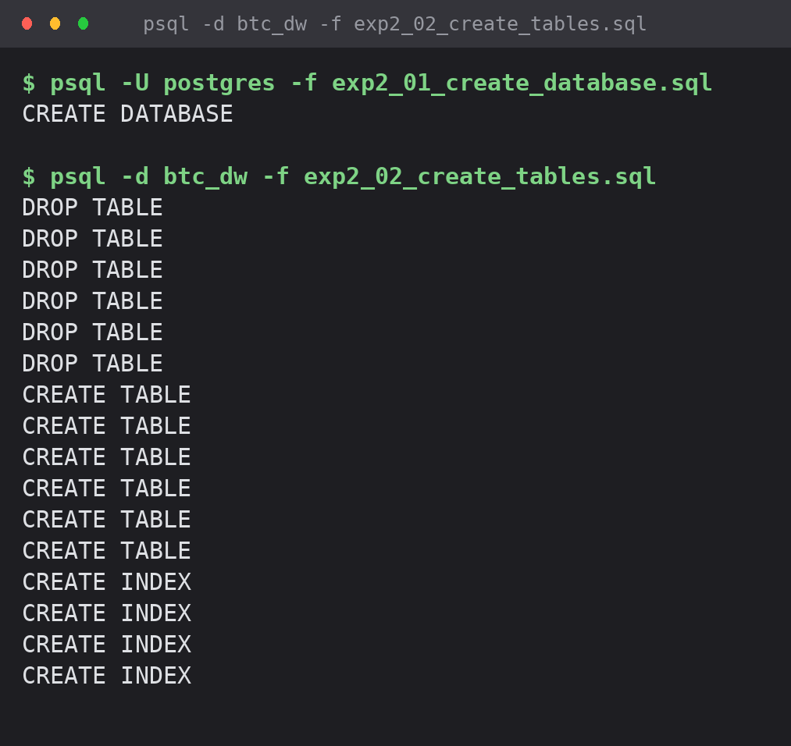
Screenshot 1: creating the database and running the DDL script
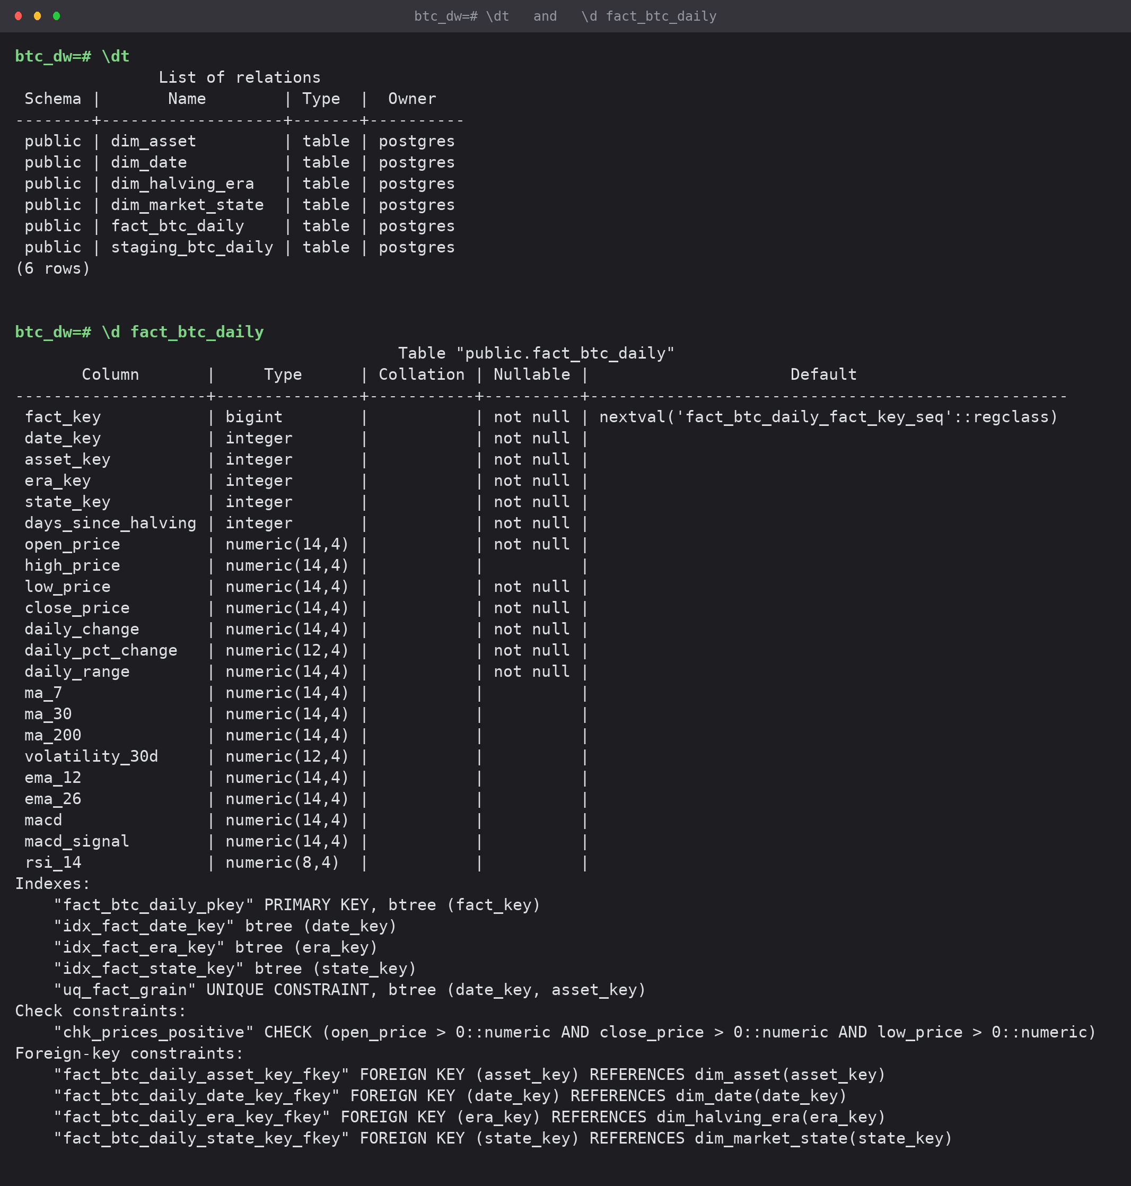
Screenshot 2: \dt listing of the six tables and the structure of fact_btc_daily with its constraints and indexes

5. Data Insertion
5.1 Step 1 — raw ingestion into staging
-- =====================================================================
-- Experiment 2 | Step 3 : load the raw CSV into the staging table
-- =====================================================================

TRUNCATE staging_btc_daily;

-- From the psql client (client-side path, no superuser needed):
-- \copy staging_btc_daily FROM 'btc_flat_final_2.csv' WITH (FORMAT csv, HEADER true, NULL '')
-- From the server (used here, file readable by the server process):
COPY staging_btc_daily
FROM '/tmp/btc_flat_final_2.csv'
WITH (FORMAT csv, HEADER true, NULL '');

-- Load audit
SELECT COUNT(*) AS rows_loaded,
MIN(date) AS first_date,
MAX(date) AS last_date,
COUNT(DISTINCT date) AS distinct_dates,
COUNT(*) - COUNT(DISTINCT date) AS duplicate_dates,
COUNT(*) FILTER (WHERE rsi_14 IS NULL) AS null_rsi,
COUNT(*) FILTER (WHERE ma_200 IS NULL) AS null_ma200
FROM staging_btc_daily;

5.2 Step 2 — dimension population
DIM_DATE is generated with generate_series rather than extracted from the data: a date dimension must be gap-free even for days on which nothing traded, and the source has 50 missing calendar days. The other dimensions are deduplicated out of staging.
-- 4.1 DIM_DATE : generated for every calendar day in the loaded range
-- (generated, not extracted - a date dimension must be gap-free)
-- ---------------------------------------------------------------------
TRUNCATE dim_date CASCADE;

INSERT INTO dim_date (date_key, full_date, day_of_month, month_no, month_name,
quarter, year, day_of_week, week_of_year, is_month_end, is_weekend)
SELECT TO_CHAR(d, 'YYYYMMDD')::INT,
d::DATE,
EXTRACT(DAY FROM d)::SMALLINT,
EXTRACT(MONTH FROM d)::SMALLINT,
TRIM(TO_CHAR(d, 'Month')),
EXTRACT(QUARTER FROM d)::SMALLINT,
EXTRACT(YEAR FROM d)::SMALLINT,
TRIM(TO_CHAR(d, 'Day')),
EXTRACT(WEEK FROM d)::SMALLINT,
(d::DATE = (DATE_TRUNC('month', d) + INTERVAL '1 month - 1 day')::DATE),
EXTRACT(ISODOW FROM d) IN (6, 7)
FROM generate_series(
(SELECT MIN(date) FROM staging_btc_daily),
(SELECT MAX(date) FROM staging_btc_daily),
INTERVAL '1 day') AS d;

-- ---------------------------------------------------------------------
-- 4.2 DIM_ASSET : deduplicated from staging
-- ---------------------------------------------------------------------
TRUNCATE dim_asset RESTART IDENTITY CASCADE;

INSERT INTO dim_asset (ticker, asset_name, asset_type, quote_currency)
SELECT DISTINCT COALESCE(ticker, 'BTC'), 'Bitcoin', 'Cryptocurrency', 'USD'
FROM staging_btc_daily;

-- ---------------------------------------------------------------------
-- 4.3 DIM_HALVING_ERA : one row per era, with its span derived from data
-- and the block reward parsed out of the era name
-- ---------------------------------------------------------------------
TRUNCATE dim_halving_era RESTART IDENTITY CASCADE;

INSERT INTO dim_halving_era (era_name, era_sequence, block_reward_btc,
era_start_date, era_end_date, era_days)
SELECT halving_era,
ROW_NUMBER() OVER (ORDER BY MIN(date))::SMALLINT,
SUBSTRING(halving_era FROM '([0-9]+\.?[0-9]*) BTC')::NUMERIC,
MIN(date),
MAX(date),
(MAX(date) - MIN(date) + 1)
FROM staging_btc_daily
GROUP BY halving_era;

-- ---------------------------------------------------------------------
-- 4.4 DIM_MARKET_STATE : the full cross product of the three descriptive
-- attributes (3 x 3 x 4 = 36 possible states)
-- ---------------------------------------------------------------------
TRUNCATE dim_market_state RESTART IDENTITY CASCADE;

INSERT INTO dim_market_state (direction, volatility_band, rsi_zone, state_label)
SELECT dir, vol, rsi, dir || ' / ' || vol || ' volatility / ' || rsi
FROM (VALUES ('Up'), ('Down'), ('Flat')) AS d(dir)
CROSS JOIN (VALUES ('Low'), ('Medium'), ('High')) AS v(vol)
CROSS JOIN (VALUES ('Oversold'), ('Neutral'), ('Overbought'), ('Unknown')) AS r(rsi);

-- ---------------------------------------------------------------------

5.3 Step 3 — fact population with surrogate-key resolution
Every business key in staging is exchanged for the corresponding surrogate key by joining to the dimensions. Two transformations happen here: the single duplicate date is removed with DISTINCT ON, and each day is classified into a market state (direction, volatility band, RSI zone) so that it can be matched to a DIM_MARKET_STATE row.
-- 4.5 FACT_BTC_DAILY : surrogate-key resolution against all 4 dimensions
-- De-duplication rule: if a date appears twice in staging, keep the
-- row with the larger traded range (the more complete record).
-- ---------------------------------------------------------------------
TRUNCATE fact_btc_daily RESTART IDENTITY;

WITH deduped AS (
SELECT DISTINCT ON (date) *
FROM staging_btc_daily
ORDER BY date, daily_range DESC NULLS LAST
),
classified AS (
SELECT s.*,
CASE WHEN s.daily_pct_change > 0.5 THEN 'Up'
WHEN s.daily_pct_change < -0.5 THEN 'Down'
ELSE 'Flat' END AS direction,
CASE WHEN s.daily_range / NULLIF(s.open,0) * 100 < 3 THEN 'Low'
WHEN s.daily_range / NULLIF(s.open,0) * 100 <= 8 THEN 'Medium'
ELSE 'High' END AS volatility_band,
CASE WHEN s.rsi_14 IS NULL THEN 'Unknown'
WHEN s.rsi_14 < 30 THEN 'Oversold'
WHEN s.rsi_14 > 70 THEN 'Overbought'
ELSE 'Neutral' END AS rsi_zone
FROM deduped s
)
INSERT INTO fact_btc_daily (
date_key, asset_key, era_key, state_key, days_since_halving,
open_price, high_price, low_price, close_price,
daily_change, daily_pct_change, daily_range,
ma_7, ma_30, ma_200, volatility_30d, ema_12, ema_26, macd, macd_signal, rsi_14)
SELECT dd.date_key,
da.asset_key,
de.era_key,
ms.state_key,
c.days_since_halving,
c.open, c.high, c.low, c.close,
c.daily_change, c.daily_pct_change, c.daily_range,
c.ma_7, c.ma_30, c.ma_200, c.volatility_30d,
c.ema_12, c.ema_26, c.macd, c.macd_signal, c.rsi_14
FROM classified c
JOIN dim_date dd ON dd.full_date = c.date
JOIN dim_asset da ON da.ticker = COALESCE(c.ticker, 'BTC')
JOIN dim_halving_era de ON de.era_name = c.halving_era
JOIN dim_market_state ms ON ms.direction = c.direction
AND ms.volatility_band = c.volatility_band
AND ms.rsi_zone = c.rsi_zone;

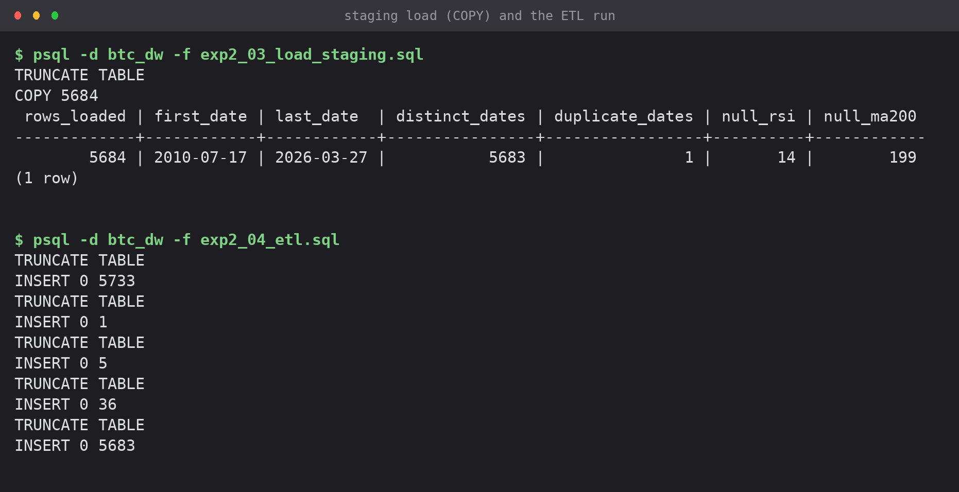
Screenshot 3: the COPY load with its audit query, and the ETL run inserting into all four dimensions and the fact table

6. Verification
Five checks were run against the loaded mart: row counts, dimension contents, referential integrity, the grain constraint, and a business-level aggregation.
-- =====================================================================
-- Experiment 2 | Step 5 : verification of the loaded star schema
-- =====================================================================

\echo '--- 5.1 Row counts in every table ---'
SELECT 'staging_btc_daily' AS table_name, COUNT(*) AS rows FROM staging_btc_daily
UNION ALL SELECT 'dim_date', COUNT(*) FROM dim_date
UNION ALL SELECT 'dim_asset', COUNT(*) FROM dim_asset
UNION ALL SELECT 'dim_halving_era', COUNT(*) FROM dim_halving_era
UNION ALL SELECT 'dim_market_state', COUNT(*) FROM dim_market_state
UNION ALL SELECT 'fact_btc_daily', COUNT(*) FROM fact_btc_daily
ORDER BY 1;

\echo ''
\echo '--- 5.2 DIM_HALVING_ERA contents ---'
SELECT era_key, era_name, block_reward_btc, era_start_date, era_end_date, era_days
FROM dim_halving_era ORDER BY era_sequence;

\echo ''
\echo '--- 5.3 Referential integrity: orphan fact rows (must all be 0) ---'
SELECT (SELECT COUNT(*) FROM fact_btc_daily f LEFT JOIN dim_date d ON f.date_key = d.date_key WHERE d.date_key IS NULL) AS orphan_date,
(SELECT COUNT(*) FROM fact_btc_daily f LEFT JOIN dim_asset a ON f.asset_key = a.asset_key WHERE a.asset_key IS NULL) AS orphan_asset,
(SELECT COUNT(*) FROM fact_btc_daily f LEFT JOIN dim_halving_era e ON f.era_key = e.era_key WHERE e.era_key IS NULL) AS orphan_era,
(SELECT COUNT(*) FROM fact_btc_daily f LEFT JOIN dim_market_state m ON f.state_key = m.state_key WHERE m.state_key IS NULL) AS orphan_state;

\echo ''
\echo '--- 5.4 Grain check: no duplicate (date, asset) pairs ---'
SELECT COUNT(*) AS duplicate_grain_rows
FROM (SELECT date_key, asset_key FROM fact_btc_daily
GROUP BY date_key, asset_key HAVING COUNT(*) > 1) t;

\echo ''
\echo '--- 5.5 Sample of the joined star (first 8 trading days of 2024) ---'
SELECT d.full_date, e.era_name, m.direction, m.volatility_band, m.rsi_zone,
f.open_price, f.close_price, ROUND(f.daily_pct_change, 2) AS pct_change
FROM fact_btc_daily f
JOIN dim_date d ON d.date_key = f.date_key
JOIN dim_halving_era e ON e.era_key = f.era_key
JOIN dim_market_state m ON m.state_key = f.state_key
WHERE d.year = 2024
ORDER BY d.full_date
LIMIT 8;

\echo ''
\echo '--- 5.6 Business check: average close price per halving era ---'
SELECT e.era_name,
COUNT(*) AS trading_days,
ROUND(AVG(f.close_price), 2) AS avg_close,
ROUND(MAX(f.high_price), 2) AS era_high,
ROUND(AVG(ABS(f.daily_pct_change)), 3) AS avg_abs_move_pct
FROM fact_btc_daily f
JOIN dim_halving_era e ON e.era_key = f.era_key
GROUP BY e.era_sequence, e.era_name
ORDER BY e.era_sequence;

\echo ''
\echo '--- 5.7 Dates present in the date dimension but with no trading row ---'
SELECT COUNT(*) AS calendar_days_without_fact
FROM dim_date d
LEFT JOIN fact_btc_daily f ON f.date_key = d.date_key
WHERE f.fact_key IS NULL;

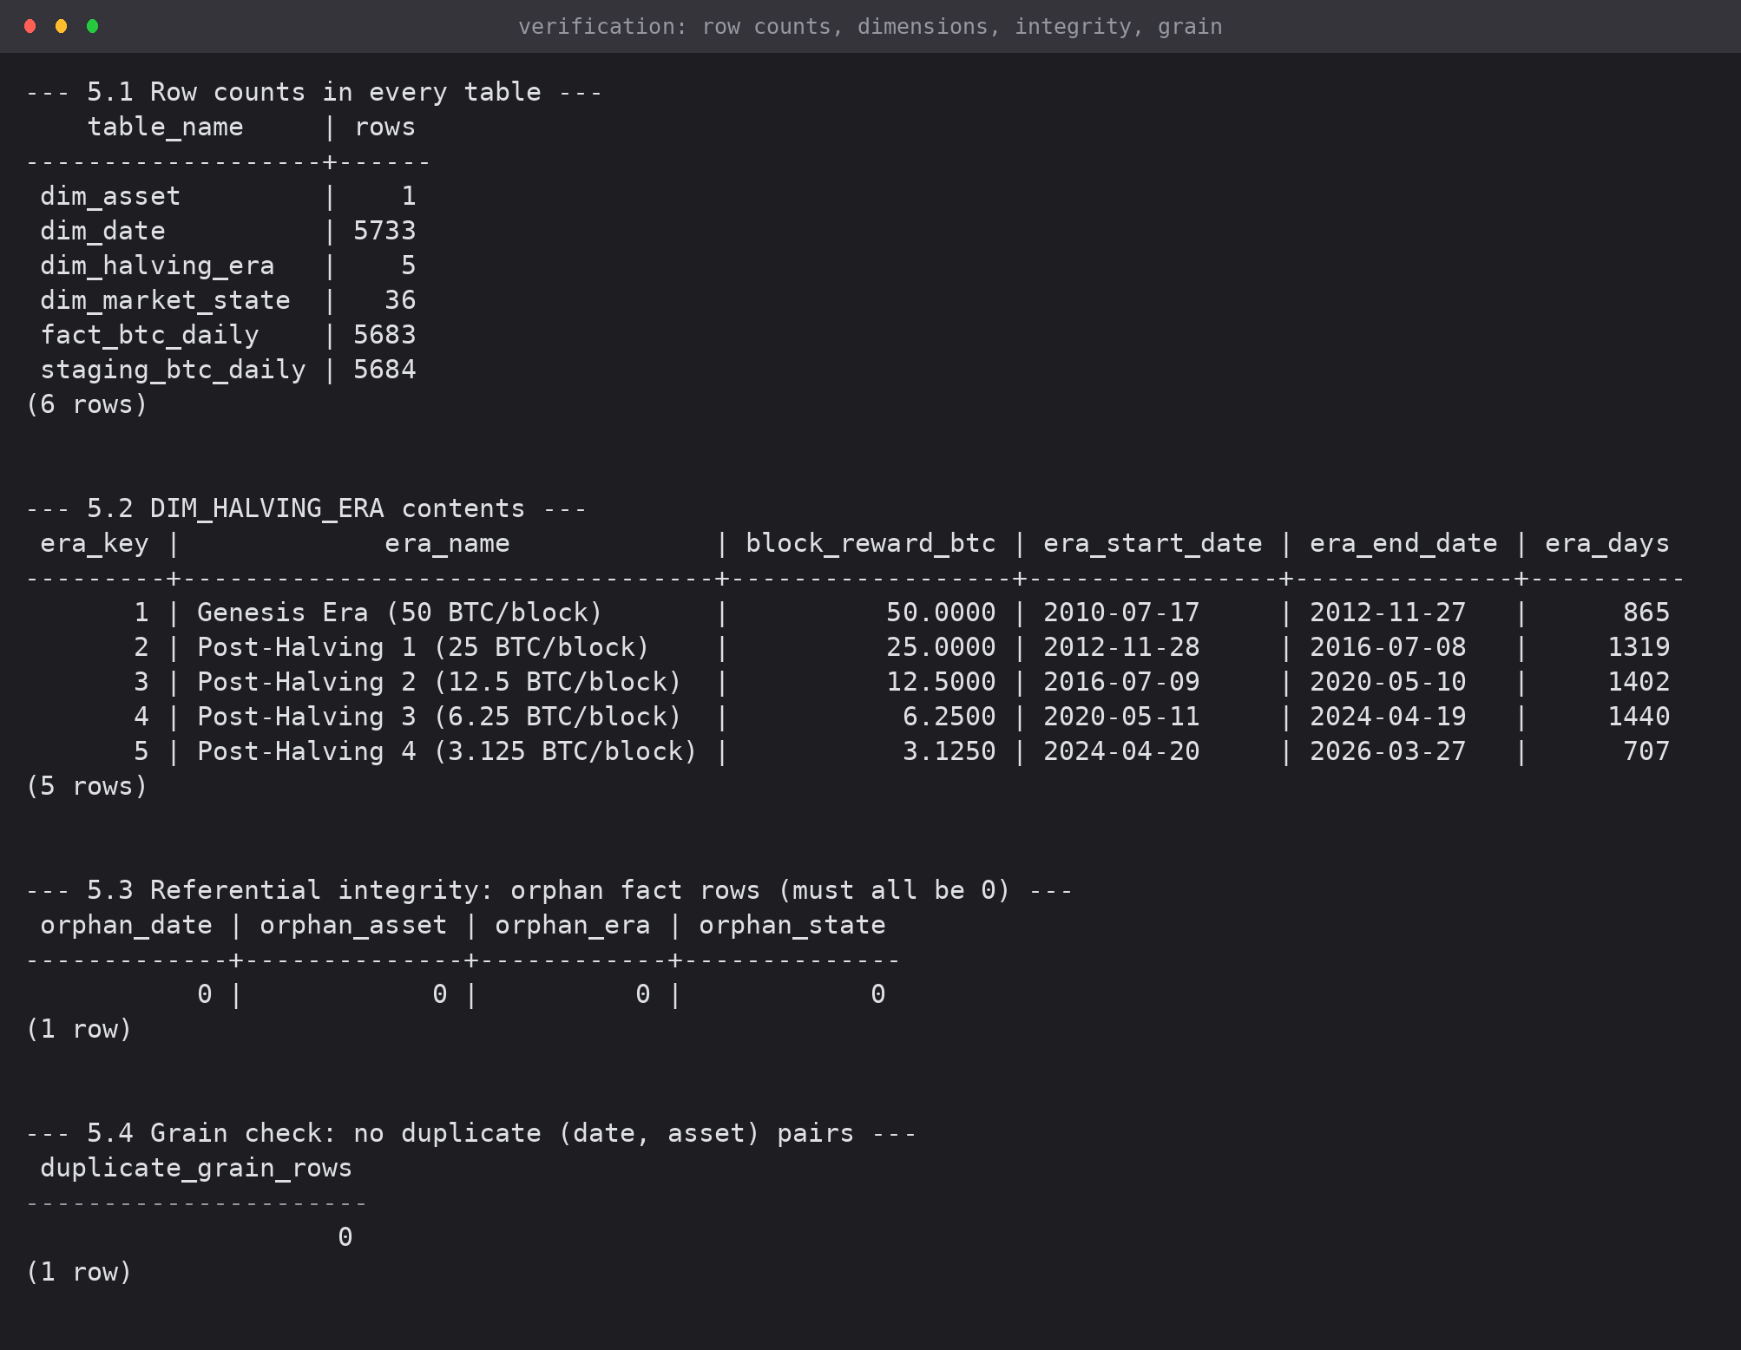
Screenshot 4: row counts, DIM_HALVING_ERA contents, zero orphan rows and zero duplicate grain rows
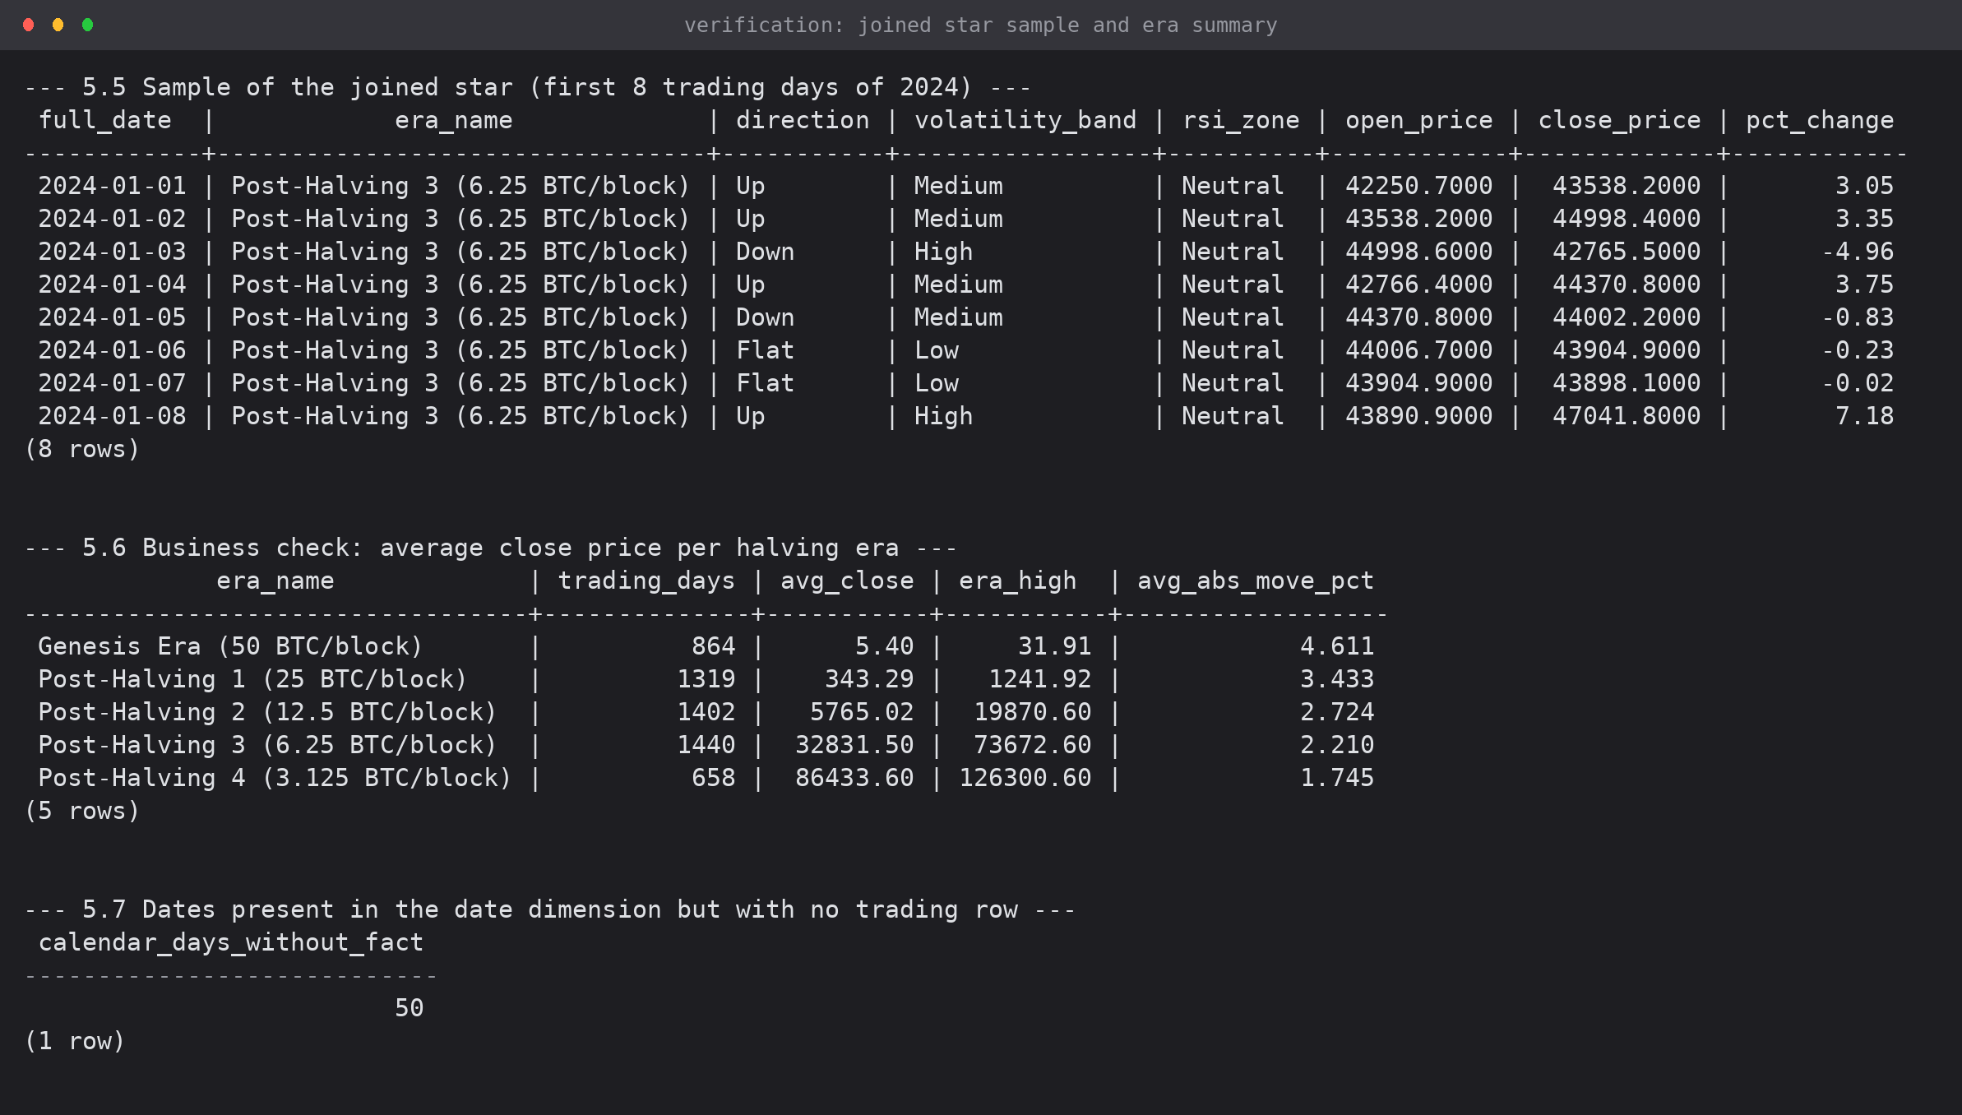
Screenshot 5: eight joined star rows from January 2024 and the per-era business summary
7. Results
7.1 Load summary
Table | Rows loaded | Note
staging_btc_daily | 5,684 | raw CSV, loaded as-is
dim_date | 5,733 | every calendar day from 17-Jul-2010 to 27-Mar-2026
dim_asset | 1 | BTC / Bitcoin / Cryptocurrency / USD
dim_halving_era | 5 | Genesis through Post-Halving 4
dim_market_state | 36 | 3 directions x 3 volatility bands x 4 RSI zones
fact_btc_daily | 5,683 | 5,684 staging rows minus 1 duplicate date

7.2 Integrity checks
Check | Result
Orphan fact rows against each of the 4 dimensions | 0, 0, 0, 0 — all keys resolve
Duplicate (date_key, asset_key) pairs | 0 — the declared grain holds
Calendar days in DIM_DATE with no fact row | 50 — the known gaps in the source
Rows rejected by CHECK (positive prices) | 0

7.3 First business result from the mart
The per-era aggregation already answers one of the business requirements from Experiment 1 — average absolute daily move falls in every successive halving era:
Halving era | Trading days | Avg close (USD) | Era high (USD) | Avg |daily move| %
Genesis (50 BTC/block) | 864 | 5.40 | 31.91 | 4.611
Post-Halving 1 (25) | 1,319 | 343.29 | 1,241.92 | 3.433
Post-Halving 2 (12.5) | 1,402 | 5,765.02 | 19,870.60 | 2.724
Post-Halving 3 (6.25) | 1,440 | 32,831.50 | 73,672.60 | 2.210
Post-Halving 4 (3.125) | 658 | 86,433.60 | 126,300.60 | 1.745

8. Conclusion
The star schema designed in Experiment 1 was implemented in PostgreSQL. A staging table, four dimension tables and one fact table were created with surrogate keys, unique constraints, check constraints, foreign keys and indexes. 5,684 raw rows were loaded by COPY, the dimensions were populated (5,733 generated dates, 1 asset, 5 eras, 36 market states) and 5,683 fact rows were inserted with full surrogate-key resolution, one duplicate date having been removed during transformation. All four referential-integrity checks returned zero orphans and the grain constraint holds, so the mart is ready for the OLAP operations of Experiment 3.
9. Files Submitted
File | Contents
sql/exp2_01_create_database.sql | database creation
sql/exp2_02_create_tables.sql | staging, dimension and fact DDL with constraints and indexes
sql/exp2_03_load_staging.sql | COPY / \copy load with a load-audit query
sql/exp2_04_etl.sql | dimension population and fact load with surrogate-key resolution
sql/exp2_05_verify.sql | row counts, integrity, grain and business verification
outputs/exp2_shot1..5 (.png) | captured psql output of every step

EXPERIMENT 3: IMPLEMENTATION OF OLAP OPERATIONS
Slice, Dice, Roll-up, Drill-down and Pivot on the Bitcoin star schema in PostgreSQL, and the same operations performed with a Pivot Table in Excel
Lab Code | Lab Name | Sem | Experiment | Course Outcome
2115120 | Data Warehousing and Mining | V | 3 | LO2

1. Aim
To implement the OLAP operations — slice, dice, roll-up, drill-down and pivot — in SQL on the Bitcoin data mart built in Experiment 2, and to perform the equivalent operations using a Pivot Table in Microsoft Excel.
2. The Cube Being Queried
The star schema of Experiment 2 forms a four-dimensional cube: time (DIM_DATE), asset (DIM_ASSET), supply era (DIM_HALVING_ERA) and market state (DIM_MARKET_STATE), with the daily price measures of FACT_BTC_DAILY as the cells. 5,683 fact rows are queried throughout.
Dimension | Hierarchy used by the operations
Time | day -> month -> quarter -> year
Halving era | era (an alternative time-like hierarchy driven by supply, not the calendar)
Market state | direction / volatility_band / rsi_zone
Asset | single member (BTC) in this data mart

3. OLAP Operations in PostgreSQL
3.1 Roll-up
Roll-up moves up a hierarchy, aggregating the detail: here the daily facts are summarised to the year level, and then with the ROLLUP operator to give quarter, year and grand-total rows in one result set.
\echo '================ 1. ROLL-UP : day -> month -> quarter -> year ================'
-- Roll-up climbs the DIM_DATE hierarchy, summarising the daily facts to
-- a coarser level. Here: yearly summary of the daily facts.
SELECT d.year,
COUNT(*) AS trading_days,
ROUND(AVG(f.close_price), 2) AS avg_close,
ROUND(MIN(f.low_price), 2) AS year_low,
ROUND(MAX(f.high_price), 2) AS year_high,
ROUND(AVG(ABS(f.daily_pct_change)), 3) AS avg_abs_move_pct
FROM fact_btc_daily f
JOIN dim_date d ON d.date_key = f.date_key
WHERE d.year BETWEEN 2021 AND 2026
GROUP BY d.year
ORDER BY d.year;

\echo ''
\echo '---- 1b. ROLL-UP with the ROLLUP operator (year -> quarter -> grand total) ----'
SELECT COALESCE(d.year::TEXT, 'ALL YEARS') AS year,
COALESCE(d.quarter::TEXT, 'ALL Q') AS quarter,
COUNT(*) AS days,
ROUND(AVG(f.close_price), 2) AS avg_close
FROM fact_btc_daily f
JOIN dim_date d ON d.date_key = f.date_key
WHERE d.year BETWEEN 2024 AND 2025
GROUP BY ROLLUP (d.year, d.quarter)
ORDER BY d.year NULLS LAST, d.quarter NULLS LAST;

\echo ''

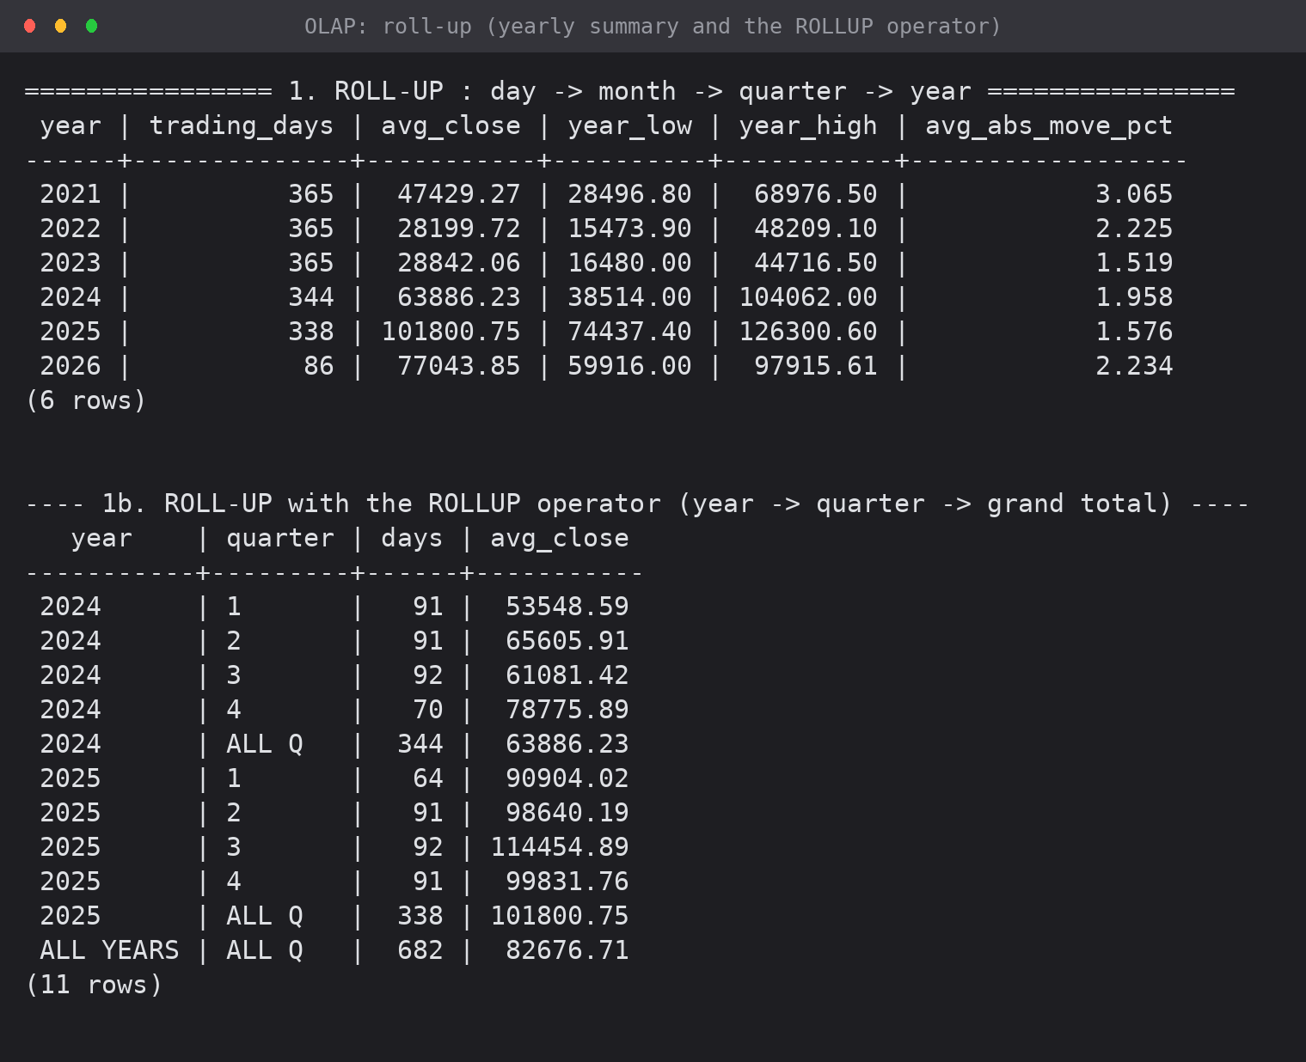
Screenshot 1: roll-up output — yearly summary and the ROLLUP operator producing sub-totals and a grand total
3.2 Drill-down
Drill-down is the inverse: the same measure is re-displayed at a finer level. The query first shows the coarse view (five halving eras), then drills into the current era month by month.
\echo '================ 2. DRILL-DOWN : era -> year -> quarter -> month ================'
-- Drill-down is the reverse of roll-up: the same measure shown at a finer
-- level of the hierarchy. Starting point (coarse) - by halving era:
SELECT e.era_name, COUNT(*) AS days, ROUND(AVG(f.close_price), 2) AS avg_close
FROM fact_btc_daily f
JOIN dim_halving_era e ON e.era_key = f.era_key
GROUP BY e.era_sequence, e.era_name
ORDER BY e.era_sequence;

\echo ''
\echo '---- 2b. drill down into Post-Halving 4, by month ----'
SELECT d.year, d.month_no, d.month_name,
COUNT(*) AS days,
ROUND(AVG(f.close_price), 2) AS avg_close,
ROUND(SUM(f.daily_change), 2) AS net_change_usd
FROM fact_btc_daily f
JOIN dim_date d ON d.date_key = f.date_key
JOIN dim_halving_era e ON e.era_key = f.era_key
WHERE e.era_name = 'Post-Halving 4 (3.125 BTC/block)'
GROUP BY d.year, d.month_no, d.month_name
ORDER BY d.year, d.month_no
LIMIT 12;

\echo ''

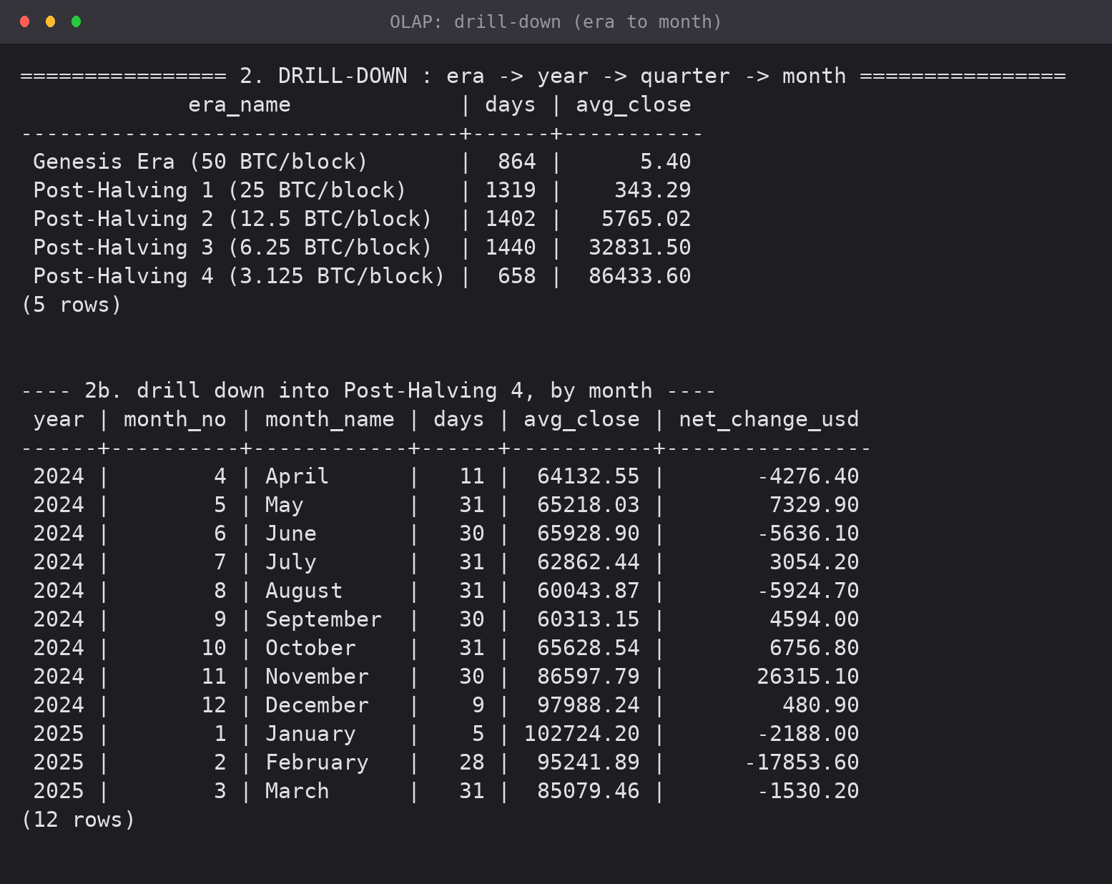
Screenshot 2: drill-down from era level to monthly detail inside Post-Halving 4
3.3 Slice
A slice fixes one dimension to a single value, producing a sub-cube of lower dimensionality. Here the market-state dimension is fixed to direction = 'Down' and the time dimension stays free.
\echo '================ 3. SLICE : fix ONE dimension to a single value ================'
-- Slice = a sub-cube obtained by fixing one dimension. Here the market-state
-- dimension is fixed to direction = ''Down'', and the remaining dimensions
-- (time) stay free.
SELECT d.year,
COUNT(*) AS down_days,
ROUND(AVG(f.daily_pct_change), 3) AS avg_down_move_pct,
ROUND(MIN(f.daily_pct_change), 2) AS worst_day_pct
FROM fact_btc_daily f
JOIN dim_date d ON d.date_key = f.date_key
JOIN dim_market_state m ON m.state_key = f.state_key
WHERE m.direction = 'Down' -- <== the slice
GROUP BY d.year
ORDER BY d.year;

\echo ''

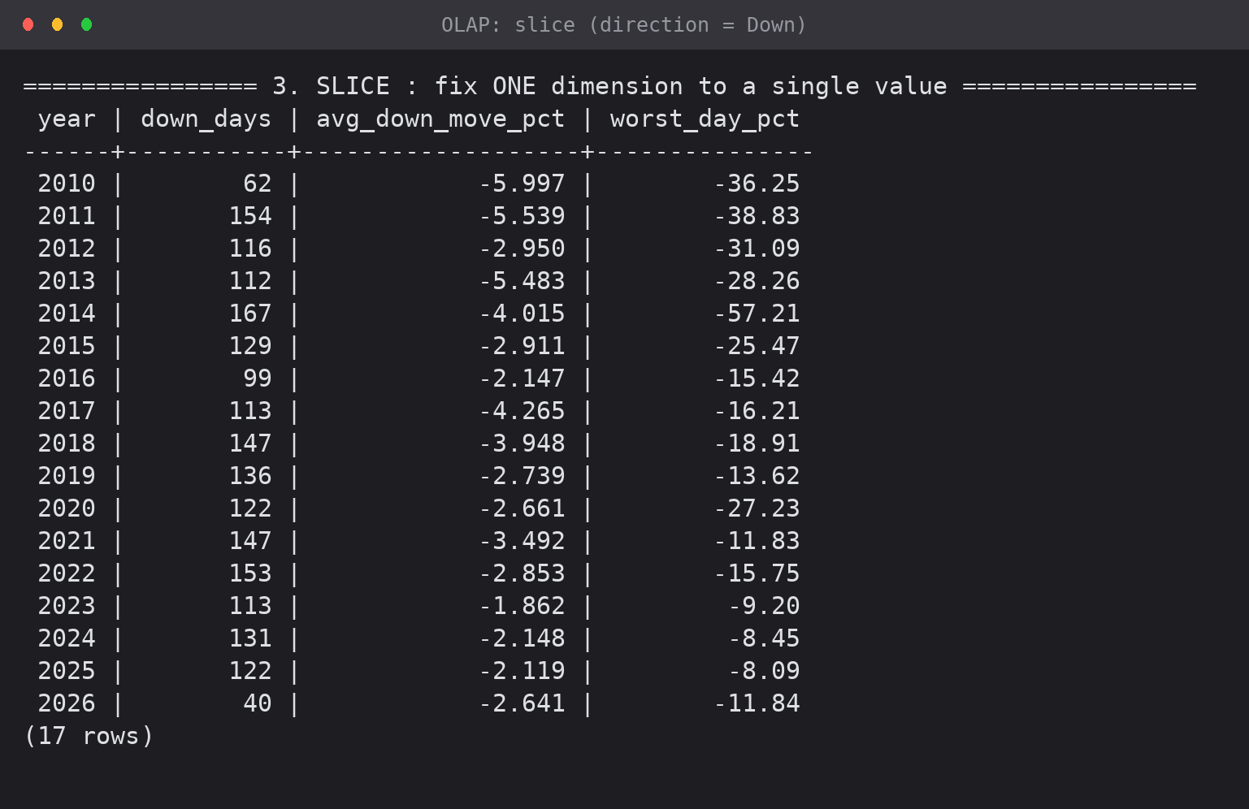
Screenshot 3: slice on direction = 'Down' — down-day count and average down move for every year

3.4 Dice
A dice selects a range or set of values on two or more dimensions at once, cutting a smaller box out of the cube: years 2020-2022, volatility band 'High' and direction 'Up'.
\echo '================ 4. DICE : restrict SEVERAL dimensions at once ================'
-- Dice = a sub-cube obtained by selecting ranges/values on two or more
-- dimensions: time 2020-2022, high volatility, and an upward move.
SELECT d.full_date, e.era_name, m.volatility_band, m.rsi_zone,
ROUND(f.daily_pct_change, 2) AS pct_change,
ROUND(f.daily_range / f.open_price * 100, 2) AS range_pct,
ROUND(f.close_price, 2) AS close_price
FROM fact_btc_daily f
JOIN dim_date d ON d.date_key = f.date_key
JOIN dim_halving_era e ON e.era_key = f.era_key
JOIN dim_market_state m ON m.state_key = f.state_key
WHERE d.year BETWEEN 2020 AND 2022 -- dimension 1: time
AND m.volatility_band = 'High' -- dimension 2: market state
AND m.direction = 'Up' -- dimension 2 (2nd attribute)
ORDER BY f.daily_pct_change DESC
LIMIT 10;

\echo ''

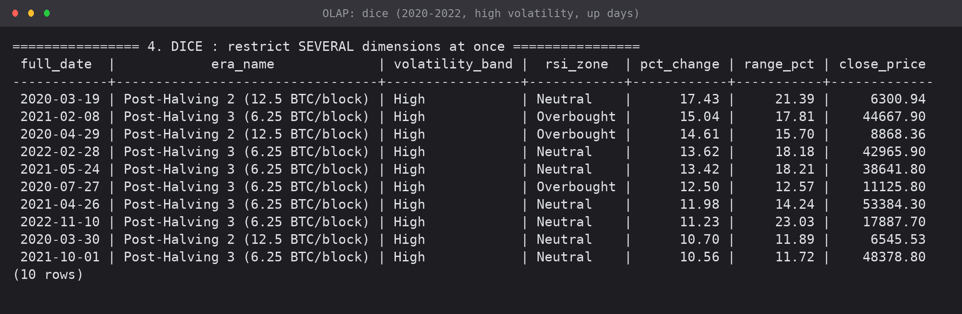
Screenshot 4: dice output — the ten largest up-moves on high-volatility days between 2020 and 2022
3.5 Pivot (rotation)
Pivoting rotates the cube so that the members of one dimension become columns. PostgreSQL expresses this with aggregate FILTER clauses; the first query pivots direction across years, the second pivots volatility band across halving eras.
\echo '================ 5. PIVOT (rotate) : year x direction cross-tab ================'
-- Pivot rotates the cube so that the values of one dimension become columns.
-- FILTER is the standard-SQL way to do this in PostgreSQL.
SELECT d.year,
COUNT(*) FILTER (WHERE m.direction = 'Up') AS up_days,
COUNT(*) FILTER (WHERE m.direction = 'Flat') AS flat_days,
COUNT(*) FILTER (WHERE m.direction = 'Down') AS down_days,
COUNT(*) AS total_days,
ROUND(100.0 * COUNT(*) FILTER (WHERE m.direction = 'Up') / COUNT(*), 1) AS pct_up
FROM fact_btc_daily f
JOIN dim_date d ON d.date_key = f.date_key
JOIN dim_market_state m ON m.state_key = f.state_key
WHERE d.year >= 2019
GROUP BY d.year
ORDER BY d.year;

\echo ''
\echo '---- 5b. PIVOT : halving era x volatility band (average absolute move %) ----'
SELECT e.era_name,
ROUND(AVG(ABS(f.daily_pct_change)) FILTER (WHERE m.volatility_band = 'Low'), 2) AS low_vol,
ROUND(AVG(ABS(f.daily_pct_change)) FILTER (WHERE m.volatility_band = 'Medium'), 2) AS medium_vol,
ROUND(AVG(ABS(f.daily_pct_change)) FILTER (WHERE m.volatility_band = 'High'), 2) AS high_vol,
COUNT(*) FILTER (WHERE m.volatility_band = 'High') AS high_vol_days
FROM fact_btc_daily f
JOIN dim_halving_era e ON e.era_key = f.era_key
JOIN dim_market_state m ON m.state_key = f.state_key
GROUP BY e.era_sequence, e.era_name
ORDER BY e.era_sequence;

\echo ''

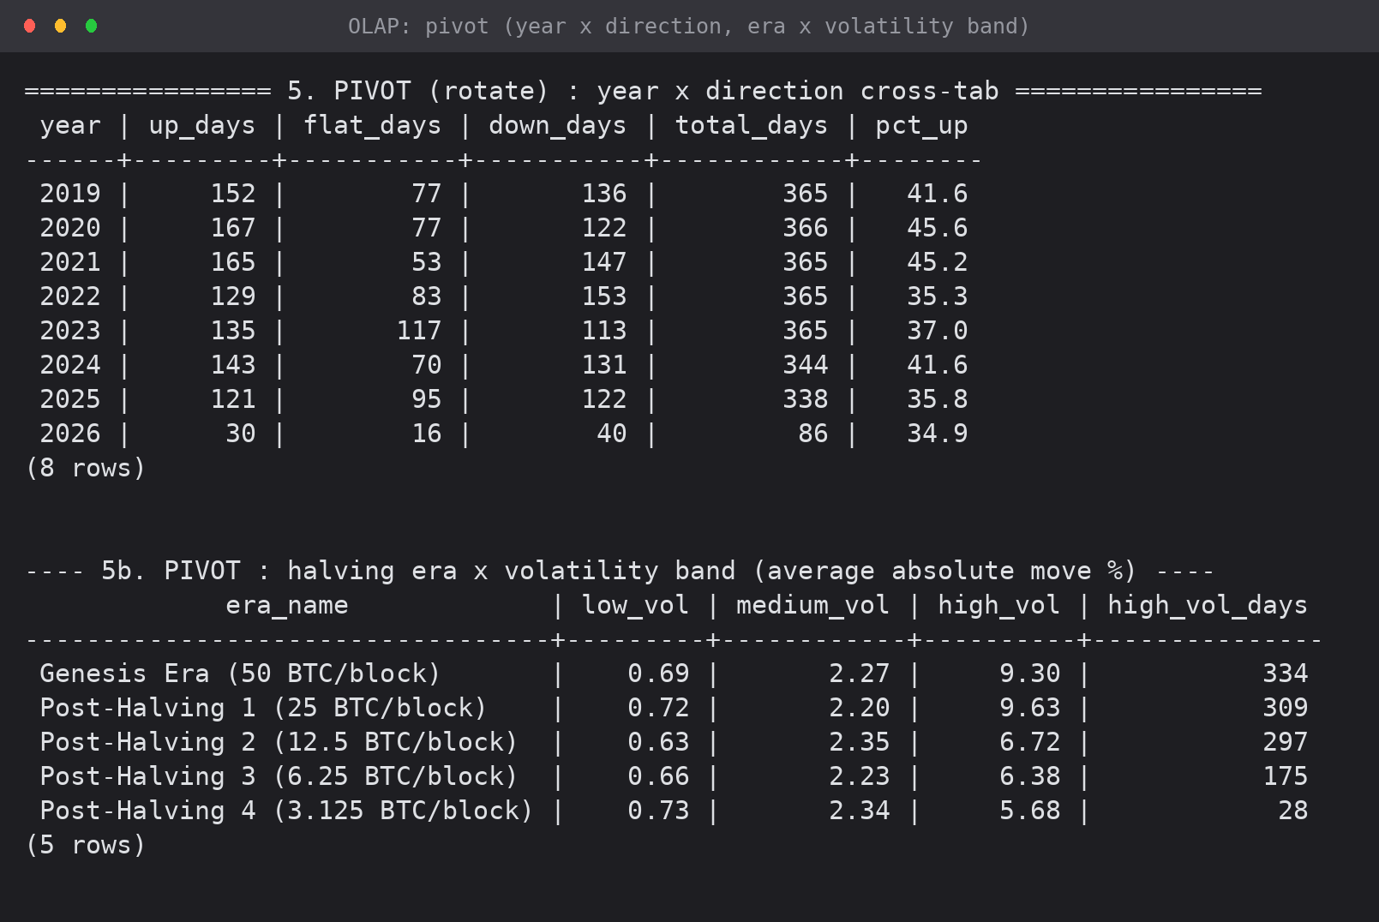
Screenshot 5: pivot output — year x direction cross-tab, and era x volatility-band cross-tab
3.6 CUBE — every combination at once
The CUBE operator generates all 2^n grouping combinations of the listed dimensions, which is the full multidimensional cube including both margins and the grand total.
\echo '================ 6. CUBE : all aggregation combinations ================'
-- CUBE produces every combination of the grouping columns, i.e. the full
-- multidimensional cube of (era x direction) including both margins.
SELECT COALESCE(e.era_name, 'ALL ERAS') AS era,
COALESCE(m.direction, 'ALL') AS direction,
COUNT(*) AS days,
ROUND(AVG(f.daily_pct_change), 3) AS avg_pct_change
FROM fact_btc_daily f
JOIN dim_halving_era e ON e.era_key = f.era_key
JOIN dim_market_state m ON m.state_key = f.state_key
WHERE e.era_sequence >= 4
GROUP BY CUBE (e.era_name, m.direction)
ORDER BY era, direction;

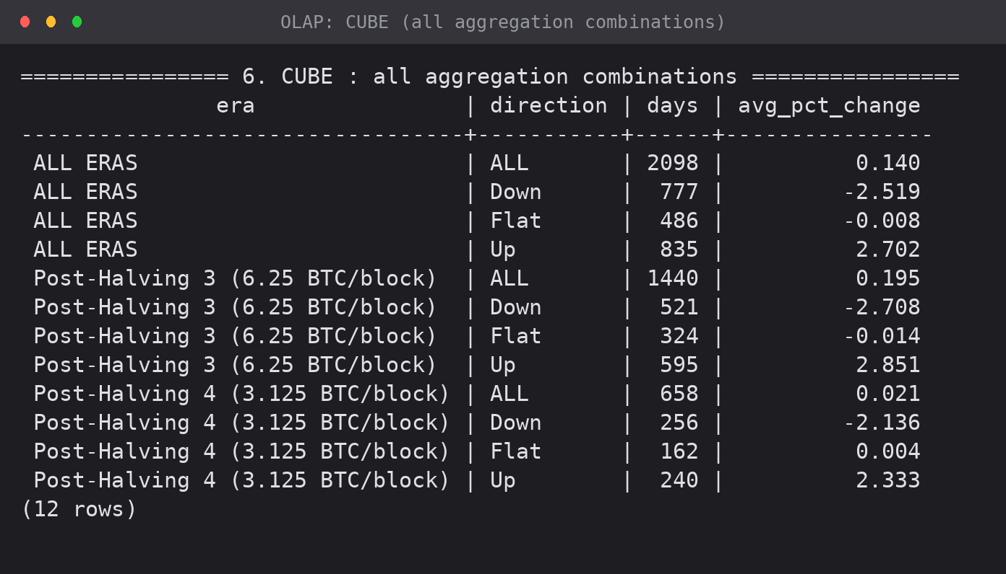
Screenshot 6: CUBE over (era x direction) with all margins

4. OLAP Operations Using a Pivot Table in Excel
The same cube was exported from PostgreSQL into Excel (Exp3_OLAP_Pivot_Analysis_v1.xlsx). The workbook contains the flat source, three pivot sheets built with live COUNTIFS / AVERAGEIFS formulas and charts, and a sheet describing how to build the equivalent native PivotTable.
4.1 Pivot source
5,683 rows exported from the joined star, one row per trading day, with the dimension attributes flattened into columns — exactly the shape a PivotTable expects.
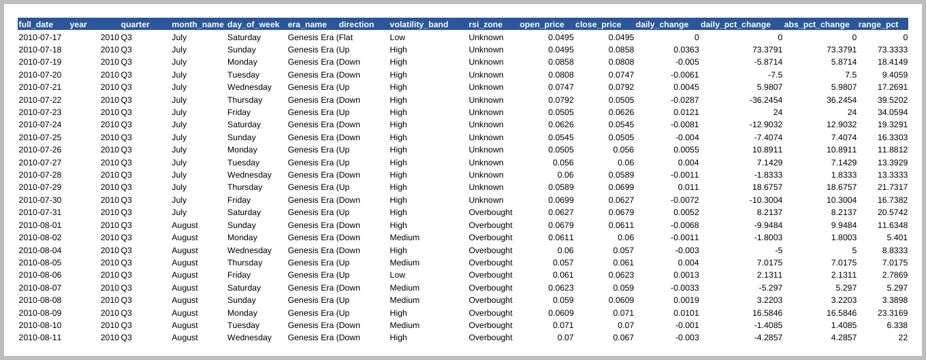
Screenshot 7: the PivotSource sheet (first rows of 5,683)
4.2 Pivot: year x direction
Rows = year, columns = direction, values = count of days. This is the same result as the SQL pivot in section 3.5, computed independently in Excel.
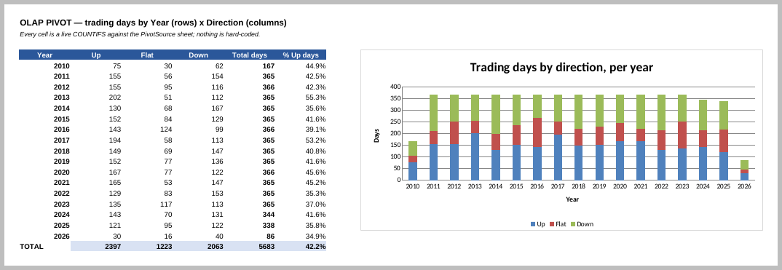
Screenshot 8: Excel pivot of trading days by year and direction, with a stacked column chart
4.3 Pivot: halving era x volatility band
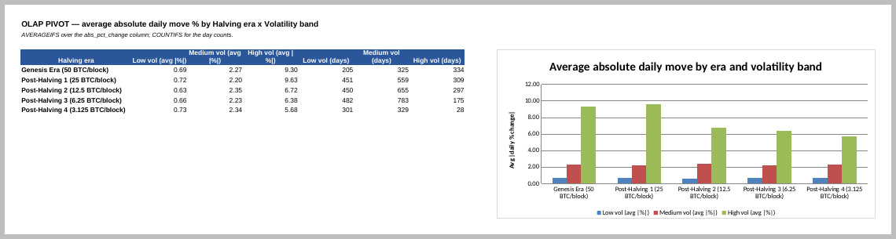
Screenshot 9: average absolute daily move by era and volatility band
4.4 Roll-up in Excel
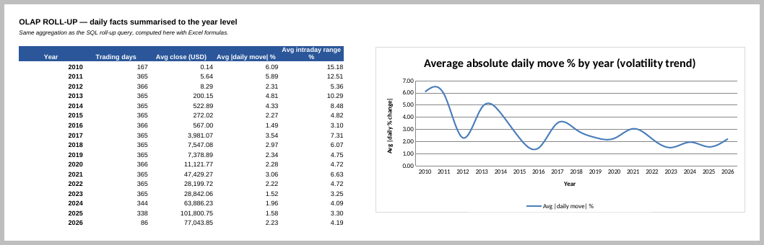
Screenshot 10: daily facts rolled up to yearly averages, with the volatility trend charted
4.5 Mapping the OLAP operations onto PivotTable actions
OLAP operation | In SQL | In an Excel PivotTable
Roll-up | GROUP BY a coarser level / ROLLUP | Collapse a row field, or remove the finer field
Drill-down | GROUP BY a finer level | Expand a row field (+), or double-click a value cell
Slice | WHERE on one dimension | A filter on a single field
Dice | WHERE on two or more dimensions | Filters on several fields at once
Pivot | aggregate ... FILTER / crosstab | Swap fields between the Rows and Columns areas

5. Results and Cross-Verification
The Excel pivots were computed from the same exported rows but with independent formulas, so they act as a check on the SQL. The two agree:
Measure | PostgreSQL result | Excel result
Up days in 2021 | 165 | 165
Down days in 2022 | 153 | 153
Total fact rows | 5,683 | 5,683 (pivot grand total)
Avg |daily move| 2021 | 3.065% | 3.06%
Avg |daily move| 2024 | 1.958% | 1.96%
Avg |move| high-vol days, Genesis era | 9.30% | 9.30%
Avg |move| high-vol days, Post-Halving 4 | 5.68% | 5.68%

5.1 Analytical findings from the OLAP session
- Volatility falls monotonically across the halving eras: on high-volatility days the average absolute move drops from 9.30% (Genesis) to 5.68% (Post-Halving 4), and the number of high-volatility days falls from 334 to 28.
- Up days outnumber down days overall (2,397 vs 2,063 of 5,683), but the split varies sharply by year — 55.3% up days in 2013 against 34.9% in 2026.
- The worst single day in the whole series is -57.21% (20 Feb 2014, Mt. Gox collapse); the worst day of 2025 is only -8.09%, another sign of the market maturing.
- The drill-down into Post-Halving 4 shows November 2024 as the strongest month of the era (+$26,315 net change), which is the post-halving rally.
6. Conclusion
All five OLAP operations were implemented in SQL against the Bitcoin star schema — roll-up (including the ROLLUP operator), drill-down, slice, dice and pivot — plus the CUBE operator for the complete set of aggregations. The same operations were reproduced in Excel with a pivot workbook of 188 live formulas and three charts, and the two implementations agree on every value checked. The exercise showed how a star schema turns analytical questions into short queries: each operation is a change of grouping level or of filter, not a rewrite.
7. Files Submitted
File | Contents
sql/exp3_olap_operations.sql | all six OLAP operations with comments
Exp3_OLAP_Pivot_Analysis_v1.xlsx | pivot source, three pivot sheets with charts, PivotTable instructions
outputs/exp3_sql1..6 (.png) | captured psql output of each OLAP operation
outputs/exp3_xl1..5 (.png) | captured Excel pivot sheets

EXPERIMENT 4: DATA PREPROCESSING AND EXPLORATION
Code review of the existing cleaning script, descriptive analysis, null-value handling, data normalization and data discretization on the Bitcoin dataset
Lab Code | Lab Name | Sem | Experiment | Course Outcome
2115120 | Data Warehousing and Mining | V | 4 | LO3

1. Aim
To implement data preprocessing on the Bitcoin case-study dataset — descriptive analysis, handling of null values, data normalization and data discretization — and to verify and correct the existing cleaning pipeline.
2. Structure of the Experiment
Part | File | Contents
A | data_cleaning_v2.py | cleaning: duplicates, calendar gaps, indicator recomputation, burn-in removal (reviewed and corrected)
B | experiment_4_preprocessing.ipynb | descriptive analysis, null handling, normalization, discretization
C | experiment_5.ipynb | feature transformation, outlier analysis and visualisation (existing notebook, re-verified)

3. Part A — Review and Correction of the Cleaning Script
The existing script data_cleaning.py was executed against the input it is configured to read (btc_flat_final_2.csv). Five issues were found; the first is fatal.
# | Issue found | Evidence | Fix in v2
1 | Crashes on the configured input file. reindex() is called while the frame still contains a duplicate date (2010-08-02). | ValueError: cannot reindex on an axis with duplicate labels. The script only completes against the older btc_flat_final.csv, which has no duplicate. | Duplicates are dropped before reindexing, keeping the row with the wider traded range.
2 | days_since_halving is overwritten with groupby(...).cumcount(), which restarts the counter at the first row of the data rather than at the halving. | For 2011-02-01 the source says 759, the cleaned file says 199. 666 rows differ — every Genesis-era row. | The source values are kept; only the inserted gap rows are filled by interpolation.
3 | Interpolated (synthetic) days are indistinguishable from traded days afterwards. | 49 rows in the cleaned file are machine-generated but carry no marker. | An is_interpolated boolean column is added.
4 | The burn-in is removed using the total null count of ma_200 as a row offset. | Correct only because every null happens to sit at the head; an interior null would silently delete valid rows. | The burn-in is removed by position: the first MA_LONG - 1 = 199 rows.
5 | OHLC consistency is not re-checked after interpolation. | The four price columns are interpolated independently and could cross. Checked: 0 violations were actually produced. | A post-interpolation validation is added, with automatic repair if it ever fires.

Equivalence check: apart from days_since_halving (the intended fix), every numeric column of the v2 output matches the original cleaned file to within 1e-6, so the correction changes only what it was meant to change.
3.1 Corrected script
data_cleaning_v2.py (steps 1-3; full listing in the file)
import pandas as pd
import numpy as np

RAW_PATH = "btc_flat_final_2.csv"
CLEAN_PATH = "btc_cleaned_v2.csv"
MA_LONG = 200 # longest rolling window -> length of the burn-in period

pd.set_option("display.width", 140)
pd.set_option("display.max_columns", 25)

# =====================================================================
# STEP 1 : load and profile the raw data
# =====================================================================
df = pd.read_csv(RAW_PATH)
df["date"] = pd.to_datetime(df["date"])

print("=" * 70)
print("BEFORE CLEANING")
print("=" * 70)
print("Shape:", df.shape)
print("\nNull counts (non-zero only):")
print(df.isnull().sum()[lambda s: s > 0].to_string() or " none")
print("\nFully duplicated rows :", int(df.duplicated().sum()))
print("Duplicated dates :", int(df["date"].duplicated().sum()))
if df["date"].duplicated().any():
dupes = df.loc[df["date"].duplicated(keep=False), "date"].dt.strftime("%Y-%m-%d").unique()
print(" duplicated date(s) :", ", ".join(dupes))
print("Sorted ascending :", df["date"].is_monotonic_increasing)

full_range = pd.date_range(df["date"].min(), df["date"].max(), freq="D")
missing_dates = full_range.difference(df["date"])
print("Missing calendar days :", len(missing_dates))
print(" ", missing_dates.strftime("%Y-%m-%d").tolist()[:8], "..." if len(missing_dates) > 8 else "")

bad_high = df[(df["high"] < df["open"]) | (df["high"] < df["close"]) | (df["high"] < df["low"])]
bad_low = df[(df["low"] > df["open"]) | (df["low"] > df["close"]) | (df["low"] > df["high"])]
non_pos = df[(df[["open", "high", "low", "close"]] <= 0).any(axis=1)]
print("High-rule violations :", len(bad_high))
print("Low-rule violations :", len(bad_low))
print("Non-positive prices :", len(non_pos))

# =====================================================================
# STEP 2 : remove duplicate dates (FIX 1 - must happen before reindex)
# =====================================================================
before = len(df)
df = (df.sort_values(["date", "daily_range"], ascending=[True, False])
.drop_duplicates(subset="date", keep="first")
.sort_values("date")
.reset_index(drop=True))
print(f"\nDuplicate dates removed: {before - len(df)} (kept the row with the wider traded range)")

# =====================================================================
# STEP 3 : fill the calendar gaps
# =====================================================================
df = df.set_index("date").reindex(full_range)
df.index.name = "date"

df["is_interpolated"] = df["close"].isna() # FIX 3 - flag synthetic rows
df["ticker"] = df["ticker"].ffill().bfill()
df["halving_era"] = df["halving_era"].ffill().bfill()

# Bitcoin trades continuously, so a straight-line bridge between the last known
# price before a gap and the first known price after it is the simplest
# defensible estimate in the absence of the real historical quotes.
for col in ["open", "high", "low", "close"]:
df[col] = df[col].interpolate(method="linear")

# FIX 2 - keep the source counter; only fill it for the inserted rows
df["days_since_halving"] = df["days_since_halving"].interpolate(method="linear").round().astype("Int64")

# FIX 5 - the four price columns were interpolated independently, so re-check
inconsistent = df[(df["high"] < df[["open", "close", "low"]].max(axis=1)) |
(df["low"] > df[["open", "close", "high"]].min(axis=1))]
print(f"OHLC inconsistencies introduced by interpolation: {len(inconsistent)}")
if len(inconsistent): # repair rather than drop
df["high"] = df[["open", "high", "low", "close"]].max(axis=1)
df["low"] = df[["open", "high", "low", "close"]].min(axis=1)
print(" -> repaired by setting high = max(OHLC) and low = min(OHLC)")

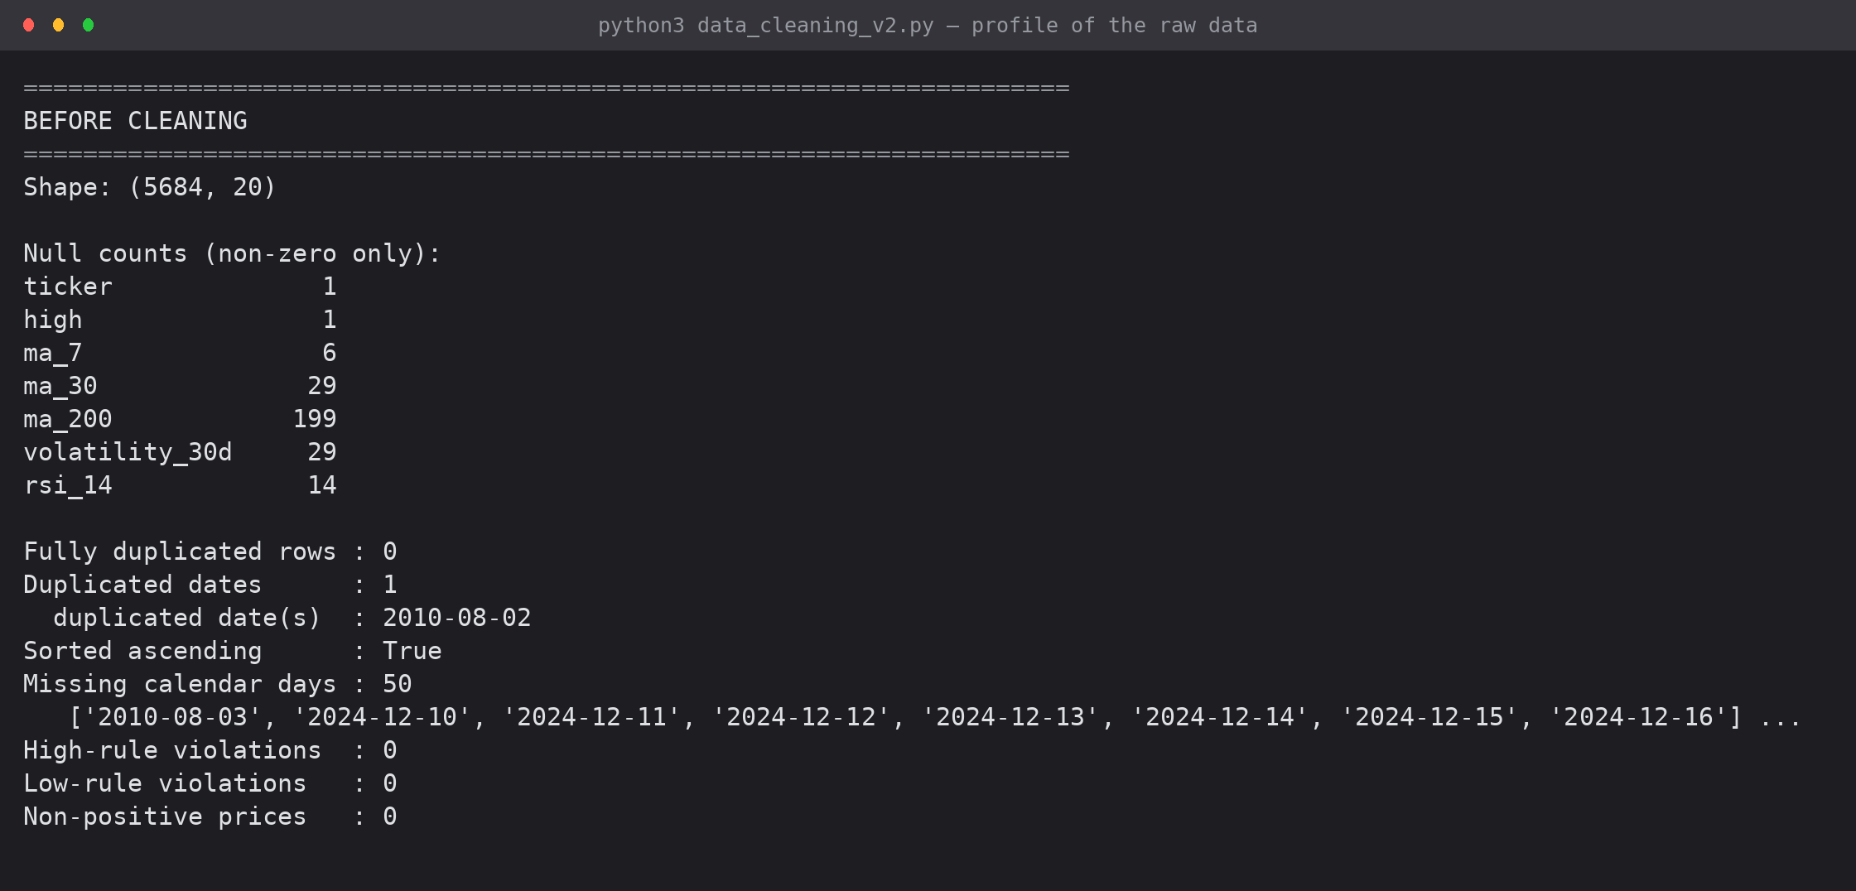
Screenshot 1: the raw-data profile printed by the corrected script — 279 nulls, 1 duplicate date, 50 missing calendar days, 0 OHLC violations
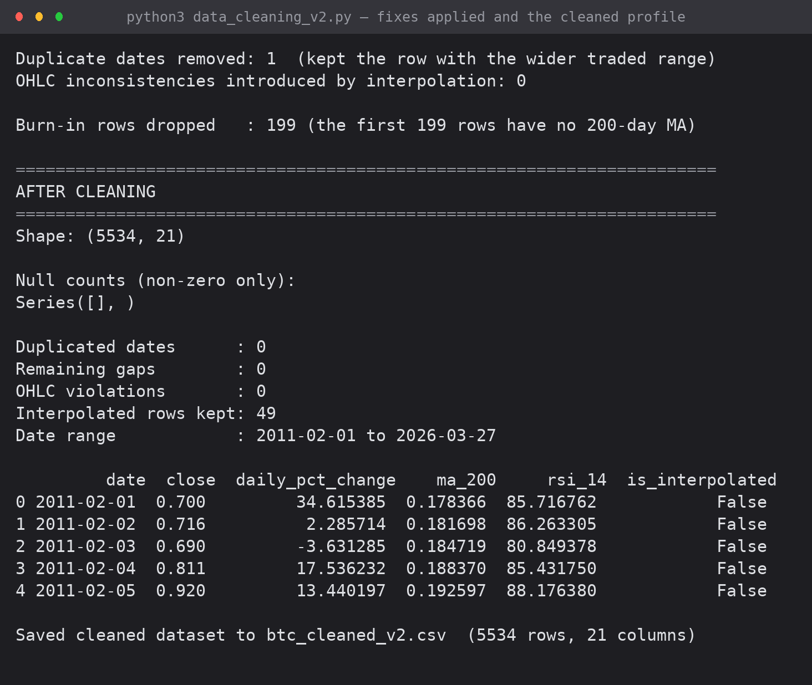
Screenshot 2: the fixes being applied and the state after cleaning — 5,534 rows, no nulls, no gaps, 49 rows flagged as interpolated

4. Part B — Descriptive Analysis
Descriptive statistics summarise central tendency, dispersion and distribution shape for every numeric attribute; they drive every later preprocessing decision.
NUM = ['open', 'high', 'low', 'close', 'daily_change', 'daily_pct_change',
'daily_range', 'ma_7', 'ma_30', 'ma_200', 'volatility_30d', 'rsi_14']

desc = df[NUM].describe().T
desc['median'] = df[NUM].median()
desc['mode'] = df[NUM].mode().iloc[0]
desc['variance'] = df[NUM].var()
desc['skewness'] = df[NUM].skew()
desc['kurtosis'] = df[NUM].kurtosis()
desc['range'] = desc['max'] - desc['min']
desc['IQR'] = df[NUM].quantile(0.75) - df[NUM].quantile(0.25)
desc = desc[['count', 'mean', 'median', 'mode', 'std', 'variance', 'min', '25%', '50%', '75%',
'max', 'range', 'IQR', 'skewness', 'kurtosis']]
print("DESCRIPTIVE STATISTICS")
desc.round(3)

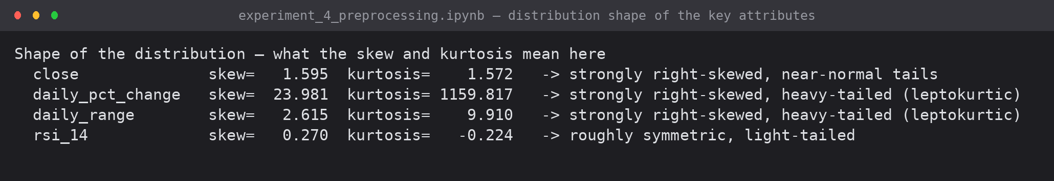
Screenshot 3: distribution shape — skewness and kurtosis of the key attributes
Reading the numbers: close price is strongly right-skewed (skew 1.595) because it grew exponentially; daily_pct_change has skew 23.98 and kurtosis 1159.8, both driven almost entirely by the single Mt. Gox print of +336.84% — a textbook demonstration of how one outlier dominates a moment-based statistic. RSI is close to symmetric (skew 0.270), as a bounded oscillator should be.
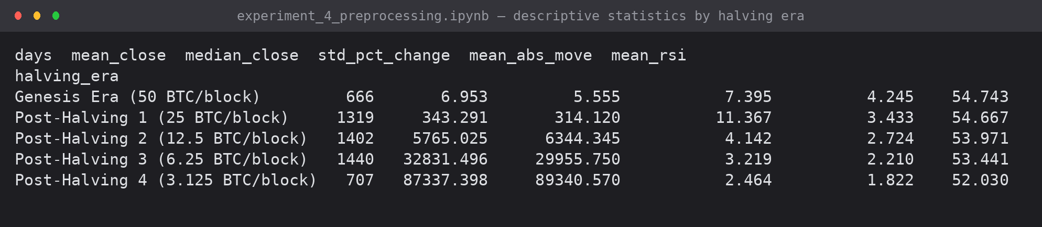
Screenshot 4: descriptive statistics grouped by halving era
Mean absolute daily move falls in every successive era — 4.245%, 3.433%, 2.724%, 2.210%, 1.822% — and the standard deviation of returns falls with it. This is the maturation effect the case study set out to measure, and it is confirmed independently in Experiments 3, 6 and 7.
5. Part B — Handling Null Values
The raw file has 279 nulls in 7 columns, spread over 199 rows (3.50% of the data). They are not one phenomenon, so they do not get one treatment.
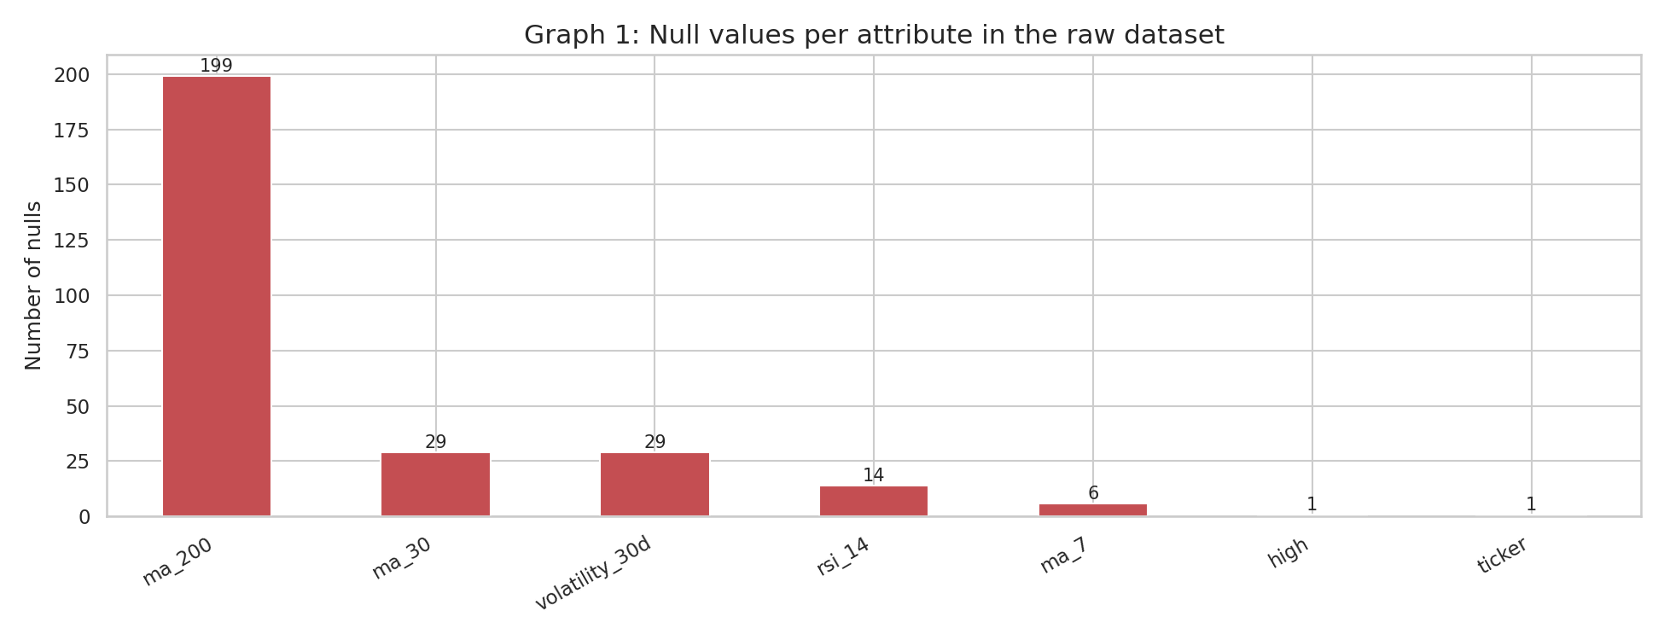
Graph 1: null values per attribute in the raw dataset
Attribute | Nulls | Type of missingness | Treatment
ma_200 | 199 | structural — a 200-day window needs 200 days | drop the burn-in rows
ma_30 / volatility_30d | 29 each | structural (30-day window) | dropped with the burn-in
rsi_14 | 14 | structural (14-day Wilder average) | dropped with the burn-in
ma_7 | 6 | structural (7-day window) | dropped with the burn-in
high | 1 | missing at random | repaired from the OHLC relation
ticker | 1 | missing at random in a constant column | forward fill
50 absent dates | — | missing rows, not missing cells | insert + linear interpolation, flagged

# Where exactly are the rsi_14 nulls?
target = 'rsi_14'
null_pos = np.where(raw[target].isnull())[0]
print(f"{target}: {len(null_pos)} nulls at row positions {null_pos.tolist()}")
print("-> they are the LEADING rows, i.e. structural burn-in, not values lost at random.\n")

strategies = {
'Listwise deletion' : raw[target].dropna(),
'Mean imputation' : raw[target].fillna(raw[target].mean()),
'Median imputation' : raw[target].fillna(raw[target].median()),
'Forward fill' : raw[target].ffill(),
'Backward fill' : raw[target].bfill(),
'Linear interpolation': raw[target].interpolate(method='linear'),
}
comparison = pd.DataFrame({
name: {'values kept': int(s.notna().sum()), 'nulls left': int(s.isna().sum()),
'mean': s.mean(), 'std': s.std()}
for name, s in strategies.items()}).T.round(4)
print("EFFECT OF EACH STRATEGY ON A STRUCTURAL (LEADING) NULL BLOCK")
print(comparison.to_string())
print("\nForward fill and interpolation cannot repair a LEADING gap - there is no earlier value to")
print("carry forward. Only deletion, back-fill or mean/median imputation change anything, and the last")
print("two would invent 14 days of indicator history. Dropping the burn-in is therefore the right call.")

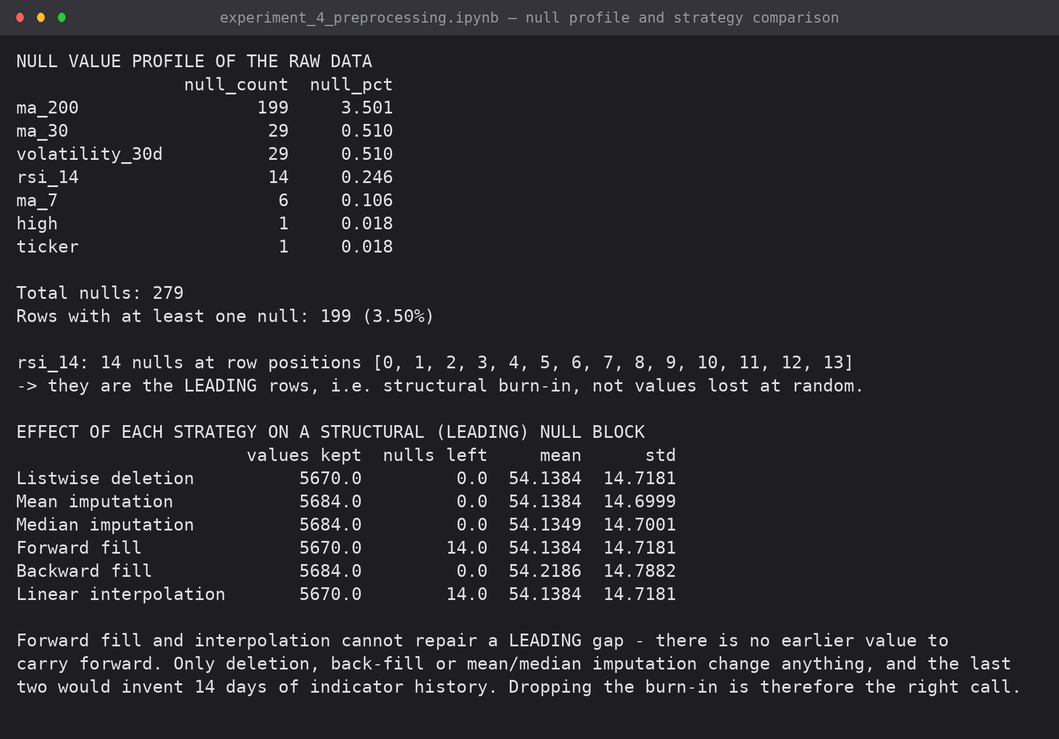
Screenshot 5: null profile, and what each strategy does to a leading (structural) null block
The comparison makes the distinction concrete: forward fill and interpolation cannot repair a leading gap at all (14 nulls remain), while mean or median imputation fills it by inventing 14 days of indicator history. Deleting the burn-in is therefore the correct treatment.
5.1 Which imputation method is actually best?
To choose the method used for the 50 inserted calendar days, 200 values were removed at random from a complete column and each strategy was scored on how well it recovered the known truth.
# For a fair comparison of the strategies, knock 200 values out of a complete
# column at random (MCAR) and measure how well each method recovers the truth.
rng = np.random.default_rng(0)
truth = df['rsi_14'].copy()
holes = rng.choice(len(truth), 200, replace=False)
damaged = truth.copy(); damaged.iloc[holes] = np.nan

candidates = {
'Mean imputation' : damaged.fillna(damaged.mean()),
'Median imputation' : damaged.fillna(damaged.median()),
'Forward fill' : damaged.ffill(),
'Linear interpolation': damaged.interpolate(method='linear'),
}
rows = []
for name, filled in candidates.items():
err = (filled.iloc[holes] - truth.iloc[holes])
rows.append({'strategy': name,
'MAE': err.abs().mean(),
'RMSE': np.sqrt((err ** 2).mean()),
'std of column after fill': filled.std(),
'std error vs truth': filled.std() - truth.std()})
print("RECOVERY TEST - 200 values removed at random from rsi_14, then imputed")
print(pd.DataFrame(rows).round(4).to_string(index=False))
print(f"\nTrue std of the column: {truth.std():.4f}")
print("Linear interpolation recovers the removed values most accurately and distorts the spread least,")
print("which is why Part A uses it for the price columns across the 50 missing calendar days.")

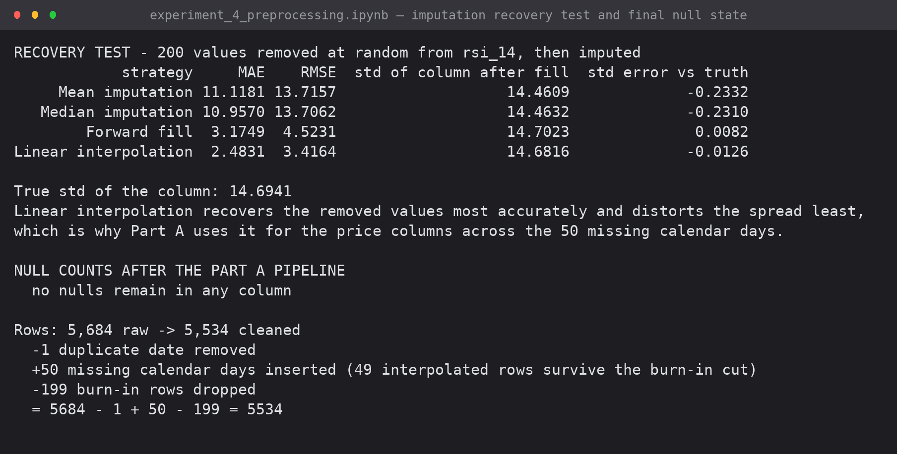
Screenshot 6: recovery test — interpolation is the most accurate and least distorting
Strategy | MAE | RMSE | Std error vs truth
Mean imputation | 11.118 | 13.716 | -0.233
Median imputation | 10.957 | 13.706 | -0.231
Forward fill | 3.175 | 4.523 | +0.008
Linear interpolation | 2.483 | 3.416 | -0.013

6. Part B — Data Normalization
Price spans five orders of magnitude ($0.68 to $125,173) while RSI is bounded to 0-100. Any distance-based algorithm would otherwise be a model of the price level alone. Three methods were implemented from their definitions.
Min-max : v' = (v - min) / (max - min) * (new_max - new_min) + new_min
Z-score : v' = (v - mean) / std
Decimal scale: v' = v / 10^j, where j = ceil(log10(max|v|))

def min_max_normalise(s, new_min=0.0, new_max=1.0):
return (s - s.min()) / (s.max() - s.min()) * (new_max - new_min) + new_min

def z_score_normalise(s):
return (s - s.mean()) / s.std()

def decimal_scale(s):
j = int(np.ceil(np.log10(s.abs().max())))
return s / (10 ** j), j

COLS = ['close', 'daily_range', 'daily_pct_change', 'rsi_14', 'volatility_30d']
norm = pd.DataFrame({'date': df['date']})
scale_report = []
for col in COLS:
norm[f'{col}_minmax'] = min_max_normalise(df[col])
norm[f'{col}_zscore'] = z_score_normalise(df[col])
scaled, j = decimal_scale(df[col])
norm[f'{col}_decimal'] = scaled
scale_report.append({
'attribute': col,
'original min': df[col].min(), 'original max': df[col].max(),
'original mean': df[col].mean(), 'original std': df[col].std(),
'minmax range': f"[{norm[f'{col}_minmax'].min():.2f}, {norm[f'{col}_minmax'].max():.2f}]",
'zscore mean': norm[f'{col}_zscore'].mean(),
'zscore std': norm[f'{col}_zscore'].std(),
'decimal j': j})
print("NORMALIZATION REPORT")
pd.DataFrame(scale_report).round(4)

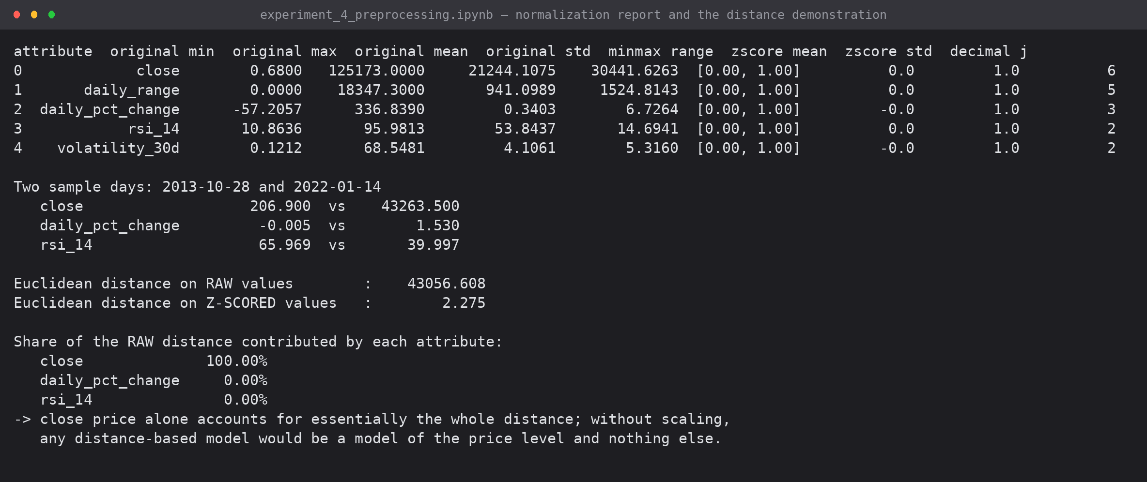
Screenshot 7: the normalization report for five attributes, and the effect of scaling on Euclidean distance
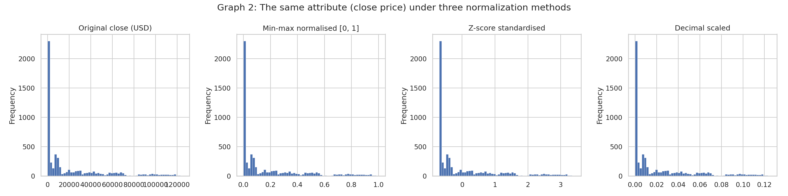
Graph 2: the close price under the three normalization methods — the axis changes, the shape does not
The distance demonstration is the practical argument: between two sample days the raw Euclidean distance is 43,056.6, of which the close price contributes 100.00% and both other attributes contribute 0.00%. After z-scoring the distance is 2.275 and all three attributes carry weight. This is why Experiments 6 and 7 standardise before clustering.
7. Part B — Data Discretization
Discretization turns a continuous attribute into a small number of labelled intervals. It is a prerequisite for the Apriori algorithm of Experiment 8, simplifies Naive Bayes in Experiment 5, and reduces the influence of extreme values.
def equal_width_bins(s, k):
lo, hi = s.min(), s.max()
edges = np.linspace(lo, hi, k + 1)
return pd.cut(s, bins=edges, include_lowest=True), edges

def equal_frequency_bins(s, k):
edges = np.unique(s.quantile(np.linspace(0, 1, k + 1)).values)
return pd.cut(s, bins=edges, include_lowest=True, duplicates='drop'), edges

K = 5
ew, ew_edges = equal_width_bins(df['daily_pct_change'], K)
ef, ef_edges = equal_frequency_bins(df['daily_pct_change'], K)

print(f"EQUAL-WIDTH binning of daily_pct_change (k = {K})")
print(" cut-points:", np.round(ew_edges, 3))
print(ew.value_counts().sort_index().to_string())
print(f"\nEQUAL-FREQUENCY binning of daily_pct_change (k = {K})")
print(" cut-points:", np.round(ef_edges, 3))
print(ef.value_counts().sort_index().to_string())
print("\nEqual width puts", f"{ew.value_counts().max() / len(df) * 100:.1f}%",
"of all days in a single bin; equal frequency keeps every bin at ~20%.")

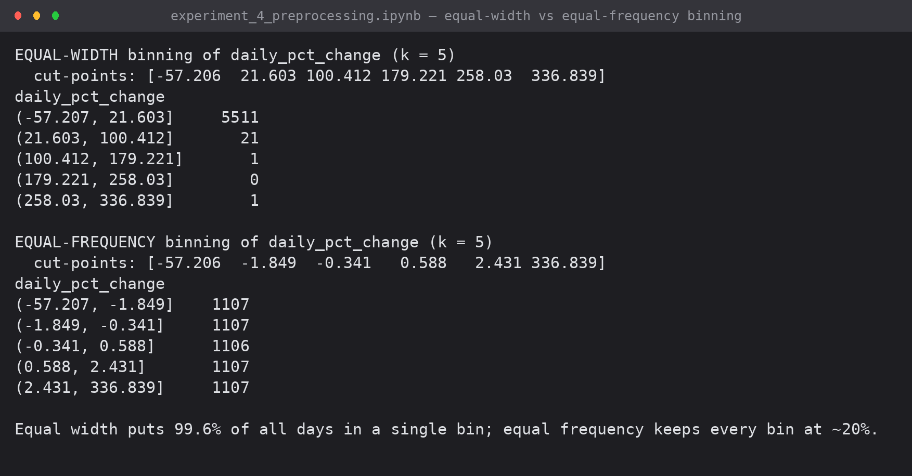
Screenshot 8: equal-width against equal-frequency binning of daily % change (k = 5)
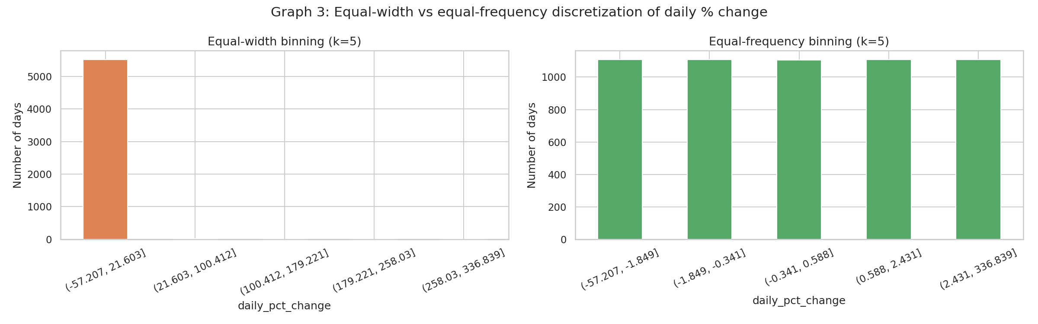
Graph 3: equal-width binning collapses into one bin; equal-frequency keeps the bins balanced
Equal-width places 99.6% of all days into a single bin, because the range is stretched by the +336.84% outlier — a clear illustration of why equal-width binning fails on skewed data. Equal-frequency holds each bin at roughly 20% of the days.
7.1 Domain-based bins used by the later experiments
# Domain-based discretization - the labels used by Experiments 5, 7 and 8
df['move_class'] = pd.cut(df['daily_pct_change'],
bins=[-np.inf, -5, -1, 1, 5, np.inf],
labels=['Large Fall', 'Fall', 'Flat', 'Rise', 'Large Rise'])
df['rsi_zone'] = pd.cut(df['rsi_14'], bins=[0, 30, 70, 100],
labels=['Oversold', 'Neutral', 'Overbought'])
df['range_band'] = pd.cut(df['daily_range'] / df['open'] * 100,
bins=[-np.inf, 3, 8, np.inf], labels=['Low', 'Medium', 'High'])
df['trend'] = np.where(df['close'] > df['ma_200'], 'Above 200-MA', 'Below 200-MA')

for col in ['move_class', 'rsi_zone', 'range_band', 'trend']:
counts = df[col].value_counts().reindex(
df[col].cat.categories if hasattr(df[col], 'cat') else sorted(df[col].unique()))
print(f"\n{col}")
for k, v in counts.items():
print(f" {str(k):14s} {v:5d} ({v/len(df)*100:5.2f}%)")

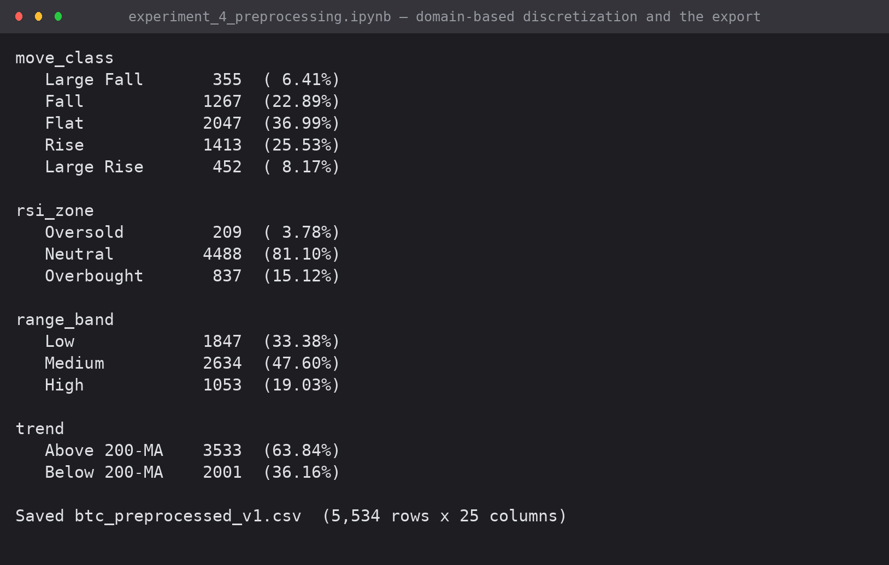
Screenshot 9: the four domain-based categorical attributes and the exported dataset
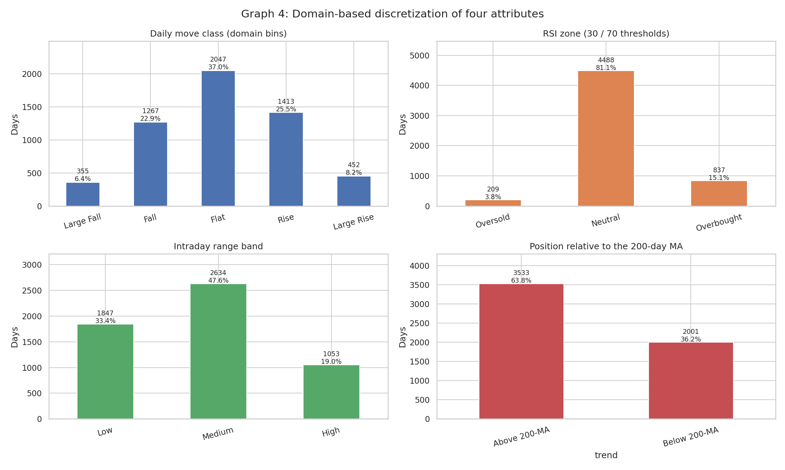
Graph 4: distribution of the four discretized attributes
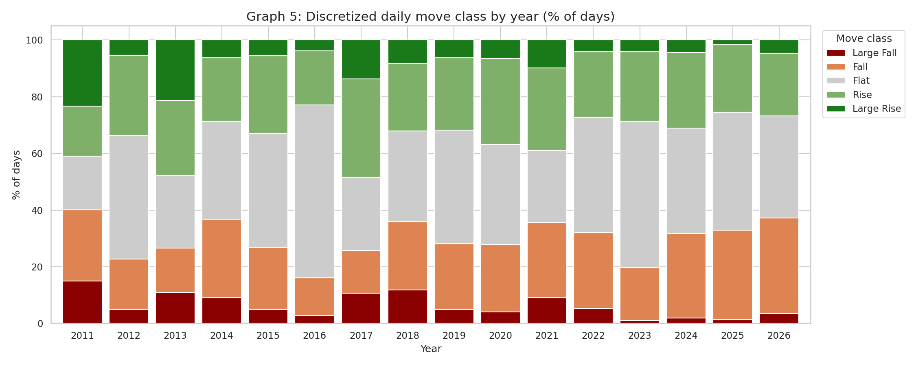
Graph 5: discretized move class by year — large moves become rarer over time
The share of days with a move larger than 5% falls from 38.3% (2011) to 3.0% (2025), which is the same maturation signal seen in the descriptive statistics, in the OLAP cross-tabs and in the clustering experiments.

8. Part C — Transformation, Outlier Analysis and Visualisation
The existing notebook experiment_5.ipynb was re-executed end to end against the cleaned dataset. It completes without errors. It performs a log transform of the close price, extracts time features, computes a 7-day rolling volatility, detects outliers by both the Z-score and IQR methods, and produces six visualisations.
Check | Result
Notebook re-executed | 22 cells, 0 errors
Rows after its dropna() | 5,528 (6 rows lost to the 7-day rolling window)
Z-score outliers (|z| > 3) on daily_pct_change | 44 days (0.80%)
IQR outliers (1.5 x IQR) | 582 days (10.53%), bounds -5.98% and +6.42%

Reconciliation of the outlier counts across experiments: Part C flags 44 days using a Z-score on daily_pct_change alone; Experiment 6 flags 72 days because it applies |z| > 3 to two features (daily percentage change and intraday range) and keeps the six rows Part C drops. The two counts are consistent — they answer different questions.
8.1 Two observations on Part C worth noting in the viva
- The correlation heatmap is computed on price levels (close, ma_30, ema, macd). Any two series that both trend upward over 15 years will correlate near 1.0 regardless of any real relationship; correlations on returns would be the stricter test.
- The Z-score outlier rule assumes a roughly stable mean and variance, but Bitcoin's volatility is far higher in 2011 than in 2025, so a fixed global threshold flags early years disproportionately. A rolling-window Z-score would be the refinement.
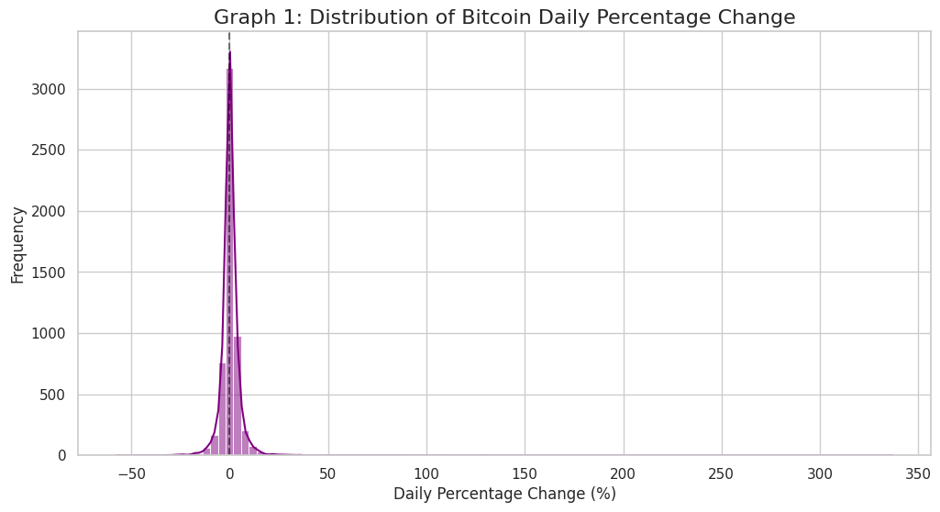
Part C, Graph 1 (from experiment_5.ipynb)
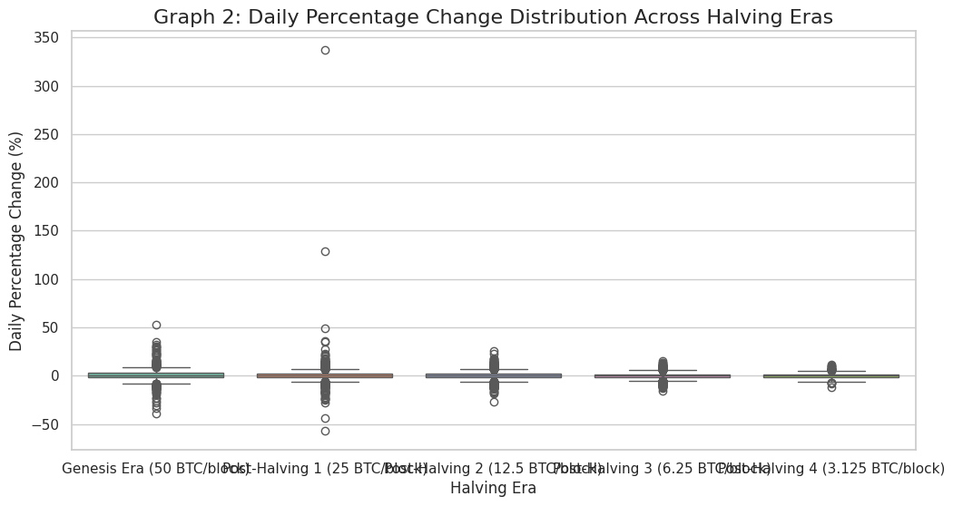
Part C, Graph 2 (from experiment_5.ipynb)
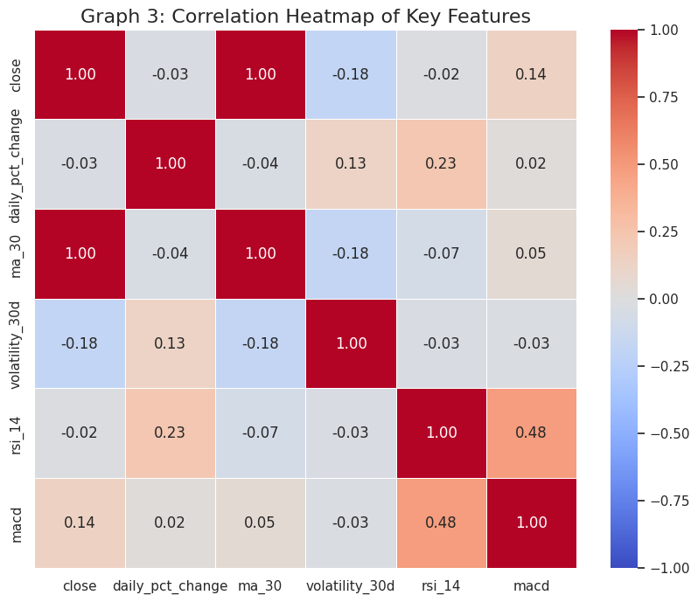
Part C, Graph 3 (from experiment_5.ipynb)
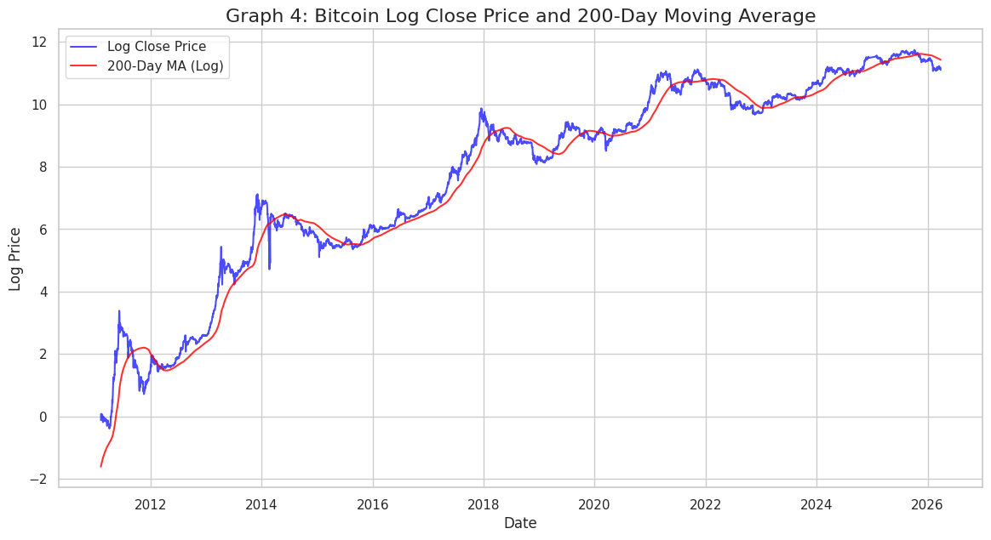
Part C, Graph 4 (from experiment_5.ipynb)
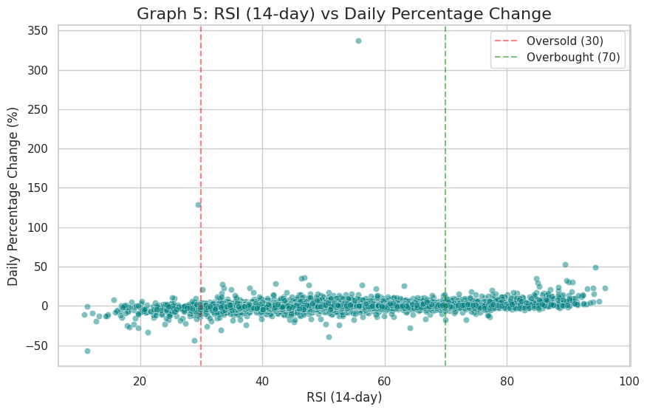
Part C, Graph 5 (from experiment_5.ipynb)
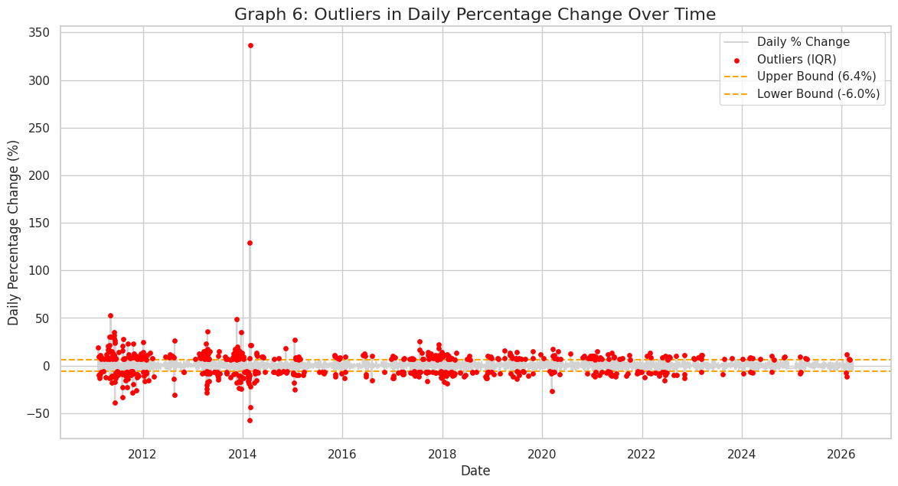
Part C, Graph 6 (from experiment_5.ipynb)
9. Results
Stage | Rows | Nulls | Note
Raw (btc_flat_final_2.csv) | 5,684 | 279 | 1 duplicate date, 50 missing calendar days
After duplicate removal | 5,683 | 279 | 2010-08-02 deduplicated
After gap filling | 5,733 | ~279 | 50 rows inserted and interpolated
After burn-in removal | 5,534 | 0 | 199 rows dropped, 49 interpolated rows retained
After Part B | 5,534 | 0 | + normalised and discretized columns, 25 columns total

Final output: btc_preprocessed_v1.csv — 5,534 rows and 25 columns, with no nulls, no duplicate dates, no calendar gaps, three normalised columns and four discretized categorical attributes.
10. Conclusion
The existing cleaning script was reviewed against its own input and found to fail on the duplicate date it reports but never removes; that and four smaller defects were corrected in data_cleaning_v2.py, which reproduces the original numeric output exactly apart from the days_since_halving column it was meant to fix.
Descriptive analysis quantified the distribution of every attribute and showed the fall in average absolute daily move across the halving eras (4.245% down to 1.822%). Null values were classified as structural or missing-at-random and treated accordingly, with a recovery test confirming linear interpolation as the most accurate filler (MAE 2.48 against 11.12 for mean imputation). Three normalization methods were implemented, and the Euclidean-distance demonstration showed why they matter: unscaled, the price attribute contributes 100% of the distance between two days. Three discretization methods were implemented, and equal-width binning was shown to collapse on this skewed data while equal-frequency and domain bins do not.

EXPERIMENT 5: IMPLEMENTATION OF NAIVE BAYESIAN AND CLASSIFICATION TREE ALGORITHMS
Predicting the next-day direction of Bitcoin from price and momentum features, with both classifiers written from first principles and evaluated on a chronologically held-out test set
Lab Code | Lab Name | Sem | Experiment | Course Outcome
2115120 | Data Warehousing and Mining | V | 5 | LO4

1. Aim
To implement the Naive Bayesian classifier and a classification (decision) tree without using any library algorithm, apply them to the Bitcoin case study, and evaluate them with a confusion matrix and the standard classification metrics.
2. Problem Definition
Element | Definition
Task | binary classification
Class label | 1 = Up (tomorrow's close is higher than today's), 0 = Down
Features (11) | daily_pct_change, range_pct, rsi_14, macd_hist, volatility_30d, close_vs_ma7, close_vs_ma30, close_vs_ma200, ret_lag1, ret_lag2, up_streak
Data | btc_preprocessed_v1.csv from Experiment 4 — 5,531 usable rows
Split | chronological 80/20: train 2011-02-03 to 2023-03-15 (4,424 rows), test 2023-03-16 to 2026-03-26 (1,107 rows)
Baseline | majority class = always predict Up = 52.57% on the test set

Every feature uses information available at or before today's close, so there is no look-ahead. The split is chronological, never random: a random split on a time series lets the model learn from future days and reports an accuracy that could never be achieved in practice.
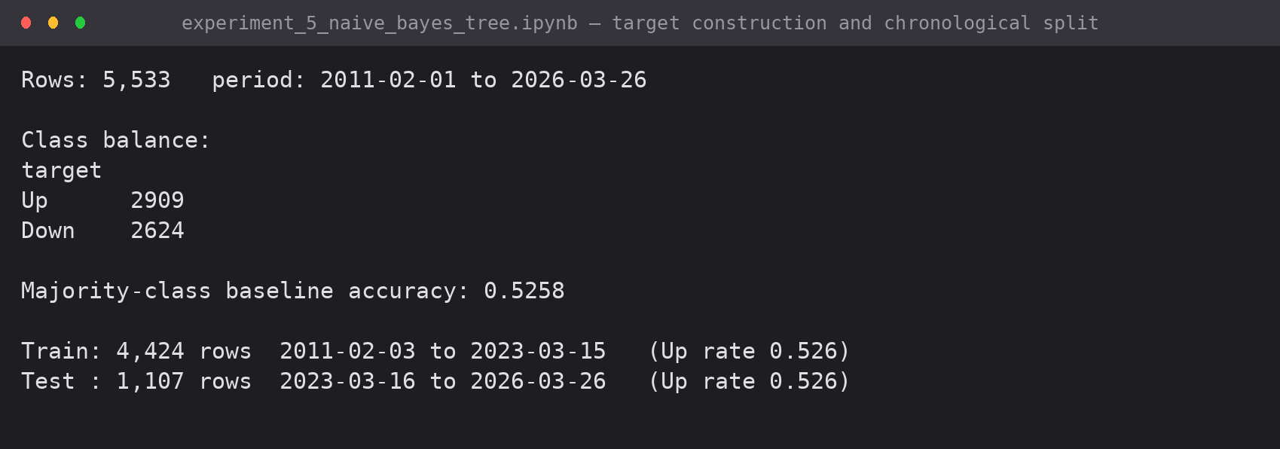
Screenshot 1: class balance and the chronological train/test split
3. Naive Bayes
3.1 Theory
Bayes' theorem : P(Ck | x) = P(x | Ck) . P(Ck) / P(x)
Naive assumption : P(x | Ck) = PRODUCT over i of P(xi | Ck)
Decision rule : y = argmax_k P(Ck) . PRODUCT P(xi | Ck)
Gaussian likelihood : P(xi | Ck) = 1/sqrt(2.pi.var) . exp(-(xi - mu)^2 / (2.var))
Implemented in logs : log P(Ck) + SUM_i log P(xi | Ck) (avoids underflow)

3.2 Implementation
class GaussianNaiveBayes:
"""Gaussian Naive Bayes written from first principles (no sklearn)."""

def __init__(self, var_smoothing=1e-9):
self.var_smoothing = var_smoothing

def fit(self, X, y):
self.classes_ = np.unique(y)
n_features = X.shape[1]
self.prior_ = np.zeros(len(self.classes_))
self.mu_ = np.zeros((len(self.classes_), n_features))
self.var_ = np.zeros((len(self.classes_), n_features))
eps = self.var_smoothing * X.var(axis=0).max()
for i, k in enumerate(self.classes_):
Xk = X[y == k]
self.prior_[i] = len(Xk) / len(X) # P(Ck)
self.mu_[i] = Xk.mean(axis=0) # mean per feature per class
self.var_[i] = Xk.var(axis=0) + eps # variance (smoothed)
return self

def _log_likelihood(self, X):
"""log P(x | Ck) + log P(Ck) for every class, shape (n_samples, n_classes)."""
out = np.zeros((len(X), len(self.classes_)))
for i in range(len(self.classes_)):
log_gauss = -0.5 * (np.log(2 * np.pi * self.var_[i])
+ (X - self.mu_[i]) ** 2 / self.var_[i])
out[:, i] = np.log(self.prior_[i]) + log_gauss.sum(axis=1)
return out

def predict_proba(self, X):
log_p = self._log_likelihood(X)
log_p -= log_p.max(axis=1, keepdims=True) # stabilise before exponentiating
p = np.exp(log_p)
return p / p.sum(axis=1, keepdims=True)

def predict(self, X):
return self.classes_[self._log_likelihood(X).argmax(axis=1)]

gnb = GaussianNaiveBayes().fit(X_train, y_train)
print("Learned priors: P(Down) = %.4f P(Up) = %.4f" % tuple(gnb.prior_))
print("\nClass-conditional means (mu) per feature:")
print(pd.DataFrame(gnb.mu_, index=['Down', 'Up'], columns=FEATURES).T.round(4).to_string())

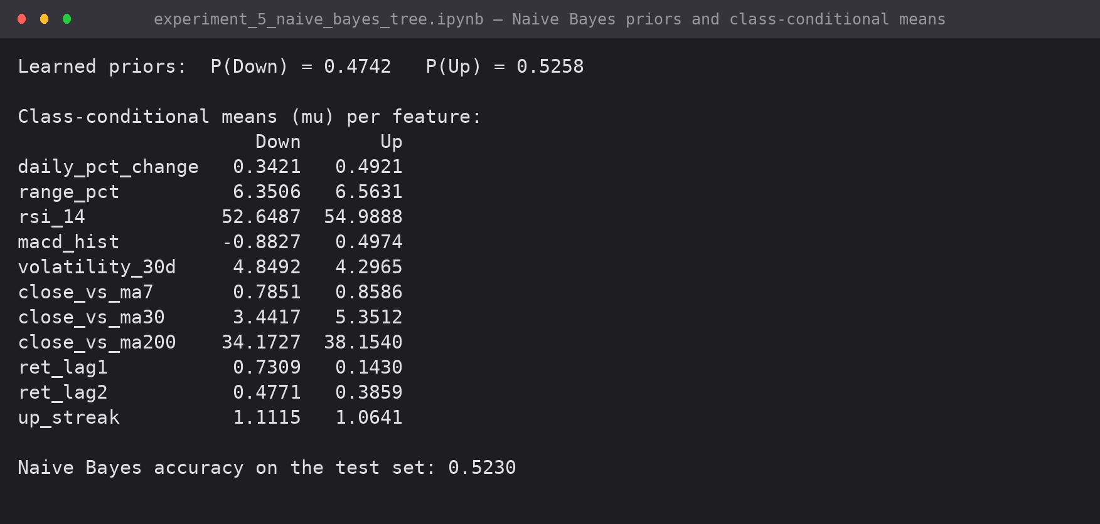
Screenshot 2: the learned priors and class-conditional means, and the resulting test accuracy
The class-conditional means are directionally sensible: days followed by a rise have a higher MACD histogram (+0.497 against -0.883), a higher RSI (54.99 against 52.65) and lower 30-day volatility (4.297 against 4.849). The separation is real but very small.

4. Classification Tree
4.1 Theory
Entropy : H(S) = - SUM_k p_k . log2(p_k)
Information gain : IG(S, A) = H(S) - SUM_v (|Sv| / |S|) . H(Sv)
Gini index (CART) : Gini(S) = 1 - SUM_k p_k^2
Split rule : choose the (feature, threshold) pair with the largest information gain
Stopping : max_depth reached, node too small, or no split gives positive gain

4.2 Implementation
def entropy(y):
if len(y) == 0:
return 0.0
p = np.bincount(y, minlength=2) / len(y)
p = p[p > 0]
return float(-(p * np.log2(p)).sum())

def gini(y):
if len(y) == 0:
return 0.0
p = np.bincount(y, minlength=2) / len(y)
return float(1 - (p ** 2).sum())

class DecisionTreeID3:
"""Binary classification tree with entropy/Gini splitting, written from scratch."""

def __init__(self, max_depth=4, min_samples_split=50, min_samples_leaf=25, criterion='entropy',
n_thresholds=32):
self.max_depth = max_depth
self.min_samples_split = min_samples_split
self.min_samples_leaf = min_samples_leaf
self.impurity = entropy if criterion == 'entropy' else gini
self.criterion = criterion
self.n_thresholds = n_thresholds

def _best_split(self, X, y):
best = {'gain': 0.0}
parent = self.impurity(y)
for j in range(X.shape[1]):
col = X[:, j]
# candidate thresholds: quantiles of the column (cheaper than every unique value)
qs = np.unique(np.quantile(col, np.linspace(0.05, 0.95, self.n_thresholds)))
for t in qs:
left = col <= t
nl, nr = int(left.sum()), int((~left).sum())
if nl < self.min_samples_leaf or nr < self.min_samples_leaf:
continue
child = (nl * self.impurity(y[left]) + nr * self.impurity(y[~left])) / len(y)
gain = parent - child
if gain > best['gain']:
best = {'gain': gain, 'feature': j, 'threshold': float(t)}
return best

def _build(self, X, y, depth):
node = {'n': len(y), 'value': int(np.bincount(y, minlength=2).argmax()),
'dist': np.bincount(y, minlength=2).tolist(),
'impurity': round(self.impurity(y), 4)}
if depth >= self.max_depth or len(y) < self.min_samples_split or len(np.unique(y)) == 1:
node['leaf'] = True
return node
split = self._best_split(X, y)
if split['gain'] <= 1e-7:
node['leaf'] = True
return node
left = X[:, split['feature']] <= split['threshold']
node.update(leaf=False, feature=split['feature'], threshold=split['threshold'],
gain=round(split['gain'], 6))
node['left'] = self._build(X[left], y[left], depth + 1)
node['right'] = self._build(X[~left], y[~left], depth + 1)
return node

def fit(self, X, y):
self.tree_ = self._build(X, y, 0)
return self

def _predict_one(self, x, node):
while not node['leaf']:
node = node['left'] if x[node['feature']] <= node['threshold'] else node['right']
return node['value'], node['dist']

def predict(self, X):
return np.array([self._predict_one(x, self.tree_)[0] for x in X])

def predict_proba(self, X):
out = []
for x in X:
_, dist = self._predict_one(x, self.tree_)
total = sum(dist)
out.append(dist[1] / total if total else 0.5)
return np.array(out)

def print_tree(self, names, node=None, indent="", branch=""):
node = self.tree_ if node is None else node
if node['leaf']:
cls = 'Up' if node['value'] == 1 else 'Down'
print(f"{indent}{branch}[leaf] predict {cls:4s} n={node['n']:5d} "
f"dist(Down,Up)={node['dist']} {self.criterion}={node['impurity']}")
return
print(f"{indent}{branch}{names[node['feature']]} <= {node['threshold']:.4f} "
f"(gain={node['gain']}, n={node['n']})")
self.print_tree(names, node['left'], indent + " ", "|-- True : ")
self.print_tree(names, node['right'], indent + " ", "|-- False: ")

tree = DecisionTreeID3(max_depth=4, criterion='entropy').fit(X_train, y_train)
print(f"Root entropy of the training set: {entropy(y_train):.4f} bits\n")
tree.print_tree(FEATURES)

4.3 The induced tree
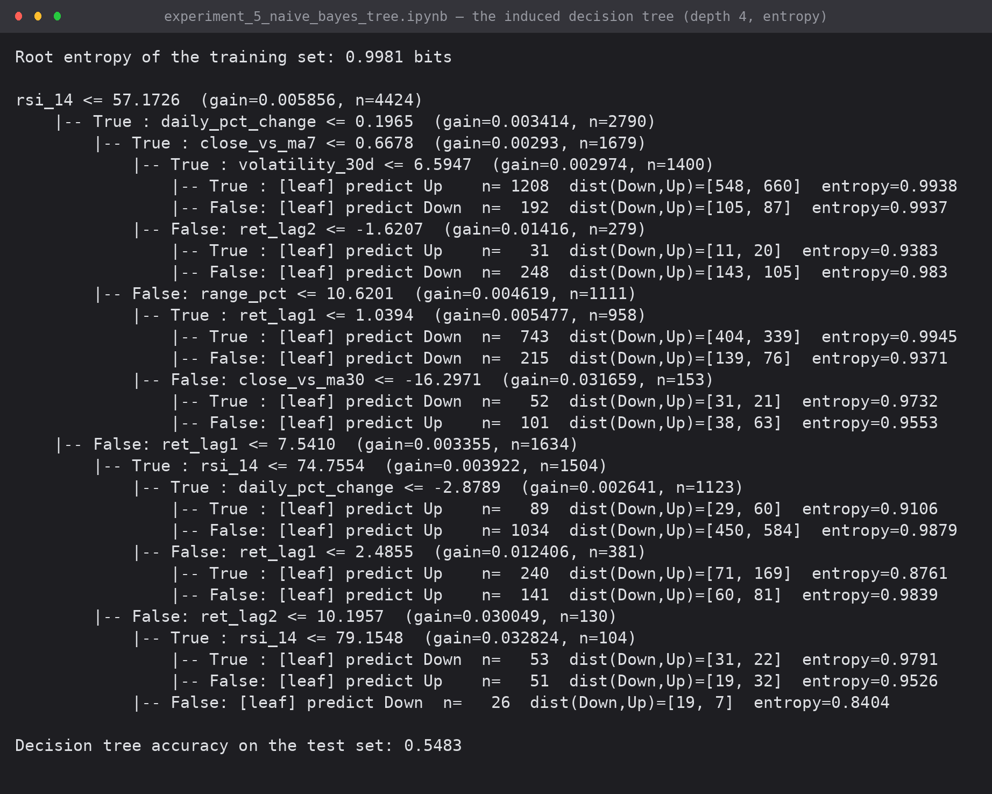
Screenshot 3: the tree induced from the training data (max_depth 4, entropy criterion)
The root splits on RSI at 57.17 with a gain of 0.0059 bits out of a root entropy of 0.9981 bits — the single most informative split available removes about half a percent of the uncertainty. Every leaf is close to 50/50, which is the honest shape of this problem.
5. Evaluation
5.1 Metrics implemented from the confusion matrix
def confusion_matrix_manual(y_true, y_pred):
tp = int(((y_pred == 1) & (y_true == 1)).sum())
tn = int(((y_pred == 0) & (y_true == 0)).sum())
fp = int(((y_pred == 1) & (y_true == 0)).sum())
fn = int(((y_pred == 0) & (y_true == 1)).sum())
return np.array([[tn, fp], [fn, tp]]), (tp, tn, fp, fn)

def metrics_manual(y_true, y_pred):
_, (tp, tn, fp, fn) = confusion_matrix_manual(y_true, y_pred)
acc = (tp + tn) / len(y_true)
prec = tp / (tp + fp) if tp + fp else 0.0
rec = tp / (tp + fn) if tp + fn else 0.0
spec = tn / (tn + fp) if tn + fp else 0.0
f1 = 2 * prec * rec / (prec + rec) if prec + rec else 0.0
return {'accuracy': acc, 'precision (Up)': prec, 'recall (Up)': rec,
'specificity (Down)': spec, 'f1 (Up)': f1}

def roc_auc_manual(y_true, scores):
"""AUC via the rank (Mann-Whitney U) identity."""
order = np.argsort(scores)
ranks = np.empty(len(scores), float)
ranks[order] = np.arange(1, len(scores) + 1)
pos, neg = (y_true == 1).sum(), (y_true == 0).sum()
return float((ranks[y_true == 1].sum() - pos * (pos + 1) / 2) / (pos * neg))

baseline = np.full_like(y_test, int(round(y_train.mean())))
results = pd.DataFrame({
'Naive Bayes' : metrics_manual(y_test, y_pred_nb),
'Decision Tree' : metrics_manual(y_test, y_pred_dt),
'Majority baseline': metrics_manual(y_test, baseline)}).T
results['ROC-AUC'] = [roc_auc_manual(y_test, y_proba_nb), roc_auc_manual(y_test, y_proba_dt), 0.5]
print("PERFORMANCE MATRIX (test set, chronologically held out)")
print(results.round(4).to_string())

for name, pred in [('Naive Bayes', y_pred_nb), ('Decision Tree', y_pred_dt)]:
cm, (tp, tn, fp, fn) = confusion_matrix_manual(y_test, pred)
print(f"\nConfusion matrix - {name}")
print(f" predicted Down predicted Up")
print(f" actual Down {tn:>12d} {fp:>12d}")
print(f" actual Up {fn:>12d} {tp:>12d}")

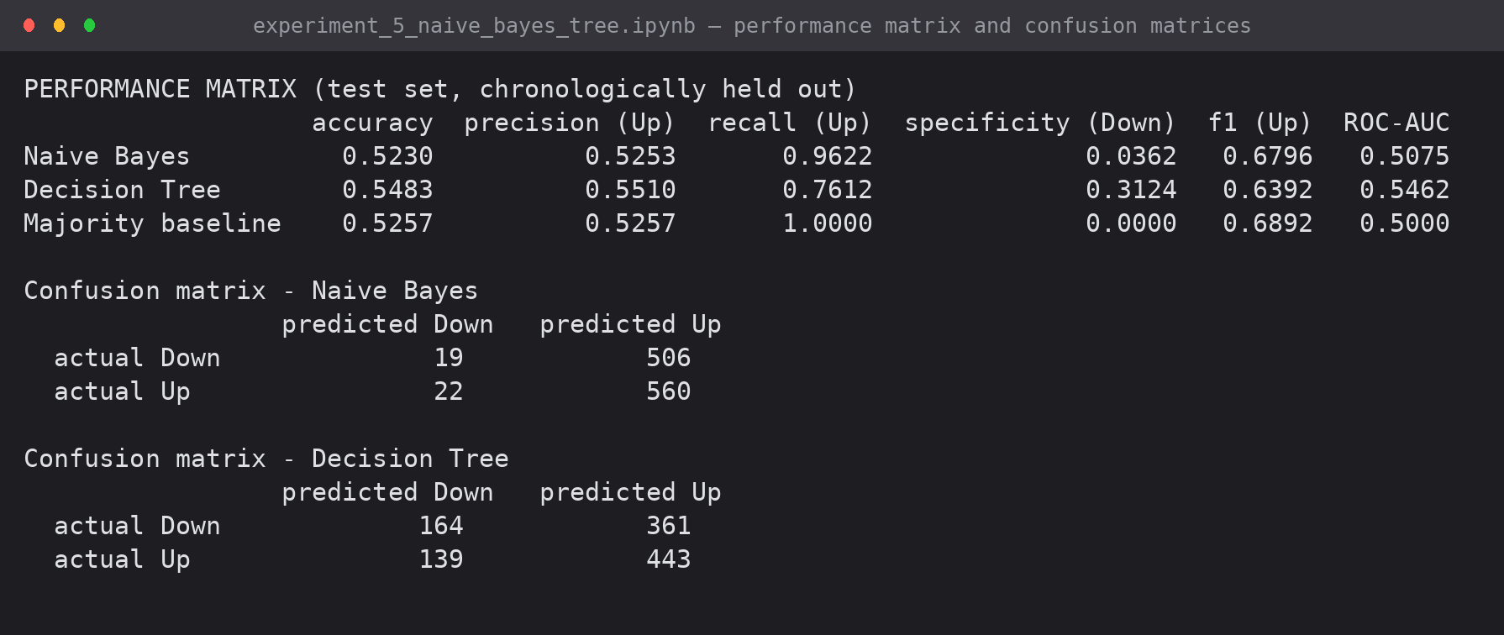
Screenshot 4: performance matrix and the confusion matrix of each classifier
5.2 Performance matrix
Model | Accuracy | Precision (Up) | Recall (Up) | Specificity | F1 (Up) | ROC-AUC
Naive Bayes (from scratch) | 0.5230 | 0.5253 | 0.9622 | 0.0362 | 0.6796 | 0.5075
Decision Tree (depth 4) | 0.5483 | 0.5510 | 0.7612 | 0.3124 | 0.6392 | 0.5462
Majority-class baseline | 0.5257 | 0.5257 | 1.0000 | 0.0000 | 0.6892 | 0.5000

Confusion matrix | Predicted Down | Predicted Up
Naive Bayes — actual Down | 19 | 506
Naive Bayes — actual Up | 22 | 560
Decision Tree — actual Down | 164 | 361
Decision Tree — actual Up | 139 | 443

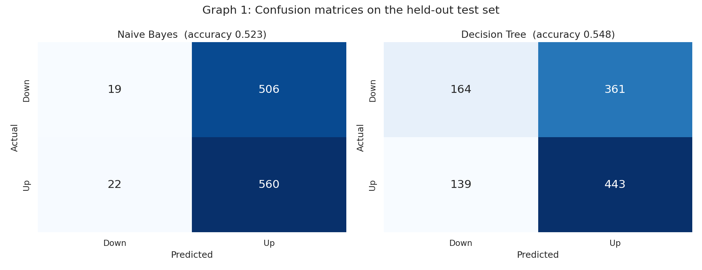
Graph 1: confusion matrices on the held-out test set
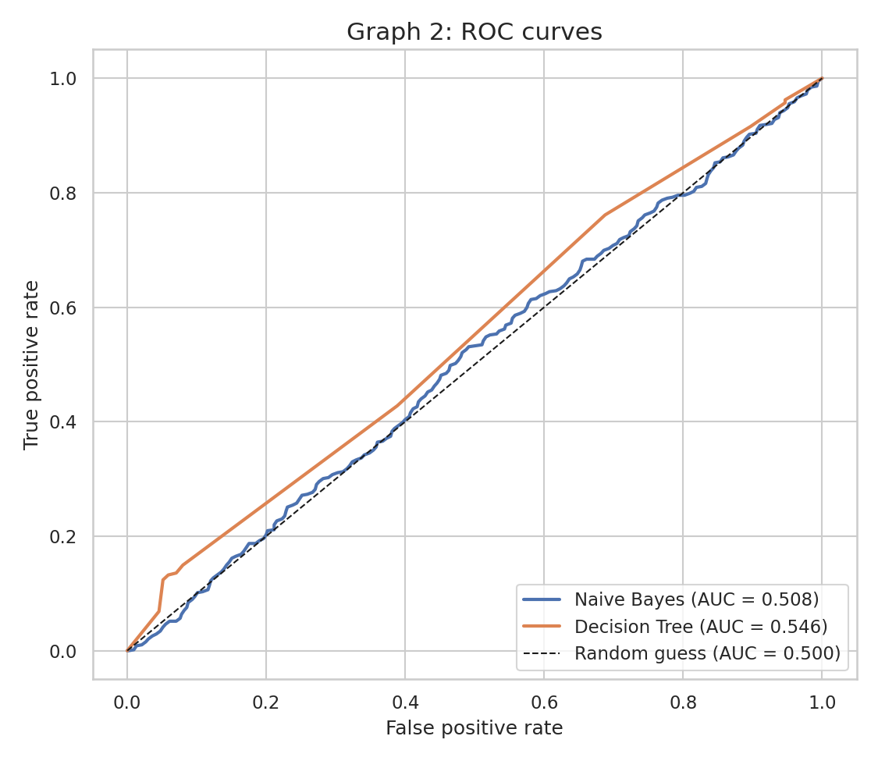
Graph 2: ROC curves — both models sit close to the diagonal

5.3 Why the accuracy is where it is
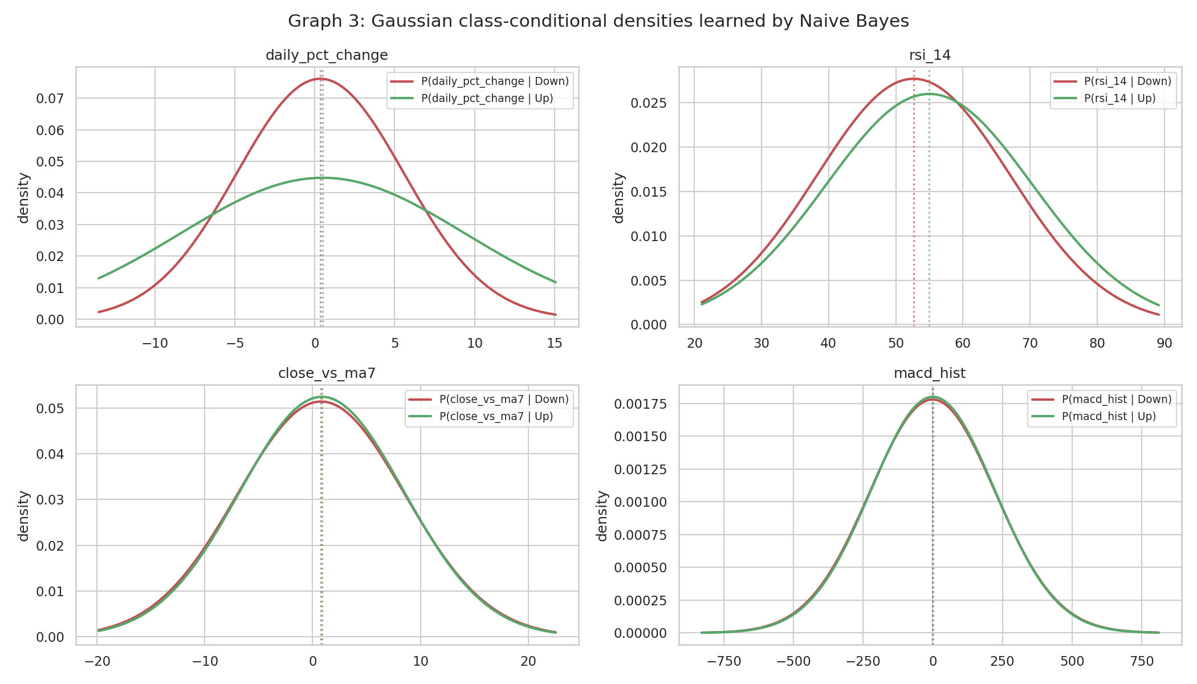
Graph 3: the Gaussian class-conditional densities learned by Naive Bayes — the Up and Down curves almost coincide
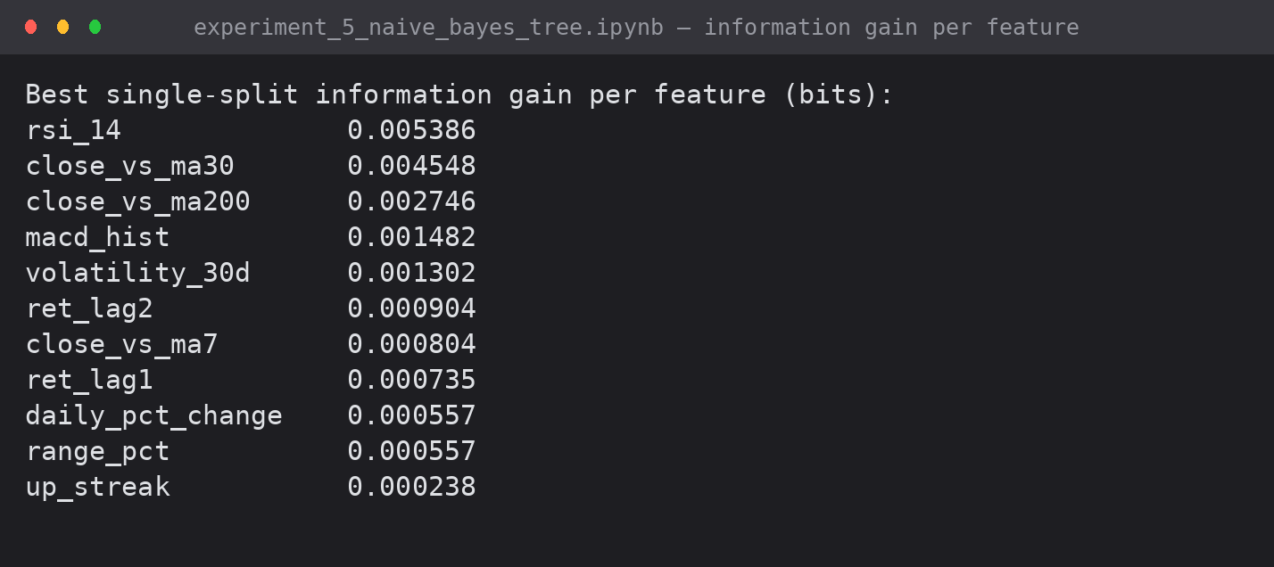
Screenshot 5: best single-split information gain per feature
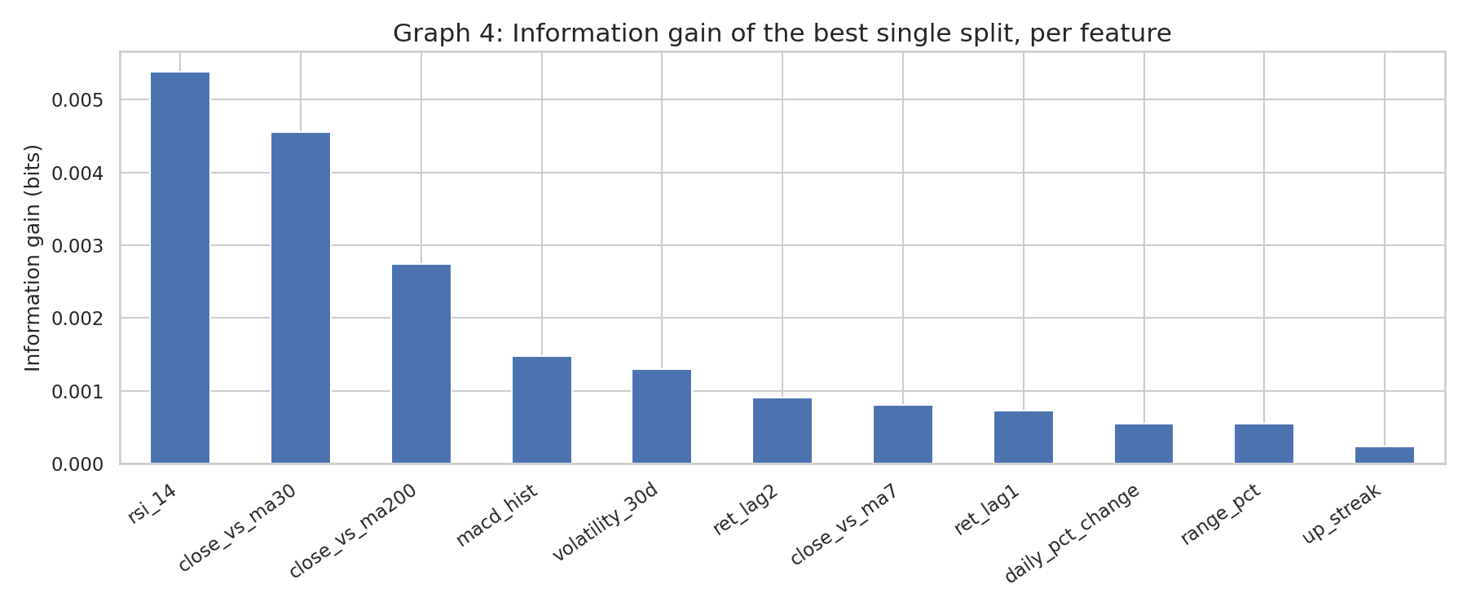
Graph 4: information gain of the best single split per feature
Root entropy is 0.9981 bits and the best single feature (RSI) removes 0.0054 bits — 0.54% of the uncertainty. That single number explains every result in this experiment.
6. Verification and Sensitivity
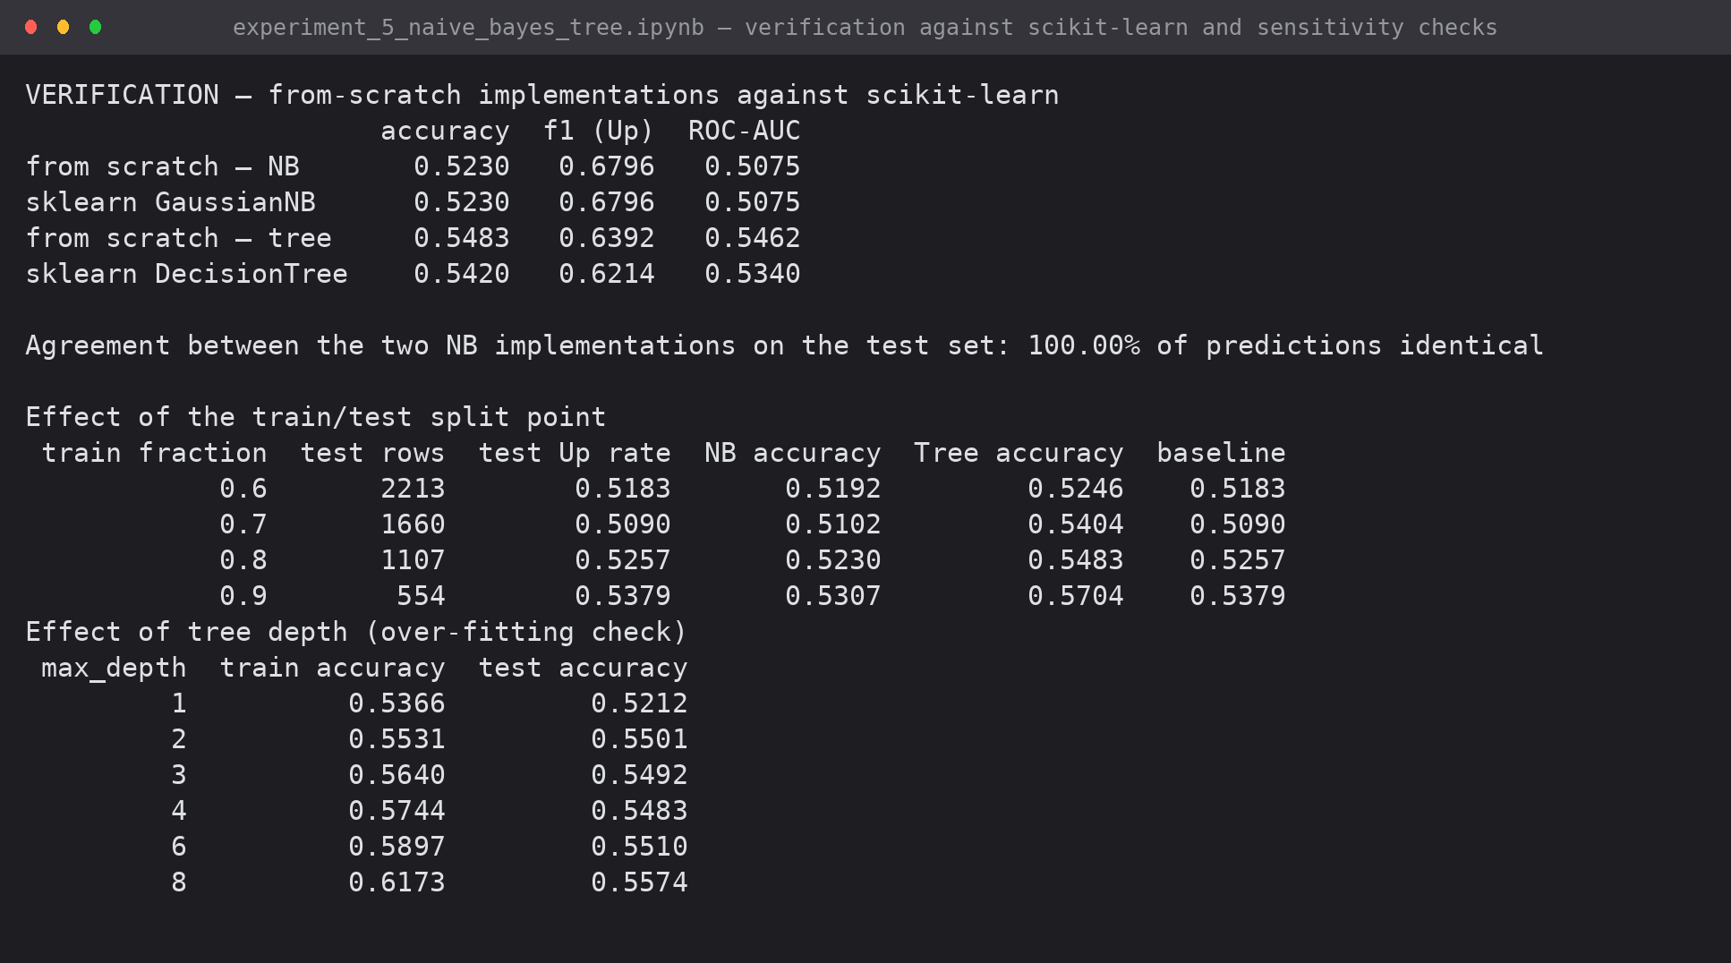
Screenshot 6: agreement with scikit-learn, and the split-point and depth sensitivity checks
Check | Result
From-scratch Naive Bayes vs sklearn GaussianNB | identical predictions on 100.00% of test rows; accuracy, F1 and AUC match to 4 dp
From-scratch tree vs sklearn DecisionTreeClassifier | 0.5483 against 0.5420 — the difference is the threshold search (quantile candidates vs all midpoints), not the criterion
Split point 0.6 / 0.7 / 0.8 / 0.9 | tree 0.525 / 0.540 / 0.548 / 0.570 against baselines 0.518 / 0.509 / 0.526 / 0.538 — consistently a little above
Tree depth 1 to 8 | training accuracy rises 0.537 to 0.617 while test accuracy stays 0.521 to 0.557 — over-fitting

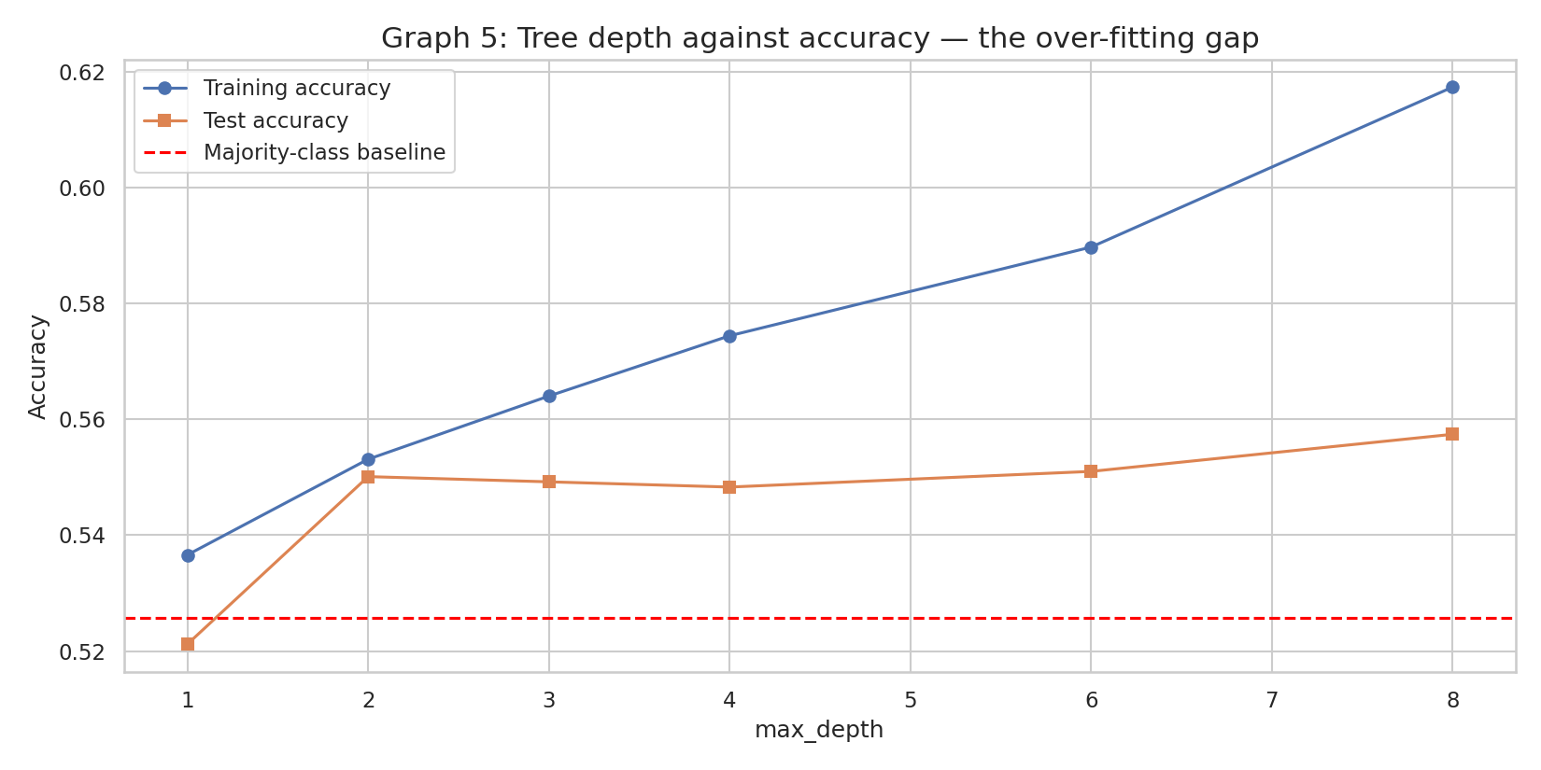
Graph 5: tree depth against accuracy — the widening train/test gap is over-fitting
7. Results and Interpretation
- The decision tree is the better model at 54.83% accuracy and ROC-AUC 0.546, about 2.3 points above the majority-class baseline, and it is the only model that catches a meaningful share of down days (specificity 0.312).
- Naive Bayes at 52.30% is fractionally below the 52.57% baseline. Its confusion matrix explains why: it predicts Up on 1,066 of 1,107 test days, so it has essentially learned the class prior.
- Both models are limited by the data, not the implementation: the classes are barely separable, as the overlapping Gaussian densities and the 0.54% information gain both show.
- The direction of the small signal is economically sensible — calm, momentum-positive days are marginally more often followed by a gain — but the effect is far too small to trade on.
- Next-day direction in a liquid, heavily arbitraged market is close to a fair coin; a result near the baseline is the expected outcome. The value of the experiment is a correct implementation and a documented benchmark: any future model must beat 54.8% on this exact chronological split.
8. Conclusion
Gaussian Naive Bayes and an ID3-style classification tree were implemented from first principles — priors, class-conditional Gaussians, log-probability scoring, entropy, information gain and recursive splitting — with no library algorithm involved, and were evaluated on 1,107 chronologically held-out trading days. The tree reached 54.83% accuracy (AUC 0.546) against a 52.57% baseline; Naive Bayes reached 52.30% (AUC 0.508) and was verified to match scikit-learn on 100% of predictions. Beyond the algorithms themselves, the experiment demonstrates what a weak signal looks like — a root entropy of 0.998 bits reduced by only 0.5% by the best feature, near-identical class densities, and a training/test gap that widens with depth while test accuracy does not improve.
9. Files Submitted
File | Contents
experiment_5_naive_bayes_tree.ipynb | executed notebook — both algorithms, evaluation, verification
exp5_outputs/exp5_g1..g5 (.png) | confusion matrices, ROC, densities, information gain, depth curve
outputs/exp5_shot1..6 (.png) | captured console output

EXPERIMENT 6: IMPLEMENTATION OF CLUSTERING ALGORITHM (K-MEANS)
K-Means written from first principles — hand-solved numerical example, full-dataset implementation, cluster visualisation, cluster analysis report and performance matrix
Lab Code | Lab Name | Sem | Experiment | Course Outcome
2115120 | Data Warehousing and Mining | V | 6 | LO4

1. Aim
To implement the K-Means clustering algorithm without using any inbuilt clustering library function, apply it to the Bitcoin case-study dataset in two dimensions, visualise the resulting clusters, and evaluate the clustering using a performance matrix.
2. Problem Statement (Case Study)
Case study: Predicting Trends and Uncovering Patterns in Bitcoin Price Movement Using Data Mining Techniques.
Bitcoin trades 24x7 and produces an uninterrupted daily OHLC series from July 2010 onwards. The case study asks for trading days to be grouped into market regimes — calm periods, steady trends and high-volatility boom-bust periods — using clustering on return and range features, and for those regimes to be visualised across the 2011-2026 timeline. This experiment answers that requirement with a hand-written K-Means implementation.
3. Dataset and Feature Selection
Source file: btc_cleaned.csv — 5,534 daily records from 01 Feb 2011 to 27 Mar 2026, produced by the cleaning pipeline of Experiment 4 (gap filling, OHLC validation, derived columns and technical indicators).
Both clustering features are expressed as percentages so that a day in 2011 (BTC around $0.50) and a day in 2026 (BTC around $70,000) are directly comparable:
Axis | Feature | Formula | Meaning
x | daily_pct_change | (close - open) / open x 100 | direction and size of the day's move
y | range_pct | (high - low) / open x 100 | intraday swing — how turbulent the day was

4. Software Used
- Python 3 — algorithm implemented manually (no sklearn.cluster)
- pandas, NumPy — data handling and array arithmetic only
- matplotlib, seaborn — plotting only
- Jupyter Notebook — experiment_6_kmeans.ipynb
5. Theory
5.1 Clustering
Clustering is an unsupervised data-mining task that partitions a dataset into groups so that objects inside a group are similar to one another and dissimilar to objects in other groups. No class labels are supplied; the grouping is discovered from the data itself. Similarity is measured with a distance function — Euclidean distance for numeric attributes.
5.2 K-Means
K-Means is a partitional, centroid-based clustering algorithm. It divides n objects into k clusters, each represented by the mean (centroid) of its members, and minimises the Sum of Squared Errors:
SSE = sum over i = 1..k of sum over p in Ci of || p - ci ||^2

Algorithm:
- Step 1 — choose k and select k initial centroids.
- Step 2 (assignment) — assign every object to the cluster of its nearest centroid, using d(p, c) = sqrt((px - cx)^2 + (py - cy)^2).
- Step 3 (update) — recompute each centroid as the arithmetic mean of the objects assigned to it.
- Step 4 — repeat steps 2 and 3 until the centroids stop moving (or a maximum number of iterations is reached). SSE decreases at every step, so the algorithm always terminates.
Properties: time complexity O(n k d i) for n objects, k clusters, d dimensions and i iterations — efficient and scalable. Limitations: k must be supplied in advance, the result depends on the initial centroids (only a local optimum is guaranteed), clusters are assumed roughly spherical and of similar size, and the mean is highly sensitive to outliers. The last two points are both visible in this experiment.

6. Part A — Hand-Solved Numerical Example (verified in code)
Eight Bitcoin trading days were taken from the cleaned dataset — four ordinary days and four turbulent days — and clustered by hand with k = 2. The same eight points, the same initial centroids and the same rounding are used by the script below, so every distance in the handwritten writeup can be checked against the program output.
Pt | Date | x = daily % change | y = range % of open
A | 2022-01-18 | 1.0 | 3.3
B | 2025-03-01 | 2.3 | 3.2
C | 2019-09-10 | -1.8 | 4.1
D | 2017-12-17 | -1.5 | 5.8
E | 2013-11-29 | 9.6 | 17.4
F | 2018-02-06 | 11.8 | 28.6
G | 2013-12-07 | -17.5 | 37.9
H | 2020-03-12 | -27.2 | 30.1

Initial centroids: C1 = A (1.0, 3.3) and C2 = C (-1.8, 4.1).
6.1 Code — exp6_paper_example.py
Core routines (full listing in exp6_paper_example.py)
def euclidean(p, q):
return math.sqrt((p[0] - q[0]) ** 2 + (p[1] - q[1]) ** 2)

def assign_clusters(points, centroids):
"""Nearest-centroid assignment. Returns (labels, distance table)."""
labels, table = [], []
for p in points:
dists = [euclidean(p, c) for c in centroids]
nearest = dists.index(min(dists))
labels.append(nearest)
table.append([round(d, 2) for d in dists])
return labels, table

def recompute_centroids(points, labels, k, old_centroids):
"""New centroid = arithmetic mean of the points assigned to that cluster."""
sums = [[0.0, 0.0] for _ in range(k)]
counts = [0] * k
for p, c in zip(points, labels):
sums[c][0] += p[0]
sums[c][1] += p[1]
counts[c] += 1
new = []
for i in range(k):
if counts[i] == 0: # empty cluster -> keep the old centroid
new.append(old_centroids[i])
else:
new.append((round(sums[i][0] / counts[i], 2),
round(sums[i][1] / counts[i], 2)))
return new

def sse(points, labels, centroids):
"""Sum of Squared Errors - the objective K-Means minimises."""
return round(sum(euclidean(p, centroids[c]) ** 2 for p, c in zip(points, labels)), 2)

def kmeans(points, names, k, initial_centroids, max_iter=10):
centroids = list(initial_centroids)
labels = None
for it in range(1, max_iter + 1):
labels, table = assign_clusters(points, centroids)

print(f"\n{'-' * 66}")
print(f"ITERATION {it}")
print(f"{'-' * 66}")
print("Centroids used:", " ".join(f"C{i+1}={c}" for i, c in enumerate(centroids)))
header = f"{'Pt':<4}{'(x, y)':<18}" + "".join(f"{'d(C'+str(i+1)+')':<10}" for i in range(k)) + "Cluster"
print(header)
for name, p, row, lab in zip(names, points, table, labels):
line = f"{name:<4}{str(p):<18}" + "".join(f"{d:<10}" for d in row) + f"C{lab+1}"
print(line)

for i in range(k):
members = [names[j] for j, lab in enumerate(labels) if lab == i]
print(f" Cluster {i+1}: {{{', '.join(members)}}}")
print(f" SSE = {sse(points, labels, centroids)}")

new_centroids = recompute_centroids(points, labels, k, centroids)
print("Recomputed centroids:", " ".join(f"C{i+1}={c}" for i, c in enumerate(new_centroids)))

if new_centroids == centroids:
print(f"\n>> Centroids unchanged -> converged after {it} iteration(s).")
return centroids, labels, it
centroids = new_centroids

return centroids, labels, max_iter

6.2 Output
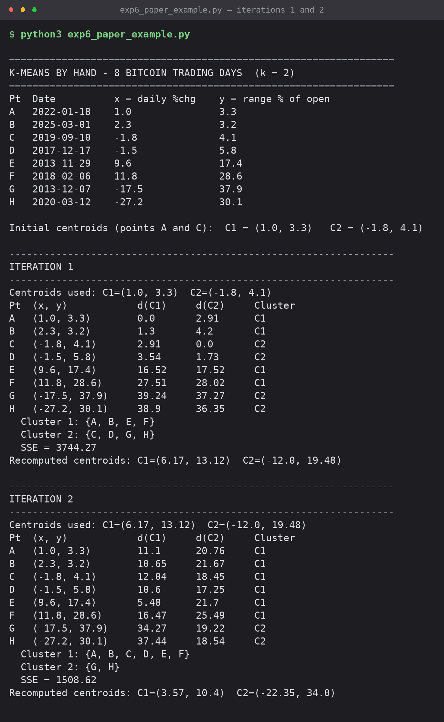
Screenshot 1: iterations 1 and 2 — distance table, cluster membership and recomputed centroids
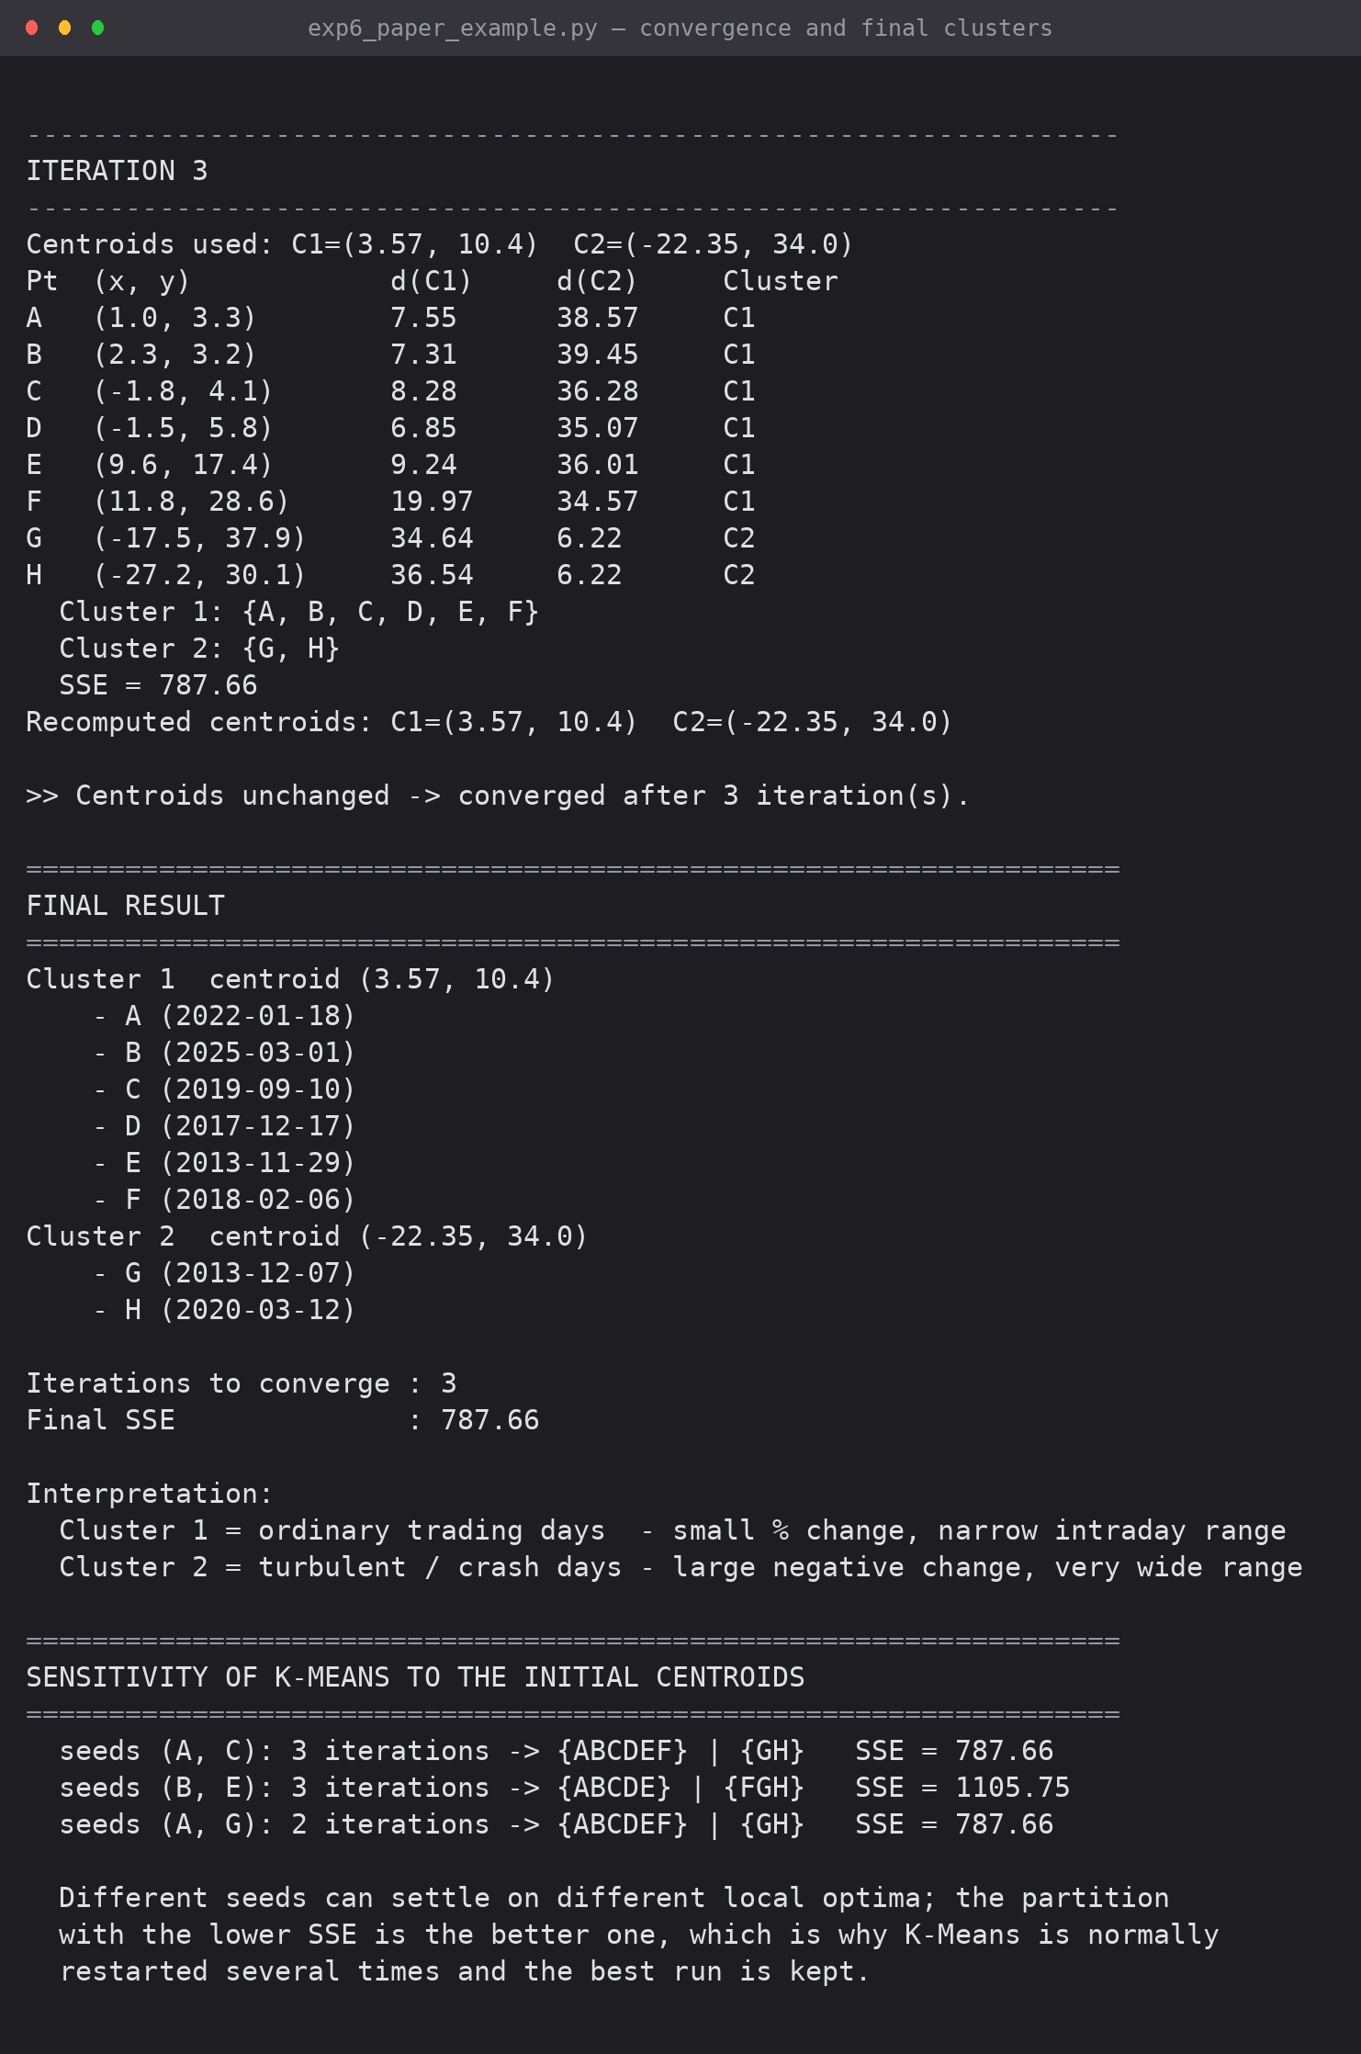
Screenshot 2: iteration 3 (convergence), final clusters and the sensitivity check on initial centroids
6.3 Result of the hand-solved example
Iteration | Cluster 1 | Cluster 2 | New C1 | New C2 | SSE
1 | {A, B, E, F} | {C, D, G, H} | (6.17, 13.12) | (-12.00, 19.48) | 3744.27
2 | {A, B, C, D, E, F} | {G, H} | (3.57, 10.40) | (-22.35, 34.00) | 1508.62
3 | {A, B, C, D, E, F} | {G, H} | unchanged | unchanged | 787.66

The centroids stop moving at iteration 3, so the algorithm converges. Cluster 1 collects the ordinary trading days and Cluster 2 isolates the two crash days (07 Dec 2013 and 12 Mar 2020, 'Black Thursday'). SSE falls monotonically 3744.27 -> 1508.62 -> 787.66, as the theory requires.
The sensitivity check in the same script shows why the initial centroids matter: seeding at (A, C) or (A, G) both reach SSE 787.66, but seeding at (B, E) converges to a different partition with SSE 1105.75 — a worse local optimum.

7. Part B — Implementation on the Full Dataset
7.1 Imports and setup
import pandas as pd
import numpy as np
import matplotlib.pyplot as plt
import seaborn as sns

# Set visual style (same conventions as Experiment 5)
sns.set_theme(style="whitegrid")
plt.rcParams['figure.figsize'] = (14, 7)

import os, warnings
warnings.filterwarnings('ignore')
OUT = "exp6_outputs"
os.makedirs(OUT, exist_ok=True)

RNG = np.random.default_rng(42) # fixed seed so the run is reproducible

7.2 Data loading and feature engineering
df = pd.read_csv('btc_cleaned.csv')
df['date'] = pd.to_datetime(df['date'])

# Feature engineering: scale-free intraday range
df['range_pct'] = df['daily_range'] / df['open'] * 100

FEATURES = ['daily_pct_change', 'range_pct']
full = df[['date', 'halving_era', 'close'] + FEATURES].dropna().reset_index(drop=True)

print("Rows in cleaned dataset :", len(full))
print("Date range :", full['date'].min().date(), "to", full['date'].max().date())
print()
print(full[FEATURES].describe().round(3))
full.head()

7.3 Outlier handling
K-Means minimises squared distance, so one distant point can pull a centroid onto itself and waste an entire cluster. The dataset contains exactly that case — 26 Feb 2014 (Mt. Gox collapse) shows a +336.8% change on a 378.7% intraday range. The extreme days flagged by the Z-score method in Experiment 5 are therefore separated out before clustering using the same rule (|z| > 3 on either feature) and reported separately as shock days.
def zscore(matrix):
return (matrix - matrix.mean(axis=0)) / matrix.std(axis=0)

Z_ALL = zscore(full[FEATURES].to_numpy(dtype=float))
outlier_mask = (np.abs(Z_ALL) > 3).any(axis=1)

shock_days = full[outlier_mask].copy()
data = full[~outlier_mask].reset_index(drop=True)

print(f"Shock days removed before clustering : {outlier_mask.sum()} "
f"({outlier_mask.sum() / len(full) * 100:.2f}% of the dataset)")
print(f"Days passed to K-Means : {len(data)}")
print("\nShock days per year:")
print(shock_days['date'].dt.year.value_counts().sort_index().to_string())
print("\nTen most extreme shock days:")
print(shock_days.nlargest(10, 'range_pct')[['date', 'daily_pct_change', 'range_pct']]
.to_string(index=False, float_format=lambda v: f"{v:8.2f}"))

7.4 Feature scaling
def zscore_standardise(matrix):
"""Manual z-score standardisation. Returns scaled matrix, means and std devs."""
mu = matrix.mean(axis=0)
sigma = matrix.std(axis=0)
return (matrix - mu) / sigma, mu, sigma

def inverse_standardise(matrix, mu, sigma):
"""Convert z-space coordinates back into original percentage units."""
return matrix * sigma + mu

X_raw = data[FEATURES].to_numpy(dtype=float)
X, MU, SIGMA = zscore_standardise(X_raw)

print("Original means :", np.round(MU, 4), " std devs :", np.round(SIGMA, 4))
print("Scaled means :", np.round(X.mean(axis=0), 6), " std devs :", np.round(X.std(axis=0), 6))
print("Scaled matrix shape:", X.shape)

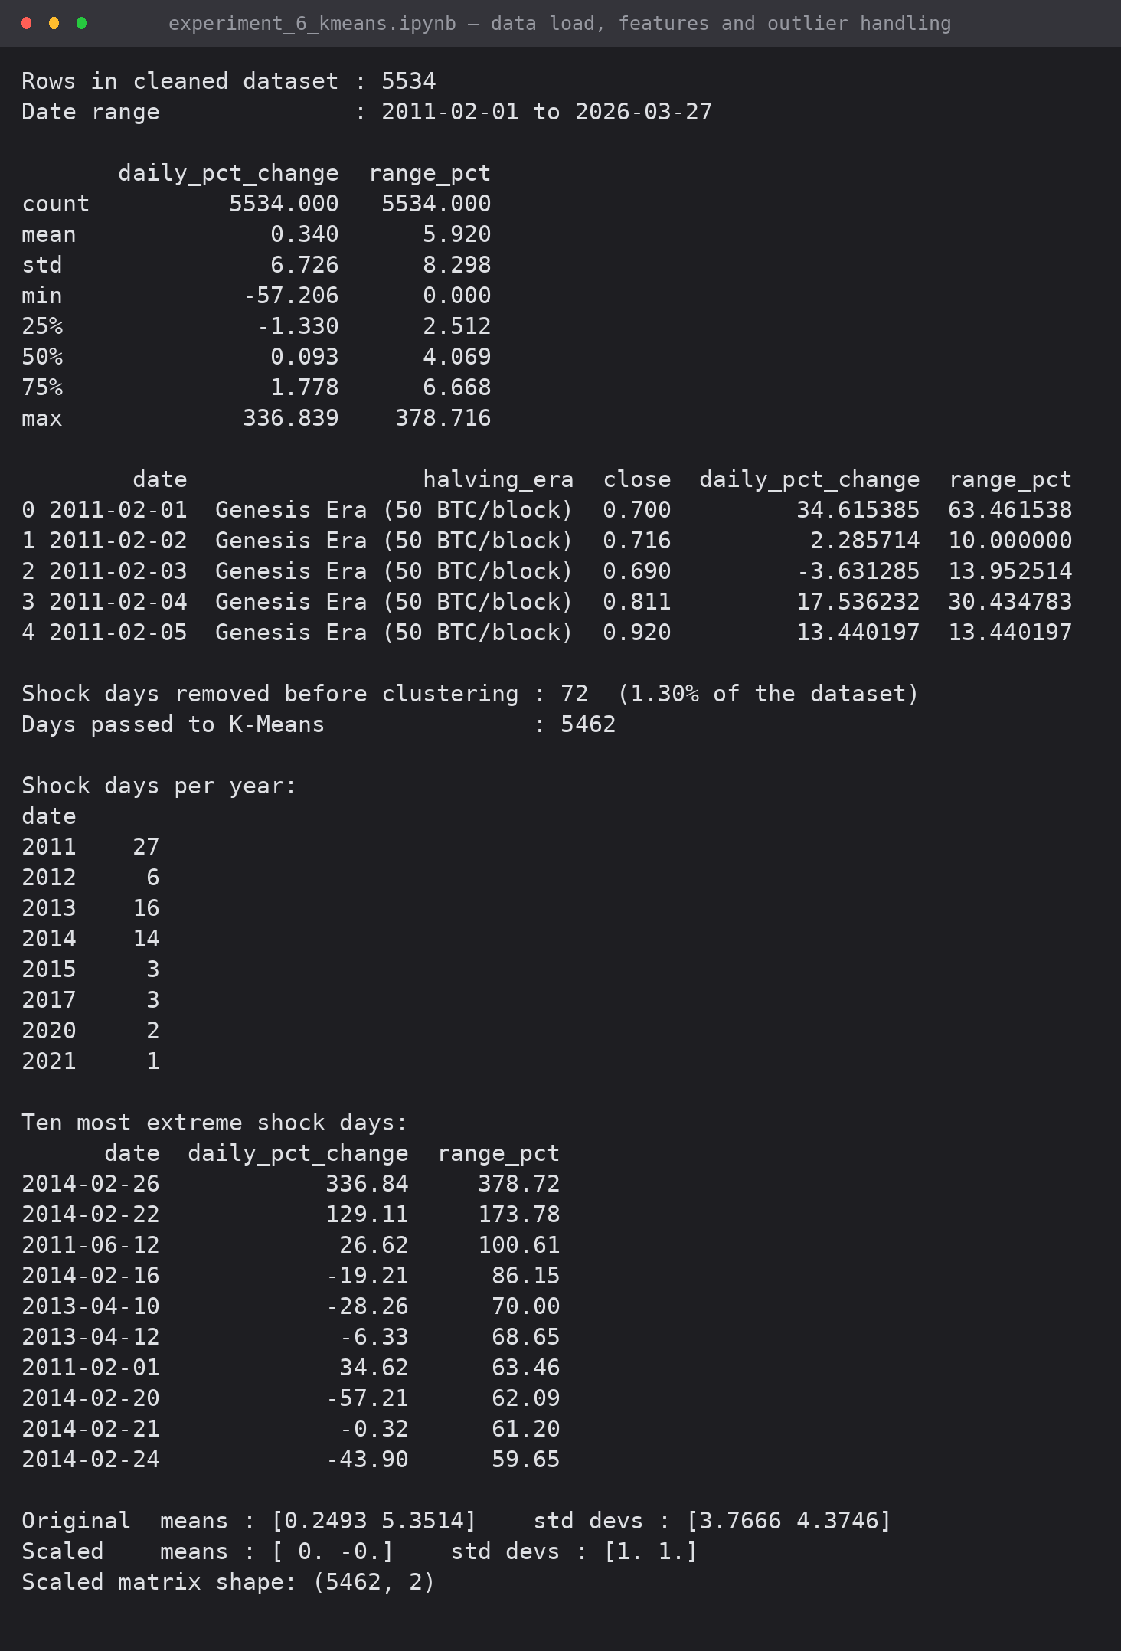
Screenshot 3: dataset summary, the 72 shock days removed, and the standardised feature matrix
7.5 K-Means implemented from scratch
def euclidean_distances(points, centroids):
"""Distance matrix of shape (n_points, k) — one row per point, one column per centroid."""
diff = points[:, None, :] - centroids[None, :, :] # (n, k, d)
return np.sqrt((diff ** 2).sum(axis=2))

def assign_clusters(points, centroids):
"""Assignment step: index of the nearest centroid for every point."""
return euclidean_distances(points, centroids).argmin(axis=1)

def update_centroids(points, labels, k, previous):
"""Update step: each centroid becomes the mean of its members (empty cluster keeps its old position)."""
new = np.empty_like(previous)
for i in range(k):
members = points[labels == i]
new[i] = members.mean(axis=0) if len(members) else previous[i]
return new

def compute_sse(points, labels, centroids):
"""Sum of squared distances of every point to its own centroid."""
return float(((points - centroids[labels]) ** 2).sum())

def kmeanspp_init(points, k, rng):
"""k-means++ seeding, written manually: each new centroid is drawn with probability
proportional to its squared distance from the closest centroid already chosen."""
centroids = [points[rng.integers(len(points))]]
for _ in range(1, k):
d2 = euclidean_distances(points, np.array(centroids)).min(axis=1) ** 2
probs = d2 / d2.sum()
centroids.append(points[rng.choice(len(points), p=probs)])
return np.array(centroids)

def kmeans_fit(points, k, rng, max_iter=100, tol=1e-6, verbose=False):
"""Full K-Means loop. Returns centroids, labels, SSE, iterations used and the SSE trace."""
centroids = kmeanspp_init(points, k, rng)
trace = []
labels = np.zeros(len(points), dtype=int)
for it in range(1, max_iter + 1):
labels = assign_clusters(points, centroids) # step 2
new_centroids = update_centroids(points, labels, k, centroids) # step 3
shift = float(np.sqrt(((new_centroids - centroids) ** 2).sum(axis=1)).max())
sse = compute_sse(points, labels, new_centroids)
trace.append(sse)
if verbose:
sizes = np.bincount(labels, minlength=k)
print(f" iter {it:>2} | max centroid shift = {shift:9.6f} | SSE = {sse:11.2f} | sizes = {sizes.tolist()}")
centroids = new_centroids
if shift < tol: # step 4: convergence
break
return centroids, labels, compute_sse(points, labels, centroids), it, trace

def kmeans_best_of(points, k, restarts, rng, verbose=False):
"""K-Means is sensitive to initialisation, so it is restarted and the lowest-SSE run kept."""
best = None
for r in range(restarts):
centroids, labels, sse, iters, trace = kmeans_fit(points, k, rng)
if verbose:
print(f" restart {r+1:>2}: SSE = {sse:11.2f} ({iters} iterations)")
if best is None or sse < best[2]:
best = (centroids, labels, sse, iters, trace)
return best

print("K-Means functions defined — no clustering library imported.")

7.6 Choosing the number of clusters
K_RANGE = range(1, 9)
elbow = []
for k in K_RANGE:
_, _, sse, iters, _ = kmeans_best_of(X, k, restarts=5, rng=np.random.default_rng(42 + k))
elbow.append(sse)
print(f"k = {k}: SSE = {sse:11.2f} ({iters} iterations in the best run)")

# Improvement contributed by each extra cluster
print("\nMarginal improvement in SSE:")
for i in range(1, len(elbow)):
abs_drop = elbow[i-1] - elbow[i]
pct_drop = abs_drop / elbow[i-1] * 100
print(f" k = {i} -> {i+1}: SSE falls by {abs_drop:8.1f} ({pct_drop:4.1f}%)")

def silhouette_samples_manual(points, labels):
"""Per-point silhouette coefficient, computed without any library helper."""
n = len(points)
unique = np.unique(labels)
dist = np.sqrt(((points[:, None, :] - points[None, :, :]) ** 2).sum(axis=2))
s = np.zeros(n)
for i in range(n):
own = labels[i]
same = (labels == own).copy()
same[i] = False
a = dist[i, same].mean() if same.any() else 0.0 # cohesion
others = [dist[i, labels == o].mean() # separation
for o in unique if o != own and (labels == o).any()]
if not others: # only one cluster present -> undefined
s[i] = 0.0
continue
b = min(others)
s[i] = 0.0 if max(a, b) == 0 else (b - a) / max(a, b)
return s

def silhouette_score_manual(points, labels):
return float(silhouette_samples_manual(points, labels).mean())

SAMPLE_N = 1500
sample_idx = np.random.default_rng(7).choice(len(X), SAMPLE_N, replace=False)
X_sample = X[sample_idx]

sil_scores = {}
for k in range(2, 7):
centroids, labels, _, _, _ = kmeans_best_of(X, k, restarts=5, rng=np.random.default_rng(100 + k))
sil_scores[k] = silhouette_score_manual(X_sample, labels[sample_idx])
print(f"k = {k}: mean silhouette = {sil_scores[k]:.4f}")

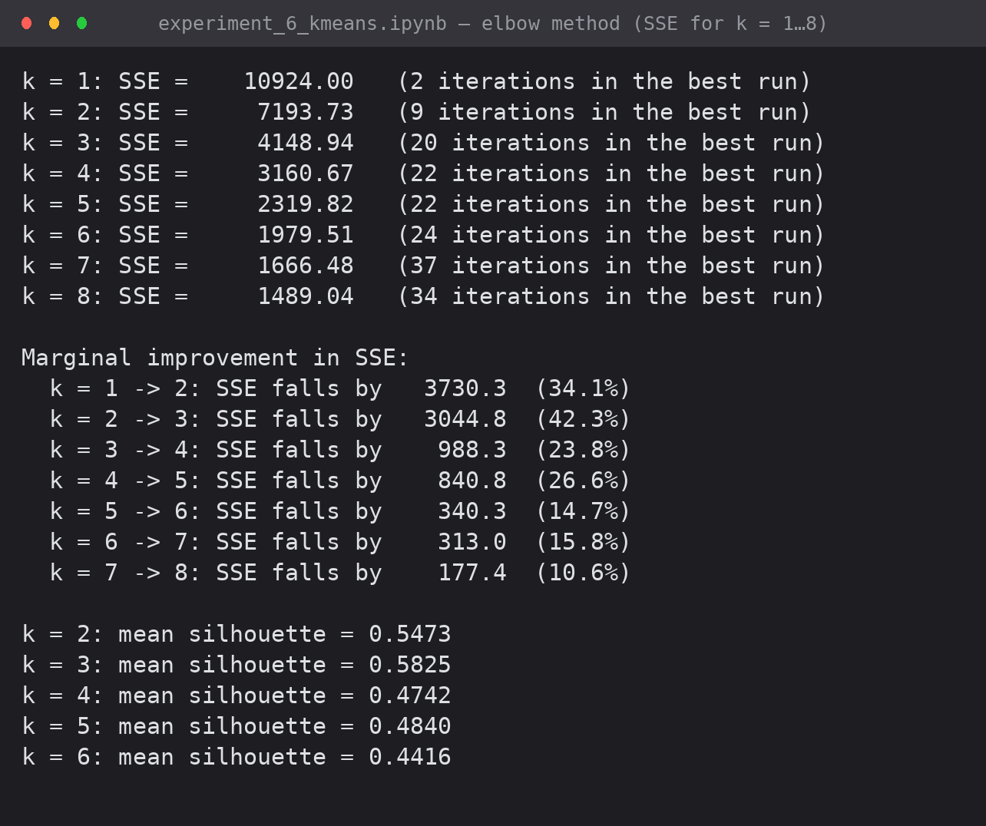
Screenshot 4: SSE for k = 1…8 with the marginal improvement per extra cluster, and the mean silhouette score for k = 2…6
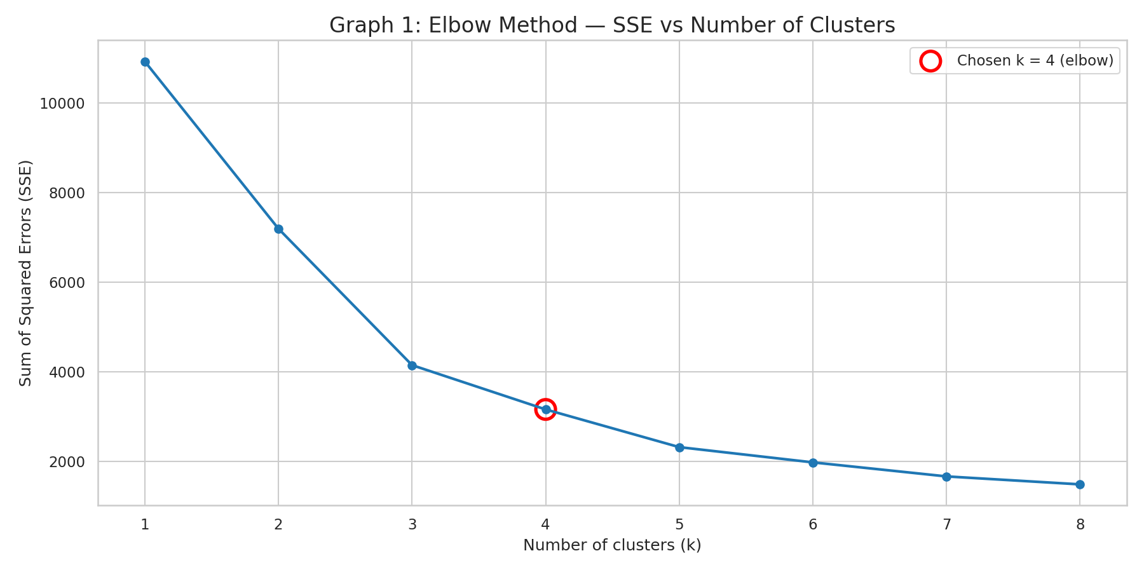
Graph 1: Elbow method — SSE against the number of clusters
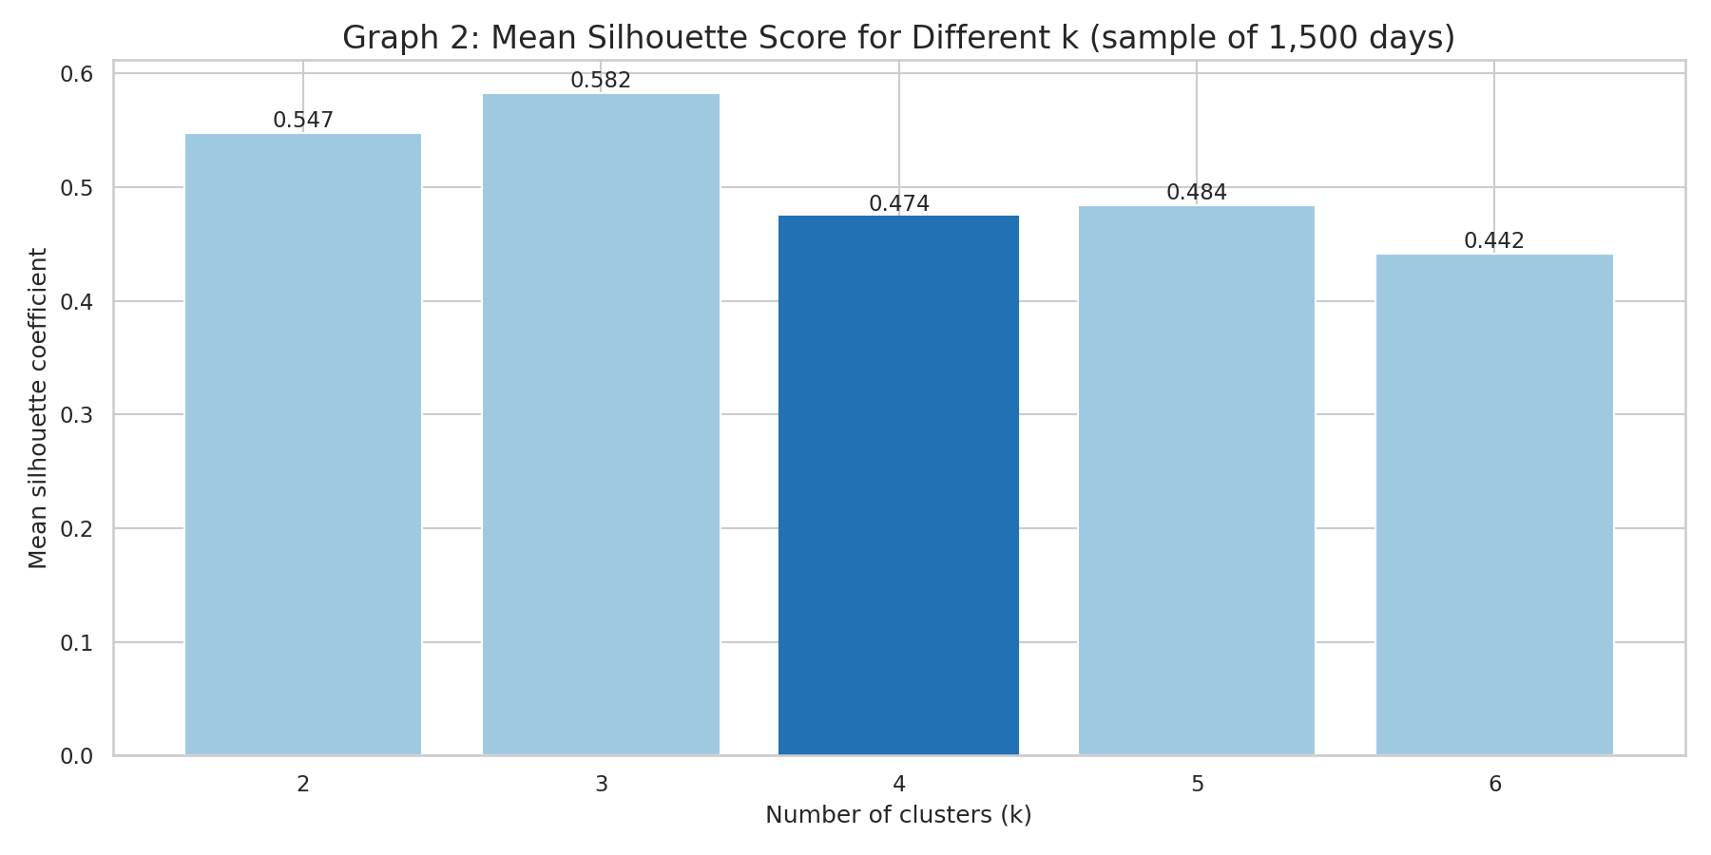
Graph 2: Mean silhouette coefficient for each candidate k
The two large SSE drops end at k = 3 (-3730 and -3045); the curve then bends at k = 4 / k = 5 (-988, -841) and is almost flat from k = 6 onwards (-340, -313, -177). The silhouette score is highest at k = 3 (0.5825) and drops to 0.4742 at k = 4. k = 4 was still chosen, for a stated reason: at k = 3 all turbulent days fall into one group, whereas the case study needs volatile-up and volatile-down days separated for any risk-alert use. The small loss in silhouette is accepted and reported rather than hidden.
7.7 Final model
K = 4
print("Restart search:")
centroids_z, labels, final_sse, iters, sse_trace = kmeans_best_of(
X, K, restarts=10, rng=np.random.default_rng(2026), verbose=True)

print("\nConvergence log of a fresh run with the same settings:")
_, _, _, _, _ = kmeans_fit(X, K, np.random.default_rng(2026), verbose=True)

data['cluster'] = labels
centroids_raw = inverse_standardise(centroids_z, MU, SIGMA)

print(f"\nBest SSE (z-space): {final_sse:.2f}")
print("\nFinal centroids in original units:")
cent_table = pd.DataFrame(centroids_raw, columns=['daily_pct_change (%)', 'range_pct (%)'])
cent_table.insert(0, 'cluster', range(K))
cent_table['members'] = np.bincount(labels, minlength=K)
cent_table['share (%)'] = (cent_table['members'] / len(data) * 100).round(2)
cent_table.round(3)

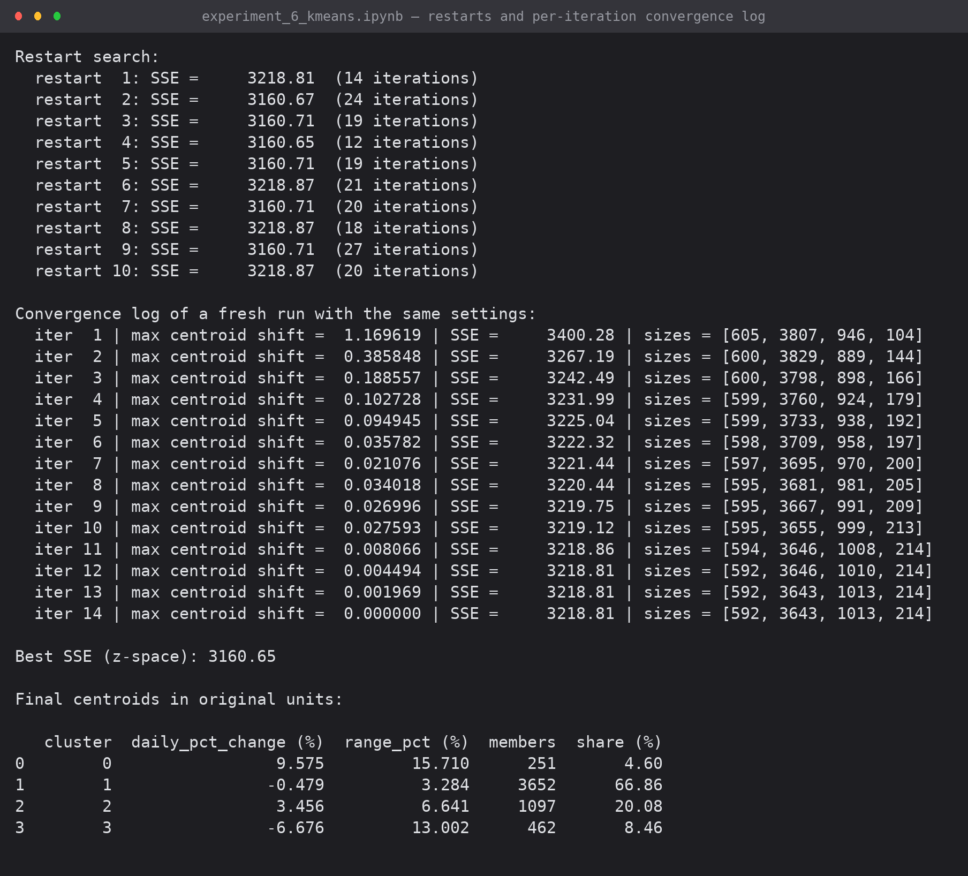
Screenshot 5: the ten restarts and the per-iteration convergence log (centroid shift, SSE, cluster sizes)
order = np.argsort(centroids_raw[:, 1]) # rank clusters by turbulence (mean range %)

def name_cluster(rank, x):
"""Label a cluster from its centroid: rank on the turbulence axis + sign of the move."""
if rank == 0:
return 'Calm / Sideways'
if rank == 1:
return 'Mild Bullish Drift' if x > 0 else 'Mild Bearish Drift'
return 'Volatile Bullish (Rally)' if x > 0 else 'Volatile Bearish (Sell-off)'

regime_names = {int(cl): name_cluster(rank, centroids_raw[cl, 0]) for rank, cl in enumerate(order)}
order_names = [regime_names[int(cl)] for cl in order]

data['regime'] = data['cluster'].map(regime_names)
cent_table['regime'] = cent_table['cluster'].map(regime_names)

print("Cluster -> regime mapping (ordered by average intraday range):")
for rank, cl in enumerate(order):
print(f" Cluster {cl}: centroid = ({centroids_raw[cl,0]:+6.2f}%, {centroids_raw[cl,1]:5.2f}%)"
f" -> {regime_names[int(cl)]}")

cent_table[['cluster', 'regime', 'daily_pct_change (%)', 'range_pct (%)', 'members', 'share (%)']].round(3)

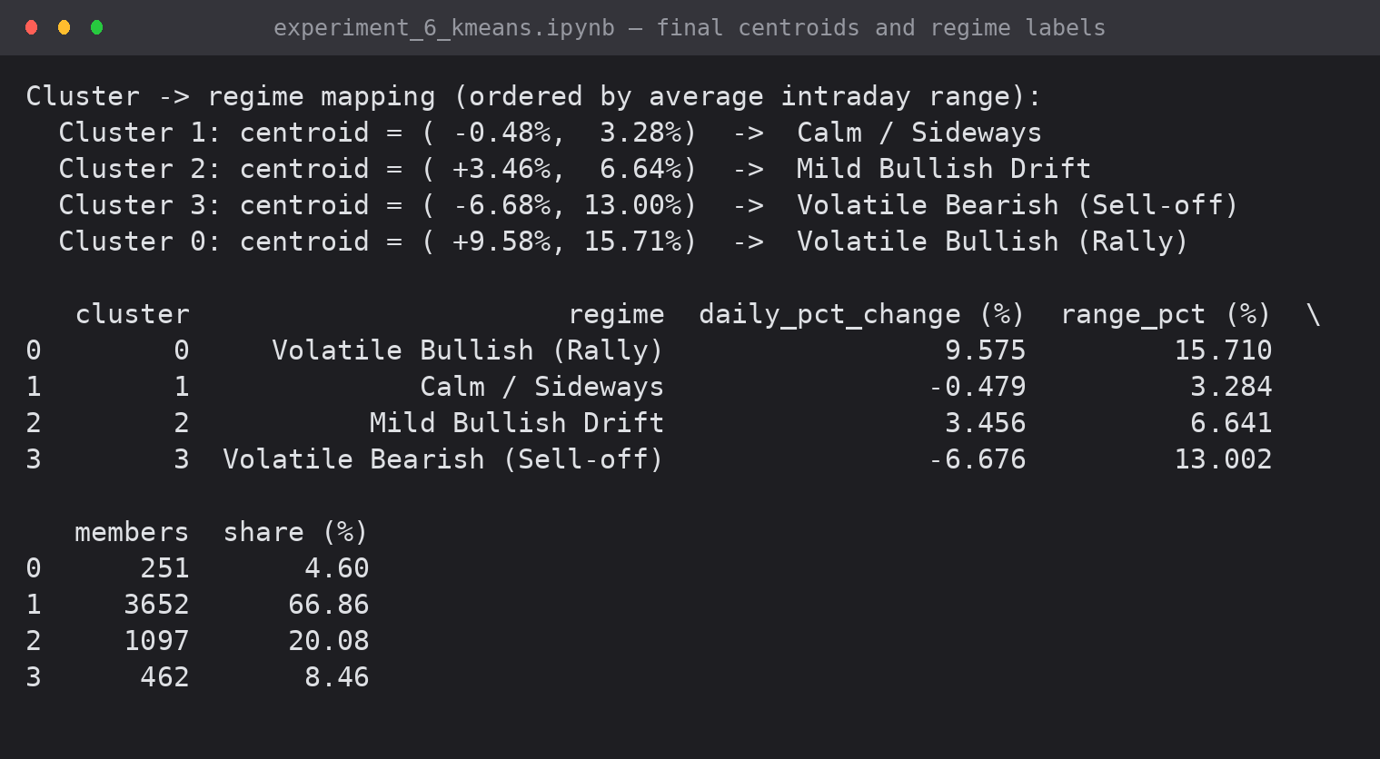
Screenshot 6: final centroids in original units and the regime label assigned to each cluster

8. Cluster Visualisation
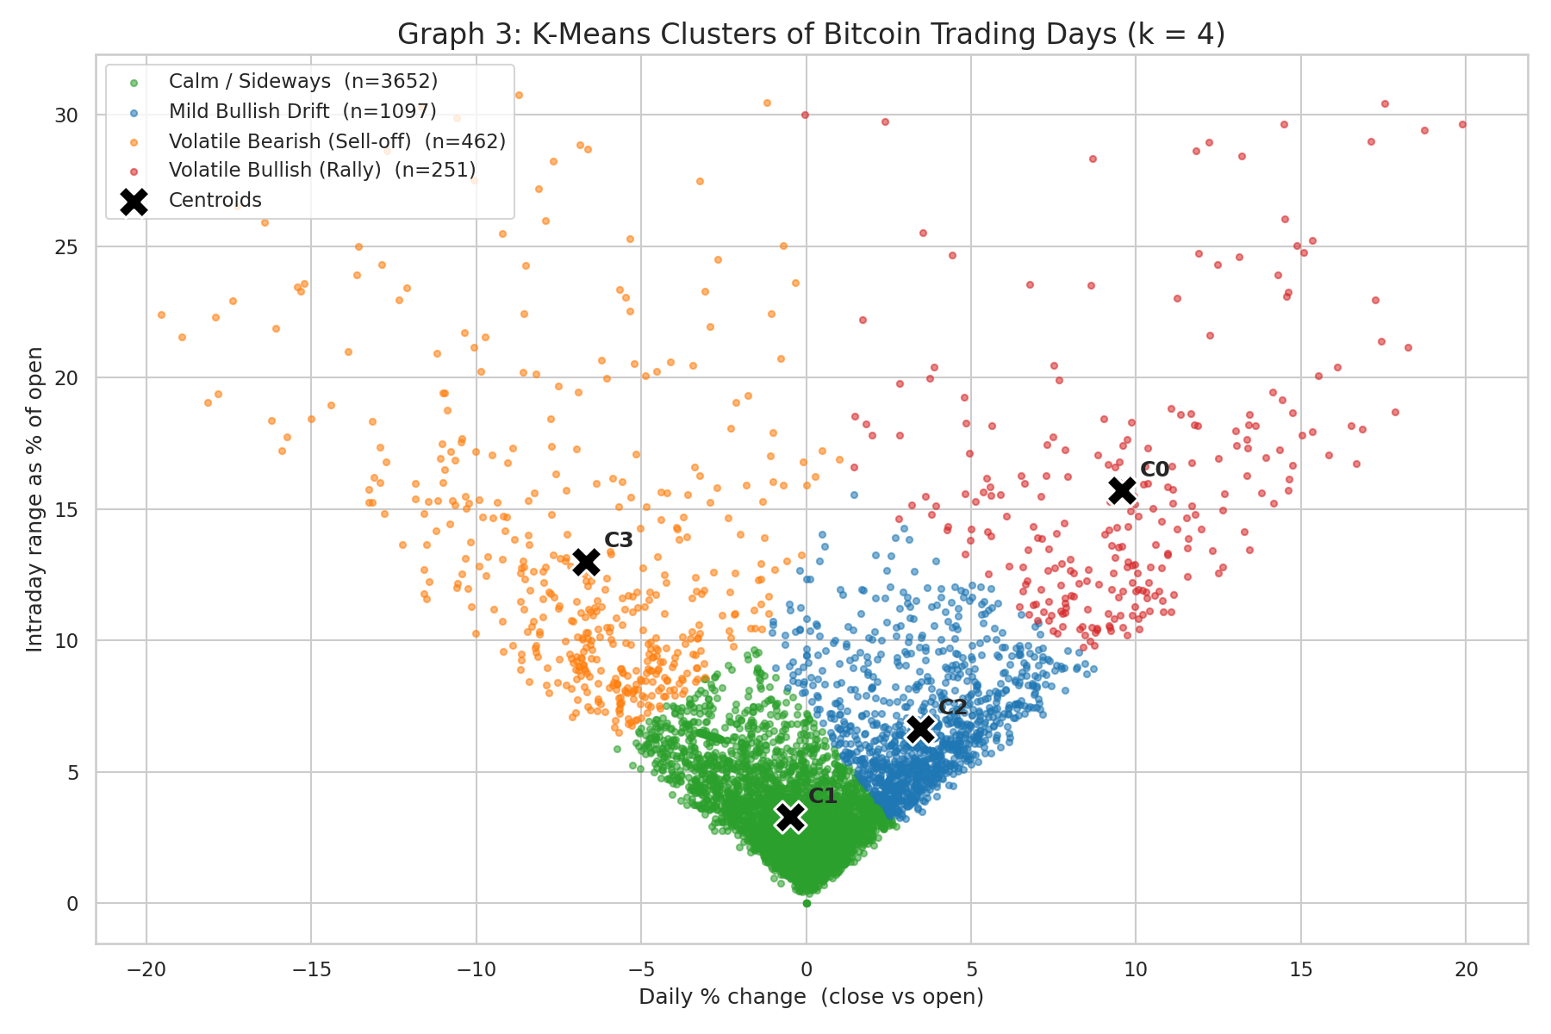
Graph 3: the four clusters in feature space with their centroids marked (X)
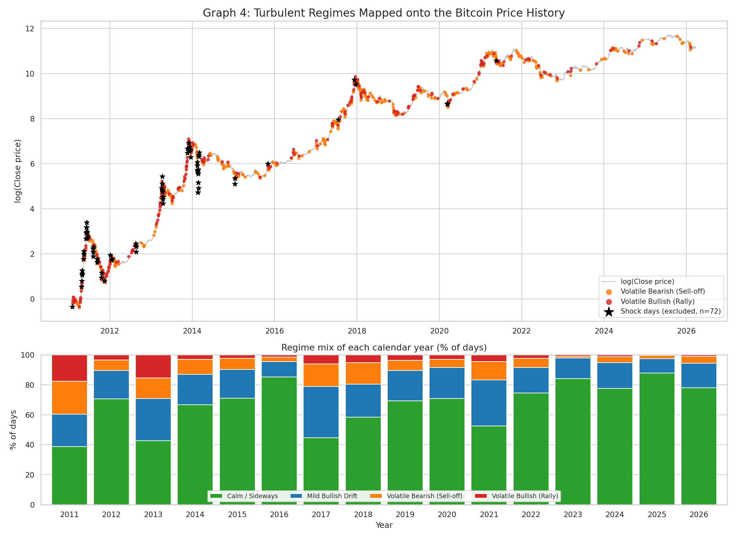
Graph 4: turbulent regimes on the price history (top) and the regime mix of every calendar year (bottom)
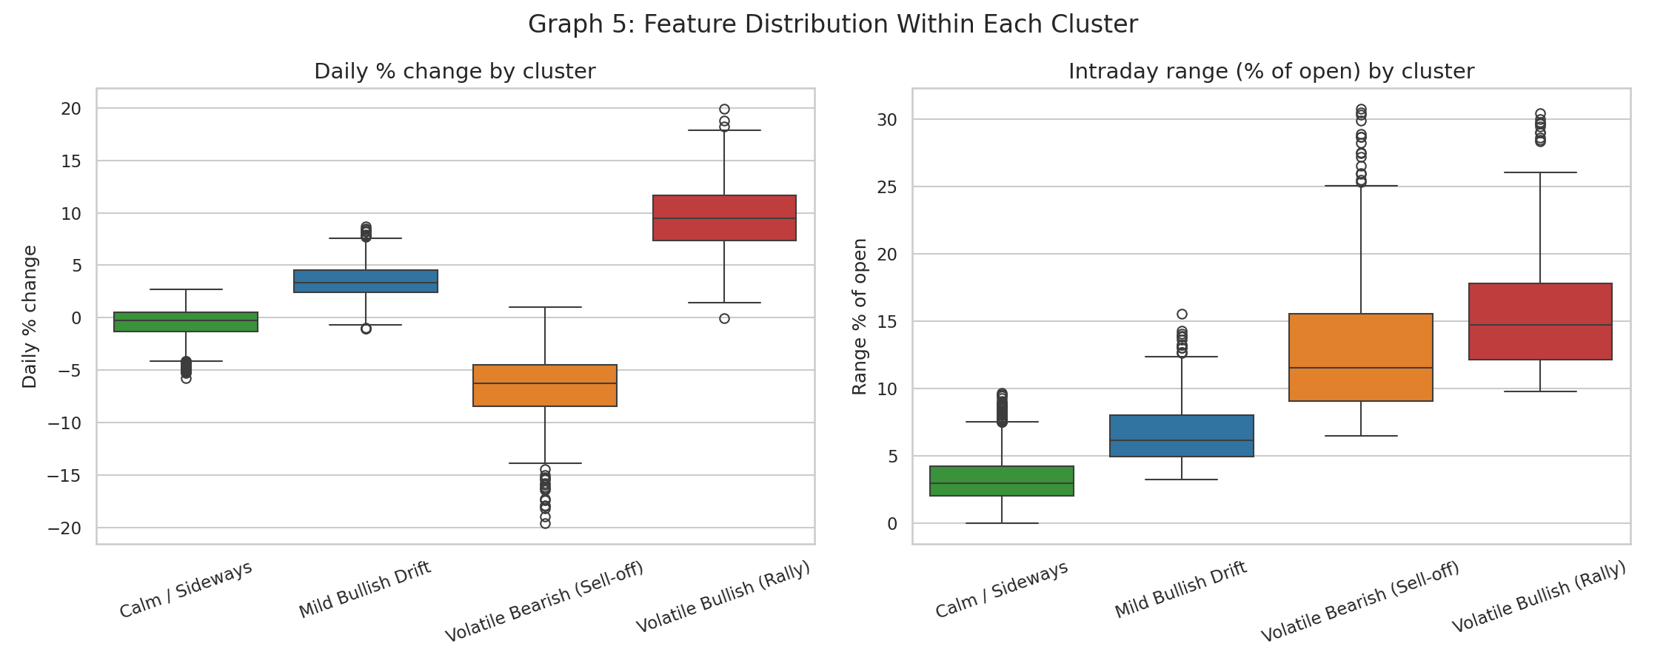
Graph 5: distribution of both features inside each cluster
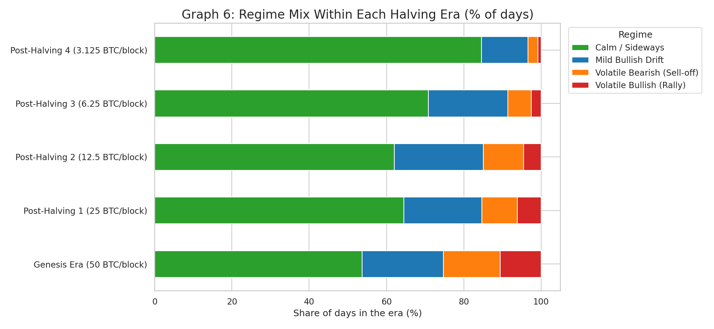
Graph 6: regime mix within each Bitcoin halving era
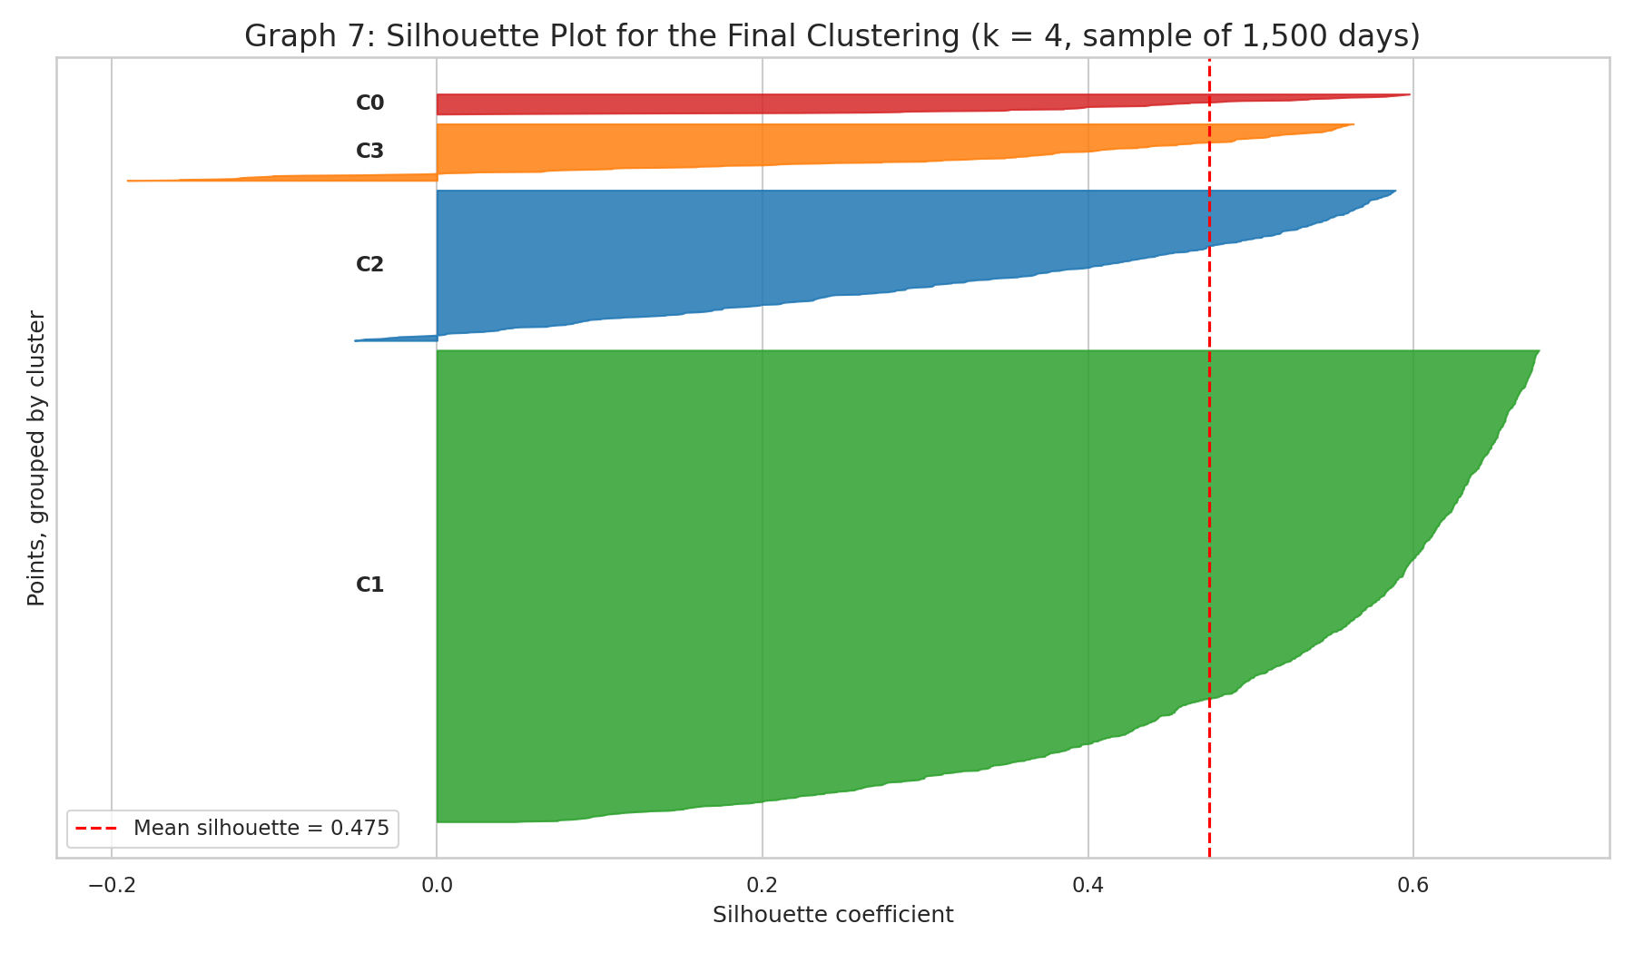
Graph 7: silhouette plot of the final clustering (sample of 1,500 days)

9. Performance Matrix
Clustering is unsupervised, so there is no accuracy to report. The model is judged on internal validity measures, all implemented manually:
def davies_bouldin_manual(points, labels, centroids):
k = len(centroids)
spread = np.array([np.sqrt(((points[labels == i] - centroids[i]) ** 2).sum(axis=1)).mean()
for i in range(k)])
sep = euclidean_distances(centroids, centroids)
ratios = []
for i in range(k):
ratios.append(max((spread[i] + spread[j]) / sep[i, j] for j in range(k) if j != i))
return float(np.mean(ratios))

def calinski_harabasz_manual(points, labels, centroids):
n, k = len(points), len(centroids)
overall = points.mean(axis=0)
between = sum(len(points[labels == i]) * ((centroids[i] - overall) ** 2).sum() for i in range(k))
within = compute_sse(points, labels, centroids)
return float((between / (k - 1)) / (within / (n - k)))

rows = []
for rank, cl in enumerate(order):
mask = labels == cl
members_z = X[mask]
d_own = np.sqrt(((members_z - centroids_z[cl]) ** 2).sum(axis=1))
rows.append({
'Cluster': f"C{cl}",
'Regime': regime_names[int(cl)],
'Size': int(mask.sum()),
'Share %': round(mask.sum() / len(X) * 100, 2),
'Centroid x (% chg)': round(centroids_raw[cl, 0], 2),
'Centroid y (range %)': round(centroids_raw[cl, 1], 2),
'Cluster SSE': round(float((d_own ** 2).sum()), 2),
'Mean intra-dist': round(float(d_own.mean()), 3),
'Max intra-dist': round(float(d_own.max()), 3),
'Silhouette': round(float(sil_vals[sil_labels == cl].mean()), 3),
})

perf = pd.DataFrame(rows)
print("PERFORMANCE MATRIX — per cluster")
print(perf.to_string(index=False))

dbi = davies_bouldin_manual(X, labels, centroids_z)
chi = calinski_harabasz_manual(X, labels, centroids_z)

print("\nPERFORMANCE MATRIX — overall")
print(f" Number of clusters (k) : {K}")
print(f" Points clustered : {len(X)}")
print(f" Iterations to converge : {iters}")
print(f" Total SSE (z-space) : {final_sse:.2f}")
print(f" Mean silhouette coefficient : {mean_sil:.4f}")
print(f" Davies-Bouldin index : {dbi:.4f} (lower is better)")
print(f" Calinski-Harabasz index : {chi:.2f} (higher is better)")
perf

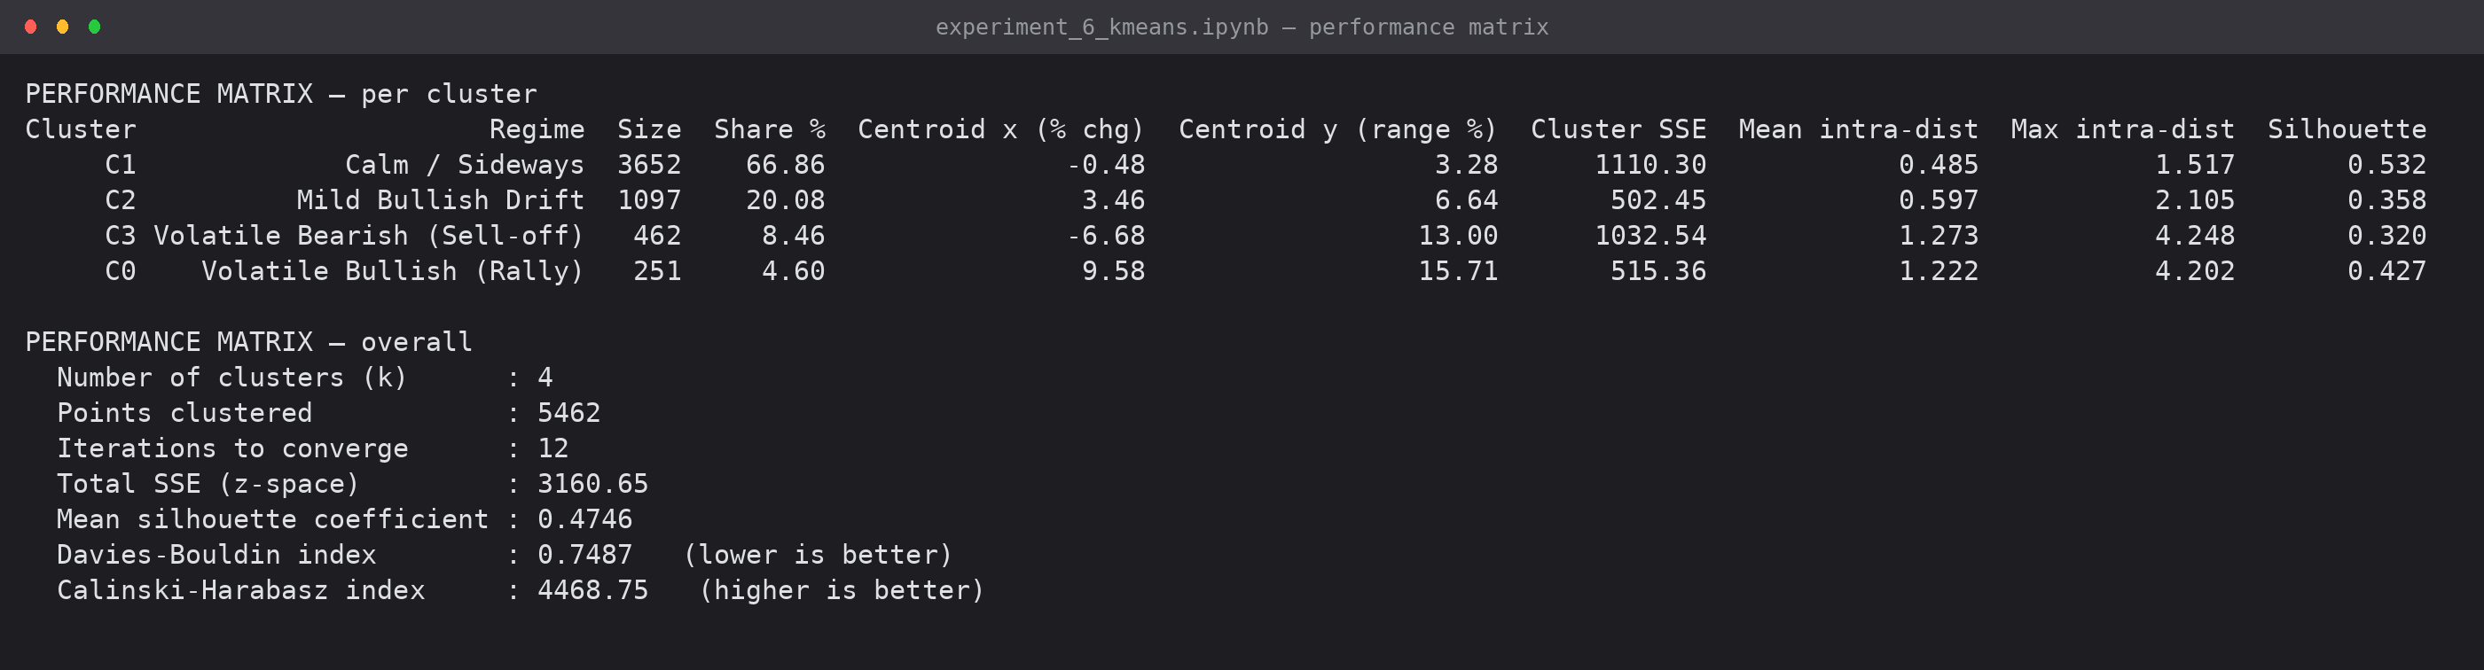
Screenshot 7: the performance matrix produced by the notebook
9.1 Per-cluster measures
Cluster | Regime | Size | Share % | Centroid (x, y) | Cluster SSE | Mean intra-dist | Silhouette
C1 | Calm / Sideways | 3652 | 66.86 | (-0.48, 3.28) | 1110.30 | 0.485 | 0.532
C2 | Mild Bullish Drift | 1097 | 20.08 | (3.46, 6.64) | 502.45 | 0.597 | 0.358
C3 | Volatile Bearish (Sell-off) | 462 | 8.46 | (-6.68, 13.00) | 1032.54 | 1.273 | 0.320
C0 | Volatile Bullish (Rally) | 251 | 4.60 | (9.58, 15.71) | 515.36 | 1.222 | 0.427

9.2 Overall measures
Measure | Value | Interpretation
Number of clusters (k) | 4 | chosen from the elbow curve and the case-study requirement
Points clustered | 5462 | 5534 cleaned days minus 72 shock days
Iterations to converge | 12 | best of 10 restarts
Total SSE (z-space) | 3160.65 | lower is better; 71% below the k = 1 baseline of 10924
Mean silhouette | 0.4746 | moderate — the data is one continuous cloud, not four separated blobs
Davies-Bouldin index | 0.7487 | below 1.0, so clusters are more separated than they are wide
Calinski-Harabasz index | 4468.75 | high — between-cluster variance dominates within-cluster variance

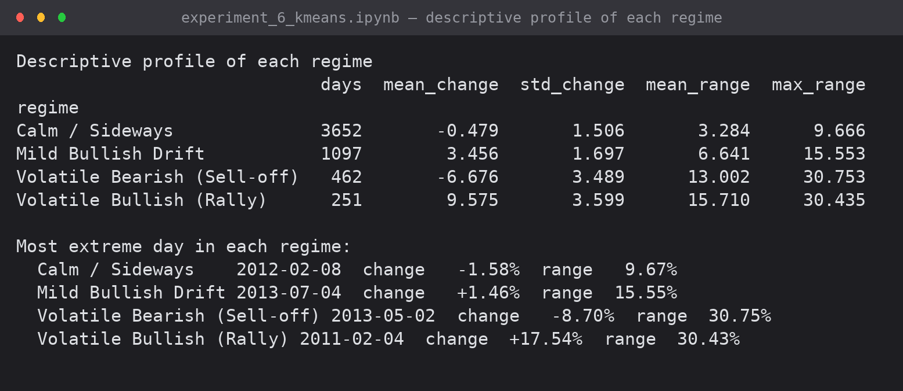
Screenshot 8: descriptive profile of each regime and its most extreme day

10. Cluster Analysis Report
10.1 The four regimes
C1 — Calm / Sideways (3,652 days, 66.9%). The average day barely moves (-0.48%) and swings only 3.3% between high and low; no member exceeds a 9.7% range. This is the market's resting state and the tightest cluster (mean intra-cluster distance 0.485, silhouette 0.532).
C2 — Mild Bullish Drift (1,097 days, 20.1%). A modest, orderly gain of +3.46% on a 6.6% range — the cluster that carries the long bull phases. Its lower silhouette (0.358) is expected: it sits between the calm core and the rally cluster, so many members are genuinely borderline days.
C3 — Volatile Bearish / Sell-off (462 days, 8.5%). Average -6.68% on a 13.0% range: the panic days, where price falls hard and swings widely inside the session.
C0 — Volatile Bullish / Rally (251 days, 4.6%). Average +9.58% on a 15.71% range — the largest average move of any cluster. Rallies are rarer than sell-offs but individually larger.
10.2 What the clusters say about the market
- Bitcoin is calm far more often than its reputation suggests: 87% of days fall in the two low-volatility clusters. The turbulence lives in the remaining 13%.
- The market has matured. The calm cluster's share rises across the halving eras — 53.7%, 64.5%, 62.0%, 70.8% and 84.6% in the current 3.125 BTC/block era — while sell-off days fall from 14.7% to 2.5% and rally days from 10.6% to 0.8%. Per year, turbulent days fall from 39.7% (2011) to 2.2% (2023) and 2.7% (2025).
- Turbulence lines up with the known boom-bust cycles. In Graph 4 the orange and red points bunch around the 2013 run-up, the 2017-18 peak and crash, the March 2020 COVID drop and the 2021 cycle — cycles the algorithm was never told about.
- Falls and rallies are not mirror images: sell-off days are almost twice as common as rally days, but the average rally is larger (+9.58% vs -6.68%).
- The 72 shock days concentrate in 2011 (27) and 2013-14 (30) — the Mt. Gox era, when a single exchange's prints could move the recorded price by hundreds of percent. Removing them is what allowed four usable regimes to form.
10.3 Limitations
- K-Means assumes roughly spherical, similar-sized clusters; the real data is a continuous V-shaped cloud (Graph 3), so the boundaries cut through a continuum rather than falling in natural gaps — which is why silhouette scores are moderate.
- The result depends on the initial centroids; restarts reduce but do not remove this.
- Only two features are used. Volume, macro news and on-chain activity would separate regimes further.
- Clustering describes the past; on its own it does not predict tomorrow's regime.
11. Conclusion
K-Means was implemented from first principles — k-means++ seeding, Euclidean assignment, centroid update, convergence test, SSE, silhouette and Davies-Bouldin — with no clustering library, and verified against a hand-solved eight-point example that converged in three iterations to SSE 787.66.
Applied to 5,462 Bitcoin trading days, the algorithm converged in 12 iterations to an SSE of 3160.65 and produced four interpretable market regimes: a dominant calm state (66.9% of days), a mild bullish drift (20.1%), volatile sell-offs (8.5%) and volatile rallies (4.6%), scoring a mean silhouette of 0.4746, a Davies-Bouldin index of 0.7487 and a Calinski-Harabasz index of 4468.75.
Two findings stand out: Bitcoin's volatility is concentrated in a small minority of days, and the share of those days has fallen in every successive halving era — quantitative evidence for the maturation the case study set out to test. The experiment also demonstrated K-Means' best-known weakness in practice: a single extreme day was enough to consume an entire cluster until the outliers identified in Experiment 5 were handled explicitly.
12. Files Submitted
File | Contents
experiment_6_kmeans.ipynb | executed notebook — from-scratch K-Means, elbow, silhouette, plots, performance matrix
exp6_paper_example.py | eight-point hand-solvable example that verifies the handwritten working
exp6_outputs/graph1…graph7 (.png) | cluster visualisations and validation plots
exp6_outputs/shot1…shot8 (.png) | captured console output of every stage
Exp6_KMeans_Running_Doc_v1.docx | this document
Exp6_KMeans_Handwritten_Writeup_v1.pdf | aim, theory, algorithm and solved example for the lab journal

EXPERIMENT 7: IMPLEMENTATION OF HIERARCHICAL CLUSTERING
Agglomerative clustering of Bitcoin market periods — proximity matrix and Lance-Williams update written from first principles, dendrograms, and cluster interpretation
Lab Code | Lab Name | Sem | Experiment | Course Outcome
2115120 | Data Warehousing and Mining | V | 7 | LO4

1. Aim
To implement an agglomerative hierarchical clustering method on the Bitcoin case-study dataset, generate dendrograms to visualise cluster formation, and analyse the hierarchical relationships among the data instances.
2. Data and Two Levels of Analysis
Analysis | Unit | Features | Size
A — market periods | one calendar month | mean daily return, volatility, mean intraday range, % up days | 176 months
B — individual days | one trading day | daily % change, intraday range % (same as Experiment 6) | 500-day sample

Analysis A gives a dendrogram that can actually be read — 176 leaves, each a month of trading. Analysis B uses the same features as the K-Means experiment so that the two clustering families can be compared directly on identical data.
2.1 Months excluded, and why
Hierarchical clustering has no notion of an outlier: every point must appear somewhere in the tree, so one extreme month becomes its own branch and consumes a top-level cluster. Three groups were removed before clustering and are reported rather than hidden.
Exclusion | Count | Months
Months rebuilt by interpolation (>25% synthetic days) | 2 | 2024-12 (71% interpolated), 2025-01 (84%) — the recording gap filled in Experiment 4
Statistical outlier months (|z| > 3 on any feature) | 4 | 2011-04, 2013-04, 2013-11, 2014-02 (Mt. Gox)
Part months (< 20 trading days) | 0 | none

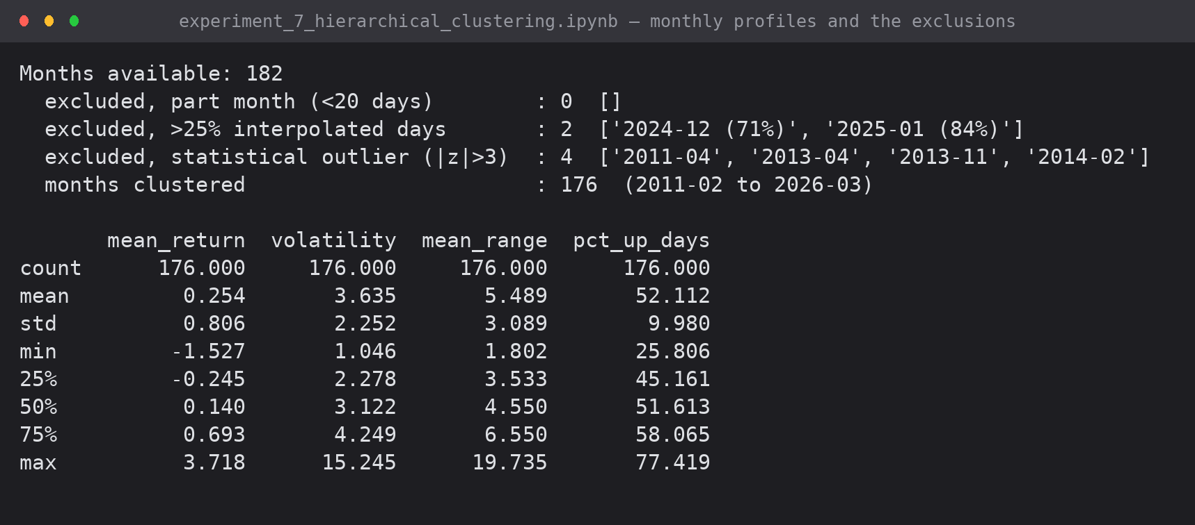
Screenshot 1: monthly profile construction and the exclusions applied
3. The Algorithm, Implemented From First Principles
3.1 AGNES
1. Start with n singleton clusters; compute the full n x n proximity matrix.
2. Find the closest pair of clusters and merge them.
3. Update the distance from the new cluster to every other cluster (linkage rule).
4. Repeat until one cluster remains, recording every merge -> that record is the dendrogram.

3.2 Linkage rules as special cases of Lance-Williams
d(k, i U j) = a_i.d(k,i) + a_j.d(k,j) + b.d(i,j) + g.|d(k,i) - d(k,j)|

Single : a_i = a_j = 1/2, b = 0, g = -1/2 -> minimum distance
Complete : a_i = a_j = 1/2, b = 0, g = +1/2 -> maximum distance
Average : a_i = ni/(ni+nj), a_j = nj/(ni+nj), b = g = 0
Ward : a_i = (ni+nk)/(ni+nj+nk), a_j = (nj+nk)/(ni+nj+nk),
b = -nk/(ni+nj+nk), g = 0 (applied to squared distances)

def euclidean_matrix(X):
"""Full n x n Euclidean proximity matrix, computed directly from the definition."""
diff = X[:, None, :] - X[None, :, :]
return np.sqrt((diff ** 2).sum(axis=2))

def agglomerative(X, method='average'):
"""AGNES with the Lance-Williams update. Returns a SciPy-compatible linkage matrix
Z with rows [cluster_a, cluster_b, distance, size]."""
n = len(X)
D = euclidean_matrix(X).astype(float)
np.fill_diagonal(D, np.inf)

active = list(range(n)) # current cluster ids (0..n-1 are the singletons)
size = {i: 1 for i in range(n)}
idx = {i: i for i in range(n)} # cluster id -> row/col in D
Z = []
next_id = n

for step in range(n - 1):
# --- 2. closest pair among the active clusters ---
best = (np.inf, None, None)
for a_pos in range(len(active)):
for b_pos in range(a_pos + 1, len(active)):
a, b = active[a_pos], active[b_pos]
d = D[idx[a], idx[b]]
if d < best[0]:
best = (d, a, b)
dist, a, b = best
na, nb = size[a], size[b]

# --- 3. Lance-Williams update of the distances to the merged cluster ---
ia, ib = idx[a], idx[b]
for k in active:
if k in (a, b):
continue
ik = idx[k]
dka, dkb = D[ik, ia], D[ik, ib]
if method == 'single':
new = 0.5 * dka + 0.5 * dkb - 0.5 * abs(dka - dkb) # = min
elif method == 'complete':
new = 0.5 * dka + 0.5 * dkb + 0.5 * abs(dka - dkb) # = max
elif method == 'average':
new = (na * dka + nb * dkb) / (na + nb)
elif method == 'ward': # Lance-Williams on squared distances
nk = size[k]
new = np.sqrt(((na + nk) * dka ** 2 + (nb + nk) * dkb ** 2 - nk * dist ** 2)
/ (na + nb + nk))
else:
raise ValueError(method)
D[ik, ia] = D[ia, ik] = new # reuse row ia for the merged cluster

# --- record the merge ---
Z.append([a, b, dist, na + nb])
active.remove(a); active.remove(b)
idx[next_id] = ia # merged cluster lives in row ia
size[next_id] = na + nb
active.append(next_id)
next_id += 1

return np.array(Z, dtype=float)

Z_scratch = agglomerative(Xm, method='average')
print("Linkage matrix built from scratch — first 8 merges")
print(pd.DataFrame(Z_scratch[:8], columns=['cluster_a', 'cluster_b', 'distance', 'size']).round(4).to_string(index=False))
print(f"\nTotal merges: {len(Z_scratch)} (= n - 1 = {len(Xm)} - 1)")
print(f"Final merge distance (root of the dendrogram): {Z_scratch[-1, 2]:.4f}")

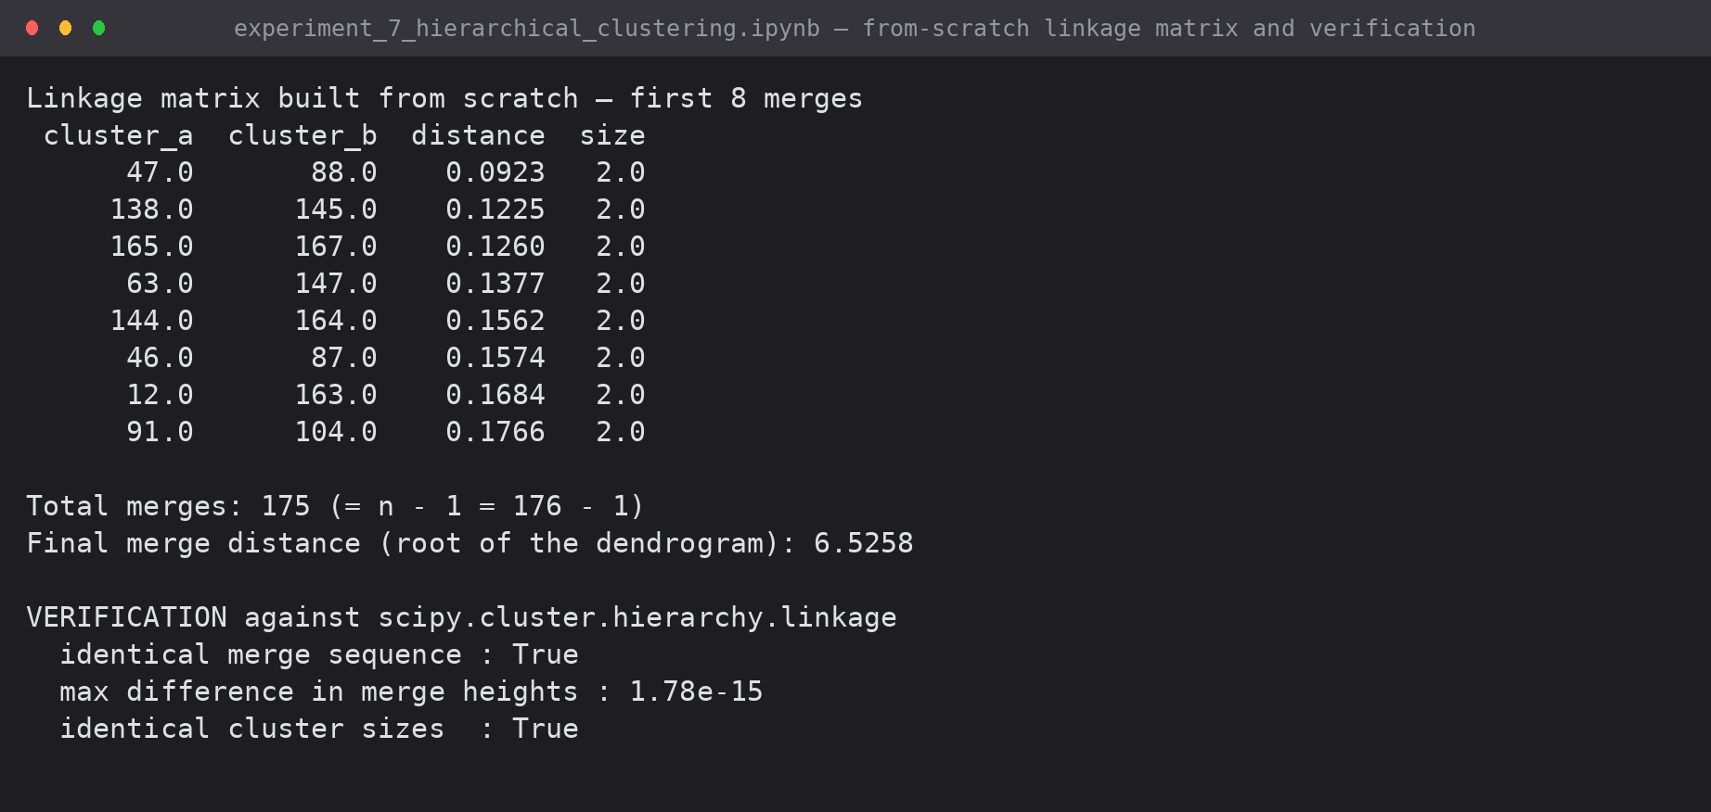
Screenshot 2: the linkage matrix produced from scratch, and verification against SciPy — identical merge sequence, merge heights matching to 1.8e-15

4. Choosing the Linkage Rule
The cophenetic correlation coefficient measures how faithfully the tree preserves the original pairwise distances. It is not the only criterion: a tree can preserve distances well and still produce a useless cut.
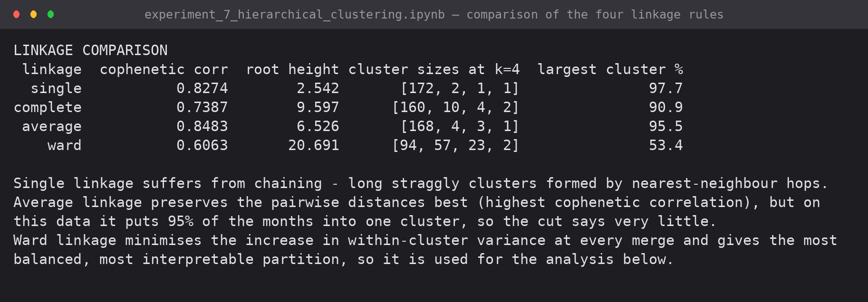
Screenshot 3: the four linkage rules compared
Linkage | Cophenetic corr. | Cluster sizes at k = 4 | Largest cluster
Single | 0.8274 | 172, 2, 1, 1 | 97.7% — chaining
Complete | 0.7387 | 160, 10, 4, 2 | 90.9%
Average | 0.8483 | 168, 4, 3, 1 | 95.5% — best distances, useless cut
Ward | 0.6063 | 94, 57, 23, 2 | 53.4% — balanced and interpretable

Average linkage preserves the distances best but places 95.5% of the months in one cluster, so the partition says almost nothing. Ward linkage minimises the increase in within-cluster variance at each merge and is the only rule of the four that produces a usable partition; it is used for the analysis, with the trade-off reported openly.
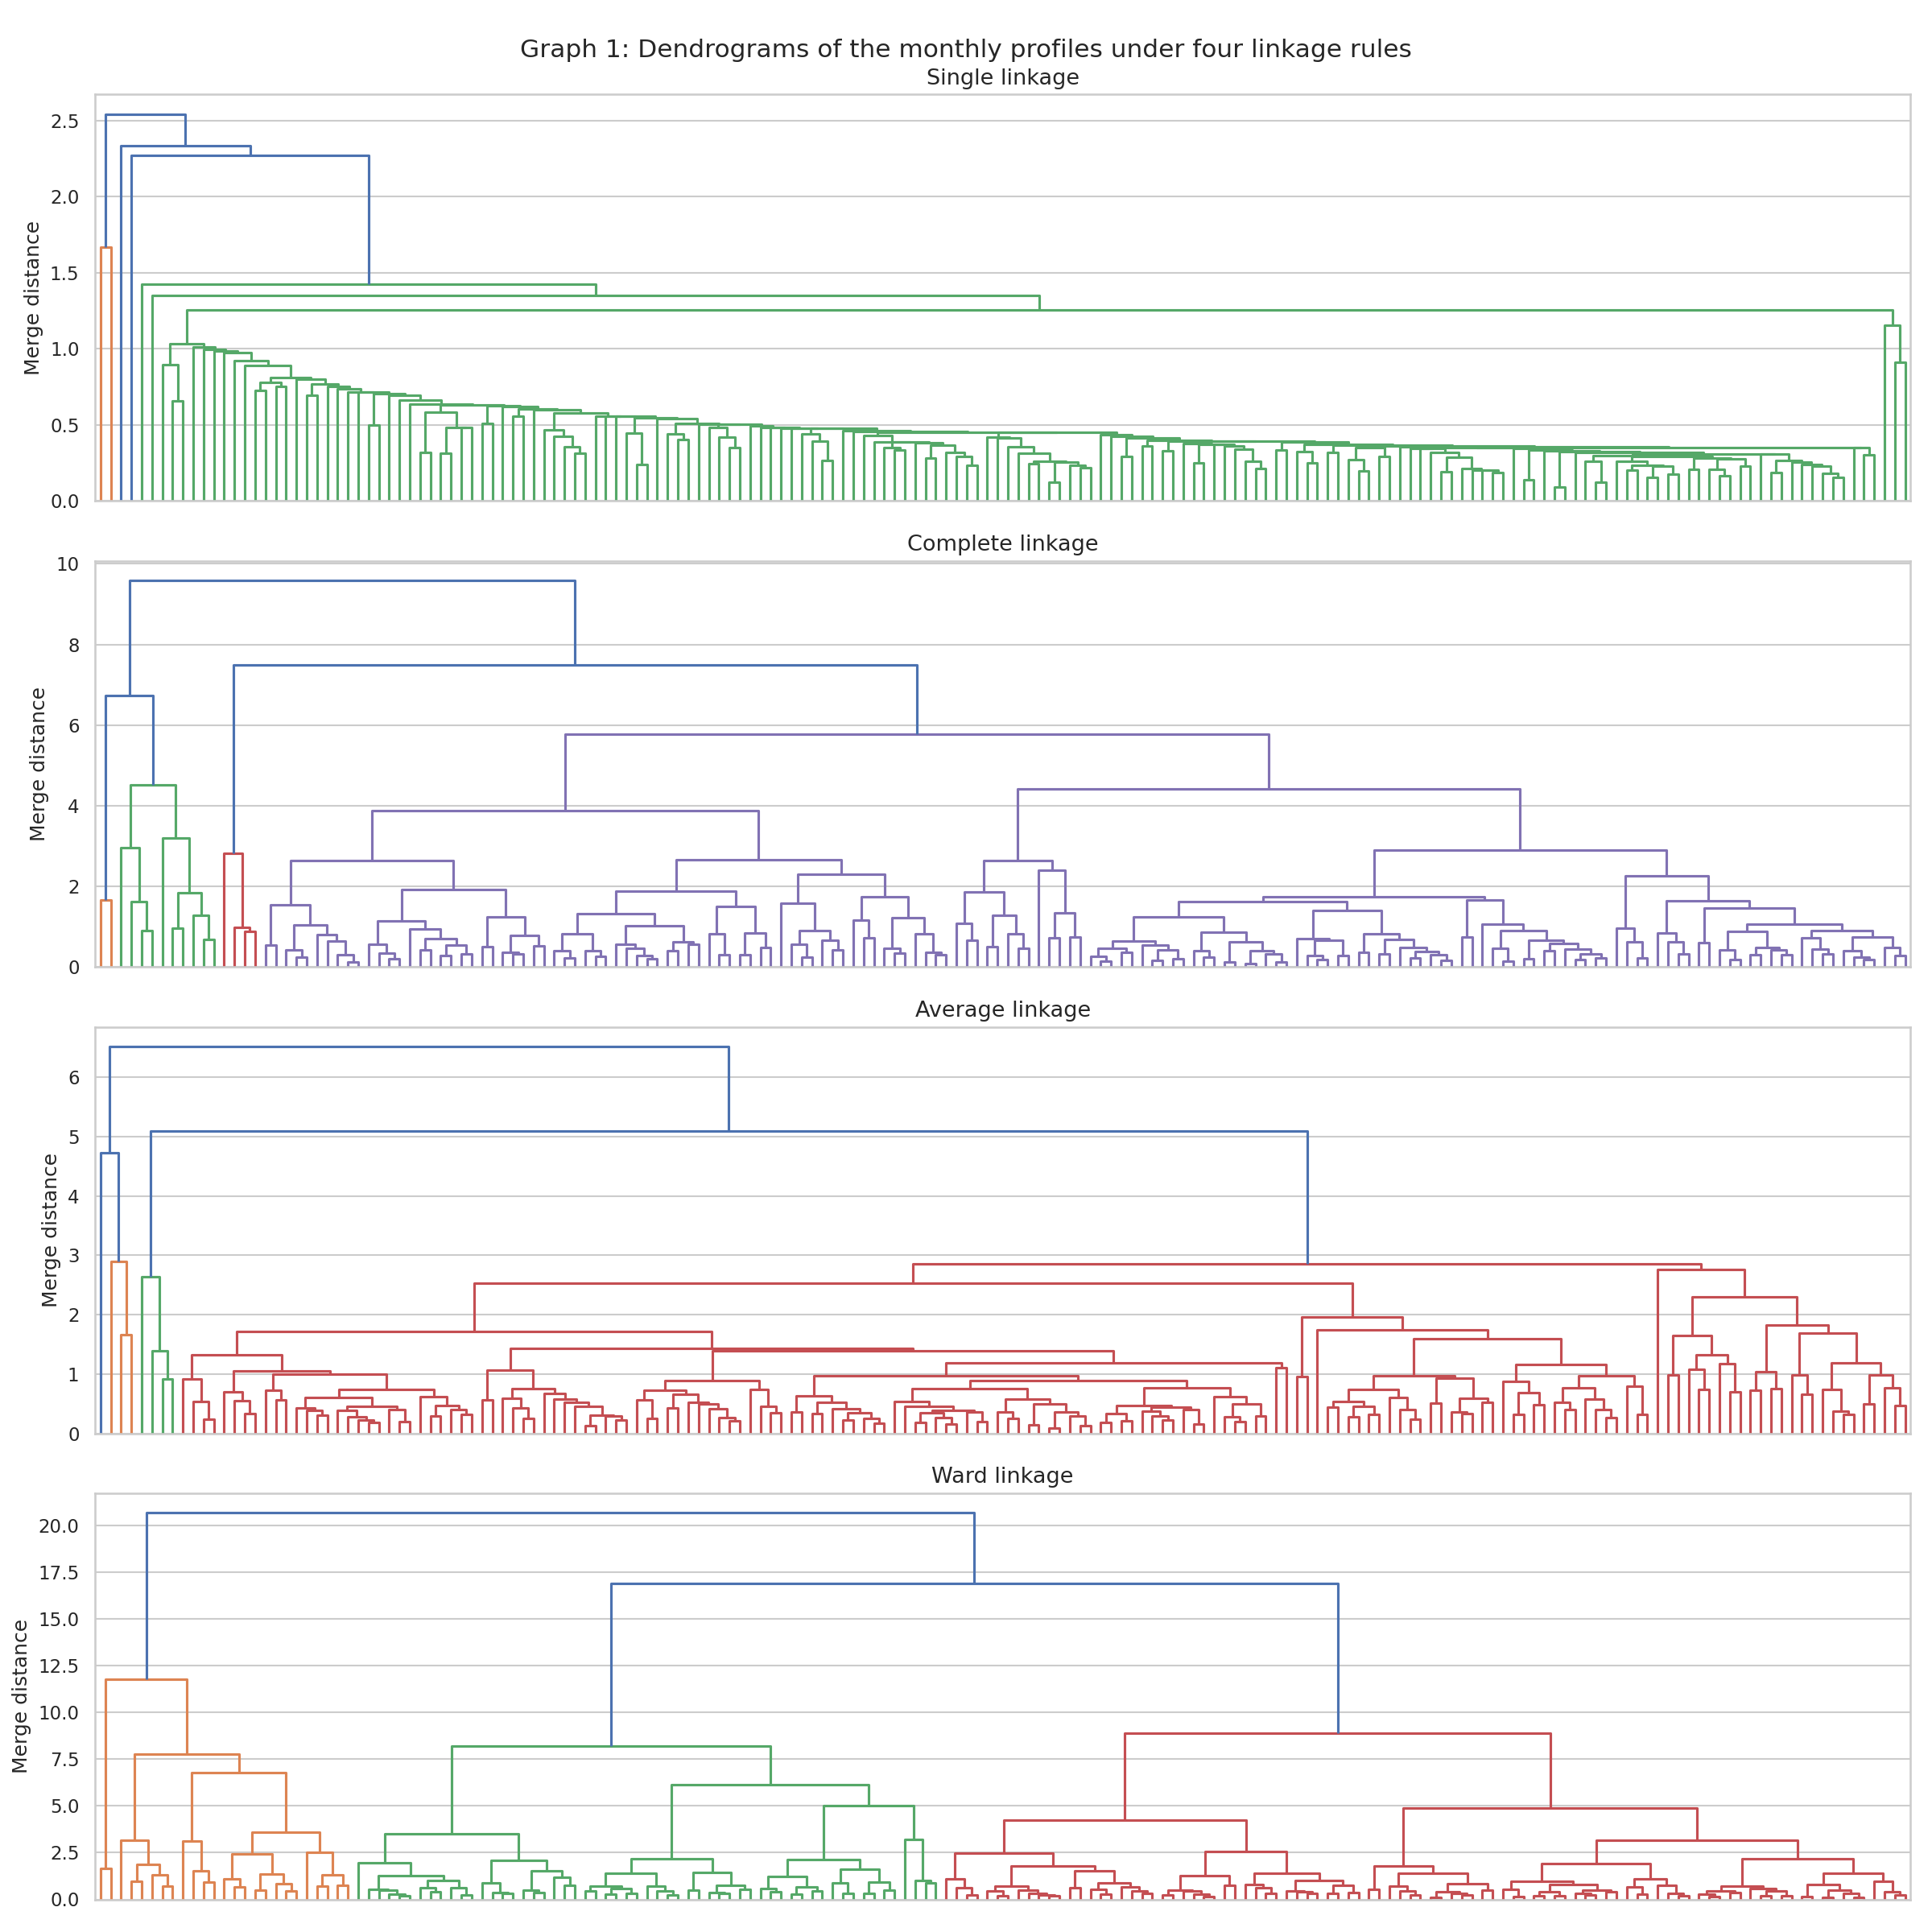
Graph 1: dendrograms under the four linkage rules — chaining is clearly visible in single linkage
5. The Dendrogram
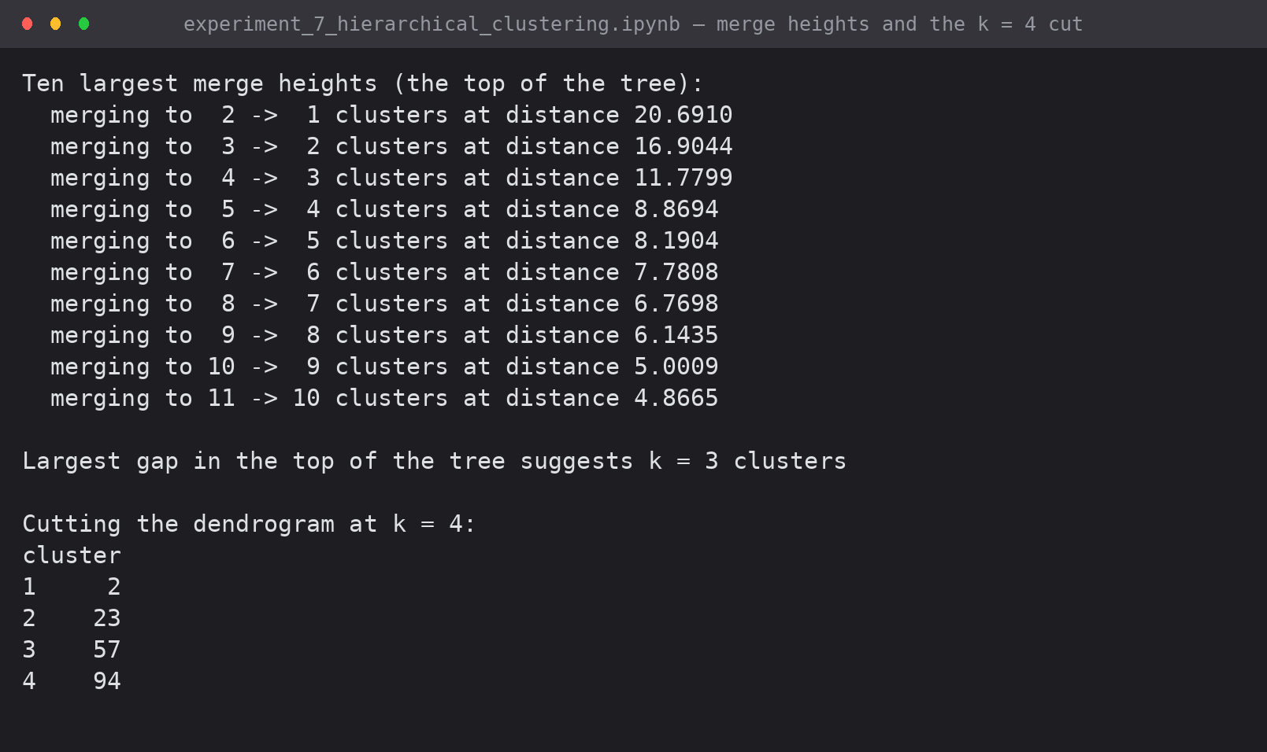
Screenshot 4: the merge heights at the top of the tree and the chosen cut
Merge heights rise slowly and then jump: 8.87 for the 5→4 merge, 11.78 for 4→3, 16.90 for 3→2 and 20.69 for the root. The tree was cut at k = 4, below the 11.78 jump.
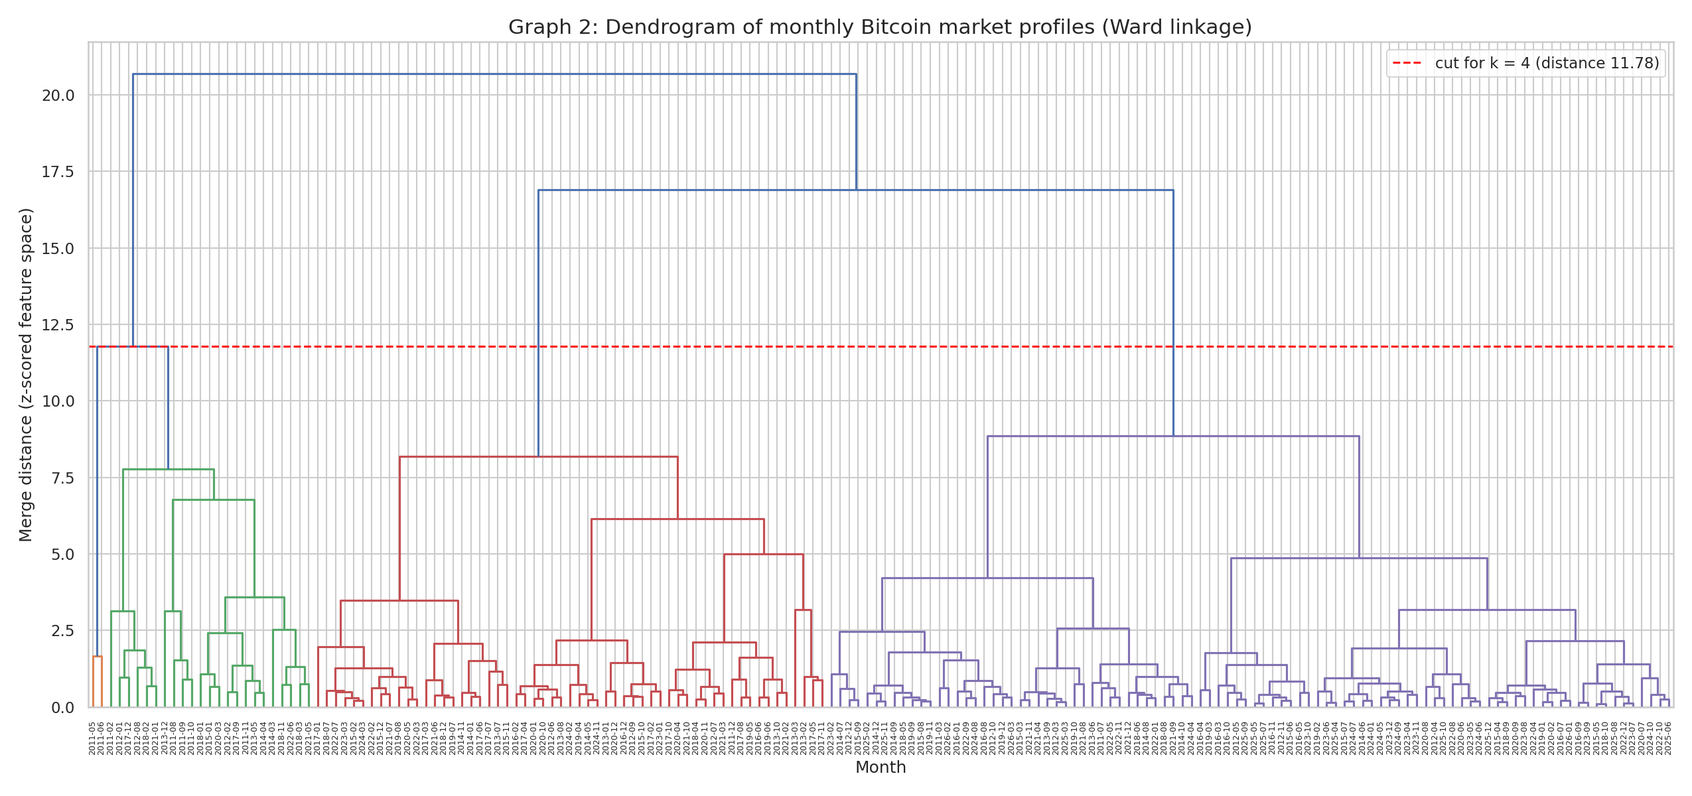
Graph 2: dendrogram of 176 monthly market profiles (Ward linkage), cut at k = 4
6. Cluster Interpretation
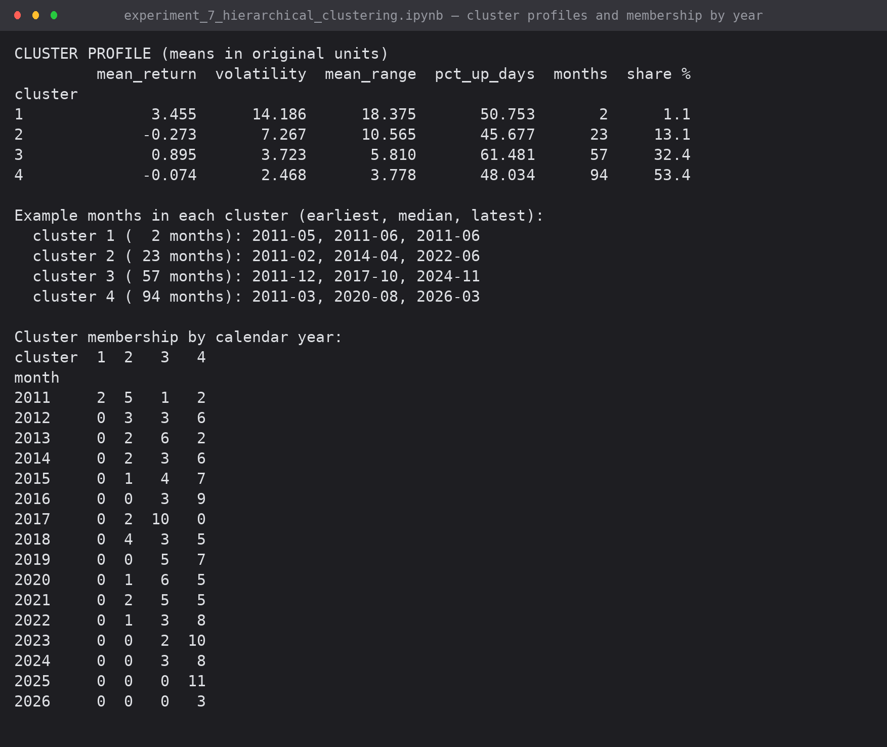
Screenshot 5: cluster profiles in original units, example months, and membership by year
Cluster | Months | Share | Mean return | Volatility | Mean range | % up days | Reading
4 | 94 | 53.4% | -0.07% | 2.47 | 3.78% | 48.0% | Quiet drift — the default state
3 | 57 | 32.4% | +0.90% | 3.72 | 5.81% | 61.5% | Steady bull month
2 | 23 | 13.1% | -0.27% | 7.27 | 10.57% | 45.7% | Turbulent / bear month
1 | 2 | 1.1% | +3.46% | 14.19 | 18.38% | 50.8% | Mania (May-Jun 2011)

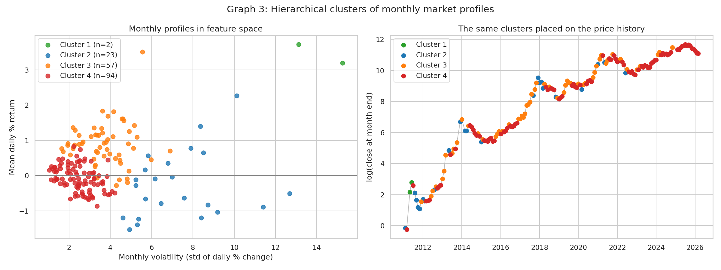
Graph 3: the clusters in feature space and placed on the price history
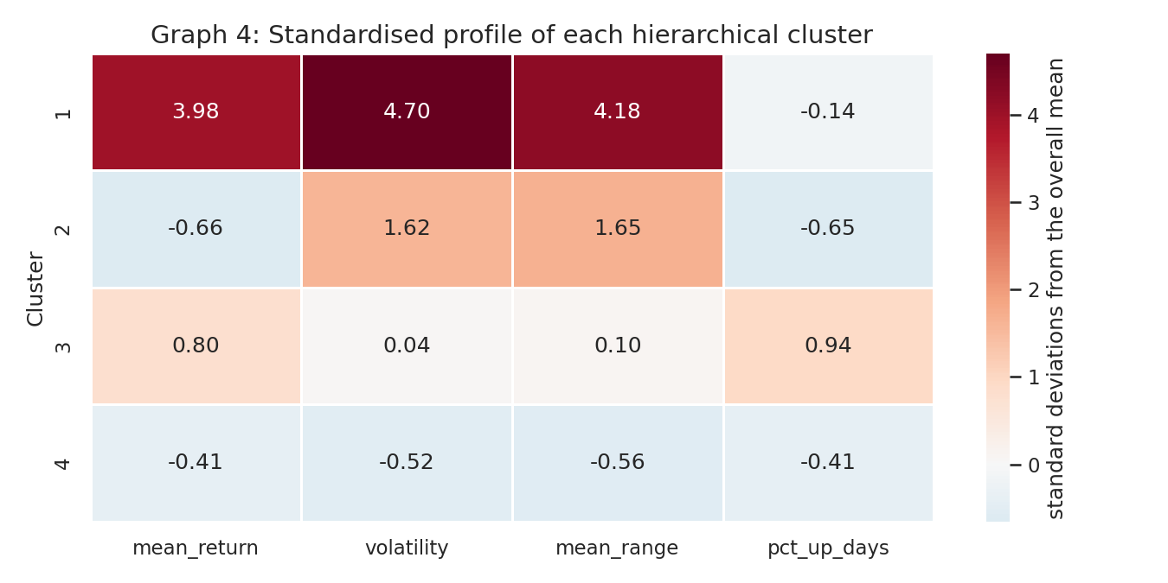
Graph 4: standardised profile of each cluster
6.1 What the hierarchy shows
- The tree separates volatility before direction. The first split divides calm months from turbulent ones; direction only matters lower down — the same structure K-Means found in Experiment 6, reached by a completely different route.
- Quiet months have taken over: cluster 4 holds 10 of 12 months in 2023, 11 of 11 in 2025 and all of 2026 so far, against 2 of 8 in 2011. No turbulent month (cluster 2) has occurred since 2022.
- Bull months are a distinct type rather than merely 'up' months: cluster 3 has 61.5% up days on a modest volatility of 3.72 — sustained advances are made of many small gains. All ten clustered months of 2017 fall here.
- May and June 2011 sit alone in cluster 1 with volatility 14.19, nearly six times the calm-month level — the first parabolic bubble is genuinely its own kind of month.

7. Comparison With K-Means (Experiment 6)
On the same 500 sampled trading days and the same two features, the hierarchical partition (Ward, k = 4) was compared with a K-Means partition of the same data.
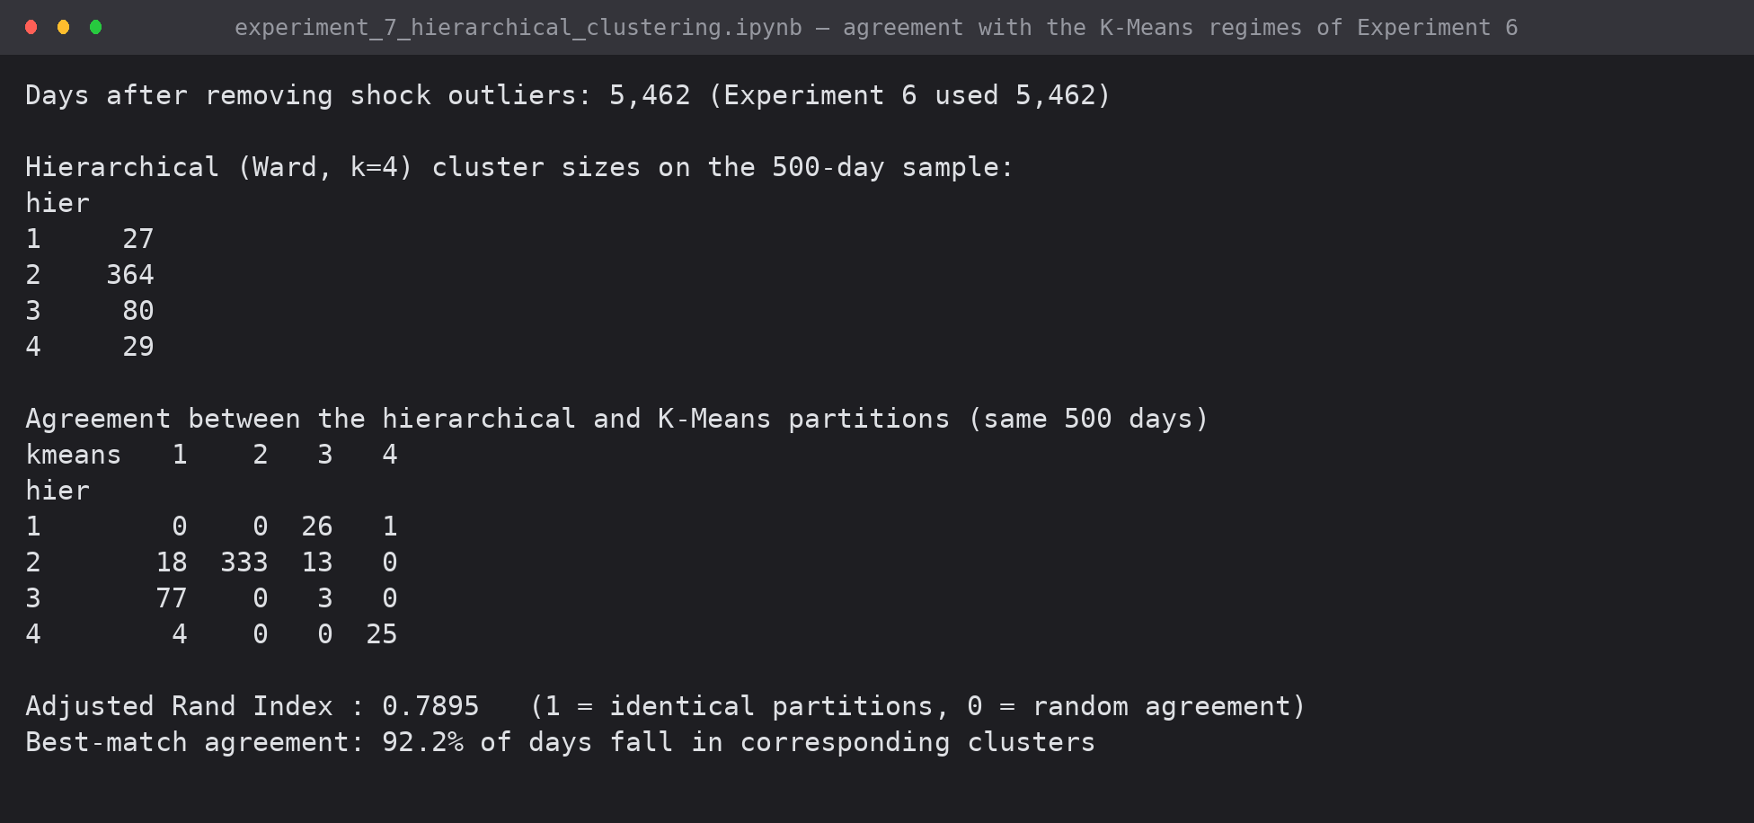
Screenshot 6: contingency table between the two partitions, with the Adjusted Rand Index
Agreement: 92.2% of days fall in corresponding clusters, Adjusted Rand Index 0.7895 (1.0 would be identical partitions, 0.0 random agreement). Two algorithms with entirely different mechanics recover essentially the same structure, which is the strongest available evidence that the regimes are a property of the data rather than of the method.
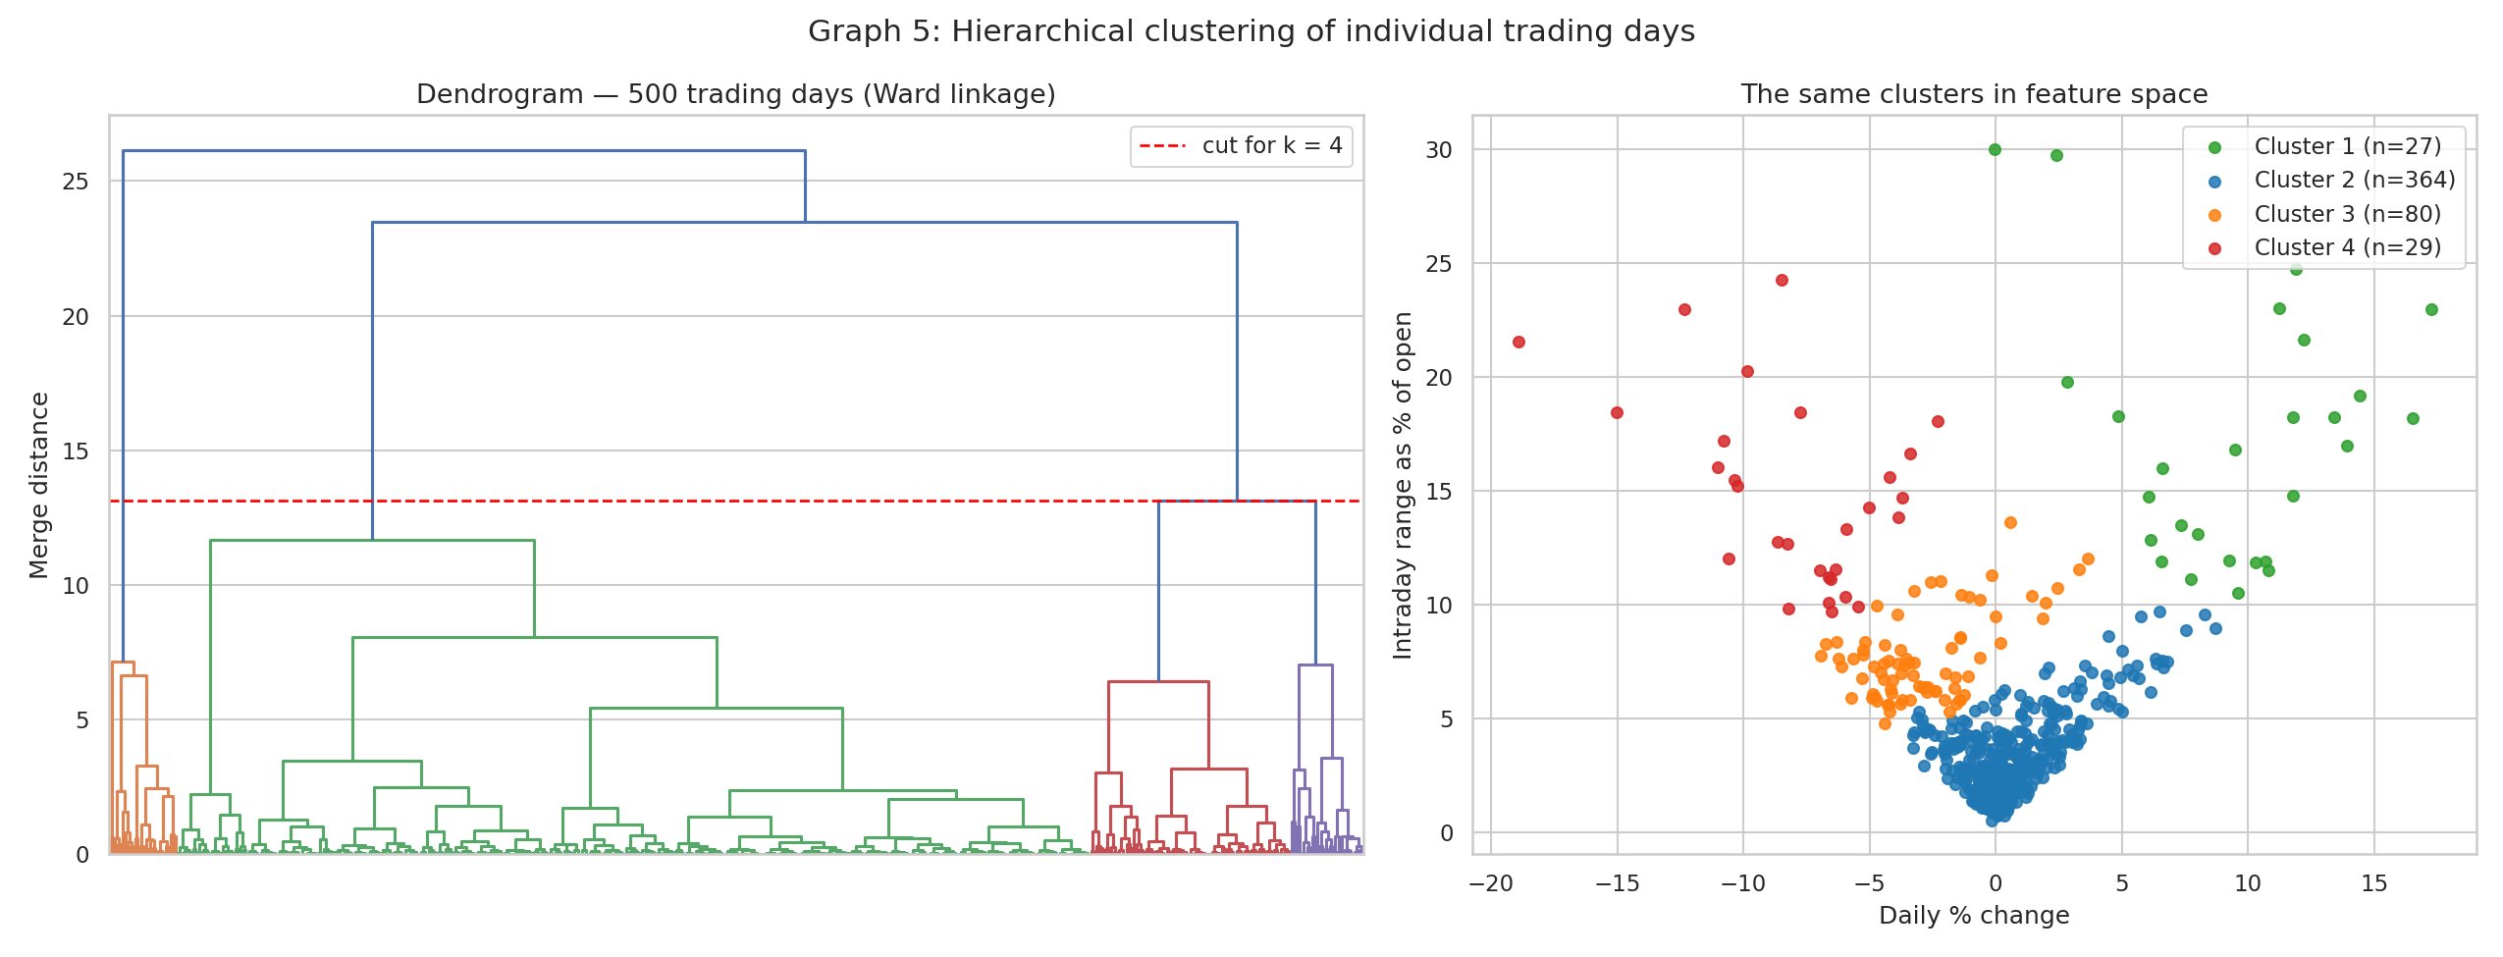
Graph 5: dendrogram of 500 individual trading days and the resulting clusters in feature space
7.1 Hierarchical against partitional clustering, as observed here
Property | K-Means (Exp 6) | Agglomerative (this experiment)
k required in advance | yes | no — the tree is cut afterwards
Stability | depends on initial centroids; needs restarts | deterministic for a given linkage
Complexity | O(n.k.d.i) — ran on all 5,462 days | O(n^3) time, O(n^2) memory — 500-day sample
Output | a flat partition | a full hierarchy showing how clusters nest
Outliers | drag the nearest centroid | form their own branch

8. Conclusion
Agglomerative hierarchical clustering was implemented from first principles — full proximity matrix, nearest-pair search and the Lance-Williams update for single, complete, average and Ward linkage — and verified against scipy.cluster.hierarchy.linkage, matching its merge sequence exactly and its merge heights to 1.8e-15.
Four linkage rules were compared on 176 monthly market profiles. Average linkage preserved the pairwise distances best (cophenetic correlation 0.848) but placed 95.5% of months in a single cluster; Ward linkage produced the only balanced partition (94 / 57 / 23 / 2) and was used for the analysis. The dendrogram separates volatility first and direction second, and shows quiet months steadily displacing turbulent ones — no turbulent month since 2022 against five in 2011.
On individual trading days the hierarchical result agrees with the K-Means regimes of Experiment 6 on 92.2% of days (Adjusted Rand Index 0.79), independently confirming the market-regime structure found there.
9. Files Submitted
File | Contents
experiment_7_hierarchical_clustering.ipynb | executed notebook — AGNES from scratch, linkage comparison, dendrograms, interpretation
exp7_outputs/exp7_g1..g5 (.png) | dendrograms, cluster scatter, profile heatmap
outputs/exp7_shot1..6 (.png) | captured console output

EXPERIMENT 8: IMPLEMENTATION OF THE ASSOCIATION RULE MINING ALGORITHM (APRIORI)
Mining frequent itemsets and association rules from Bitcoin trading days, with the level-wise algorithm and every interest measure written from first principles
Lab Code | Lab Name | Sem | Experiment | Course Outcome
2115120 | Data Warehousing and Mining | V | 8 | LO4

1. Aim
To implement the Apriori algorithm on the Bitcoin case-study dataset, generate frequent itemsets and association rules, and evaluate them using support, confidence and lift.
2. The Transaction Model
Association rule mining needs transactions of items, not continuous numbers. Each trading day is treated as one transaction, and its items are the discretized attributes produced in Experiment 4. A rule then has a plain reading, for example: on days when MACD is bullish, RSI is overbought and price is above the 200-day average, the next day closes higher.
Item family | Values | Meaning
MOVE= | Large Fall, Fall, Flat, Rise, Large Rise | size and direction of today's move
RANGE= | Low, Medium, High | intraday range as a % of the open
RSI= | Oversold, Neutral, Overbought | 14-day RSI zone
TREND= | Above200MA, Below200MA | position against the 200-day moving average
MACD= | Bullish, Bearish | MACD above or below its signal line
VOL= | Low, Medium, High | 30-day volatility tercile
NEXT= | Up, Down | the outcome: tomorrow's direction

df = pd.read_csv("btc_preprocessed_v1.csv", parse_dates=['date']).sort_values('date').reset_index(drop=True)

# outcome item: what the market did on the following day
df['next_pct'] = df['daily_pct_change'].shift(-1)
df = df.iloc[:-1].copy()

# volatility terciles (equal-frequency discretization, as in Experiment 4)
vol_lo, vol_hi = df['volatility_30d'].quantile([1/3, 2/3])

def items_for_row(r):
items = []
# 1. size and direction of today's move
items.append('MOVE=' + str(r['move_class']))
# 2. intraday range band
items.append('RANGE=' + str(r['range_band']))
# 3. momentum oscillator zone
items.append('RSI=' + str(r['rsi_zone']))
# 4. long-term trend position
items.append('TREND=' + ('Above200MA' if r['close'] > r['ma_200'] else 'Below200MA'))
# 5. MACD state
items.append('MACD=' + ('Bullish' if r['macd'] > r['macd_signal'] else 'Bearish'))
# 6. regime volatility
items.append('VOL=' + ('Low' if r['volatility_30d'] <= vol_lo
else 'High' if r['volatility_30d'] > vol_hi else 'Medium'))
# 7. the outcome to be predicted
items.append('NEXT=' + ('Up' if r['next_pct'] > 0 else 'Down'))
return items

transactions = [items_for_row(r) for _, r in df.iterrows()]
print(f"Transactions (trading days): {len(transactions):,}")
print(f"Items per transaction : {len(transactions[0])}")

all_items = sorted({i for t in transactions for i in t})
print(f"Distinct items : {len(all_items)}")
print("\nExample transaction —", df['date'].iloc[0].date())
for i in transactions[0]:
print(" ", i)

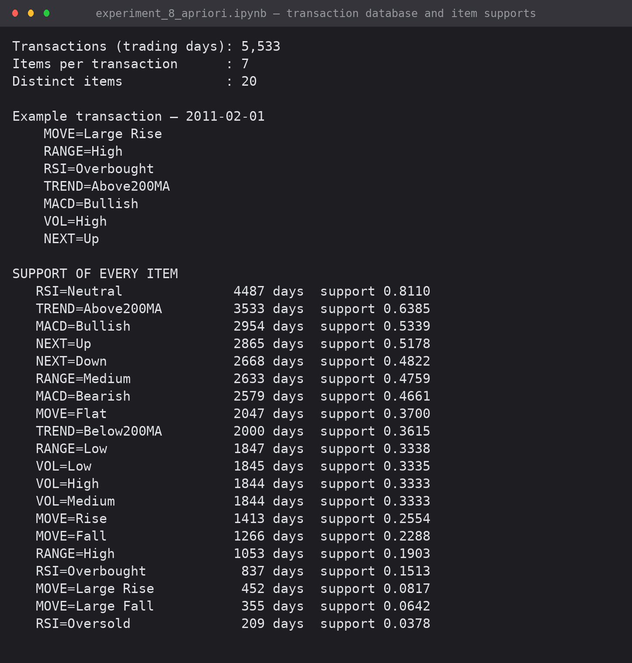
Screenshot 1: the transaction database — 5,533 days, 7 items each, 20 distinct items, with the support of every item
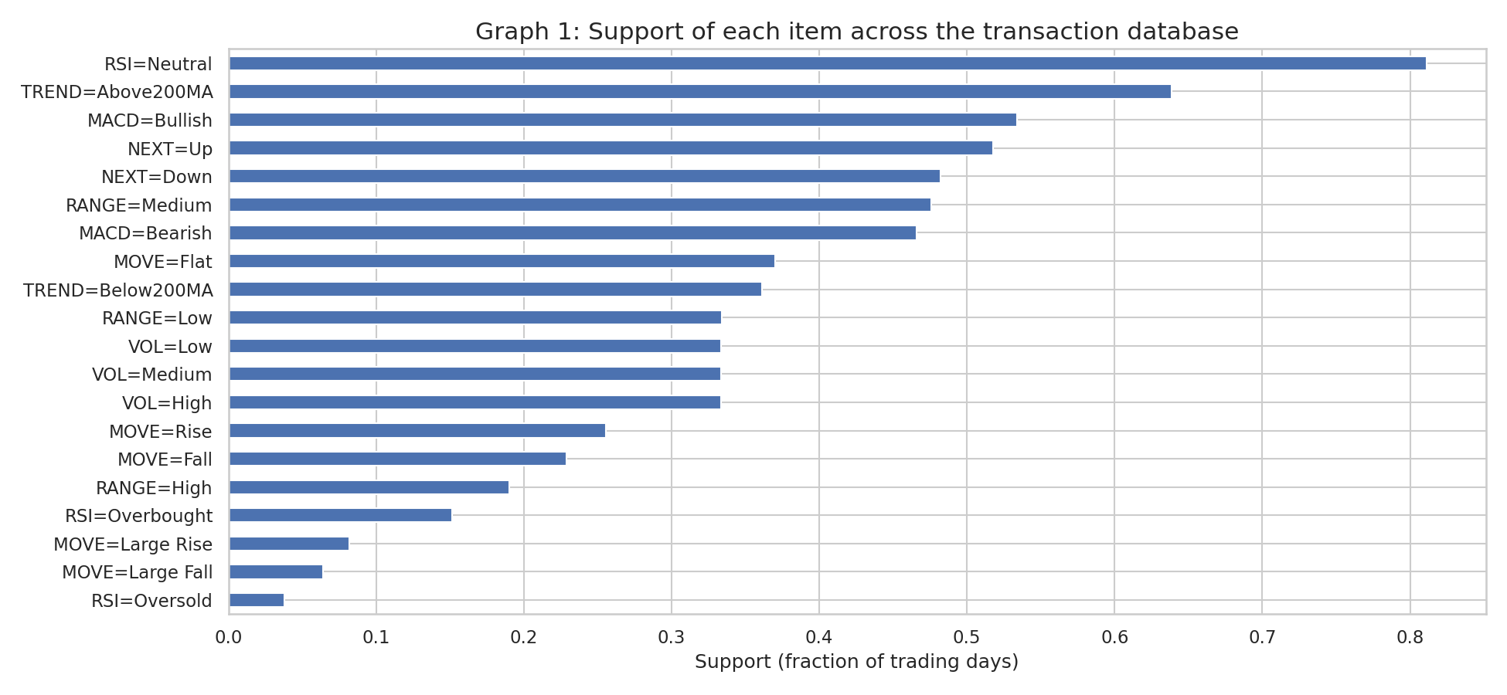
Graph 1: support of each item across the database
3. Theory
support(X) = (transactions containing X) / (total transactions)
confidence(X->Y) = support(X U Y) / support(X)
lift(X->Y) = confidence(X->Y) / support(Y) 1 = independent, >1 positive
leverage(X->Y) = support(X U Y) - support(X).support(Y)
conviction(X->Y) = (1 - support(Y)) / (1 - confidence)

Apriori property (downward closure): every subset of a frequent itemset is frequent; equivalently, if an itemset is infrequent then none of its supersets can be frequent. This is what makes the search tractable — whole branches are discarded without ever being counted.
The algorithm is level-wise: find frequent 1-itemsets; join pairs of frequent (k-1)-itemsets that share their first k-2 items to form candidates; prune any candidate with an infrequent (k-1)-subset; count the survivors in one database scan; repeat until nothing frequent remains.
4. Implementation
def apriori(transactions, min_support, verbose=True):
"""Classic level-wise Apriori. Returns {itemset (frozenset): support} and a per-level log."""
n = len(transactions)
tsets = [set(t) for t in transactions]
min_count = min_support * n

# ---- L1 ----
counts = {}
for t in tsets:
for item in t:
counts[frozenset([item])] = counts.get(frozenset([item]), 0) + 1
L = {k: v for k, v in counts.items() if v >= min_count}
frequent = dict(L)
log = [{'k': 1, 'candidates': len(counts), 'frequent': len(L)}]
if verbose:
print(f" k=1 : {len(counts):5d} candidates -> {len(L):5d} frequent")

k = 2
while L:
prev = sorted(L, key=lambda s: sorted(s))
# ---- JOIN step: merge two (k-1)-itemsets sharing their first k-2 items ----
candidates = set()
for i in range(len(prev)):
a = sorted(prev[i])
for j in range(i + 1, len(prev)):
b = sorted(prev[j])
if a[:k - 2] == b[:k - 2]:
candidates.add(frozenset(a) | frozenset(b))
candidates = {cand for cand in candidates if len(cand) == k}
n_joined = len(candidates)

# ---- PRUNE step: every (k-1)-subset must be frequent (Apriori property) ----
candidates = {cand for cand in candidates
if all(frozenset(sub) in L for sub in combinations(sorted(cand), k - 1))}
n_pruned = n_joined - len(candidates)

# ---- COUNT step: one pass over the database ----
counts = {cand: 0 for cand in candidates}
for t in tsets:
for cand in candidates:
if cand <= t:
counts[cand] += 1
L = {cand: cnt for cand, cnt in counts.items() if cnt >= min_count}
frequent.update(L)
log.append({'k': k, 'candidates': n_joined, 'pruned by Apriori property': n_pruned,
'counted': len(counts), 'frequent': len(L)})
if verbose:
print(f" k={k} : {n_joined:5d} joined, {n_pruned:5d} pruned, {len(counts):5d} counted "
f"-> {len(L):5d} frequent")
k += 1

return {s: c / n for s, c in frequent.items()}, pd.DataFrame(log)

MIN_SUPPORT = 0.05
t0 = time.time()
print(f"APRIORI (min_support = {MIN_SUPPORT} = {int(MIN_SUPPORT*len(transactions))} days)")
freq, level_log = apriori(transactions, MIN_SUPPORT)
print(f"\nFrequent itemsets found: {len(freq)} in {time.time()-t0:.2f} s")
print(f"Largest itemset size : {max(len(s) for s in freq)}")
print()
print(level_log.fillna('').to_string(index=False))

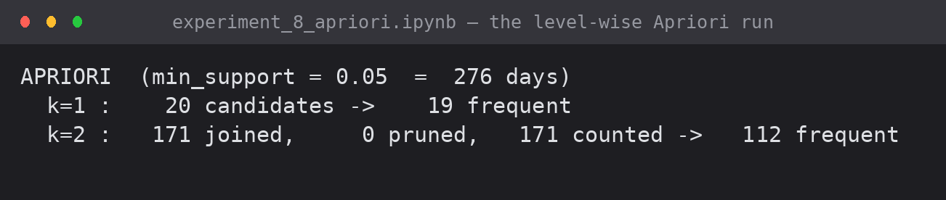
Screenshot 2: the level-wise run at min_support 0.05 — candidates joined, candidates pruned by the Apriori property, and frequent itemsets at each level
k | Candidates joined | Pruned by the Apriori property | Counted | Frequent
1 | 20 | — | 20 | 19
2 | 171 | 0 | 171 | 112
3 | 484 | 132 | 352 | 265
4 | 564 | 231 | 333 | 200
5 | 185 | 125 | 60 | 32
6 | 7 | 5 | 2 | 1
7 | 0 | 0 | 0 | 0

629 frequent itemsets were found in 0.49 seconds, the largest of size 6. The pruning step removed 493 candidates that never had to be counted against the database — the Apriori property earning its keep.
4.1 Verification
Correctness was checked by exhaustive enumeration: every possible itemset of size 1, 2 and 3 was counted directly and compared with what Apriori returned.
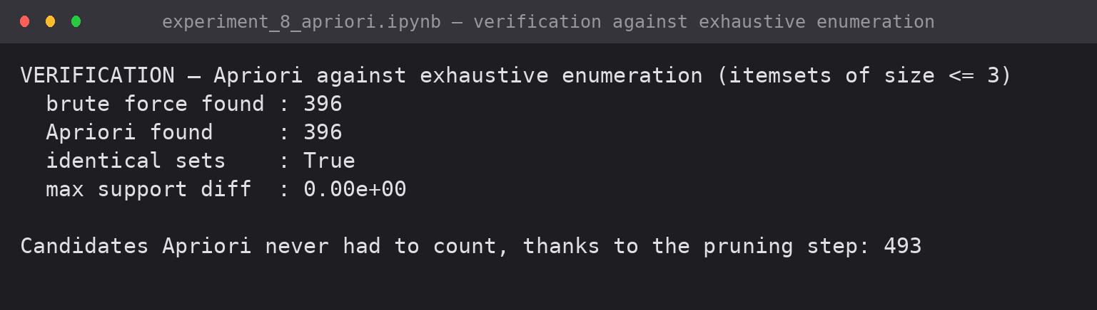
Screenshot 3: Apriori against brute-force enumeration — 396 itemsets each, identical sets, zero difference in support

5. Rule Generation
def generate_rules(freq, min_confidence):
rules = []
for itemset, sup in freq.items():
if len(itemset) < 2:
continue
for r in range(1, len(itemset)):
for ante in combinations(sorted(itemset), r):
ante = frozenset(ante)
cons = itemset - ante
conf = sup / freq[ante]
if conf < min_confidence:
continue
sup_c = freq[cons]
lift = conf / sup_c
rules.append({
'antecedent': ', '.join(sorted(ante)),
'consequent': ', '.join(sorted(cons)),
'support': sup,
'confidence': conf,
'lift': lift,
'leverage': sup - freq[ante] * sup_c,
'conviction': (1 - sup_c) / (1 - conf) if conf < 1 else np.inf,
'n_days': int(round(sup * len(transactions)))})
return pd.DataFrame(rules).sort_values('lift', ascending=False).reset_index(drop=True)

MIN_CONF = 0.60
rules = generate_rules(freq, MIN_CONF)
print(f"Rules with support >= {MIN_SUPPORT} and confidence >= {MIN_CONF}: {len(rules)}")
print(f" of which lift > 1.0 : {(rules['lift'] > 1).sum()}")
print(f" of which lift > 1.2 : {(rules['lift'] > 1.2).sum()}")
print("\nTop 15 rules by lift")
print(rules.head(15).round(4).to_string(index=False))

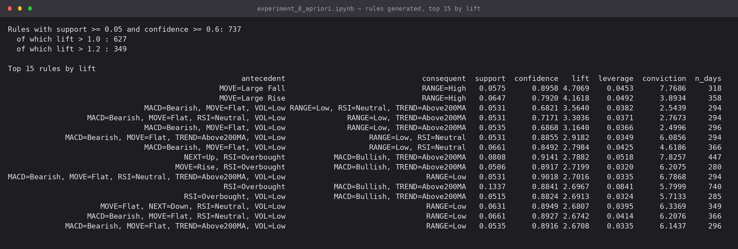
Screenshot 4: 737 rules at min_support 0.05 and min_confidence 0.60, top 15 by lift
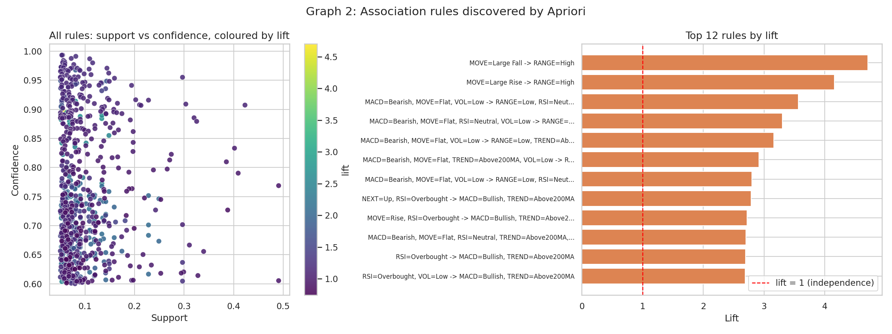
Graph 2: all rules in the support-confidence plane coloured by lift, and the top 12 by lift
6. Results
6.1 Summary
Quantity | Value
Transactions (trading days) | 5,533
Distinct items | 20
min_support / min_confidence | 0.05 (276 days) / 0.60
Frequent itemsets | 629 (largest of size 6)
Candidates pruned, never counted | 493
Association rules | 737 — 627 with lift > 1, 349 with lift > 1.2
Verification | identical to exhaustive enumeration for all itemsets of size <= 3

6.2 Strong rules — the same-day structure
Rule | Support | Confidence | Lift
{MOVE=Large Fall} -> {RANGE=High} | 0.058 | 0.896 | 4.71
{MOVE=Large Rise} -> {RANGE=High} | 0.065 | 0.792 | 4.16
{MACD=Bearish, MOVE=Flat, VOL=Low} -> {RANGE=Low, RSI=Neutral, TREND=Above200MA} | 0.053 | 0.682 | 3.56
{RSI=Overbought} -> {MACD=Bullish, TREND=Above200MA} | 0.134 | 0.884 | 2.70

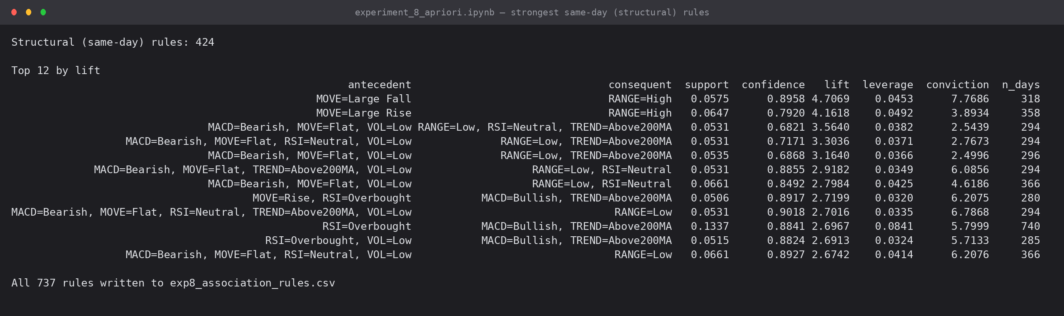
Screenshot 5: the strongest same-day rules
- A day that moves more than 5% almost always has a wide intraday range (lift 4.71). Large moves and wide ranges are two views of the same volatility.
- The momentum indicators imply one another: overbought RSI implies bullish MACD and price above the 200-day average on 88.4% of occasions (lift 2.70). Apriori has independently rediscovered that RSI, MACD and the moving-average trend are all functions of the same price series — useful to know before feeding all three to a classifier as if they were independent evidence.
- {MACD=Bearish, MOVE=Flat, VOL=Low} -> {RANGE=Low, RSI=Neutral, TREND=Above200MA} is the signature of a quiet consolidation day inside an uptrend (lift 3.56).
6.3 Predictive rules — the weak half
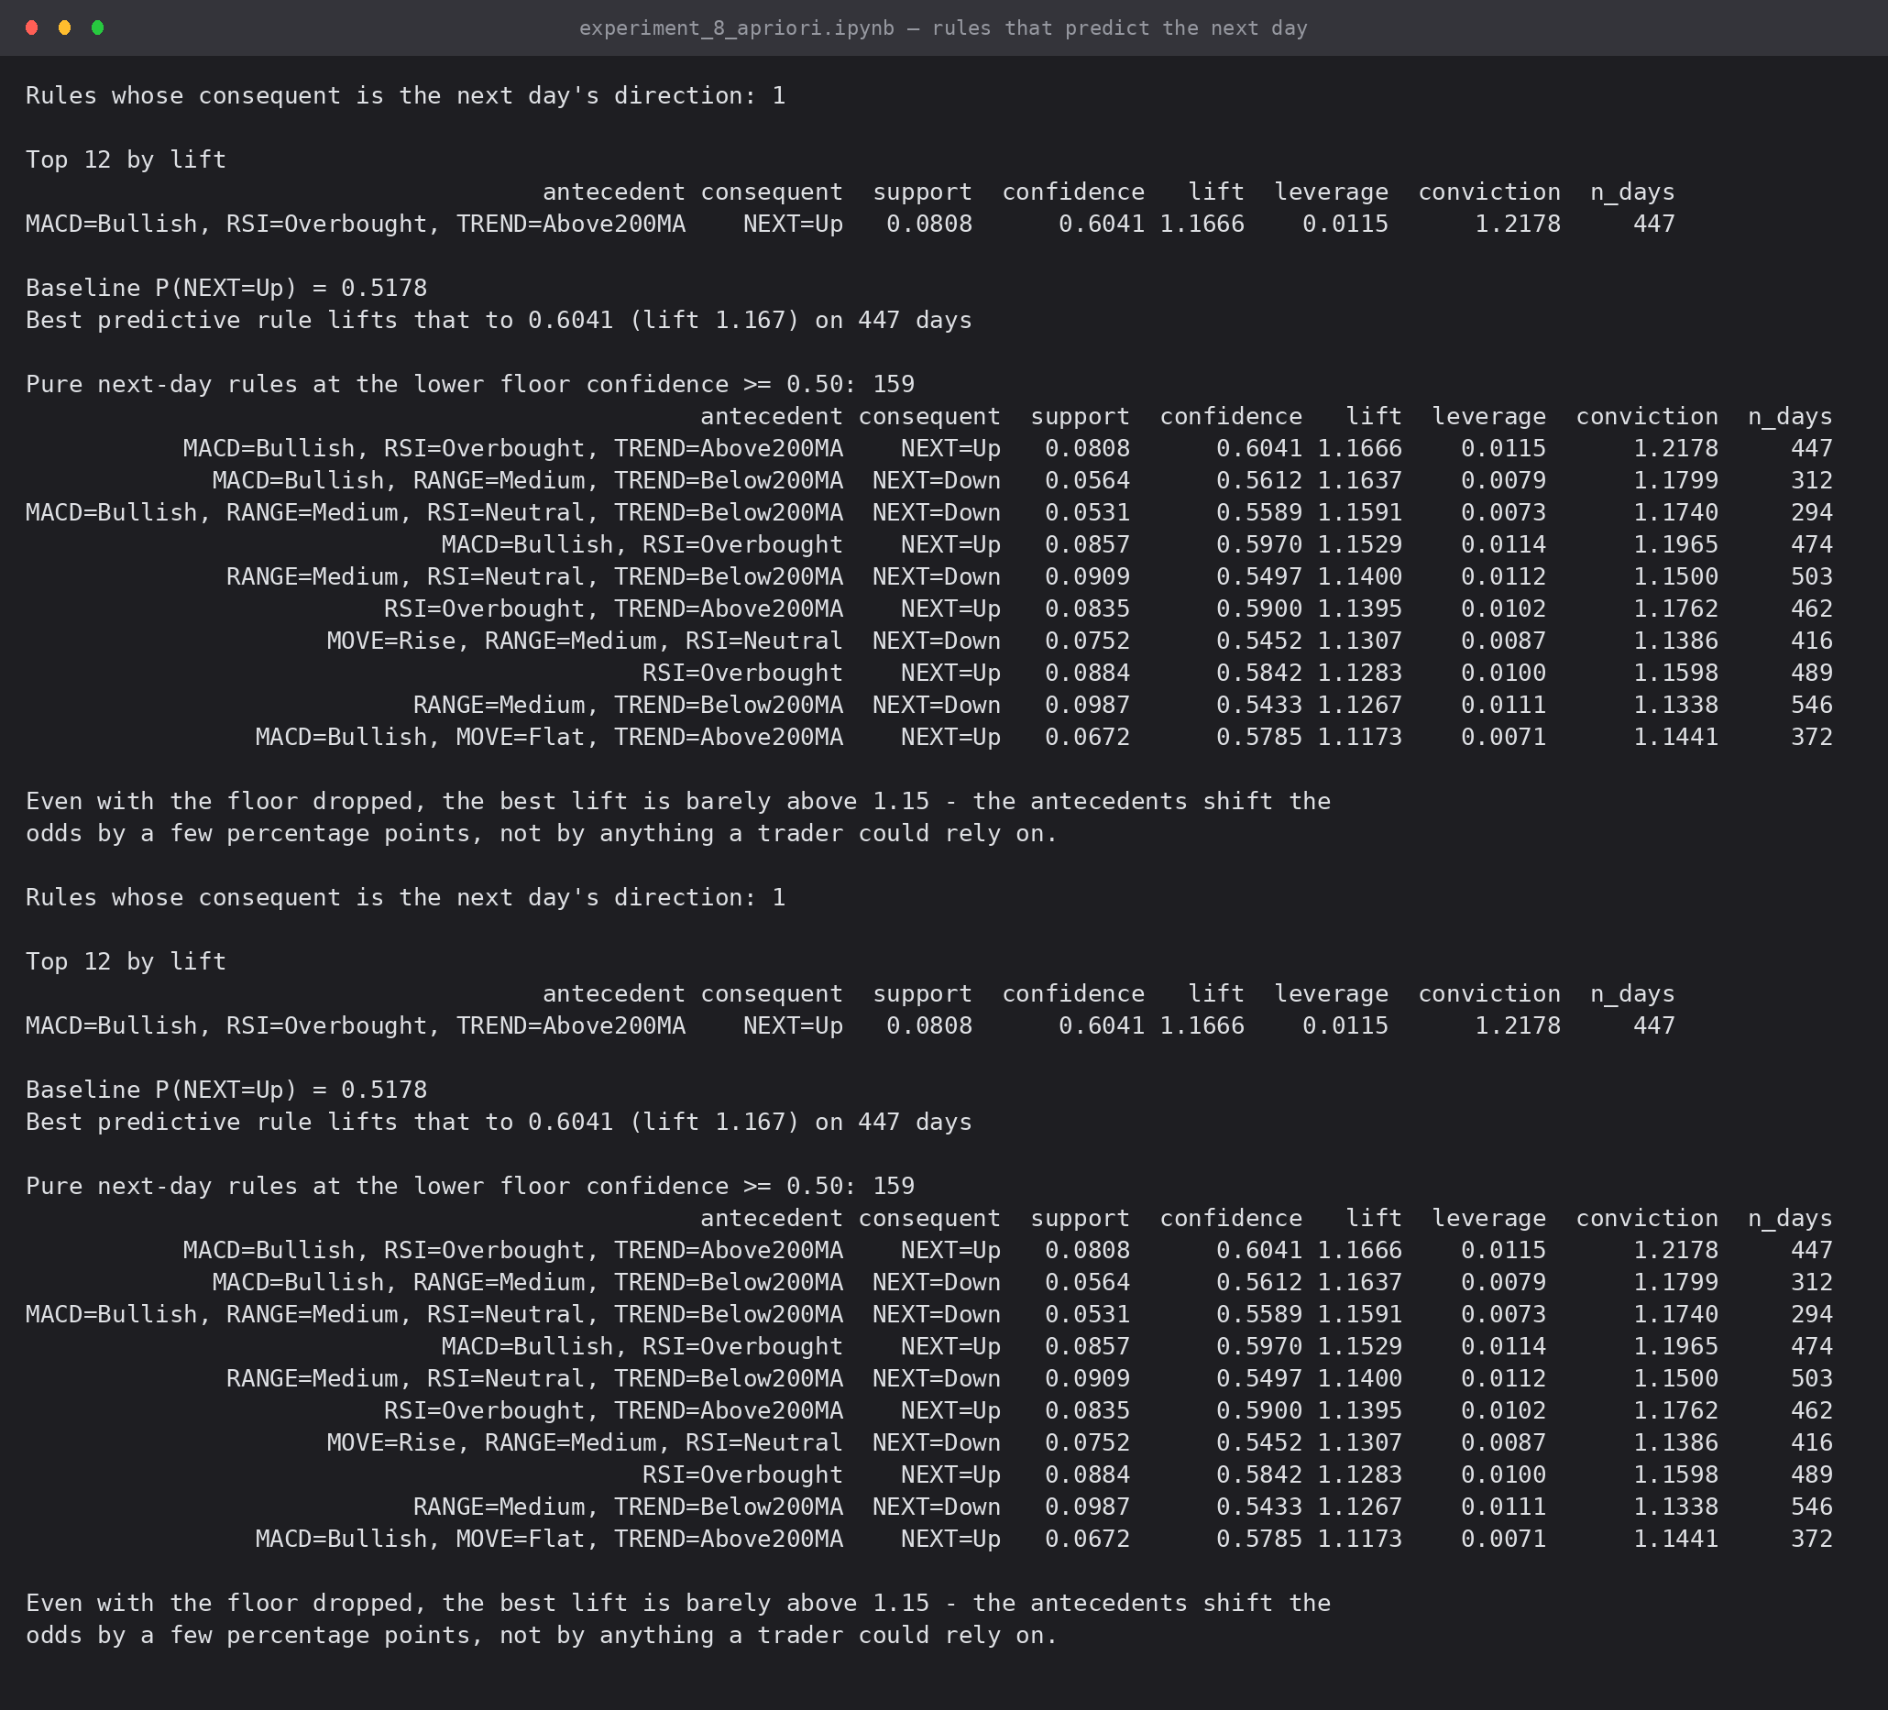
Screenshot 6: rules whose consequent is the next day's direction, at both confidence floors
Exactly one rule with a pure next-day consequent clears confidence 0.60:
{MACD=Bullish, RSI=Overbought, TREND=Above200MA} -> {NEXT=Up}
support 0.0808 (447 days) confidence 0.6041 lift 1.1666 leverage 0.0115

Against a base rate of P(NEXT=Up) = 0.5178 that is an improvement of 8.6 percentage points, on 8% of days. Lowering the floor to confidence 0.50 yields 159 more rules, but the best lift anywhere is 1.167 and the tenth-best is already down to 1.117.
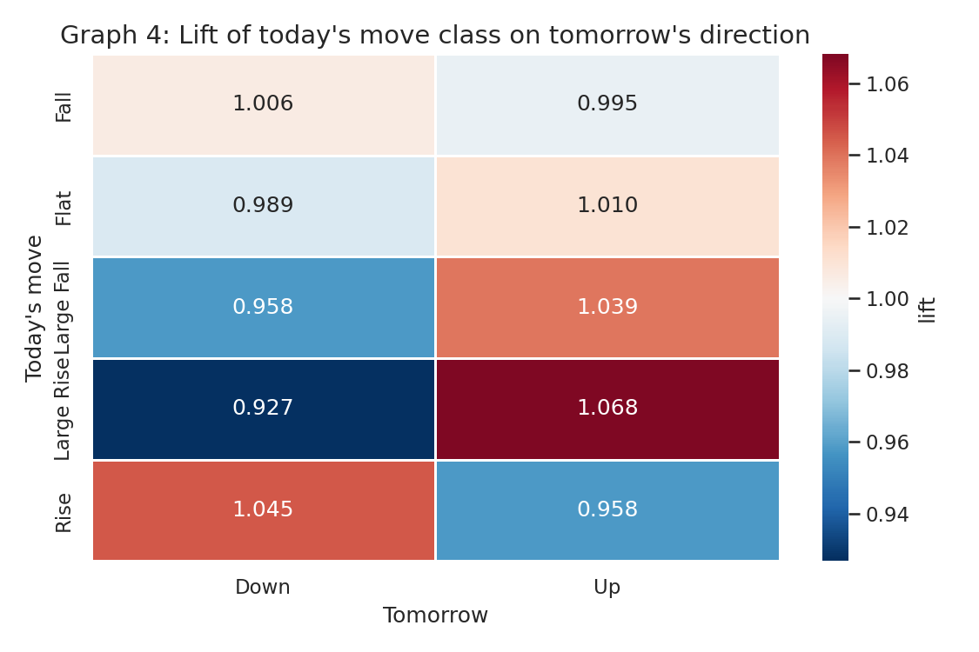
Graph 4: lift of today's move class on tomorrow's direction — every cell sits within a few percent of 1.000, i.e. near-independence
This agrees with Experiment 5, where the best classifier reached 54.8% against a 52.6% baseline and the best feature removed only 0.5% of the entropy. Three independent techniques — classification, information gain and association rules — report the same conclusion: strong same-day structure, almost no next-day signal.
6.4 The min_support trade-off
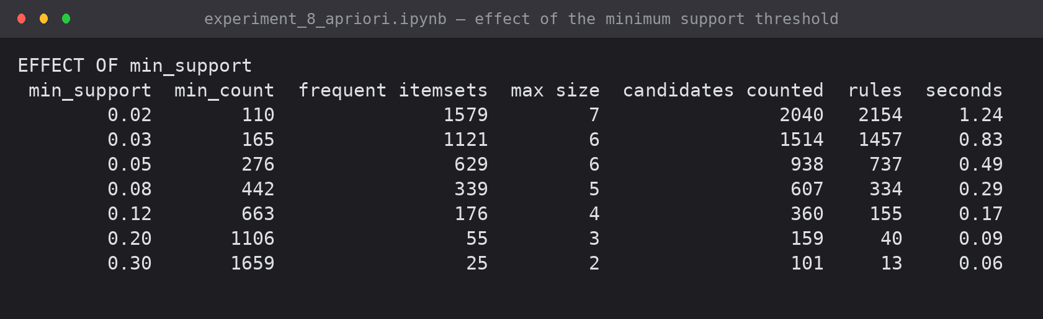
Screenshot 7: effect of the minimum support threshold
min_support | Frequent itemsets | Max size | Candidates counted | Rules | Runtime
0.02 | 1,579 | 7 | 2,040 | 2,154 | 1.25 s
0.03 | 1,121 | 6 | 1,514 | 1,457 | 0.90 s
0.05 | 629 | 6 | 938 | 737 | 0.52 s
0.08 | 339 | 5 | 607 | 334 | 0.31 s
0.12 | 176 | 4 | 360 | 155 | 0.18 s
0.20 | 55 | 3 | 159 | 40 | 0.08 s
0.30 | 25 | 2 | 101 | 13 | 0.06 s

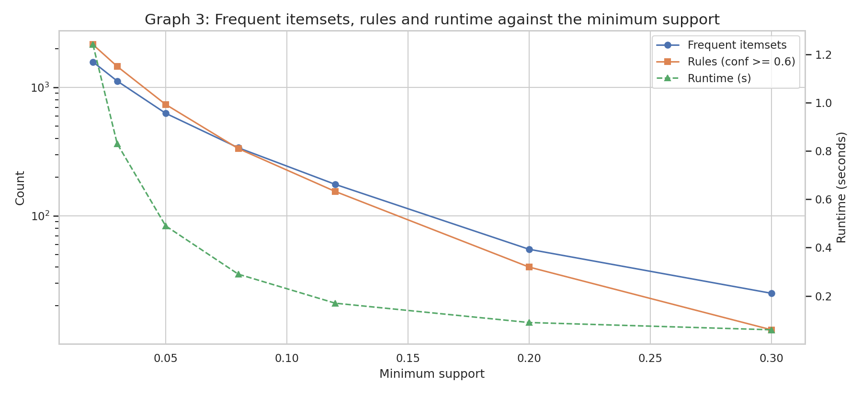
Graph 3: frequent itemsets, rules and runtime against the minimum support
Halving the threshold roughly doubles both the number of itemsets and the runtime. 0.05 was chosen because it keeps only patterns that hold on at least 276 days while remaining computable in half a second.
7. Conclusion
The Apriori algorithm was implemented from first principles — the F(k-1) x F(k-1) join, pruning by the Apriori property, one database scan per level, and rule generation with support, confidence, lift, leverage and conviction — and verified against exhaustive enumeration, with which it agrees exactly for every itemset of size 3 or smaller. Pruning saved 493 candidate counts.
From 5,533 daily transactions over 20 items, 629 frequent itemsets and 737 rules were mined. The rules divide cleanly: same-day associations are strong (a large move implies a wide range at lift 4.71; the momentum indicators imply one another at lift 2.70), while next-day associations are weak — one rule reaching 60.4% confidence at lift 1.17 against a 51.8% base rate, and nothing stronger anywhere in the search. That is consistent with the classification results of Experiment 5 and is the honest finding for a liquid, heavily arbitraged market.
8. Files Submitted
File | Contents
experiment_8_apriori.ipynb | executed notebook — Apriori, rule generation, verification, analysis
exp8_association_rules.csv | all 737 rules with support, confidence, lift, leverage, conviction
exp8_outputs/exp8_g1..g4 (.png) | item supports, rule scatter, support scan, lift heatmap
outputs/exp8_shot1..7 (.png) | captured console output

