Appendix

Neural Network Based Path Prediction

(1) GPS_Path_Prediction.m



on running this file in Matlab following window appears:

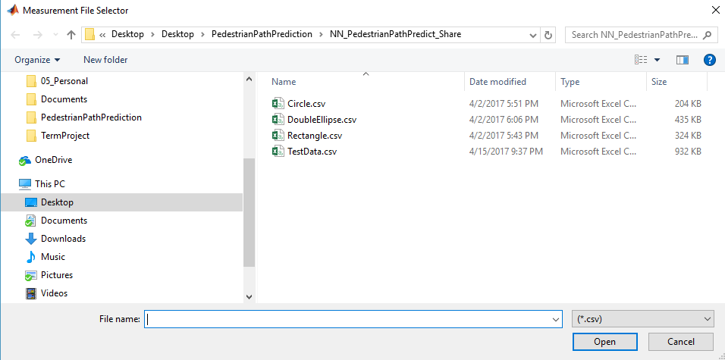

Select the measurement file(.csv) here.

Next following dialog box appears:

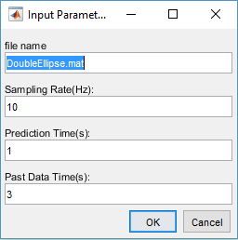

Enter the filename(for saving the processed data from measurement file), sampling rate, Prediction time in seconds and the Past Data Time window length in seconds.

Result:

Running this command results into following two mat files:

DoubleEllipse.mat: processed measurement file which is used by Neural Network Simulink model. described in part(4)

DoubleEllipse_NN.mat: File containing Neural Network training data. This file is used by data_prep.m file (described in part 2)

(2) DataPrep.m

This file is used to stack all the training data together before initiating Neural Network training.

(3) Training Neural Network:

Please refer to the presentation(PedestrianPathPredictionUsingGPSData.ppt) from slides 16 to 23

(4) Prediction_3sAdvance_2output.slx

Use the Simulink model generated from Neural Network training in this Simulink model.

Please note that this model has data buffer for 50 samples (1 current and 49 past) for x and y each. Based on the prediction time being used, you will be required to manually adjust the buffer.