ASSESSMENT TOOL 1

NAME: B. JAI SRINIVASAN
REG NO: 192524151
COURSE CODE: DSA0502
COURSE: QUERY PROCESSING

Q1. Hospital Patient Analysis Dashboard

Dataset columns
Your patient dataset should contain:
Column | Description
Age | Patient age
Blood_Pressure | Blood pressure
Cholesterol | Cholesterol level
BMI | Body Mass Index
Treatment_Cost | Treatment cost
Admission_Date | Date of admission

Required visualizations
- Age Distribution
  - Histogram
  - Shows the distribution of patient ages.
- Blood Pressure Distribution
  - Histogram
  - Identifies common BP ranges.
- Cholesterol Distribution
  - Histogram
  - Shows cholesterol-level distribution.
- BMI Distribution
  - Histogram/boxplot
  - Helps identify unusual BMI values.
- Treatment Cost Distribution
  - Histogram
  - Shows the spread of medical expenses.
- Age vs Treatment Cost
  - Scatter plot
  - Identifies whether treatment costs increase with age.
- BMI vs Treatment Cost
  - Scatter plot
  - Examines the relationship between BMI and expenses.
- Blood Pressure vs Cholesterol
  - Scatter plot
  - Shows relationships between health indicators.
- Monthly Admissions
  - Line plot
  - Groups admission dates by month and identifies seasonal patterns.
- Daily/Monthly Admission Trend
- Time-series plot
- Helps identify periods with unusually high admissions.
- Lag Plot
- Compares current admission counts with previous admission counts.
- Useful for identifying recurring patterns.
- Autocorrelation Plot
- Determines whether admission patterns repeat over time.

Python implementation
import pandas as pd
import numpy as np
import matplotlib.pyplot as plt
from pandas.plotting import lag_plot, autocorrelation_plot

# =========================================================
# HOSPITAL PATIENT DATASET - CREATED INSIDE THE CODE
# =========================================================

np.random.seed(42)

n = 180

# Generate admission dates over 18 months
dates = pd.date_range(
start="2025-01-01",
end="2026-06-30",
periods=n
)

# Create dataset
df = pd.DataFrame({
"Patient_ID": [f"P{i:03d}" for i in range(1, n + 1)],

"Age": np.random.randint(18, 81, n),

"Blood_Pressure": np.random.randint(100, 181, n),

"Cholesterol": np.random.randint(130, 301, n),

"BMI": np.round(
np.random.uniform(18, 40, n), 1
),

"Treatment_Cost": np.random.randint(
10000, 100001, n
),

"Admission_Date": dates
})

# Save dataset as CSV
df.to_csv("hospital_patients.csv", index=False)

print("========================================")
print("HOSPITAL DATASET CREATED")
print("========================================")

print(df.head())

print("\nDataset Shape:")
print(df.shape)

print("\nDataset Information:")
print(df.info())

print("\nStatistical Summary:")
print(df.describe())

# =========================================================
# 1. AGE DISTRIBUTION
# =========================================================

plt.figure(figsize=(8, 5))

plt.hist(
df["Age"],
bins=10,
edgecolor="black"
)

plt.title("Patient Age Distribution")
plt.xlabel("Age")
plt.ylabel("Number of Patients")
plt.grid(axis="y", alpha=0.3)

plt.show()

# =========================================================
# 2. BLOOD PRESSURE DISTRIBUTION
# =========================================================

plt.figure(figsize=(8, 5))

plt.hist(
df["Blood_Pressure"],
bins=10,
edgecolor="black"
)

plt.title("Blood Pressure Distribution")
plt.xlabel("Blood Pressure")
plt.ylabel("Number of Patients")
plt.grid(axis="y", alpha=0.3)

plt.show()

# =========================================================
# 3. CHOLESTEROL DISTRIBUTION
# =========================================================

plt.figure(figsize=(8, 5))

plt.hist(
df["Cholesterol"],
bins=10,
edgecolor="black"
)

plt.title("Cholesterol Distribution")
plt.xlabel("Cholesterol")
plt.ylabel("Number of Patients")
plt.grid(axis="y", alpha=0.3)

plt.show()

# =========================================================
# 4. BMI DISTRIBUTION
# =========================================================

plt.figure(figsize=(8, 5))

plt.hist(
df["BMI"],
bins=10,
edgecolor="black"
)

plt.title("BMI Distribution")
plt.xlabel("BMI")
plt.ylabel("Number of Patients")
plt.grid(axis="y", alpha=0.3)

plt.show()

# =========================================================
# 5. TREATMENT COST DISTRIBUTION
# =========================================================

plt.figure(figsize=(8, 5))

plt.hist(
df["Treatment_Cost"],
bins=15,
edgecolor="black"
)

plt.title("Treatment Cost Distribution")
plt.xlabel("Treatment Cost")
plt.ylabel("Number of Patients")
plt.grid(axis="y", alpha=0.3)

plt.show()

# =========================================================
# 6. AGE VS TREATMENT COST
# =========================================================

plt.figure(figsize=(8, 5))

plt.scatter(
df["Age"],
df["Treatment_Cost"],
alpha=0.7
)

plt.title("Age vs Treatment Cost")
plt.xlabel("Age")
plt.ylabel("Treatment Cost")

plt.grid(alpha=0.3)

plt.show()

# =========================================================
# 7. BMI VS TREATMENT COST
# =========================================================

plt.figure(figsize=(8, 5))

plt.scatter(
df["BMI"],
df["Treatment_Cost"],
alpha=0.7
)

plt.title("BMI vs Treatment Cost")
plt.xlabel("BMI")
plt.ylabel("Treatment Cost")

plt.grid(alpha=0.3)

plt.show()

# =========================================================
# 8. BLOOD PRESSURE VS CHOLESTEROL
# =========================================================

plt.figure(figsize=(8, 5))

plt.scatter(
df["Blood_Pressure"],
df["Cholesterol"],
alpha=0.7
)

plt.title("Blood Pressure vs Cholesterol")
plt.xlabel("Blood Pressure")
plt.ylabel("Cholesterol")

plt.grid(alpha=0.3)

plt.show()

# =========================================================
# 9. MONTHLY ADMISSIONS
# =========================================================

df["Month"] = df["Admission_Date"].dt.to_period("M")

monthly_admissions = df.groupby("Month").size()

plt.figure(figsize=(12, 5))

monthly_admissions.plot(
marker="o"
)

plt.title("Monthly Hospital Admissions")
plt.xlabel("Month")
plt.ylabel("Number of Admissions")

plt.xticks(rotation=45)

plt.grid(alpha=0.3)

plt.tight_layout()

plt.show()

# =========================================================
# 10. DAILY ADMISSION TREND
# =========================================================

daily_admissions = (
df.groupby("Admission_Date")
.size()
)

plt.figure(figsize=(12, 5))

daily_admissions.plot(
marker="o"
)

plt.title("Hospital Admission Trend")
plt.xlabel("Admission Date")
plt.ylabel("Number of Admissions")

plt.grid(alpha=0.3)

plt.tight_layout()

plt.show()

# =========================================================
# 11. LAG PLOT
# =========================================================

if len(monthly_admissions) >= 2:

plt.figure(figsize=(7, 5))

lag_plot(
monthly_admissions
)

plt.title(
"Lag Plot of Monthly Hospital Admissions"
)

plt.xlabel(
"Previous Month Admissions"
)

plt.ylabel(
"Current Month Admissions"
)

plt.grid(alpha=0.3)

plt.show()

# =========================================================
# 12. AUTOCORRELATION PLOT
# =========================================================

if len(monthly_admissions) >= 3:

plt.figure(figsize=(10, 5))

autocorrelation_plot(
monthly_admissions
)

plt.title(
"Autocorrelation of Hospital Admissions"
)

plt.xlabel("Lag")

plt.ylabel("Autocorrelation")

plt.grid(alpha=0.3)

plt.show()

# =========================================================
# 13. CORRELATION ANALYSIS
# =========================================================

numeric_columns = [
"Age",
"Blood_Pressure",
"Cholesterol",
"BMI",
"Treatment_Cost"
]

correlation = df[numeric_columns].corr()

print("\n========================================")
print("CORRELATION MATRIX")
print("========================================")

print(correlation)

# =========================================================
# FINAL FINDINGS
# =========================================================

print("\n========================================")
print("KEY FINDINGS")
print("========================================")

print(
"Average Age:",
round(df["Age"].mean(), 2)
)

print(
"Average Blood Pressure:",
round(df["Blood_Pressure"].mean(), 2)
)

print(
"Average Cholesterol:",
round(df["Cholesterol"].mean(), 2)
)

print(
"Average BMI:",
round(df["BMI"].mean(), 2)
)

print(
"Average Treatment Cost:",
round(df["Treatment_Cost"].mean(), 2)
)

print(
"Maximum Treatment Cost:",
df["Treatment_Cost"].max()
)

print(
"Minimum Treatment Cost:",
df["Treatment_Cost"].min()
)

print("\nHospital analysis completed successfully!")

OUTPUT:
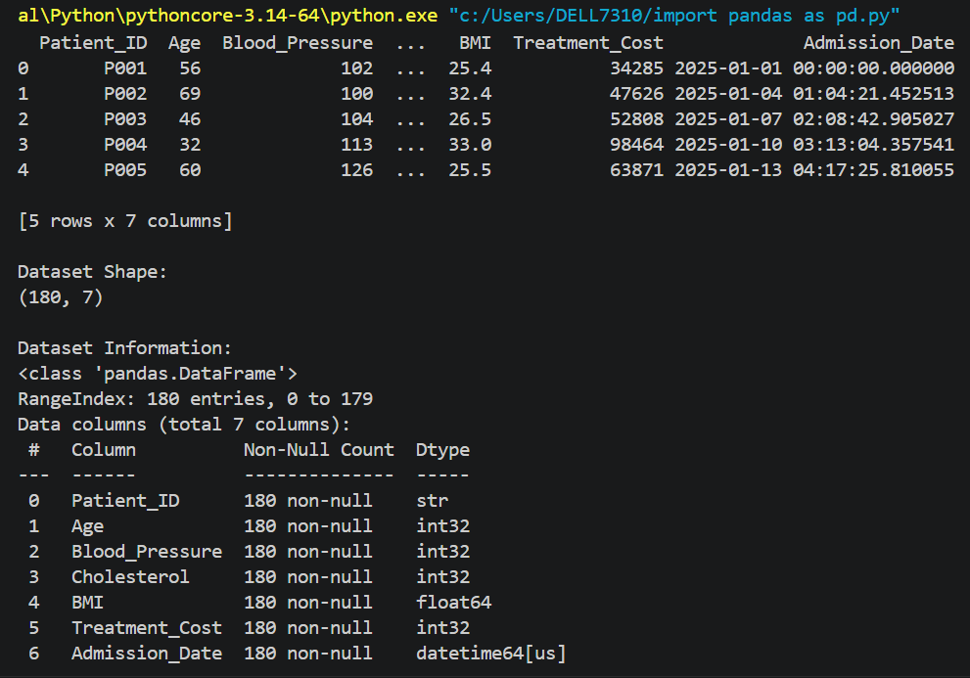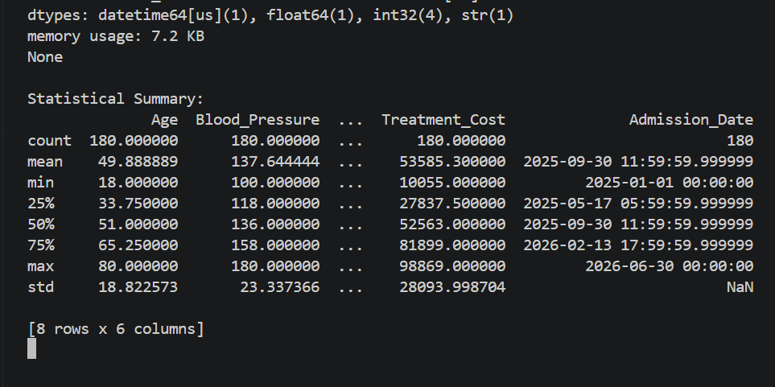

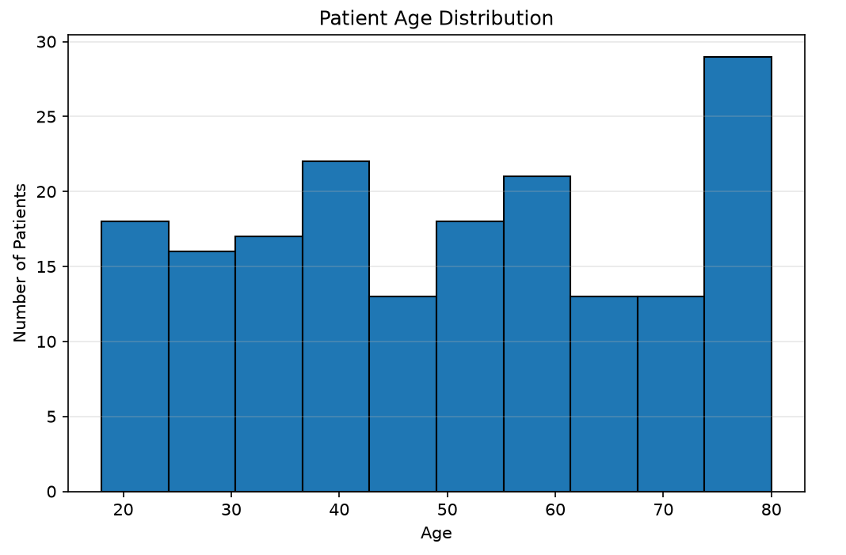
G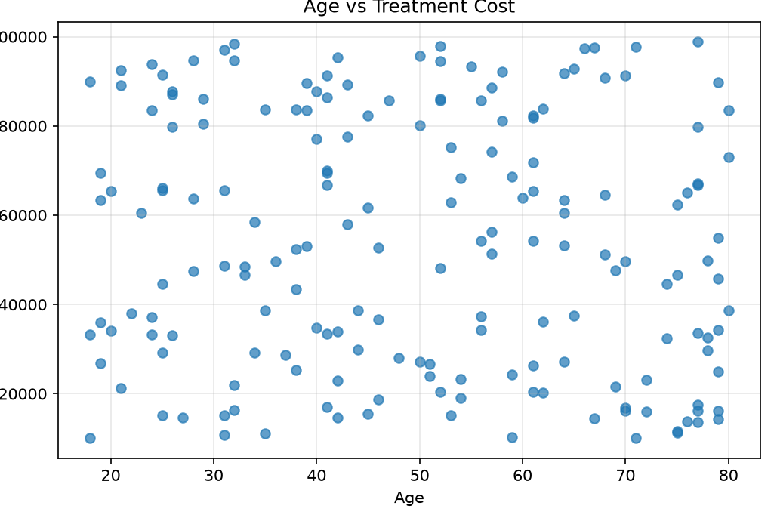
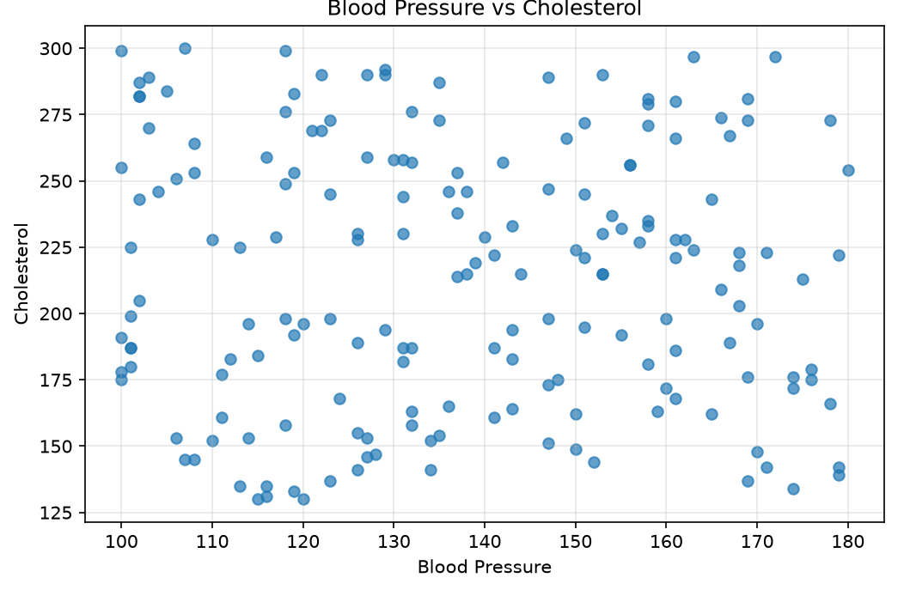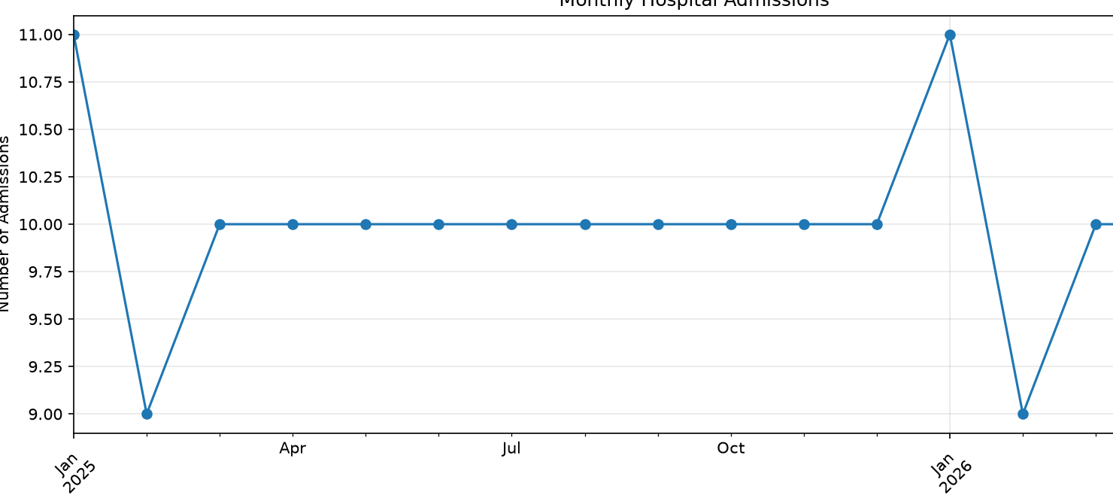
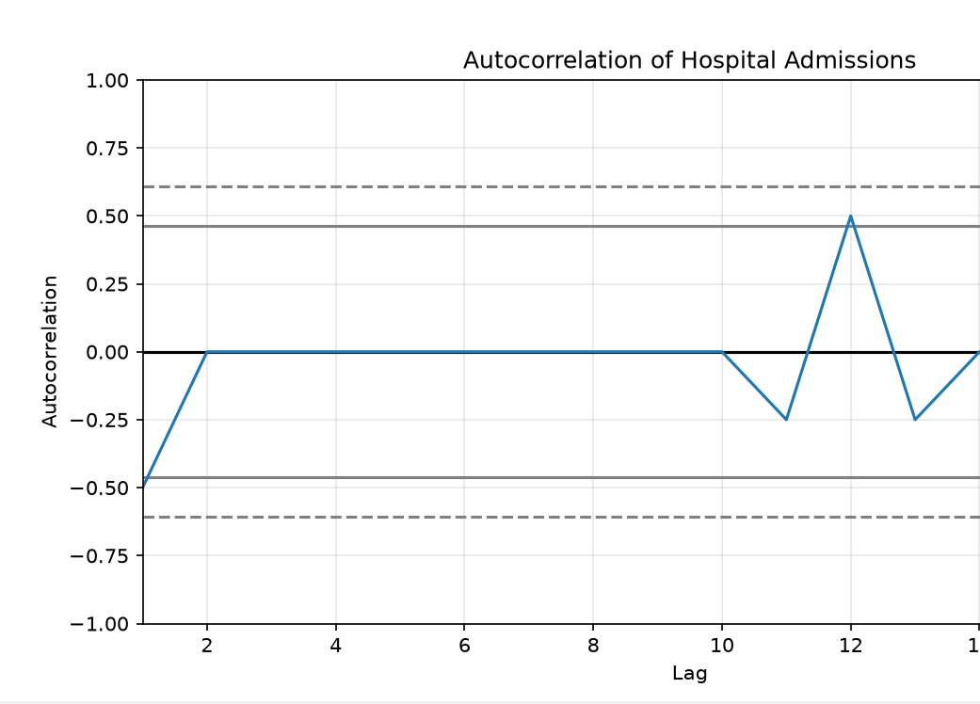
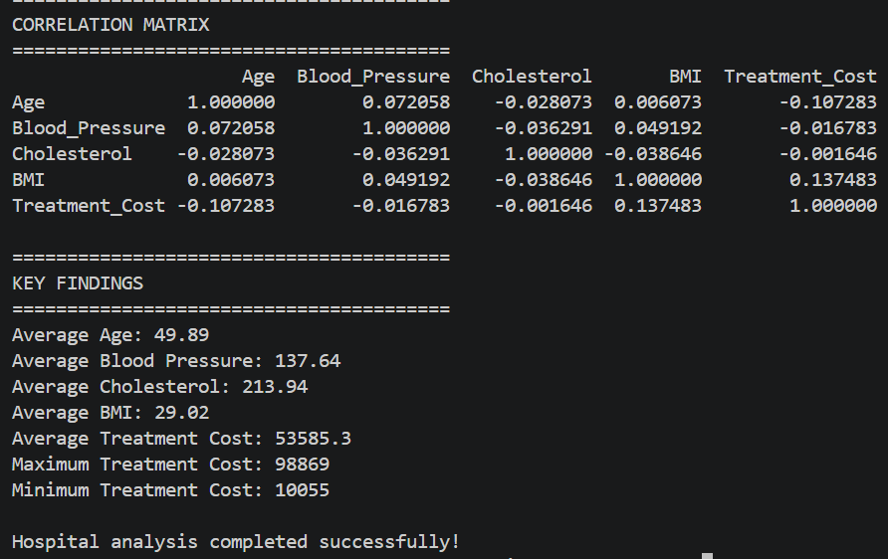

Dashboard conclusion
The hospital dashboard can be used to identify:
- The most common patient age group.
- Typical blood pressure, cholesterol and BMI ranges.
- The relationship between patient characteristics and treatment costs.
- Months with unusually high hospital admissions.
- Whether admission patterns repeat periodically.
- Possible outliers in health measurements and treatment costs.

Q2. Stock Market Pattern Analysis Dashboard

Dataset columns
Column | Description
Date | Trading date
Open | Opening price
Close | Closing price
High | Highest price
Low | Lowest price
Volume | Trading volume

Required visualizations
- Closing Price Evolution
  - Line chart
  - Shows stock price movement over time.
- Opening vs Closing Price
  - Line/scatter plot
  - Compares opening and closing prices.
- Daily Trading Range
  - High - Low
  - Shows daily price volatility.
- Price Distribution
  - Histogram
  - Shows the distribution of closing prices.
- Trading Volume Distribution
  - Histogram
  - Shows common trading-volume levels.
- Price vs Volume
  - Scatter plot
  - Determines whether high trading volume is associated with price movements.
- Open vs Close Relationship
  - Scatter plot
  - Examines the relationship between opening and closing prices.
- Pandas Plot
  - Use Pandas .plot() for time-series visualization.
- Lag Plot
  - Compares today's closing price with the previous trading day's price.
- Autocorrelation Plot
- Determines whether today's price depends on previous prices.
- Bootstrap Analysis
- Repeatedly samples returns to estimate uncertainty around the mean return.

Python implementation
import pandas as pd
import numpy as np
import matplotlib.pyplot as plt
from pandas.plotting import lag_plot, autocorrelation_plot

# =========================================================
# STOCK MARKET DATASET - CREATED INSIDE THE CODE
# =========================================================

np.random.seed(123)

n = 300

# Generate trading dates
dates = pd.bdate_range(
start="2025-01-01",
periods=n
)

# Generate stock prices
initial_price = 150

daily_returns = np.random.normal(
loc=0.0005,
scale=0.018,
size=n
)

closing_prices = (
initial_price *
np.cumprod(1 + daily_returns)
)

# Opening prices
opening_prices = closing_prices * (
1 + np.random.normal(0, 0.006, n)
)

# High prices
high_prices = np.maximum(
opening_prices,
closing_prices
) * (
1 + np.abs(
np.random.normal(0, 0.012, n)
)
)

# Low prices
low_prices = np.minimum(
opening_prices,
closing_prices
) * (
1 - np.abs(
np.random.normal(0, 0.012, n)
)
)

# Trading volume
volume = np.random.lognormal(
mean=np.log(2000000),
sigma=0.35,
size=n
).astype(int)

# Create DataFrame
df = pd.DataFrame({

"Date": dates,

"Open": np.round(
opening_prices, 2
),

"High": np.round(
high_prices, 2
),

"Low": np.round(
low_prices, 2
),

"Close": np.round(
closing_prices, 2
),

"Volume": volume
})

# Save dataset
df.to_csv(
"stock_data.csv",
index=False
)

# Set Date as index
df.set_index(
"Date",
inplace=True
)

print("========================================")
print("STOCK DATASET CREATED")
print("========================================")

print(df.head())

print("\nDataset Shape:")
print(df.shape)

print("\nStatistical Summary:")
print(df.describe())

# =========================================================
# 1. STOCK PRICE EVOLUTION
# =========================================================

plt.figure(figsize=(12, 5))

df["Close"].plot()

plt.title(
"Stock Closing Price Evolution"
)

plt.xlabel("Date")
plt.ylabel("Closing Price")

plt.grid(alpha=0.3)

plt.show()

# =========================================================
# 2. OPENING VS CLOSING PRICE
# =========================================================

plt.figure(figsize=(12, 5))

plt.plot(
df.index,
df["Open"],
label="Open"
)

plt.plot(
df.index,
df["Close"],
label="Close"
)

plt.title(
"Opening vs Closing Price"
)

plt.xlabel("Date")
plt.ylabel("Price")

plt.legend()

plt.grid(alpha=0.3)

plt.show()

# =========================================================
# 3. HIGH AND LOW PRICE
# =========================================================

plt.figure(figsize=(12, 5))

plt.plot(
df.index,
df["High"],
label="High"
)

plt.plot(
df.index,
df["Low"],
label="Low"
)

plt.title(
"Daily High and Low Prices"
)

plt.xlabel("Date")
plt.ylabel("Price")

plt.legend()

plt.grid(alpha=0.3)

plt.show()

# =========================================================
# 4. CLOSING PRICE DISTRIBUTION
# =========================================================

plt.figure(figsize=(8, 5))

plt.hist(
df["Close"],
bins=25,
edgecolor="black"
)

plt.title(
"Closing Price Distribution"
)

plt.xlabel("Closing Price")
plt.ylabel("Frequency")

plt.grid(axis="y", alpha=0.3)

plt.show()

# =========================================================
# 5. TRADING VOLUME DISTRIBUTION
# =========================================================

plt.figure(figsize=(8, 5))

plt.hist(
df["Volume"],
bins=25,
edgecolor="black"
)

plt.title(
"Trading Volume Distribution"
)

plt.xlabel("Trading Volume")
plt.ylabel("Frequency")

plt.grid(axis="y", alpha=0.3)

plt.show()

# =========================================================
# 6. PRICE VS VOLUME
# =========================================================

plt.figure(figsize=(8, 5))

plt.scatter(
df["Volume"],
df["Close"],
alpha=0.6
)

plt.title(
"Trading Volume vs Closing Price"
)

plt.xlabel("Trading Volume")
plt.ylabel("Closing Price")

plt.grid(alpha=0.3)

plt.show()

# =========================================================
# 7. OPEN VS CLOSE RELATIONSHIP
# =========================================================

plt.figure(figsize=(8, 5))

plt.scatter(
df["Open"],
df["Close"],
alpha=0.6
)

plt.title(
"Opening Price vs Closing Price"
)

plt.xlabel("Opening Price")
plt.ylabel("Closing Price")

plt.grid(alpha=0.3)

plt.show()

# =========================================================
# 8. DAILY PRICE RANGE
# =========================================================

df["Daily_Range"] = (
df["High"] -
df["Low"]
)

plt.figure(figsize=(12, 5))

df["Daily_Range"].plot()

plt.title(
"Daily Stock Price Range"
)

plt.xlabel("Date")
plt.ylabel("High - Low")

plt.grid(alpha=0.3)

plt.show()

# =========================================================
# 9. DAILY RETURNS
# =========================================================

df["Returns"] = (
df["Close"].pct_change()
)

plt.figure(figsize=(8, 5))

plt.hist(
df["Returns"].dropna(),
bins=30,
edgecolor="black"
)

plt.title(
"Distribution of Daily Returns"
)

plt.xlabel("Daily Return")
plt.ylabel("Frequency")

plt.grid(axis="y", alpha=0.3)

plt.show()

# =========================================================
# 10. LAG PLOT
# =========================================================

close_data = df["Close"].dropna()

plt.figure(figsize=(7, 5))

lag_plot(
close_data
)

plt.title(
"Lag Plot of Closing Prices"
)

plt.xlabel(
"Previous Closing Price"
)

plt.ylabel(
"Current Closing Price"
)

plt.grid(alpha=0.3)

plt.show()

# =========================================================
# 11. AUTOCORRELATION PLOT
# =========================================================

plt.figure(figsize=(10, 5))

autocorrelation_plot(
close_data
)

plt.title(
"Autocorrelation of Closing Prices"
)

plt.xlabel("Lag")

plt.ylabel("Autocorrelation")

plt.grid(alpha=0.3)

plt.show()

# =========================================================
# 12. BOOTSTRAP ANALYSIS
# =========================================================

returns = (
df["Returns"]
.dropna()
.values
)

bootstrap_means = []

for i in range(1000):

sample = np.random.choice(
returns,
size=len(returns),
replace=True
)

bootstrap_means.append(
sample.mean()
)

bootstrap_means = np.array(
bootstrap_means
)

# Bootstrap distribution
plt.figure(figsize=(8, 5))

plt.hist(
bootstrap_means,
bins=30,
edgecolor="black"
)

plt.title(
"Bootstrap Distribution of Mean Daily Return"
)

plt.xlabel(
"Mean Daily Return"
)

plt.ylabel(
"Frequency"
)

plt.grid(axis="y", alpha=0.3)

plt.show()

# =========================================================
# 13. BOOTSTRAP CONFIDENCE INTERVAL
# =========================================================

lower = np.percentile(
bootstrap_means,
2.5
)

upper = np.percentile(
bootstrap_means,
97.5
)

print("\n========================================")
print("BOOTSTRAP ANALYSIS")
print("========================================")

print(
"Mean Daily Return:",
round(returns.mean(), 6)
)

print(
"95% Confidence Interval:"
)

print(
"Lower:",
round(lower, 6)
)

print(
"Upper:",
round(upper, 6)
)

# =========================================================
# 14. CORRELATION ANALYSIS
# =========================================================

correlation = df[
[
"Open",
"High",
"Low",
"Close",
"Volume"
]
].corr()

print("\n========================================")
print("STOCK CORRELATION MATRIX")
print("========================================")

print(correlation)

# =========================================================
# FINAL FINDINGS
# =========================================================

print("\n========================================")
print("KEY FINDINGS")
print("========================================")

print(
"Average Closing Price:",
round(df["Close"].mean(), 2)
)

print(
"Maximum Closing Price:",
round(df["Close"].max(), 2)
)

print(
"Minimum Closing Price:",
round(df["Close"].min(), 2)
)

print(
"Average Trading Volume:",
round(df["Volume"].mean(), 0)
)

print(
"Average Daily Return:",
round(df["Returns"].mean(), 6)
)

print("\nStock analysis completed successfully!")

OUTPUTS:

