

SIMATS ENGINEERING

Saveetha Institute of Medical and Technical Sciences
Chennai- 602105

NAME: B. JAI SRINIVASAN
REG. NO: 192524151
COURSE CODE: DSA0502
COURSE: QUERY PROCESSING
CO2 – AT1

SCENARIO 1
Hospital Patient Record Management System:
A multi-specialty hospital receives thousands of patients every month. Currently, patient records are maintained manually, making it difficult to track patient history, doctor consultations, prescriptions, laboratory tests, and billing information. The hospital management wants a database-driven application that can store patient details, doctor information, appointments, treatment records, and payment details. Each patient may visit multiple doctors over time, and doctors may consult many patients. Laboratory tests and prescriptions must also be linked to patient records. The system should provide quick access to patient histories and generate reports on disease trends and doctor workloads. Design a relational database schema for this system and use Python SQL libraries to connect to the database and manage patient information efficiently.
CODE:
import sqlite3
# Connect to SQLite Database
conn = sqlite3.connect("hospital.db")
cursor = conn.cursor()
# -------------------------
# Create Tables
# -------------------------
cursor.execute("""
CREATE TABLE IF NOT EXISTS Patient(
patient_id INTEGER PRIMARY KEY,
name TEXT,
age INTEGER,
gender TEXT,
phone TEXT,
address TEXT
)
""")
cursor.execute("""
CREATE TABLE IF NOT EXISTS Doctor(
doctor_id INTEGER PRIMARY KEY,
name TEXT,
specialization TEXT,
phone TEXT
)
""")
cursor.execute("""
CREATE TABLE IF NOT EXISTS Appointment(
appointment_id INTEGER PRIMARY KEY,
patient_id INTEGER,
doctor_id INTEGER,
appointment_date TEXT,
diagnosis TEXT,
FOREIGN KEY(patient_id) REFERENCES Patient(patient_id),
FOREIGN KEY(doctor_id) REFERENCES Doctor(doctor_id)
)
""")
cursor.execute("""
CREATE TABLE IF NOT EXISTS Prescription(
prescription_id INTEGER PRIMARY KEY,
appointment_id INTEGER,
medicine TEXT,
dosage TEXT,
FOREIGN KEY(appointment_id) REFERENCES Appointment(appointment_id)
)
""")
cursor.execute("""
CREATE TABLE IF NOT EXISTS LabTest(
test_id INTEGER PRIMARY KEY,
appointment_id INTEGER,
test_name TEXT,
result TEXT,
FOREIGN KEY(appointment_id) REFERENCES Appointment(appointment_id)
)
""")
cursor.execute("""
CREATE TABLE IF NOT EXISTS Payment(
payment_id INTEGER PRIMARY KEY,
appointment_id INTEGER,
amount REAL,
payment_date TEXT,
status TEXT,
FOREIGN KEY(appointment_id) REFERENCES Appointment(appointment_id)
)
""")
# -------------------------
# Insert Sample Data
# -------------------------
cursor.execute("INSERT INTO Patient VALUES (1,'Rahul',25,'Male','9876543210','Chennai')")
cursor.execute("INSERT INTO Patient VALUES (2,'Priya',30,'Female','9876543222','Madurai')")

cursor.execute("INSERT INTO Doctor VALUES (101,'Dr. Kumar','Cardiologist','9000011111')")
cursor.execute("INSERT INTO Doctor VALUES (102,'Dr. Meena','Neurologist','9000022222')")

cursor.execute("INSERT INTO Appointment VALUES (201,1,101,'2026-08-01','High Blood Pressure')")
cursor.execute("INSERT INTO Appointment VALUES (202,2,102,'2026-08-02','Migraine')")

cursor.execute("INSERT INTO Prescription VALUES (301,201,'Amlodipine','5 mg Daily')")
cursor.execute("INSERT INTO Prescription VALUES (302,202,'Paracetamol','500 mg Twice Daily')")

cursor.execute("INSERT INTO LabTest VALUES (401,201,'Blood Pressure','150/95')")
cursor.execute("INSERT INTO LabTest VALUES (402,202,'MRI Brain','Normal')")

cursor.execute("INSERT INTO Payment VALUES (501,201,1500,'2026-08-01','Paid')")
cursor.execute("INSERT INTO Payment VALUES (502,202,2200,'2026-08-02','Pending')")

conn.commit()

# -------------------------
# Display Patient History
# -------------------------
print("\nPATIENT HISTORY\n")
query = """
SELECT Patient.name,
Doctor.name,
Appointment.appointment_date,
Appointment.diagnosis,
Prescription.medicine,
LabTest.test_name,
Payment.amount,
Payment.status
FROM Appointment
JOIN Patient
ON Appointment.patient_id=Patient.patient_id
JOIN Doctor
ON Appointment.doctor_id=Doctor.doctor_id

JOIN Prescription
ON Appointment.appointment_id=Prescription.appointment_id

JOIN LabTest
ON Appointment.appointment_id=LabTest.appointment_id

JOIN Payment
ON Appointment.appointment_id=Payment.appointment_id
"""
cursor.execute(query)
rows = cursor.fetchall()
for row in rows:
print("Patient :", row[0])
print("Doctor :", row[1])
print("Date :", row[2])
print("Disease :", row[3])
print("Medicine:", row[4])
print("Lab Test:", row[5])
print("Bill :", row[6])
print("Status :", row[7])
print("--------------------------")

conn.close()

OUTPUT:

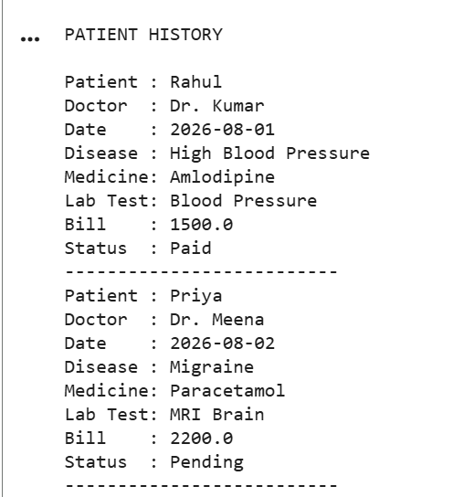

SCENARIO 2
Food Delivery Application:
A food delivery platform connects customers, restaurants, and delivery agents through a mobile application. Customers place orders from different restaurants, while delivery agents deliver food to specified locations. Restaurants maintain menus and pricing information. The platform must track orders, delivery status, payments, and customer feedback. Management wants analytical reports on popular restaurants, peak ordering times, and delivery performance. Design a database containing tables for customers, restaurants, menu items, orders, delivery agents, and payments. Implement Python-based CRUD operations to manage customer orders and delivery records.
CODE:
import sqlite3
# Connect to Database
conn = sqlite3.connect("food_delivery.db")
cursor = conn.cursor()

# -----------------------------
# Create Tables
# -----------------------------
cursor.execute("""
CREATE TABLE IF NOT EXISTS Customer(
customer_id INTEGER PRIMARY KEY,
name TEXT,
phone TEXT,
address TEXT
)
""")
cursor.execute("""
CREATE TABLE IF NOT EXISTS Restaurant(
restaurant_id INTEGER PRIMARY KEY,
name TEXT,
location TEXT
)
""")
cursor.execute("""
CREATE TABLE IF NOT EXISTS MenuItem(
menu_id INTEGER PRIMARY KEY,
restaurant_id INTEGER,
item_name TEXT,
price REAL,
FOREIGN KEY(restaurant_id) REFERENCES Restaurant(restaurant_id)
)
""")
cursor.execute("""
CREATE TABLE IF NOT EXISTS DeliveryAgent(
agent_id INTEGER PRIMARY KEY,
name TEXT,
phone TEXT
)
""")
cursor.execute("""
CREATE TABLE IF NOT EXISTS Orders(
order_id INTEGER PRIMARY KEY,
customer_id INTEGER,
restaurant_id INTEGER,
menu_id INTEGER,
agent_id INTEGER,
order_date TEXT,
quantity INTEGER,
delivery_status TEXT,
FOREIGN KEY(customer_id) REFERENCES Customer(customer_id),
FOREIGN KEY(restaurant_id) REFERENCES Restaurant(restaurant_id),
FOREIGN KEY(menu_id) REFERENCES MenuItem(menu_id),
FOREIGN KEY(agent_id) REFERENCES DeliveryAgent(agent_id)
)
""")
cursor.execute("""
CREATE TABLE IF NOT EXISTS Payment(
payment_id INTEGER PRIMARY KEY,
order_id INTEGER,
amount REAL,
payment_mode TEXT,
payment_status TEXT,
FOREIGN KEY(order_id) REFERENCES Orders(order_id)
)
""")
cursor.execute("""
CREATE TABLE IF NOT EXISTS Feedback(
feedback_id INTEGER PRIMARY KEY,
order_id INTEGER,
rating INTEGER,
comments TEXT,
FOREIGN KEY(order_id) REFERENCES Orders(order_id)
)
""")
# -----------------------------
# Insert Sample Data
# -----------------------------
cursor.execute("INSERT INTO Customer VALUES(1,'Rahul','9876543210','Chennai')")
cursor.execute("INSERT INTO Customer VALUES(2,'Priya','9876543222','Coimbatore')")
cursor.execute("INSERT INTO Restaurant VALUES(101,'Pizza Palace','Chennai')")
cursor.execute("INSERT INTO Restaurant VALUES(102,'Burger Hub','Coimbatore')")
cursor.execute("INSERT INTO MenuItem VALUES(201,101,'Veg Pizza',350)")
cursor.execute("INSERT INTO MenuItem VALUES(202,102,'Cheese Burger',180)")
cursor.execute("INSERT INTO DeliveryAgent VALUES(301,'Arun','9000011111')")
cursor.execute("INSERT INTO DeliveryAgent VALUES(302,'Kiran','9000022222')")
cursor.execute("INSERT INTO Orders VALUES(401,1,101,201,301,'2026-08-01',2,'Delivered')")
cursor.execute("INSERT INTO Orders VALUES(402,2,102,202,302,'2026-08-01',1,'Out for Delivery')")
cursor.execute("INSERT INTO Payment VALUES(501,401,700,'UPI','Paid')")
cursor.execute("INSERT INTO Payment VALUES(502,402,180,'Cash','Pending')")
cursor.execute("INSERT INTO Feedback VALUES(601,401,5,'Excellent Food')")
cursor.execute("INSERT INTO Feedback VALUES(602,402,4,'Fast Delivery')")
conn.commit()
# -----------------------------------
# CRUD OPERATIONS
# -----------------------------------
# CREATE
print("\nNEW ORDER ADDED")
cursor.execute("""
INSERT INTO Orders
VALUES(403,1,102,202,302,'2026-08-02',3,'Preparing')
""")
conn.commit()
# READ
print("\nORDER DETAILS\n")
query="""
SELECT Customer.name,
Restaurant.name,
MenuItem.item_name,
Orders.quantity,
DeliveryAgent.name,
Orders.delivery_status,
Payment.amount,
Payment.payment_status
FROM Orders
JOIN Customer
ON Orders.customer_id=Customer.customer_id
JOIN Restaurant
ON Orders.restaurant_id=Restaurant.restaurant_id
JOIN MenuItem
ON Orders.menu_id=MenuItem.menu_id

JOIN DeliveryAgent
ON Orders.agent_id=DeliveryAgent.agent_id
LEFT JOIN Payment
ON Orders.order_id=Payment.order_id
"""
cursor.execute(query)
rows=cursor.fetchall()
for row in rows:
print("Customer :",row[0])
print("Restaurant :",row[1])
print("Food Item :",row[2])
print("Quantity :",row[3])
print("Delivery Agent :",row[4])
print("Status :",row[5])
print("Amount :",row[6])
print("Payment :",row[7])
print("---------------------------")
# UPDATE
cursor.execute("""
UPDATE Orders
SET delivery_status='Delivered'
WHERE order_id=402
""")
conn.commit()
print("\nOrder 402 Updated Successfully\n")
# DELETE
cursor.execute("""
DELETE FROM Feedback
WHERE feedback_id=602
"""
conn.commit()
print("Feedback Deleted Successfully")
conn.close()
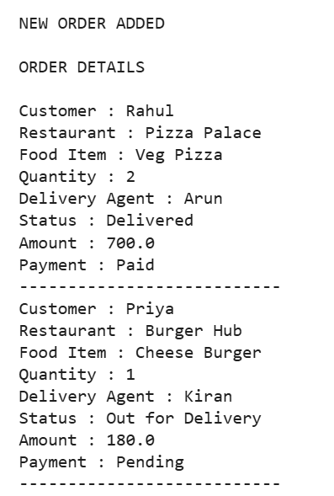
OUTPUT:
