

SIMATS ENGINEERING

Saveetha Institute of Medical and Technical Sciences
Chennai- 602105

Name: B. JAI SRINIVASAN
Reg no: 192524151
Course Code: DSA0502
Course: QUERY PROCESSING

SET - 10
19.Write a Pandas program to display the dimensions or shape of the World alcohol consumption dataset. Also extract the column names from the dataset.
CODE:
import pandas as pd

# Built-in dataset
data = {
"Year": [2010, 2011, 2012, 2013, 2014],
"Country": ["India", "USA", "France", "Japan", "Brazil"],
"Beer": [2.5, 3.2, 4.1, 2.8, 3.5],
"Wine": [1.2, 2.4, 3.5, 2.1, 1.8],
"Spirits": [1.5, 2.1, 2.8, 1.9, 2.3],
"Total_Alcohol": [5.2, 7.7, 10.4, 6.8, 7.6]
}

# Create DataFrame
df = pd.DataFrame(data)

# Display dataset
print("World Alcohol Consumption Dataset:")
print(df)

# Display shape
print("\nShape of the dataset:", df.shape)

# Display number of rows and columns
print("Number of rows:", df.shape[0])
print("Number of columns:", df.shape[1])

# Display column names
print("\nColumn Names:")
print(df.columns.tolist())

OUTPUT:
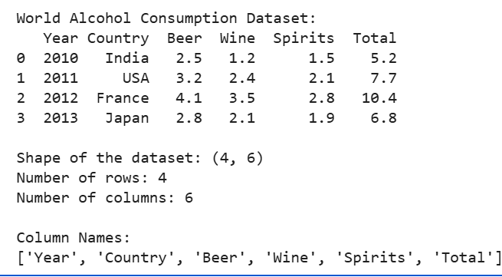

20. Write a Pandas program to find the index of a given substring of a
DataFrame column.

CODE:
import pandas as pd

# Built-in dataset
data = {
"Country": ["India", "United States", "France", "Japan", "Brazil"],
"Beer": [2.5, 3.2, 4.1, 2.8, 3.5],
"Wine": [1.2, 2.4, 3.5, 2.1, 1.8]
}

# Create DataFrame
df = pd.DataFrame(data)

print("Dataset:")
print(df)

# Given substring
substring = "Japan"

# Find index of rows containing the substring
index = df[df["Country"].str.contains(substring, case=False, na=False)].index

print("\nIndex of substring 'Japan':")
print(index.tolist())

OUTPUT:
