

SIMATS ENGINEERING

Saveetha Institute of Medical and Technical Sciences
Chennai- 602105

NAME: B. JAI SRINIVASAN
REG. NO: 192524151
COURSE CODE: DSA0502
COURSE: QUERY PROCESSING
CO3 – AT3

Question 5 – Healthcare Patient Dataset Integration
A hospital stores patient information in Registration, Laboratory, and Billing datasets. Patient names may contain spelling errors, phone numbers use different formats, emails may be invalid, dates have different formats, and duplicate patient records exist across departments.
Task: Develop a Python program to clean and integrate the three datasets. Identify bad data and missing values, validate fields using RegEx, detect duplicates, perform fuzzy matching, standardize dates and categorical values, identify numerical outliers, and merge the datasets. Save the final cleaned dataset and create a script that can be tested on newly received patient data.

DATASETS
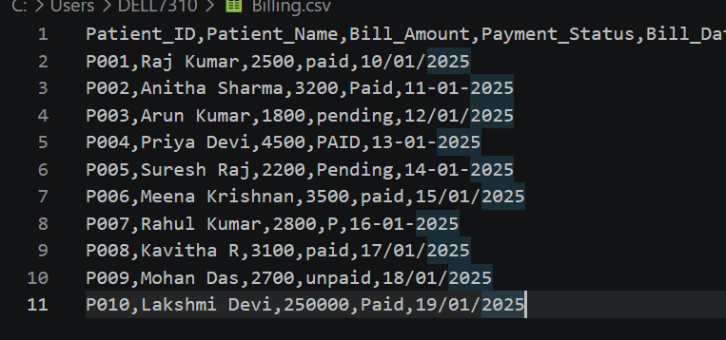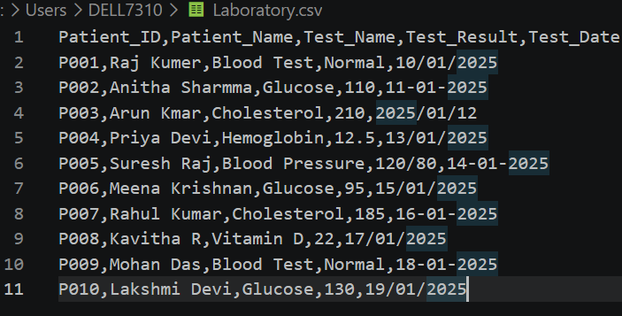
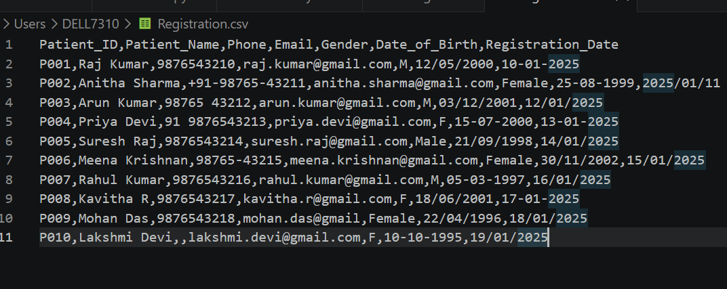
PYTHON CODE
import pandas as pd
import numpy as np
import re
from difflib import SequenceMatcher

# ============================================================
# HEALTHCARE PATIENT DATASET INTEGRATION
# ============================================================

print("=" * 70)
print(" HEALTHCARE PATIENT DATASET INTEGRATION")
print("=" * 70)

# ============================================================
# 1. LOAD DATASETS
# ============================================================

registration = pd.read_csv("Registration.csv")
laboratory = pd.read_csv("Laboratory.csv")
billing = pd.read_csv("Billing.csv")

print("\n1. DATASETS LOADED")
print("----------------------------")
print("Registration:", registration.shape)
print("Laboratory :", laboratory.shape)
print("Billing :", billing.shape)

# ============================================================
# 2. CLEAN COLUMN NAMES
# ============================================================

def clean_column_names(df):

df.columns = (
df.columns
.str.strip()
.str.lower()
.str.replace(" ", "_")
)

return df

registration = clean_column_names(registration)
laboratory = clean_column_names(laboratory)
billing = clean_column_names(billing)

print("\n2. COLUMN NAMES STANDARDIZED")

# ============================================================
# 3. IDENTIFY MISSING VALUES
# ============================================================

print("\n" + "=" * 70)
print("3. MISSING VALUE ANALYSIS")
print("=" * 70)

print("\nRegistration Missing Values:")
print(registration.isnull().sum())

print("\nLaboratory Missing Values:")
print(laboratory.isnull().sum())

print("\nBilling Missing Values:")
print(billing.isnull().sum())

# ============================================================
# 4. DETECT DUPLICATES
# ============================================================

print("\n" + "=" * 70)
print("4. DUPLICATE ANALYSIS")
print("=" * 70)

print(
"Registration duplicates:",
registration.duplicated().sum()
)

print(
"Laboratory duplicates:",
laboratory.duplicated().sum()
)

print(
"Billing duplicates:",
billing.duplicated().sum()
)

# Remove exact duplicate rows
registration = registration.drop_duplicates()
laboratory = laboratory.drop_duplicates()
billing = billing.drop_duplicates()

# ============================================================
# 5. CLEAN PATIENT NAMES
# ============================================================

def clean_name(name):

if pd.isna(name):
return np.nan

name = str(name).strip()

name = re.sub(
r"[^A-Za-z\s]",
"",
name
)

name = re.sub(
r"\s+",
" ",
name
)

return name.title()

registration["patient_name"] = (
registration["patient_name"]
.apply(clean_name)
)

laboratory["patient_name"] = (
laboratory["patient_name"]
.apply(clean_name)
)

billing["patient_name"] = (
billing["patient_name"]
.apply(clean_name)
)

print("\n5. PATIENT NAMES CLEANED")

# ============================================================
# 6. PHONE NUMBER REGEX VALIDATION
# ============================================================

def clean_phone(phone):

if pd.isna(phone):
return np.nan

phone = str(phone)

# Remove +, -, spaces, etc.
phone = re.sub(
r"\D",
"",
phone
)

# Remove Indian country code
if phone.startswith("91") and len(phone) == 12:
phone = phone[2:]

# Validate 10-digit Indian mobile number
if re.fullmatch(
r"[6-9]\d{9}",
phone
):
return phone

return np.nan

registration["phone"] = (
registration["phone"]
.apply(clean_phone)
)

print("\n6. PHONE NUMBERS VALIDATED USING REGEX")

print(
registration[
["patient_id", "phone"]
].to_string(index=False)
)

# ============================================================
# 7. EMAIL REGEX VALIDATION
# ============================================================

def clean_email(email):

if pd.isna(email):
return np.nan

email = str(email).strip().lower()

pattern = (
r"^[a-zA-Z0-9._%+-]+"
r"@[a-zA-Z0-9.-]+"
r"\.[a-zA-Z]{2,}$"
)

if re.fullmatch(pattern, email):
return email

return np.nan

registration["email"] = (
registration["email"]
.apply(clean_email)
)

print("\n7. EMAIL ADDRESSES VALIDATED USING REGEX")

print(
registration[
["patient_id", "email"]
].to_string(index=False)
)

# ============================================================
# 8. STANDARDIZE DATES
# ============================================================

def standardize_date(date):

if pd.isna(date):
return pd.NaT

return pd.to_datetime(
date,
errors="coerce",
dayfirst=True
)

registration["date_of_birth"] = (
registration["date_of_birth"]
.apply(standardize_date)
)

registration["registration_date"] = (
registration["registration_date"]
.apply(standardize_date)
)

laboratory["test_date"] = (
laboratory["test_date"]
.apply(standardize_date)
)

billing["bill_date"] = (
billing["bill_date"]
.apply(standardize_date)
)

print("\n8. DATES STANDARDIZED")

# ============================================================
# 9. STANDARDIZE GENDER
# ============================================================

registration["gender"] = (
registration["gender"]
.astype(str)
.str.strip()
.str.lower()
.replace({

"m": "Male",
"male": "Male",

"f": "Female",
"female": "Female",

"o": "Other",
"other": "Other"
})
)

print("\n9. GENDER STANDARDIZED")

# ============================================================
# 10. STANDARDIZE PAYMENT STATUS
# ============================================================

billing["payment_status"] = (
billing["payment_status"]
.astype(str)
.str.strip()
.str.lower()
.replace({

"paid": "Paid",
"p": "Paid",

"pending": "Pending",
"unpaid": "Pending",
"un-paid": "Pending"
})
)

print("\n10. PAYMENT STATUS STANDARDIZED")

# ============================================================
# 11. FUZZY MATCHING
# ============================================================

def similarity(name1, name2):

if pd.isna(name1) or pd.isna(name2):
return 0

return SequenceMatcher(
None,
str(name1).lower(),
str(name2).lower()
).ratio()

def fuzzy_match(
reference_names,
target_name,
threshold=0.80):

if pd.isna(target_name):
return np.nan

best_match = target_name
best_score = 0

for ref_name in reference_names:

score = similarity(
target_name,
ref_name
)

if score > best_score:

best_score = score
best_match = ref_name

if best_score >= threshold:

return best_match

return target_name

# Registration names are the master names
reference_names = (
registration["patient_name"]
.dropna()
.unique()
)

# Laboratory fuzzy matching
laboratory["matched_patient_name"] = (
laboratory["patient_name"]
.apply(
lambda x: fuzzy_match(
reference_names,
x
)
)
)

print("\n" + "=" * 70)
print("11. FUZZY MATCHING - LABORATORY")
print("=" * 70)

print(
laboratory[
[
"patient_name",
"matched_patient_name"
]
].to_string(index=False)
)

# Replace names
laboratory["patient_name"] = (
laboratory["matched_patient_name"]
)

laboratory.drop(
columns=["matched_patient_name"],
inplace=True
)

# ============================================================
# 12. NUMERICAL OUTLIER DETECTION
# ============================================================

print("\n" + "=" * 70)
print("12. NUMERICAL OUTLIER DETECTION")
print("=" * 70)

def find_outliers_iqr(df, column):

values = pd.to_numeric(
df[column],
errors="coerce"
)

Q1 = values.quantile(0.25)
Q3 = values.quantile(0.75)

IQR = Q3 - Q1

lower_limit = Q1 - (1.5 * IQR)
upper_limit = Q3 + (1.5 * IQR)

outliers = df[
(values < lower_limit) |
(values > upper_limit)
]

print("\nQ1:", Q1)
print("Q3:", Q3)
print("IQR:", IQR)
print("Lower Limit:", lower_limit)
print("Upper Limit:", upper_limit)

return outliers

outliers = find_outliers_iqr(
billing,
"bill_amount"
)

print("\nDetected Outliers:")

if not outliers.empty:

print(
outliers.to_string(index=False)
)

else:

print("No outliers found.")

# ============================================================
# 13. HANDLE MISSING VALUES
# ============================================================

print("\n" + "=" * 70)
print("13. HANDLING MISSING VALUES")
print("=" * 70)

registration["gender"] = (
registration["gender"]
.replace("nan", np.nan)
.fillna("Unknown")
)

# ============================================================
# 14. MERGE LABORATORY DATA
# ============================================================

lab_summary = (
laboratory
.groupby("patient_id")
.agg({

"test_name":
lambda x: ", ".join(
x.astype(str)
),

"test_result":
lambda x: ", ".join(
x.astype(str)
)
})
.reset_index()
)

master = registration.merge(
lab_summary,
on="patient_id",
how="left"
)

# ============================================================
# 15. MERGE BILLING DATA
# ============================================================

billing_summary = (
billing
.groupby("patient_id")
.agg({

"bill_amount": "sum",

"payment_status":
lambda x: ", ".join(
x.astype(str)
.unique()
)
})
.reset_index()
)

master = master.merge(
billing_summary,
on="patient_id",
how="left"
)

# ============================================================
# 16. REMOVE DUPLICATE PATIENT IDs
# ============================================================

master = master.drop_duplicates(
subset=["patient_id"]
)

# ============================================================
# 17. STANDARDIZE FINAL DATES
# ============================================================

master["date_of_birth"] = (
pd.to_datetime(
master["date_of_birth"],
errors="coerce"
)
.dt.strftime("%Y-%m-%d")
)

master["registration_date"] = (
pd.to_datetime(
master["registration_date"],
errors="coerce"
)
.dt.strftime("%Y-%m-%d")
)

# ============================================================
# 18. SAVE FINAL DATASET
# ============================================================

master.to_csv(
"final_cleaned_patient_data.csv",
index=False
)

# ============================================================
# 19. DISPLAY FINAL DATASET
# ============================================================

print("\n" + "=" * 70)
print("14. FINAL CLEANED DATASET")
print("=" * 70)

print(
master.to_string(index=False)
)

# ============================================================
# 20. FINAL DATA QUALITY REPORT
# ============================================================

print("\n" + "=" * 70)
print("15. FINAL DATA QUALITY REPORT")
print("=" * 70)

print(
"\nTotal Patients:",
master["patient_id"].nunique()
)

print(
"Total Columns:",
len(master.columns)
)

print(
"Duplicate Patient IDs:",
master["patient_id"].duplicated().sum()
)

print("\nMissing Values:")
print(master.isnull().sum())

print("\n" + "=" * 70)
print("FINAL FILE CREATED:")
print("final_cleaned_patient_data.csv")
print("=" * 70)

OUTPUT
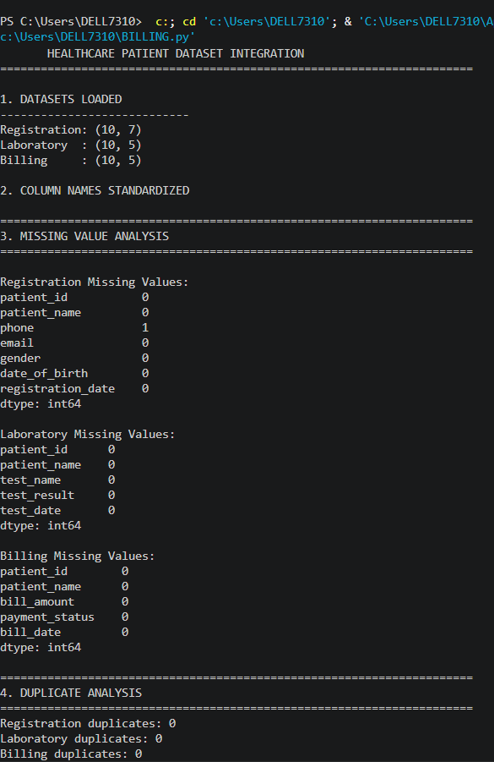
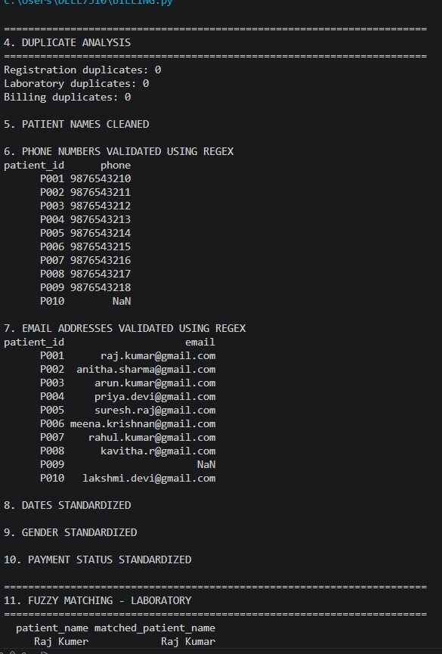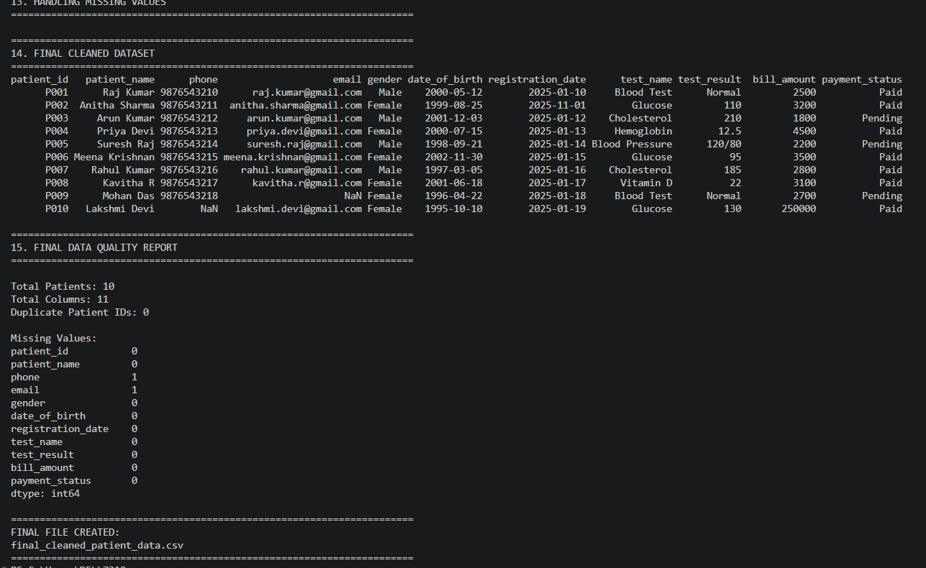

Question 1 – Customer Dataset Integration
Three customer datasets from Online, Retail, and Support systems contain inconsistent names, phone numbers, email addresses, dates, duplicate records, and missing values.
Task: Using Python/Pandas, clean and integrate the datasets by identifying invalid values, formatting data, removing duplicates, applying fuzzy matching and RegEx validation, standardizing fields, and saving the final master dataset in CSV and JSON formats. Create a reusable cleanup script and test it with a new dataset.
PYTHON CODE (WITH DTASET):
import pandas as pd
import numpy as np
import re
from difflib import SequenceMatcher

# ============================================================
# QUESTION 1 - CUSTOMER DATASET INTEGRATION
# ONLINE + RETAIL + SUPPORT
# EXACTLY 10 CUSTOMERS
# ============================================================

print("=" * 75)
print(" CUSTOMER DATASET INTEGRATION")
print("=" * 75)

# ============================================================
# 1. CREATE ONLINE DATASET
# ============================================================

online_data = {
"Customer_ID": [
"C001", "C002", "C003", "C004", "C005",
"C006", "C007", "C008", "C009", "C010"
],

"Customer_Name": [
"Raj Kumar",
"Anitha Sharma",
"Arun Kumar",
"Priya Devi",
"Suresh Raj",
"Meena Krishnan",
"Rahul Kumar",
"Kavitha R",
"Mohan Das",
"Lakshmi Devi"
],

"Phone": [
"9876543210",
"+91-98765-43211",
"98765 43212",
"91 9876543213",
"9876543214",
"98765-43215",
"9876543216",
"9876543217",
"9876543218",
""
],

"Email": [
"raj.kumar@gmail.com",
"anitha.sharma@gmail.com",
"arun.kumar@gmail.com",
"priya.devi@gmail.com",
"suresh.raj@gmail.com",
"meena.krishnan@gmail.com",
"rahul.kumar@gmail.com",
"kavitha.r@gmail.com",
"mohan.das@gmail",
"lakshmi.devi@gmail.com"
],

"Order_Date": [
"10/01/2025",
"11-01-2025",
"2025/01/12",
"13/01/2025",
"14-01-2025",
"15/01/2025",
"16-01-2025",
"17/01/2025",
"18-01-2025",
"19/01/2025"
],

"City": [
"Chennai",
"Chennai",
"Bangalore",
"Coimbatore",
"Madurai",
"Chennai",
"Bangalore",
"Chennai",
"Salem",
"Chennai"
]
}

online = pd.DataFrame(online_data)

# ============================================================
# 2. CREATE RETAIL DATASET
# ============================================================

retail_data = {
"Customer_ID": [
"C001", "C002", "C003", "C004", "C005",
"C006", "C007", "C008", "C009", "C010"
],

"Customer_Name": [
"Raj Kumer",
"Anitha Sharmma",
"Arun Kmar",
"Priya Devi",
"Suresh Raj",
"Meena Krishnan",
"Rahul Kumar",
"Kavitha R",
"Mohan Das",
"Lakshmi Devi"
],

"Phone": [
"98765-43210",
"9876543211",
"9876543212",
"9876543213",
"+91-9876543214",
"9876543215",
"9876543216",
"9876543217",
"9876543218",
"9876543219"
],

"Email": [
"raj.kumar@gmail.com",
"anitha.sharma@gmail.com",
"arun.kumar@gmail.com",
"priya.devi@gmail.com",
"suresh.raj@gmail.com",
"meena.krishnan@gmail.com",
"rahul.kumar@gmail.com",
"kavitha.r@gmail.com",
"mohan.das@gmail.com",
"lakshmi.devi@gmail.com"
],

"Purchase_Date": [
"10-01-2025",
"11/01/2025",
"12-01-2025",
"2025/01/13",
"14/01/2025",
"15-01-2025",
"16/01/2025",
"17-01-2025",
"18/01/2025",
"19-01-2025"
],

"City": [
"Chennai",
"Chennai",
"Bangalore",
"Coimbatore",
"Madurai",
"Chennai",
"Bangalore",
"Chennai",
"Salem",
"Chennai"
]
}

retail = pd.DataFrame(retail_data)

# ============================================================
# 3. CREATE SUPPORT DATASET
# ============================================================

support_data = {
"Customer_ID": [
"C001", "C002", "C003", "C004", "C005",
"C006", "C007", "C008", "C009", "C010"
],

"Customer_Name": [
"Raj Kumar",
"Anitha Sharma",
"Arun Kumar",
"Priya Devi",
"Suresh Raj",
"Meena Krishnan",
"Rahul Kumar",
"Kavitha R",
"Mohan Das",
"Lakshmi Devi"
],

"Phone": [
"9876543210",
"+91 98765 43211",
"98765 43212",
"9876543213",
"9876543214",
"9876543215",
"9876543216",
"9876543217",
"9876543218",
"9876543219"
],

"Email": [
"raj.kumar@gmail.com",
"anitha.sharma@gmail.com",
"arun.kumar@gmail.com",
"priya.devi@gmail.com",
"",
"meena.krishnan@gmail.com",
"rahul.kumar@gmail.com",
"kavitha.r@gmail.com",
"mohan.das@gmail.com",
"lakshmi.devi@gmail.com"
],

"Ticket_Date": [
"10/01/2025",
"11-01-2025",
"12/01/2025",
"13-01-2025",
"14/01/2025",
"15-01-2025",
"16/01/2025",
"17-01-2025",
"18-01-2025",
"19/01/2025"
],

"Issue_Type": [
"Payment",
"Delivery",
"Product",
"Payment",
"Delivery",
"Product",
"Payment",
"Delivery",
"Product",
"Payment"
]
}

support = pd.DataFrame(support_data)

# ============================================================
# 4. DISPLAY ORIGINAL DATASETS
# ============================================================

print("\n" + "=" * 75)
print("ORIGINAL ONLINE DATASET")
print("=" * 75)
print(online.to_string(index=False))

print("\n" + "=" * 75)
print("ORIGINAL RETAIL DATASET")
print("=" * 75)
print(retail.to_string(index=False))

print("\n" + "=" * 75)
print("ORIGINAL SUPPORT DATASET")
print("=" * 75)
print(support.to_string(index=False))

# ============================================================
# 5. SAVE ORIGINAL DATASETS
# ============================================================

online.to_csv("Online.csv", index=False)
retail.to_csv("Retail.csv", index=False)
support.to_csv("Support.csv", index=False)

print("\nOriginal datasets saved successfully.")

# ============================================================
# 6. CLEAN COLUMN NAMES
# ============================================================

def clean_columns(df):

df.columns = (
df.columns
.str.strip()
.str.lower()
.str.replace(" ", "_")
)

return df

online = clean_columns(online)
retail = clean_columns(retail)
support = clean_columns(support)

# ============================================================
# 7. MISSING VALUE ANALYSIS
# ============================================================

print("\n" + "=" * 75)
print("MISSING VALUE ANALYSIS")
print("=" * 75)

print("\nOnline:")
print(online.isnull().sum())

print("\nRetail:")
print(retail.isnull().sum())

print("\nSupport:")
print(support.isnull().sum())

# ============================================================
# 8. DUPLICATE DETECTION
# ============================================================

print("\n" + "=" * 75)
print("DUPLICATE ANALYSIS")
print("=" * 75)

print("Online duplicates:", online.duplicated().sum())
print("Retail duplicates:", retail.duplicated().sum())
print("Support duplicates:", support.duplicated().sum())

online = online.drop_duplicates()
retail = retail.drop_duplicates()
support = support.drop_duplicates()

# ============================================================
# 9. CLEAN CUSTOMER NAMES
# ============================================================

def clean_name(name):

if pd.isna(name):
return np.nan

name = str(name).strip()

name = re.sub(
r"[^A-Za-z\s]",
"",
name
)

name = re.sub(
r"\s+",
" ",
name
)

return name.title()

for df in [online, retail, support]:

df["customer_name"] = (
df["customer_name"]
.apply(clean_name)
)

print("\nCustomer names cleaned.")

# ============================================================
# 10. PHONE NUMBER REGEX VALIDATION
# ============================================================

def clean_phone(phone):

if pd.isna(phone) or str(phone).strip() == "":
return np.nan

phone = str(phone)

# Remove spaces, + and -
phone = re.sub(
r"\D",
"",
phone
)

# Remove Indian country code
if phone.startswith("91") and len(phone) == 12:
phone = phone[2:]

# Validate 10-digit mobile number
if re.fullmatch(
r"[6-9]\d{9}",
phone
):
return phone

return np.nan

for df in [online, retail, support]:

df["phone"] = (
df["phone"]
.apply(clean_phone)
)

print("\nPhone numbers validated using RegEx.")

# ============================================================
# 11. EMAIL REGEX VALIDATION
# ============================================================

def clean_email(email):

if pd.isna(email) or str(email).strip() == "":
return np.nan

email = str(email).strip().lower()

pattern = (
r"^[a-zA-Z0-9._%+-]+"
r"@[a-zA-Z0-9.-]+"
r"\.[a-zA-Z]{2,}$"
)

if re.fullmatch(pattern, email):
return email

return np.nan

for df in [online, retail, support]:

df["email"] = (
df["email"]
.apply(clean_email)
)

print("\nEmail addresses validated using RegEx.")

# ============================================================
# 12. STANDARDIZE DATES
# ============================================================

def standardize_date(date):

if pd.isna(date) or str(date).strip() == "":
return pd.NaT

return pd.to_datetime(
date,
errors="coerce",
dayfirst=True
)

online["order_date"] = (
online["order_date"]
.apply(standardize_date)
)

retail["purchase_date"] = (
retail["purchase_date"]
.apply(standardize_date)
)

support["ticket_date"] = (
support["ticket_date"]
.apply(standardize_date)
)

print("\nDates standardized.")

# ============================================================
# 13. FUZZY MATCHING
# ============================================================

def similarity(name1, name2):

if pd.isna(name1) or pd.isna(name2):
return 0

return SequenceMatcher(
None,
str(name1).lower(),
str(name2).lower()
).ratio()

def fuzzy_match(
reference_names,
target_name,
threshold=0.80):

if pd.isna(target_name):
return np.nan

best_match = target_name
best_score = 0

for ref_name in reference_names:

score = similarity(
target_name,
ref_name
)

if score > best_score:

best_score = score
best_match = ref_name

if best_score >= threshold:
return best_match

return target_name

# Online is the master reference
reference_names = (
online["customer_name"]
.dropna()
.unique()
)

# Retail fuzzy matching
retail["matched_name"] = (
retail["customer_name"]
.apply(
lambda x: fuzzy_match(
reference_names,
x
)
)
)

print("\n" + "=" * 75)
print("FUZZY MATCHING - RETAIL")
print("=" * 75)

print(
retail[
["customer_name", "matched_name"]
].to_string(index=False)
)

retail["customer_name"] = retail["matched_name"]

retail.drop(
columns=["matched_name"],
inplace=True
)

# Support fuzzy matching
support["matched_name"] = (
support["customer_name"]
.apply(
lambda x: fuzzy_match(
reference_names,
x
)
)
)

support["customer_name"] = support["matched_name"]

support.drop(
columns=["matched_name"],
inplace=True
)

# ============================================================
# 14. STANDARDIZE CITY
# ============================================================

for df in [online, retail]:

df["city"] = (
df["city"]
.astype(str)
.str.strip()
.str.title()
)

# ============================================================
# 15. CREATE MASTER DATASET
# ============================================================

master = online[
[
"customer_id",
"customer_name",
"phone",
"email",
"order_date",
"city"
]
].copy()

# ============================================================
# 16. MERGE RETAIL DATA
# ============================================================

retail_summary = (
retail
.groupby("customer_id")
.agg({
"purchase_date": "max",
"city": "first"
})
.reset_index()
)

master = master.merge(
retail_summary,
on="customer_id",
how="left",
suffixes=("", "_retail")
)

# ============================================================
# 17. MERGE SUPPORT DATA
# ============================================================

support_summary = (
support
.groupby("customer_id")
.agg({
"ticket_date": "max",
"issue_type":
lambda x: ", ".join(
x.astype(str).unique()
)
})
.reset_index()
)

master = master.merge(
support_summary,
on="customer_id",
how="left"
)

# ============================================================
# 18. REMOVE DUPLICATE CUSTOMERS
# ============================================================

master = master.drop_duplicates(
subset=["customer_id"]
)

# ============================================================
# 19. HANDLE MISSING VALUES
# ============================================================

master["phone"] = (
master["phone"]
.fillna("Not Available")
)

master["email"] = (
master["email"]
.fillna("Not Available")
)

master["city"] = (
master["city"]
.fillna("Unknown")
)

master["issue_type"] = (
master["issue_type"]
.fillna("No Support Ticket")
)

# ============================================================
# 20. STANDARDIZE FINAL DATE FORMAT
# ============================================================

date_columns = [
"order_date",
"purchase_date",
"ticket_date"
]

for column in date_columns:

master[column] = (
pd.to_datetime(
master[column],
errors="coerce"
)
.dt.strftime("%Y-%m-%d")
)

# ============================================================
# 21. SAVE FINAL MASTER DATASET - CSV
# ============================================================

master.to_csv(
"final_customer_master.csv",
index=False
)

# ============================================================
# 22. SAVE FINAL MASTER DATASET - JSON
# ============================================================

master.to_json(
"final_customer_master.json",
orient="records",
indent=4
)

# ============================================================
# 23. DISPLAY FINAL MASTER DATASET
# ============================================================

print("\n" + "=" * 75)
print("FINAL CUSTOMER MASTER DATASET")
print("=" * 75)

print(
master.to_string(index=False)
)

# ============================================================
# 24. FINAL DATA QUALITY REPORT
# ============================================================

print("\n" + "=" * 75)
print("FINAL DATA QUALITY REPORT")
print("=" * 75)

print(
"\nTotal Customers:",
master["customer_id"].nunique()
)

print(
"Total Columns:",
len(master.columns)
)

print(
"Duplicate Customer IDs:",
master["customer_id"].duplicated().sum()
)

print("\nRemaining Missing Values:")
print(master.isnull().sum())

# ============================================================
# 25. REUSABLE CLEANUP FUNCTION
# ============================================================

def clean_new_customer(customer):

customer = customer.copy()

# Clean name
if "Customer_Name" in customer:

customer["Customer_Name"] = clean_name(
customer["Customer_Name"]
)

# Clean phone
if "Phone" in customer:

customer["Phone"] = clean_phone(
customer["Phone"]
)

# Clean email
if "Email" in customer:

customer["Email"] = clean_email(
customer["Email"]
)

# Standardize date
if "Date" in customer:

customer["Date"] = standardize_date(
customer["Date"]
)

return customer

# ============================================================
# 26. TEST WITH NEW CUSTOMER DATA
# ============================================================

print("\n" + "=" * 75)
print("TESTING NEW CUSTOMER DATA")
print("=" * 75)

new_customer = {
"Customer_ID": "C011",
"Customer_Name": " Karthik@ Kumar ",
"Phone": "+91-98765-55555",
"Email": "KARTHIK.KUMAR@GMAIL.COM",
"Date": "25/01/2025"
}

print("\nBefore Cleaning:")
print(new_customer)

cleaned_customer = clean_new_customer(
new_customer
)

print("\nAfter Cleaning:")
print(cleaned_customer)

# ============================================================
# 27. FINAL MESSAGE
# ============================================================

print("\n" + "=" * 75)
print("FILES CREATED SUCCESSFULLY")
print("=" * 75)

print("""
Online.csv
Retail.csv
Support.csv

final_customer_master.csv
final_customer_master.json
""")

print("=" * 75)
print(" CUSTOMER DATA INTEGRATION COMPLETED")
print("=" * 75)

OUTPUT:
