

SIMATS ENGINEERING

Saveetha Institute of Medical and Technical Sciences
Chennai- 602105

Name: B. JAI SRINIVASAN
Reg no: 192524151
Course Code: DSA0502
Course: QUERY PROCESSING

SET - 13
25.Write a Python program to plot two or more lines with legends, different widths and colors.

CODE:
import matplotlib.pyplot as plt

# Data
x = [1, 2, 3, 4]
y1 = [2, 4, 6, 8]
y2 = [1, 3, 5, 7]
y3 = [5, 7, 6, 8]

# Plot lines
plt.plot(x, y1, color='red', linewidth=2, label='Line 1')
plt.plot(x, y2, color='blue', linewidth=3, label='Line 2')
plt.plot(x, y3, color='green', linewidth=4, label='Line 3')

# Labels and title
plt.xlabel("X-axis")
plt.ylabel("Y-axis")
plt.title("Multiple Lines with Different Widths and Colors")

# Display legend
plt.legend()

# Display grid
plt.grid(True)

# Show graph
plt.show()

OUTPUT:
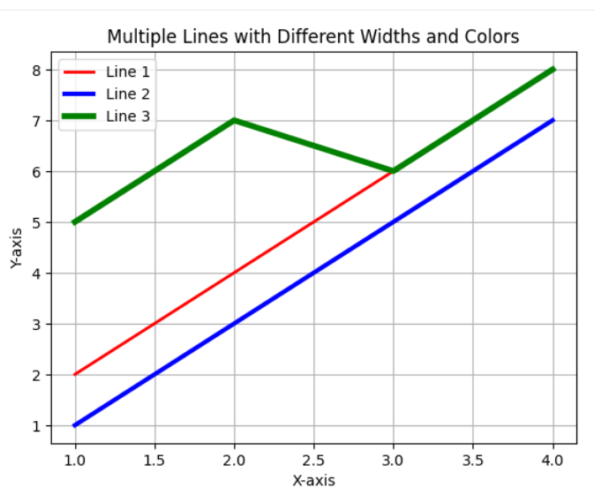

26. Write a Python program to create multiple plots.
CODE:
import matplotlib.pyplot as plt

# Data
x = [1, 2, 3, 4]
y1 = [2, 4, 6, 8]
y2 = [1, 3, 5, 7]
y3 = [5, 7, 6, 8]
# Plot lines
plt.plot(x, y1, color='red', linewidth=2, label='Line 1')
plt.plot(x, y2, color='blue', linewidth=3, label='Line 2')
plt.plot(x, y3, color='green', linewidth=4, label='Line 3')

# Data
x = [1, 2, 3, 4, 5]
y1 = [2, 4, 6, 8, 10]
y2 = [10, 8, 6, 4, 2]

# Create multiple plots
plt.figure(figsize=(10, 8))

# Plot 1 - Line graph
plt.subplot(2, 2, 1)
plt.plot(x, y1)
plt.title("Line Plot")
plt.xlabel("X-axis")
plt.ylabel("Y-axis")

# Plot 2 - Bar graph
plt.subplot(2, 2, 2)
plt.bar(x, y1)
plt.title("Bar Plot")
plt.xlabel("X-axis")
plt.ylabel("Y-axis")

# Plot 3 - Scatter plot
plt.subplot(2, 2, 3)
plt.scatter(x, y1)
plt.title("Scatter Plot")
plt.xlabel("X-axis")
plt.ylabel("Y-axis")

# Plot 4 - Pie chart
plt.subplot(2, 2, 4)
plt.pie(y1, labels=x, autopct='%1.1f%%')
plt.title("Pie Chart")

# Adjust spacing
plt.tight_layout()

# Show all plots
plt.show()
plt.xlabel("X-axis")
plt.ylabel("Y-axis")
plt.title("Multiple Lines with Different Widths and Colors")

# Display legend
plt.legend()

# Display grid
plt.grid(True)

# Show graph
plt.show()

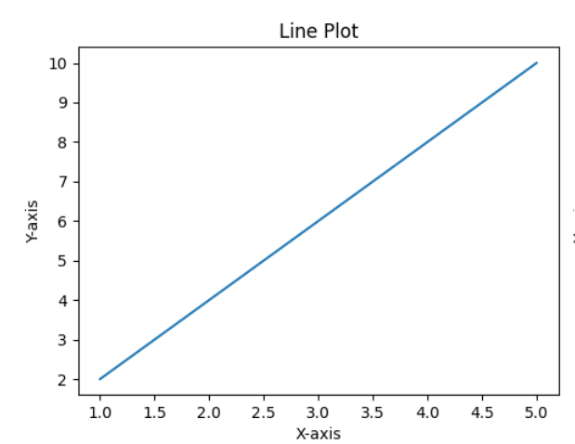
OUTPUT:
