

CO1-AT2
NAME: B. JAI SRINIVASAN
REG NO: 192524151
COURSE CODE: DSA0502
COURSE: QUERY PROCESSING

QUESTION-1
Banking Transaction Analysis
Transaction details are stored in transactions.csv.
Task:
- Read the dataset.
- Identify transactions above ₹1,00,000.
- Count debit and credit transactions.
- Generate a summary report.

DATASET
Order.csv
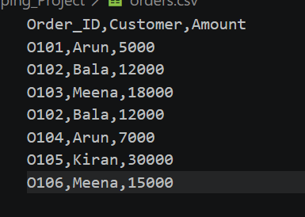
DATASET
transaction.csv
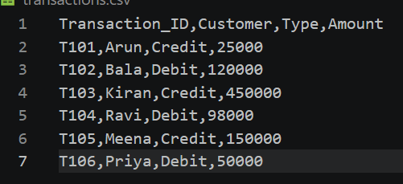

banking.py (CODE 1)

import pandas as pd

# Read the CSV file
df = pd.read_csv("transactions.csv")

print("=" * 50)
print("BANKING TRANSACTION ANALYSIS")
print("=" * 50)

# Display dataset
print("\nTransactions Dataset:\n")
print(df)

# Identify transactions above ₹1,00,000
high_value = df[df["Amount"] > 100000]

print("\n" + "=" * 50)
print("TRANSACTIONS ABOVE ₹1,00,000")
print("=" * 50)

if high_value.empty:
print("No transactions above ₹1,00,000.")
else:
print(high_value)

# Count Debit and Credit transactions
debit_count = (df["Type"] == "Debit").sum()
credit_count = (df["Type"] == "Credit").sum()

print("\n" + "=" * 50)
print("DEBIT AND CREDIT TRANSACTION COUNT")
print("=" * 50)
print("Debit Transactions :", debit_count)
print("Credit Transactions:", credit_count)

# Calculate total transaction amount
total_amount = df["Amount"].sum()

# Summary Report
print("\n" + "=" * 50)
print("SUMMARY REPORT")
print("=" * 50)
print("Total Transactions :", len(df))
print("High Value Transactions :", len(high_value))
print("Debit Transactions :", debit_count)
print("Credit Transactions :", credit_count)
print("Total Transaction Amount : ₹", total_amount”)

OUTPUT:
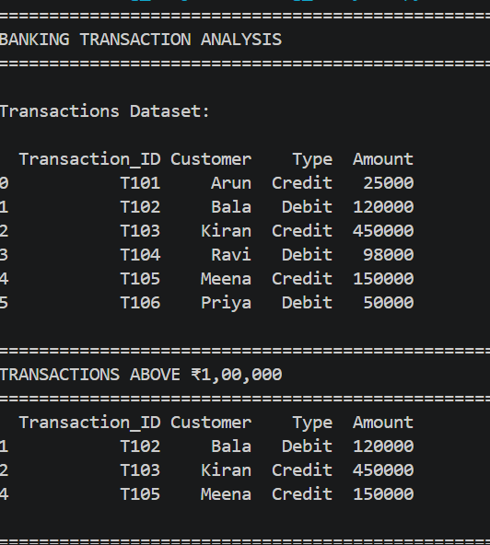
QUESTION-2
Online Shopping Orders
Order information is stored in orders.csv.
Task:
- Find duplicate order IDs.
- Remove duplicate orders.
- Calculate total order amount.
- Identify the customer with the highest purchase value.

DATASET:


CODE:
import pandas as pd

# Read the CSV file
df = pd.read_csv("orders.csv")

print("=" * 50)
print("ONLINE SHOPPING ORDERS ANALYSIS")
print("=" * 50)

# Display dataset
print("\nOriginal Orders Dataset:\n")
print(df)

# Find duplicate Order IDs
duplicates = df[df.duplicated(subset="Order_ID", keep=False)]

print("\n" + "=" * 50)
print("DUPLICATE ORDER IDs")
print("=" * 50)

if duplicates.empty:
print("No duplicate Order IDs found.")
else:
print(duplicates)

# Remove duplicate orders
df_clean = df.drop_duplicates(subset="Order_ID")

print("\n" + "=" * 50)
print("DATASET AFTER REMOVING DUPLICATES")
print("=" * 50)
print(df_clean)

# Calculate total order amount
total_amount = df_clean["Amount"].sum()

print("\n" + "=" * 50)
print("TOTAL ORDER AMOUNT")
print("=" * 50)
print("₹", total_amount)

# Customer-wise purchase value
customer_purchase = df_clean.groupby("Customer")["Amount"].sum()

print("\n" + "=" * 50)
print("CUSTOMER PURCHASE SUMMARY")
print("=" * 50)
print(customer_purchase)

# Highest purchase value
highest_customer = customer_purchase.idxmax()
highest_value = customer_purchase.max()

print("\n" + "=" * 50)
print("CUSTOMER WITH HIGHEST PURCHASE VALUE")
print("=" * 50)
print("Customer :", highest_customer)
print("Purchase Value : ₹", highest_value)

# Summary Report
print("\n" + "=" * 50)
print("SUMMARY REPORT")
print("=" * 50)
print("Total Orders :", len(df))
print("Duplicate Orders :", len(df) - len(df_clean))
print("Orders After Cleaning :", len(df_clean))
print("Total Order Amount : ₹", total_amount)
print("Highest Purchasing Customer:", highest_customer)
print("Highest Purchase Value : ₹", highest_value)

OUTPUT:
