

SIMATS ENGINEERING

Saveetha Institute of Medical and Technical Sciences
Chennai- 602105

Name: B. JAI SRINIVASAN
Reg no: 192524151
Subject and Course Code:
DSA0502 - QUERY PROCESSING FOR DATA SCIENCE

9.Write a Pandas program to create a Pivot table and find the total sale amount region wise, manager wise, sales man wise.
Code:
import pandas as pd

# Creating sample sales data
data = {
'Region': ['East', 'East', 'West', 'West', 'North', 'South', 'North', 'South'],
'Manager': ['John', 'John', 'Mary', 'Mary', 'David', 'Sam', 'David', 'Sam'],
'Salesman': ['A', 'B', 'C', 'D', 'E', 'F', 'A', 'C'],
'Sale_Amount': [25000, 30000, 40000, 35000, 28000, 45000, 22000, 38000]
}

df = pd.DataFrame(data)

print("Original DataFrame:")
print(df)

# Creating Pivot Table
pivot = pd.pivot_table(
df,
values='Sale_Amount',
index=['Region', 'Manager', 'Salesman'],
aggfunc='sum'
)

print("\nPivot Table:")
print(pivot)
Output:
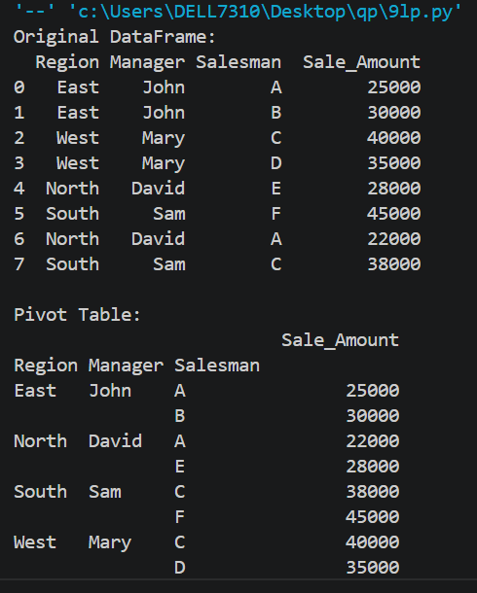

10.Create a data frame of ten rows, four columns with random values. Write a Pandas program to highlight the negative numbers red and positive numbers black.
Code:
import pandas as pd
import numpy as np

# Generate random values
np.random.seed(10)

df = pd.DataFrame(
np.random.randint(-100, 100, size=(10, 4)),
columns=['A', 'B', 'C', 'D']
)

print("Original DataFrame:")
print(df)

# Function to apply colors
def color_numbers(val):
if val < 0:
return 'color: red'
else:
return 'color: black'

# Styled DataFrame
styled_df = df.style.applymap(color_numbers)

styled_df

Output:
