

SIMATS ENGINEERING

Saveetha Institute of Medical and Technical Sciences
Chennai- 602105

Name: B. JAI SRINIVASAN
Reg no: 192524151
Course Code: DSA0502
Course: QUERY PROCESSING

SET - 14
27.Write a Python programming to display a bar chart of the popularity of programming Languages.

CODE:
import matplotlib.pyplot as plt

# Programming languages and their popularity
languages = ['Python', 'Java', 'C', 'C++', 'JavaScript']
popularity = [90, 75, 65, 60, 80]

# Create bar chart
plt.bar(languages, popularity)

# Add labels and title
plt.xlabel("Programming Languages")
plt.ylabel("Popularity")
plt.title("Popularity of Programming Languages")

# Display chart
plt.show()

OUTPUT:
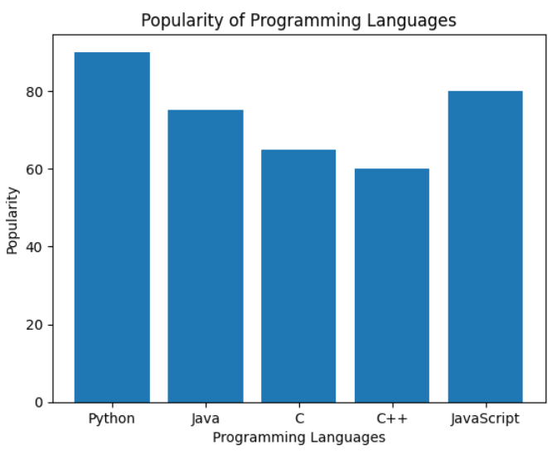

28.Write a Python programming to display a horizontal bar chart of the popularity of programming Languages.

CODE:
import matplotlib.pyplot as plt

# Programming languages and their popularity
languages = ['Python', 'Java', 'C', 'C++', 'JavaScript']
popularity = [90, 75, 65, 60, 80]

# Create horizontal bar chart
plt.barh(languages, popularity)

# Add labels and title
plt.xlabel("Popularity")
plt.ylabel("Programming Languages")
plt.title("Popularity of Programming Languages")

# Display chart
plt.show()

OUTPUT:
