

SIMATS ENGINEERING

Saveetha Institute of Medical and Technical Sciences
Chennai- 602105

Name: B. JAI SRINIVASAN
Reg no: 192524151
Subject and Course Code:
DSA0502 - QUERY PROCESSING FOR DATA SCIENCE

SET-5
11. Create a DataFrame of 10 rows and 4 columns with random values. Convert some values to NaN. Highlight the NaN values.

Code
import pandas as pd
import numpy as np

# Create DataFrame with random values
df = pd.DataFrame(
np.random.randn(10, 4),
columns=['A', 'B', 'C', 'D']
)

# Convert some values to NaN
df.iloc[2, 1] = np.nan
df.iloc[5, 3] = np.nan
df.iloc[7, 0] = np.nan

print("Original DataFrame:\n")
print(df)

# Highlight NaN values with Yellow color
def highlight_nan(value):
if pd.isna(value):
return 'background-color: yellow; color: black'
else:
return ''

styled_df = df.style.applymap(highlight_nan)

# Display in Jupyter Notebook / Google Colab
styled_df

Output
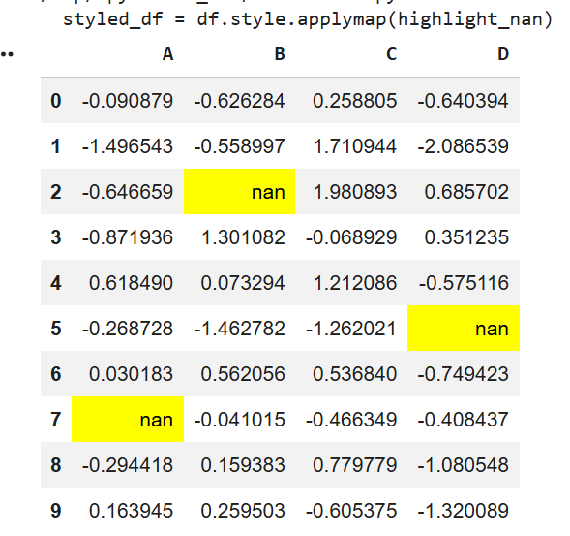

12. Create a DataFrame of 10 rows and 4 columns with random values. Set DataFrame background color to Black and font color to Yellow.

Code
import pandas as pd
import numpy as np

# Create DataFrame
df = pd.DataFrame(
np.random.randn(10, 4),
columns=['A', 'B', 'C', 'D']
)

print("Original DataFrame:\n")
print(df)

# Apply black background and yellow font
styled_df = df.style.set_properties(**{
'background-color': 'black',
'color': 'yellow'
})

# Display in Jupyter Notebook
styled_df

Output

