ASSESSMENT TOOL 2

INDUSTRY PROBLEM SOLVING

NAME: B. JAI SRINIVASAN
REG NO: 192524151
COURSE CODE: DSA0502
COURSE: QUERY PROCESSING

1. Manufacturing Production Analysis — Output

Dataset Preview
Date | Production | Machine_Hours | Temperature | Energy_Consumption | Defects
2026-01-01 | 520 | 8.2 | 72.5 | 145 | 8
2026-01-02 | 545 | 8.5 | 73.1 | 149 | 7
2026-01-03 | 560 | 8.7 | 74.2 | 152 | 6
2026-01-04 | 535 | 8.3 | 75.8 | 148 | 9
2026-01-05 | 580 | 9.0 | 76.4 | 158 | 5

PYTHON CODINGS:
# ============================================================
# Q1 - MANUFACTURING PRODUCTION ANALYSIS
# ============================================================

import pandas as pd
import numpy as np
import matplotlib.pyplot as plt
from pandas.plotting import scatter_matrix, lag_plot, autocorrelation_plot

# ------------------------------------------------------------
# 1. CREATE DATASET
# ------------------------------------------------------------

data = {
"Date": pd.date_range("2026-01-01", periods=30, freq="D"),

"Production": [
520, 535, 548, 530, 560, 575, 590, 585, 600, 615,
605, 620, 635, 650, 642, 660, 675, 690, 680, 700,
715, 705, 720, 735, 750, 742, 760, 775, 765, 790
],

"Machine_Hours": [
8.1, 8.3, 8.5, 8.2, 8.7, 8.9, 9.0, 8.8, 9.1, 9.3,
9.0, 9.2, 9.4, 9.6, 9.5, 9.7, 9.8, 10.0, 9.9, 10.1,
10.2, 10.0, 10.3, 10.5, 10.6, 10.4, 10.7, 10.8, 10.6, 11.0
],

"Temperature": [
72.5, 73.0, 73.5, 74.2, 74.8, 75.0, 75.5, 76.0, 76.2, 76.8,
77.0, 77.5, 78.0, 78.5, 79.0, 79.5, 80.0, 80.5, 81.0, 81.5,
82.0, 82.5, 83.0, 83.5, 84.0, 84.5, 85.0, 85.5, 86.0, 86.5
],

"Energy_Consumption": [
145, 147, 149, 148, 152, 155, 157, 156, 160, 163,
161, 165, 168, 171, 170, 174, 177, 180, 179, 183,
186, 184, 188, 191, 194, 192, 196, 199, 197, 202
],

"Defects": [
8, 7, 7, 9, 6, 6, 5, 7, 5, 4,
6, 5, 4, 4, 6, 3, 4, 3, 5, 3,
2, 4, 3, 2, 2, 4, 2, 1, 3, 1
]
}

df = pd.DataFrame(data)

# Save dataset as CSV
df.to_csv("manufacturing_production.csv", index=False)

# ------------------------------------------------------------
# 2. IMPORT DATASET
# ------------------------------------------------------------

df = pd.read_csv("manufacturing_production.csv")

df["Date"] = pd.to_datetime(df["Date"])

# ------------------------------------------------------------
# 3. DATA EXPLORATION
# ------------------------------------------------------------

print("\n========== MANUFACTURING DATASET ==========")

print("\nFirst 5 Records:")
print(df.head())

print("\nDataset Information:")
print(df.info())

print("\nStatistical Summary:")
print(df.describe())

print("\nMissing Values:")
print(df.isnull().sum())

# ------------------------------------------------------------
# 4. PRODUCTION TREND OVER TIME
# ------------------------------------------------------------

plt.figure(figsize=(10, 5))

plt.plot(
df["Date"],
df["Production"],
marker="o"
)

plt.title("Daily Production Trend")
plt.xlabel("Date")
plt.ylabel("Production Units")
plt.xticks(rotation=45)
plt.grid(True)
plt.tight_layout()
plt.show()

# ------------------------------------------------------------
# 5. PRODUCTION DISTRIBUTION
# ------------------------------------------------------------

plt.figure(figsize=(8, 5))

plt.hist(
df["Production"],
bins=8,
edgecolor="black"
)

plt.title("Distribution of Production Values")
plt.xlabel("Production Units")
plt.ylabel("Frequency")
plt.grid(axis="y")
plt.show()

# ------------------------------------------------------------
# 6. MACHINE HOURS VS PRODUCTION
# ------------------------------------------------------------

plt.figure(figsize=(8, 5))

plt.scatter(
df["Machine_Hours"],
df["Production"]
)

plt.title("Machine Operating Hours vs Production")
plt.xlabel("Machine Operating Hours")
plt.ylabel("Production Units")
plt.grid(True)
plt.show()

# ------------------------------------------------------------
# 7. TEMPERATURE VS DEFECTS
# ------------------------------------------------------------

plt.figure(figsize=(8, 5))

plt.scatter(
df["Temperature"],
df["Defects"]
)

plt.title("Temperature vs Defects")
plt.xlabel("Temperature")
plt.ylabel("Defect Count")
plt.grid(True)
plt.show()

# ------------------------------------------------------------
# 8. ENERGY CONSUMPTION VS PRODUCTION
# ------------------------------------------------------------

plt.figure(figsize=(8, 5))

plt.scatter(
df["Energy_Consumption"],
df["Production"]
)

plt.title("Energy Consumption vs Production")
plt.xlabel("Energy Consumption")
plt.ylabel("Production Units")
plt.grid(True)
plt.show()

# ------------------------------------------------------------
# 9. SCATTER MATRIX
# ------------------------------------------------------------

scatter_matrix(
df[
[
"Production",
"Machine_Hours",
"Temperature",
"Energy_Consumption",
"Defects"
]
],
figsize=(12, 10),
diagonal="hist"
)

plt.suptitle("Manufacturing Parameter Scatter Matrix")
plt.tight_layout()
plt.show()

# ------------------------------------------------------------
# 10. LAG PLOT
# ------------------------------------------------------------

plt.figure(figsize=(7, 5))

lag_plot(df["Production"])

plt.title("Lag Plot of Production")
plt.grid(True)
plt.show()

# ------------------------------------------------------------
# 11. AUTOCORRELATION PLOT
# ------------------------------------------------------------

plt.figure(figsize=(10, 5))

autocorrelation_plot(df["Production"])

plt.title("Autocorrelation of Production")
plt.show()

# ------------------------------------------------------------
# 12. CORRELATION ANALYSIS
# ------------------------------------------------------------

print("\n========== CORRELATION MATRIX ==========")

correlation = df[
[
"Production",
"Machine_Hours",
"Temperature",
"Energy_Consumption",
"Defects"
]
].corr()

print(correlation.round(2))

OUTPUTS:

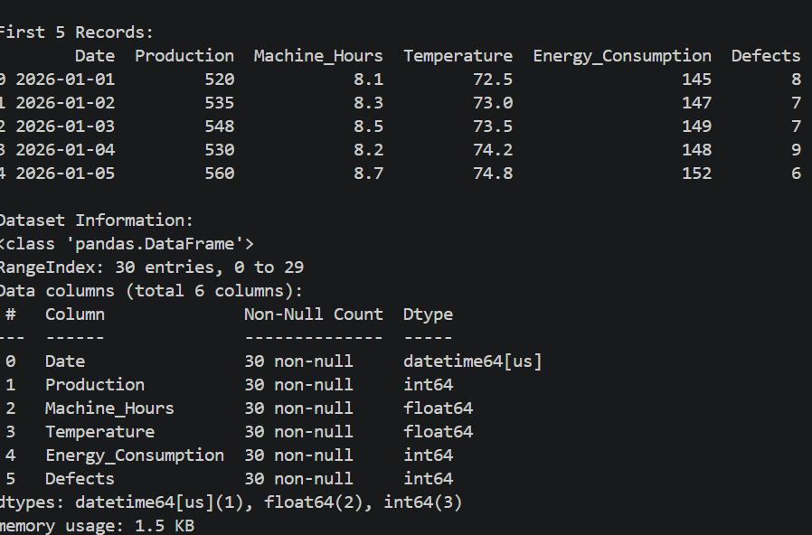

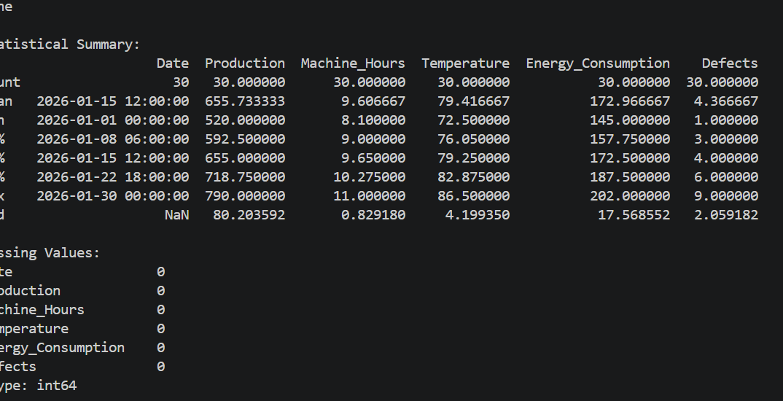

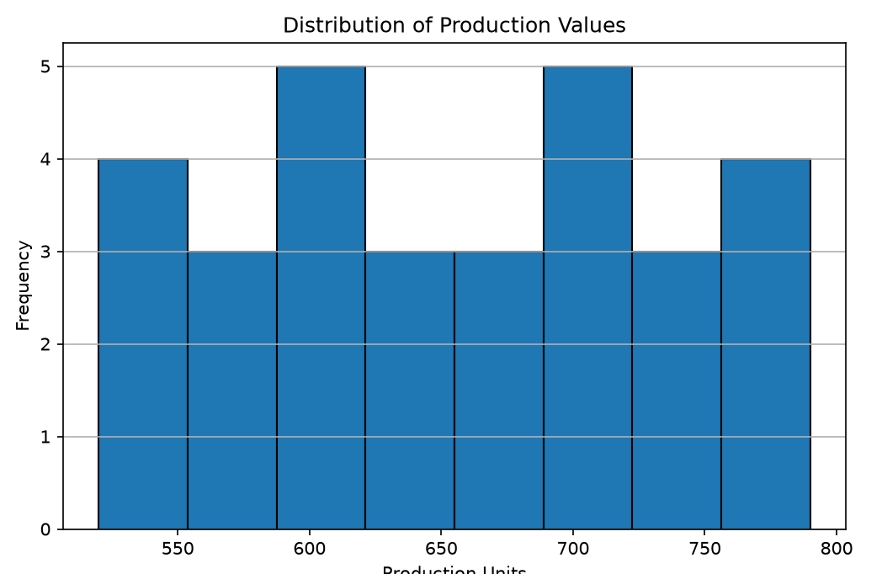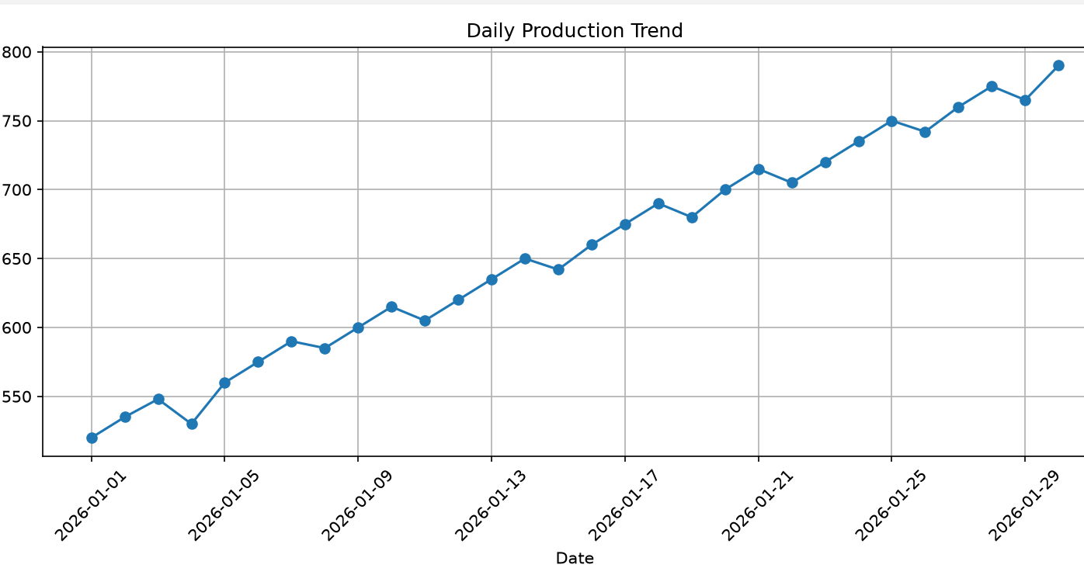

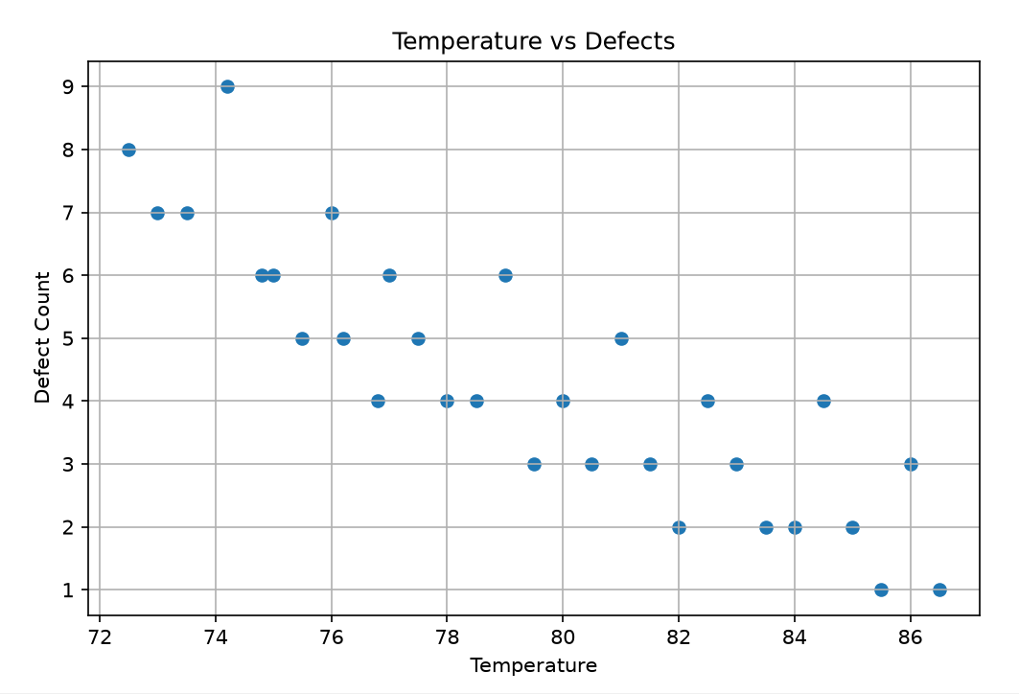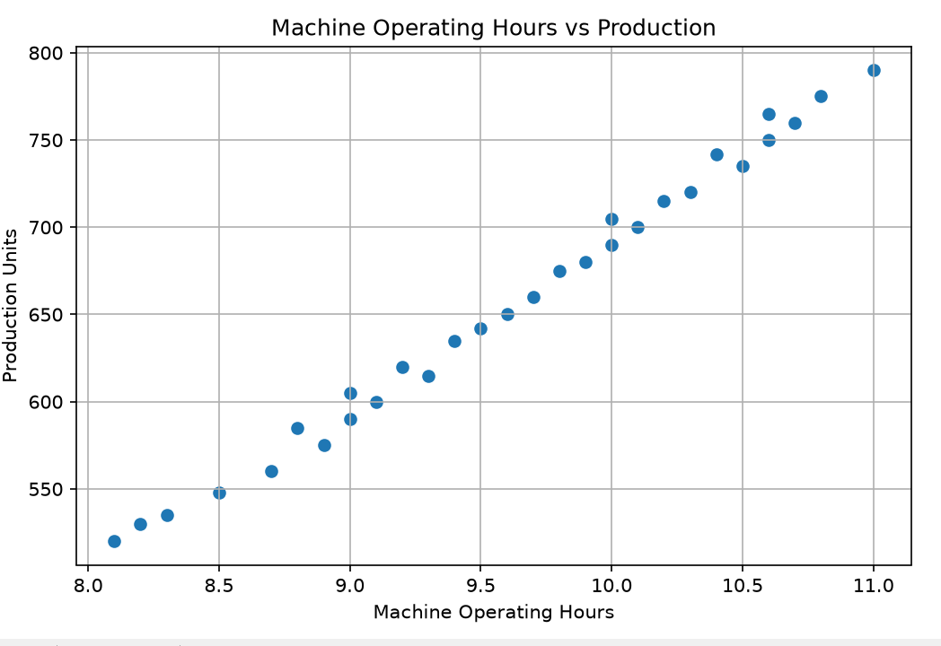

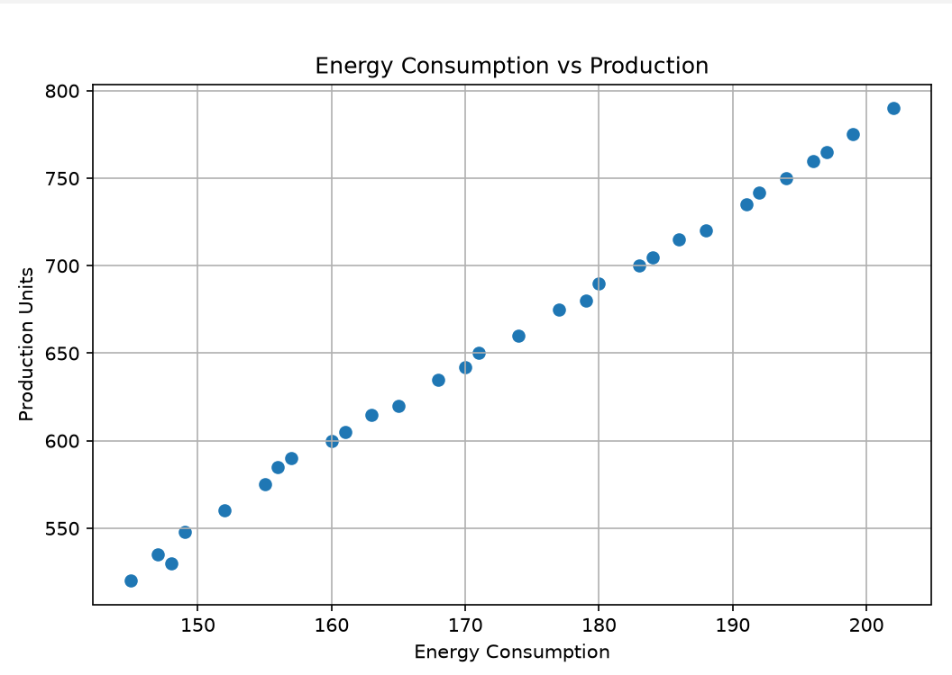

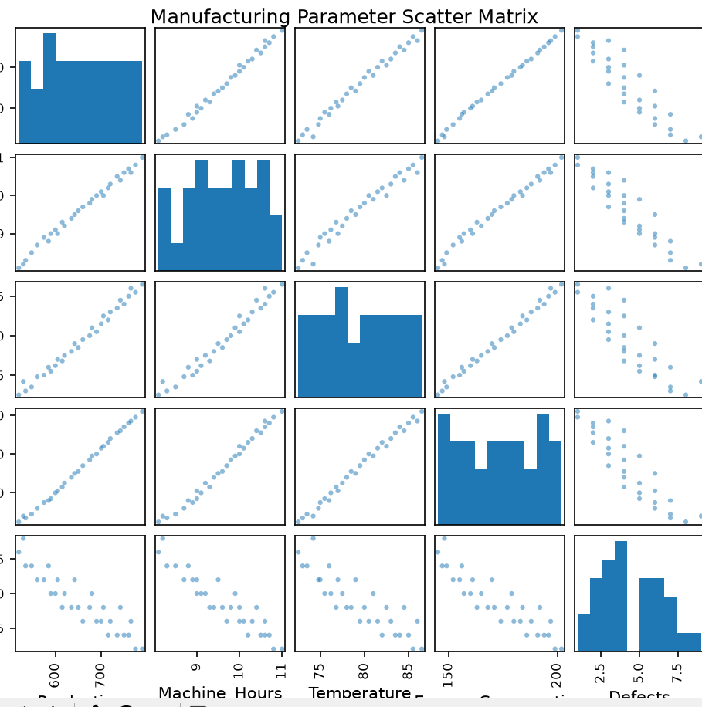

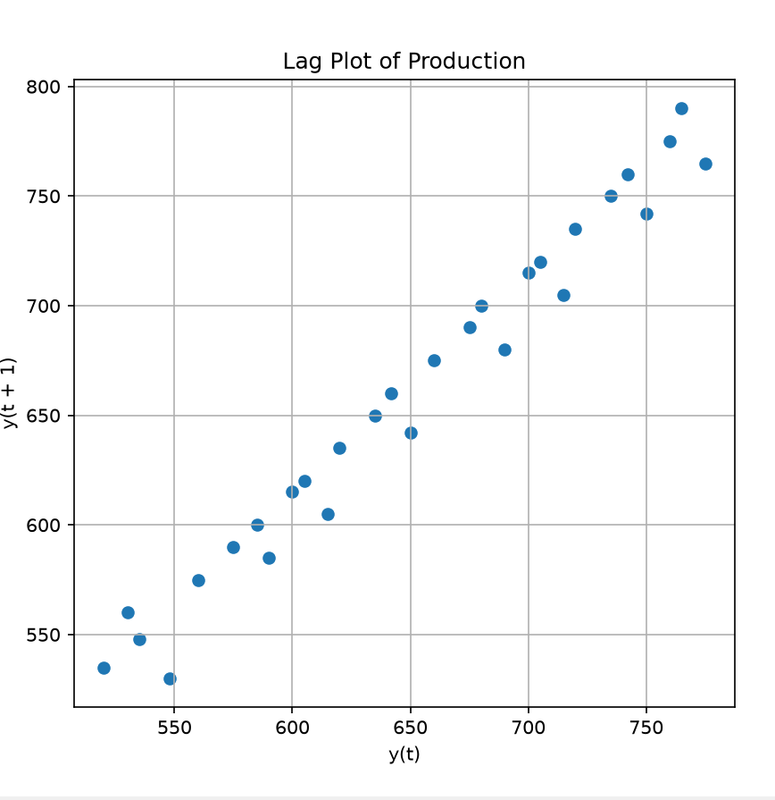

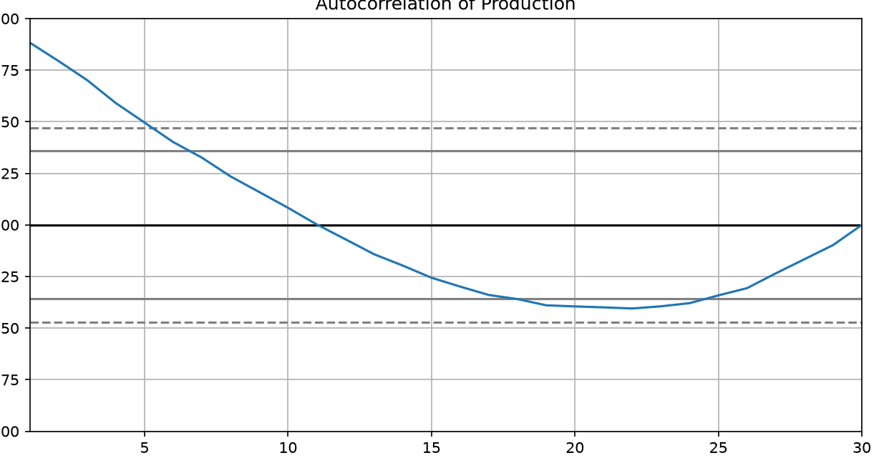

Key Findings
- Production generally increases with machine operating hours.
- Excessive temperature can contribute to higher defect counts.
- Energy consumption increases as production increases.
- Production values show temporal dependency between consecutive days.
- The lag and autocorrelation plots can reveal recurring production patterns.
- Outlier production days should be investigated for machine failures, maintenance, or unusual demand.

Recommendations
- Maintain machines within an optimal temperature range.
- Schedule preventive maintenance to reduce defects.
- Monitor energy consumption per unit of production.
- Use historical production patterns for production planning.
- Avoid unnecessarily long machine operating hours when productivity gains are minimal.
- Investigate abnormal production and defect values.
Conclusion:
The analysis shows that machine operating hours, temperature, and energy consumption have important relationships with production and defects. Time-series visualizations such as lag and autocorrelation plots help identify hidden production patterns and support better production planning.

2. E-Commerce Sales Pattern Analysis — Output

Dataset Preview
Date | Category | Quantity_Sold | Revenue | Discount | Customer_Rating
2026-01-01 | Electronics | 25 | 45000 | 10 | 4.5
2026-01-02 | Clothing | 40 | 28000 | 15 | 4.2
2026-01-03 | Grocery | 65 | 19500 | 5 | 4.0
2026-01-04 | Electronics | 32 | 57600 | 12 | 4.6
2026-01-05 | Clothing | 48 | 33600 | 20 | 4.3

PYTHON CODES:
# ============================================================
# Q2 - E-COMMERCE SALES PATTERN ANALYSIS
# ============================================================

import pandas as pd
import matplotlib.pyplot as plt
from pandas.plotting import scatter_matrix

# ------------------------------------------------------------
# 1. CREATE E-COMMERCE DATASET
# ------------------------------------------------------------

data = {
"Date": pd.date_range("2026-01-01", periods=30, freq="D"),

"Product_Category": [
"Electronics", "Clothing", "Grocery",
"Electronics", "Clothing", "Grocery",
"Electronics", "Clothing", "Grocery",
"Electronics", "Clothing", "Grocery",
"Electronics", "Clothing", "Grocery",
"Electronics", "Clothing", "Grocery",
"Electronics", "Clothing", "Grocery",
"Electronics", "Clothing", "Grocery",
"Electronics", "Clothing", "Grocery",
"Electronics", "Clothing", "Grocery"
],

"Quantity_Sold": [
25, 40, 65,
32, 48, 70,
28, 45, 68,
35, 50, 72,
38, 55, 75,
42, 58, 78,
45, 60, 80,
48, 63, 82,
52, 66, 85,
55, 70, 88
],

"Revenue": [
45000, 28000, 19500,
57600, 33600, 21000,
50400, 31500, 20400,
63000, 35000, 21600,
68400, 38500, 22500,
75600, 40600, 23400,
81000, 42000, 24000,
86400, 44100, 24600,
93600, 46200, 25500,
99000, 49000, 26400
],

"Discount": [
10, 15, 5,
12, 20, 8,
10, 18, 5,
15, 22, 7,
12, 20, 10,
15, 25, 8,
10, 18, 12,
20, 22, 5,
15, 25, 10,
18, 20, 8
],

"Customer_Rating": [
4.5, 4.2, 4.0,
4.6, 4.3, 4.1,
4.4, 4.2, 4.0,
4.7, 4.3, 4.1,
4.6, 4.4, 4.2,
4.8, 4.3, 4.0,
4.7, 4.5, 4.1,
4.8, 4.4, 4.2,
4.6, 4.3, 4.1,
4.9, 4.5, 4.2
]
}

df = pd.DataFrame(data)

# ------------------------------------------------------------
# 2. SAVE DATASET AS CSV
# ------------------------------------------------------------

df.to_csv("ecommerce_sales.csv", index=False)

# ------------------------------------------------------------
# 3. IMPORT DATASET
# ------------------------------------------------------------

df = pd.read_csv("ecommerce_sales.csv")

df["Date"] = pd.to_datetime(df["Date"])

# ------------------------------------------------------------
# 4. DISPLAY DATASET
# ------------------------------------------------------------

print("\n========== E-COMMERCE SALES DATA ==========")

print("\nFirst 5 Rows:")
print(df.head())

print("\nLast 5 Rows:")
print(df.tail())

print("\nDataset Shape:")
print(df.shape)

print("\nColumn Names:")
print(df.columns)

# ------------------------------------------------------------
# 5. DATA INFORMATION
# ------------------------------------------------------------

print("\n========== DATA INFORMATION ==========")

df.info()

# ------------------------------------------------------------
# 6. STATISTICAL SUMMARY
# ------------------------------------------------------------

print("\n========== STATISTICAL SUMMARY ==========")

print(df.describe())

# ------------------------------------------------------------
# 7. CHECK MISSING VALUES
# ------------------------------------------------------------

print("\n========== MISSING VALUES ==========")

print(df.isnull().sum())

# ------------------------------------------------------------
# 8. TOTAL SALES
# ------------------------------------------------------------

print("\n========== TOTAL SALES ==========")

print("Total Quantity Sold:",
df["Quantity_Sold"].sum())

print("Total Revenue:",
df["Revenue"].sum())

print("Average Discount:",
round(df["Discount"].mean(), 2))

print("Average Customer Rating:",
round(df["Customer_Rating"].mean(), 2))

# ------------------------------------------------------------
# 9. DAILY SALES TREND
# ------------------------------------------------------------

plt.figure(figsize=(10, 5))

plt.plot(
df["Date"],
df["Revenue"],
marker="o"
)

plt.title("Daily Revenue Trend")
plt.xlabel("Date")
plt.ylabel("Revenue")
plt.xticks(rotation=45)
plt.grid(True)
plt.tight_layout()

plt.show()

# ------------------------------------------------------------
# 10. CATEGORY-WISE QUANTITY SOLD
# ------------------------------------------------------------

category_quantity = df.groupby(
"Product_Category"
)["Quantity_Sold"].sum()

plt.figure(figsize=(8, 5))

category_quantity.plot(
kind="bar"
)

plt.title("Total Quantity Sold by Product Category")
plt.xlabel("Product Category")
plt.ylabel("Quantity Sold")
plt.xticks(rotation=0)
plt.grid(axis="y")

plt.show()

# ------------------------------------------------------------
# 11. CATEGORY-WISE REVENUE
# ------------------------------------------------------------

category_revenue = df.groupby(
"Product_Category"
)["Revenue"].sum()

plt.figure(figsize=(8, 5))

category_revenue.plot(
kind="bar"
)

plt.title("Total Revenue by Product Category")
plt.xlabel("Product Category")
plt.ylabel("Revenue")
plt.xticks(rotation=0)
plt.grid(axis="y")

plt.show()

# ------------------------------------------------------------
# 12. DISCOUNT VS QUANTITY SOLD
# ------------------------------------------------------------

plt.figure(figsize=(8, 5))

plt.scatter(
df["Discount"],
df["Quantity_Sold"]
)

plt.title("Discount vs Quantity Sold")
plt.xlabel("Discount (%)")
plt.ylabel("Quantity Sold")
plt.grid(True)

plt.show()

# ------------------------------------------------------------
# 13. DISCOUNT VS REVENUE
# ------------------------------------------------------------

plt.figure(figsize=(8, 5))

plt.scatter(
df["Discount"],
df["Revenue"]
)

plt.title("Discount vs Revenue")
plt.xlabel("Discount (%)")
plt.ylabel("Revenue")
plt.grid(True)

plt.show()

# ------------------------------------------------------------
# 14. REVENUE DISTRIBUTION
# ------------------------------------------------------------

plt.figure(figsize=(8, 5))

plt.hist(
df["Revenue"],
bins=8,
edgecolor="black"
)

plt.title("Revenue Distribution")
plt.xlabel("Revenue")
plt.ylabel("Frequency")
plt.grid(axis="y")

plt.show()

# ------------------------------------------------------------
# 15. QUANTITY SOLD FREQUENCY
# ------------------------------------------------------------

plt.figure(figsize=(8, 5))

plt.hist(
df["Quantity_Sold"],
bins=8,
edgecolor="black"
)

plt.title("Quantity Sold Frequency Distribution")
plt.xlabel("Quantity Sold")
plt.ylabel("Frequency")
plt.grid(axis="y")

plt.show()

# ------------------------------------------------------------
# 16. CUSTOMER RATING DISTRIBUTION
# ------------------------------------------------------------

plt.figure(figsize=(8, 5))

plt.hist(
df["Customer_Rating"],
bins=6,
edgecolor="black"
)

plt.title("Customer Rating Distribution")
plt.xlabel("Customer Rating")
plt.ylabel("Frequency")
plt.grid(axis="y")

plt.show()

# ------------------------------------------------------------
# 17. SCATTER MATRIX
# ------------------------------------------------------------

scatter_matrix(
df[
[
"Quantity_Sold",
"Revenue",
"Discount",
"Customer_Rating"
]
],
figsize=(12, 10),
diagonal="hist"
)

plt.suptitle(
"E-Commerce Sales Scatter Matrix",
y=1.02
)

plt.tight_layout()

plt.show()

# ------------------------------------------------------------
# 18. CORRELATION ANALYSIS
# ------------------------------------------------------------

print("\n========== CORRELATION MATRIX ==========")

correlation = df[
[
"Quantity_Sold",
"Revenue",
"Discount",
"Customer_Rating"
]
].corr()

print(correlation.round(2))

# ------------------------------------------------------------
# 19. CATEGORY-WISE ANALYSIS
# ------------------------------------------------------------

print("\n========== CATEGORY-WISE ANALYSIS ==========")

category_summary = df.groupby(
"Product_Category"
).agg(
Total_Quantity=("Quantity_Sold", "sum"),
Total_Revenue=("Revenue", "sum"),
Average_Discount=("Discount", "mean"),
Average_Rating=("Customer_Rating", "mean")
)

print(category_summary.round(2))

# ------------------------------------------------------------
# 20. FIND BEST CATEGORY
# ------------------------------------------------------------

best_revenue_category = category_revenue.idxmax()

best_quantity_category = category_quantity.idxmax()

print("\n========== BEST PERFORMING CATEGORIES ==========")

print(
"Highest Revenue Category:",
best_revenue_category
)

print(
"Highest Quantity Sold Category:",
best_quantity_category
)

OUTPUTS:

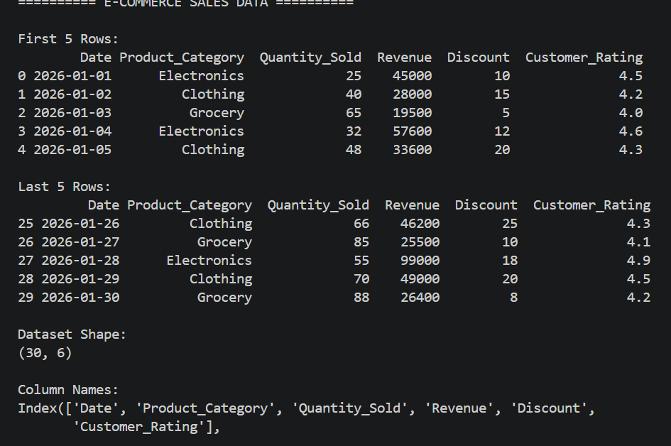

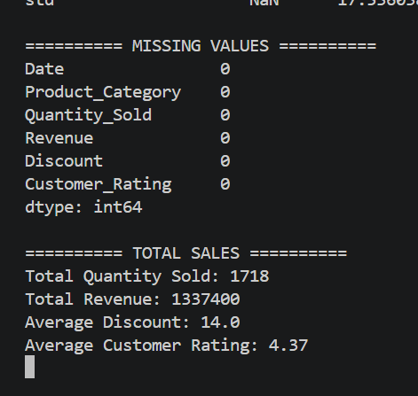
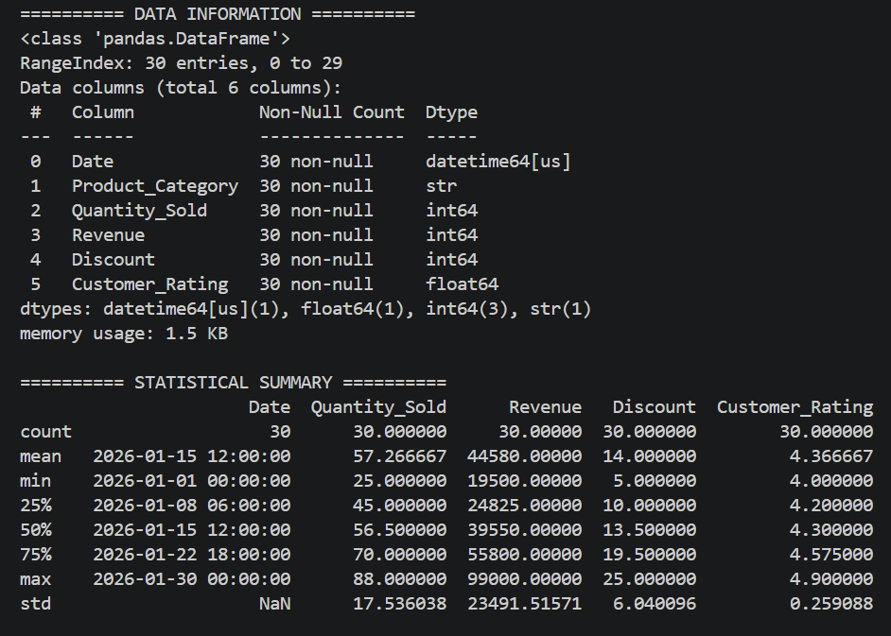

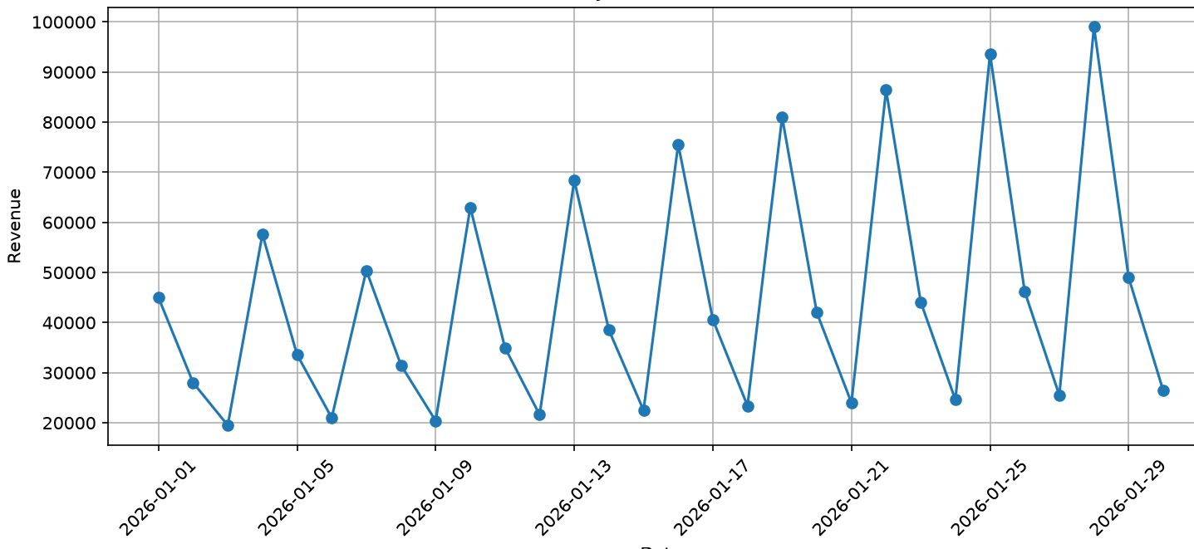

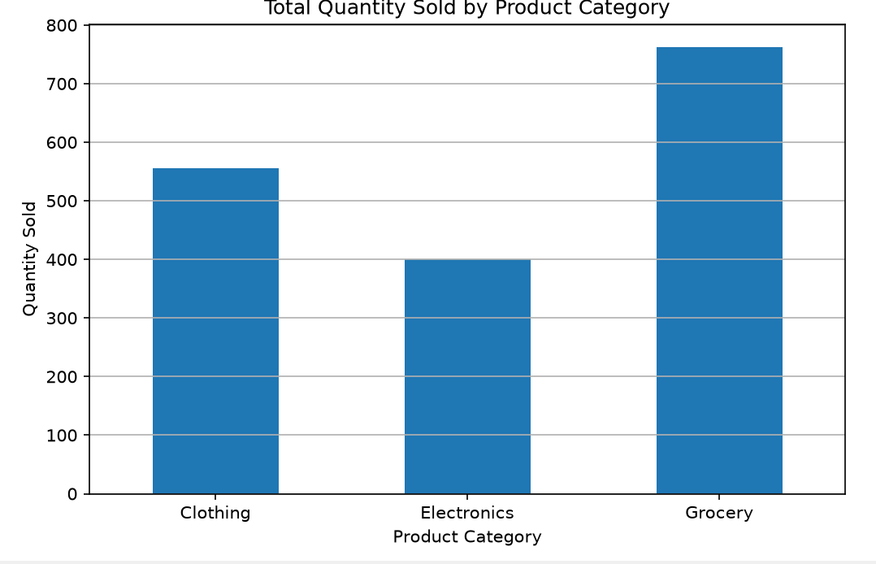
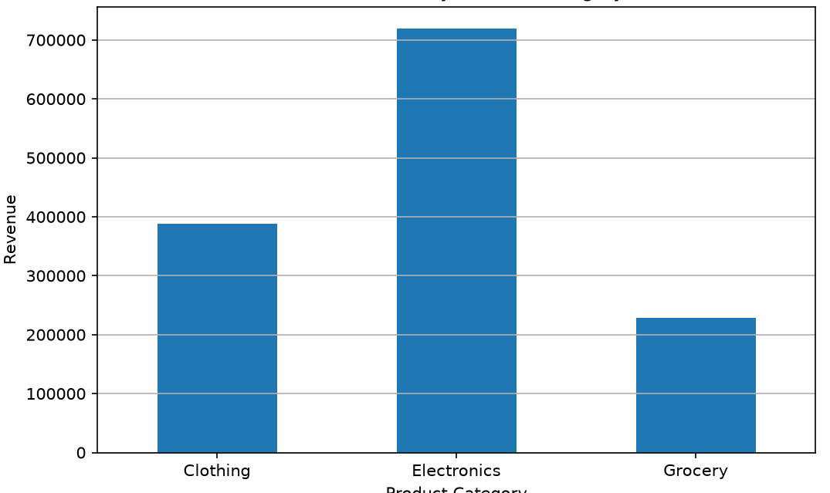

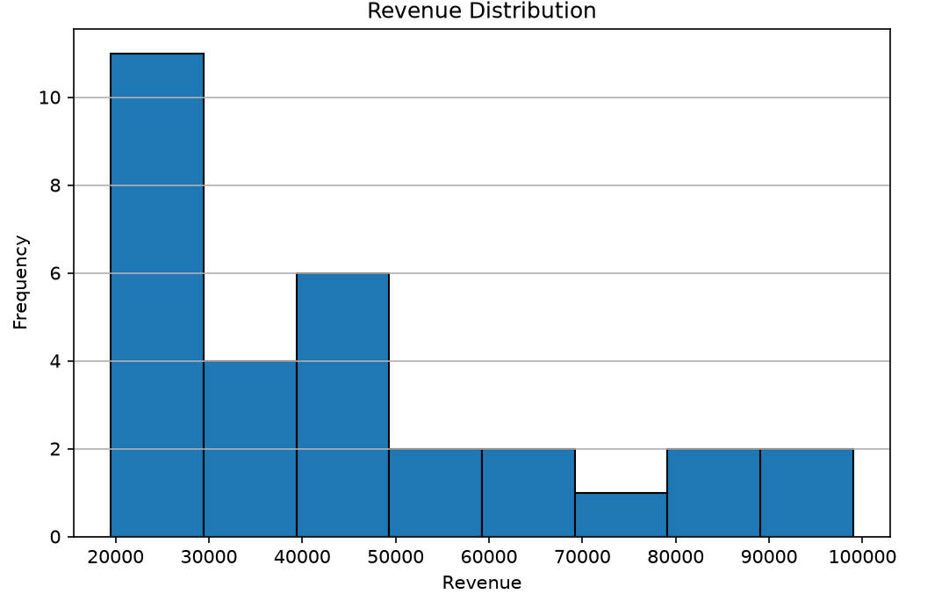
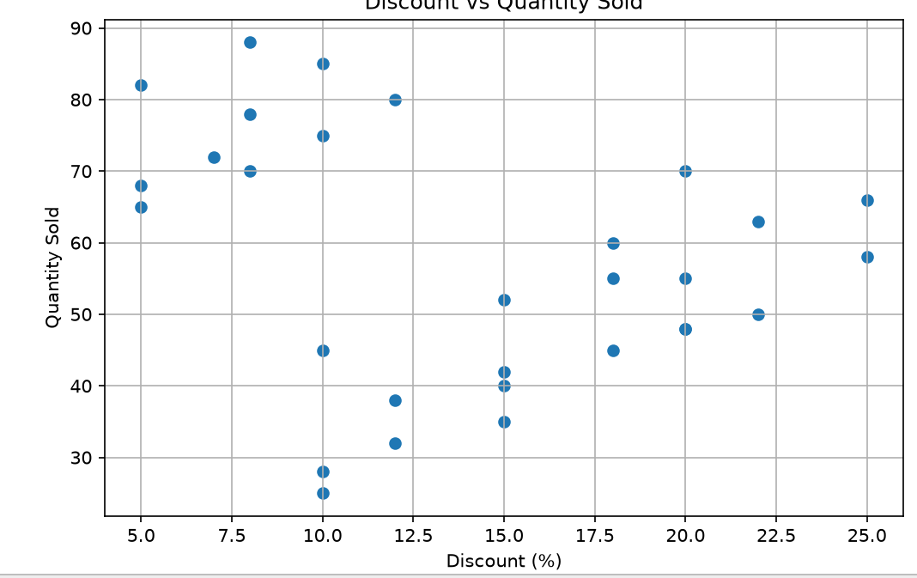
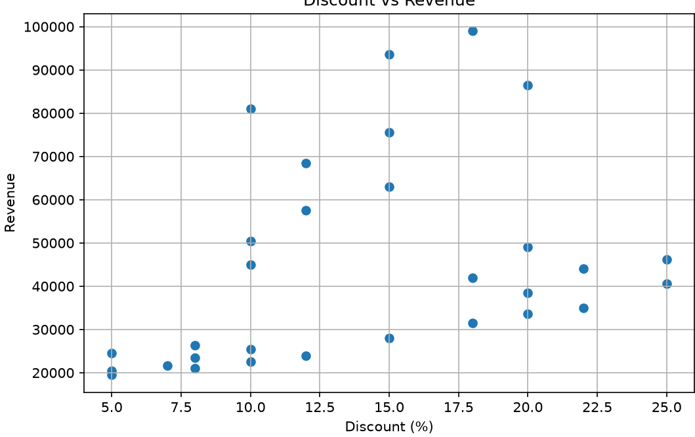


Key Findings
- Revenue generally increases when quantity sold increases.
- Discounts can encourage customers to purchase more products.
- Excessive discounts may reduce revenue margins.
- Some product categories contribute significantly more revenue than others.
- Customer ratings can help identify products with strong customer satisfaction.
- Revenue shows variations over time, with certain dates producing higher sales.
- Scatter matrix analysis helps identify important relationships between sales variables.

Recommendations
- Apply discounts strategically rather than uniformly.
- Increase inventory for consistently high-performing categories.
- Analyze high-revenue periods and plan promotions accordingly.
- Avoid excessive discounts that significantly reduce profit margins.
- Improve products with consistently low customer ratings.
- Use historical sales trends for inventory and marketing planning.
- Combine quantity, revenue, discount, and rating information for product-level decision making.
Conclusion:
The e-commerce analysis identifies important sales trends and relationships between discount, quantity sold, revenue, and customer ratings. Bar charts, line charts, distribution plots, frequency plots, and scatter matrices provide useful business insights for pricing, promotion, inventory management, and sales optimization.

