

SIMATS ENGINEERING

Saveetha Institute of Medical and Technical Sciences
Chennai- 602105

Name: B. JAI SRINIVASAN
Reg no: 192524151
Course Code: DSA0502
Course: QUERY PROCESSING

SET - 8
15.Write a Pandas program to keep the rows with at least 2 NaN values in a given DataFrame.
Code:
import pandas as pd
import numpy as np

# Create DataFrame
data = {
"A": [1, np.nan, np.nan, 4],
"B": [np.nan, np.nan, 3, 4],
"C": [1, 2, np.nan, np.nan],
"D": [np.nan, np.nan, np.nan, 5]
}

df = pd.DataFrame(data)

print("Original DataFrame:")
print(df)

# Keep rows having at least 2 NaN values
result = df[df.isnull().sum(axis=1) >= 2]

print("\nRows with at least 2 NaN values:")
print(result)

Output
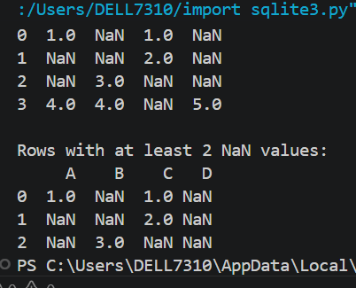

16.Write a Pandas program to split the following dataframe into groups based on school code. Also check the type of GroupBy object.

Code:
import pandas as pd

# Create DataFrame
data = {
"School_Code": ["S001", "S001", "S002", "S002", "S003"],
"Student": ["John", "Alice", "Bob", "David", "Eva"],
"Marks": [85, 90, 78, 88, 95]
}

df = pd.DataFrame(data)
print("Original DataFrame:")
print(df)

# Group by School_Code
grouped = df.groupby("School_Code")
print("\nType of GroupBy Object:")
print(type(grouped))
print("\nGroups:")
for name, group in grouped:
print("\nSchool Code:", name)
print(group)

Output

