

SIMATS ENGINEERING

Saveetha Institute of Medical and Technical Sciences
Chennai- 602105

Name: B. JAI SRINIVASAN
Reg no: 192524151
Subject and Course Code:
DSA0502 - QUERY PROCESSING FOR DATA SCIENCE

Lab Programs – Set 1
1.Write a Pandas program to select the distinct department id from employees file.
Code:
import pandas as pd
data = {
"employee_id": [101, 102, 103, 104, 105],
"employee_name": ["John", "Alice", "Bob", "David", "Emma"],
"department_id": [10, 20, 10, 30, 20]
}
df = pd.DataFrame(data)
print("Distinct Department IDs:")
print(df["department_id"].drop_duplicates())

Output:
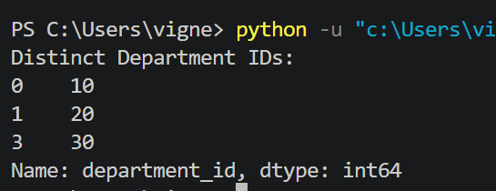

2. Write a Pandas program to display the IDs of employees who have done two or more
Code:
import pandas as pd
data = {
"employee_id": [101, 102, 101, 103, 102, 104],
"job_id": ["IT_PROG", "HR_REP", "SALES", "CLERK", "MANAGER", "ANALYST"]
}
df = pd.DataFrame(data)
job_count = df["employee_id"].value_counts()
print("Employees who have done two or more jobs:")
print(job_count[job_count >= 2].index.tolist())

Output:
