

SIMATS ENGINEERING

Saveetha Institute of Medical and Technical Sciences
Chennai- 602105

Name: B. JAI SRINIVASAN
Reg no: 192524151
Course Code: DSA0502
Course: QUERY PROCESSING

SET-7
13.Write a Pandas program to detect missing values of a given DataFrame. Display True or False.
Code:
import pandas as pd
import numpy as np

# Create DataFrame
data = {
"Name": ["John", "Alice", "Bob", "David"],
"Age": [25, np.nan, 30, 28],
"City": ["Chennai", "Delhi", np.nan, "Mumbai"]
}

df = pd.DataFrame(data)

print("Original DataFrame:")
print(df)

print("\nMissing Values (True/False):")
print(df.isnull())

Output
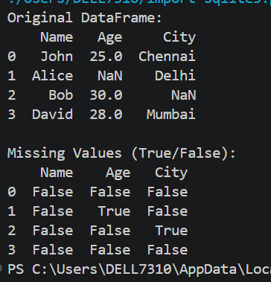

14. Write a Pandas program to find and replace the missing values in a given DataFrame which do not have any valuable information.

Code:
import pandas as pd
import numpy as np

# Create DataFrame
data = {
"Name": ["John", "Alice", "Bob", "David"],
"Age": [25, np.nan, 30, 28],
"City": ["Chennai", "Delhi", np.nan, "Mumbai"]
}

df = pd.DataFrame(data)

print("Original DataFrame:")
print(df)

# Replace missing values
df["Age"] = df["Age"].fillna(df["Age"].mean()) # Replace with mean
df["City"] = df["City"].fillna("Unknown") # Replace with text

print("\nDataFrame after replacing missing values:")
print(df)

Output

