

SIMATS ENGINEERING

Saveetha Institute of Medical and Technical Sciences
Chennai- 602105

Name: B. JAI SRINIVASAN
Reg no: 192524151
Course Code: DSA0502
Course: QUERY PROCESSING

SET - 18
35.Write a Python program to draw a scatter plot comparing two subject marks
CODE:
import matplotlib.pyplot as plt

# Marks of students in two subjects
maths = [78, 85, 62, 90, 72, 88, 95, 67, 81, 74]
science = [82, 80, 65, 92, 70, 85, 90, 72, 79, 76]

# Scatter plot
plt.scatter(maths, science)

plt.xlabel('Maths Marks')
plt.ylabel('Science Marks')
plt.title('Scatter Plot Comparing Two Subject Marks')

plt.show()

OUTPUT:
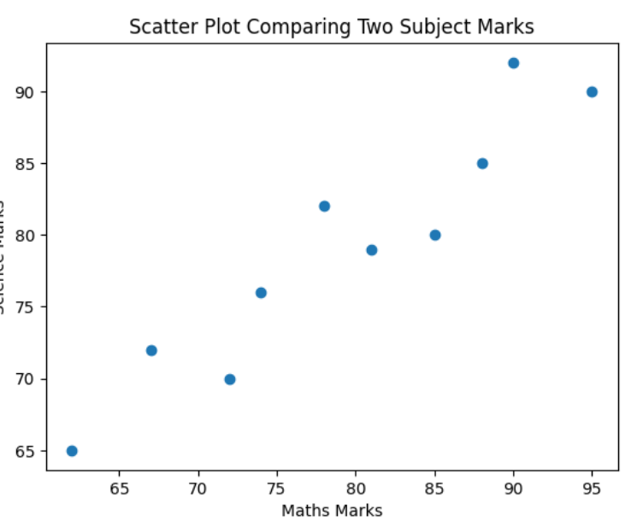

36.Write a Python program to draw a scatter plot for three different groups comparing weights and heights.

CODE:
import matplotlib.pyplot as plt

# Group 1
height1 = [150, 155, 160, 165, 170]
weight1 = [50, 53, 56, 60, 65]

# Group 2
height2 = [155, 160, 165, 170, 175]
weight2 = [52, 58, 62, 67, 72]

# Group 3
height3 = [160, 165, 170, 175, 180]
weight3 = [55, 60, 66, 71, 78]

# Scatter plots
plt.scatter(height1, weight1, label='Group 1')
plt.scatter(height2, weight2, label='Group 2')
plt.scatter(height3, weight3, label='Group 3')

plt.xlabel('Height (cm)')
plt.ylabel('Weight (kg)')
plt.title('Height vs Weight for Three Groups')
plt.legend()

plt.show()
OUTPUT:
