ASSESSMENT TOOL 3
VISUALIZATION DESIGN ACTIVITY

NAME: B. JAI SRINIVASAN
REG NO: 192524151
COURSE CODE: DSA0502
COURSE: QUERY PROCESSING

Selected Activity 1 (from 1–5): Activity 4 – Pandas Visualization Activity
Task: Create a DataFrame containing Product, Sales, and Profit. Generate appropriate visualizations directly using Pandas.

Approach
A DataFrame with six products, along with their Sales and Profit figures, was created using Pandas. Three visualizations were generated directly using the DataFrame's built-in .plot() method: a grouped bar chart comparing Sales and Profit per product, a pie chart showing each product's share of total sales, and a line plot showing the profit trend across products.

Python Code
"""
Activity 4: Pandas Visualization Activity
Task: Create a DataFrame containing Product, Sales, and Profit.
Generate appropriate visualizations directly using Pandas.
"""

import pandas as pd
import matplotlib.pyplot as plt

# ---- Step 1: Create the DataFrame ----
data = {
"Product": ["Laptop", "Mobile", "Tablet", "Headphones", "Smartwatch", "Printer"],
"Sales": [120, 210, 90, 150, 175, 60],
"Profit": [25, 45, 15, 30, 40, 10]
}

df = pd.DataFrame(data)
print("DataFrame:\n", df)

# ---- Step 2: Bar plot of Sales and Profit per Product (using Pandas .plot()) ----
ax1 = df.plot(
x="Product",
y=["Sales", "Profit"],
kind="bar",
figsize=(8, 5),
color=["#4C72B0", "#DD8452"],
edgecolor="black"
)
ax1.set_title("Product-wise Sales and Profit", fontsize=14, fontweight="bold")
ax1.set_xlabel("Product")
ax1.set_ylabel("Amount (in units)")
ax1.legend(title="Metric")
ax1.grid(axis="y", linestyle="--", alpha=0.6)
plt.xticks(rotation=30)
plt.tight_layout()
plt.savefig("task4_bar_plot.png", dpi=150)
plt.close()

# ---- Step 3: Pie chart of Sales share using Pandas .plot() ----
ax2 = df.set_index("Product")["Sales"].plot(
kind="pie",
figsize=(6, 6),
autopct="%1.1f%%",
startangle=90,
ylabel=""
)
ax2.set_title("Sales Share by Product", fontsize=14, fontweight="bold")
plt.tight_layout()
plt.savefig("task4_pie_chart.png", dpi=150)
plt.close()

# ---- Step 4: Line plot of Profit trend across products using Pandas .plot() ----
ax3 = df.plot(
x="Product",
y="Profit",
kind="line",
marker="o",
figsize=(8, 5),
color="green"
)
ax3.set_title("Profit Trend Across Products", fontsize=14, fontweight="bold")
ax3.set_xlabel("Product")
ax3.set_ylabel("Profit")
ax3.grid(True, linestyle="--", alpha=0.6)
plt.tight_layout()
plt.savefig("task4_line_plot.png", dpi=150)
plt.close()

print("\nAll plots saved: task4_bar_plot.png, task4_pie_chart.png, task4_line_plot.png")

DataFrame Output
Product Sales Profit
Laptop 120 25
Mobile 210 45
Tablet 90 15
Headphones 150 30
Smartwatch 175 40
Printer 60 10

Visualization Outputs
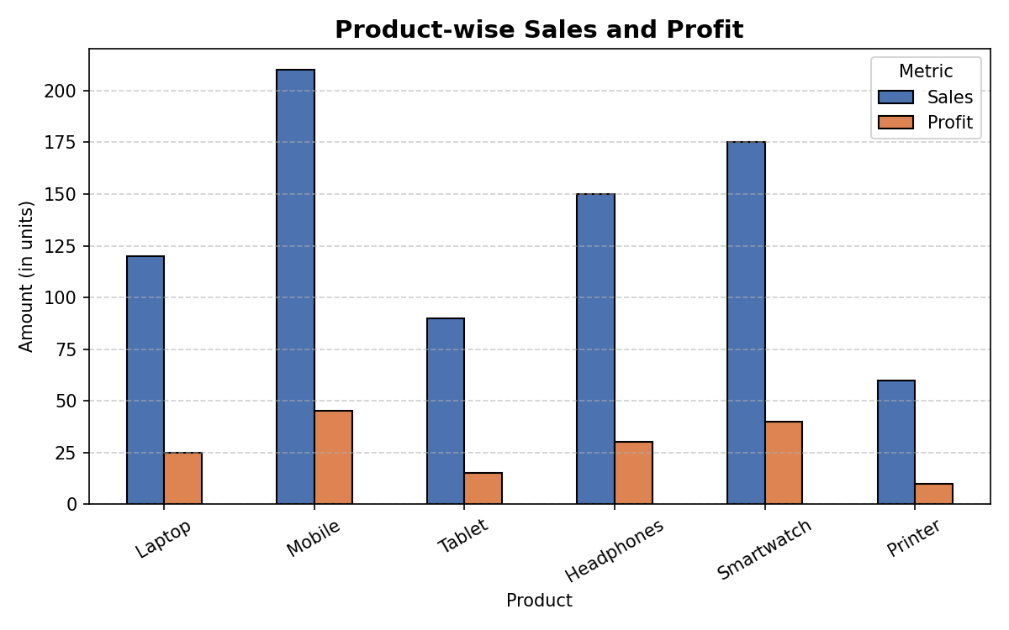
Figure 1: Product-wise Sales and Profit (Pandas grouped bar chart)
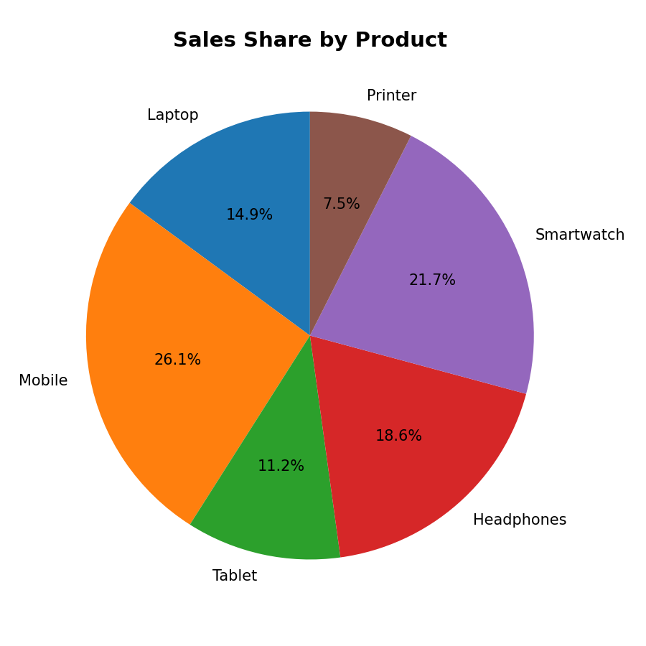
Figure 2: Sales Share by Product (Pandas pie chart)
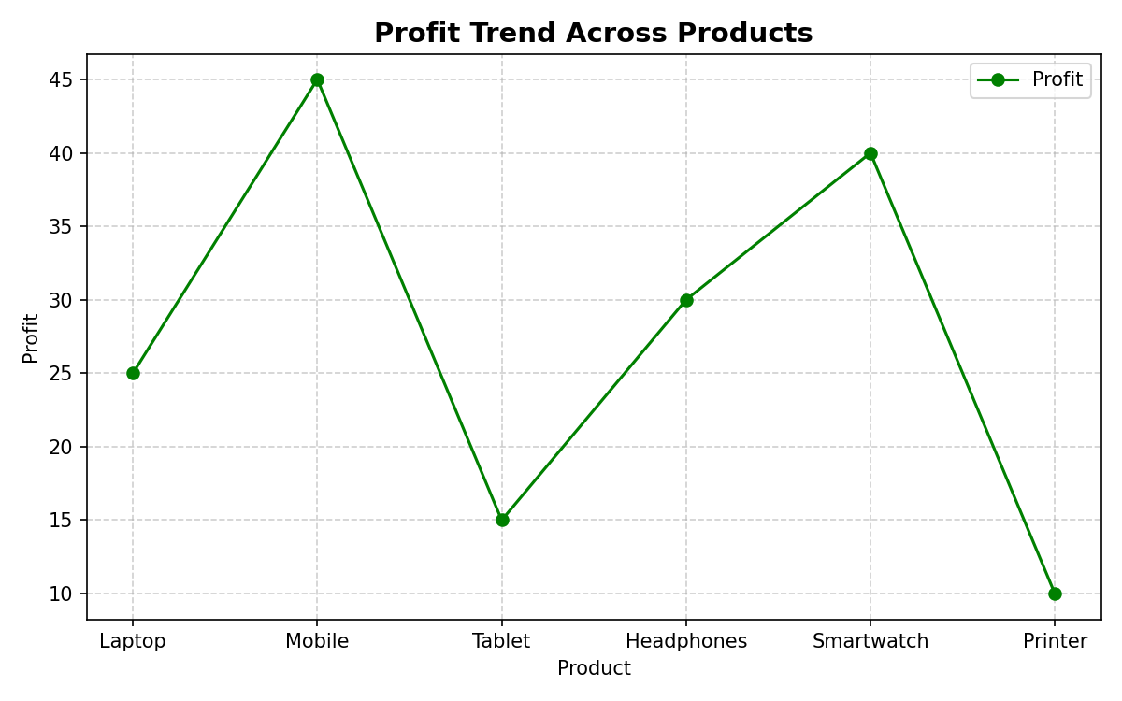
Figure 3: Profit Trend Across Products (Pandas line plot)

Observations
• Mobile recorded the highest Sales (210 units) as well as the highest Profit (45 units), making it the strongest-performing product.
• The pie chart shows Mobile contributes the largest share of total sales, followed by Smartwatch and Headphones.
• The line plot indicates that profit generally tracks the sales pattern across products, dipping for Tablet and Printer, which also have the lowest sales figures — suggesting a positive relationship between sales volume and profit for this dataset.

Selected Activity 2 (from 6–12): Activity 7 – Distribution Visualization
Task: Create a histogram of student marks or employee salaries. Identify the approximate shape, center, spread, and possible skewness.

Approach
A dataset of 200 simulated student marks (out of 100) was generated using a normal distribution (mean = 68, standard deviation = 12), then clipped to a valid 0–100 range. A histogram with 15 bins was plotted using Matplotlib, with vertical reference lines marking the mean and median to aid interpretation of the distribution's center and shape.

Python Code
"""
Activity 7: Distribution Visualization
Task: Create a histogram of student marks or employee salaries.
Identify the approximate shape, center, spread, and possible skewness.
"""

import numpy as np
import pandas as pd
import matplotlib.pyplot as plt

# ---- Step 1: Generate a dataset of student marks (out of 100) ----
np.random.seed(42)
marks = np.random.normal(loc=68, scale=12, size=200) # roughly normal distribution
marks = np.clip(marks, 0, 100) # keep marks within valid range

df = pd.DataFrame({"Marks": marks})

# ---- Step 2: Plot histogram ----
plt.figure(figsize=(8, 5))
plt.hist(df["Marks"], bins=15, color="#55A868", edgecolor="black", alpha=0.85)
plt.axvline(df["Marks"].mean(), color="red", linestyle="--", linewidth=2,
label=f"Mean = {df['Marks'].mean():.2f}")
plt.axvline(df["Marks"].median(), color="blue", linestyle="--", linewidth=2,
label=f"Median = {df['Marks'].median():.2f}")
plt.title("Distribution of Student Marks", fontsize=14, fontweight="bold")
plt.xlabel("Marks")
plt.ylabel("Frequency (No. of Students)")
plt.legend()
plt.grid(axis="y", linestyle="--", alpha=0.6)
plt.tight_layout()
plt.savefig("task7_histogram.png", dpi=150)
plt.close()

# ---- Step 3: Summary statistics for interpretation ----
mean_val = df["Marks"].mean()
median_val = df["Marks"].median()
std_val = df["Marks"].std()
skew_val = df["Marks"].skew()

print("Summary Statistics:")
print(f"Mean = {mean_val:.2f}")
print(f"Median = {median_val:.2f}")
print(f"Std Dev= {std_val:.2f}")
print(f"Skewness = {skew_val:.3f}")

Summary Statistics
Mean = 67.51
Median = 67.95
Std Dev = 11.16
Skewness = 0.127

Visualization Output
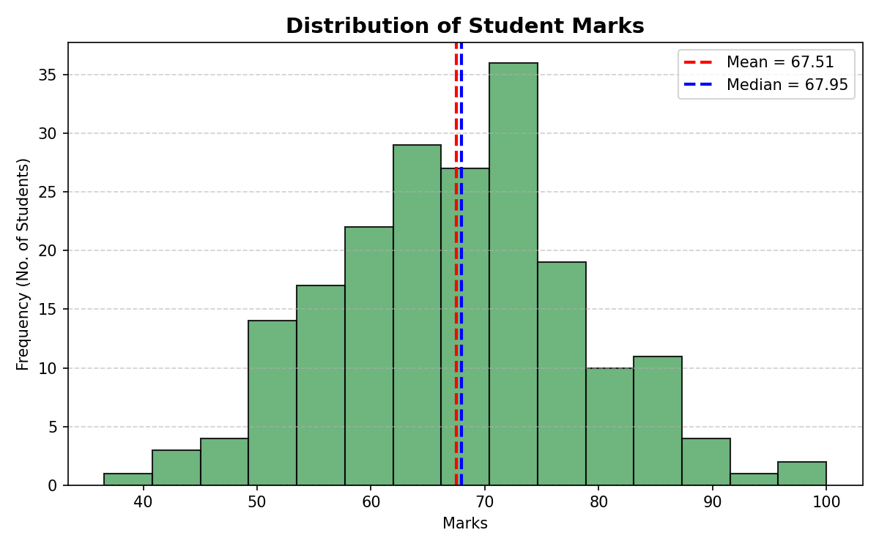
Figure 4: Distribution of Student Marks (Histogram with mean and median)

Observations
• Shape: The histogram is approximately bell-shaped (roughly symmetric / mound-shaped), consistent with a near-normal distribution.
• Center: The mean (67.51) and median (67.95) are very close to each other, confirming an approximately symmetric distribution centered around 67–68 marks.
• Spread: The standard deviation of about 11.16 marks indicates a moderate spread, with most students scoring roughly between 56 and 79 marks (within one standard deviation of the mean).
• Skewness: The skewness value of 0.127 is very close to zero, indicating the distribution is nearly symmetric with only a very slight right (positive) skew — i.e., a marginally longer tail toward higher marks.

