

SIMATS ENGINEERING

Saveetha Institute of Medical and Technical Sciences
Chennai- 602105

NAME: B. JAI SRINIVASAN
REG. NO: 192524151
COURSE CODE: DSA0502
COURSE: QUERY PROCESSING
CO2 – AT2

QUESTION 1
Online Shopping System
Database tables include:
- Customer(CustomerID, Name)
- Product(ProductID, ProductName, Price)
- Order(OrderID, CustomerID, OrderDate)
- OrderDetails(OrderID, ProductID, Quantity)
Each order may contain multiple products.
CODE:
import sqlite3
# -----------------------------
# Connect to SQLite Database
# -----------------------------
conn = sqlite3.connect("shopping.db")
cursor = conn.cursor()
# -----------------------------
# Create Tables
# -----------------------------
cursor.execute("""
CREATE TABLE IF NOT EXISTS Customer(
CustomerID INTEGER PRIMARY KEY,
Name TEXT
)
""")
cursor.execute("""
CREATE TABLE IF NOT EXISTS Product(
ProductID INTEGER PRIMARY KEY,
ProductName TEXT,
Price REAL
)
""")
cursor.execute("""
CREATE TABLE IF NOT EXISTS Orders(
OrderID INTEGER PRIMARY KEY,
CustomerID INTEGER,
OrderDate TEXT,
FOREIGN KEY(CustomerID) REFERENCES Customer(CustomerID)
)
""")
cursor.execute("""
CREATE TABLE IF NOT EXISTS OrderDetails(
OrderID INTEGER,
ProductID INTEGER,
Quantity INTEGER,
PRIMARY KEY(OrderID, ProductID),
FOREIGN KEY(OrderID) REFERENCES Orders(OrderID),
FOREIGN KEY(ProductID) REFERENCES Product(ProductID)
)
""")
# -----------------------------
# Delete Old Data (Optional)
# -----------------------------
cursor.execute("DELETE FROM OrderDetails")
cursor.execute("DELETE FROM Orders")
cursor.execute("DELETE FROM Product")
cursor.execute("DELETE FROM Customer")
# -----------------------------
# Insert Sample Data
# -----------------------------
customers = [
(1, "Rahul"),
(2, "Priya")
]
products = [
(101, "Laptop", 55000),
(102, "Mouse", 700),
(103, "Keyboard", 1200),
(104, "Headphones", 2500)
]

orders = [
(201, 1, "2026-08-01"),
(202, 2, "2026-08-02")
]
order_details = [
(201, 101, 1),
(201, 102, 2),
(202, 103, 1),
(202, 104, 1)
]
cursor.executemany("INSERT INTO Customer VALUES (?,?)", customers)
cursor.executemany("INSERT INTO Product VALUES (?,?,?)", products)
cursor.executemany("INSERT INTO Orders VALUES (?,?,?)", orders)
cursor.executemany("INSERT INTO OrderDetails VALUES (?,?,?)", order_details)
conn.commit()
# =====================================================
# CREATE OPERATION
# =====================================================
cursor.execute("INSERT INTO Orders VALUES (203,1,'2026-08-03')")
cursor.execute("INSERT INTO OrderDetails VALUES (203,104,2)")
conn.commit()
print("===== CREATE OPERATION =====")
print("New Order Added Successfully\n")
# =====================================================
# READ OPERATION
# =====================================================
print("===== READ OPERATION =====\n")
query = """
SELECT
Customer.Name,
Orders.OrderID,
Orders.OrderDate,
Product.ProductName,
Product.Price,
OrderDetails.Quantity,
(Product.Price * OrderDetails.Quantity) AS Total
FROM Orders
JOIN Customer
ON Orders.CustomerID = Customer.CustomerID
JOIN OrderDetails
ON Orders.OrderID = OrderDetails.OrderID
JOIN Product
ON OrderDetails.ProductID = Product.ProductID
ORDER BY Orders.OrderID;
"""
cursor.execute(query)
rows = cursor.fetchall()
for row in rows:
print("Customer :", row[0])
print("Order ID :", row[1])
print("Date :", row[2])
print("Product :", row[3])
print("Price :", row[4])
print("Quantity :", row[5])
print("Total :", row[6])
print("--------------------------------")
# =====================================================
# UPDATE OPERATION
# =====================================================
cursor.execute("""
UPDATE OrderDetails
SET Quantity = 3
WHERE OrderID = 201 AND ProductID = 102
""")
conn.commit()
print("\n===== UPDATE OPERATION =====")
print("Quantity Updated Successfully")
# =====================================================
# DELETE OPERATION
# =====================================================
cursor.execute("""
DELETE FROM OrderDetails
WHERE OrderID = 202
AND ProductID = 104
""")
conn.commit()
print("\n===== DELETE OPERATION =====")
print("Product Deleted Successfully")
conn.close()

OUTPUT:
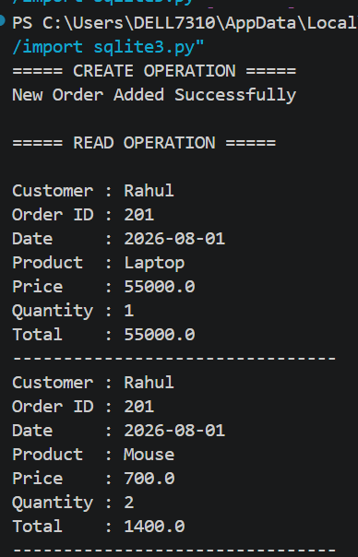
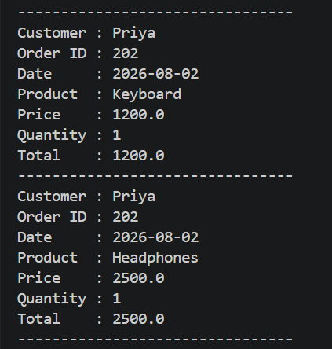
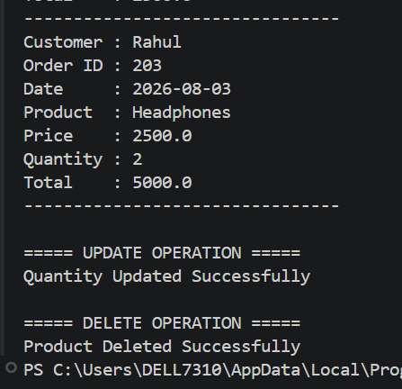
Viva Questions
Q1. Why is the OrderDetails table required in this schema?
Ans:
The Order_Details table is required to manage the many-to-many relationship between Orders and Products. A single order can contain multiple products, and a product can be included in many different orders. It stores the Product_ID and Quantity for each order, avoiding data duplication and ensuring proper database normalization.
Q2. What would happen if ProductID were stored directly in the Order table?
Ans:
If Product_ID were stored directly in the Orders table, each order could contain only one product. To store multiple products in the same order, the order information would have to be repeated, causing data redundancy, wasted storage, and update, insertion, and deletion anomalies. Therefore, using a separate Order_Details table is the correct and efficient database design.
QUESTION 2
Hotel Reservation System
Tables:
- Customer(CustomerID, Name)
- Room(RoomID, RoomType)
- Reservation(ReservationID, CustomerID, RoomID, CheckIn, CheckOut)
Rooms can be booked by different customers at different times.
CODE:
import sqlite3

# Connect Database
conn = sqlite3.connect("hotel.db")
cursor = conn.cursor()
# -----------------------------
# Create Tables
# -----------------------------
cursor.execute("""
CREATE TABLE IF NOT EXISTS Customer(
CustomerID INTEGER PRIMARY KEY,
Name TEXT
)
""")
cursor.execute("""
CREATE TABLE IF NOT EXISTS Room(
RoomID INTEGER PRIMARY KEY,
RoomType TEXT
)
""")
cursor.execute("""
CREATE TABLE IF NOT EXISTS Reservation(
ReservationID INTEGER PRIMARY KEY,
CustomerID INTEGER,
RoomID INTEGER,
CheckIn TEXT,
CheckOut TEXT,
FOREIGN KEY(CustomerID) REFERENCES Customer(CustomerID),
FOREIGN KEY(RoomID) REFERENCES Room(RoomID)
)
""")
# -----------------------------
# Delete Previous Data
# -----------------------------
cursor.execute("DELETE FROM Reservation")
cursor.execute("DELETE FROM Room")
cursor.execute("DELETE FROM Customer")
# -----------------------------
# Insert Sample Data
# -----------------------------
customers = [
(1,"Rahul"),
(2,"Priya")
]
rooms = [
(101,"Single"),
(102,"Double"),
(103,"Deluxe")
]
reservations = [
(201,1,101,"2026-08-10","2026-08-12"),
(202,2,103,"2026-08-11","2026-08-15")
]
cursor.executemany("INSERT INTO Customer VALUES(?,?)",customers)
cursor.executemany("INSERT INTO Room VALUES(?,?)",rooms)
cursor.executemany("INSERT INTO Reservation VALUES(?,?,?,?,?)",reservations)
conn.commit()
# ==================================================
# CREATE
# ==================================================

cursor.execute("""
INSERT INTO Reservation
VALUES(203,1,102,'2026-08-20','2026-08-23')
""")
conn.commit()
print("Reservation Added Successfully\n")
# ==================================================
# READ
# ==================================================
print("HOTEL RESERVATION DETAILS\n")
query = """
SELECT
Customer.Name,
Room.RoomType,
Reservation.CheckIn,
Reservation.CheckOut
FROM Reservation
JOIN Customer
ON Reservation.CustomerID=Customer.CustomerID
JOIN Room
ON Reservation.RoomID=Room.RoomID
"""
cursor.execute(query)
rows = cursor.fetchall()
for row in rows:
print("Customer :",row[0])
print("Room Type:",row[1])
print("Check In :",row[2])
print("Check Out:",row[3])
print("----------------------------")
# ==================================================
# UPDATE
# ==================================================
cursor.execute("""
UPDATE Reservation
SET CheckOut='2026-08-25'
WHERE ReservationID=203
""")
conn.commit()
print("Reservation Updated Successfully\n")
# ==================================================
# DELETE
# ==================================================
cursor.execute("""
DELETE FROM Reservation
WHERE ReservationID=202
""")

conn.commit()
print("Reservation Cancelled Successfully")
conn.close()

OUTPUT:
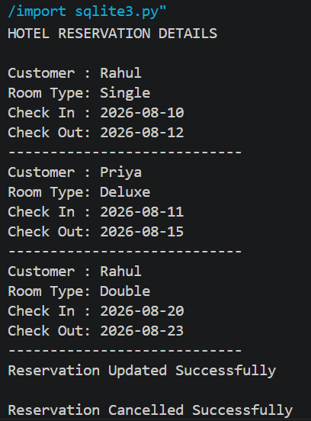
VIVA QUESTIONS:

Q1. Why should reservation details be maintained separately from room details?
Ans:
Reservation details should be maintained separately because a room can be booked many times by different customers. The Room table stores permanent information (such as Room ID and Room Type), while the Reservation table stores temporary booking information (such as Customer ID, Check-In, and Check-Out dates). This avoids data duplication and follows database normalization principles.

Q2. How would you prevent double booking of rooms using the schema?
Ans:
Double booking can be prevented by checking whether the room is already reserved for the requested Check-In and Check-Out dates before inserting a new reservation. If another reservation exists with overlapping dates for the same room, the system should reject the new booking.
Example SQL check:
SELECT *
FROM Reservation
WHERE RoomID = 101
AND CheckIn < '2026-08-15'
AND CheckOut > '2026-08-10';

