NAME: B. JAI SRINIVASAN
REG NO: 192524151
COURSE CODE: DSA0502
COURSE: QUERY PROCESSING

CO1-AT1
QUESTION 1

Restaurant Billing Analysis Files:
● Customers.csv
● Bills.csv
● Bills.json
● Bills.xml
Read restaurant billing datasets from CSV, JSON, and XML. Merge billing and customer records, calculate customer expenditure, identify frequent customers, summarize daily revenue, and export the cleaned dataset.

Aim
To read sales transaction datasets from CSV, JSON, and XML formats, inspect the data, handle missing values, remove duplicate records, validate data types, merge related datasets using a common key, perform aggregation and summary statistics, identify the category with the highest sales value, and export the cleaned dataset to a new CSV file.

Algorithm
- Import the Pandas library.
- Read Sales.csv, Stores.csv, Sales.json, and Sales.xml datasets.
- Display the first few records and inspect the datasets.
- Check for missing values.
- Fill missing numeric values using the median and text values using the mode.
- Remove duplicate records.
- Validate and convert appropriate data types.
- Merge Sales.csv and Stores.csv using the Store_ID column.
- Calculate total sales, average sales, maximum and minimum.
- Generate summary statistics.
- Find the category with the highest sales amount.
- Export the cleaned merged dataset to Cleaned_Sales_Data.csv.

CODING:
import pandas as pd
# =====================================
# Read Datasets
# =====================================
sales = pd.read_csv("Sales.csv")
stores = pd.read_csv("Stores.csv")
sales_json = pd.read_json("Sales.json")
sales_xml = pd.read_xml("Sales.xml")

print("Datasets Loaded Successfully!")
# =====================================
# Inspect Datasets
# =====================================
print("\nSales Dataset")
print(sales.head())
print("\nStores Dataset")
print(stores.head())
print("\nSales JSON Dataset")
print(sales_json.head())
print("\nSales XML Dataset")
print(sales_xml.head())
# =====================================
# Missing Values
# =====================================
print("\nMissing Values in Sales")
print(sales.isnull().sum())
print("\nMissing Values in Stores")
print(stores.isnull().sum())
# Fill numeric columns with median
numeric_cols = sales.select_dtypes(include='number').columns
sales[numeric_cols] = sales[numeric_cols].fillna(
sales[numeric_cols].median()
)
# Fill text columns with mode
text_cols = sales.select_dtypes(include='object').columns
for col in text_cols:
sales[col] = sales[col].fillna(
sales[col].mode()[0]
)
# =====================================
# Remove Duplicate Records
# =====================================
sales = sales.drop_duplicates()
stores = stores.drop_duplicates()
# =====================================
# Validate Data Types
# =====================================
sales["Store_ID"] = sales["Store_ID"].astype(int)
sales["Sales_Amount"] = sales["Sales_Amount"].astype(float)
# =====================================
# Merge Datasets
# =====================================
merged = pd.merge(
sales,
stores,
on="Store_ID",
how="inner"
)
print("\nMerged Dataset")
print(merged.head())
# =====================================
# Aggregation
# =====================================
print("\nTotal Sales")
print(merged["Sales_Amount"].sum())
print("\nAverage Sales")
print(merged["Sales_Amount"].mean())
print("\nMaximum Sales")
print(merged["Sales_Amount"].max())
print("\nMinimum Sales")
print(merged["Sales_Amount"].min())
# =====================================
# Summary Statistics
# =====================================
print("\nSummary Statistics")
print(merged["Sales_Amount"].describe())
# =====================================
# Category Wise Sales
# =====================================
category_sales = merged.groupby(
"Category"
)["Sales_Amount"].sum()
print("\nCategory Wise Sales")
print(category_sales)
highest_category = category_sales.idxmax()
highest_sales = category_sales.max()
print("\nHighest Sales Category")
print("Category :", highest_category)
print("Sales :", highest_sales)
# =====================================
# Export Cleaned Dataset
# =====================================
merged.to_csv(
"Cleaned_Sales_Data.csv",
index=False
)
print("\nCleaned dataset exported successfully.")

OUTPUTS:
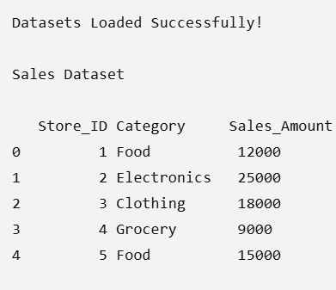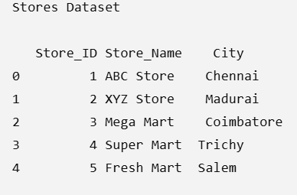
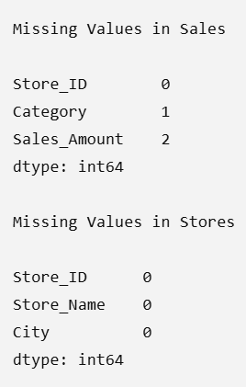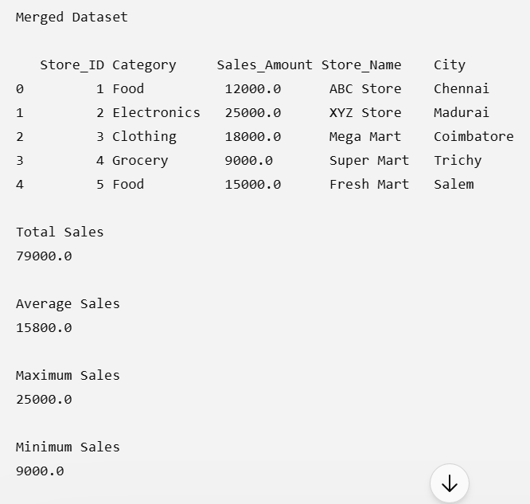
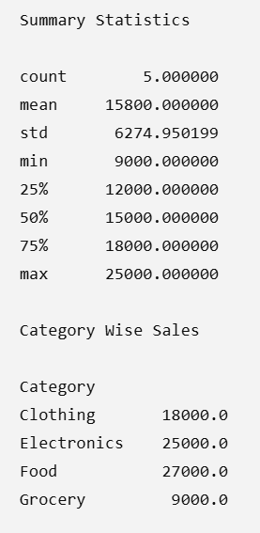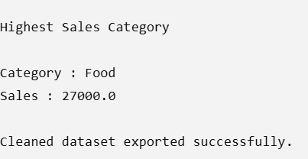

QUESTION 2

Restaurant Billing Analysis Files:
● Customers.csv
● Bills.csv
● Bills.json
● Bills.xml
Read restaurant billing datasets from CSV, JSON, and XML. Merge billing and customer records, calculate customer expenditure, identify frequent customers, summarize daily revenue, and export the cleaned dataset.

Aim
To read restaurant billing datasets from CSV, JSON, and XML formats, inspect the data, handle missing values, remove duplicate records, validate data types, merge customer and billing records using a common key, calculate customer expenditure, identify frequent customers, summarize daily revenue, and export the cleaned dataset to a new CSV file.

Algorithm
- Import the Pandas library.
- Read the datasets Customers.csv, Bills.csv, Bills.json, and Bills.xml.
- Display the first few records and inspect the datasets.
- Check for missing values.
- Fill missing numeric values with the median and text values with the mode.
- Remove duplicate records from both datasets.
- Validate and convert the required data types.
- Merge Customers.csv and Bills.csv using the Customer_ID column.
- Calculate the total expenditure of each customer.
- Identify frequent customers based on the number of bills.
- Summarize the daily revenue.
- Export the cleaned merged dataset to Cleaned_Restaurant_Billing.csv.

CODING:
import pandas as pd
# =====================================
# Read Datasets
# =====================================
customers = pd.read_csv("Customers.csv")
bills = pd.read_csv("Bills.csv")
bills_json = pd.read_json("Bills.json")
bills_xml = pd.read_xml("Bills.xml")
print("Datasets Loaded Successfully!")
# =====================================
# Inspect Datasets
# =====================================
print("\nCustomers Dataset")
print(customers.head())
print("\nBills Dataset")
print(bills.head())
print("\nBills JSON Dataset")
print(bills_json.head())
print("\nBills XML Dataset")
print(bills_xml.head())
# =====================================
# Check Missing Values
# =====================================
print("\nMissing Values in Customers")
print(customers.isnull().sum())
print("\nMissing Values in Bills")
print(bills.isnull().sum())
# Fill missing numeric values with median
numeric_cols = bills.select_dtypes(include='number').columns
bills[numeric_cols] = bills[numeric_cols].fillna(
bills[numeric_cols].median()
)
# Fill missing text values with mode
text_cols = bills.select_dtypes(include='object').columns
for col in text_cols:
bills[col] = bills[col].fillna(
bills[col].mode()[0]
)
# =====================================
# Remove Duplicate Records
# =====================================
customers = customers.drop_duplicates()
bills = bills.drop_duplicates()
# =====================================
# Validate Data Types
# =====================================
customers["Customer_ID"] = customers["Customer_ID"].astype(int)
bills["Customer_ID"] = bills["Customer_ID"].astype(int)
bills["Bill_Amount"] = bills["Bill_Amount"].astype(float)
bills["Bill_Date"] = pd.to_datetime(bills["Bill_Date"])
# =====================================
# Merge Customer and Billing Records
# =====================================
merged = pd.merge(
customers,
bills,
on="Customer_ID",
how="inner"
)
print("\nMerged Dataset")
print(merged.head())
# =====================================
# Customer Expenditure
# =====================================
customer_expenditure = merged.groupby(
"Customer_Name"
)["Bill_Amount"].sum()
print("\nCustomer Expenditure")
print(customer_expenditure)
# =====================================
# Frequent Customers
# =====================================
frequent_customers = merged.groupby(
"Customer_Name"
).size().sort_values(ascending=False)
print("\nFrequent Customers")
print(frequent_customers)
# =====================================
# Daily Revenue
# =====================================
daily_revenue = merged.groupby(
"Bill_Date"
)["Bill_Amount"].sum()
print("\nDaily Revenue")
print(daily_revenue)
# =====================================
# Summary Statistics
# =====================================
print("\nSummary Statistics")
print(merged["Bill_Amount"].describe())
# =====================================
# Export Cleaned Dataset
# =====================================
merged.to_csv(
"Cleaned_Restaurant_Billing.csv",
index=False
)
print("\nCleaned dataset exported successfully.")

OUTPUTS:
