- CS Login: **dspatel6**

- Wisc ID: **9085310937**

- Email: **dspatel6@wisc.edu /** [**dspatel6@cs.wisc.edu**](mailto:dspatel6@cs.wisc.edu)

**CPU Specifications**

**- Processor 13th Gen Intel(R) Core(TM) i5-1350P 1.90 GHz**

**- Installed RAM 16.0 GB (15.4 GB usable)**

**- Total Cores 12**

**- Performance-cores 4**

**- Efficient-cores 8**

**- Total Threads 16**

**- Max Turbo Frequency 4.70 GHz**

**- Performance-core Max Turbo Frequency 4.70 GHz**

**- Efficient-core Max Turbo Frequency 3.50 GHz**

**Memory bandwidth**

**DDR5-4800 (Dual-Channel)**

**Memory speed: 4800 MT/s**

**Bus width per DIMM: 64 bits (8 bytes)**

**Channels: 2 (dual-channel)**

**4800 × 8 × 2 = 76.8 GB/s**

**Compiler**

**```bash**

**$ g++ --version**

**g++ (Ubuntu 14.2.0-16ubuntu1) 14.2.0**

**Copyright (C) 2024 Free Software Foundation, Inc.**

**This is free software; see the source for copying conditions. There is NO**

**warranty; not even for MERCHANTABILITY or FITNESS FOR A PARTICULAR PURPOSE.**

**```**

**OS**

**```bash**

**$ cat /etc/os-release**

**PRETTY_NAME="Ubuntu Plucky Puffin (development branch)"**

**NAME="Ubuntu"**

**VERSION_ID="25.04"**

**```**

**Compilation command**

**```bash**

**$ make**

**```**

**Results for our implementation:**



**Observations:**

* **In case of 512 * 512 resolution, changing block-size to higher block-sizes does not impact the performance significantly**
* **We see a huge performance increase when going from number-of-threads 1 to 6, but same is not true when moving from 6 to 12. This might be because we must be hitting memory bounds before we hit the compute bounds. It is easily evident from the 4086 * 4086 resolution matrix**
* **With higher resolutions of matrices, the block-size parameter has a higher impact on performance than the smaller resolutions**
* **In higher resolutions, there is a lot of performance which is left on the table which is achieved by using parallel compute**

**Results for MKL-based implementation:**

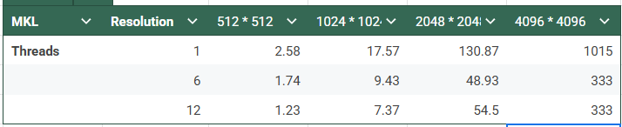

**Observations:**

* **In MKL-based implementation, we no longer see performance improvement when moving from 6 to 12 threads.**