BANKING SECTOR
Customer Churn Prediction
& Business Intelligence Analysis

An End-to-End Data Analytics Project
Excel → SQL → Python (Machine Learning) → Power BI

Prepared By | Divyaa Shri B
Role | Data Analyst
Domain | Banking / Financial Services
Tools Used | MS Excel · MySQL · Python · Power BI
Report Date | September 2026

Table of Contents
1. Executive Summary
2. Problem Statement
2.1 Business Background
2.2 Business Problem
3. Objectives
3.1 Business Objectives
3.2 Analytical Objectives
3.3 Success Criteria
4. Proposed Solution & Approach
5. Tools & Technologies Used
6. Methodology / Project Workflow
7. Phase 1 — Data Preparation in Excel
7.1 Steps Performed in Excel
7.2 Why This Step Matters
8. Phase 2 — Database Design & Analysis in SQL
8.1 Database & Table Creation
8.2 Data Loading
8.3 Exploratory SQL Analysis
9. Phase 3 — Data Analysis & Machine Learning in Python
9.1 Data Understanding
9.2 Data Quality Assessment
9.3 Feature Engineering (Python)
9.4 Target Variable & Exploratory Data Analysis
9.5 Churn Analysis (Feature Relationships)
9.6 Churn Rate Analysis by Segment
9.7 Statistical Testing
9.8 High-Risk Customer Analysis
9.9 Machine Learning Data Preparation
9.10 Machine Learning Models Built
9.11 Model Evaluation
9.12 Model Comparison
9.13 Cross-Validation
9.14 Final Model Selection
9.15 Feature Importance Analysis
9.16 Prediction, Risk Segmentation, Scenario & Forecast
9.17 Exporting Results for Power BI
10. Phase 4 — Business Intelligence Dashboard in Power BI
10.1 Dashboard Structure
10.2 – 10.8 Page-by-Page Breakdown (7 Pages)
11. Key Business Insights
12. Strategic Business Recommendations
13. Conclusion

1. Executive Summary
Customer attrition is one of the most expensive problems a retail bank faces — acquiring a new customer typically costs far more than retaining an existing one. This project builds an end-to-end analytics solution that analyzes the behavior of 28,382 bank customers, identifies the key drivers behind why customers leave, predicts which customers are at risk using machine learning, and translates those predictions into a business-ready decision-support dashboard.
The project was executed across four connected stages — Excel for data preparation and feature engineering, SQL (MySQL Workbench) for structured data storage and exploratory querying, Python for deep exploratory analysis, statistical testing and machine learning, and Power BI for an interactive six-page executive dashboard. A Random Forest classifier was selected as the final churn-prediction model after comparing it against Logistic Regression, Decision Tree, and XGBoost, achieving the strongest overall balance of accuracy, ROC-AUC, and cross-validated stability.
Project Snapshot
- 28,382 customers analyzed | 25 original data attributes
- Overall churn rate: 18.53% (5,260 churned vs. 23,122 retained)
- 4 machine learning models built, evaluated and cross-validated
- Random Forest selected as final model — ROC-AUC 0.845, 5-fold CV mean 0.833
- 621 customers flagged as Very High Risk, requiring immediate retention action
- 6-page interactive Power BI dashboard delivering KPIs, drivers and strategic recommendations

2. Problem Statement

2.1 Business Background
Banks invest significant resources in acquiring new customers through marketing campaigns, promotions, and relationship-building activities. However, customer acquisition costs are typically much higher than customer retention costs. When customers leave the bank, the institution not only loses recurring revenue but also forfeits the investment made in acquiring and servicing that relationship.

2.2 Business Problem
The bank is experiencing customer attrition, where customers stop using banking services or close their accounts, and currently has no proactive system in place to identify customers who are at risk of leaving before they actually do. The challenge is to analyze customer demographic, financial, and behavioral data to understand why customers churn, and to build a system that can flag at-risk customers early enough for the retention team to intervene.

3. Objectives

3.1 Business Objectives
- Analyze customer behavior and churn patterns across the customer base.
- Identify the key factors and drivers that influence customer churn.
- Segment customers based on their churn risk level.
- Develop a machine learning model to predict which customers are likely to churn.
- Provide actionable, targeted retention strategies for the business.

3.2 Analytical Objectives
The project was structured to answer specific business questions across four themes:

Customer Profile Analysis
- Which age groups have the highest churn rates?
- Does gender influence churn behavior?
- Which occupations experience higher churn?

Financial Behavior Analysis
- Do customers with lower account balances churn more frequently?
- Is there a relationship between credit/debit activity and churn?
- How does net worth category relate to attrition risk?

Engagement & Predictive Analysis
- Does customer tenure (vintage) and transaction recency affect churn?
- Which machine learning model predicts churn most reliably?
- Which features contribute most to the prediction, and how can risk be scored for every customer?

3.3 Success Criteria

Business Success
- High-risk customers can be identified early, before they actually churn.
- Retention campaigns can be targeted effectively at the right segments.
- Churn-related insights are clear and actionable for business stakeholders.

Analytical Success
- The model achieves strong, statistically validated predictive performance (ROC-AUC, recall, cross-validation stability).
- Findings are statistically significant (validated via Chi-Square hypothesis testing) rather than anecdotal.

4. Proposed Solution & Approach
The proposed solution is an end-to-end customer churn analytics pipeline that moves the raw dataset through progressively deeper layers of processing — structured storage, statistical and predictive analysis, and finally a decision-ready visual dashboard — so that both technical and non-technical stakeholders can act on the findings.
- Prepare and enrich the raw dataset in Excel with feature-engineered columns needed for downstream analysis (vintage in years, vintage segment, age group, balance segment).
- Store the enriched dataset in a relational database (MySQL) and perform foundational SQL-based exploratory analysis to validate churn patterns at the database layer.
- Perform deep exploratory data analysis, statistical hypothesis testing, and customer segmentation in Python to scientifically validate churn drivers.
- Train, evaluate, and compare multiple machine learning classification models, select the best-performing model, and use it to score every customer with a churn probability and risk level.
- Run business scenario and forecast simulations to estimate the impact of different retention strategies.
- Export all prediction outputs into Power BI and build a 7-page interactive navigation dashboard combining KPIs, visual analysis, predictive results, and strategic recommendations for business decision-makers.

5. Tools & Technologies Used
Layer | Tool / Technology | Purpose
Data Preparation | MS Excel | Data cleaning, CSV-to-Excel conversion
Database | MySQL Workbench (SQL) | Database design, data loading, exploratory SQL analysis
Analysis & Modeling | Python (VS Code, Jupyter Notebook) | EDA, statistical testing, ML model building & evaluation
Libraries | Pandas, NumPy, scikit-learn, XGBoost, matplotlib, seaborn, SciPy | Data manipulation, ML algorithms, statistical tests, visualization
Visualization | Power BI | Interactive 7-page executive dashboard with KPIs and insights

6. Methodology / Project Workflow
This project follows an end-to-end customer churn analytics workflow, beginning with data preparation and progressing through exploratory analysis, machine learning model development, predictive analytics, and business recommendations. Each stage feeds directly into the next, ensuring traceability from the raw Kaggle dataset to the final business dashboard.
1 | Data Collection | Raw dataset sourced from Kaggle (churn_prediction data)
2 | Data Preparation (Excel) | Cleaning, formatting, and feature engineering
3 | Database Storage (SQL) | Table design, data load, exploratory SQL queries
4 | Exploratory Data Analysis (Python) | Univariate, bivariate, statistical analysis
5 | Statistical Testing | Chi-Square tests to validate significant churn drivers
6 | Machine Learning Modeling | Train & evaluate 4 classification models
7 | Model Selection & Feature Importance | Cross-validation, final model, key driver ranking
8 | Predictive Analytics | Churn probability, risk segmentation, scenario & forecast analysis
9 | Business Intelligence (Power BI) | 6-page interactive dashboard with insights & recommendations

The following sections describe each of these four phases — Excel, SQL, Python, and Power BI — in full detail, covering every step and method used.

7. Phase 1 — Data Preparation in Excel
The raw dataset was sourced from Kaggle as a CSV file containing banking customer records with demographic, financial, and transactional attributes. Before any database work or analysis, the data was prepared and enriched in Microsoft Excel.

7.1 Steps Performed in Excel
1. Source the raw dataset — Downloaded the bank customer churn dataset from Kaggle as a CSV file.
2. Convert to Excel format — Converted the CSV into an Excel workbook (.xlsx) to allow easier manual inspection, formatting, and formula-based feature engineering.
3. Initial data review — Reviewed column headers, data types, and spot-checked values for obvious inconsistencies before engineering new columns.
4. Engineer the 'vintage in years' column — Converted the existing 'vintage' field (customer tenure, recorded in days) into a more business-friendly 'vintage in years' figure.
5. Engineer the 'vintage segmentation' column — Bucketed customers into tenure-based segments (e.g., New Customer, Regular Customer, Loyal Customer) using the vintage-in-years value, to support engagement-based churn analysis later in Python and Power BI.
6. Engineer the 'age group' column — Binned the continuous 'age' field into business-relevant age brackets (18-25, 26-35, 36-45, 46-55, 55+) for demographic-level churn analysis.
7. Engineer the 'balance segment' column — Bucketed customer account balances into Low / Medium / High balance segments to support financial-behavior churn analysis.
8. Confirm the 'churn' target column — Verified the binary churn indicator column (1 = churned, 0 = retained) was correctly populated and consistently coded, since this becomes the target variable for every downstream analysis and machine learning model.
9. Save the enriched dataset — Saved the enriched file as the working dataset (churn_prediction.xlsx / churn_prediction.csv) to be loaded into MySQL for the next phase.

7.2 Why This Step Matters
Feature engineering at the Excel stage created the categorical groupings (age group, balance segment, vintage segment) that are used consistently across every later stage of the project — from SQL GROUP BY queries, to Python EDA and statistical testing, to the filters and visuals in the final Power BI dashboard. Performing this once, early, and consistently ensured that every downstream tool referenced the same business-friendly categories.

8. Phase 2 — Database Design & Analysis in SQL (MySQL Workbench)
With the dataset enriched in Excel, the next phase moved the data into a structured relational database using MySQL Workbench. This served two purposes: giving the data a proper structured home, and validating initial churn patterns using SQL before moving into deeper Python-based analysis.

8.1 Database & Table Creation
A dedicated database (bank_churn) and a customer_churn table were created with an explicit schema covering all 25 customer attributes, including primary key constraints on customer_id and appropriately typed columns for demographic, financial, and engineered fields (vintage_in_years, vintage_segmentation, age_group, balance_segment).
- CREATE DATABASE IF NOT EXISTS bank_churn — created the project database.
- DROP TABLE IF EXISTS customer_churn — ensured a clean slate before table creation.
- CREATE TABLE customer_churn (...) — defined all 25 columns with appropriate data types (INT, DECIMAL, VARCHAR, TINYINT) including customer_id as PRIMARY KEY.

8.2 Data Loading
The enriched CSV file was bulk-loaded into the customer_churn table using MySQL's LOAD DATA LOCAL INFILE command, with field and line terminators configured to correctly parse the comma-separated, quote-enclosed source file, and the header row skipped on import.

8.3 Exploratory SQL Analysis
A series of aggregate SQL queries were run directly against the database to validate churn patterns at the source before any Python analysis began. Key queries included:
- Total Customers — a simple COUNT(*) to confirm the full customer base size (28,382 records).
- Churn Summary — SUM(churn), retained count, and overall churn rate using AVG(churn)*100.
- Churn by Gender — grouped churn rate comparison across gender categories.
- Churn by Age Group — grouped churn rate comparison across the engineered age_group field.
- Churn by Occupation — grouped churn rate comparison across occupation categories.
- Churn by Customer Net-Worth Category — grouped churn rate by customer_nw_category.
- Churn by Balance Segment — grouped churn rate by the engineered balance_segment field.
- Average Balance by Churn Status — comparing average current and current-month balances between churned and retained customers.
- Transaction Activity Analysis — churn rate segmented by last_transaction recency.
- Customer Balance Statistics — MIN, MAX, AVG, and STDDEV of current_balance across the full customer base.
- High-Value Churned Customers — a targeted query identifying the top 20 churned customers ranked by current balance, to spotlight high-value attrition cases.

SQL Phase — Purpose in the Pipeline
- Established a structured, query-able source of truth for the dataset
- Validated initial churn-rate patterns (by gender, age group, occupation, balance) before deeper Python analysis
- Surfaced high-value churned customers as an early red flag for the business
- Confirmed the dataset was clean and ready for the analytical and ML phases in Python

9. Phase 3 — Data Analysis & Machine Learning in Python
The core analytical work was carried out in a Jupyter Notebook (Customer_Churn_EDA.ipynb), structured as a 23-step, end-to-end analytics pipeline — from data understanding through to final business conclusions. Each step below reflects the actual structure and sequence used in the notebook.

9.1 Data Understanding
The dataset was loaded into the Python environment using pandas, and its structure was explored to understand the available customer information, data types, and overall shape before any cleaning or analysis began.
- Imported core libraries: pandas, NumPy, matplotlib, seaborn, SciPy, and scikit-learn.
- Loaded the enriched CSV into a DataFrame and previewed the first rows.
- Checked dataset shape — confirmed 28,382 rows and 25 columns.
- Reviewed column names, data types, and generated summary statistics (mean, std, min, max, quartiles) for numerical fields.
- Reviewed the target variable (churn) to understand its distribution ahead of modeling.

9.2 Data Quality Assessment
Before analysis, the dataset was checked for completeness and integrity issues that could bias results or affect model performance.
- Missing Value Analysis — counted null values across all columns to identify fields requiring imputation or exclusion.
- Duplicate Analysis — checked for fully duplicated customer records; the dataset was confirmed to contain zero duplicate rows.
This step confirmed the dataset was largely complete and reliable, giving confidence in the downstream statistical and modeling results.

9.3 Feature Engineering (Python)
Building on the Excel-stage features, additional behavioral features were engineered directly in Python to better capture customer engagement and activity trends:
- Date Feature Processing — parsed and standardized date-type fields for downstream calculations.
- days_since_last_transaction — calculated transaction recency, a key engagement signal.
- Balance Change % — percentage change between current and previous month balances, capturing financial trend direction.
- Credit Activity Change — change in monthly credit activity between periods.
- Debit Activity Change — change in monthly debit activity between periods.

9.4 Target Variable & Exploratory Data Analysis (EDA)
With the target variable (churn) profiled, a broad exploratory analysis was conducted across both numerical and categorical features.

Numerical Analysis
- Generated summary statistics for all numeric fields.
- Conducted skewness analysis to identify heavily skewed distributions (e.g., balance fields) requiring careful interpretation.
- Visualized distributions of key numerical features (age, balance, credit/debit activity, vintage).

Categorical Analysis
- Frequency distribution analysis across all categorical fields.
- Deep-dive into gender distribution and occupation distribution across the customer base.

9.5 Churn Analysis (Feature Relationships)
Each feature was analyzed specifically against the churn outcome to surface early behavioral patterns.

Numerical Features vs. Churn
- Age vs. Churn
- Balance vs. Churn
- Credit Activity vs. Churn
- Debit Activity vs. Churn
- Vintage (tenure) vs. Churn
- Transaction Recency vs. Churn

Categorical Features vs. Churn
- Gender vs. Churn
- Occupation vs. Churn
- Net Worth Category vs. Churn

9.6 Churn Rate Analysis by Segment
Churn rate was calculated precisely across every major customer segment to quantify — not just visualize — where attrition risk concentrates:
- Churn rate by Age Group
- Churn rate by Gender
- Churn rate by Occupation
- Churn rate by Net Worth Category
- Churn rate by Balance Segment
- Churn rate by Vintage Segment
- Churn rate by Number of Dependents

9.7 Statistical Testing
To move beyond visual patterns and establish statistically valid churn drivers, a Chi-Square Test of Independence was applied to every categorical feature against the churn outcome. The objective was to formally determine whether an observed relationship between a feature and churn was statistically significant, or could be attributed to random variation.

Methodology
- Null Hypothesis (H0): the feature is independent of churn (no real relationship).
- Alternative Hypothesis (H1): the feature is significantly associated with churn.
- Significance level (alpha) set at 0.05 — a feature was considered a statistically significant churn driver if its p-value fell below this threshold.
- The test was run programmatically across all categorical features, capturing the Chi-Square statistic, p-value, and degrees of freedom for each.

Result
The test identified 6 statistically significant churn drivers out of the categorical features tested:
Feature | Interpretation
Occupation | Statistically significant association with churn (p < 0.05)
Balance Segment | Statistically significant association with churn (p < 0.05)
Age Group | Statistically significant association with churn (p < 0.05)
Gender | Statistically significant association with churn (p < 0.05)
City | Statistically significant association with churn (p < 0.05)
Customer Net-Worth Category | Statistically significant association with churn (p < 0.05)
This statistical validation gave confidence that the churn drivers highlighted throughout the project — and later surfaced in the Power BI dashboard — are genuine, evidence-based relationships rather than coincidental patterns in the data.

9.8 High-Risk Customer Analysis
Before building predictive models, a rules-based high-risk segmentation exercise was performed directly on the historical data to identify which existing customer segments already show elevated churn rates, and where the greatest retention opportunity lies.
- Segment-Level Customer Analysis — churn rate computed across combinations of key segments.
- High-Risk Group Identification — segments with churn rates well above the portfolio average were flagged.
- Risk Classification — segments categorized into risk tiers.
- Top 10 High-Risk Segments — ranked and visualized for business prioritization.
- Retention Opportunity Detection — segments combining high churn rate with high customer volume were identified as priority retention opportunities.
- Business Priority Assignment & Recommended Retention Actions — each high-risk segment was assigned a recommended action.
- Opportunity Scoring & Ranking — a composite score was used to rank retention opportunities by potential business impact.

9.9 Machine Learning Data Preparation
With the exploratory and statistical groundwork complete, the dataset was prepared for machine learning modeling.
- Defined the target variable (y) as the churn column.
- Defined the feature set (X) from the remaining relevant columns.
- Dropped irrelevant/identifier columns (e.g., customer_id) that would not contribute predictive value.
- Handled missing values in the feature set.
- Applied One-Hot Encoding to convert categorical variables into numerical format suitable for machine learning algorithms.
- Performed a Train-Test Split to create separate training and hold-out evaluation datasets.
- Applied Feature Scaling (standardization) specifically for the Logistic Regression model, which is sensitive to feature magnitude.

9.10 Machine Learning Models Built
Four classification algorithms were trained and evaluated to predict customer churn, ranging from a simple linear baseline to more sophisticated ensemble methods:

1. Logistic Regression
- Trained as a linear baseline model.
- Generated churn predictions and churn probability scores.

2. Decision Tree
- Trained a single decision-tree classifier to capture non-linear relationships.
- Generated predictions and probability scores.

3. Random Forest
- Trained an ensemble of decision trees to reduce overfitting and improve generalization.
- Generated predictions and probability scores.

4. XGBoost
- Trained a gradient-boosted tree ensemble for high-performance classification.
- Generated predictions and probability scores.

9.11 Model Evaluation
Each of the four models was evaluated on the held-out test set using a confusion matrix and a full classification report (precision, recall, F1-score, and support), giving a balanced view of how well each model distinguishes churned customers from retained ones.

9.12 Model Comparison
All four models were compared side-by-side on five standard classification metrics: Accuracy, Precision, Recall, F1-Score, and ROC-AUC. ROC-AUC and Recall were prioritized, since correctly catching customers who will actually churn (recall) is more business-critical than overall accuracy in a churn-prediction use case.
Model | Accuracy | Precision | Recall | F1-Score | ROC-AUC
Logistic Regression | 82.02% | 69.62% | 5.23% | 0.097 | 0.770
Decision Tree | 85.22% | 68.33% | 37.74% | 0.486 | 0.814
Random Forest | 85.80% | 72.69% | 37.45% | 0.494 | 0.845
XGBoost | 86.00% | 67.53% | 47.05% | 0.555 | 0.828

9.13 Cross-Validation
To confirm that model performance would generalize beyond the single train-test split, 5-fold cross-validation was performed on all four models, evaluating the mean ROC-AUC and its standard deviation across folds.
Model | Mean ROC-AUC (5-Fold CV) | Std. Deviation
Logistic Regression | 0.7550 | 0.0130
Decision Tree | 0.7990 | 0.0106
Random Forest | 0.8328 | 0.0068
XGBoost | 0.8160 | 0.0052
Random Forest not only achieved the highest mean cross-validated ROC-AUC, but also one of the lowest standard deviations — indicating consistent, stable performance across different data samples rather than a result specific to one particular train-test split.

9.14 Final Model Selection
Model Selection — Random Forest
- Highest single-split ROC-AUC among all models: 0.845
- Highest mean cross-validated ROC-AUC: 0.833, with strong stability (std dev 0.0068)
- Best precision (72.7%) among all four models — fewer false positives in flagging churn risk
- Balanced overall performance across accuracy, recall and F1-score without the instability seen in other models
- Selected as the final production model for customer churn prediction
Random Forest demonstrated the strongest overall predictive performance based on evaluation metrics and cross-validation results, and was therefore selected as the final model for customer churn prediction and for all downstream predictive analytics.

9.15 Feature Importance Analysis
With Random Forest selected as the final model, its built-in feature importance scores were extracted and ranked to identify which variables contribute most to churn prediction — directly informing which levers the business should focus on.
Rank | Feature | Importance
1 | Current Balance | 13.15%
2 | Balance Change % | 12.48%
3 | Current Month Debit | 6.42%
4 | Current Month Balance | 6.05%
5 | Debit Change % | 5.21%
6 | Average Monthly Balance (Prev. Quarter 2) | 5.03%
7 | Previous Month Debit | 4.90%
The feature importance results reveal a clear pattern: financial-behavior features (current balance, balance change percentage, debit activity) dominate as churn predictors — considerably more influential than static demographic attributes such as age or gender alone. This insight directly informed the business recommendation to prioritize monitoring of balance trends and transaction activity as early-warning signals.

9.16 Customer Churn Prediction, Risk Segmentation, Scenario & Forecast Analysis

Churn Prediction & Probability Scoring
- Applied the final Random Forest model to predict churn outcomes for every customer in the dataset.
- Generated churn probability scores for each customer, providing a confidence measure behind each prediction rather than a simple yes/no flag.

Customer Risk Segmentation
- Categorized every customer into business-friendly risk tiers (Low, Medium, High, Very High) based on predicted churn probability.
- Assigned a Retention Priority and a Recommended Action to each risk tier, translating model output directly into next steps for the retention team.
Risk Level | Customer Count | % of Base
Low Risk | 23,618 | 83.21%
Medium Risk | 1,344 | 4.74%
High Risk | 2,799 | 9.86%
Very High Risk | 621 | 2.19%

Business Scenario Analysis
- Modeled the current baseline churn prediction against alternative retention-campaign scenarios (e.g., varying campaign success rates).
- Built a scenario comparison table to estimate how different retention strategies could shift future churn outcomes.

Future Churn Forecast
- Projected future customer churn under defined business assumptions to support long-term retention planning.
- Framed explicitly as scenario-based estimates rather than statistical time-series forecasts, to set correct expectations for decision-makers.

9.17 Exporting Results for Power BI
The final step of the Python phase was to export all prediction and analysis outputs as clean CSV files, ready to be imported directly into Power BI for dashboard construction:
- prediction_results.csv — per-customer churn predictions, probabilities, and risk levels.
- risk_summary.csv — aggregated customer counts and percentages by risk level.
- business_scenarios.csv — scenario comparison outputs for retention-strategy planning.
- forecast_results.csv — future churn forecast projections.
- feature_importance.csv — ranked feature importance scores from the final Random Forest model.

10. Phase 4 — Business Intelligence Dashboard in Power BI
The final phase brought every prior stage together into a single, interactive, decision-ready dashboard. The prediction, risk, scenario, forecast, and feature-importance CSV files exported from Python were imported into Power BI, where a 6-page navigation dashboard was designed with consistent KPIs, filters, and business insights on every page.

10.1 Dashboard Structure
The dashboard uses a consistent left-hand navigation panel across all pages (Overview, Demographics, Financials, Engagement, Churn Analysis, Predictions, Scenarios), allowing stakeholders to move fluidly between the historical, diagnostic, and predictive views of the same customer base.
- Consistent KPI cards at the top of each page for at-a-glance metrics.
- Interactive filters (e.g., Gender, Age Group, Occupation) allowing dynamic slicing of the visuals.
- A dedicated 'Key Business Insights' or 'Predicted Business Insights' panel on each analytical page, translating charts into plain-language takeaways.
- Data source and model refresh details footer (Model: Random Forest) for transparency and auditability.

10.2 Page 1 — Executive Summary
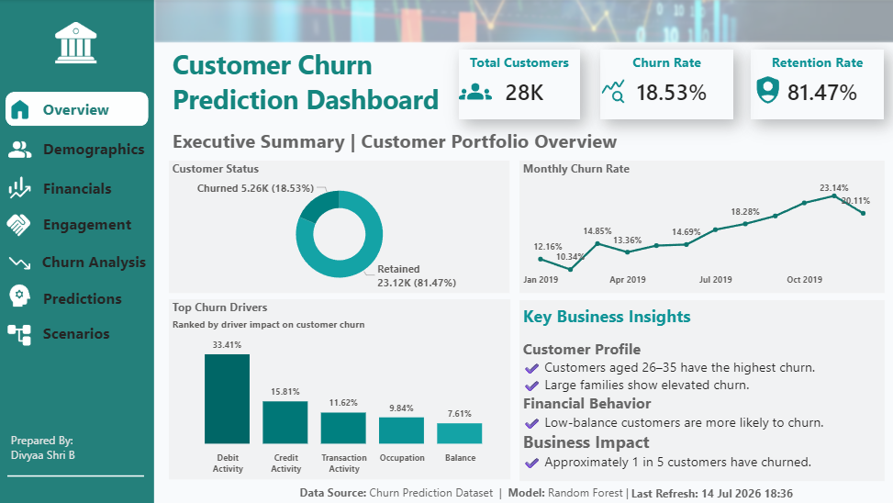
Dashboard Page 1: Executive Summary — Customer Churn Prediction Overview
The landing page delivers the headline portfolio metrics at a glance: 28K total customers, an 18.53% churn rate, and an 81.47% retention rate. A donut chart breaks down churned vs. retained customers, while a monthly churn-rate trend line shows churn climbing from around 10-12% early in the year to a peak above 23% later in the year. A ranked bar chart of top churn drivers (Debit Activity, Credit Activity, Transaction Activity, Occupation, Balance) sets up the diagnostic story continued on later pages, alongside a written summary of key business insights on customer profile, financial behavior, and overall business impact.

10.3 Page 2 — Customer Demographics
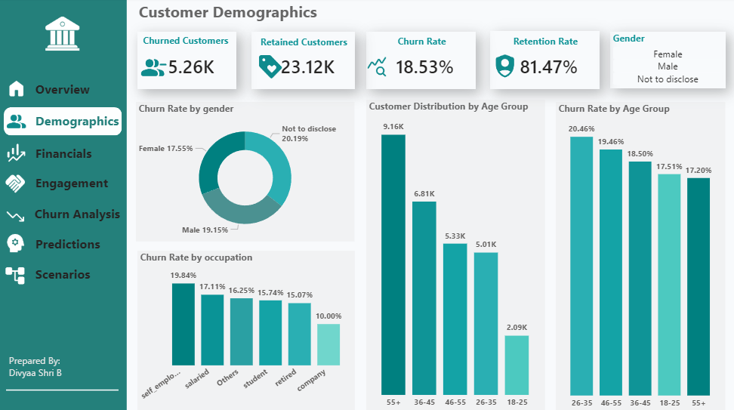
Dashboard Page 2: Customer Demographics
This page breaks churn down by gender, age group, and occupation. Churn rate is fairly close across gender categories (Female 17.55%, Male 19.15%, Not-to-disclose 20.19%), while age shows a much sharper pattern — the 26-35 age group has the highest churn rate (20.46%), tapering down through older age brackets. Self-employed customers churn at the highest rate among occupation categories (19.84%), notably higher than salaried or company-employed customers.

10.4 Page 3 — Financial Analysis
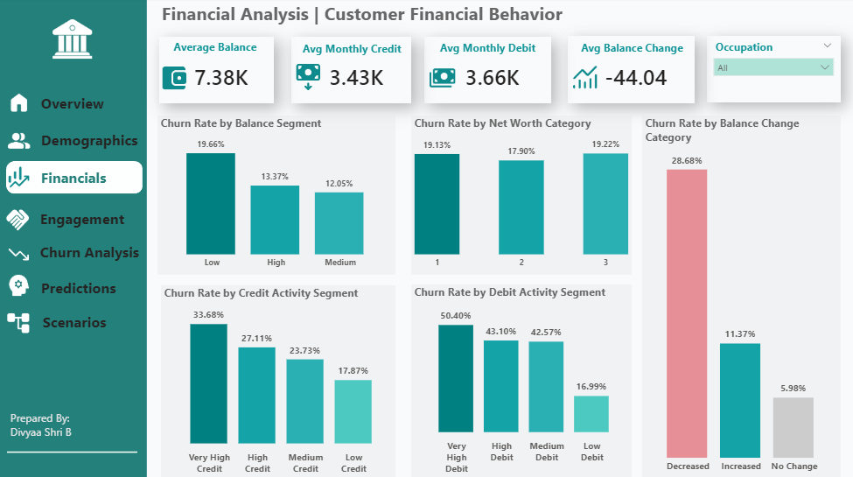
Dashboard Page 3: Financial Analysis — Customer Financial Behavior
The financial view is where the strongest churn signals emerge. Customers in the Low balance segment churn at 19.66% versus 12.05% for Medium and 13.37% for High — confirming balance level as a meaningful risk factor. The starkest pattern is in the Balance Change Category chart: customers whose balance decreased churn at 28.68%, nearly five times the rate of those with no balance change (5.98%). Debit and credit activity show a similar gradient, with Very High Debit Activity customers churning at 50.40% — by far the strongest single behavioral signal on this page.

10.5 Page 4 — Customer Relationship Analysis
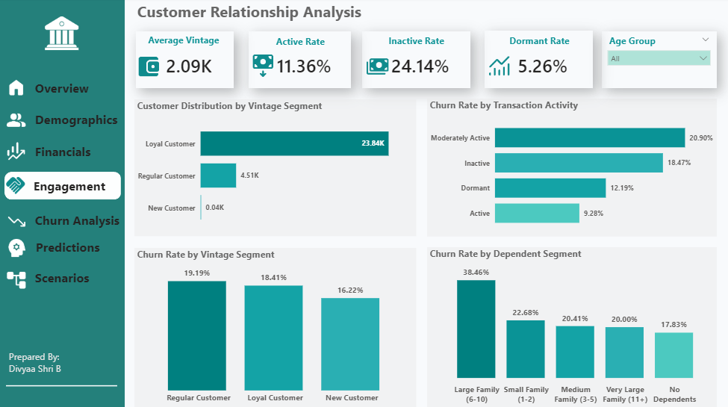
Dashboard Page 4: Customer Relationship Analysis — Engagement
This page examines tenure and household structure. The customer base is overwhelmingly composed of Loyal Customers (23.84K), yet loyal and regular customers churn at similar rates (19.19% and 18.41% respectively) — suggesting tenure alone is not a strong protective factor. Family size shows a clearer gradient: customers with Large Families (6-10 dependents) churn at 38.46%, more than double the rate of customers with No Dependents (17.83%), making household size a notable secondary risk factor.

10.6 Page 5 — Customer Churn Analysis
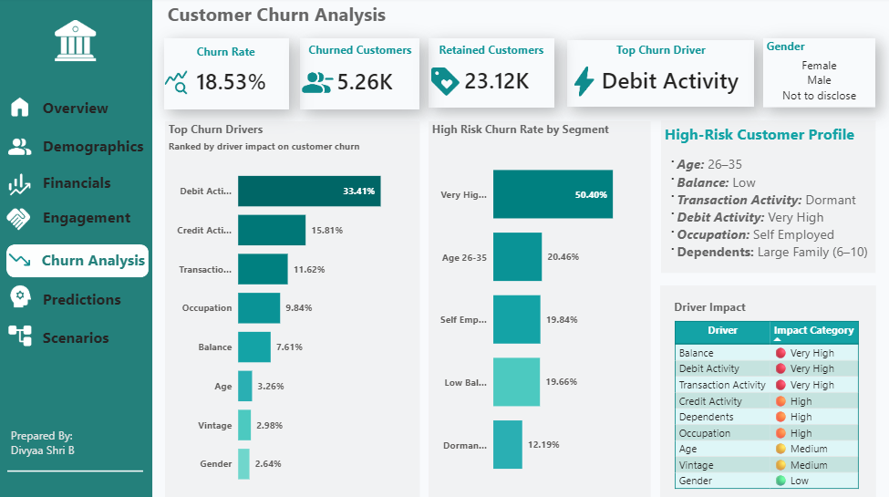
Dashboard Page 5: Customer Churn Analysis — Driver Ranking & High-Risk Profile
This page consolidates the diagnostic findings into a single driver-ranked view, confirming Debit Activity (33.41% impact) as the top churn driver, followed by Credit Activity (15.81%) and Transaction Activity (11.62%). A composite 'High-Risk Customer Profile' box distills these findings into a single actionable description: a self-employed customer aged 26-35, with a low balance, dormant transaction activity, very high debit activity, and a large family (6-10 dependents) — the archetype the retention team should prioritize.

10.7 Page 6 — Predictive Customer Churn Analytics
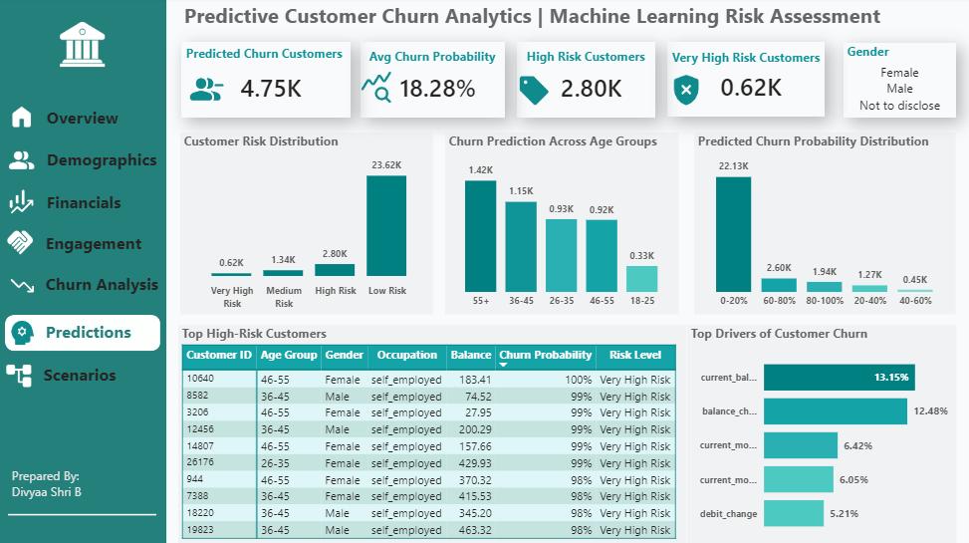
Dashboard Page 6: Predictive Customer Churn Analytics — Machine Learning Risk Assessment
This page surfaces the Random Forest model's output directly: 4.75K customers are predicted to churn, at an average predicted churn probability of 18.28%. The risk distribution shows 2.80K High Risk and 620 Very High Risk customers requiring priority attention. A ranked table of the highest-risk individual customers (by churn probability) gives the retention team a ready-to-action worklist, while a driver chart confirms current balance and balance-change percentage as the model's top predictive features — consistent with the Python feature-importance analysis.

10.8 Page 7 — Business Action Scenarios
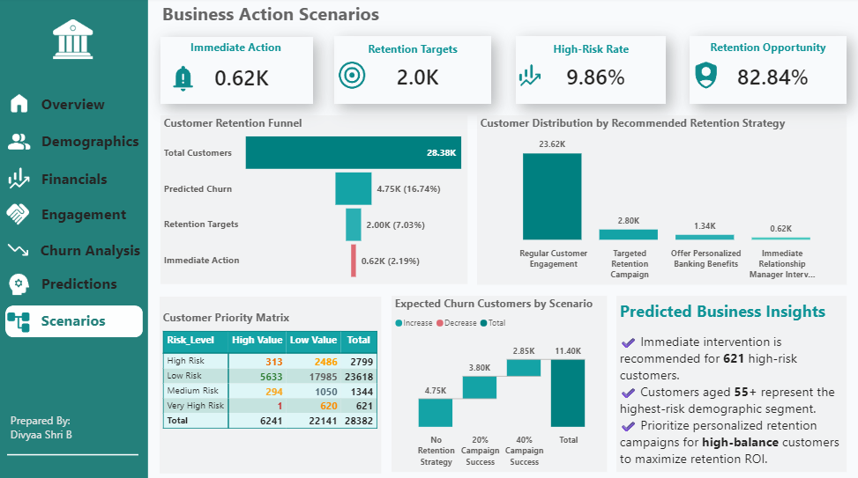
Dashboard Page 7: Business Action Scenarios
The final page converts predictive output into a business action plan. A retention funnel shows the path from the full 28.38K customer base down to 4.75K predicted churns, 2.00K retention targets, and 620 customers requiring immediate action. A customer priority matrix cross-tabs risk level against customer value (High/Low), and a waterfall chart models how different retention-campaign success rates (0%, 20%, 40%) would reduce the expected number of churned customers — directly supporting budget and resourcing conversations with leadership.
Power BI Phase — What the Dashboard Delivers
- A single navigable view spanning historical diagnostics through to predictive, forward-looking action
- KPIs and visuals consistent with, and traceable back to, the SQL and Python analysis
- A ready-to-use worklist of the highest-risk customers for the retention team
- Scenario modeling that quantifies the potential impact of different retention campaign strategies

11. Key Business Insights

11.1 Customer Profile
- Customers aged 26-35 have the highest churn rate (20.46%) of any age group, making early-tenure young professionals a priority segment.
- Self-employed customers churn at a higher rate (19.84%) than salaried, company, or retired customers, pointing to income-stability-related attrition risk.
- Large families (6-10 dependents) show a markedly elevated churn rate (38.46%) compared to customers with no dependents (17.83%).

11.2 Financial Behavior
- Low-balance customers are more likely to churn (19.66%) than Medium- or High-balance customers, confirming balance level as a direct risk indicator.
- A decreasing account balance is the single strongest financial red flag: customers with a decreased balance churn at 28.68%, nearly 5x the rate of those with no balance change.
- Very high debit activity is associated with a 50.40% churn rate — the highest churn rate of any single segment across the entire analysis.
- Current balance and balance-change percentage are confirmed by the Random Forest model as the two most important predictive features overall (13.15% and 12.48% importance respectively).

11.3 Statistical Validation
- Chi-Square testing statistically confirmed 6 significant churn drivers: Occupation, Balance Segment, Age Group, Gender, City, and Customer Net-Worth Category — meaning these relationships are unlikely to be due to chance.

11.4 Business Impact
- Approximately 1 in 5 customers (18.53%) has churned — a substantial and costly proportion of the customer base.
- 621 customers (2.19% of the base) are classified as Very High Risk and require immediate relationship-manager intervention.
- A further 2,799 customers (9.86%) are classified as High Risk, representing the next tier of targeted retention campaigns.
- Customers aged 55+ represent the highest-risk demographic segment in absolute volume terms within the predictive model output.

12. Strategic Business Recommendations
Based on the combined SQL, statistical, and machine-learning findings, the following actions are recommended to reduce customer attrition and improve retention ROI:

12.1 Immediate Actions
1. Deploy Relationship Managers to Very High Risk customers — Immediately assign the 621 Very High Risk customers to relationship managers for direct, personalized outreach before they churn.
2. Monitor balance trend as an early-warning signal — Since balance change percentage is a top predictive feature, implement automated alerts when a customer's balance shows a sustained downward trend.
3. Target self-employed and 26-35 age-group customers — Design retention offers and engagement programs specifically tailored to self-employed customers and the 26-35 age bracket, given their elevated churn rates.

12.2 Medium-Term Actions
4. Launch targeted retention campaigns by risk tier — Use the 2.80K High Risk and 1.34K Medium Risk customer segments to run tiered, cost-appropriate retention campaigns rather than a one-size-fits-all approach.
5. Offer personalized banking benefits to high-balance, high-risk customers — Prioritize personalized banking benefits and loyalty incentives for high-value customers who also fall into elevated risk categories, to maximize retention ROI.
6. Re-engage large-family and low-balance segments — Develop family-oriented banking products or dependent-linked benefits for large-family customers, and low-balance engagement programs (e.g., micro-savings nudges) for low-balance customers.

12.3 Long-Term / Strategic Actions
7. Operationalize the churn model into a live monitoring system — Move the Random Forest model from a one-time analysis into a recurring or real-time scoring pipeline, so risk levels stay current as customer behavior evolves.
8. Track retention campaign impact against the scenario model — Use the business-scenario and forecast framework built in Python to measure whether actual retention campaign results are tracking against the modeled 20%/40% success scenarios, and refine strategy accordingly.
9. Extend feature set over time — As new behavioral data becomes available (e.g., digital banking engagement, complaint history), incorporate it into future model iterations to further improve churn prediction precision.

13. Conclusion

13.1 Project Summary
This project analyzed customer churn behavior in the banking sector using exploratory data analysis, statistical testing, customer segmentation, and machine learning techniques, executed across a coordinated Excel → SQL → Python → Power BI pipeline. The objective was to identify churn drivers, predict customer attrition, and provide actionable retention strategies to the business.

13.2 Key Findings
- Customer age, balance level, occupation, and net worth category significantly influence churn behavior, statistically validated via Chi-Square testing.
- High-risk customer segments were successfully identified through both rules-based segmentation and machine-learning-based risk scoring.
- Customer engagement and financial activity (balance trend, debit/credit activity) are stronger churn indicators than demographic factors alone.
- The overall churn rate of 18.53% represents a substantial retention opportunity for the bank.

13.3 Model Performance
Multiple models were evaluated, including Logistic Regression, Decision Tree, Random Forest, and XGBoost. Random Forest achieved the best overall performance based on ROC-AUC, Recall, F1-Score, and cross-validation results, and was therefore selected as the final churn-prediction model.

13.4 Business Impact
- Enables proactive identification of customers at risk of churn, rather than reactive loss reporting.
- Supports targeted retention campaigns and customer engagement initiatives based on data-driven risk tiers.
- Helps reduce customer attrition and the associated revenue loss.
- Improves customer satisfaction and long-term customer value through timely, relevant intervention.

13.5 Final Conclusion
The project successfully identified key churn drivers and developed an effective churn prediction model. By combining structured data engineering, statistical rigor, and machine learning across Excel, SQL, Python, and Power BI, the bank can make data-driven decisions, improve customer retention, and implement proactive strategies to reduce churn and enhance overall business performance.

