WEEK 1 – SPRINT NOTES

Project: Heavy Supplier, Inventory and Warehouse Analytics
Sprint: Week 1 – Foundation and Exploration
Scrum Master: Peter Joy
Team: 3 Data Analysts
Date: 28 – 09 – 2026

- Sprint Goal
Profiling and understanding the available supply-chain datasets, establish data quality and relationship between tables, define an initial KPI framework and identify priority business questions for subsequent analysis.
- Sprint Objectives
- Profile the available datasets.
- Review the field documentation.
- Identify important columns and keys.
- Examine missing values and duplicates.
- Assess data quality and consistency.
- Determine relationships between datasets.
- Develop an initial list of KPIs.
- Identify potential business questions for future analysis.
- Document findings for the team’s GitHub repository.

- Team Members and Responsibilities
Team member | Role | Responsibilities
Joy | Data Analyst / Scrum Master | - Coordinate sprint  - Document notes  - Business questions planning  - Contributing to data analysis
Risleen | Data Analyst | - Data profiling, cleaning and quality assessing  - Determination of relationships between datasets  - Assist in developing initial business questions
Divya | Data Analyst | - Help establish data dictionary  - Identify potential KPIs  - Assist in developing initial business questions

- Datasets
The list of files identified and downloaded are;
- branches.csv
- customers.csv
- inventory.csv
- invoices.csv
- payments.csv
- products.csv
- purchase_orders_header.csv
- purchase_orders_lines.csv
- sales_orders_header.csv
- sales_orders_lines.csv
- stock_ledger.csv
- suppliers.csv
- fields documentation.docx

- Potential KPIs
- Total sales
- Total purchase value
- Inventory quantity/value
- Inventory turnover
- Stockout rate
- Warehouse throughput
- Supplier contribution
- Product movement

- Potential Business Questions
- Which products are fast-moving?
- Which products are slow-moving or potentially dead stock?
- Which warehouse handle the highest volume?
- Which suppliers contribute the most?
- Are there signs of overstocking or stockout risk?
- How does product movement vary over time?

- Decisions Made
Team agreed to;
- use WhatsApp for day-to-day communication.
- conduct regular check-ins.
- Work collaboratively while maintaining individual task ownership.
- Begin with data foundation and exploration before selecting deeper analytical tasks.

- Action Items (after meeting)
Action | Team member(s) responsible
Reviewed project requirements and available datasets | All team members
Profiled dataset structures and identified key fields and relationships. | Divya and Risleen
Reviewed cleaned datasets and established them as the team's working source of truth. | Joy (Scrum master)
Conducted data-quality and consistency checks. | Divya and Risleen
Identified initial business questions and KPI requirements. | All team members
Set up the Power BI data model and imported relevant cleaned datasets. | Joy (Scrum master)
Created initial DAX measures for sales, orders, procurement and inventory. | Joy (Scrum master)
Developed the initial Supply Chain KPI Overview dashboard. | Joy (Scrum master)
Created initial visualizations for branch sales, product movement and supplier procurement. | Joy (Scrum master)
Prepared the foundation for subsequent product, inventory, warehouse, supplier and customer analysis. | Joy (Scrum master)
Creation of Team’s GitHub account and uploading of week 1files | Divya
Documentation of findings during dataset profiling | Divya
Documentation of Sprint note for week 1 | Joy (Scrum master)

- Next Check-in: 02 – 10 - 2026

KPI cards
- Total Sales Revenue
- Total Units Sold
- Total Sales Orders
- Average Order Value
- Total Procurement Spend
- Current Inventory
- Products Below Reorder Level
- Overstocked Products

Visuals
- Sales by Branch
- Products by Units Sold
- Inventory Status
- Procurement Spend by Supplier

Business Questions Identified
Initial Business Questions
- Which products are the fastest- and slowest-moving across branches?
- Which products are currently understocked, adequately stocked, or overstocked?
- Which products present the highest inventory risk based on demand, stock levels, criticality and lead time?
- How does inventory movement vary across products and branches?
- Which branches generate the highest revenue relative to operational cost and warehouse capacity?
- Which suppliers contribute the most to procurement spending?
- How reliable are suppliers in meeting expected delivery dates?
- Does actual supplier delivery performance align with recorded supplier reliability scores?
- Which customer segments generate the highest purchase value and order activity?
- How do sales, invoicing and payment behaviour vary across customers and branches?
- Are inventory levels aligned with actual product demand?
- Which areas present opportunities for inventory, warehouse, supplier or customer optimisation?

Some of the questions answered in week 1
1. The fastest moving product is Pressure Sensor PS-90 and the slowest moving product is Track Roller TR-60
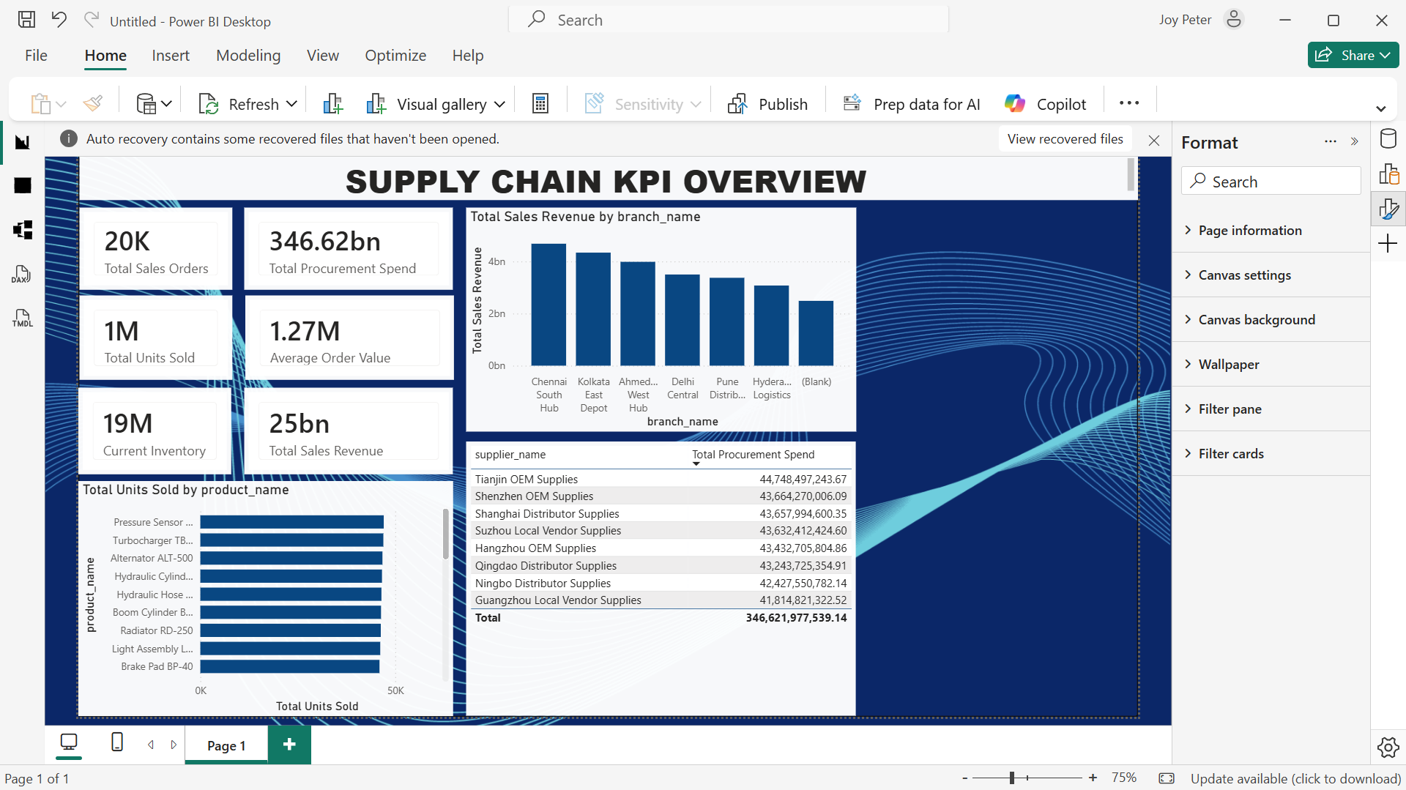

2. All of the products (180) are overstocked
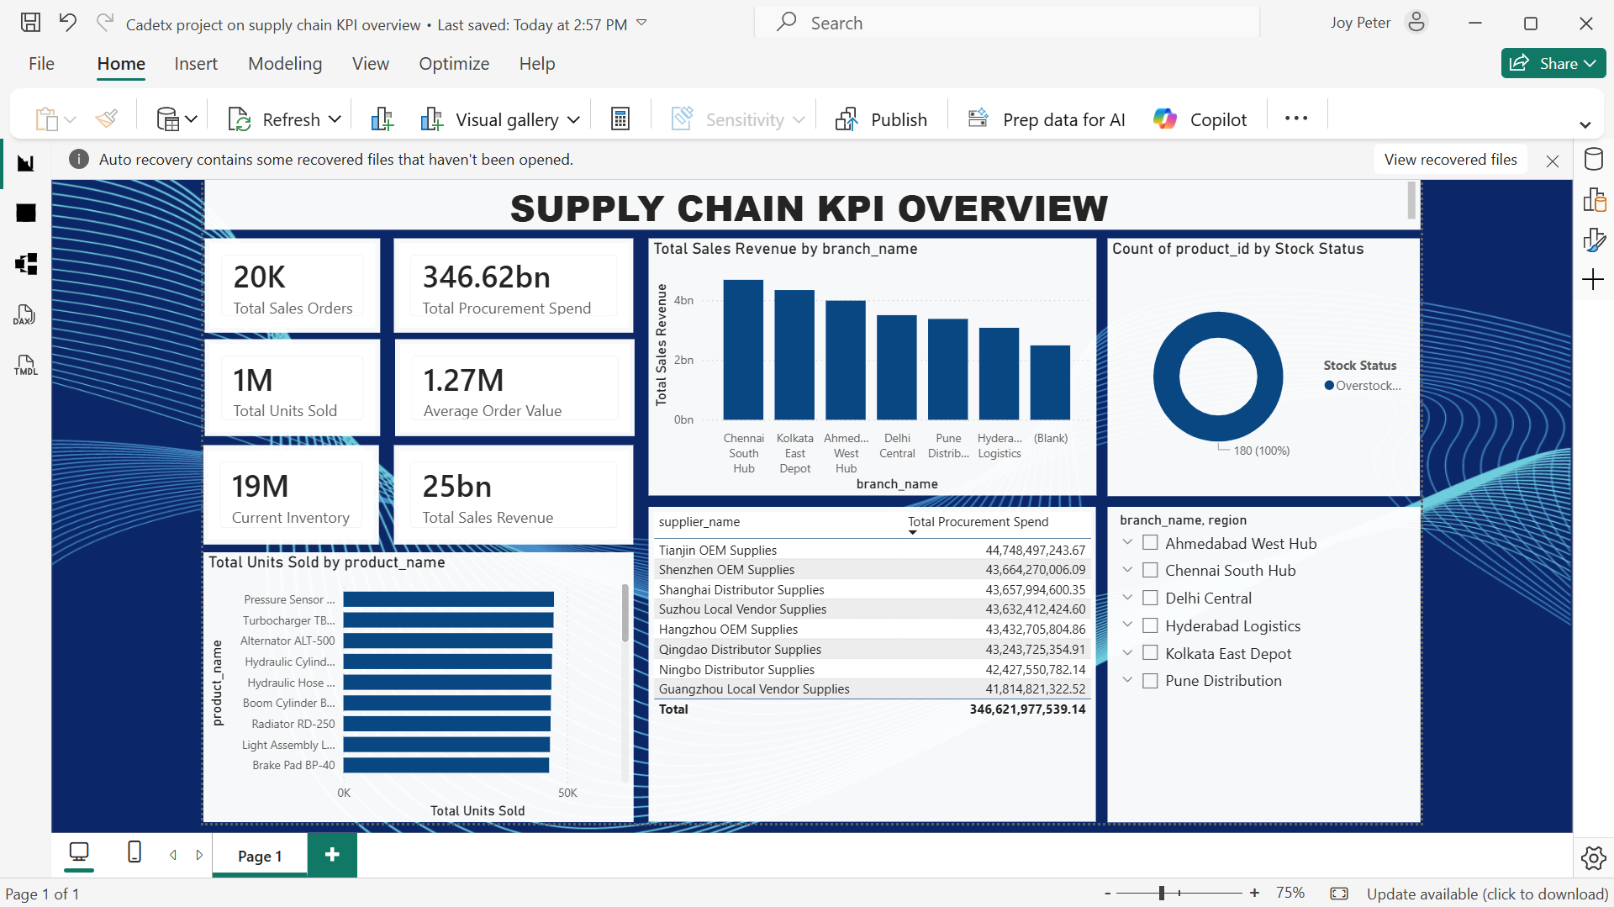

5. Chennai Soouth Hub generates the highest revenue relative to operational cost and warehouse capacity.

6. Tianjin OEM supplies contribute the most to procurement spending

