Python internship
”Password manager”
Prepared by
DIVYA JHA

Executive Summary
This report provides details of the ONLINE PYTHON INTERNSHIP provided by upskill Campus and The IoT Academy in collaboration with Industrial Partner UniConverge Technologies Pvt Ltd (UCT).
This internship was focused on a project/problem statement provided by UCT. We had to finish the project including the report in 4 weeks’ time.
My project was password manager in which I have made the project using python language.
This internship gave me a very good opportunity to get exposure to problems and design/implement solution for that. It was an overall great experience to have this internship.

TABLE OF CONTENTS
1 Preface 3
2 Introduction 4
2.1 About UniConverge Technologies Pvt Ltd 4
2.2 About upskill Campus 8
2.3 Objective 9
2.4 Reference 9
2.5 Glossary 10
3 Problem Statement 11
4 Existing and Proposed solution 12
5 Proposed Design/ Model 13
5.1 High Level Diagram (if applicable) 13
5.2 Low Level Diagram (if applicable) 13
5.3 Interfaces (if applicable) 13
6 Performance Test 14
6.1 Test Plan/ Test Cases 14
6.2 Test Procedure 14
6.3 Performance Outcome 14
7 My learnings 15
8 Future work scope 16

Preface

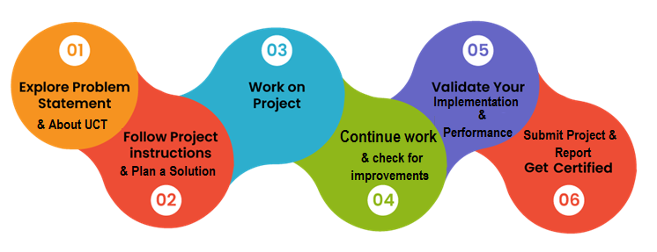
This report presents the work completed during my 4-week Online Python Internship conducted by Upskill Campus in collaboration with UniConverge Technologies Pvt. Ltd. (UCT). The internship provided an excellent opportunity to strengthen my programming skills, gain practical knowledge of Python, and understand the fundamentals of software development through hands-on learning.
During the internship, I learned the core concepts of Python programming, including variables, data types, operators, conditional statements, loops, functions, file handling, and object-oriented programming. I also explored Python libraries such as NumPy and Pandas, which helped me understand data manipulation and numerical computing.
As part of the internship, I designed and developed a Password Manager using Python and SQLite. The project allows users to securely store, search, view, delete, and generate passwords through a modular Python application. This project enhanced my understanding of database connectivity, modular programming, debugging techniques, and problem-solving skills.
The internship not only improved my technical knowledge but also strengthened my confidence in software development, project implementation, and version control using GitHub. It provided practical exposure to real-world project development and encouraged me to apply theoretical concepts to build a functional application.
Overall, this internship has been a valuable learning experience that has contributed significantly to my professional growth. The knowledge and skills acquired during this program will serve as a strong foundation for my future academic projects, internships, and career in software development.

Key Learnings
- Improved Python programming skills.
- Learned NumPy and Pandas for data analysis.
- Developed a Password Manager using Python and SQLite.
- Gained experience in debugging and modular programming.
- Learned GitHub basics for project management and version control.
Acknowledgement
I sincerely thank Upskill Campus, UniConverge Technologies Pvt. Ltd. (UCT)

Introduction

About UniConverge Technologies Pvt Ltd
A company established in 2013 and working in Digital Transformation domain and providing Industrial solutions with prime focus on sustainability and RoI.
For developing its products and solutions it is leveraging various Cutting Edge Technologies e.g. Internet of Things (IoT), Cyber Security, Cloud computing (AWS, Azure), Machine Learning, Communication Technologies (4G/5G/LoRaWAN), Java Full Stack, Python, Front end etc.

- UCT IoT Platform ()
UCT Insight is an IOT platform designed for quick deployment of IOT applications on the same time providing valuable “insight” for your process/business. It has been built in Java for backend and ReactJS for Front end. It has support for MySQL and various NoSql Databases.
- It enables device connectivity via industry standard IoT protocols - MQTT, CoAP, HTTP, Modbus TCP, OPC UA
- It supports both cloud and on-premises deployments.
It has features to
• Build Your own dashboard
• Analytics and Reporting
• Alert and Notification
• Integration with third party application(Power BI, SAP, ERP)
• Rule Engine

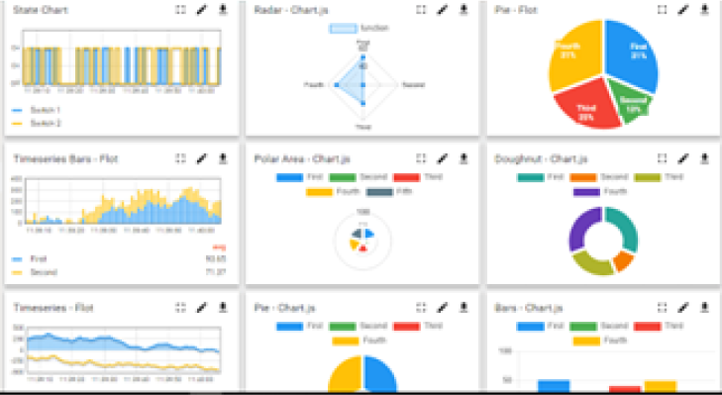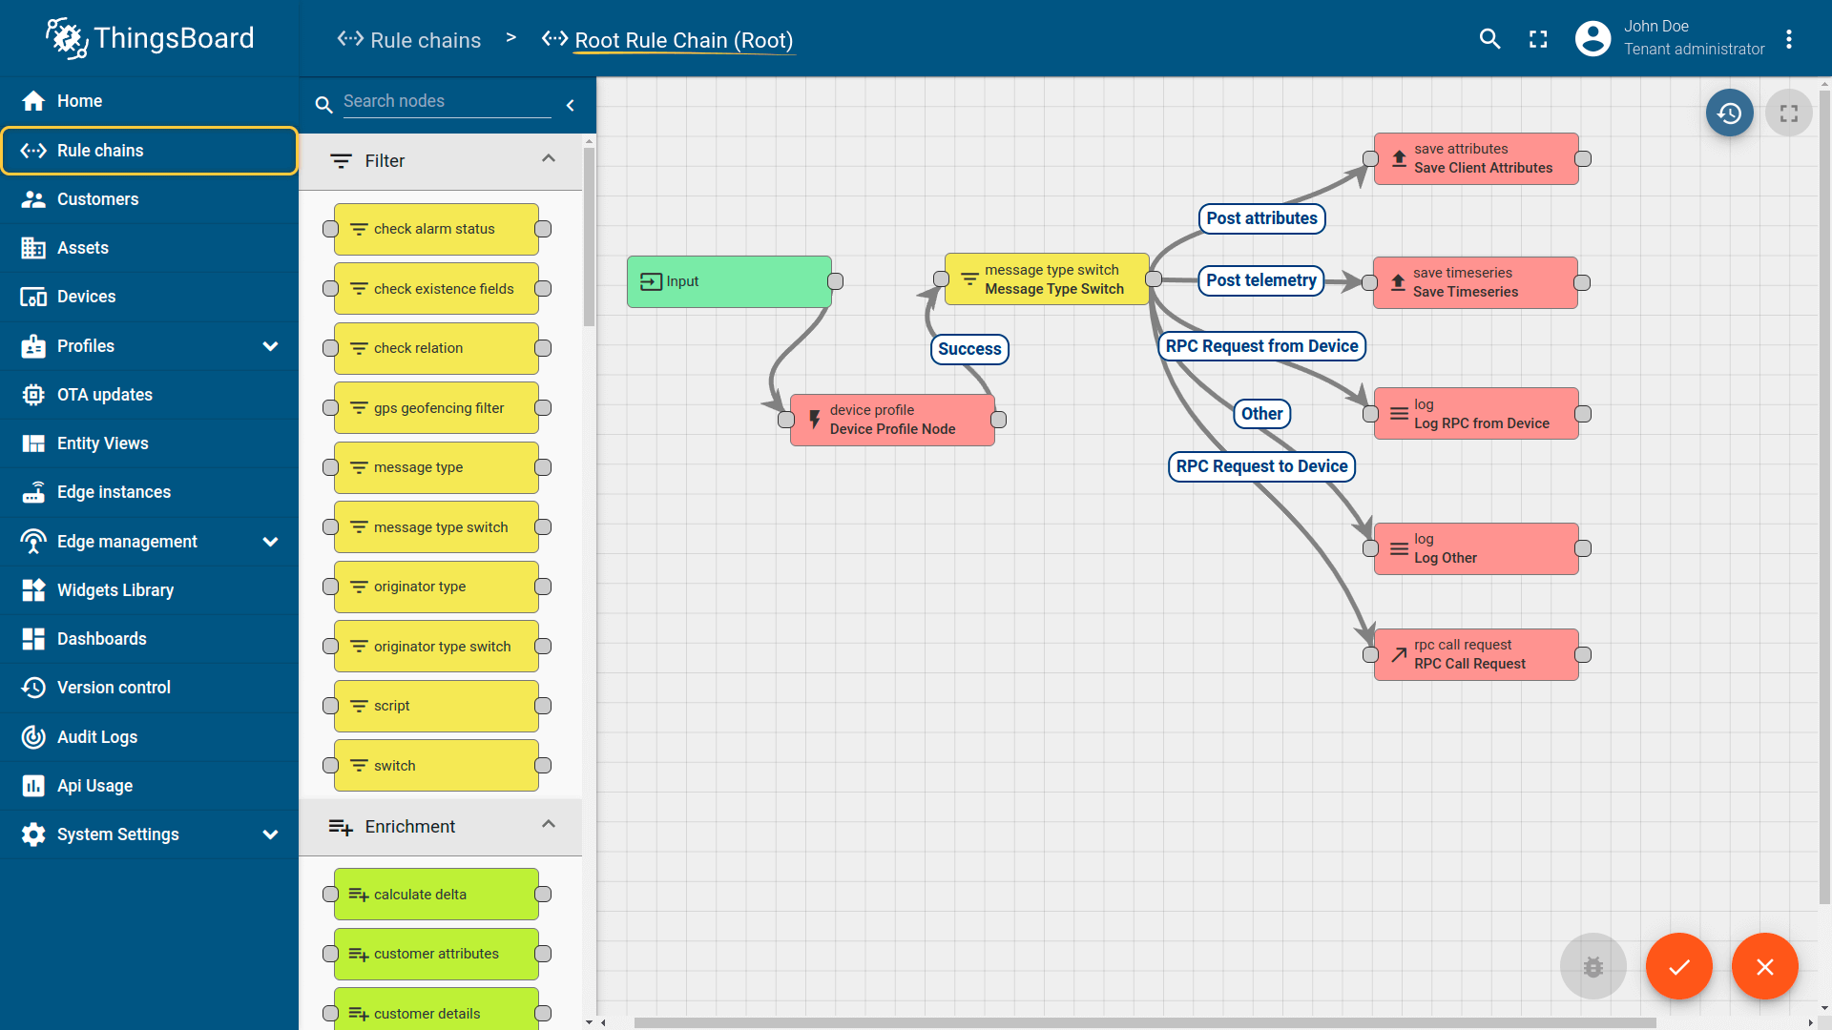

- Smart Factory Platform ()
Factory watch is a platform for smart factory needs.
It provides Users/ Factory
- with a scalable solution for their Production and asset monitoring
- OEE and predictive maintenance solution scaling up to digital twin for your assets.
- to unleased the true potential of the data that their machines are generating and helps to identify the KPIs and also improve them.
- A modular architecture that allows users to choose the service that they what to start and then can scale to more complex solutions as per their demands.
Its unique SaaS model helps users to save time, cost and money.
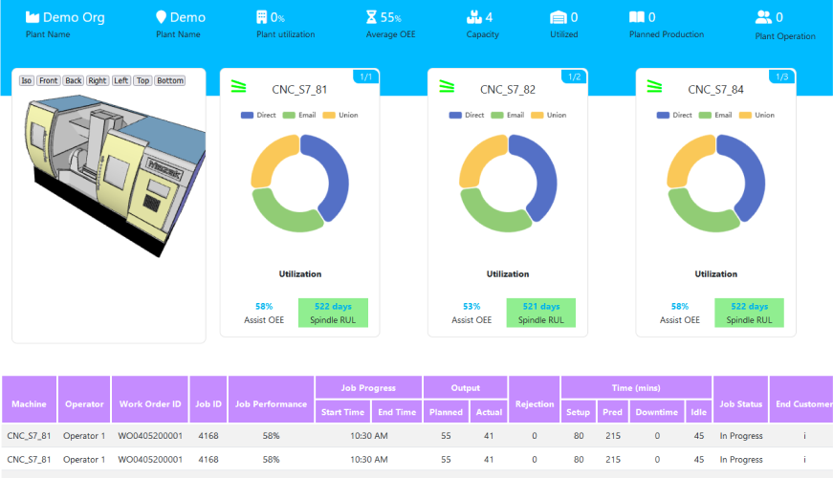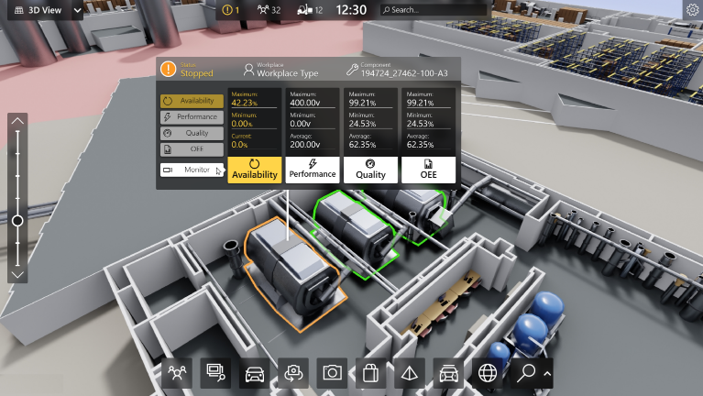

- 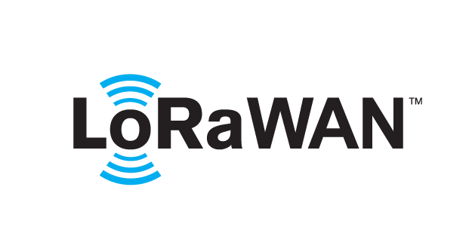 based Solution
UCT is one of the early adopters of LoRAWAN teschnology and providing solution in Agritech, Smart cities, Industrial Monitoring, Smart Street Light, Smart Water/ Gas/ Electricity metering solutions etc.
- Predictive Maintenance
UCT is providing Industrial Machine health monitoring and Predictive maintenance solution leveraging Embedded system, Industrial IoT and Machine Learning Technologies by finding Remaining useful life time of various Machines used in production process.
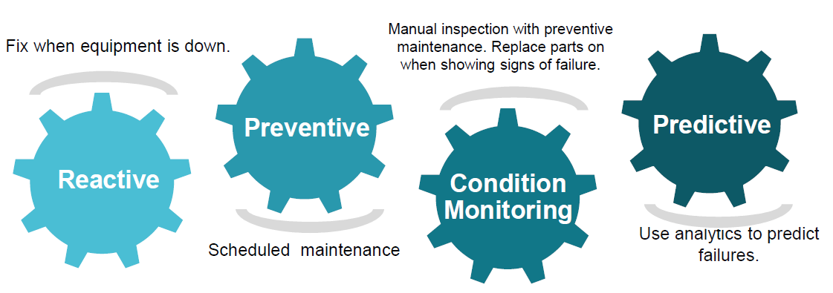

About upskill Campus (USC)
upskill Campus along with The IoT Academy and in association with Uniconverge technologies has facilitated the smooth execution of the complete internship process.
USC is a career development platform that delivers personalized executive coaching in a more affordable, scalable and measurable way.




Seeing need of upskilling in self paced manner along-with additional support services e.g. Internship, projects, interaction with Industry experts, Career growth Services
https://www.upskillcampus.com/
upSkill Campus aiming to upskill 1 million learners in next 5 year

The IoT Academy
The IoT academy is EdTech Division of UCT that is running long executive certification programs in collaboration with EICT Academy, IITK, IITR and IITG in multiple domains.

Objectives of this Internship program
The objective for this internship program was to
☛ get practical experience of working in the industry.
☛ to solve real world problems.
☛ to have improved job prospects.
☛ to have Improved understanding of our field and its applications.
☛ to have Personal growth like better communication and problem solving.

Reference
[1]
[2]
[3]

Glossary
Terms | Acronym

Problem Statement
In today's digital world, users maintain multiple online accounts for banking, education, social media, shopping, email, and various other services. Remembering different usernames and strong passwords for each account can be difficult. As a result, many users either reuse the same password across multiple platforms or store their passwords in notebooks or plain text files, which creates serious security risks.
Traditional methods of password management are not only inconvenient but also vulnerable to unauthorized access and data loss. There is a need for a simple, secure, and efficient system that enables users to store, organize, search, and manage their passwords in one place.
To address this problem, a Password Manager using Python and SQLite has been developed. The application allows users to securely store website credentials, search for saved passwords, view all stored records, delete unnecessary entries, and generate strong random passwords. SQLite is used as the backend database to ensure reliable local storage, while Python provides an easy-to-use and modular implementation.
This project aims to simplify password management while improving data organization and reducing the risk associated with weak or repeated passwords.

- Objectives of the Project
- To develop a secure password management application using Python.
- To store user credentials efficiently using SQLite.
- To generate strong and random passwords.
- To provide features for adding, searching, viewing, and deleting stored passwords.
- To improve users' password management practices through a simple and user-friendly application.

Existing and Proposed solution

- Existing Solution
Most users manage their passwords by writing them in notebooks, saving them in plain text files, or using the same password for multiple accounts. While some web browsers provide password-saving features, they are limited to browser-based accounts and may not allow users to organize or manage credentials efficiently.
The limitations of existing methods include:
- Insecure storage of passwords in notebooks or text files.
- Difficulty in remembering multiple passwords.
- Reuse of the same password across different websites, increasing security risks.
- Lack of a centralized system to search, view, and manage stored passwords.
- Limited password generation features in traditional methods.

- Proposed Solution
To overcome these limitations, a Password Manager using Python and SQLite has been developed. The application provides a simple and efficient way to securely manage website credentials.
The proposed system allows users to:
- Store website names, usernames, and passwords in an SQLite database.
- Search for saved passwords using the website name.
- View all stored credentials.
- Delete passwords that are no longer required.
- Generate strong random passwords for improved security.
- Organize password records through a modular Python application.
SQLite is used as the backend database because it is lightweight, reliable, and easy to integrate with Python.

- Value Addition
The developed Password Manager offers several advantages over traditional methods:
- Improved organization of password records.
- Secure local storage using SQLite.
- Faster retrieval of saved credentials.
- Random password generation for stronger account security.
- Simple and user-friendly implementation.
- Modular code structure, making the application easy to maintain and extend.
- Practical implementation of Python programming and database management concepts learned during the internship.

Code submission (Github link) divya-18047/upskill-campus

Report submission (Github link) : first make placeholder, copy the link.

Proposed Design/ Model

The Password Manager is designed as a modular Python application that securely stores and manages user credentials using an SQLite database. The application follows a simple workflow where users can perform different password management operations through a menu-driven interface.
The system consists of separate Python modules for database connectivity, password generation, viewing stored passwords, searching records, deleting records, and the main program that integrates all functionalities. SQLite is used as the backend database to store password records locally in a structured format.
The design focuses on simplicity, modularity, and efficient data management while providing essential password management features.

High Level Diagram (if applicable)
+--------------------+
| User |
+---------+----------+
|
v
+----------------------+
| Python Application |
| (Main Program) |
+----------+-----------+
|
+------------------+------------------+
| | | | |
v v v v v
Add Password Search View All Delete Generate
Passwords Passwords Passwords Password
|
v
+----------------------+
| SQLite Database |
+----------------------+

Figure 1: HIGH LEVEL DIAGRAM OF THE SYSTEM

Low Level Diagram (if applicable)
Start
|
v
Display Main Menu
|
+-------------------------------+
| |
v v
Choose Option Exit Program
|
+-----------------------------------------------+
| | | | |
v v v v v
Add Search View Delete Generate Password
Password Password Passwords Password
| | | | |
+-------+---------+----------+------------------+
|
v
SQLite Database
|
v
Display Result
|
v
Return to Menu

Interfaces (if applicable)
The Password Manager provides a simple menu-driven command-line interface developed using Python. The user interacts with the system by selecting the desired operation from the main menu.

  - Main Interfaces
- Add Password: Stores website name, username, and password in the SQLite database.
- Search Password: Searches credentials based on the website name.
- View Passwords: Displays all stored credentials.
- Delete Password: Removes selected password records from the database.
- Password Generator: Creates strong random passwords using Python.
- SQLite Database: Stores all password records securely on the local system.

Performance Test
Performance testing was conducted to evaluate the efficiency, reliability, and responsiveness of the Password Manager application under normal operating conditions. The application was tested on a Windows system using Python and SQLite to ensure that all core functionalities performed smoothly.
- Performance Test Objectives
- Verify that password records are stored quickly and accurately.
- Measure the response time of search operations.
- Ensure efficient retrieval of stored passwords.
- Test the speed of password generation.
- Validate the stability of SQLite database operations.
- Confirm that the application performs without crashes or data loss.
- Performance Test Results
Test Activity | Expected Result | Actual Result | Status
Add Password | Password saved instantly | Successfully saved | Pass
Search Password | Record retrieved quickly | Retrieved within seconds | Pass
View Passwords | Display all records correctly | All records displayed | Pass
Delete Password | Record removed successfully | Record deleted successfully | Pass
Generate Password | Strong random password generated | Password generated correctly | Pass
Database Connection | Stable connection with SQLite | Connection successful | Pass

Test Plan/ Test Cases
The testing process was carried out to verify that each feature of the Password Manager application worked correctly and produced the expected results. Different scenarios were tested to ensure that the application performs reliably under normal usage conditions.
- Objectives of Testing
- Verify that passwords are stored correctly.
- Ensure password search returns accurate results.
- Validate that password deletion works properly.
- Test password generation functionality.
- Confirm successful interaction with the SQLite database.
- Check the application's stability for invalid inputs

Test Procedure
The Password Manager application was tested systematically to ensure that all functionalities worked correctly and met the project requirements. The testing process was performed on a Windows operating system using Python and SQLite.
The following procedure was followed during testing:
- Step 1: Database Initialization
- Run the database.py file.
- Verify that the SQLite database and the required table are created successfully.
- Step 2: Add Password
- Execute the main program.
- Enter the website name, username, and password.
- Verify that the entered details are stored correctly in the SQLite database.
- Step 3: Search Password
- Run the search module.
- Enter an existing website name.
- Verify that the correct username and password are displayed.
- Step 4: View Stored Passwords
- Execute the view module.
- Verify that all saved password records are displayed accurately.
- Step 5: Delete Password
- Run the delete module.
- Enter the website name to be deleted.
- Verify that the selected record is removed successfully from the database.
- Step 6: Generate Password
- Execute the password generator module.
- Verify that a strong random password containing letters, numbers, and special characters is generated.
- Step 7: Validate Database
- Open the SQLite database or use the view module.
- Confirm that all operations (Add, Search, Delete) are correctly reflected in the database.
- Step 8: Error Handling
- Test the application by searching for a non-existing website.
- Verify that an appropriate message is displayed without causing the application to crash.

- Testing Environment
Parameter | Details
Operating System | Windows 10/11
Programming Language | Python 3.x
Database | SQLite
IDE | Visual Studio Code
Version Control | GitHub

Performance Outcome
The Password Manager application was successfully tested, and all major functionalities performed as expected. The system demonstrated stable and reliable performance during the execution of different operations.
The outcomes of the performance testing are as follows:
- The application successfully stored user credentials in the SQLite database without any data loss.
- Password search operations retrieved the correct records quickly and accurately.
- The "View Passwords" feature displayed all stored credentials correctly.
- Password deletion functionality removed the selected records successfully from the database.
- The random password generator produced strong and secure passwords containing a combination of uppercase letters, lowercase letters, numbers, and special characters.
- SQLite database connectivity remained stable throughout the testing process.
- The application responded efficiently to user inputs and completed all operations without crashes or unexpected errors.
- The modular design of the application made the code easier to understand, maintain, and extend with additional features.
- Overall Performance
The Password Manager achieved all the objectives defined for the project. The application proved to be efficient, reliable, and user-friendly for managing passwords locally using Python and SQLite. The successful completion of all test cases indicates that the system is suitable for basic password management and provides a strong foundation for future enhancements such as password encryption, graphical user interface (GUI), cloud synchronization, and multi-user support.

My learnings

The 4-week Online Python Internship conducted by Upskill Campus in collaboration with UniConverge Technologies (UCT) provided me with practical exposure to Python programming and software development. Throughout the internship, I strengthened my programming fundamentals and gained hands-on experience by developing a real-world project.
- Week 1 – Python Fundamentals
- Learned Python installation and environment setup.
- Understood variables, data types, operators, and user input.
- Practiced conditional statements and loops.
- Solved basic Python programming exercises.
- Week 2 – Functions and Programming Concepts
- Learned Python functions and their importance in modular programming.
- Understood function arguments, return values, and scope.
- Practiced writing reusable code.
- Completed quizzes and coding exercises based on Python fundamentals.
- Week 3 – NumPy and Pandas
- Learned the basics of the NumPy library for numerical computations.
- Performed array creation and mathematical operations using NumPy.
- Learned Pandas DataFrame and Series concepts.
- Practiced data manipulation, filtering, and handling tabular data.
- Week 4 – Assessment and Project Development
- Successfully completed the Python assessment quiz.
- Developed a Password Manager using Python and SQLite.
- Implemented features such as:
  - Add Password
  - Search Password
  - View Stored Passwords
  - Delete Password
  - Generate Strong Password
- Learned SQLite database connectivity with Python.
- Organized the project using multiple Python modules.
- Uploaded the project to GitHub and learned the basics of version control.
- Technical Skills Gained
- Python Programming
- Functions and Modular Programming
- NumPy
- Pandas
- SQLite Database
- CRUD Operations
- Password Generation
- Git & GitHub Basics
- Debugging and Error Handling
- Problem Solving
- Overall Learning Outcome
This internship significantly improved my Python programming skills and gave me confidence in developing real-world applications. Working on the Password Manager project helped me understand how programming concepts, databases, and modular code work together to create a complete software application. I also gained valuable experience in project documentation, GitHub repository management, and software development practices.

Future work scope

The current Password Manager application successfully provides essential features such as storing, searching, viewing, deleting, and generating passwords using Python and SQLite. However, the application can be further enhanced by incorporating advanced security measures and additional functionalities.
Some possible future improvements are:
- User Authentication: Add a master password or biometric authentication to ensure that only authorized users can access the stored credentials.
- Password Encryption: Encrypt all stored passwords using modern encryption algorithms such as AES or Fernet to improve data security.
- Graphical User Interface (GUI): Replace the command-line interface with a user-friendly GUI using Tkinter or PyQt for a better user experience.
- Cloud Synchronization: Enable secure cloud backup and synchronization so users can access their passwords across multiple devices.
- Password Strength Analyzer: Integrate a feature that evaluates password strength and provides recommendations for creating more secure passwords.
- Import and Export Functionality: Allow users to import existing passwords from CSV files and export their data for backup purposes.
- Cross-Platform Support: Extend the application to work seamlessly on Windows, Linux, macOS, and mobile platforms.
- Automatic Backup and Recovery: Implement automatic database backup and recovery options to prevent accidental data loss.
- Browser Integration: Develop browser extensions to automatically save and retrieve passwords while browsing websites.
- Multi-User Support: Enable multiple user accounts with separate encrypted password databases.
- Conclusion
The Password Manager project successfully demonstrates the practical application of Python programming and SQLite database management. It provides a secure and efficient solution for storing and managing passwords while

