Sample Experiments:
1. Lists, Links and Images
a. Write a HTML program, to explain the working of lists.
Note: It should have an ordered list, unordered list, nested lists and ordered list in an unordered list and definition lists.

Aim:
To write and execute an HTML program to demonstrate the working of different types of lists, such as Unordered List, Ordered List, Description List, and Nested List.
Description:
- <ul> – Used to create an unordered list with bullet points.
- <ol> – Used to create an ordered list with numbers or letters.
- <li> – Used to define individual items in a list.
- <dl> – Used to create a description list.
- <dt> – Used to define the term or item.
- <dd> – Used to provide the description of the term.
Program:
<!DOCTYPE html>
<html>
<head>
<title>All Types of HTML Lists</title>
</head>
<body>
<h1>All Types of Lists in HTML</h1>
<p align="right"><b>P.Divya Spandana</b></p>
<p align="right"><b>24K61A1285</b></p>
<!-- 1. Unordered List -->
<h2>1. Unordered List</h2>
<h3>Fruits</h3>
<ul>
<li>Apple</li>
<li>Banana</li>
<li>Mango</li>
<li>Orange</li>
<li>Grapes</li>
</ul>
<!-- 2. Ordered List -->
<h2>2. Ordered List</h2>
<h3>Vegetables</h3>
<ol>
<li>Carrot</li>
<li>Potato</li>
<li>Tomato</li>
<li>Brinjal</li>
<li>Spinach</li>
</ol>
<!-- Ordered List with Different Types -->
<h3>Ordered List with Type</h3>
<ol type="A">
<li>Carrot</li>
<li>Potato</li>
<li>Tomato</li>
</ol>
<ol type="a">
<li>Carrot</li>
<li>Potato</li>
<li>Tomato</li>
</ol>
<ol type="I">
<li>Carrot</li>
<li>Potato</li>
<li>Tomato</li>
</ol>
<!-- 3. Description List -->
<h2>3. Description List</h2>
<dl>
<dt><b>Apple</b></dt>
<dd>A sweet fruit rich in vitamins and fiber.</dd>
<dt><b>Mango</b></dt>
<dd>A sweet and juicy tropical fruit.</dd>
<dt><b>Carrot</b></dt>
<dd>An orange vegetable that is good for eyesight.</dd>

<dt><b>Spinach</b></dt>
<dd>A green leafy vegetable rich in iron.</dd>
</dl>
<!-- 4. Nested List -->
<h2>4. Nested List</h2>
<h3>Food Items</h3>
<ul>
<li>Fruits
<ul>
<li>Apple</li>
<li>Banana</li>
<li>Mango</li>
</ul>
</li>
<li>Vegetables
<li>Carrot</li>
<li>Potato</li>
<li>Tomato</li>
</ul>
</li>
</ul>
</body>
</html>
Output:
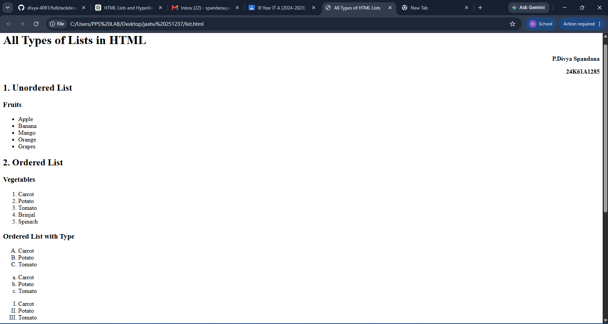
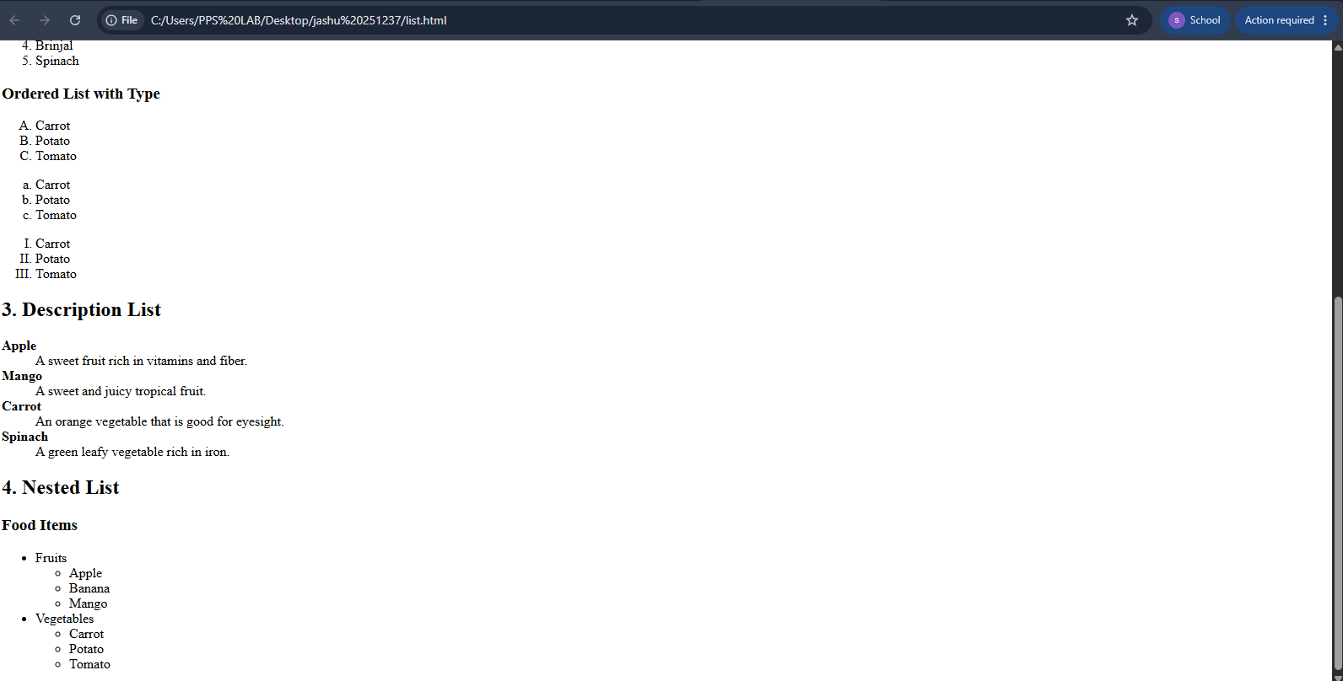

Experiment 1(b): HTML Hyperlinks

Aim
To write a HTML program to demonstrate the working of hyperlinks using the <a> tag with href and target attributes.

Description:
- The <a> (anchor) tag is used to create hyperlinks in HTML.
- The href attribute specifies the URL or destination of the link.
- The target attribute specifies where the linked page will open.
- target="_blank" opens the link in a new tab, while target="_self" opens it in the same tab.

Tags Used:
- <a> – Creates a hyperlink.
- href – Specifies the destination of the hyperlink.
- target – Specifies where to open the linked page.
- <h1> – Displays the heading.
- <p> – Displays a paragraph.
- <br> – Inserts a line break.

Program:

<!DOCTYPE html>

<html>

<head>

<title>Hyperlinks Example</title>

</head>

<body>

<h1>HTML Hyperlinks</h1>

<p align="right"><b>P.Divya Spandana</b></p>

<p align="right"><b>24K61A1285</b></p>

<p>Click the following links to visit different websites:</p>

<a href="https://www.google.com" target="_blank">

Visit Google

</a>

<br><br>

<a href="https://www.youtube.com" target="_blank">

Visit YouTube

</a>

<br><br>

<a href="https://www.wikipedia.org" target="_self">

Visit Wikipedia

</a>

</body>

</html>
Output:
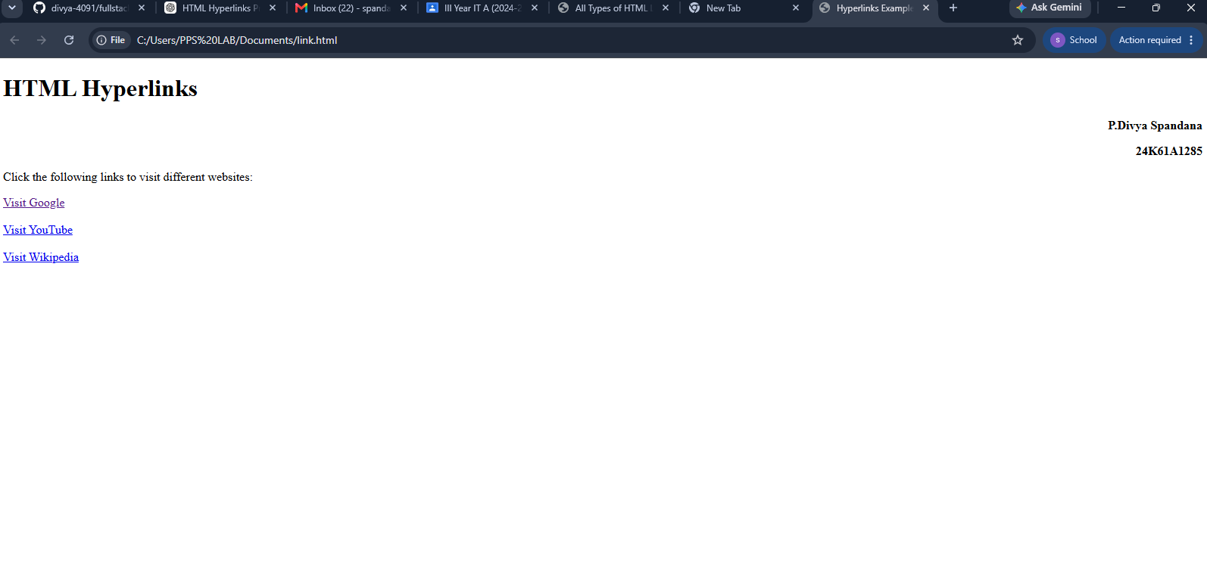

Experiment1(c): Images with Hyperlinks

Aim:
To create an HTML document that displays your image and your friend’s image with a specific height and width, and to navigate to their respective profiles when the images are clicked.

Description:
- The <img> tag is used to display images on a webpage.
- The src attribute specifies the image location.
- The width and height attributes specify the image size.
- The <a> tag is used to make an image clickable.
- The href attribute specifies the profile page to open.
- The target="_blank" attribute opens the profile in a new tab.

Tags Used:
- <html> – Defines the HTML document.
- <img> – Displays an image.
- <a> – Creates a hyperlink.
- src – Specifies the image path.
- href – Specifies the profile link.
- width – Sets image width.
- height – Sets image height.
- target – Specifies where the profile opens.

Program:
<!DOCTYPE html>
<html>
<head>
<title>My Profile</title>
</head>
<body>
<h1>My Profile and Friend Profile</h1>
<p align="right"><b>P.Divya Spandana</b></p>
<p align="right"><b>24K61A1285</b></p>

<a href="myprofile.html">
<img src="myimage.jpg" width="200" height="200" alt="My Image">
</a>
<a href="friendprofile.html">
<img src="friendimage.jpg" width="200" height="200" alt="Friend's Image">
</a>
</body>
</html>
Output: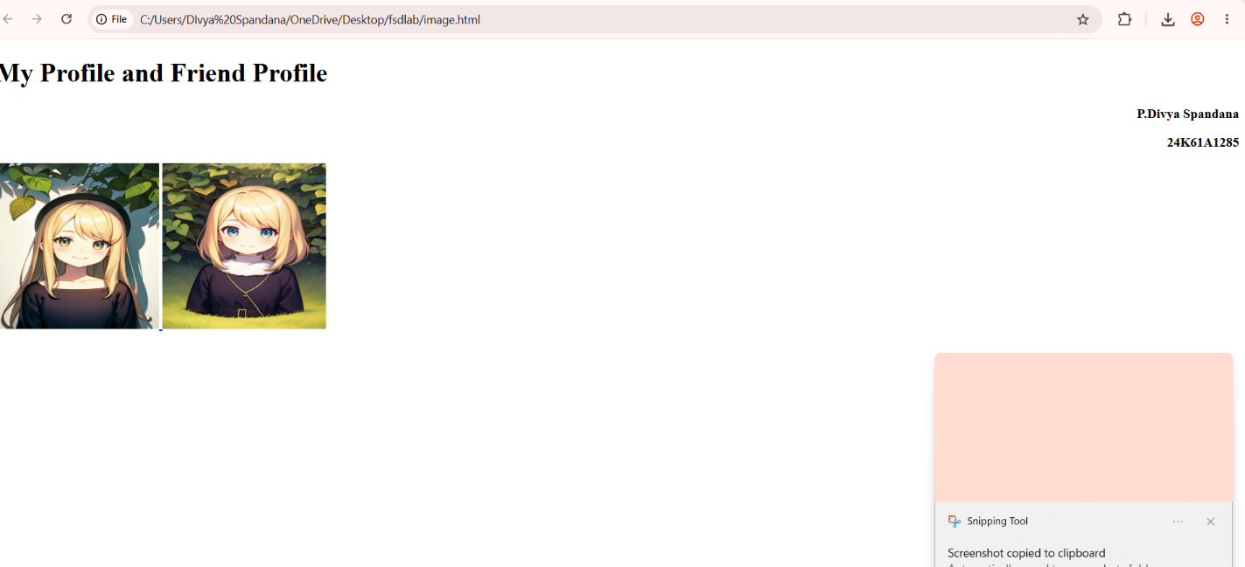

Experiment1(d):Image Gallery Using Thumbnails
Aim:
To create an HTML image gallery using 100 × 100 pixel thumbnails, where each thumbnail is linked to its full-sized image.
Description:
- The <img> tag is used to display images.
- The width and height attributes set each thumbnail to 100 × 100 pixels.
- The <a> tag is used to make each thumbnail a clickable link.
- Clicking a thumbnail opens the full-sized image.
Program:
<!DOCTYPE html>
<html>
<head>
<title>Image Gallery</title>
</head>
<body>
<h1>My Image Gallery</h1>
<p align="right"><b>P.Divya Spandana</b></p>
<p align="right"><b>24K61A1285</b></p>
<a href="image1.jpg">
<img src="image1.jpg" width="100" height="100" alt="Image 1">
</a>

<a href="image2.jpg">
<img src="image2.jpg" width="100" height="100" alt="Image 2">
</a>
<a href="image3.jpg">
<img src="image3.jpg" width="100" height="100" alt="Image 3">
</a>
<a href="image4.jpg">
<img src="image4.jpg" width="100" height="100" alt="Image 4">
</a>
</body>
</html>
Output:
