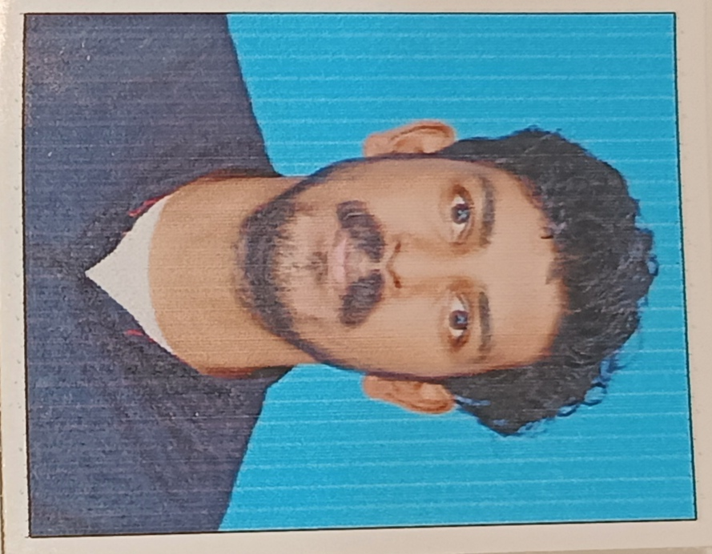
CURRICULAM VITAE

Name : ANISH KARMA TM
Age : 28
Dateof birth : 16-04-1994
Address for communication: Kallelikudi (h) South vazhakulam Chemberakky 683105 Perumbavoor
Phone/Mobile : 9744182451
Email : tmanishkarma@gmail.com
EducationalQualifications: B.com

Year of passing | Qualification | Specialisation or Subjects | School / College/  University / Institute | Total marks %/ CGPA | Any other relevant information
2009 | SSC / 10th/ |  | S.N.D.P H.S.S  Venkurinje | 65%
2011 | HSC / 12th/ | Commerce Computer | Govt. H.S.S  Vechoochira Colony | 68%
2014 | Graduation | B.Com (Computer) | St.Antony’s College Kanjirappally (Bharathiyar  University)

Work experience:

No of years | Organisation | Designation | Job responsibilities | Any other relevant  information
One Year Six Months | Raymonds | Junior Accountant and Cashier | Updating financial statements, maintaining accounts receivable and accounts payable, , and  preparing financial reports
Two Year Eight Months | St.Marys Rubbers Pvt. Ltd | Logistics Supervisor | - Understanding planning, shipping, warehouse management and inventory systems.  - Managing daily routes/schedules of shipments and deliveries.  - Tracking the progressof shipments.  - Knowing all aspectsof warehouseoperations.  - Reviewing inventoryneeds and keeping adequatestock.
3 years | Lenora Gloves Pvt. Ltd | Store In charge and Logistics In charge | - Costminimization,  - Keeping a record of sales and restocking the storeaccordingly.  - Managing and training storestaff.,  - Ensuring that the storeis kept clean andorganized.,  - Keeping a Record ofSales and restocking the store accordingly

Hobbies / interests: Driving, Cricket, Free Time Spent With My Wife Married: Yes
Languagesknown: English, Hindi, Malayalam, Tamil

Last salary drawn: Gross (including PF, HRA, etc.) - Rs.28000

CARRIER OBJECTIVE

To obtain a respectable position in your organization this will enable me to use my talents, creatively and ability to the maximum and contribute to the growth of organization as well as myself

DECLARATION

I hereby declare that the above mentioned statements are true and correct to the knowledge and belief

Place :

Date : Anish Karma TM

