RESUME
A.V.V.S.P.P.R. RAGHAVENDRA 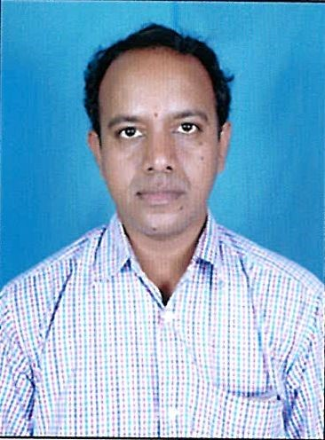

S/o: A.V. VISWESWARA RAO

PULLETIKURRU,

AMBAJIPETA MANDAL

Pin: 533239
DR.BR.AMBETHKAR KONASEEMA DIST. phone: 9989854558

Email:raghavendra.ayyagari@gmail.com
I aspire to work as commerce Postgraduate using my skills and to see myself in a position of increasing responsibility and contribute success to the organization.
EDUCATIONAL QUALIFICATIONS
COURSE | BOARD/UNIVERSITY | YEAR OF STUDY | AGGREGATE
M.com  (Accountancy) | ACHARYANAGARJUNA UNIVERSITY  CENTER FOR DISTANCE EDUCATION | 2013-14  (CAL. YR) | 60.00%
B.com | ANDHRA UNIVERSITY  S.N.S.N.R. DEGREE COLLEGE | 2005-2008 | 63.25%
Intermediate  (C.E.C) | BOARD OF INTERMEDIATE  EDUCATION.  SRI NANNA RAJU JUNIOR COLLEGE | 2003-2005 | 79.30%
S.S.C | BOARD OF SECONDARY EDUCATION.  Z.P.H. SCHOOL | 1999-2000 | 67.00%

TECHNICAL QUALIFICATIONS:

- Knowledge in PGDCA
- Knowledge in TALLY 9.0.

- ERP (.NET 5.15 VERSION)
WORKING EXPERIENCE:
- Worked as Marketing Executive in Tata indicom From Oct 2008 to December 2009
- Worked As Jr. Accountant in Prasad & Co from February2010 to July 2010
- Worked as computer operator in RWS&S department from February 2011
To March- 2012
- Worked as Accountant and Audit Assistant in KPG&CO from April 2012
To September-2016
- Worked as Junior Relationship Executive in Muthoot Finance Ltd. From Nov-2016
To Jan 2018
- Working as Senior Assistant (ACCOUNTS) in NCC Ltd from Feb-2018

OTHER ACTIVITES:
- I actively participated in cultural programmes conducted in the school in anniversary celebrations.

PERSONAL PROFILE:
Name : A.V.V.S.P.P.R. RAGHAVENDRA
DOB : 13 MARCH 1985
Father’s Name : A. V. VISWESWARA RAO
Phone. No : 9989854558
Language’s known : Telugu, English and Hindi.
DECLARATION:
I hereby solemnly declare that all the statements made in the above application are true and
correct to the best of my knowledge.

Place: PULLETIKURRU.

Date: 08.04.2023 YOURS TRULY,

A.V.V.S.P.P.R. RAGHAVENDRA

