RESUME

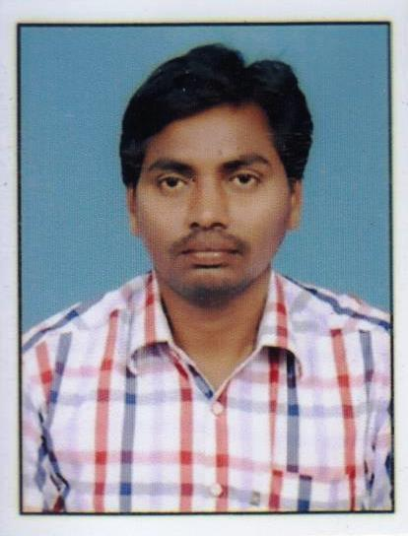
S.PAVANKUMAR
Mobile: +919703322067 E-mail: pavankumarsabbu1987@gmail.com
Career Objective:-

Seeking Position to utilize my skills and abilities administration in Industry that offers professional growth while being resourceful Imitative and flexible.

Educational Qualifications:-

- M.B.A (finance &Marketing) from NNS VIdhya College, Chirala in 2010.
Software Skills:-

- Tally ERP9.0& MS-Office & SAP

Professional Experience Summary:-

Employer: - CJN HITECH MOTORS PVT LTD(EICHER).ONGOLE.
Designation: - Accountant
Duration: - 12TH SEP-2018 to 25th Dec -2021
Responsibilities:-

- Cash Handling & Cash book Maintained Day to Day Transactions
- Bank transaction & bank statement reconciliations
- GST Sale invoice bills & Purchases bill ,vouchers
- Payment Approvals & Suspense’s cash maintain
- GST filing reconciliations
- Employee’s Salary Statement Preparation
Professional Experience Summary:-

Employer: - Sahni Auto Agencies Hp lubricants distribution point At ongole
Designation: - Accountant
Duration: - March 1st2011 to 25 August 2018
Responsibilities:-

- Maintained of Sale invoice bills & Purchase& voucher & Receipt
- Bank transaction & bank statement reconciliations
- Handle with cash & cash Book& Salary Statement
- Tally Inventory stock maintained

Personal Traits:

- Have a global mindset to work in a knowledge sharing and team oriented environment.
- Good communication skills, hard working, patient attitude and taking related.
- Having responsibility for all company rules &regulation operation role
Personal Profile:

Name : S.PAVAN KUMAR
Father’s Name : ANJAIAH
Date of Birth : 25-06-1987
Gender : Male
Marital Status : Married
Nationality : Indian
Languages Known : English, &Telugu
Permanent Address: H.NO:-1-13,
CHAVATAPALEM (PO)
NAGULUPPALAPADU (Mdl) Prakasam (District), A.P...
Declaration:
I hereby declare that the above written particulars are true to the best of my knowledge and belief.
(SABBU PAVANKUMAR)

