RESUME
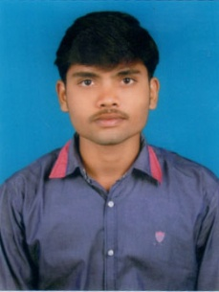
VINOD VARIKALLU
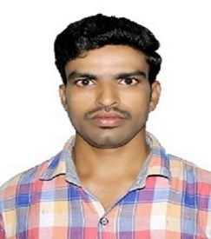

Email– vinodvarikallu@gmail.com
Contact No.-9666755562, 9573941809

Professional Objective:
To work for an organization that gives me ample opportunities of learning and gaining knowledge. So that in turn I can contribute to the growth and development of the company and simultaneously widen my horizons.
Work Experience: 5.0 Years
Working as an Accountant in Akshara international schools Hyderabad.Since November 2017.
Key Result Areas:
- Follow up with customers on payment dues/Discrepancies.
- Bank Reconciliation, Vendor Ledger reconciliation
- Inter branch accounts reconciliation
- Employeepayroll process.
- Pretty good with Ms Excel
- Preparation of monthly reports
- E Waybill creation
- Maintenance of cash & Bank books
- Year end closing/ Balance sheet entries
- Inventory status report submission in Excel
- Cross checking of bills and vouchers.

Academic Profile:
- MBA (Finance & HR) from Priyadarshini College of Computer Science and Research (O.U) 2017.
- B.COM (CA) From Priyadarshini Degree& PG College (K.U) 2015.

Skill Sets:
- Operating systems : Windows 10, Windows 7.
- Additional skills :Ms Office, Tally ERP9

Personal skills:
- Comprehensive problem solving abilities.
- Remarkable analytical and logical skills
- Ability to give best results in pressure situations.
- Effective communication and interpersonal skills

Personal Profile:
Name : Varikallu Vinod
Father’s name : Venkateswarlu
Gender : Male
Marital status : Married
Languages known : English, Telugu, Hindi
Nationality : Indian
Date of Birth : 10/07/1993
Permanent Address : VK Ramavaram, Mulakalapalli, Bhadradri Kothagudem 507115
Present Address : Allwyncolony, Jagathgirigutta, Kukatpally, Hyd 500072

Motto:
Learn anything that push me one step forward from others. Keep learning & master with into generate with full from soul, Ready to take challenges, ease in accessibility.

Declaration:

I hereby confirm that above furnished details are best of my knowledge and I assure you that I will deliver my duties with dedication and sincerity.

VINOD VARIKALLU

