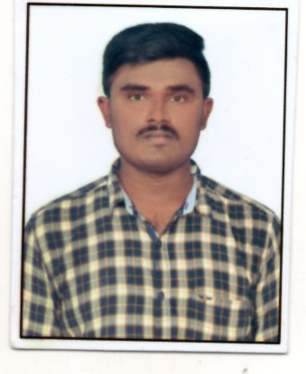
G.VASUDEVA REDDY

E -mail: vasu15071996@gmail.com Address: 97/A,
Phone : +91 8106759333 Near peacock circle,
Beside sbi street,
Pragathi nagar,
Hyderabad
Telangana ,
500090.

Objective

To work in a firm with a professional work driven environment where I can apply and utilize my Knowledge, Skills which would enable me as a fresh graduate to grow while fulfilling the Organization goals

Education summary

Course | Year of passing | Name of School/College | Board/University | %Marks obtained
PG(M.B.A) | MAY-2018 | Vasavi institute of management and computer science. | JNTU  Anantapur | 80.00
DEGREE  (B.COM COMPUTERS) | 2016 | Vaibhav Degree College | Rayalaseema University. | 74.00
Intermediate  (M.E.C) | 2013 | Sri Medha’v’ Vijayawada. | Board of Intermediate Education, A.P. | 77.00
S.S.C | 2011 | Jeevan Jyothi high school | Board of Secondary Education, A.P. | 83.00

Project Work Details
Project Title: Financial statement analysis.
Description : Financial statement analysis is the process of reviewing and analyzing a company’s financial statements to make better economic decisions. These statements include the income statement, balance sheet, statement of cash flows, and a statement of changes in equity.
.

Computer Literacy

M.S OFFICE
ACCOUNTING WITH TALLY AND GST RETURNS
Experience
Work as an ACCOUNTANT in KUDALA ASSOLCIATES from SEP 2018 to MARCH 2020
Working as an ACCOUNTANT in SRI VIJAYA DURGA INFRA from JUNE 2020 to PRESENT.
Duties:-
1. Examining the company’s financial records and reporting activities.
2. Making sure secure records are held of all accounts.
3. Preparing monthly management accounts.
4. Completing detailed accounting transaction
5. Checking invoices against orders.
6. Filling GST returns.

Personality Trait

- My determination to learn; diligence at work
- Imagination and Visualization
- Strong motivational and leaderships skills.
- Exuberant
- Ability to work as individual as well as in group.

Personal Interests

- Playing cricket
- Listening to music
- Watching movies

Declaration

I here by assure that all the details furnished above are true to the best of my knowledge and belief.

Place :
Date :
(G VASUDEVA REDDY.)

